AI ASSISTED CODING

NAMEk.vrushikesh
BATCH:40
ROLL NO : 2303A52218

Lab 15 – Backend API Development: Creating RESTful services
with AI
Task Descriptor-1: (Setup Fast API Backend )
Instructions:
• Install FastAPI and Uvicorn.
• Use AI to generate a basic FastAPI application with one endpoint
Sample Code:
from fastapi import FastAPI
app = FastAPI()
@app.get("/")
def read_root():
return {"message": "Welcome to AI-powered FastAPI"}
Expected Output:
Running the server and accessing:
http://127.0.0.1:8000/
Response:
{"message": "Welcome to AI-powered FastAPI"}
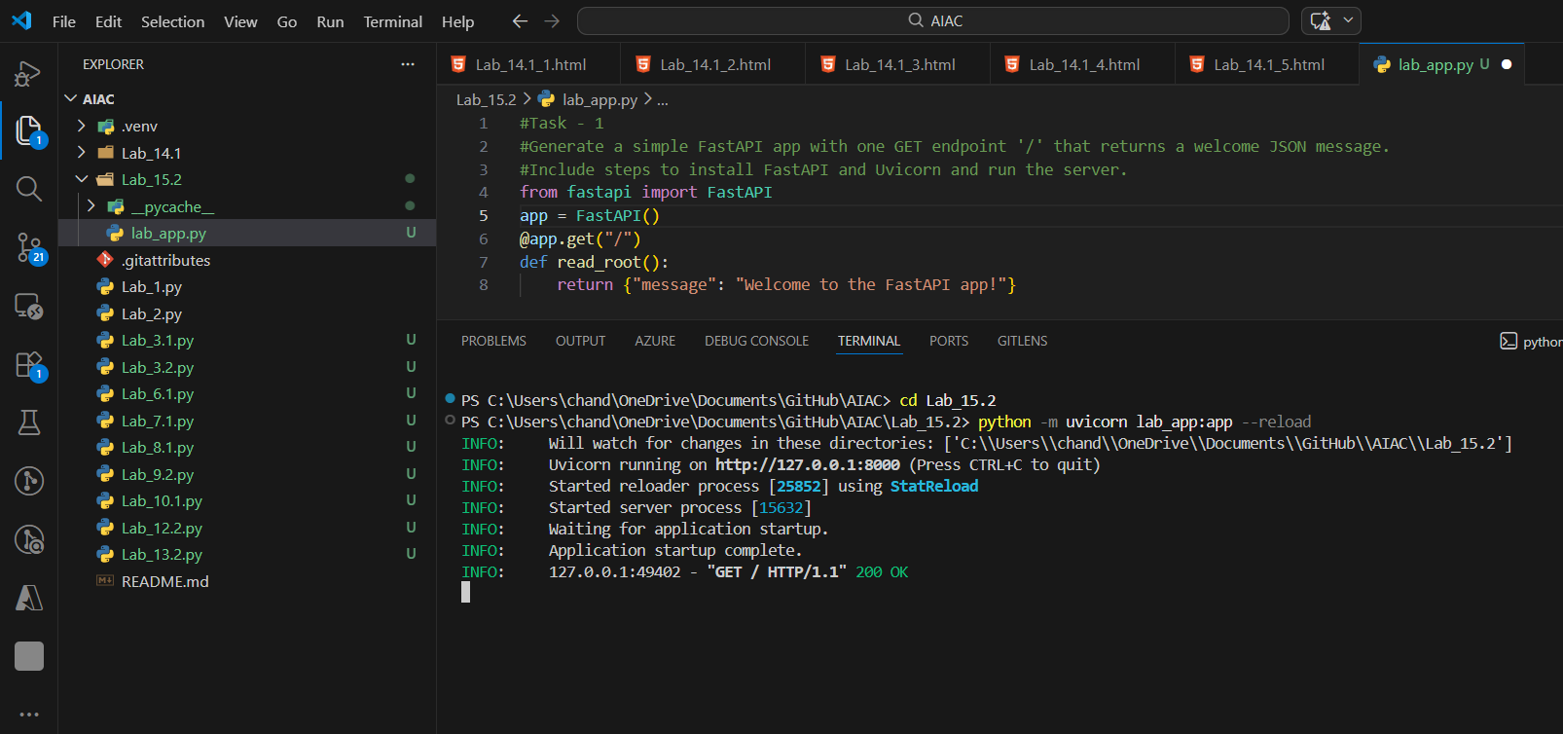
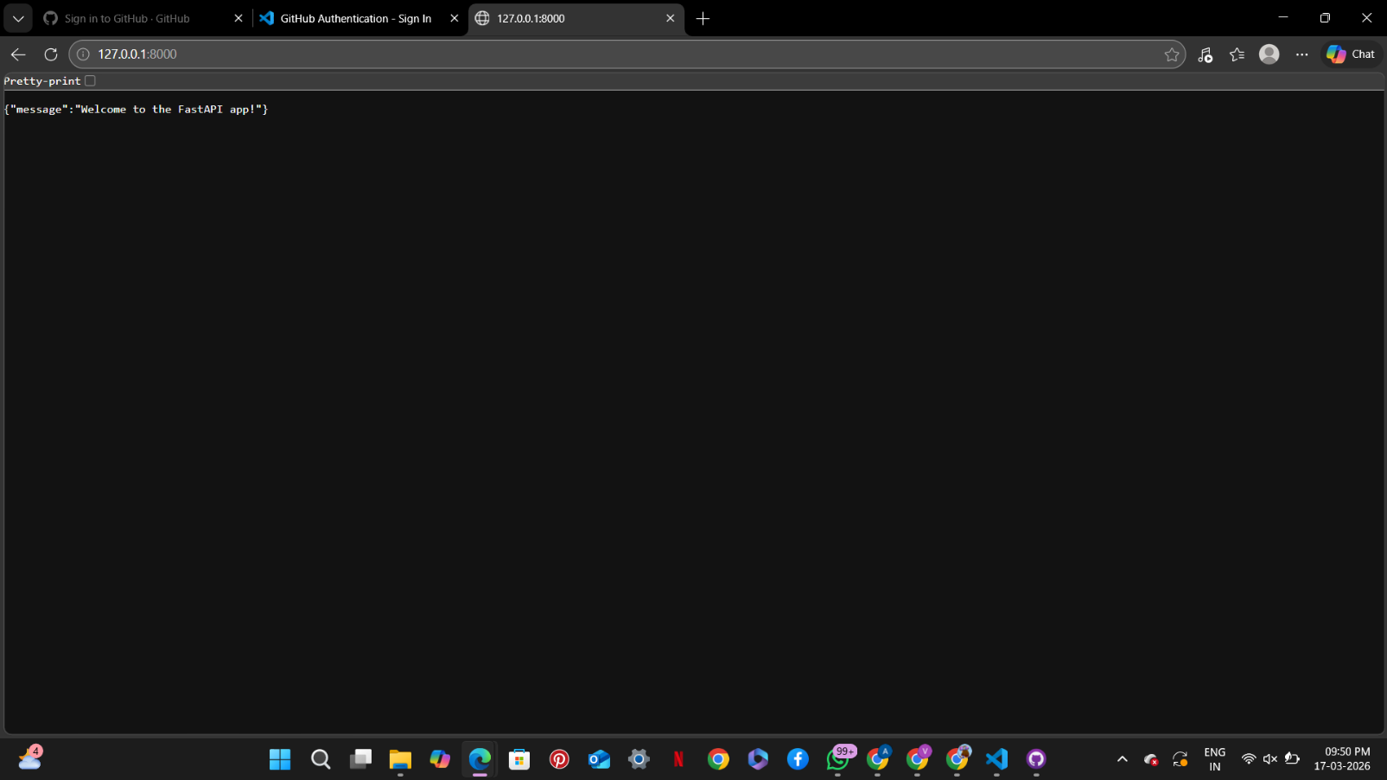
ANALYSIS
- Installs FastAPI and Uvicorn for backend development.
- Creates a basic API with one GET endpoint.
- Returns a JSON response to the client.
- Demonstrates how to run a server locally.
- Builds foundation for further API tasks.

Task Descriptor- 2: (API – Create and Read Items)
Instructions:
• Implement endpoints to add and retrieve products.
• Use a Python list as temporary storage.
Sample Code:
items = []
@app.get("/items")
def get_items():
return items
@app.post("/items")
def add_item(item: dict):
items.append(item)
return {"message": "Item created", "item": item}
Expected Output:
GET /items → []
POST /items with {"name":"Pen","price":20}
→ {"message":"Itemcreated","item":{"name":"Pen","price":20}}
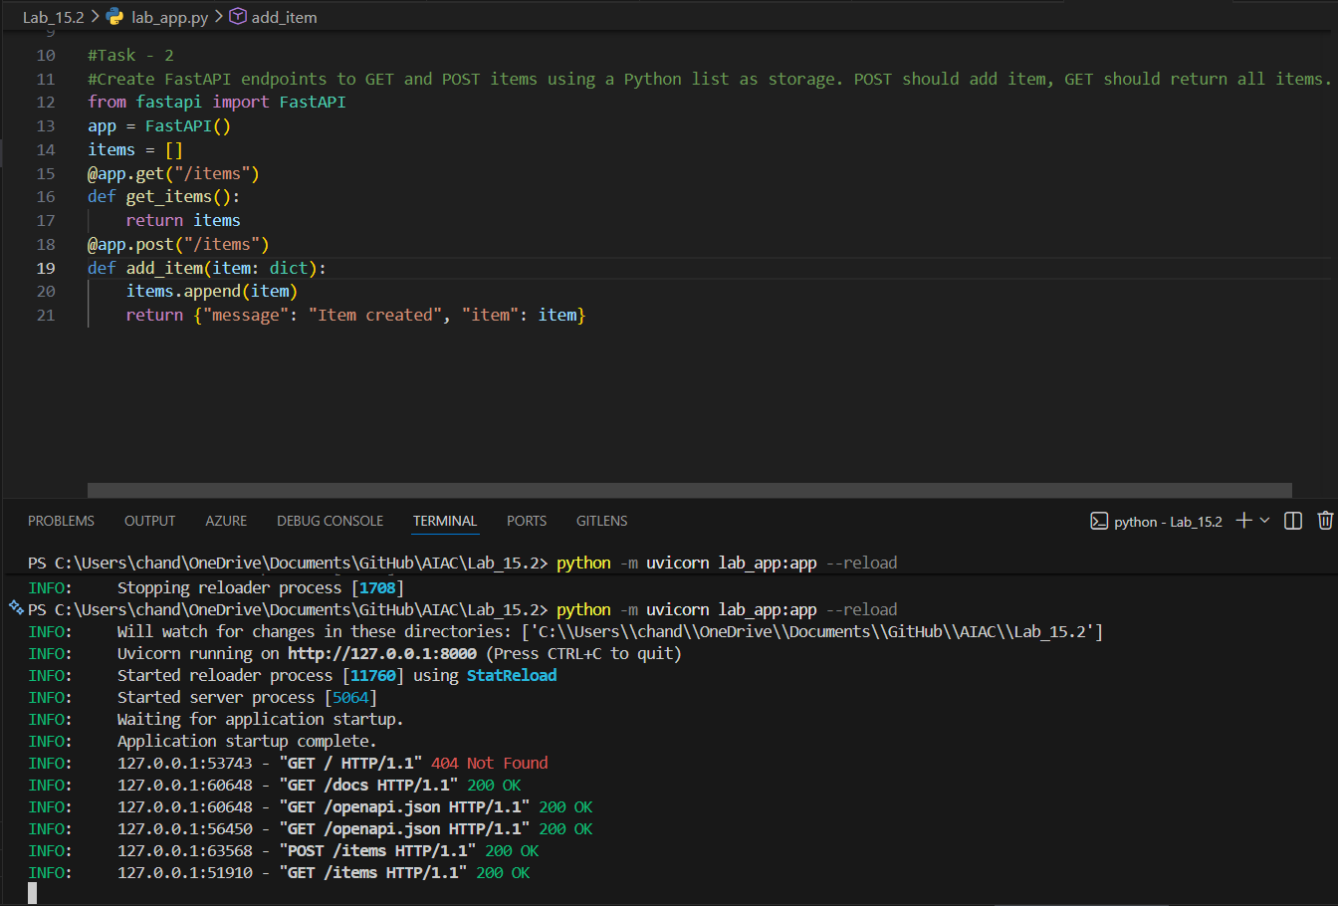
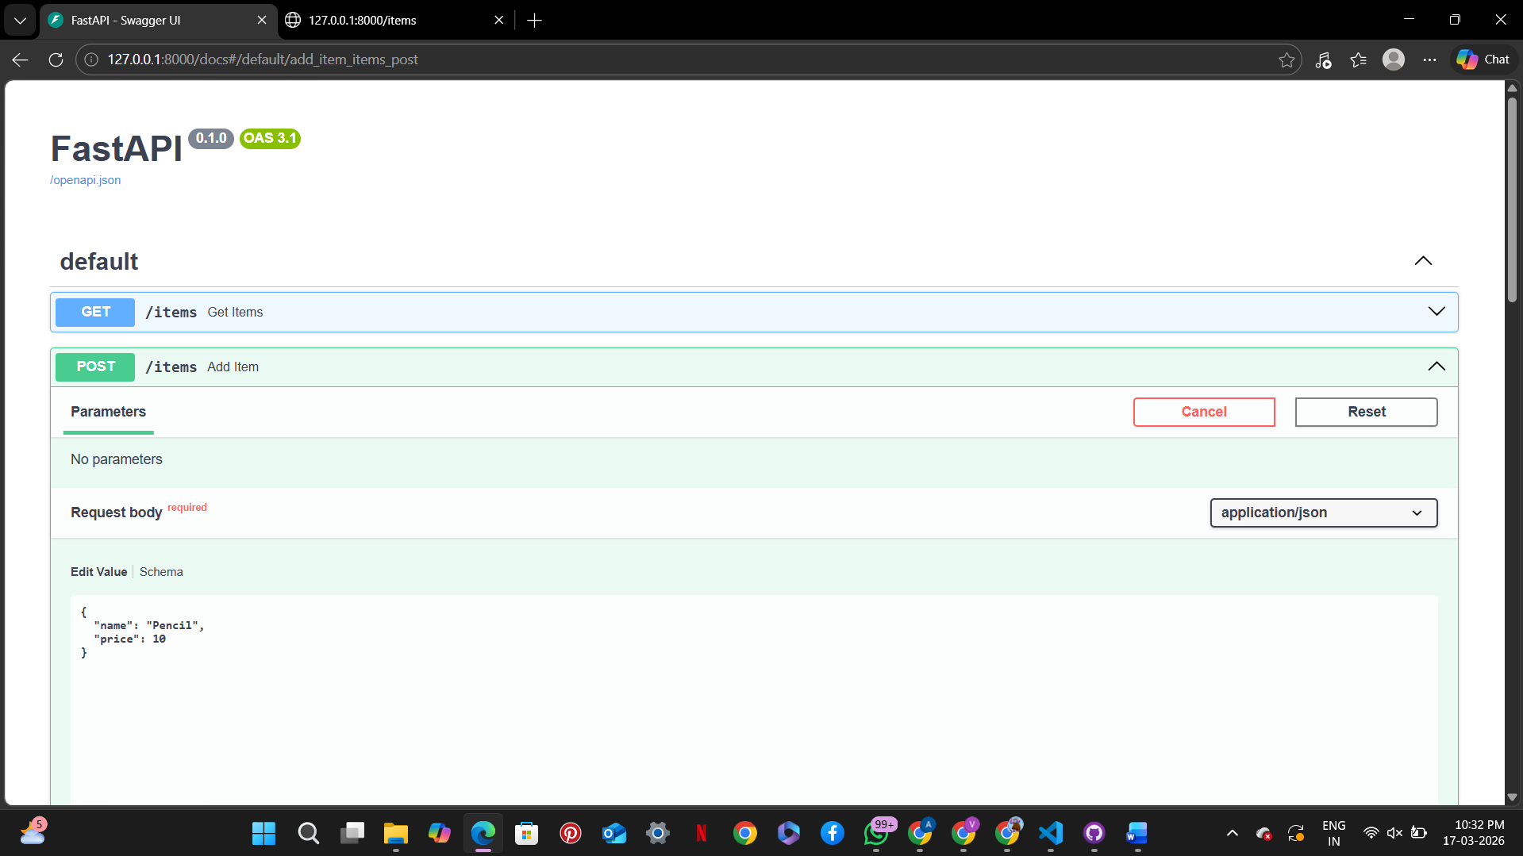
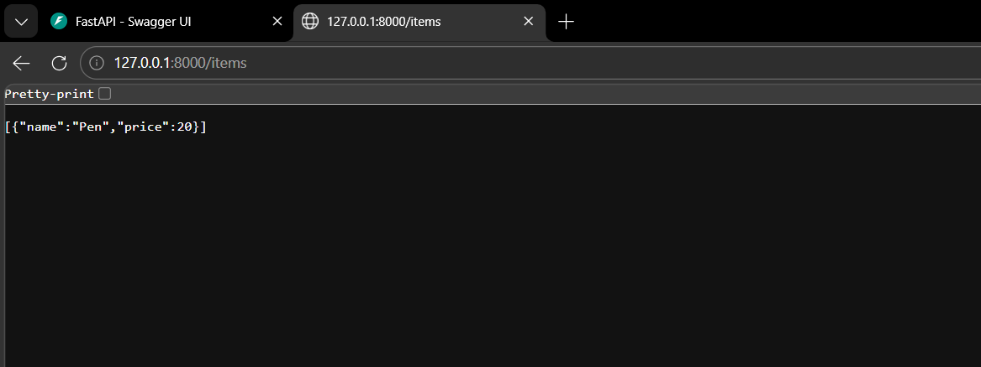
ANALYSIS
- Implements GET and POST methods.
- Uses a Python list as temporary storage.
- Allows adding new items dynamically.
- Retrieves all stored items.
- Introduces basic CRUD operations.

Task Descriptor- 3: (Update Existing Item)
Instructions:
• Use AI to generate an endpoint to update an item using its index.
Sample Code:
@app.put("/items/{index}")
def update_item(index: int, item: dict):
if index >= len(items):
return {"error": "Item not found"}
items[index] = item
return {"message": "Item updated", "item": item}
Expected Output:
PUT /items/0 with {"name":"Pencil","price":10}
→ {"message":"Itemupdated","item":{"name":"Pencil","price":10}}
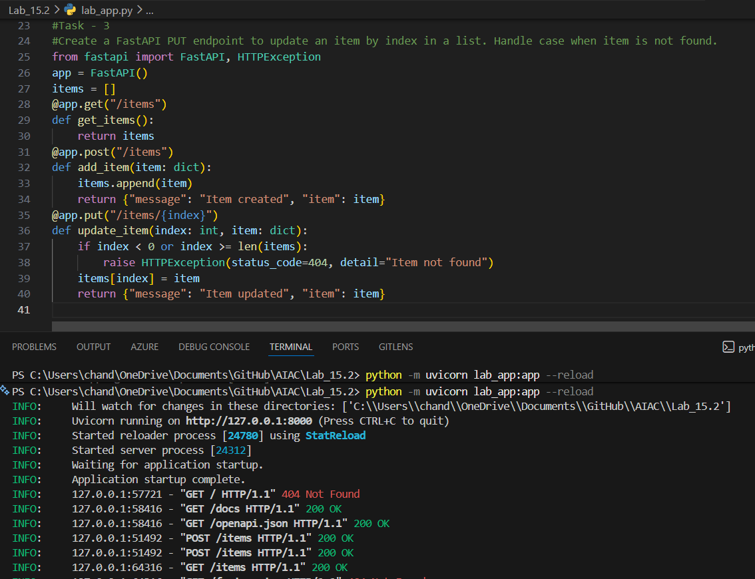

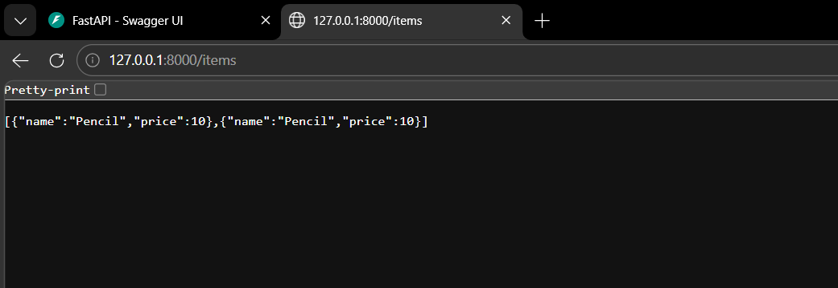
ANALYSIS
- Uses PUT method to update existing data.
- Updates item based on index position.
- Checks for invalid index (error handling).
- Replaces old data with new data.
- Improves data manipulation skills.

Task Descriptor- 4: (Delete Item)
Instructions:
• Implement deletion of an item by index.
Sample Code:
@app.delete("/items/{index}")
def delete_item(index: int):
if index >= len(items):
return {"error": "Item not found"}
removed = items.pop(index)
return {"message": "Item removed", "item": removed}
Expected Output:
DELETE /items/0
→ {"message":"Itemremoved","item":{"name":"Pencil","price":10}}
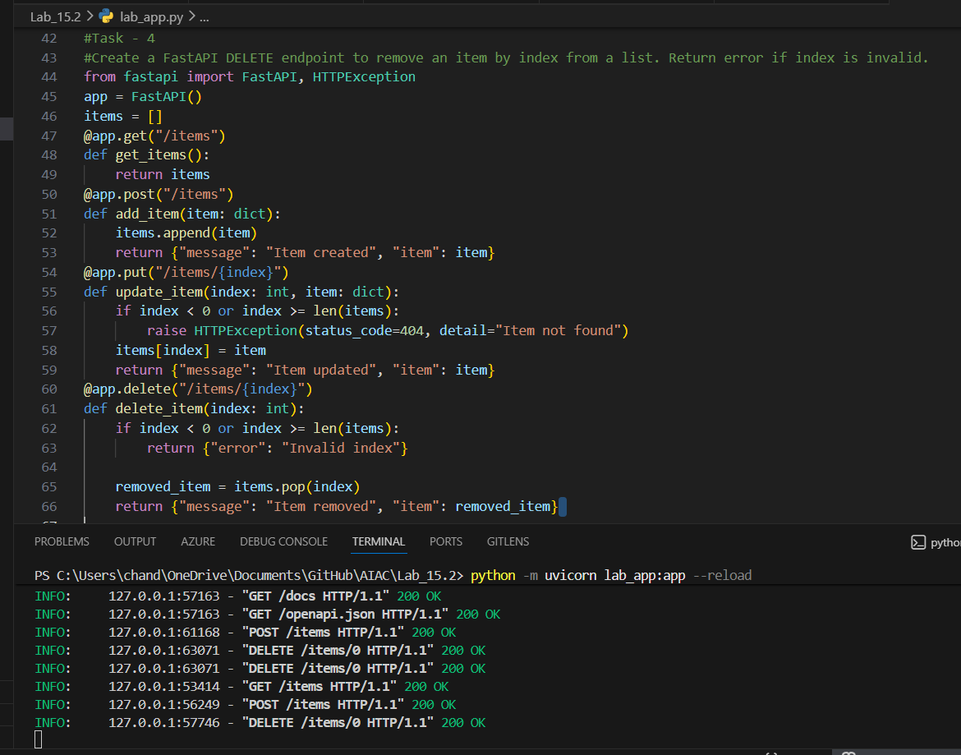
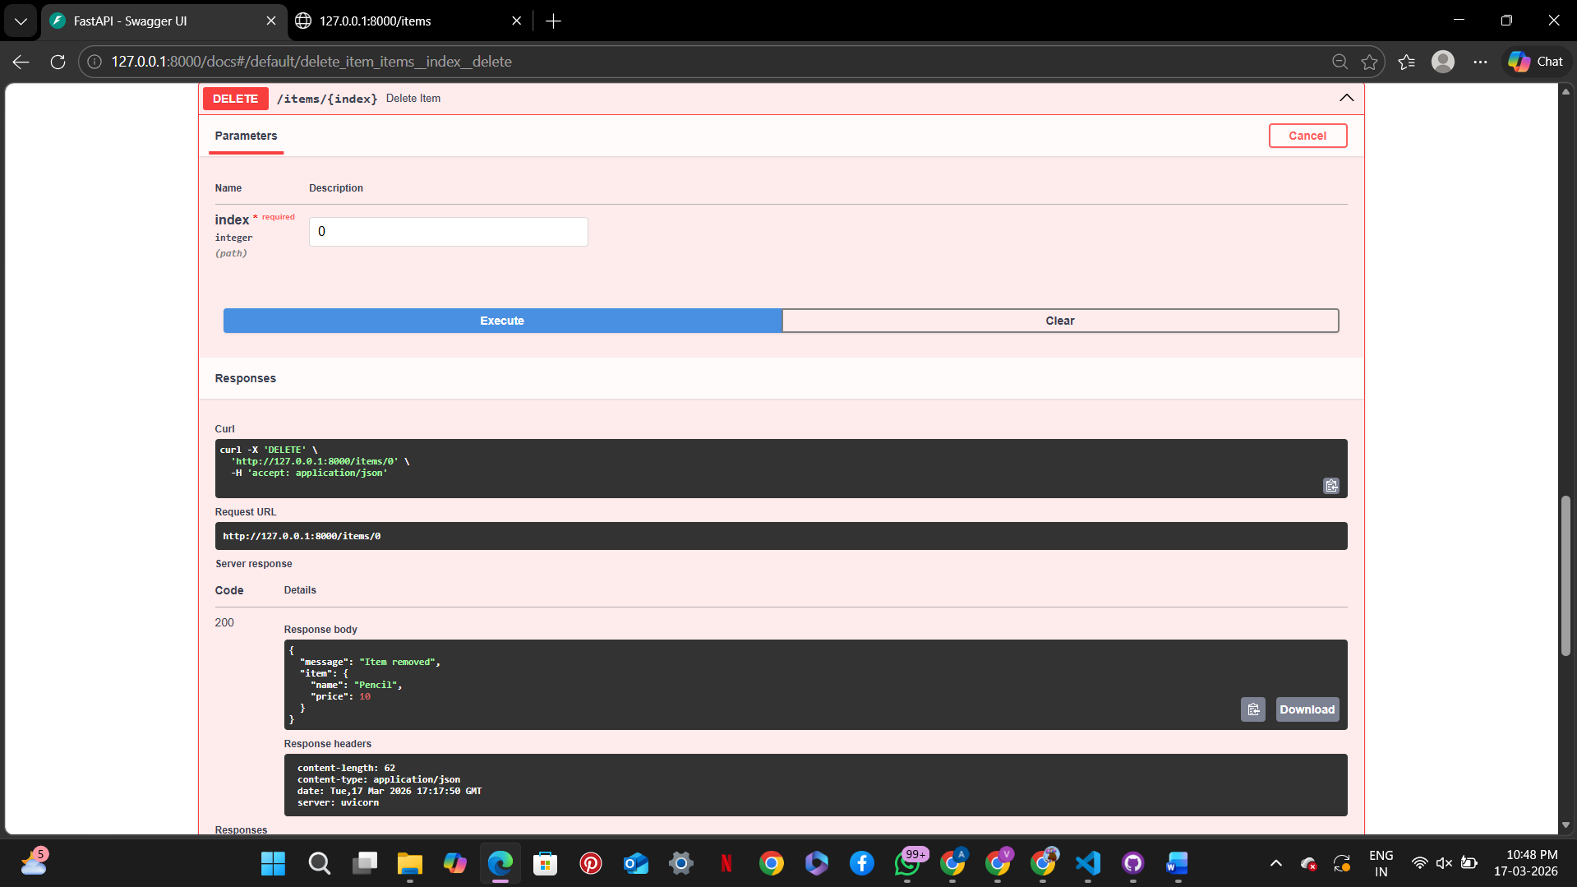
ANALYSIS
- Uses DELETE method to remove items.
- Deletes item using index value.
- Validates index before deletion.
- Returns removed item as response.
- Ensures safe data handling.

Task Descriptor -5: (Add Auto-Generated Documentation)
Instructions:
• Use AI to add inline comments and docstrings for all endpoints.
• Optionally, integrate Swagger / Flask-RESTX to auto-generate
API documentation.
Sample Code:
@app.route('/items', methods=['GET'])
def get_items():
"""
GET /items
Returns a list of all items in the store.
"""
return jsonify(items)
Expected Output:
• Clear documentation for all endpoints, e.g., via /docs if using
Swagger.
• Students should be able to see endpoint description, methods, and
sample payloads.
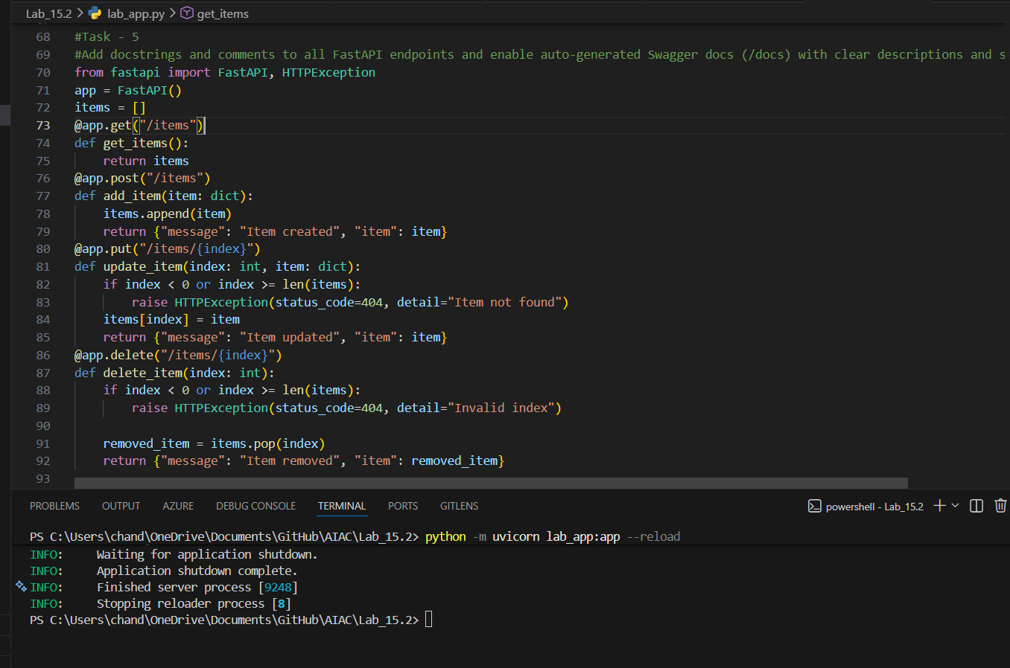
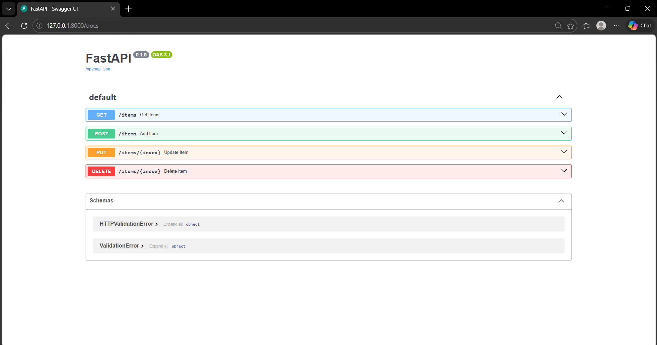
ANALYSIS
- Adds docstrings to explain endpoints.
- Enables automatic Swagger documentation.
- Helps users understand API usage easily.
- Displays request/response formats.
- Improves readability and usability of API.

