Volunteers Repairing Homes (VRH)

VRH Corporation is a 501(c)3 charitable organization. Our purpose is to help people in the northern Virginia area who are in need of assistance to make their homes safer, warmer, dryer, and more accessible or more energy efficient.
- VRH helps people financially challenged, persons with temporary or permanent disabilities, victims of natural or man-made disasters or other people requiring home repair assistance.
- Projects are completed by a small Team of 4-6 people consisting of volunteers and contractors when needed. Services are at no cost to the homeowner.
- VRH adheres to the concepts of social justice and confidentiality. VRH volunteers respect the dignity, privacy, diversity and uniqueness of each recipient of assistance.

Example Projects
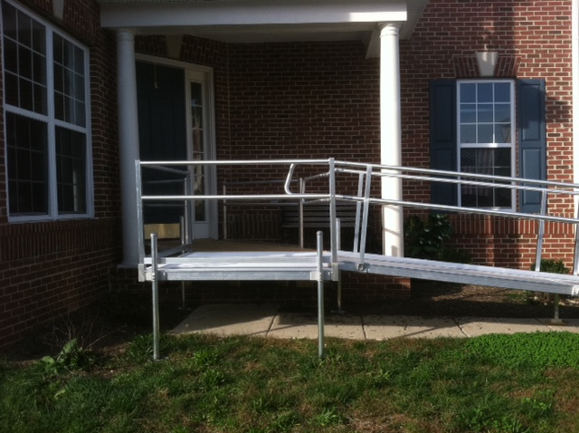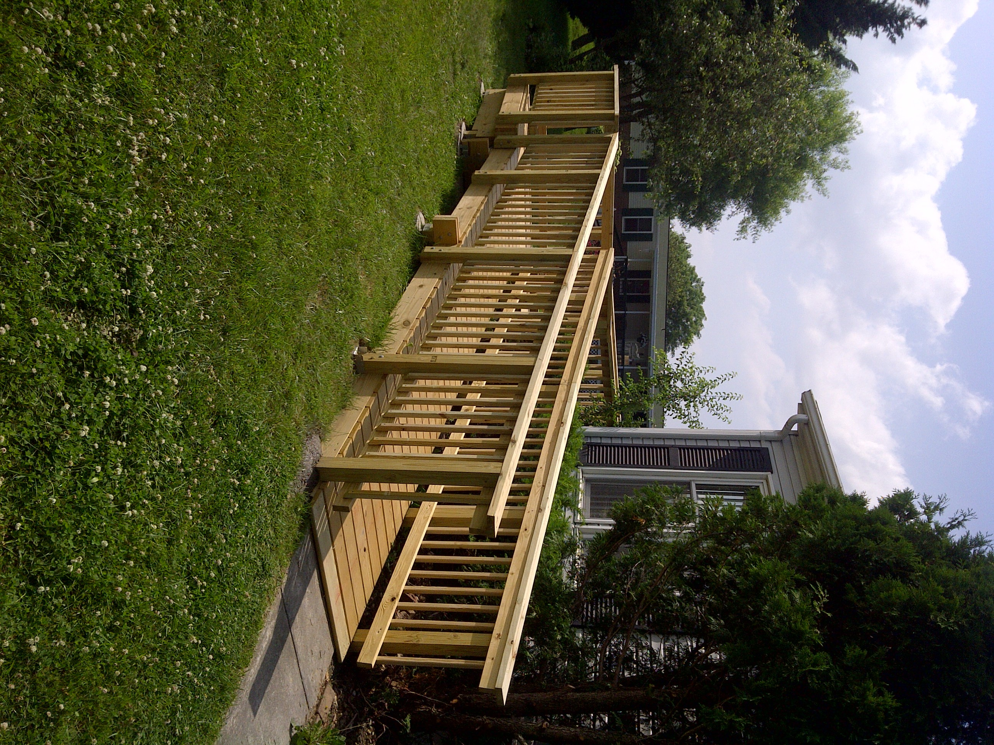
Wheelchair Ramp projects in Lorton (left) and Winchester (right)

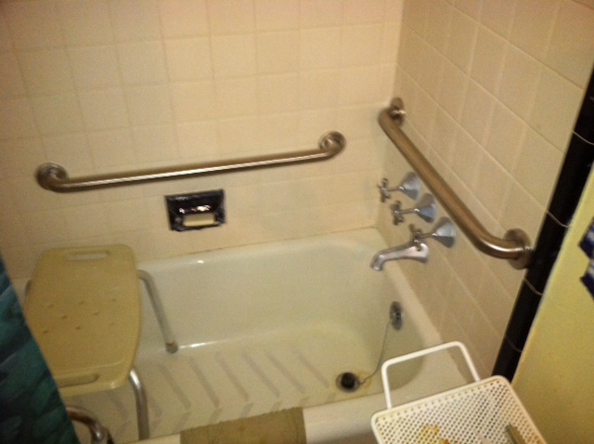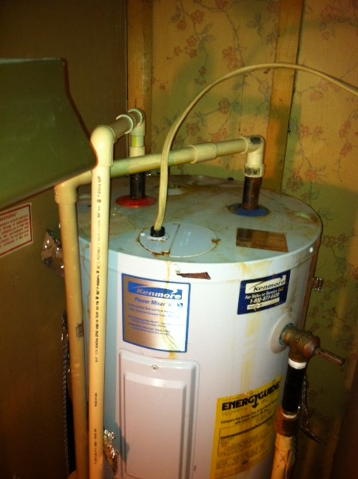
Installation of ADA grabs bars in Alexandria (left), and an old hot water heater that was replaced in Winchester (right)

If you or someone you know needs help please call!
Contact our Project Coordinator, vrhvolunteers@gmail.com, 571-253-7124

How YOU Can Help!
- Volunteer to assist in projects
- Make a donation via check or gift card for materials, make payable to Volunteers Repairing Homes, 4232 Worcester Drive, Fairfax, VA 22032. Volunteers Repairing Homes is a 501(c)3 charitable organization, and a financial statement is available upon request from the Commonwealth of Virginia Office of Charitable and Regulatory Programs.

