**Commands for File Management:**

* cd: Modify the directory

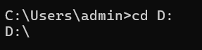

The cd command is used to change the current working directory.

* cd /usr/include to change to the /usr/include directory
* cd sys to go down one level of the directory tree to the sys directory
* cd .. to go up one level of the directory tree
* dir: Display the directory’s contents

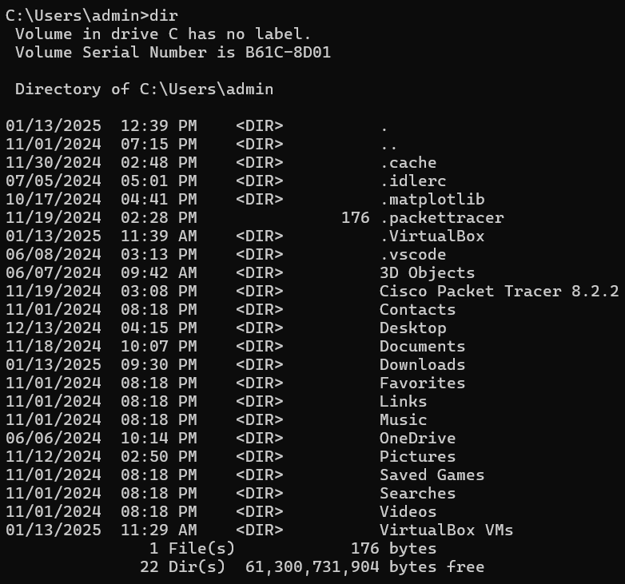

Displays the contents of a directory in alphabetical order. If no options or directory location are specified, it displays all files and directories in the current working directory.

* mkdir & rmdir: make a new directory and removes an empty directory

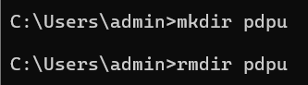

mkdir

Creates a new directory. For example, mkdir newdirectoryname creates a new directory named newdirectoryname. You can also use mkdir to create multiple directories at once.

rmdir

Removes an empty directory. For example, rmdir directoryname removes the directory named directoryname. rmdir will not remove directories that contain files or subdirectories. If you need to remove a non-empty directory, you can use the rm -r command.

* del: remove files

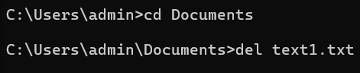

To delete a file, you can use the syntax del “filename”. For example, to delete a file named Math_file.txt, you can use the command del “Math_file.txt”. You can also use wildcards like * and ? to delete multiple files at once. However, you should use wildcards carefully to avoid deleting files unintentionally.

* copy: Transfers files between locations

* Copy a file

To copy a file from one location to another, you can use the command copy <filename> <destination>. For example, to copy myfile.txt from the C: drive to the E: drive, you can use the command copy c:\myfile.txt e:.

* Copy all files with a wildcard

To copy all text files in the current directory to the E: drive, you can use the command copy *.txt e:.

* Copy files and subdirectories

To copy all files and subdirectories from one location to another, you can use the /s option. For example, to copy all content from apples into bacon, including subdirectories, you can use the command copy apples bacon /s.

* Combine files

To combine multiple files into one, you can use the copy command with multiple file names. For example, to combine mar89.rpt, apr89.rpt, and may89.rpt into a file named Report, you can use the command copy mar89.rpt + apr89.rpt + may89.rpt Report.

* Copy binary files

To combine several binary files into one, you can use the copy command with the /b option. For example, to combine all binary files into a file named Combined.exe, you can use the command copy /b *.exe Combined.exe.

* move: rename or move files

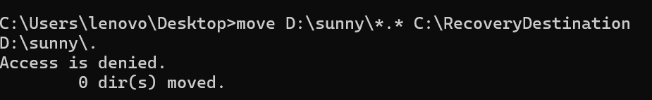

* [drive:][path]filename1 –  
  Specifies the location and name of the file or files you want to move.
* destination –  
  Specifies the new location of the file. The destination can consist of a drive letter and colon, a directory name, or a combination. If you are moving only one file, you can also include a filename if you want to rename the file when you move it.
* [drive:][path]dirname1 –  
  Specifies the directory you want to rename.
* dirname2 –  
  Specifies the new name of the directory.
* /Y –  
  Suppresses prompting to confirm you want to overwrite an existing destination file.
* /Y –  
  Causes prompting to confirm you want to overwrite an existing destination file.
* ren: rename folders and files

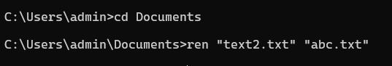

* [<drive>:][<path>]<filename1>: Specifies the location and name of the file or files to rename
* <filename2>: Specifies the new name for the file
* Robocop: A powerful tool for copying files

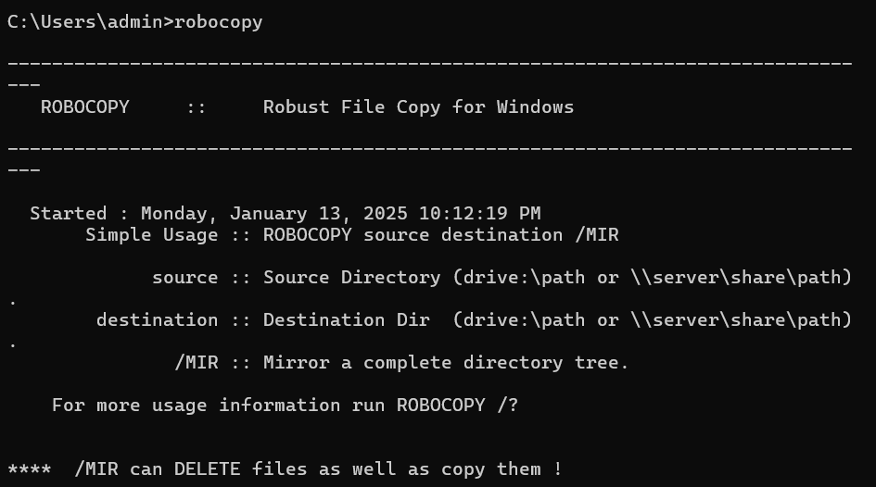

* Function: Robocopy is a built-in Windows command used to robustly copy files and directories between locations, offering advanced options like resuming interrupted transfers and detailed logging.
* Basic syntax: robocopy <source_directory> <destination_directory> [options]
* Common options:
  + /a: Copies only files with the archive attribute set
  + /e: Copies all subdirectories
  + /l: Lists files without copying them
  + /v: Provides verbose output, showing skipped files
  + /mir: Mirrors the source directory to the destination, deleting extra files

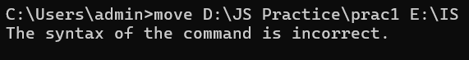

**Commands for System Information:**

* systeminfo: It provides comprehensive system information

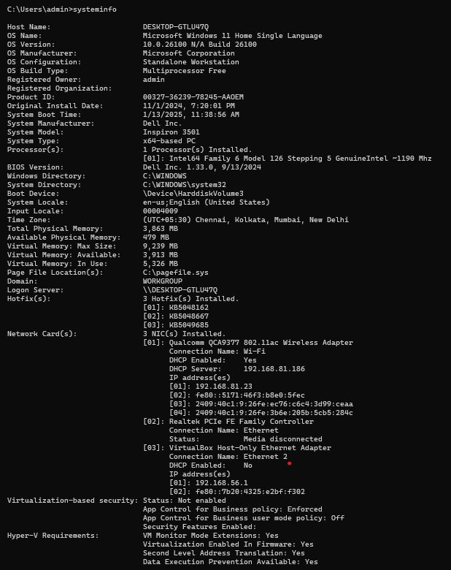

* ver: The cmd windows version is displayed

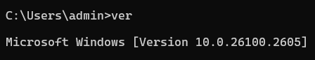

* Hostname: Shows the name of the computer

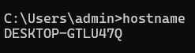

* tasklist: Shows active processes

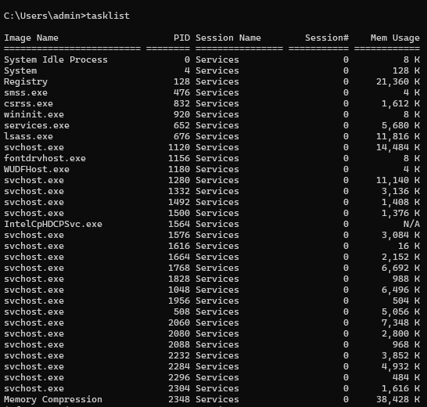

**Commands for Networks:**

* Ping: Verifies if a network host is reachable

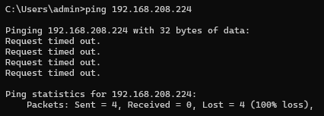t

* tracert: Trace a network host path

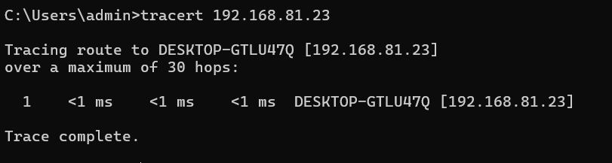

* netstat: shows the port and active network connections

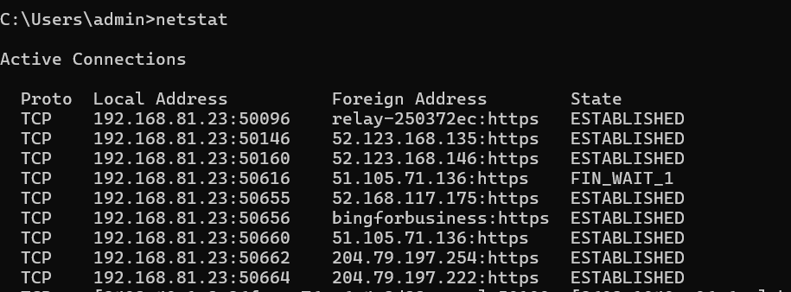

* nslookup: Returns the DNS response for a given IP address or domain name

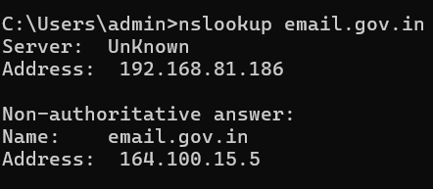

* net: Manages users and network resources

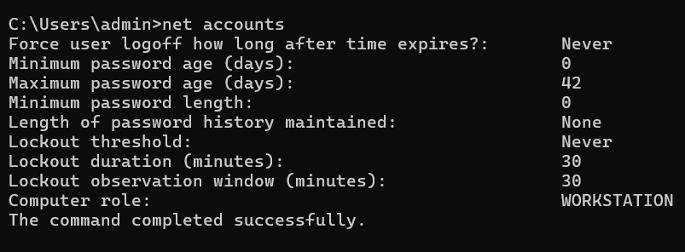

**Commands for Disk Management:**

* chkdsk: Identifies and corrects disk problems
* What does the CHKDSK command do?
* Scans for drive errors
* Displays a report on the status of the disk
* Pauses if it finds errors and displays messages
* Fixes some errors, but only if you specify the /r parameter
* Other CHKDSK commands
* chkdsk *.* Checks all files in the current directory for noncontiguous blocks
* /L Checks the current log file size
* /help Displays all supported parameters for CHKDSK
* diskpart: An administrative tool for managing volumes and disk partitions.

Examples of DiskPart commands

* List disk: Shows the available disks
* Select disk: Chooses a disk
* Create volume: Creates a volume
* Clean: Wipes a drive
* Format: Formats a disk
* List volume: Shows the available volumes
* format: disk formating

The format command in CMD can:

* Create a new root directory and file system for the disk
* Check for bad areas on the disk
* Delete all data on the disk
* defrag: Resolves fragmentation on the disk

To defrag a disk using the command prompt (CMD), the command is simply "defrag"; however, you usually need to specify the drive letter you want to defrag by adding it after the command, like "defrag C:" to defrag the C drive.

Key points about using "defrag" in CMD:

* Access CMD as administrator: To properly defrag, always open the command prompt with administrator privileges.
* Specifying drive letter: Add a colon after the drive letter you want to defrag, like "C:".
* Modern Windows: While the "defrag" command still works in newer Windows versions, the preferred method is often to use the "Defragment and Optimize Drives" tool accessed through the GUI.
* wmic: Get knowledge on system management

WMIC is a command-line interface that provides detailed information about a Windows computer's hardware or software. You can use it to:

* List and manage processes, services, and startup executables
* Retrieve system information
* Customize the output and control the information displayed

**Commands for User Management:**

* Net user: Take control of user accounts

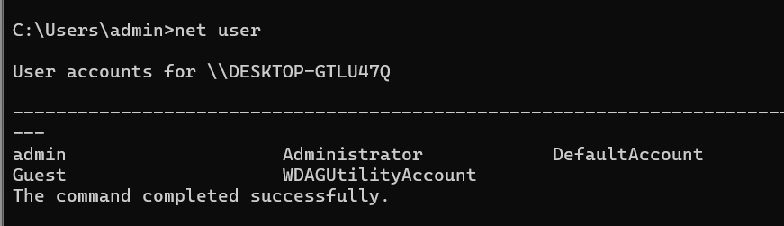

* Local group: Oversee group membership

Net

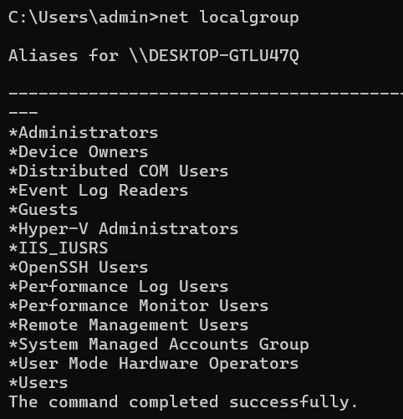

* whoami: Prints the current user’s name



**Commands for Power Management:**

* power control: Adjust Power Parameters

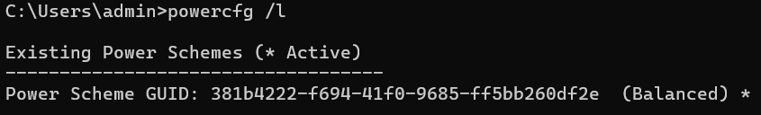

* shutdown: Put the computer on standby or shut down

To shut down a computer using the Command Prompt (CMD), you can type the command shutdown /s and press Enter:

* Open the Command Prompt
* Type shutdown /s
* Press Enter

**Batch commands and scripting:**

* echo: Shows messages and turns on and off C Prompt echoing

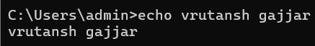

* set: Environment variables can be seen or set

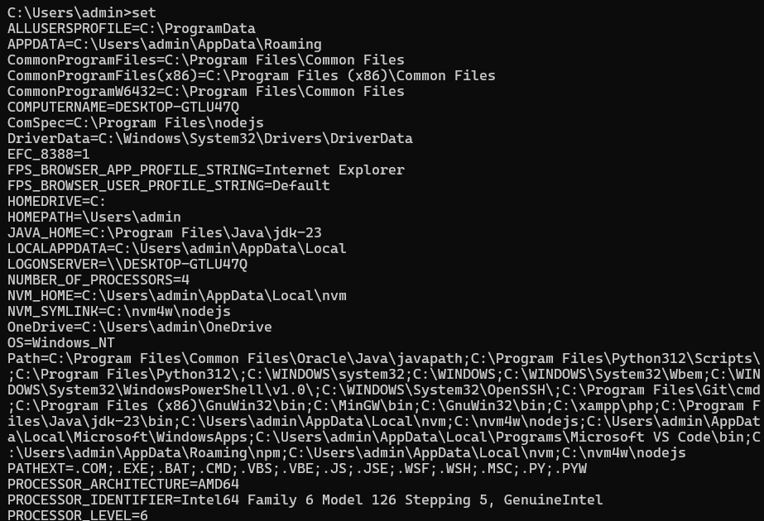

* pause: Put an end to the processing of a batch file.Calls a different batch file



* goto: Modifies the batch file’s execution to a label

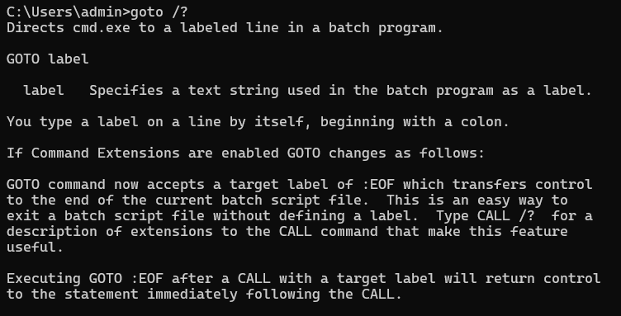

**Commands for system configuration:**

* sfc: System File Checker and Repair

The SFC utility checks the integrity of Windows system files and repairs them if needed. The process may take some time to complete. After the process is complete, you should reboot your computer.

You can also run the SFC command from Windows PowerShell (Admin).

The SFC command must be executed from an elevated Command Prompt window for it to work properly.

* reg: oversees the registry of cmd windows

The reg command is a command-line tool in Windows that allows you to query, modify, and manipulate the Windows registry. The reg command is built into Windows 10 and 11.

Here are some examples of reg commands:

* reg copy: Copies a registry entry to a specified location
* reg delete: Deletes a subkey or entries from the registry
* reg export: Copies the specified subkeys, entries, and values of the local computer into a file
* reg import: Copies the contents of a file that contains exported registry subkeys, entries, and values into the registry of the local computer
* reg add: Adds a new subkey or entry to the registry
* reg save: Specifies the name and path of the created file