**PANDIT DEENDAYAL ENERGY UNIVERSITY**

**SCHOOL OF TECHNOLOGY**



**Course: Cyber Security Lab**

**Course Code: 23CP310P**

**LAB MANUAL**

**B.Tech. (Computer Engineering)**

**Semester 6**

**Submitted to: Submitted by:**

Dr. Utkarsh Tiwari Vrutansh Gajjar

22BCP431

G11

**Practical No:** 4

**Practical Name:** Malware Creation

**1. CREATE A MESSAGE BOX POP UP VIRUS**

@echo off

msg * "This is an educational pop-up message."

**Output:-**

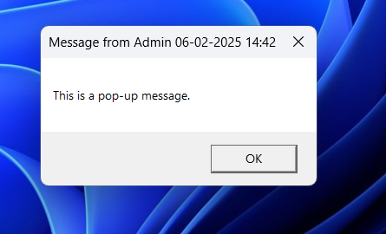

**2. CREATE A VIRTICAL MATRIX VIRUS**

@echo off

color 02

:matrix

echo %random%%random%%random%%random%%random%%random%%random%%random%

goto matrix

**Output:-**

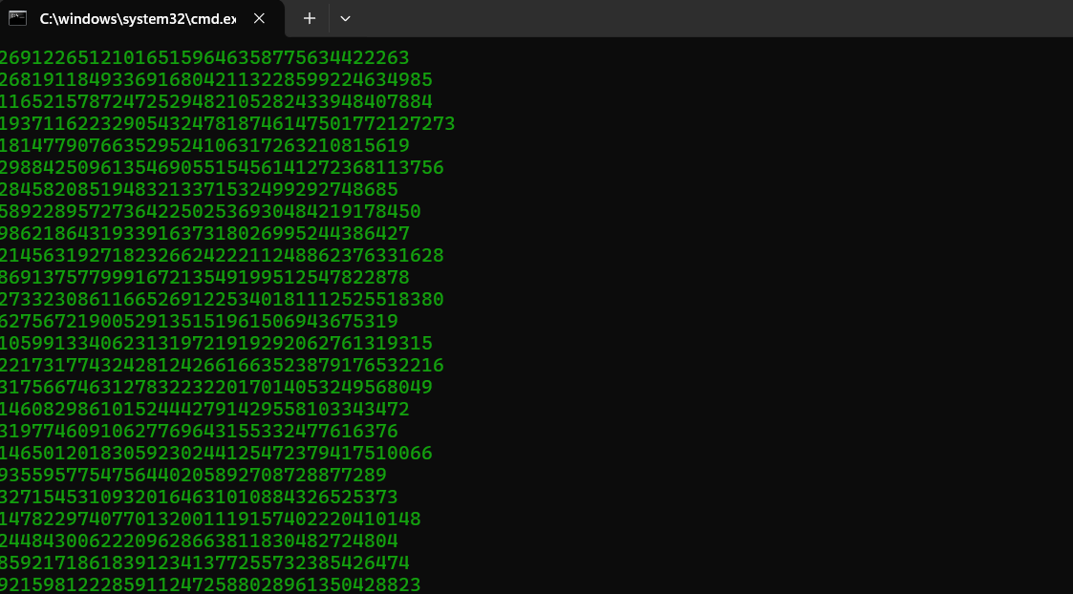

**3. MAKE EVERY APPLICATION POP UP VIRUS**

@echo off

start notepad.exe

start calc.exe

start cmd.exe

start msedge.exe

start explorer.exe

start taskmgr.exe

**Output:-**

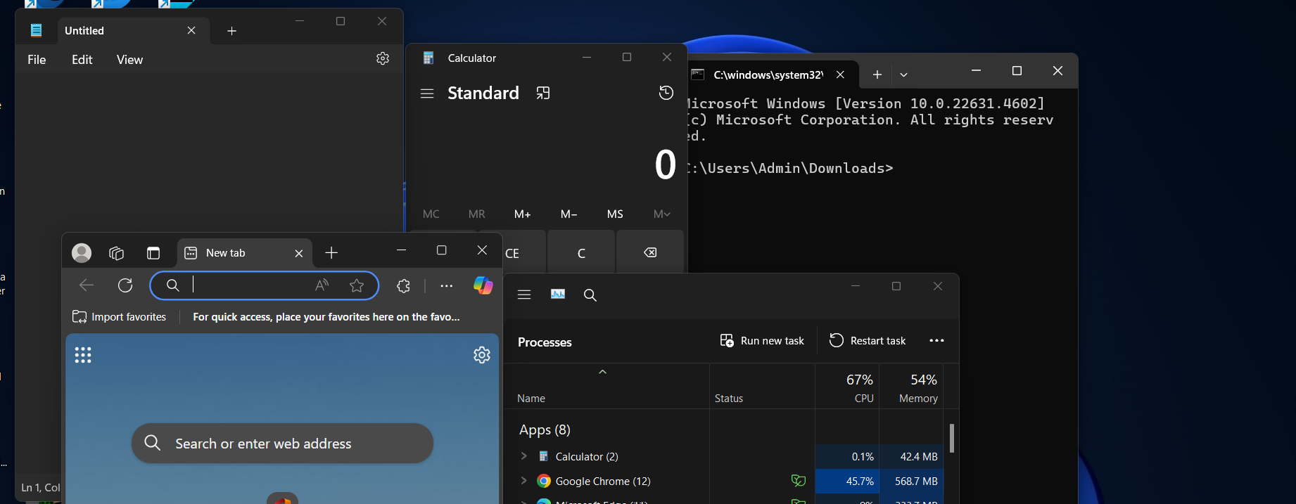

**Phase 2**

**Explicit Execution of Malware:**

To run the malware without explicit execution we have to add the particular batch file in the startup folder such that on every reboot of the system the malware automatically trigger.

**1.** Press **Win+R** to open Run Dialog Box.

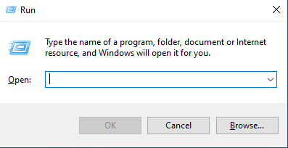

**2.** Type *shell:startup* in dialog box and press Enter. This will open startup folder for us.

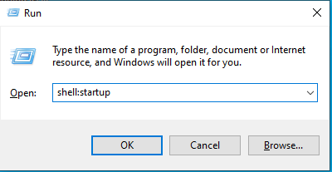

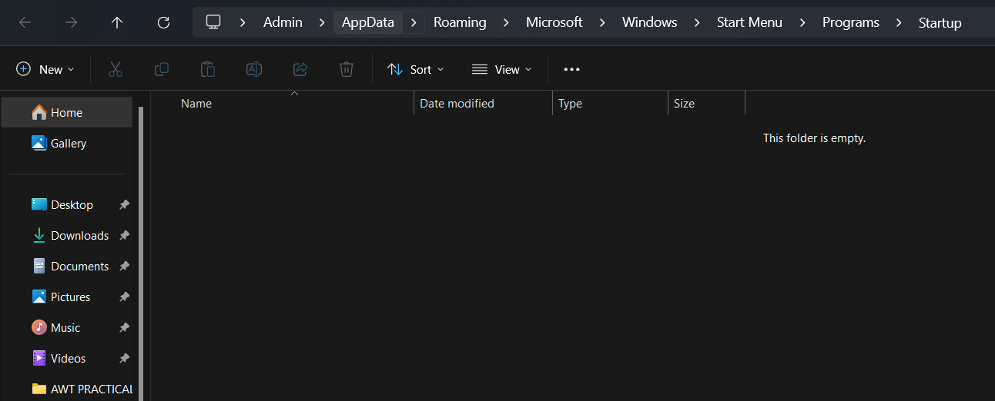

**3.** Add the malware/batch file into startup folder that you want to trigger on every reboot.

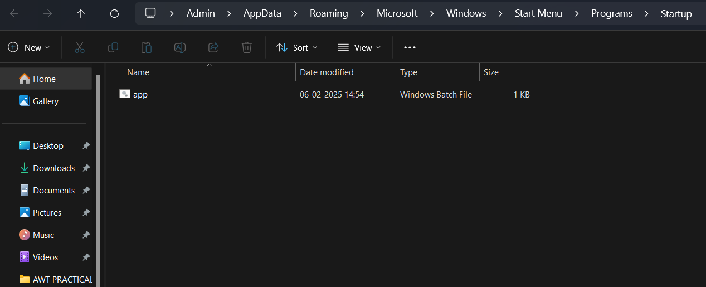

Now, after every reboot of the system the batch file will automatically execute itself.

**Run Malware as Background Process:**

* First, we have to convert the bat file into exe file because executable files can executed on system without any dependencies, as it’s a standalone executable.
* Converting to .exe allows us to customize the behaviour of program. For example, you can make the console window invisible or display custon icon for executable file.

**1.** Download and Install Bat to Exe Converter

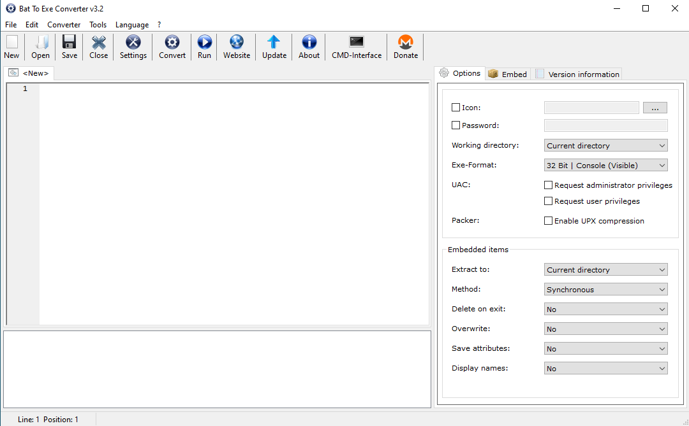

**2.** Select .bat file by clicking on “Open” button.

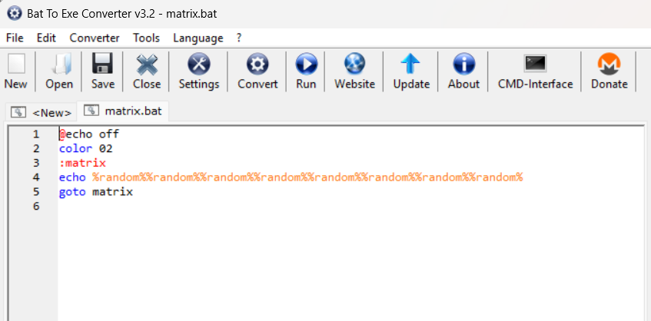

**3.** Configure additional options, such as visibility of console window.

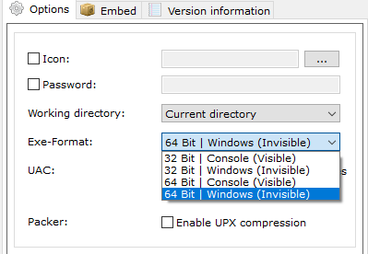

**4.** Click “Convert” to generate exe file.

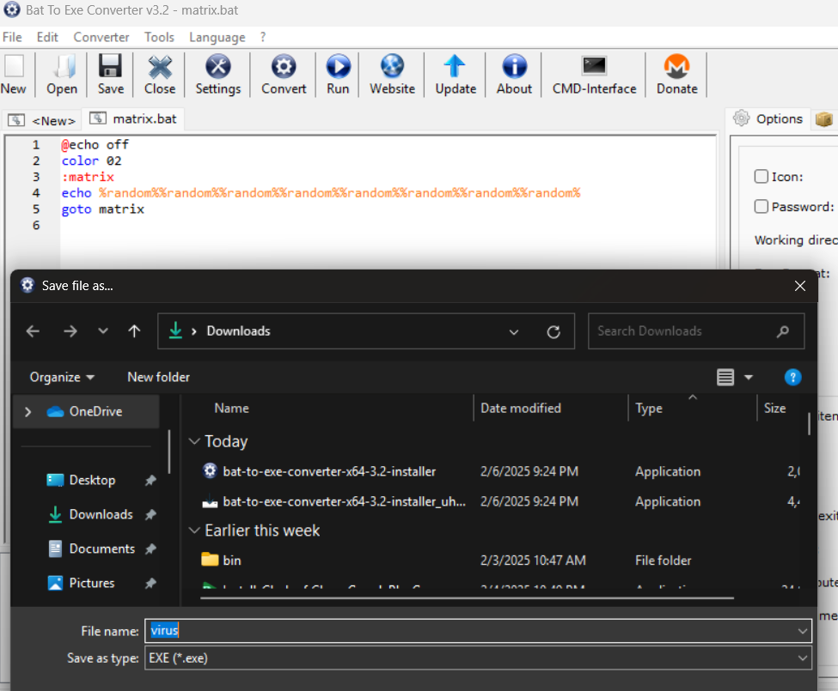

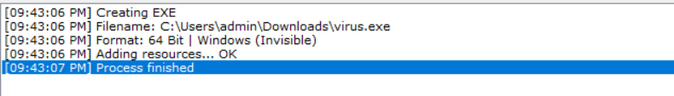

**5.** Run converted exe file

The executable is now running as a background process and doesn’t show up in task manager.

