1.Find total sales.
select Cast(sum(Sales) as decimal(10,2)) as total_sales from Sample;
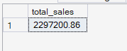
2.Find total profit.
select cast(sum(Profit) as decimal (10,2)) as total_proft from Sample;
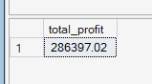
3.Find total orders.
select count(distinct Order_ID) as total_orders from Sample
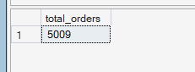
4.Find total sales by region.
select Region,cast(sum(Sales) as decimal(10,2)) as total_sales_by_region from Sample group by Region
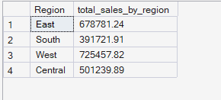
5.Find total sales by sub-category.
select Sub_Category,cast(sum(sales) as decimal(10,2)) as total_sales from Sample group by Sub_Category;
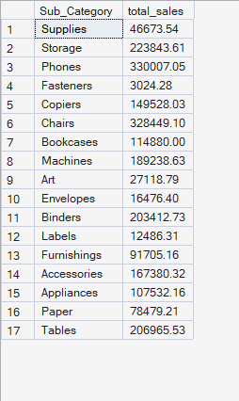
6.Find top 5 total profit by state.
select top 5 state,sum(Profit) as total_profit from Sample group by State
order by sum(Profit) desc;
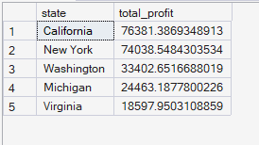
7.Find top 5 customers by sales.
select top 5 Customer_ID,Customer_Name,sum(Sales) as total_sales from Sample group by Customer_ID,Customer_Name
order by sum(Sales) desc

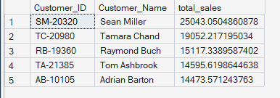
8.Find top 5 products by sales.
select top 5 Product_Name,cast(sum(Sales) as decimal (10,2)) as total_sales from Sample group by Product_Name
order by sum(Sales) desc
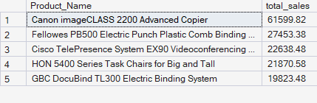
9. Find total sales percentage by category.
select Category,cast((sum(Sales) * 100) / (select sum(Sales) from Sample) as decimal (10,2)) as percentage
from Sample group by Category
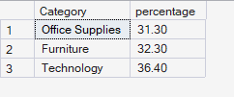
10.Find total sales by shipping mode.
select Ship_Mode,cast((sum(Sales)*100)/(select sum(Sales) from Sample) as decimal(10,2)) as total_sales from Sample group by Ship_Mode;
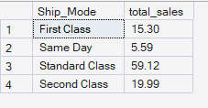
11.Find the highest-selling category.
select top 1 Category,cast(sum(Sales) as decimal(10,2)) as highest_selling from Sample group by Category order by sum(Sales) desc;
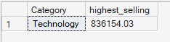
use retail;

