**Kadane Algorithm**

**Algo:** To find maximum contiguous array sum.

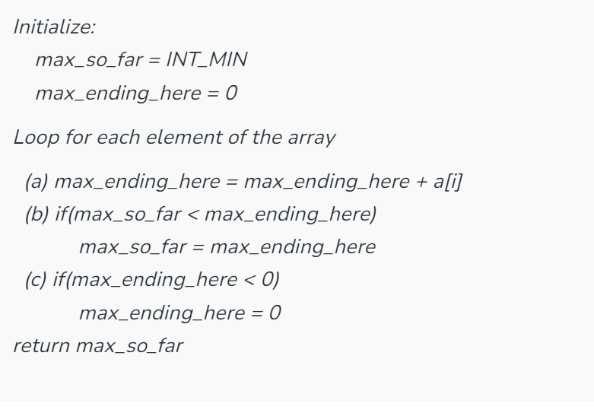

**Algo:** To find minimum contiguous array sum.

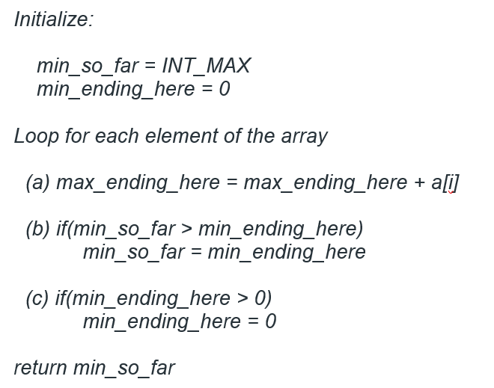

**Algo**: To Find the start and end pos of Maximum contiguous Array.

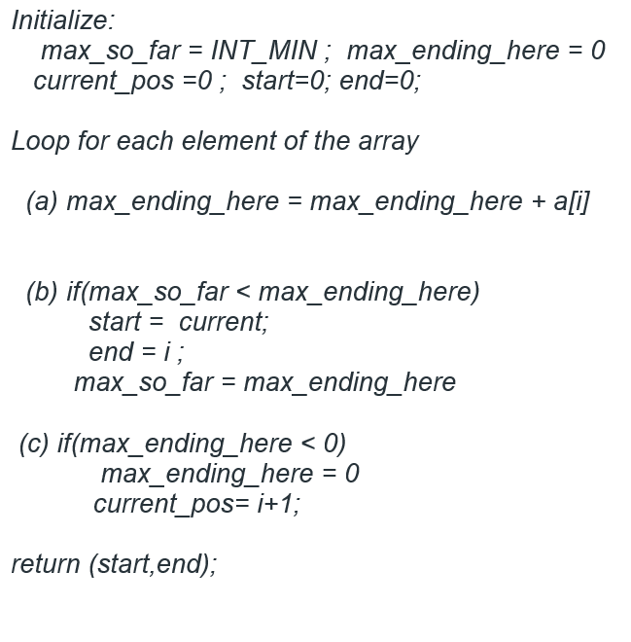

select * from SCRM_INTGR.OEM_JOB_DTL t where t.job_module_id=102 and t.oem_module_id not in (30,31)

and trunc(t.submitdate)='23-july-24' order by 1 desc;

select * from SCRM_INTGR.OEM_JOB_DTL t where t.job_module_id=111

and trunc(t.submitdate)='23-july-24' order by 1 desc;

select * from SCRM_INTGR.INT_ERP_FILE_MST t where t.client_moduleid=102;

select * from SCRM_INTGR.INT_ERP_FILE_MST t where t.client_moduleid=111;

select * from scrm_intgr.si_debug_dtl d where d.proc_exec_id='401347';

select * from scrm_intgr.si_datesapprocess_log s where s.proc_exec_id='401347';

select * from scrm_intgr.oem_error_dtl order by 5 desc;

*---1--7:00AM*

select * from INT_PRODUCT_FROM_SAP a order by a.create_date desc;

*--2--7:00AM*

select * from INT_BOM_FROM_SAP a order by a.create_date desc;

*--#NAME?*

select * from INT_DELIVERY_FROM_SAP a order by a.create_date desc;

*--5--01AM-07AM-01PM-07PM*

select * from INT_WARRANTY_FROM_SAP a order by a.create_date desc;

*--#NAME?*

select * from INT_PO_FOR_SAP a order by a.createdon desc;

*--#NAME?*

select * from SCRMPRESTG.INT_PURC_RET_FOR_SAP a order by a.createdon desc;

*--8--10AM,1:30PM,5PM(RSC)--10:30PM(ASC)*

select * from INT_BILLING_FOR_SAP a order by a.createdon desc;

*--9--10pm*

select * from INT_CUST_MST_FOR_SAP a order by a.createdon desc;

*--10--10:30PM*

select * from INT_TICKET_FOR_SAP a order by a.createdon desc;

*--#NAME?*

select * from INT_AUTOGR_FOR_SAP a order by a.createdon desc;

Select * from scrmorient.stg_json_data_resp m where m.procid=28 and trunc(m.createdon)='23-July-24' order by 1 desc;

*--Select * from scrmorient.stg_json_data_req m where m.procid=27 order by 1 desc and trunc(m.createdon)='07-June-24' order by 1 desc;*

*--Select * from scrmorient.stg_json_data_resp_hst m where m.procid=27 and m.jsonclob like '%2024050365%';*

select * from Stg_Dispatchfranchise_Resp order by 1 desc;

select * from stg_createsoh_resp order by 1 desc;

select * from Stg_Sales_Return_Defect_Resp order by 1 desc;

select * from stg_serviceclaim_po_resp order by 1 desc;

select * from stg_service_claim_payout order by 1 desc;