Task2:

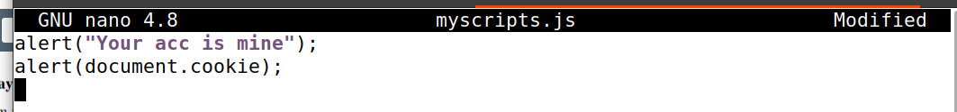

Task3:



Task4:

Task5:

Question3:

Task6:

Task7:



