# Project Name : EShopper Vegetable

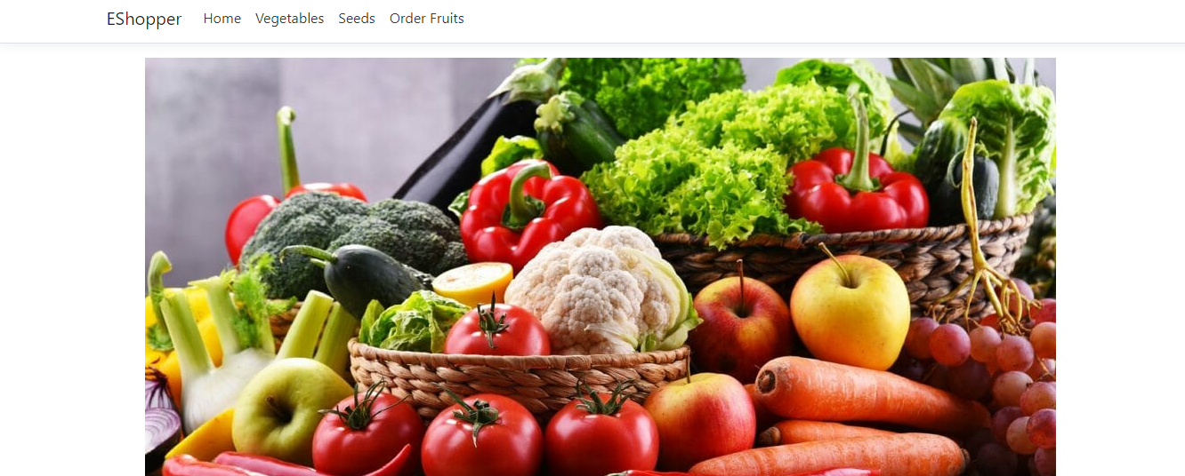

# Project Requirement :

Simple EShopper Project that can add record for vegetables and seeds in the database for record purposes and through CRUD operation we can control edit and delete operations to.

**Systems Analysis –** This platform was built with ASP.NET. The key feature is adding a record of different things that taking record

The project team assessed the project's scope and devised a timetable and resource allocation strategy based on their findings.

**Systems design** – This is a high-level description of how a computer-based system would satisfy the requirements; it is expected to be a single-user system that does not rely on data connection for the primary facility.

**Systems Specifications**

OS -Windows 10

IDE- Visual Studio

**Programming** – ASP.NET and C# was used for functionality completed as a working system in an MVC model.

Step 2***:*** Produced a project proposal contained that includes home page, Add vegetables, add seeds and order fruits page

Project Goal – Build a platform for record keeping of Eshoppers vegetable

Project Objectives – The main objectives of the project was to enable that anyone can add record in it whos ever is admin at that time

Project Scope – A full-fledge website develop 5 page website development

1. Context – A Admin Login Facility
2. ASP.NET language platform
3. Stakeholders of the product: People who want to book tour
4. Backend or API integration

Project Deliverables –

1. Analysis documentation
2. Design documentation
3. Executable program
4. User documentation

|  |  |  |
| --- | --- | --- |
| **Milestone** | **Time taken** | **Finalized** |
| Designing | 1 Days | Yes |
| Programming | 2 Days | Yes |
| Documentation | 2 days | Yes |

Resources

|  |  |
| --- | --- |
| Processor | 1 GHz |
| RAM | 512 MB |
| Disk space (minimum) |  |
| 32-bit | 4.5 GB |
| 64-bit | 4.5 GB |

# 

# Add new Vegetable

# 

# Inserted data can be viewed, edit and delete

# 

# Seeds page

# 

# Order Fruits Page

# 