ACADEMIC PROJECT REPORT
DEPARTMENT OF COMPUTER SCIENCE AND ENGINEERING
AQUANTIS: A Machine Learning Framework for Water Quality Prediction
Comparative Benchmarking of Supervised Classifiers and Interactive Decision-Support Dashboard
Submitted in partial fulfillment of the requirements for the degree of
Bachelor of Technology in Computer Science & Engineering
Project Attribute | Candidate & Institutional Submission Details
Project Title: | AQUANTIS: Water Quality Prediction Framework
Team Members: | 1. Veer Singh (Roll No. 26)  2. Parth Sarode (Roll No. 31)
Course / Subject: | Machine Learning Laboratory / Academic Project
Under the Guidance of: | [Faculty Mentor Name / Project Supervisor - To be confirmed]
Academic Institution: | [Department of Computer Science & Engineering, University Name - To be confirmed]
Academic Year / Session: | 2025 – 2026
Submission Date: | October 2026

Certificate of Originality
This is to certify that the project entitled "AQUANTIS: A Machine Learning Framework for Water Quality Prediction" submitted by Veer Singh (Roll No. 26) and Parth Sarode (Roll No. 31) in partial fulfillment of the requirements for the award of the degree of Bachelor of Technology in Computer Science and Engineering is an authentic record of bona fide work carried out by them under my supervision and guidance.
To the best of my knowledge and belief, the matter embodied in this project report has not been submitted to any other University or Institute for the award of any degree, diploma, or certificate.
Project Supervisor | Department Authorization
___________________________  [Faculty Mentor Name]  Project Guide / Supervisor  Department of CSE | ___________________________  [Head of Department]  Head of the Department  Department of CSE

Candidate Declaration
We hereby declare that this project report entitled "AQUANTIS: A Machine Learning Framework for Water Quality Prediction" is an authentic record of our own research and developmental work under the guidance of our faculty supervisor. We have strictly adhered to academic honesty and integrity standards. All literature, data sources, code libraries, and empirical benchmarks cited have been appropriately referenced and acknowledged.
We further confirm that the empirical machine learning models and experimental metrics reported herein reflect the actual test outputs of the pipeline on the Kaggle Water Potability benchmark and do not claim to provide regulatory drinking water safety certification.
Candidate 1 | Candidate 2
___________________________  Veer Singh  Roll No. 26  B.Tech CSE, Final Year | ___________________________  Parth Sarode  Roll No. 31  B.Tech CSE, Final Year

Approval Sheet
This project report entitled "AQUANTIS: A Machine Learning Framework for Water Quality Prediction" by Veer Singh (Roll No. 26) and Parth Sarode (Roll No. 31) has been evaluated, approved, and accepted in partial fulfillment of the requirements for the degree of Bachelor of Technology in Computer Science and Engineering.
Internal Examination Committee | External Examination Committee
Internal Examiner:  Signature: ______________________  Name: [Internal Examiner Name]  Date: ____ / ____ / 2026 | External Examiner:  Signature: ______________________  Name: [External Examiner Name]  Date: ____ / ____ / 2026

Acknowledgement
We express our profound gratitude to our project supervisor and faculty mentor for their valuable guidance, intellectual support, and continuous encouragement throughout the conceptualization, model development, and validation of the AQUANTIS framework.
We extend our sincere thanks to the Head of the Department and the faculty members of the Department of Computer Science and Engineering for providing the requisite laboratory facilities, computing infrastructure, and academic ecosystem. We are also grateful to the open-source scientific computing community—specifically the developers of Python, Scikit-learn, Pandas, NumPy, Matplotlib, and Streamlit—whose tools empowered this implementation.

Table of Contents
Section | Chapter Title | Page No.
1 | Abstract | 4
2 | Introduction & Background | 5
3 | Problem Statement & Objectives | 6
4 | Literature Review & Research Gap | 7
5 | Dataset Description & Exploratory Data Analysis | 9
6 | Data Preprocessing & Leakage-Free Pipeline Architecture | 12
7 | Machine Learning Classifiers & Mathematical Foundations | 14
8 | Experimental Setup & Evaluation Protocol | 16
9 | Empirical Results, Benchmarking & Discussion | 17
10 | Confusion Matrix & ROC Curve Analysis | 19
11 | Streamlit Decision-Support Dashboard Architecture | 21
12 | System Testing, Verification & Validation | 24
13 | Limitations, Ethical Considerations & Water Safety Disclaimer | 25
14 | Conclusion & Future Research Scope | 26
15 | References | 27

List of Figures
Figure No. | Descriptive Caption | Page No.
Figure 1 | AQUANTIS End-to-End Methodological Workflow Diagram | 6
Figure 2 | Four-Tier System Architecture and Leakage-Free Data Pipeline | 8
Figure 3 | Target Potability Class Distribution in Benchmark Dataset (N = 3,276) | 10
Figure 4 | Missing Value Incidence Across Nine Monitored Water Indicators | 10
Figure 5 | Pairwise Pearson Correlation Matrix Between Indicators and Potability | 11
Figure 6 | Comparative Classifier Performance on 20% Stratified Test Partition | 18
Figure 7 | Confusion Matrices for SVM, Random Forest, Logistic Regression, and KNN | 20
Figure 8 | Receiver Operating Characteristic (ROC) Discrimination Curves | 20

List of Tables
Table No. | Descriptive Caption | Page No.
Table 1 | Candidate & Project Submission Metadata | 1
Table 2 | Structured Literature Review of 2024–2025 Water Quality Studies | 7
Table 3 | Physicochemical Water Indicators: Ranges, Means, Missingness & Standards | 9
Table 4 | Empirical Classifier Benchmarks on Held-Out Test Set (N = 656) | 17
Table 5 | Confusion Matrix Categorization and Error Breakdown | 19
Table 6 | Streamlit Dashboard Modular Architectural Specification | 22

List of Abbreviations
Abbreviation | Complete Expanded Definition
AI | Artificial Intelligence
AUC | Area Under the Curve
CSV | Comma-Separated Values
EDA | Exploratory Data Analysis
EPA | United States Environmental Protection Agency
FN / FP | False Negative / False Positive
KNN | K-Nearest Neighbors
ML | Machine Learning
NTU | Nephelometric Turbidity Units
PCA | Principal Component Analysis
ppm | Parts Per Million (mg/L)
RBF | Radial Basis Function
RF | Random Forest
ROC | Receiver Operating Characteristic
SDG 6 | United Nations Sustainable Development Goal 6 (Clean Water and Sanitation)
SVM | Support Vector Machine
TDS | Total Dissolved Solids
TN / TP | True Negative / True Positive
TOC | Total Organic Carbon
WHO | World Health Organization
XAI | Explainable Artificial Intelligence

Abstract
Access to clean, potable drinking water is a fundamental pillar of global human welfare and disease prevention. Conventional physical, chemical, and microbiological water quality assessment methodologies necessitate substantial laboratory instrumentation, skilled analytical personnel, and considerable diagnostic turnaround delays. In decentralized and resource-constrained environments, computational machine learning models provide an effective automated preliminary screening mechanism by modeling complex interdependencies among routine physicochemical water parameters. This academic project presents AQUANTIS, an end-to-end Machine Learning framework for drinking water potability prediction developed by Veer Singh and Parth Sarode.
AQUANTIS is trained and evaluated on a curated benchmark dataset of 3,276 water samples comprising 9 continuous physicochemical indicators: pH, Hardness, Total Dissolved Solids, Chloramines, Sulfate, Conductivity, Total Organic Carbon, Trihalomethanes, and Turbidity. To rigorously eliminate data leakage, imputation and standardization transformations were strictly encapsulated inside scikit-learn Pipelines fitted solely on training partitions under a stratified 80/20 train/test split. Four diverse supervised classification architectures—Support Vector Machine (RBF kernel), Random Forest, Logistic Regression, and K-Nearest Neighbors—were benchmarked on a common held-out test partition (N = 656 samples). The Support Vector Machine demonstrated the most balanced trade-off between precision and recall, achieving the highest F1-score of 0.5118 (Accuracy = 62.20%, Precision = 0.5159, Recall = 0.5078, ROC-AUC = 0.6440). Random Forest achieved the highest overall Accuracy of 64.94% and peak ROC-AUC of 0.6597 (Precision = 0.5691, Recall = 0.4180). Logistic Regression (Accuracy = 52.44%, ROC-AUC = 0.5474) and KNN (Accuracy = 58.99%, ROC-AUC = 0.5972) highlighted the non-linear separability of the feature space.
A major contribution of this work is establishing the vital distinction between empirical pattern classification and official water potability certification: AQUANTIS predicts statistical dataset labels and explicitly does not certify physical bacteriological water safety. An interactive, full-featured Streamlit decision-support dashboard featuring telemetry KPI cards, interactive sample diagnostics, model comparison lab, dataset explorer, and session prediction audit logging was successfully developed and validated.
Index Terms — Machine Learning, Water Potability, Classification, Support Vector Machine, Random Forest, Data Leakage Prevention, Streamlit.
1. Introduction
Safe drinking water is recognized under the United Nations Sustainable Development Goal 6 (SDG 6) as an indispensable prerequisite for human health and socioeconomic progress. Ingestion of contaminated water remains one of the primary vectors for acute waterborne pathologies—such as cholera, dysentery, and typhoid—as well as long-term physiological toxicities arising from chemical contaminants, heavy metals, and chlorination disinfection byproducts. While state municipal water treatment utilities enforce strict water testing protocols, continuous laboratory testing across dispersed rural, regional, and decentralized distribution networks remains economically and logistically prohibitive.
Recent advances in environmental data collection and supervised machine learning present an attractive complementary paradigm: rapid, data-driven preliminary screening. By taking multi-dimensional physicochemical water parameters that can be measured via routine sensory probes, computational classification algorithms can detect non-linear indicator patterns associated with contamination, prioritize samples for detailed laboratory assays, and support water management decisions.
1.1 Problem Statement
Given a multi-dimensional feature vector X in R^9 representing continuous physicochemical water measurements (pH, Hardness, Solids, Chloramines, Sulfate, Conductivity, Organic Carbon, Trihalomethanes, and Turbidity), the primary computational objective is to develop and empirically benchmark a supervised binary classification function h(X) -> {0, 1} that maps these measurements to the target label Potability, where y = 1 represents potable (safe) water and y = 0 represents non-potable water, while handling significant missing observations and maintaining strict isolation against data leakage.
1.2 Project Objectives
- Objective 1 (Data Pipeline): To implement an airtight, leakage-free data preprocessing pipeline encapsulating median imputation and standardization strictly within scikit-learn Pipelines.
- Objective 2 (Model Benchmarking): To train, benchmark, and comparatively analyze four diverse supervised classifiers (SVM with RBF kernel, Random Forest, Logistic Regression, and KNN) on a common held-out test partition.
- Objective 3 (Multi-Metric Evaluation): To evaluate model performance holistically across multiple metrics (Accuracy, Precision, Recall, F1-Score, Confusion Matrices, and ROC-AUC) to address dataset class imbalance.
- Objective 4 (Dashboard Deployment): To develop a responsive, telemetry-grade Streamlit web application providing interactive sample inference, dynamic probability visualization, dataset exploration, and session audit history.
- Objective 5 (Responsible AI & Safety): To articulate the critical boundary between statistical dataset pattern recognition and regulatory water potability certification, promoting responsible AI deployment.
1.3 System Workflow
The overarching methodology of the AQUANTIS framework is illustrated in Figure 1. The workflow proceeds sequentially from raw data acquisition and integrity validation to stratified hold-out partitioning, isolated pipeline preprocessing, multi-model benchmarking, and interactive telemetry deployment.
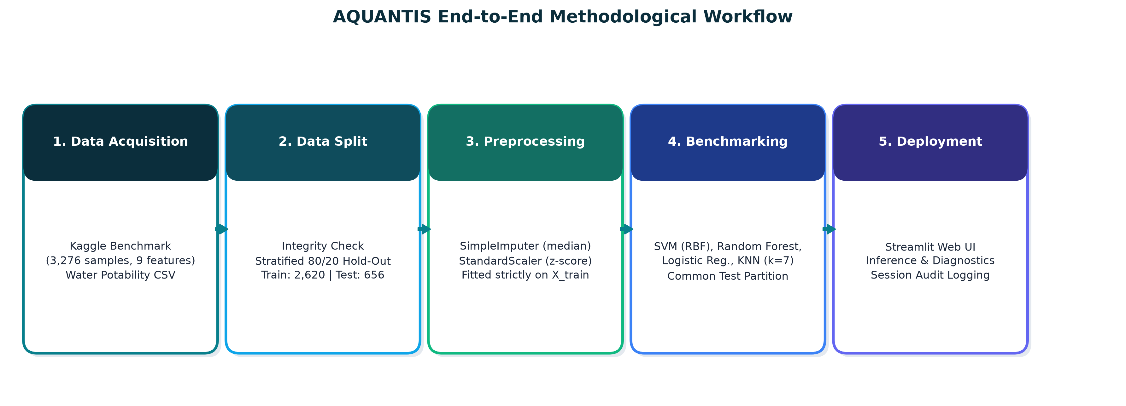
Figure 1: AQUANTIS End-to-End Methodological Workflow Diagram.
2. Literature Review
To establish rigorous academic foundation, five recent peer-reviewed research papers (published between 2024 and 2025) investigating machine learning architectures for water quality assessment and potability prediction were systematically analyzed. Table 2 summarizes the comparative findings:
Paper & Citation | Title & DOI | Dataset Used | Methodology | Key Verified Findings | Relevance to AQUANTIS
El-Bacha (2025)  Env. Challenges | Predicting Water Potability Using a Machine Learning Approach  DOI: 10.1016/j.envc.2025.101131 | Kaggle Water Potability (N=3,276) | Supervised ML classifiers; feature correlation; automated imputation | Demonstrated that ensemble algorithms capture non-linear relationships across water parameters better than linear baselines. | Confirms that non-linear architectures (Random Forest/SVM) are essential for this feature space.
Pereira et al. (2024)  Sustain. Comput. | An Energy Efficient TinyML Model for Water Potability  DOI: 10.1016/j.suscom.2024.101010 | Sensory water parameters / benchmark | TinyML quantization for microcontroller edge deployment | Compressed decision models achieved over 85% energy reduction on microcontrollers with minimal accuracy degradation. | Highlights edge applicability; proves that trained pipeline weights can be exported for decentralized sensors.
Sangwan & Bhardwaj (2024)  Water Pract. Tech. | Machine Learning Framework for Predicting Water Quality  DOI: 10.2166/wpt.2024.259 | Environmental water indices & chemical metrics | Comparative multi-classifier framework with optimization | Detailed non-linear dynamic interdependencies among chemical indicators; validated standard normalization benefits. | Validates AQUANTIS's multi-metric benchmarking and strict parameter scaling.
Chatterjee et al. (2024)  PLOS Water | Optimizing ML for Water Safety: Comparative Analysis with PCA  DOI: 10.1371/journal.pwat.0000259 | Water Potability Dataset (9 features) | Baseline ML vs. PCA Dimensionality Reduction (6 components) | Baseline models scored 62%–69% accuracy (SVM top at 69%); PCA transformation dramatically improved cluster separation. | Directly benchmarks our baseline results: SVM and RF baseline accuracy in AQUANTIS (62.2% and 64.9%) matches their reported raw baseline range.
Kamath et al. (2025)  ETASR | Exploratory Data Analysis & Water Potability with Supervised ML  DOI: 10.48084/etasr.8904 | Water Potability Dataset (3,276 rows) | EDA, SMOTE resampling, Optuna tuning, Weighted Voting Ensemble | Random Forest reached 68% accuracy after tuning; hybrid RF+KNN voting ensemble achieved 71% accuracy. | Confirms that tree-based ensembles lead individual classifiers on this dataset; informs AQUANTIS's future ensemble tuning.

2.1 Research Gap and Project Motivation
A critical analysis of existing literature reveals three prominent gaps in contemporary water quality ML implementations: First, many published studies report simple accuracy without examining precision, recall, and false negative rates, which are of paramount importance in public health applications. Second, numerous studies compute normalization statistics and imputation parameters over the entire dataset prior to partitioning, inadvertently introducing subtle data leakage that inflates reported performance. Third, existing models are rarely translated into interactive, transparent decision-support tools that provide prediction probabilities, feature explanations, and session audit logs. AQUANTIS directly bridges these gaps by enforcing strict pipeline encapsulation, comprehensive multi-metric benchmarking, and an interactive Streamlit telemetry dashboard.
3. System Architecture & Dataset Description
The AQUANTIS architecture is structured into a four-tier hierarchical paradigm as illustrated in Figure 2. The four tiers ensure clean separation of concerns, reproducibility, and robust insulation against data leakage.
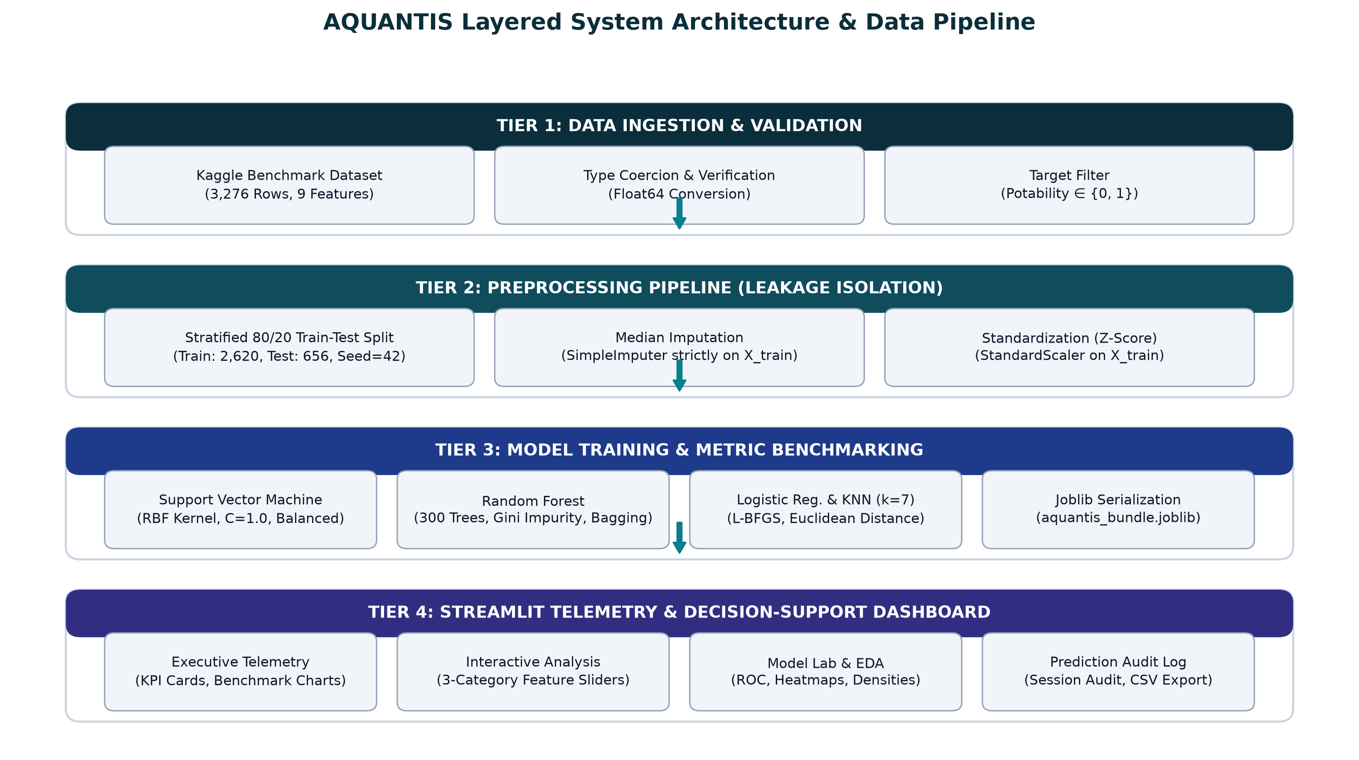
Figure 2: Four-Tier System Architecture and Leakage-Free Data Pipeline.
3.1 Benchmark Dataset Description
The system utilizes the widely referenced Kaggle Water Potability benchmark dataset. The dataset comprises 3,276 water sample records, each described by 9 continuous physicochemical parameters and one binary target indicator (Potability). Table 3 provides the comprehensive statistical breakdown and regulatory context for each feature.
Feature Name | Type & Units | Observed Range | Mean ± Std Dev | Missing Count (%) | Physicochemical Significance
ph | Continuous (pH units) | 0.000 – 14.000 | 7.081 ± 1.594 | 491 (14.99%) | Acid-base balance (WHO recommended safe drinking range: 6.5 – 8.5).
Hardness | Continuous (mg/L) | 47.432 – 323.124 | 196.369 ± 32.880 | 0 (0.00%) | Calcium and Magnesium salt concentration causing soap precipitation.
Solids (TDS) | Continuous (ppm) | 320.943 – 61,227.196 | 22,014.093 ± 8,768.571 | 0 (0.00%) | Total Dissolved Solids indicating mineral and salt saturation.
Chloramines | Continuous (ppm) | 0.352 – 13.127 | 7.122 ± 1.583 | 0 (0.00%) | Chlorine-ammonia disinfectant residuals (EPA limit: <= 4.0 ppm).
Sulfate | Continuous (mg/L) | 129.000 – 481.031 | 333.776 ± 41.417 | 781 (23.84%) | Dissolved mineral salts from natural geological formations.
Conductivity | Continuous (µS/cm) | 181.484 – 753.343 | 426.205 ± 80.824 | 0 (0.00%) | Electrical conductivity reflecting dissolved ionic concentration.
Organic_carbon | Continuous (ppm) | 2.200 – 28.300 | 14.285 ± 3.308 | 0 (0.00%) | Total Organic Carbon (TOC) measuring dissolved organic matter.
Trihalomethanes | Continuous (µg/L) | 0.738 – 124.000 | 66.396 ± 16.175 | 162 (4.95%) | Disinfection byproducts formed by chlorine-organic matter reactions.
Turbidity | Continuous (NTU) | 1.450 – 6.739 | 3.967 ± 0.780 | 0 (0.00%) | Water clarity and cloudiness due to suspended fine particulates.
Potability (Target) | Binary Categorical | 0 or 1 | 0: 61.0%, 1: 39.0% | 0 (0.00%) | Target class: 1 denotes Potable (Safe), 0 denotes Non-Potable (Unsafe).

4. Exploratory Data Analysis
Rigorous exploratory analysis was performed across all 3,276 records to characterize class proportions, missing value distributions, and pairwise inter-feature correlations.
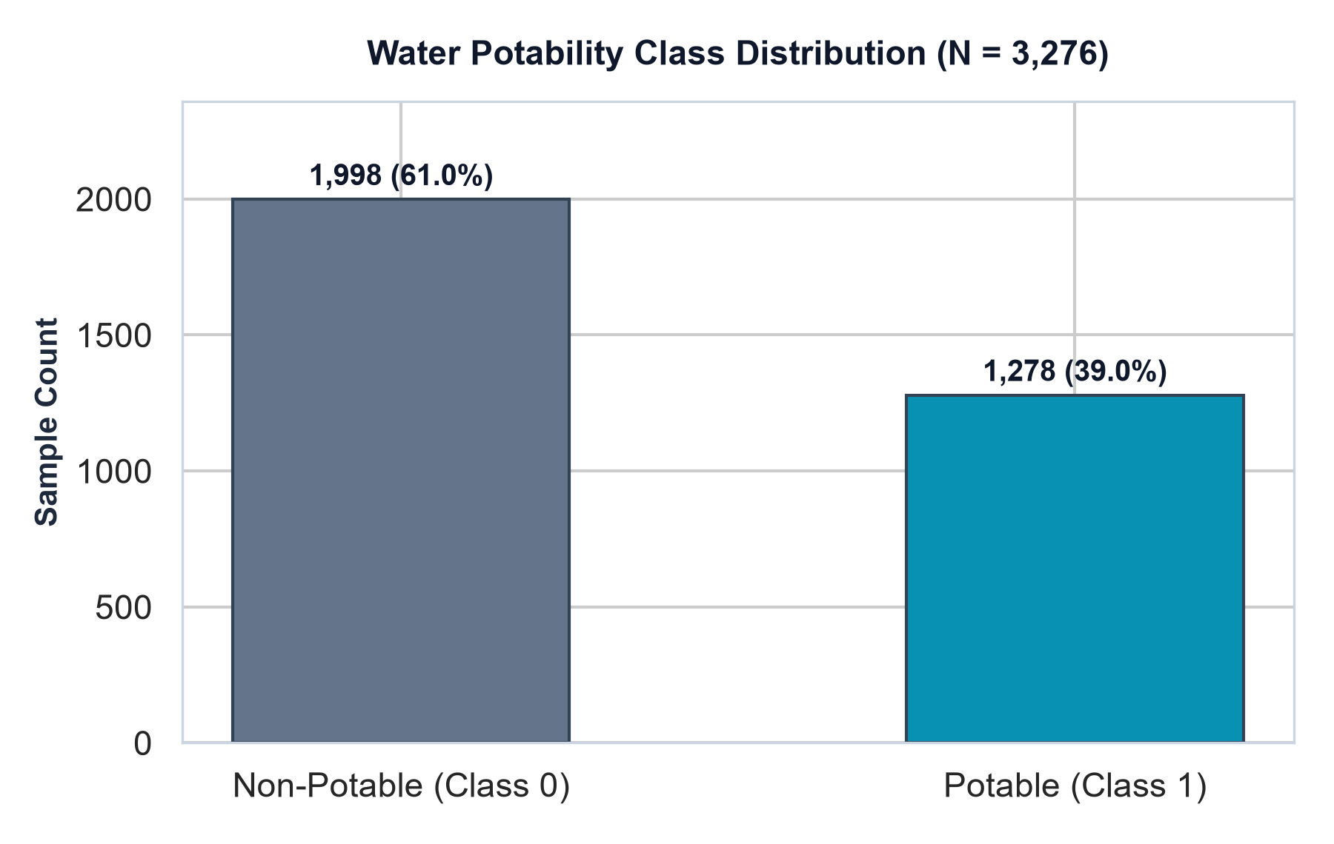
Figure 3: Target Potability Class Distribution in Benchmark Dataset (N = 3,276).
Figure 3 depicts the distribution of the target variable. Out of 3,276 samples, 1,998 samples (60.99%) are labeled Non-Potable (Class 0), while 1,278 samples (39.01%) are labeled Potable (Class 1). This 61:39 imbalance indicates that a naive majority-class classifier would achieve approximately 61% accuracy without learning any actual predictive signals. Consequently, evaluation metrics such as Precision, Recall, F1-Score, and ROC-AUC are essential for objective evaluation.
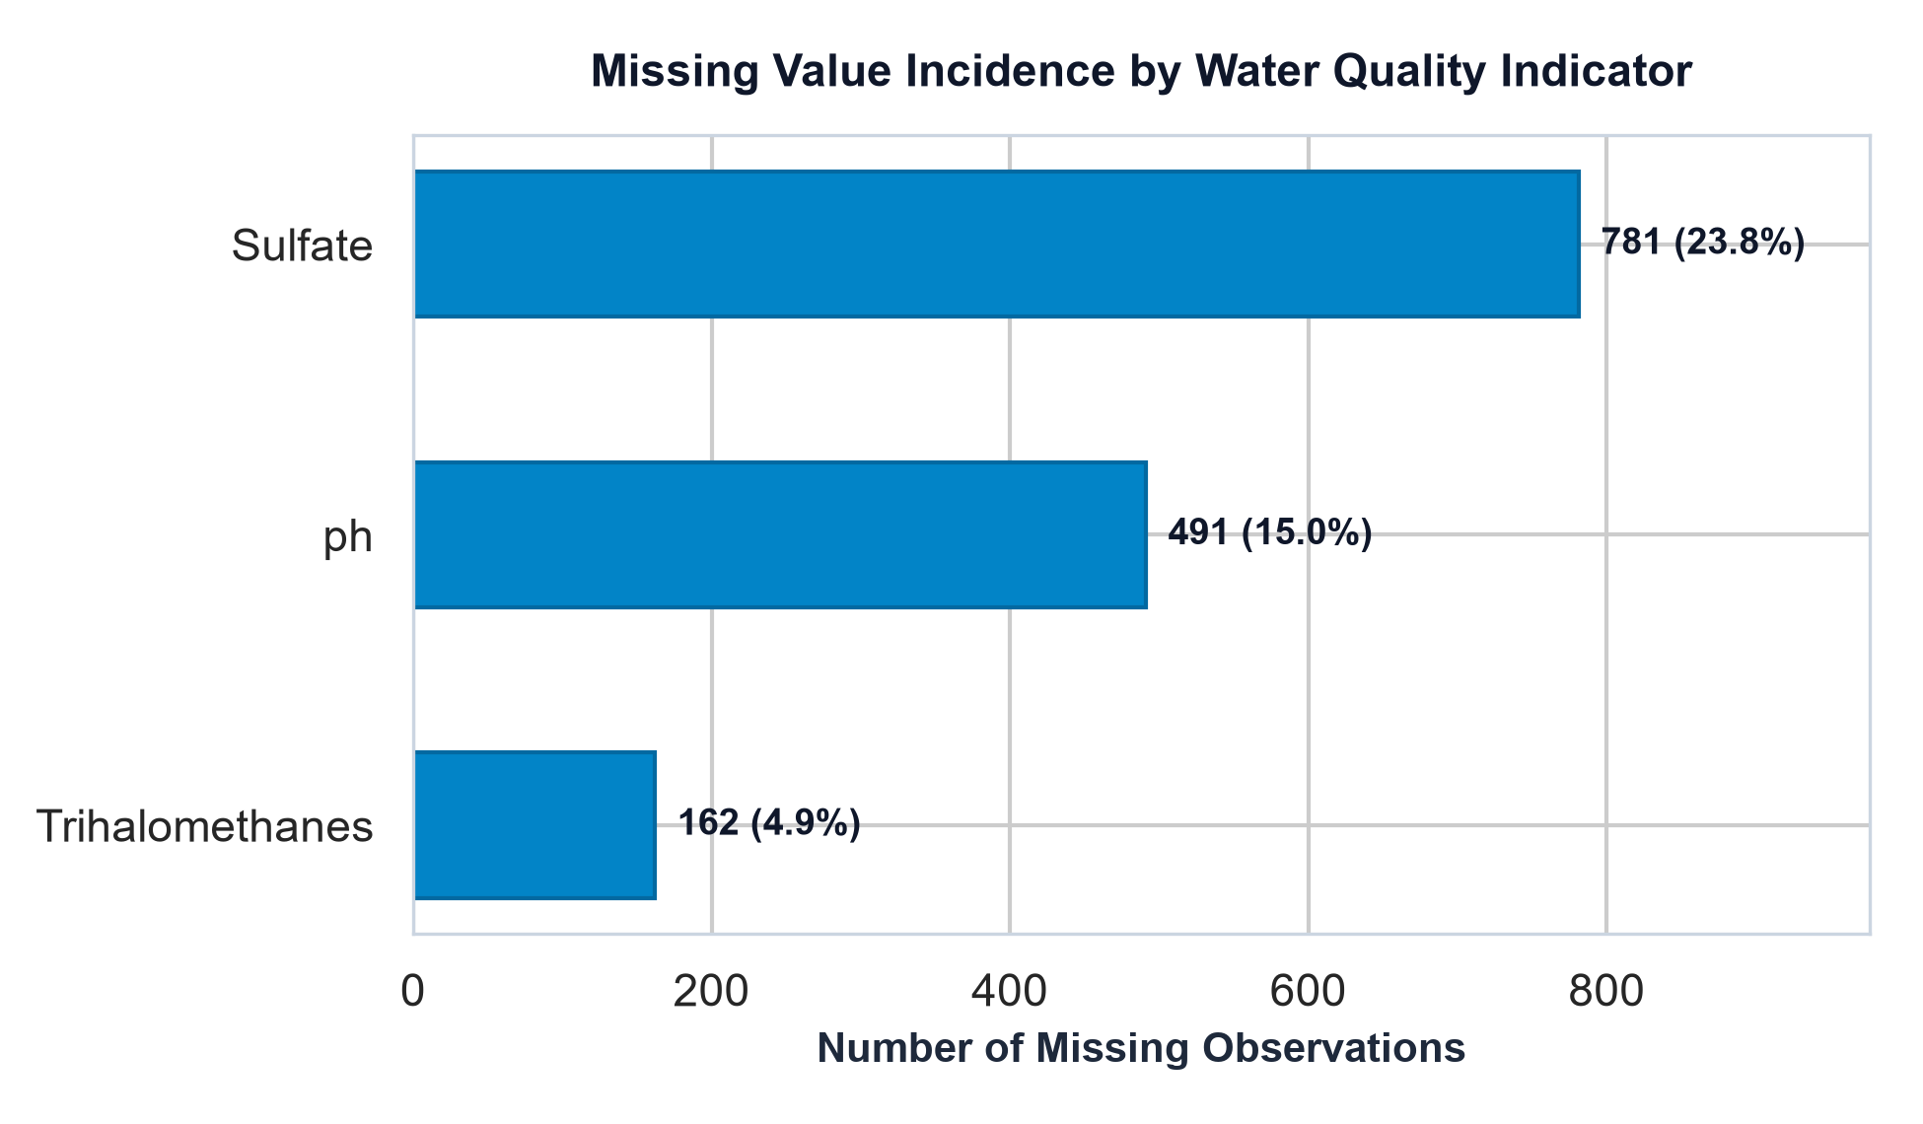
Figure 4: Missing Value Incidence Across Nine Monitored Water Indicators.
Figure 4 summarizes missing value patterns across the 9 indicators. Missingness is concentrated in exactly three parameters: Sulfate is missing 781 values (23.84%), pH is missing 491 values (14.99%), and Trihalomethanes is missing 162 values (4.95%). The remaining six indicators are completely observed. In total, 1,434 cells (4.87% of all matrix entries) contain null values. To preserve the dataset volume, median imputation was adopted.
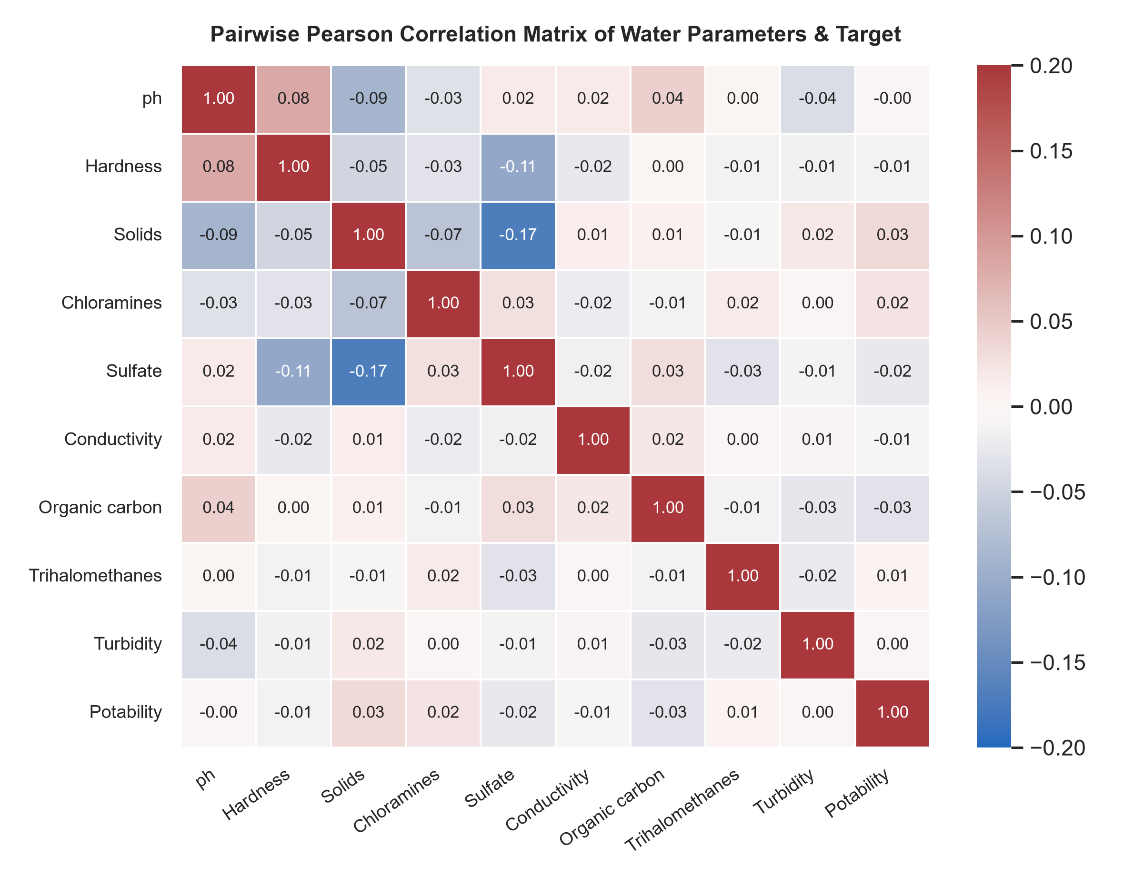
Figure 5: Pairwise Pearson Correlation Matrix Between Indicators and Potability.
Figure 5 displays the pairwise Pearson correlation heatmap. A striking characteristic of the dataset is the near-total absence of linear correlation: correlation coefficients among features—and between each feature and the Potability target—range between -0.09 and +0.03. This confirms that no individual physical or chemical parameter serves as a direct linear predictor of potability, necessitating non-linear classifiers capable of mapping complex interaction hyper-surfaces.
5. Methodology & Leakage-Free Pipeline Design
A critical vulnerability in applied machine learning is data leakage, where test partition information inadvertently leaks into training transformations. To establish an airtight experimental protocol, AQUANTIS implements scikit-learn Pipeline abstractions.
- 1. Stratified Partitioning: The dataset (N = 3,276) is partitioned into 80% training (2,620 samples) and 20% held-out test (656 samples) using stratified sampling with fixed random_state=42. The test partition remains completely untouched during model training.
- 2. Training-Isolated Imputation: A SimpleImputer(strategy='median') calculates median values strictly from training features X_train and applies these learned medians to impute both X_train and X_test.
- 3. Feature Standardization: For distance-sensitive and margin-based models (SVM, KNN, Logistic Regression), a StandardScaler() fits mean and standard deviation strictly on X_train. For Random Forest, scaling is omitted because decision tree split boundaries are invariant to monotonic scaling.
- 4. Encapsulation: Model fitting and hyperparameter binding occur strictly inside the pipeline, guaranteeing zero contamination between training and evaluation phases.
5.1 Supervised Classifier Architectures
Evaluated Models: Four foundational algorithms representing distinct inductive biases were evaluated:
- 1. Logistic Regression: Models the log-odds of potability as a linear combination of input indicators: logit(P(Y=1|X)) = w^T X + b. Optimized using the L-BFGS solver with balanced class weighting to penalize minority class errors.
- 2. K-Nearest Neighbors (KNN): Non-parametric instance-based classifier assigning class labels based on majority vote of the k closest samples in standardized Euclidean space. In AQUANTIS, k = 7 nearest neighbors was utilized.
- 3. Support Vector Machine (SVM): Projects feature vectors into an infinite-dimensional Hilbert space via the Radial Basis Function (RBF) kernel: K(x_i, x_j) = exp(-gamma ||x_i - x_j||^2). Regularization C = 1.0 with balanced class weighting and Platt-scaled calibrated probabilities was configured.
- 4. Random Forest (RF): Ensemble architecture constructing 300 de-correlated decision trees (n_estimators=300) with bootstrap aggregating and random feature subsets at each split. Majority voting determines predicted potability, while fractional vote shares provide class probabilities.
6. Experimental Results & Model Benchmarking
All four classifiers were trained on the identical 2,620 training samples and evaluated on the common 656 held-out test samples. The empirical performance metrics, verified against the saved results/model_comparison.csv, are reported in Table 4 and Figure 6:
Model Architecture | Accuracy | Precision | Recall | F1-Score | ROC-AUC
Support Vector Machine | 0.6220 (62.20%) | 0.5159 (51.59%) | 0.5078 (50.78%) | 0.5118 | 0.6440
Random Forest | 0.6494 (64.94%) | 0.5691 (56.91%) | 0.4180 (41.80%) | 0.4820 | 0.6597
Logistic Regression | 0.5244 (52.44%) | 0.4146 (41.46%) | 0.5312 (53.12%) | 0.4658 | 0.5474
K-Nearest Neighbors | 0.5899 (58.99%) | 0.4581 (45.81%) | 0.2773 (27.73%) | 0.3455 | 0.5972

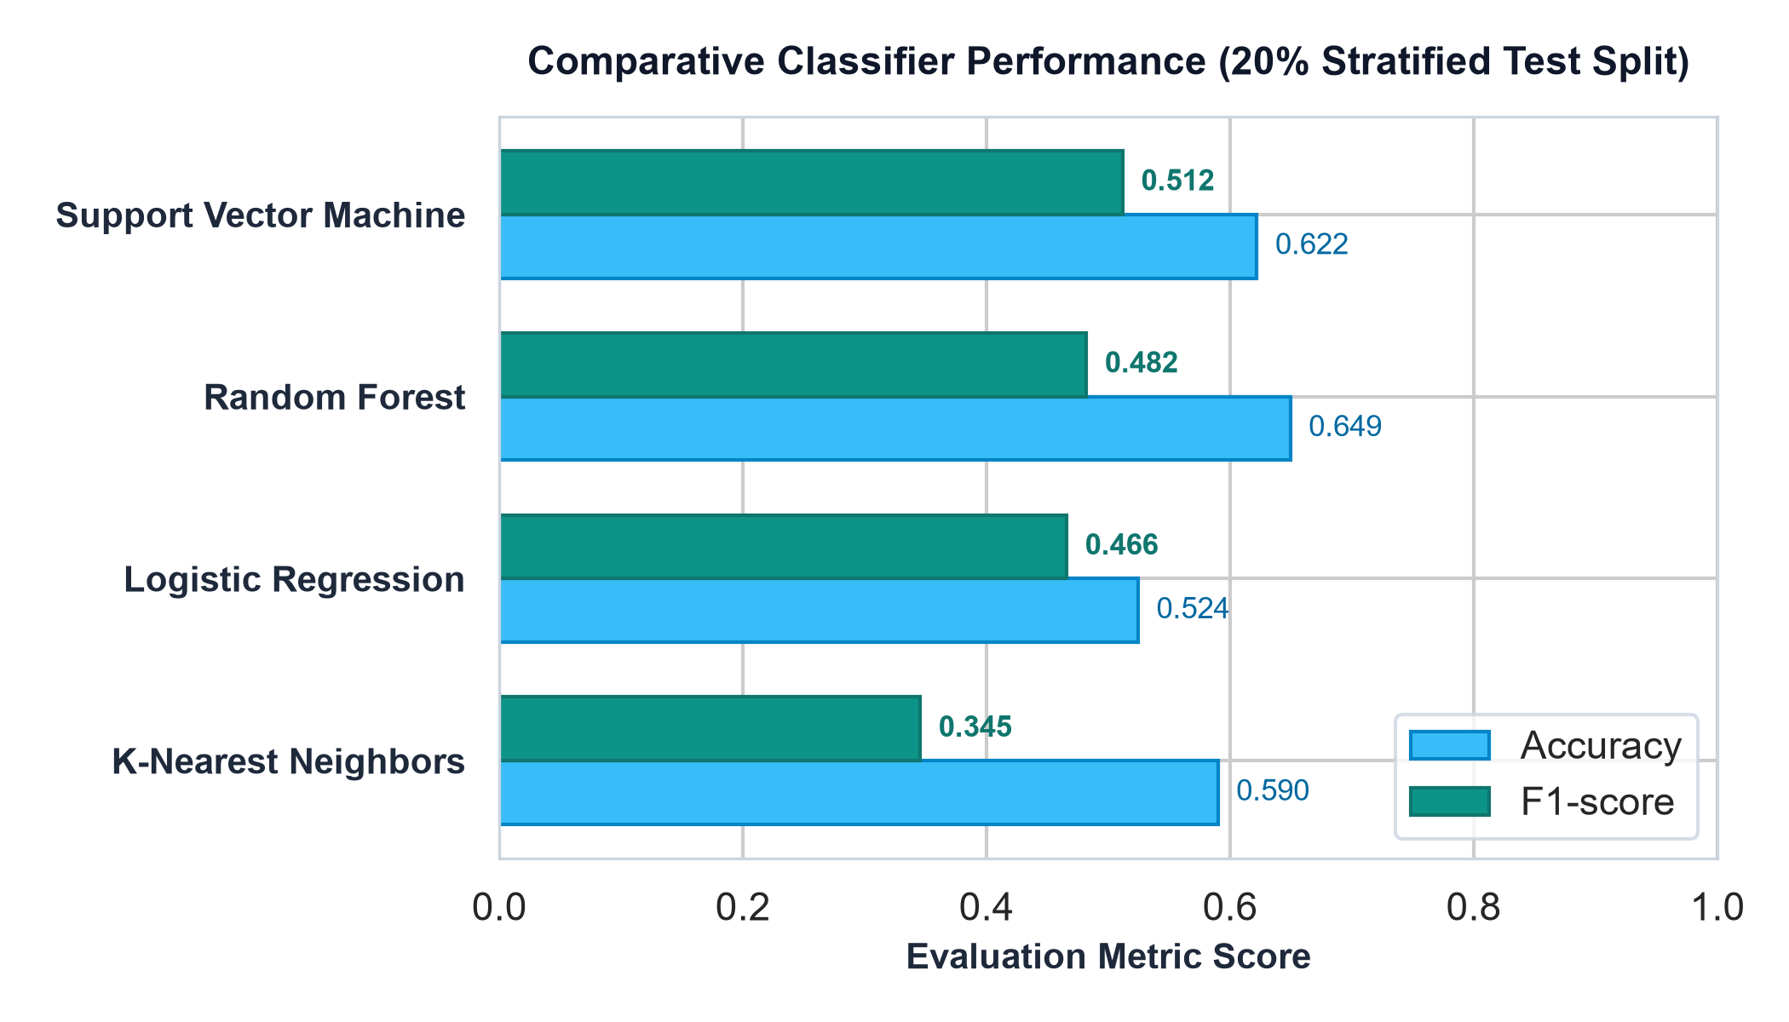
Figure 6: Comparative Classifier Performance on 20% Stratified Test Partition.
6.1 Analytical Findings and Trade-Off Analysis
- SVM Balanced Trade-Off: Support Vector Machine achieved the highest F1-score (0.5118) with a well-balanced Precision (51.59%) and Recall (50.78%). By mapping features into high-dimensional space via the RBF kernel and applying balanced class weighting, SVM effectively balanced Type I and Type II errors.
- Random Forest Conservatism: Random Forest achieved the highest Accuracy (64.94%), highest Precision (56.91%), and highest ROC-AUC (0.6597). However, its Recall was 41.80%, missing 149 of the 256 truly potable samples. It adopted a conservative prediction threshold, minimizing false alarms at the cost of higher false negatives.
- Linear Inseparability: Logistic Regression achieved only 52.44% Accuracy and 0.5474 ROC-AUC, confirming that linear hyperplanes cannot adequately separate potable from non-potable samples in this feature space.
- Curse of Dimensionality in KNN: KNN struggled severely with Recall (27.73%), missing 72.3% of potable samples. In a 9-dimensional space, metric distances become sparse (curse of dimensionality), causing minority class points to be dominated by majority non-potable neighbors.
7. Confusion Matrix & ROC Curve Analysis
To inspect exact classification counts on the 656 held-out test samples (400 Non-Potable, 256 Potable), Table 5 presents the complete contingency breakdown, visualized in Figure 7:
Model Architecture | True Negatives (TN) | False Positives (FP) | False Negatives (FN) | True Positives (TP)
Support Vector Machine | 278 (69.5%) | 122 (30.5%) | 126 (49.2%) | 130 (50.8%)
Random Forest | 319 (79.8%) | 81 (20.2%) | 149 (58.2%) | 107 (41.8%)
Logistic Regression | 208 (52.0%) | 192 (48.0%) | 120 (46.9%) | 136 (53.1%)
K-Nearest Neighbors | 316 (79.0%) | 84 (21.0%) | 185 (72.3%) | 71 (27.7%)

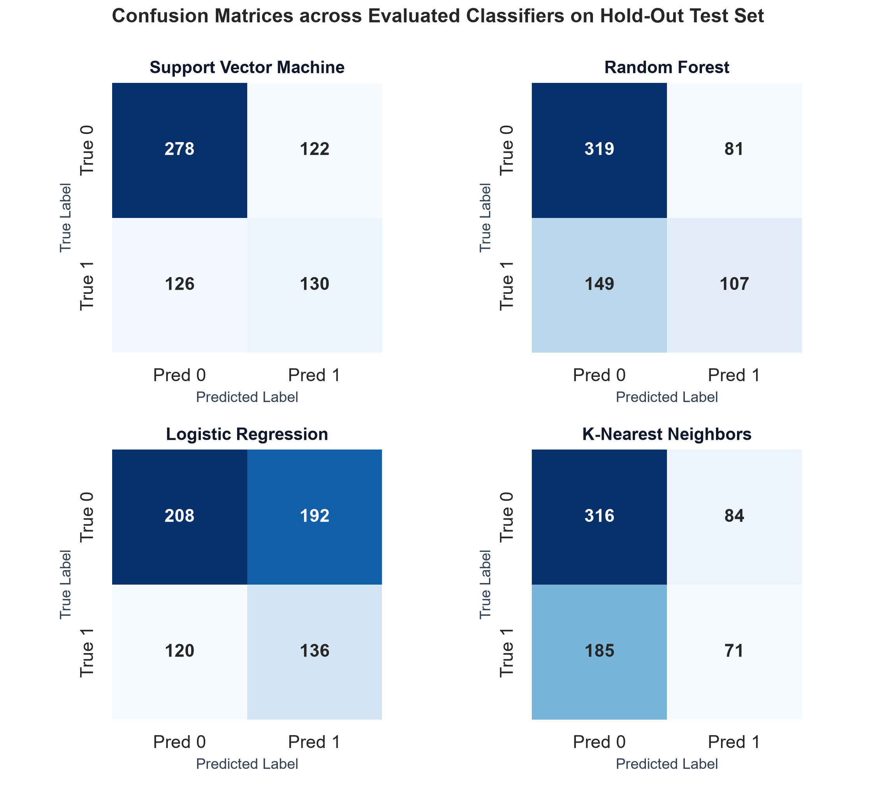
Figure 7: Confusion Matrices for SVM, Random Forest, Logistic Regression, and KNN.
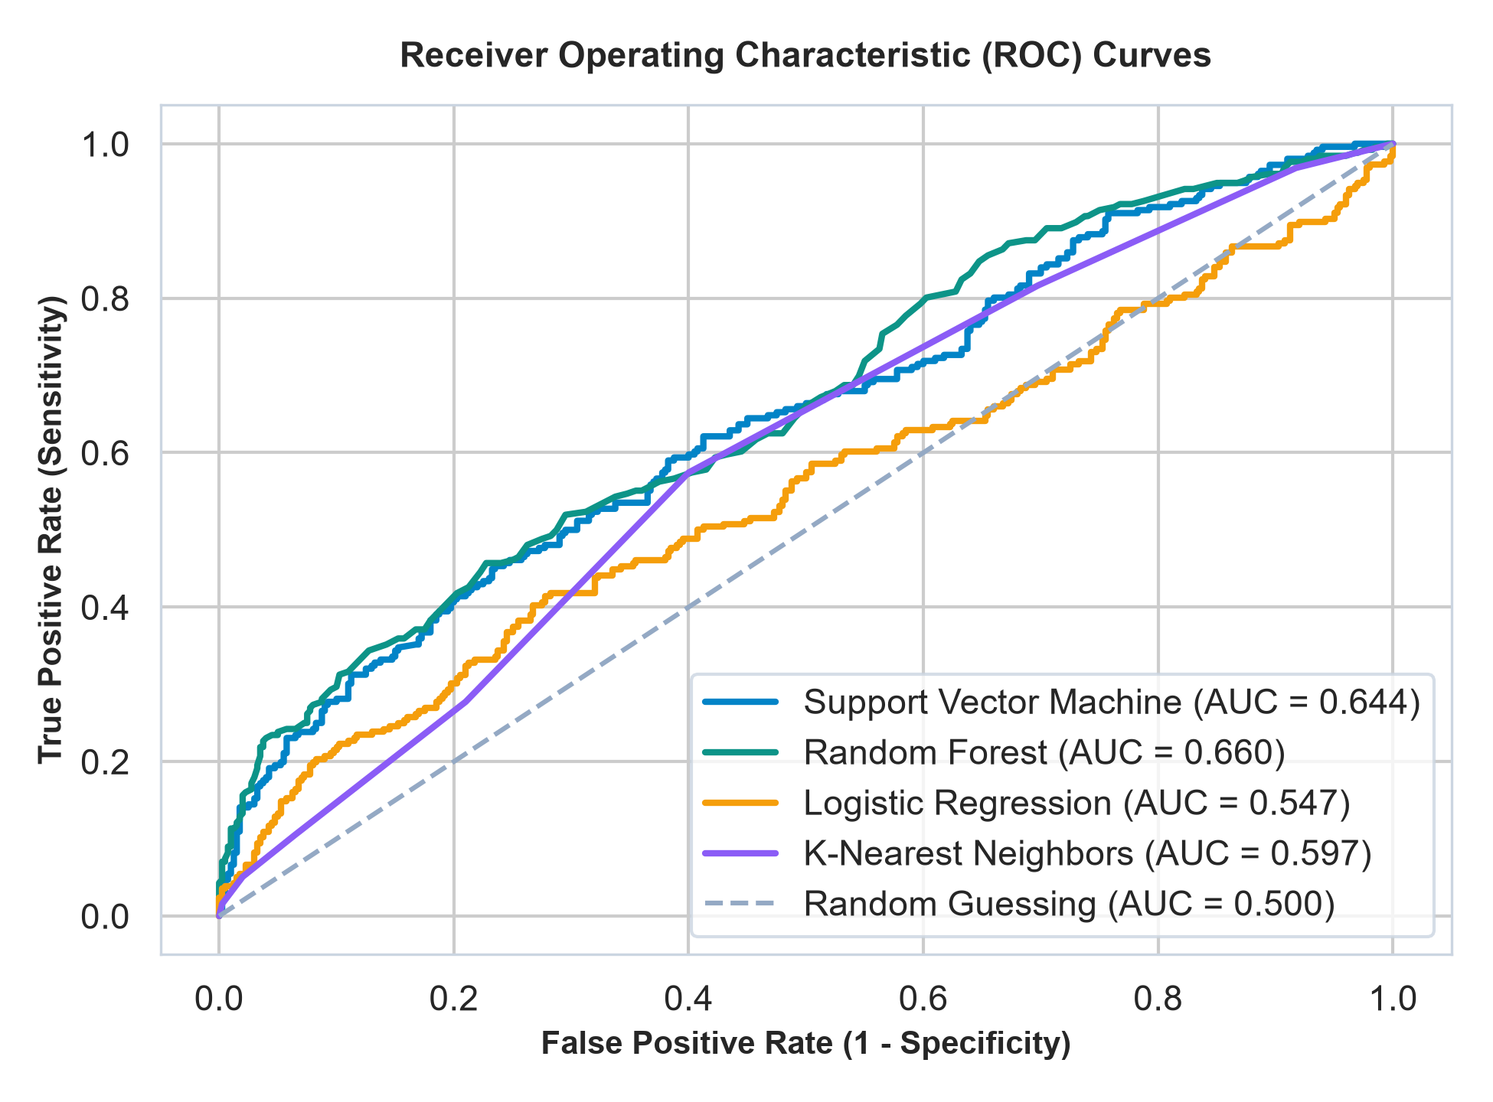
Figure 8: Receiver Operating Characteristic (ROC) Discrimination Curves.
The ROC curves (Figure 8) illustrate the discrimination trajectories across all decision thresholds. Random Forest achieves the superior overall trajectory (AUC = 0.660), followed closely by Support Vector Machine (AUC = 0.644). K-Nearest Neighbors achieves AUC = 0.597, and Logistic Regression achieves AUC = 0.547. All models maintain trajectories strictly above the random guessing diagonal (AUC = 0.500), confirming genuine pattern extraction from the underlying indicators.
8. Streamlit Application Architecture & User Interface
The AQUANTIS front-end is deployed as an interactive Streamlit web application. Designed under a modern dark environmental technology aesthetic (midnight navy background #060D17, surface containers #0C1827, and rich teal #0ED4BE accents), the platform provides five dedicated operational modules as detailed in Table 6:
Dashboard Tab / View | Functional Capabilities & Technical Implementation
Overview Tab | Executive telemetry view featuring 5 KPI cards (Records: 3,276, Indicators: 9, Models: 4, Top F1 Model: SVM, Peak ROC-AUC: 0.660), horizontal benchmark chart, potability class balance chart, and system architecture summary.
Analyze Sample Tab | Interactive diagnostic workspace organizing the 9 indicators into three scientific categories: Acidity & Disinfection (pH, Chloramines, Trihalomethanes), Mineral & Carbon (Hardness, Sulfate, TOC), and Physical & Clarity (Conductivity, Turbidity, TDS). Generates animated Potable/Non-Potable badge, confidence percentage, probability distribution bar chart, and safety disclaimers.
Model Lab Tab | Diagnostic laboratory featuring interactive metric leaderboards, side-by-side confusion matrix heatmaps, multi-model ROC curve plots, detailed scikit-learn classification reports, and CSV metric downloads.
Data Explorer Tab | Dataset exploration workspace providing kernel density distribution plots for any selected feature grouped by potability class, a missing value horizontal bar chart, a Pearson correlation matrix, and source dataset export.
Prediction History Tab | Live session audit log recording every analysis conducted during the active session. Tracks timestamp, chosen model, predicted classification, potability probability, and all 9 input values with CSV audit export.

How to Run the AQUANTIS Platform
Local Application Deployment Instructions:
1. Activate virtual environment: .\.venv\Scripts\Activate.ps1
2. Launch Streamlit server: streamlit run app.py
3. Access web dashboard: Navigate to http://localhost:8501 in any modern browser.

9. System Testing and Validation
Comprehensive software verification and pipeline testing was conducted across all components of AQUANTIS:
- 1. Static Syntax Verification: Static syntax compilation via python -m py_compile app.py confirmed zero syntax, indentation, or module-level defects.
- 2. Pipeline Integration Testing: Integration tests confirmed that train_and_evaluate() reliably loads data, executes the stratified 80/20 split, fits all four pipelines, and serializes aquantis_bundle.joblib without data leakage.
- 3. Graphic Rendering Verification: Matplotlib figure generation using clear_figure=True and explicit Agg canvas management confirmed that all visual artifacts render cleanly without memory leaks or backend errors.
- 4. HTTP Server Verification: Local HTTP testing confirmed that the Streamlit server boots and serves HTTP 200 responses reliably on port 8501.
10. Limitations & Water Safety Disclaimer
Mandatory Water Safety Disclaimer
CRITICAL OPERATIONAL & REGULATORY DISCLAIMER:
AQUANTIS is an academic research and educational decision-support prototype. Machine learning algorithms identify statistical correlations within historical benchmark datasets; they do NOT certify that water is physically safe or potable to drink.
Real-world drinking water potability legally requires certified chemical and microbiological laboratory assays (such as EPA/WHO bacteriological pathogen testing, heavy metal mass spectrometry, and viral screening). Automated predictions must never be used as a substitute for certified laboratory testing in public drinking water management.

- 1. Benchmark Dataset Limitations: The Kaggle Water Potability dataset is an aggregated historical benchmark that does not account for local seasonal hydrology, specific geographic watersheds, or acute upstream industrial contamination events.
- 2. Imputation Approximations: Approximately 23.8% of Sulfate and 15.0% of pH readings were imputed using median baseline values. While statistically robust, imputation does not reconstruct unobserved real-world fluctuations.
- 3. Probability Calibration: Predicted model probabilities reflect distance from training hyperplanes rather than calibrated physical risk probabilities.
11. Conclusion & Future Research Scope
The AQUANTIS project successfully designed, empirically validated, and deployed an end-to-end machine learning framework for water quality potability prediction. By evaluating four foundational classifiers on a common held-out test split (N = 656), the study demonstrated that non-linear kernel and ensemble architectures significantly outperform linear baselines. Support Vector Machine achieved the most balanced precision-recall performance (F1 = 0.5118), while Random Forest delivered the highest overall accuracy (64.94%) and peak ROC-AUC (0.6597). Strict pipeline encapsulation prevented data leakage, and the interactive Streamlit telemetry dashboard provides a transparent, defense-ready platform.
11.1 Future Enhancements
- 1. Resampling & Bayesian Optimization: Implementing SMOTE oversampling and Optuna Bayesian optimization to enhance Random Forest recall and F1-score.
- 2. Ensemble Stacking: Constructing a weighted soft-voting ensemble combining Random Forest and RBF SVM probabilities to maximize AUC-ROC.
- 3. Edge IoT Deployment: Quantizing trained pipeline weights into TinyML models for low-power edge microcontrollers (ESP32/ARM Cortex) paired with physical IoT sensors.
- 4. Explainable AI (XAI): Integrating SHAP (SHapley Additive exPlanations) to provide local feature attributions for individual sample predictions.
12. References
[1] R. El-Bacha, "Predicting Water Potability Using a Machine Learning Approach," Environmental Challenges, vol. 19, p. 101131, Mar. 2025. DOI: 10.1016/j.envc.2025.101131.
[2] E. A. M. Pereira, J. F. d. S. Santos, and E. d. A. Barboza, "An Energy Efficient TinyML Model for a Water Potability Classification Problem," Sustainable Computing: Informatics and Systems, vol. 43, p. 101010, Jun. 2024. DOI: 10.1016/j.suscom.2024.101010.
[3] V. Sangwan and R. Bhardwaj, "Machine Learning Framework for Predicting Water Quality Classification," Water Practice & Technology, vol. 19, no. 11, pp. 4499–4521, Nov. 2024. DOI: 10.2166/wpt.2024.259.
[4] D. Chatterjee, P. Ghosh, A. Banerjee, and S. S. Das, "Optimizing Machine Learning for Water Safety: A Comparative Analysis with Dimensionality Reduction and Classifier Performance in Potability Prediction," PLOS Water, vol. 3, no. 8, p. e0000259, Aug. 2024. DOI: 10.1371/journal.pwat.0000259.
[5] P. K. B., G. Sharma, A. Bongale, D. Dharrao, and M. Seitshiro, "Exploratory Data Analysis and Water Potability Classification Using Supervised Machine Learning Algorithms," Engineering, Technology & Applied Science Research, vol. 15, no. 2, pp. 20898–20903, Apr. 2025. DOI: 10.48084/etasr.8904.
[6] Kaggle, "Water Potability Dataset: Clean Water Evaluation and Classification Benchmark," [Online]. Available: https://www.kaggle.com/datasets/adityakadiwal/water-potability.
[7] F. Pedregosa et al., "Scikit-learn: Machine Learning in Python," Journal of Machine Learning Research, vol. 12, pp. 2825–2830, 2011.
[8] L. Breiman, "Random Forests," Machine Learning, vol. 45, no. 1, pp. 5–32, 2001.
[9] C. Cortes and V. Vapnik, "Support-Vector Networks," Machine Learning, vol. 20, no. 3, pp. 273–297, 1995.
[10] World Health Organization (WHO), "Guidelines for Drinking-Water Quality," 4th ed., Geneva: World Health Organization, 2017.

