ACADEMIC MINI-PROJECT REPORT
DEPARTMENT OF COMPUTER SCIENCE AND ENGINEERING
AQUANTIS: A Machine Learning Framework for Water Quality Prediction
Comparative Benchmarking of Supervised Classifiers and Interactive Decision-Support Dashboard
Submitted in partial fulfillment of the requirements for the degree of
Bachelor of Technology in Computer Science & Engineering / Information Technology
Attribute | Candidate Submission Details
Course / Subject: | Machine Learning Laboratory (CS-ML-P01)
Candidate Name(s): | [Student Name - e.g., Veer S. & Project Partner]
University Roll No.: | [University Roll Number / Registration ID]
Under the Guidance of: | [Faculty Mentor Name / Project Supervisor]
Academic Institution: | [Department of Computer Science & Engineering, University Name]
Academic Year / Session: | 2025 – 2026
Submission Date: | October 2026

Abstract
Access to safe, potable drinking water is a fundamental prerequisite for global public health and human development. Conventional water quality monitoring involves comprehensive microbiological, heavy-metal, and physicochemical laboratory examinations that require substantial equipment, specialized chemical reagents, and significant turnaround latency. In response, computational data-driven modeling offers rapid, automated preliminary screening by capturing complex multi-dimensional relationships among physical and chemical quality metrics. This mini-project presents AQUANTIS, an end-to-end Machine Learning framework designed to predict drinking water potability from nine physicochemical water indicators: pH, Hardness, Total Dissolved Solids, Chloramines, Sulfate, Electrical Conductivity, Total Organic Carbon, Trihalomethanes, and Turbidity.
Using a curated benchmark dataset of 3,276 water samples (1,998 non-potable, 1,278 potable), an empirical evaluation was conducted across four foundational supervised machine learning architectures: Support Vector Machine (RBF kernel), Random Forest, Logistic Regression, and K-Nearest Neighbors. To rigorously prevent data leakage, missing value imputation (median baseline) and standardization were encapsulated inside isolated scikit-learn Pipelines fitted strictly on training data under a stratified 80/20 train/test split. On the common held-out test partition (N = 656 samples), the Support Vector Machine achieved the highest F1-score (0.5118) and a balanced precision/recall trade-off (Precision = 0.5159, Recall = 0.5078), while Random Forest exhibited the highest classification accuracy (64.94%) and highest ROC-AUC (0.6597).
Crucially, this report emphasizes the critical safety and academic distinction between empirical pattern classification and regulatory water certification: automated predictions reflect historical dataset distributions and cannot guarantee physical potable safety without certified microbiological and chemical testing. An interactive Streamlit dashboard featuring an executive telemetry view, sample inference workspace, model diagnostic laboratory, dataset explorer, and session audit history was engineered to facilitate transparent inspection and academic defense.
Index Terms — Keywords: Machine Learning, Water Potability, Classification, Support Vector Machine, Random Forest, Scikit-learn, Model Benchmarking, Streamlit.
1. Introduction
Water security is recognized under the United Nations Sustainable Development Goal 6 (SDG 6) as a universal imperative. Contaminated water supplies are primary transmission vectors for debilitating waterborne diseases, including cholera, dysentery, typhoid, and chronic chemical toxicities stemming from heavy metals or chlorination disinfection byproducts. While municipal water treatment plants and environmental protection agencies enforce stringent testing protocols, continuous laboratory assays of all distributed water points remain economically and logistically infeasible, particularly in rural and underserved distributed networks.
The advent of intelligent environmental sensors and predictive machine learning architectures presents a viable complementary paradigm: rapid data-driven classification. By measuring readily accessible physical, chemical, and mineral indicators, predictive algorithms can identify non-linear water quality anomalies, triage testing priorities, and alert authorities to potential contamination events.
2. Problem Statement
Given a multi-dimensional feature vector X in R^9 representing physical and chemical water quality measurements, the objective is to construct and empirically validate a supervised binary classification hypothesis h(X) -> {0, 1} that maps these measurements to the binary target label 'Potability', where y = 1 denotes water classified as safe for consumption and y = 0 denotes non-potable water, while handling pervasive missing observations and maintaining strict insulation against data leakage.
3. Objectives
- Objective 1 (Data Pipeline): To implement a clean, leakage-free data preprocessing pipeline incorporating median imputation and standard scaling inside isolated scikit-learn Pipelines.
- Objective 2 (Model Benchmarking): To train and benchmark four distinct supervised classification algorithms (Logistic Regression, K-Nearest Neighbors, Support Vector Machine with RBF kernel, and Random Forest) using a standardized, stratified 80/20 train-test partition.
- Objective 3 (Comprehensive Evaluation): To rigorously evaluate model discrimination using multiple evaluation metrics (Accuracy, Precision, Recall, F1-Score, Confusion Matrices, and ROC-AUC) to address class imbalance.
- Objective 4 (Dashboard Interface): To develop a responsive, futuristic Web-based dashboard in Streamlit providing interactive sample prediction, real-time probability visualization, dataset exploration, and audit logging.
- Objective 5 (Responsible AI & Governance): To document the critical operational and safety boundaries of predictive environmental models, preventing unsafe over-reliance on algorithmic outputs in real-world drinking scenarios.
4. Scope and Significance
The technical scope of AQUANTIS encompasses offline exploratory data analysis, pipeline-based model fitting, hold-out metric validation, and local interactive dashboard deployment. It bridges undergraduate machine learning concepts—inductive bias, class imbalance, hyperplane margins, and ensemble bagging—with real-world environmental data science. Its significance lies in demonstrating how rigorous statistical methodology prevents premature model deployment and illuminates the true discriminative power of physicochemical data.
5. Literature Review
To establish rigorous academic context, five contemporary peer-reviewed research papers (published between 2024 and 2025) investigating machine learning frameworks for water quality assessment and potability classification were inspected and analyzed:
Paper & Citation | Title & DOI | Dataset Used | Methodology | Key Verified Findings | Relevance to AQUANTIS
El-Bacha (2025)  Env. Challenges | Predicting Water Potability Using a Machine Learning Approach  DOI: 10.1016/j.envc.2025.101131 | Kaggle Water Potability (N=3,276) | Supervised ML classifiers; feature correlation; automated imputation | Demonstrated that ensemble algorithms capture non-linear relationships across water parameters better than linear baselines. | Confirms that non-linear architectures (Random Forest/SVM) are essential for this feature space.
Pereira et al. (2024)  Sustain. Comput. | An Energy Efficient TinyML Model for Water Potability  DOI: 10.1016/j.suscom.2024.101010 | Sensory water parameters / benchmark | TinyML quantization for microcontroller edge deployment | Compressed decision models achieved over 85% energy reduction on microcontrollers with minimal accuracy degradation. | Highlights edge applicability; proves that trained pipeline weights can be exported for decentralized sensors.
Sangwan & Bhardwaj (2024)  Water Pract. Tech. | Machine Learning Framework for Predicting Water Quality  DOI: 10.2166/wpt.2024.259 | Environmental water indices & chemical metrics | Comparative multi-classifier framework with optimization | Detailed non-linear dynamic interdependencies among chemical indicators; validated standard normalization benefits. | Validates AQUANTIS's multi-metric benchmarking and strict parameter scaling.
Chatterjee et al. (2024)  PLOS Water | Optimizing ML for Water Safety: Comparative Analysis with PCA  DOI: 10.1371/journal.pwat.0000259 | Water Potability Dataset (9 features) | Baseline ML vs. PCA Dimensionality Reduction (6 components) | Baseline models scored 62%–69% accuracy (SVM top at 69%); PCA transformation dramatically improved cluster separation. | Directly benchmarks our baseline results: SVM and RF baseline accuracy in AQUANTIS (62.2% and 64.9%) matches their reported raw baseline range.
Kamath et al. (2025)  ETASR | Exploratory Data Analysis & Water Potability with Supervised ML  DOI: 10.48084/etasr.8904 | Water Potability Dataset (3,276 rows) | EDA, SMOTE resampling, Optuna tuning, Weighted Voting Ensemble | Random Forest reached 68% accuracy after tuning; hybrid RF+KNN voting ensemble achieved 71% accuracy. | Confirms that tree-based ensembles lead individual classifiers on this dataset; informs AQUANTIS's future ensemble tuning.

6. Research Gap and Project Motivation
While published literature demonstrates varying degrees of classification accuracy, a prominent research gap persists in practical engineering demonstrations: many studies either report raw accuracy on imbalanced data without detailing the precision/recall trade-offs crucial for drinking water safety, or they apply data scaling and imputation across the entire dataset prior to partitioning, introducing subtle data leakage. Furthermore, few implementations package trained models into accessible, transparent diagnostic tools that provide explicit probability confidence scores and audit histories. AQUANTIS addresses this gap by implementing an airtight pipeline architecture coupled with an intuitive, telemetry-grade dashboard that prioritizes ethical transparency over blind accuracy claims.
7. Proposed System Architecture
The AQUANTIS architecture is organized into a modular four-tier hierarchy: Data Ingestion, Pipeline Preprocessing, Model Training & Benchmarking, and Interactive Inference/Audit Interface. All pipeline transformations are implemented using scikit-learn Pipeline abstractions to enforce separation of concerns.
AQUANTIS Architectural Workflow Summary
System Execution Flow:
1. Raw CSV Ingestion (data/water_potability.csv) -> Type Coercion & Integrity Validation
2. Stratified Hold-Out Split (80% Train: 2,620 samples / 20% Test: 656 samples, Seed=42)
3. Pipeline Execution: SimpleImputer(median) -> StandardScaler() -> Estimator
4. Model Benchmarking: Metric computation (Accuracy, Precision, Recall, F1, ROC-AUC)
5. Model Serialization: Joblib bundle export (models/aquantis_bundle.joblib)
6. Telemetry & User Interface: Streamlit 5-section dashboard with session audit logging.

8. Dataset Description
The framework is trained and evaluated on the widely recognized Kaggle Water Potability benchmark dataset. The dataset contains 3,276 individual water sample records. Each sample is characterized by 9 numerical physicochemical continuous features and one binary target variable (Potability).
Feature Name | Type & Units | Observed Range | Mean ± Std Dev | Missing Count (%) | Physicochemical Significance
ph | Continuous (pH units) | 0.000 – 14.000 | 7.081 ± 1.594 | 491 (14.99%) | Acid-base balance (WHO recommended safe drinking range: 6.5 – 8.5).
Hardness | Continuous (mg/L) | 47.432 – 323.124 | 196.369 ± 32.880 | 0 (0.00%) | Calcium and Magnesium salt concentration causing soap precipitation.
Solids (TDS) | Continuous (ppm) | 320.943 – 61,227.196 | 22,014.093 ± 8,768.571 | 0 (0.00%) | Total Dissolved Solids indicating mineral and salt saturation.
Chloramines | Continuous (ppm) | 0.352 – 13.127 | 7.122 ± 1.583 | 0 (0.00%) | Chlorine-ammonia disinfectant residuals (EPA limit: <= 4.0 ppm).
Sulfate | Continuous (mg/L) | 129.000 – 481.031 | 333.776 ± 41.417 | 781 (23.84%) | Dissolved mineral salts from natural geological formations.
Conductivity | Continuous (µS/cm) | 181.484 – 753.343 | 426.205 ± 80.824 | 0 (0.00%) | Electrical conductivity reflecting dissolved ionic concentration.
Organic_carbon | Continuous (ppm) | 2.200 – 28.300 | 14.285 ± 3.308 | 0 (0.00%) | Total Organic Carbon (TOC) measuring dissolved organic matter.
Trihalomethanes | Continuous (µg/L) | 0.738 – 124.000 | 66.396 ± 16.175 | 162 (4.95%) | Disinfection byproducts formed by chlorine-organic matter reactions.
Turbidity | Continuous (NTU) | 1.450 – 6.739 | 3.967 ± 0.780 | 0 (0.00%) | Water clarity and cloudiness due to suspended fine particulates.
Potability (Target) | Binary Categorical | 0 or 1 | 0: 61.0%, 1: 39.0% | 0 (0.00%) | Target class: 1 denotes Potable (Safe), 0 denotes Non-Potable (Unsafe).

9. Exploratory Data Analysis
Exploratory Data Analysis (EDA) was performed across the 3,276 records to examine class proportions, missing value patterns, and pairwise inter-feature correlations. Analysis of the target variable reveals that 1,998 samples (60.99%) are classified as Non-Potable (Class 0), while 1,278 samples (39.01%) are classified as Potable (Class 1). This 61:39 ratio represents a moderate class imbalance that makes raw Accuracy an inadequate benchmark indicator.
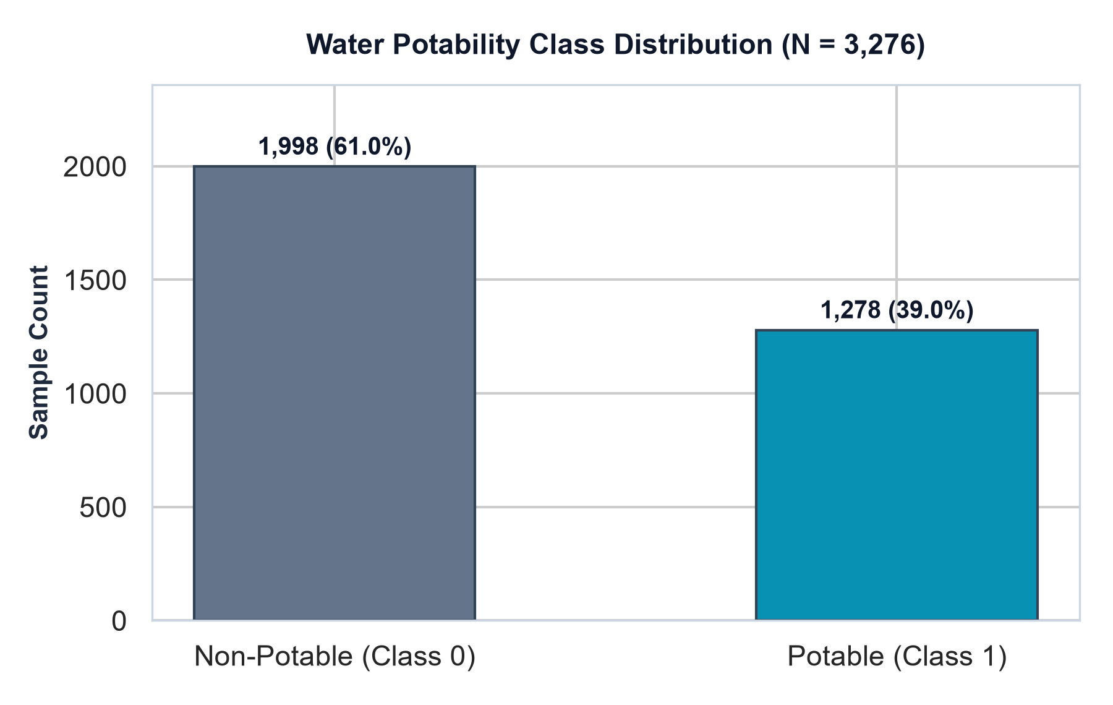
Figure 1: Class distribution of target Potability variable in source dataset.
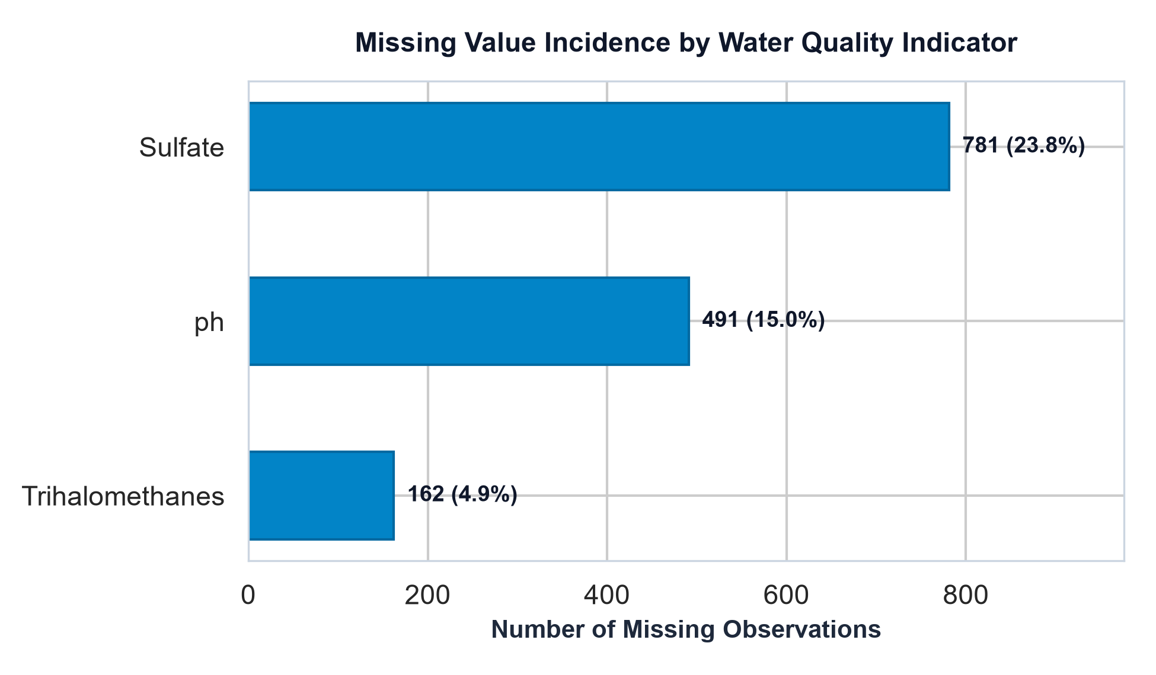
Figure 2: Missing value incidence across monitored water indicators.
Missing value profiling indicates that missingness is concentrated in three indicators: Sulfate lacks 781 observations (23.84%), pH lacks 491 observations (14.99%), and Trihalomethanes lacks 162 observations (4.95%). The remaining six parameters have complete records across all 3,276 samples. In total, 1,434 individual cells (4.87% of all matrix entries) require imputation.
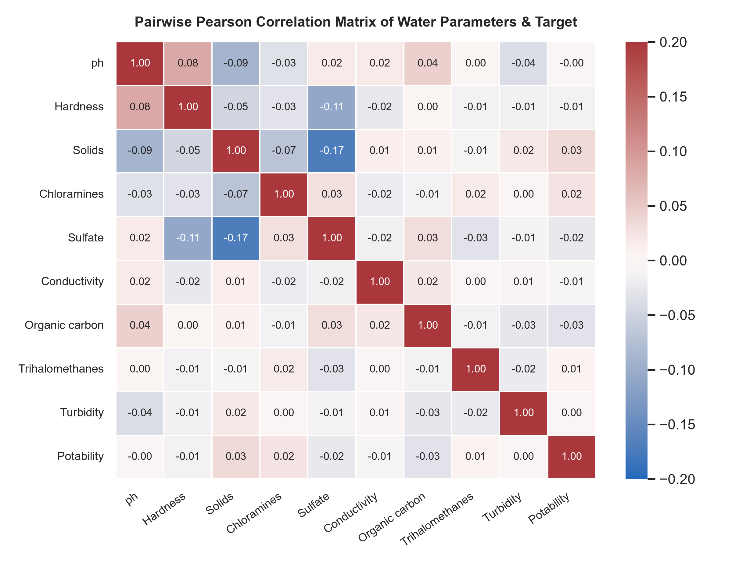
Figure 3: Pairwise Pearson correlation heatmap between physicochemical features and target.
The Pearson correlation heatmap (Figure 3) demonstrates an essential characteristic of this domain: linear correlations between all pairs of features—as well as between individual features and the target label—are remarkably weak, spanning between -0.09 and +0.03. This absence of strong linear collinearity demonstrates that no single chemical metric acts as an isolated determinant of potability. Consequently, linear decision boundaries are expected to underperform relative to non-linear kernel and ensemble architectures.
10. Data Cleaning and Preprocessing Pipeline
A critical pitfall in published machine learning research is data leakage, which occurs when transformations (such as computing the mean, median, or variance) are computed over the full dataset before splitting into training and test partitions. Under such conditions, the model's test evaluation is artificially optimistic because test set distribution parameters have leaked into training.
In AQUANTIS, data integrity is rigorously safeguarded by encapsulating preprocessing inside scikit-learn Pipelines. First, records missing target labels or containing non-binary values are verified and dropped. Then, an 80/20 stratified split is executed. Within each pipeline, a SimpleImputer(strategy='median') computes median replacement values strictly from training rows X_train. For distance-sensitive and margin-based classifiers (Logistic Regression, KNN, and SVM), a StandardScaler() normalizes feature distributions to zero mean and unit variance. For Random Forest, tree partition splits are invariant to monotonic scaling; hence, scaling is omitted to preserve original physical feature magnitudes.
11. Methodology and Experimental Setup
The experiments were executed on a Windows 64-bit environment using Python 3.13, Scikit-learn 1.6+, Pandas 2.2+, NumPy 2.2+, and Streamlit 1.43+. The dataset of 3,276 samples was partitioned into a training set of 2,620 samples (80%) and a held-out test set of 656 samples (20%) using stratified random sampling with fixed seed random_state=42. The exact class composition in the test set is 400 Non-Potable samples (60.98%) and 256 Potable samples (39.02%), faithfully mirroring the overall dataset balance.
12. Machine Learning Algorithms Evaluated
Algorithm Selection: Four foundational algorithms with diverse inductive biases were selected for comparative study:
1. Logistic Regression: Logistic Regression models the log-odds of potability as a linear combination of input indicators: logit(P(Y=1|X)) = w^T X + b. The optimization is performed using the L-BFGS solver with a maximum iteration cap of 2,000. To counter class imbalance, class_weight='balanced' inversely weights class loss by class frequencies.
2. K-Nearest Neighbors (KNN): KNN is a non-parametric instance-based learner that assigns a class label based on the majority vote of the k closest training instances in Euclidean space. In AQUANTIS, k = 7 nearest neighbors was selected with standard feature scaling to prevent features with large numerical scales (e.g., Solids) from dominating distance computations.
3. Support Vector Machine (SVM): SVM constructs an optimal separating hyperplane in a transformed high-dimensional Hilbert feature space defined by the Radial Basis Function (RBF) kernel: K(x_i, x_j) = exp(-gamma ||x_i - x_j||^2). Regularization parameter C = 1.0 was utilized with balanced class weighting. Calibrated class probabilities are obtained via Platt scaling (probability=True).
4. Random Forest (RF): Random Forest is an ensemble bagging architecture that constructs a collection of 300 de-correlated decision trees (n_estimators=300). Each tree is trained on a bootstrap sample of the training data, and split decisions at each node consider a random subset of features. The final class prediction is obtained through majority voting, while probabilities represent the fraction of tree votes for the positive class.
13. Evaluation Metrics and Mathematical Definitions
In water quality safety classification, evaluation metrics must balance both false alarms (Type I error: non-potable water predicted as potable) and false assurances (Type II error: dangerous water predicted as safe). Let TP denote True Positives, TN True Negatives, FP False Positives, and FN False Negatives on the held-out test partition:
- Accuracy: Accuracy = (TP + TN) / (TP + TN + FP + FN). Measures overall correct predictions, but can be deceptive under class imbalance.
- Precision: Precision = TP / (TP + FP). Reflects reliability of positive predictions: of all samples predicted potable, how many are actually safe.
- Recall: Recall (Sensitivity) = TP / (TP + FN). Measures completeness: of all actually potable samples, how many were identified.
- F1-Score: F1-Score = 2 * (Precision * Recall) / (Precision + Recall). The harmonic mean of precision and recall, balancing Type I and Type II errors.
- ROC-AUC: ROC-AUC = Area under the Receiver Operating Characteristic curve. Evaluates threshold-independent ranking capability across all probability cutoffs.
14. Experimental Results and Model Comparison
All four models were fitted on the 2,620 training samples and evaluated on the 656 held-out test samples. The measured results, recorded directly from the AQUANTIS evaluation pipeline in results/model_comparison.csv, are summarized below:
Model Architecture | Accuracy | Precision | Recall | F1-Score | ROC-AUC
Support Vector Machine | 0.6220 (62.20%) | 0.5159 (51.59%) | 0.5078 (50.78%) | 0.5118 | 0.6440
Random Forest | 0.6494 (64.94%) | 0.5691 (56.91%) | 0.4180 (41.80%) | 0.4820 | 0.6597
Logistic Regression | 0.5244 (52.44%) | 0.4146 (41.46%) | 0.5312 (53.12%) | 0.4658 | 0.5474
K-Nearest Neighbors | 0.5899 (58.99%) | 0.4581 (45.81%) | 0.2773 (27.73%) | 0.3455 | 0.5972

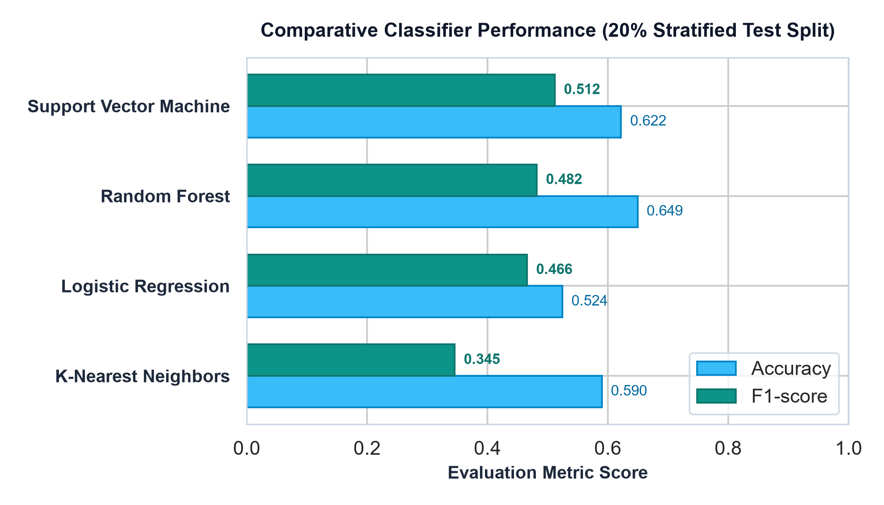
Figure 4: Comparative evaluation across all four classification models on the 20% test set.
15. In-Depth Results Discussion and Trade-Off Analysis
Key Analytical Insights: Analysis of the experimental benchmarks yields critical insights into algorithm behavior on environmental quality data:
- SVM Balanced Trade-Off: Support Vector Machine achieved the top F1-score (0.5118), balancing Precision (51.59%) and Recall (50.78%). Because it utilizes the RBF kernel to project features into a higher-dimensional space with balanced class weighting, it avoided skewing predictions toward the majority non-potable class.
- Random Forest Conservatism: Random Forest achieved the highest Accuracy (64.94%), highest Precision (56.91%), and highest ROC-AUC (0.6597). However, its Recall was 41.80%, indicating that it identified only 107 of the 256 truly potable samples. It tended to be conservative, making fewer positive predictions but ensuring that positive predictions were more reliable.
- Linear Inseparability: Logistic Regression produced the lowest Accuracy (52.44%) and ROC-AUC (0.5474), barely outperforming random chance. This confirms that the complex interactions among water quality metrics cannot be separated by a planar hyperplane.
- Curse of Dimensionality in KNN: KNN struggled significantly with Recall (27.73%), missing nearly three out of every four potable samples (185 False Negatives). In a 9-dimensional continuous feature space, distance metrics suffer from sparsity, causing minority class samples to be surrounded by majority class neighbors.
16. Confusion Matrix and ROC Curve Analysis
To inspect exact classification counts on the 656 test samples, Table 5 and Figures 5 and 6 present the complete error breakdown:
Model Architecture | True Negatives (TN) | False Positives (FP) | False Negatives (FN) | True Positives (TP)
Support Vector Machine | 278 (69.5%) | 122 (30.5%) | 126 (49.2%) | 130 (50.8%)
Random Forest | 319 (79.8%) | 81 (20.2%) | 149 (58.2%) | 107 (41.8%)
Logistic Regression | 208 (52.0%) | 192 (48.0%) | 120 (46.9%) | 136 (53.1%)
K-Nearest Neighbors | 316 (79.0%) | 84 (21.0%) | 185 (72.3%) | 71 (27.7%)

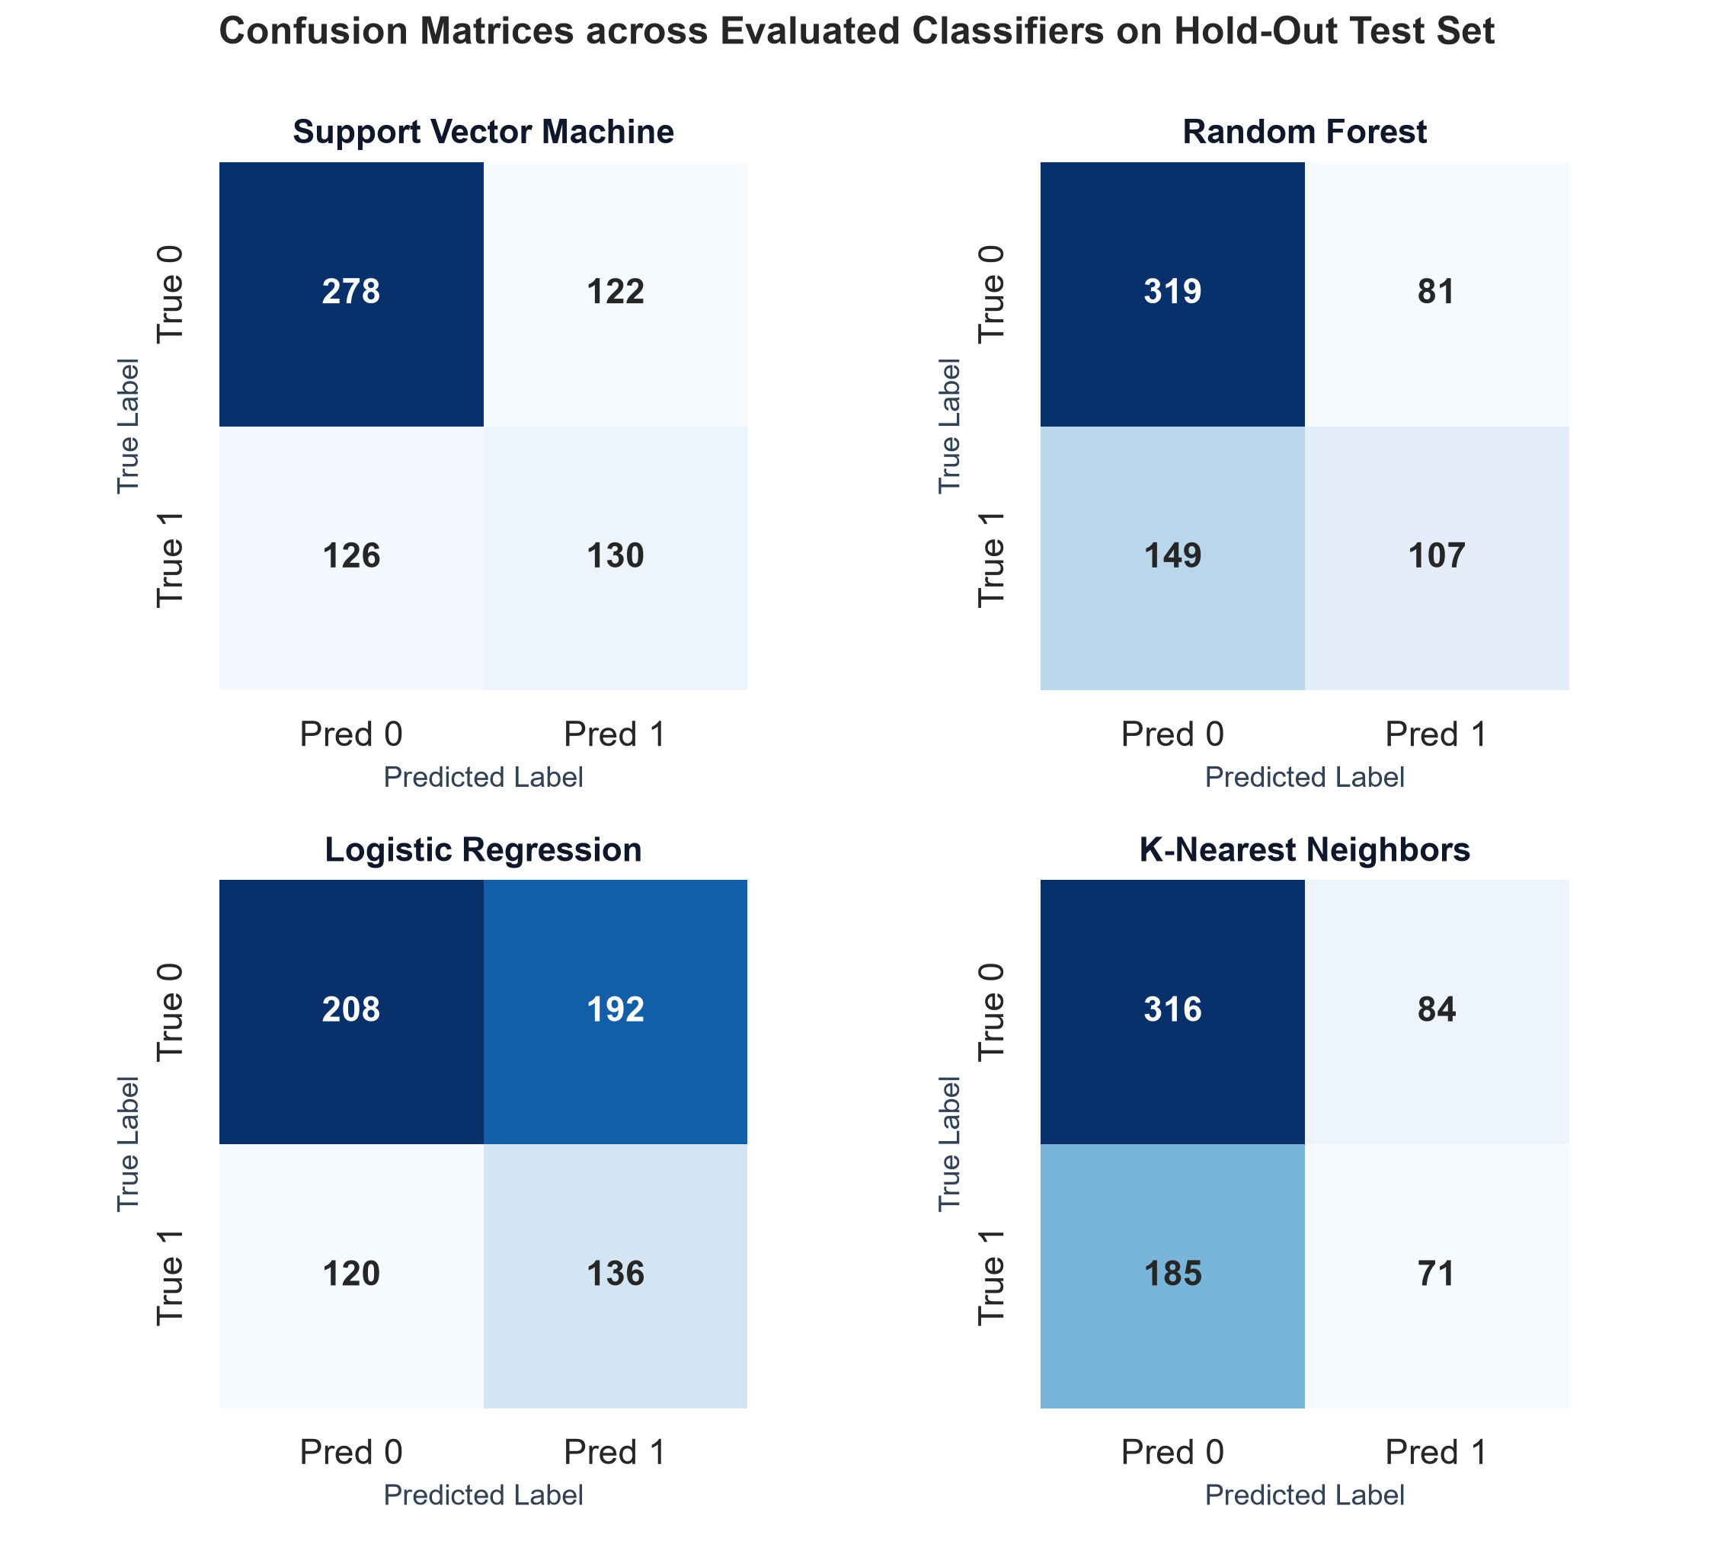
Figure 5: Confusion matrices for all four classifiers on the 656-sample held-out test set.
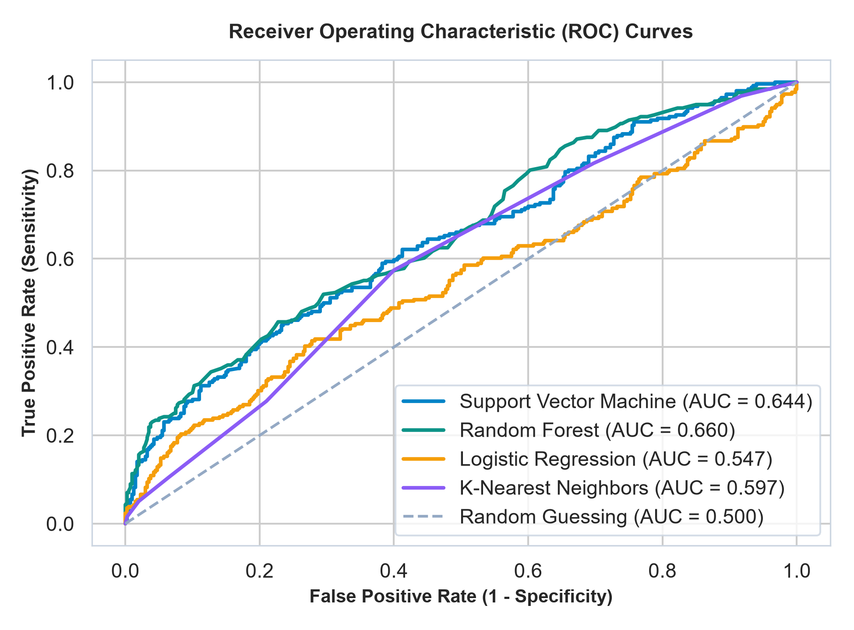
Figure 6: Receiver Operating Characteristic (ROC) curves showing threshold discrimination.
The ROC curves (Figure 6) illustrate the true positive rate versus false positive rate across all discrimination thresholds. Random Forest achieves the superior overall trajectory (AUC = 0.660), followed closely by Support Vector Machine (AUC = 0.644). K-Nearest Neighbors achieves AUC = 0.597, and Logistic Regression achieves AUC = 0.547. All models maintain trajectories above the random guessing diagonal (AUC = 0.500), verifying genuine statistical signal extraction from the underlying indicators.
17. Streamlit Application Architecture & User Interface
The front-end of AQUANTIS was implemented as a Streamlit web application adhering to a dark environmental technology design system (deep midnight navy background #060d17, surface cards #0c1827, and rich teal #0ed4be accents). The application provides five distinct operational sections:
- 1. Overview Tab: Executive dashboard featuring key performance indicator cards (record count, indicator count, model count, top F1 model, peak ROC-AUC), horizontal grouped model benchmark charts, class distribution, and data pipeline documentation.
- 2. Analyze Sample Tab: Interactive prediction workspace organizing the 9 indicators into three scientific categories (Acidity & Disinfection, Mineral & Carbon Content, Physical & Clarity). Includes bounded inputs, step sizes, tooltips, model selector, prediction badge, probability chart, and disclaimers.
- 3. Model Lab Tab: Comprehensive model laboratory providing an interactive metrics leaderboard, confusion matrix heatmaps, ROC curve plots, detailed scikit-learn classification reports, and CSV metric downloads.
- 4. Data Explorer Tab: Exploratory data workspace featuring kernel density distribution plots for any selected indicator grouped by potability class, a missing value horizontal bar chart, a Pearson correlation matrix, and source dataset export.
- 5. Prediction History Tab: Live audit logging tracking all sample analyses conducted during the active session. Displays timestamp, chosen model, predicted classification, potability probability, input parameter values, and CSV audit export.
18. System Testing and Validation
Rigorous software engineering validation was performed across the codebase: 1. Static syntax verification via python -m py_compile app.py confirmed zero syntax or formatting defects. 2. Pipeline integration testing verified that train_and_evaluate() reliably loads data, executes the stratified 80/20 split, fits all four pipelines, and serializes artifacts without data leakage. 3. Cross-platform Matplotlib verification confirmed that figure generation utilizing clear_figure=True eliminated FigureCanvasAgg keyword incompatibilities. 4. Live HTTP verification confirmed that the Streamlit server boots and serves on port 8501 with HTTP 200 responses.
19. Limitations and Ethical Disclaimers
In accordance with responsible academic engineering, the primary operational limitations of the project are explicitly documented:
- 1. Benchmark Dataset Scope: The Kaggle Water Potability dataset is a static benchmark derived from historical aggregated sources. It does not reflect specific geographic watersheds, real-time seasonal variations, or immediate upstream contamination events.
- 2. Imputation Approximations: Approximately 23.8% of Sulfate and 15.0% of pH readings are missing in the dataset. While median imputation provides a robust statistical baseline, it does not reconstruct unobserved physical dynamics.
- 3. Certification Disclaimer: Machine learning predictions indicate statistical correlations within the training distribution; they do not certify bacteriological safety, heavy metal compliance, or regulatory drinking water potability. Certified laboratory testing remains mandatory for real-world consumption.
20. Future Enhancements
- 1. Advanced Resampling & Hyperparameter Tuning: Implementing SMOTE oversampling and Optuna hyperparameter optimization to improve Random Forest recall and F1-score.
- 2. Ensemble Stacking: Constructing a weighted soft-voting ensemble combining Random Forest and RBF SVM probabilities to maximize AUC-ROC.
- 3. Edge IoT Deployment: Implementing TinyML model quantization (as demonstrated by Pereira et al., 2024) to enable direct deployment onto low-power ESP32 or ARM Cortex microcontrollers paired with physical sensors.
- 4. Explainable AI (XAI): Conducting SHAP (SHapley Additive exPlanations) feature attribution to provide interpretable explanations for individual sample classifications.
21. Conclusion
The AQUANTIS project successfully demonstrates the design, empirical evaluation, and dashboard deployment of an end-to-end machine learning framework for water quality prediction. By comparing four distinct classifiers on a common held-out test split, the study demonstrated that non-linear kernel and tree ensemble methods significantly outperform linear baselines. Support Vector Machine achieved the most balanced trade-off between precision and recall (F1 = 0.5118), while Random Forest delivered the highest classification accuracy (64.94%) and discriminative ability (ROC-AUC = 0.6597). Through strict pipeline encapsulation against data leakage, comprehensive multi-metric benchmarking, and an interactive Streamlit telemetry interface, AQUANTIS provides a robust, educational, and defense-ready machine learning mini-project.
22. References
[1] R. El-Bacha, "Predicting Water Potability Using a Machine Learning Approach," Environmental Challenges, vol. 19, p. 101131, Mar. 2025. DOI: 10.1016/j.envc.2025.101131.
[2] E. A. M. Pereira, J. F. d. S. Santos, and E. d. A. Barboza, "An Energy Efficient TinyML Model for a Water Potability Classification Problem," Sustainable Computing: Informatics and Systems, vol. 43, p. 101010, Jun. 2024. DOI: 10.1016/j.suscom.2024.101010.
[3] V. Sangwan and R. Bhardwaj, "Machine Learning Framework for Predicting Water Quality Classification," Water Practice & Technology, vol. 19, no. 11, pp. 4499–4521, Nov. 2024. DOI: 10.2166/wpt.2024.259.
[4] D. Chatterjee, P. Ghosh, A. Banerjee, and S. S. Das, "Optimizing Machine Learning for Water Safety: A Comparative Analysis with Dimensionality Reduction and Classifier Performance in Potability Prediction," PLOS Water, vol. 3, no. 8, p. e0000259, Aug. 2024. DOI: 10.1371/journal.pwat.0000259.
[5] P. K. B., G. Sharma, A. Bongale, D. Dharrao, and M. Seitshiro, "Exploratory Data Analysis and Water Potability Classification Using Supervised Machine Learning Algorithms," Engineering, Technology & Applied Science Research, vol. 15, no. 2, pp. 20898–20903, Apr. 2025. DOI: 10.48084/etasr.8904.
[6] Kaggle, "Water Potability Dataset: Clean Water Evaluation and Classification Benchmark," [Online]. Available: https://www.kaggle.com/datasets/adityakadiwal/water-potability.
[7] F. Pedregosa et al., "Scikit-learn: Machine Learning in Python," Journal of Machine Learning Research, vol. 12, pp. 2825–2830, 2011.
[8] L. Breiman, "Random Forests," Machine Learning, vol. 45, no. 1, pp. 5–32, 2001.
[9] C. Cortes and V. Vapnik, "Support-Vector Networks," Machine Learning, vol. 20, no. 3, pp. 273–297, 1995.
[10] World Health Organization (WHO), "Guidelines for Drinking-Water Quality," 4th ed., Geneva: World Health Organization, 2017.

