Codes for visualization taken from “Visualization-lecture-slides-notes” slide on Canvas

For , Scatter Plot

x <- insurance$age  
y <- insurance$charges

plot(x,y,main = "Age vs Charges",xlab = "Age", ylab = "Charges", pch = 19, frame = T, col ="red")

model <- lm(y ~ x, data = insurance)

abline(model, col = "blue")

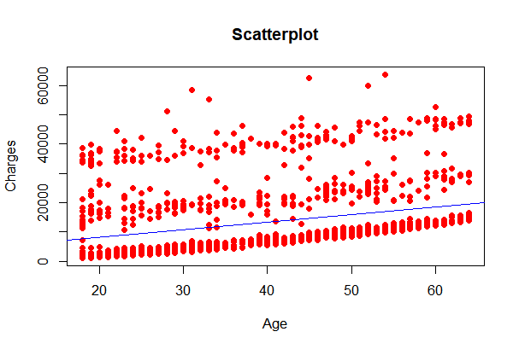

For, Histogram with normal curve

insurance <- read.csv("path/insurance.csv")

y <- insurance$charges

h <- hist(y, 6, main = "Charges Frequency", xlab = "Charges", ylab = "Frequency", col = "Yellow")

x <- seq(0, 60000,1)

mn <- mean(y)

stdDev <- sd(y)

yn <- dnorm(x, mean=mn, sd=stdDev)

box.size <- diff(h$mids[1:2]) * length(y)

yn <- yn * box.size

lines(x, yn, col="blue")

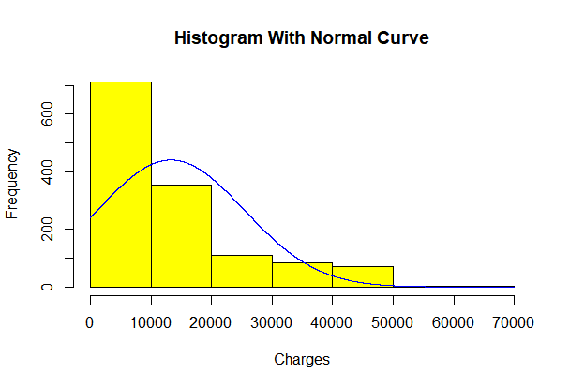

Codes for analysis taken from “Correlation-lecture-slides” slide on Canvas

Kendalls Method :

insurance<- read.csv("C:/Users/badhu/Desktop/github/A073/insurance.csv"

kendall_test <- cor.test(insurance$age, insurance$charges, method = "kendall")  
print(kendall_test)  
  
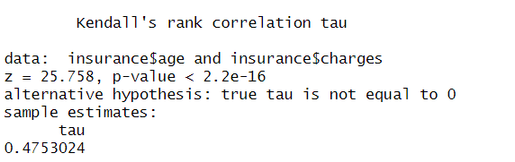  
  
Spear’s Man Method:

spearman_test <- cor.test(insurance$age, insurance$charges, method = "spearman")

print(spearman_test)

