- The files were not getting uploaded in cloudshell with cloudshell upload command , then tried UI way.
- Mvn build has to be triggered inside cloudshell which I was not aware and then ran.
- Maven commands are by default not recognized so need to use chmod +x mvnw
- Java 21 was not supported by cloudshell for building through maven and had to update maven using sudo apt update
sudo apt install maven -y
- Java 21 was not supported and had to install it as well
- 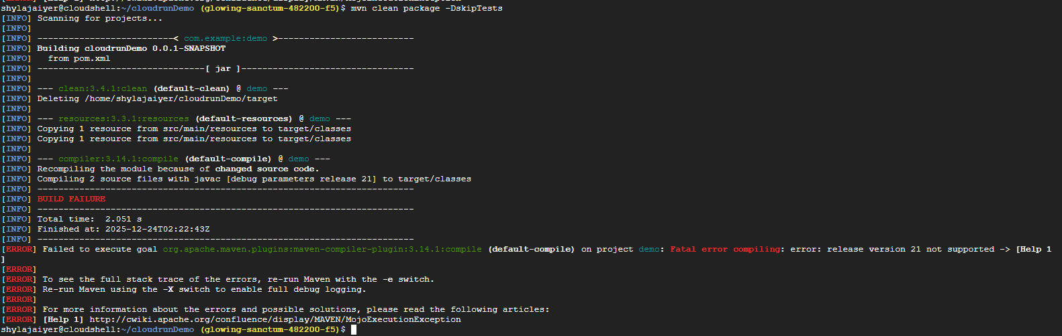
- Setting java_home to 1 as this is defaulting to version 17
- 