Day 2 Practice Sheet — VLOOKUP, INDEX-MATCH, COUNTIF, SUMIF & Pivot Table
Module: Excel for Data Analysis — Lookups & Pivot Tables
Prepared By: Mr. Akarsh/ Dr. Ravneet Kaur
Objective: Practise lookup functions, conditional aggregation, and Pivot Table creation.
SAMPLE DATASET
Sheet 1 has Orders. Sheet 2 (Products) has ProductID, ProductName, Category, StandardPrice.
Order ID | Salesperson | City | Product ID | Quantity | Actual Price | Discount%
ORD-001 | Amit Sharma | Delhi | P001 | 2 | 43000 | 5
ORD-002 | Priya Singh | Mumbai | P002 | 5 | 17500 | 3
ORD-003 | Rahul Verma | Chennai | P003 | 3 | 21000 | 5
ORD-004 | Neha Gupta | Pune | P001 | 1 | 45000 | 0
ORD-005 | Amit Sharma | Delhi | P002 | 4 | 18000 | 0
ORD-006 | Priya Singh | Mumbai | P001 | 2 | 44000 | 2
ORD-007 | Rohit Jain | Jaipur | P003 | 6 | 22000 | 0
ORD-008 | Neha Gupta | Pune | P002 | 3 | 17800 | 2
ORD-009 | Rahul Verma | Chennai | P001 | 1 | 45000 | 0
Order ID Salesperson City ProductID Quantity Actual Price Discount%
ORD-010 Rohit Jain Jaipur P002 2 18000 5
PRACTICE QUESTIONS
Question | Task Description | Your Answer / Code
Q1 [VLOOKUP] | In a new column 'Product Name', use VLOOKUP to look up  ProductID in the Products table and return the Product Name. Wrap in IFERROR.
Q2 [VLOOKUP] | Add another column 'Category' using VLOOKUP to pull the Category from the Products table.
Q3 [INDEXMATCH] | Repeat Q1 using INDEX-MATCH instead of VLOOKUP. Compare: do both give the same result?
Q4 [COUNTIF] | Count how many orders were placed by 'Amit Sharma' using COUNTIF.
Q5 [COUNTIF] | Count how many orders have Quantity greater than 3 using COUNTIF with a condition.
Q6 [SUMIF] | Calculate total Actual Price for orders from 'Delhi' using SUMIF.
Q7 [SUMIF] | Calculate total quantity sold for ProductID 'P001' using SUMIF.
Q8 [COUNTIFS] | Count orders where City = 'Mumbai' AND Quantity > 2 using COUNTIFS.
Q9 [Pivot Table] | Create a Pivot Table showing total Actual Price per City. Place City in Rows, Actual Price as Value (Sum).
Q10 [Pivot Table] | Create a second Pivot Table showing total Quantity sold per ProductID per Salesperson. Add a Slicer on City.
BONUS | Format your Pivot Table with a built-in style. Add a Pivot Chart (bar chart) connected to the first Pivot Table.

- =IFERROR(VLOOKUP(E2,Products!$A$2:$C$100,2,FALSE),"Not Found")
- =VLOOKUP(E2,Products!$A$2:$C$100,3,FALSE)
- =INDEX(Products!$B$2:$B$100,MATCH(E2,Products!$A$2:$A$100,0))
- =COUNTIF(B2:B11,"Amit Sharma")
- =COUNTIF(F2:F11,">3")
- =SUMIF(C2:C11,"Delhi",G2:G11)
- =SUMIF(E2:E11,"P001",F2:F11)
- =COUNTIFS(C2:C11,"Mumbai",F2:F11,">2")
Row Labels | Sum of Actual Price
Chennai | 66000
Delhi | 61000
Jaipur | 22000
Mumbai | 61500
Pune | 62800
Grand Total | 273300
9.
10.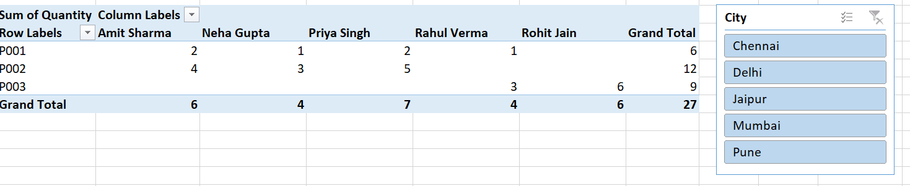BONUS.