# SPGH

(Wireless Sensor Network Project)

**Group Number :**  7

**Group Members :** Nilesh Gupta, Vyom Saxena, Krishan Hariramani

**Project Domain** : SMART HOME

**Project Objective** : To develop a power efficient Smart home system for automate various actuators like Air Conditioner, Motor pump, Light etc., and hence reducing resource wastage, increasing security and cutting down human efforts. All this to be done without decreasing the life of the node.

**Flow Chart** :

Sensing Light, water Level and Movement on Roof

Sending the data to Arduino 2 through HC-05 Bluetooth module

Arduino 2 installed on ground floor implementing all the Actuators using the sensor values. It also senses temperature and movement inside the house to increase security and automate Air conditioner

HC–05’s on Arduino 2 Collect all the data from Arduino 1. It also accepts input from processing

**Application** : It can be used to reduce water wastage by automatically turning of the motor pump in any kind factory.

Increase the security of roof through sensing any movement which hardly observes any and sounding the buzzer wirelessly if detected any. Could also indicate arrival of any guest through front door using IR Sensor and Buzzer, Hence automatic doorbell.

Reduce electricity wastage by automatically shutting off the lights in the morning. It could very well be used with the street lights. Also automation of cooling system by monitoring the temperature of the environment. It could be used in the factories with hast conditions.

**Hardware Used** : 2 Bread Boards

1 IR Sensor 80 Rs

1 Arduino UNO 450 Rs

1 Arduino Mega 830 Rs

3 HC-05 Bluetooth Module 1017 Rs

1 Temperature Sensor 119 Rs

1 PIR Sensor 149 Rs

1 LDR sensor 200 Rs

Few LED’s 20 Rs

Jumper Wires 20 Rs

Water and a container NIL

+9v battery 22 Rs

1 Laptop 45,000 Rs

Android phone 17,000 Rs

Total Project Cost –2907 Rs

P.S. The total system was free of cost for us and built through university issued products.

**SnapShot of circuits** :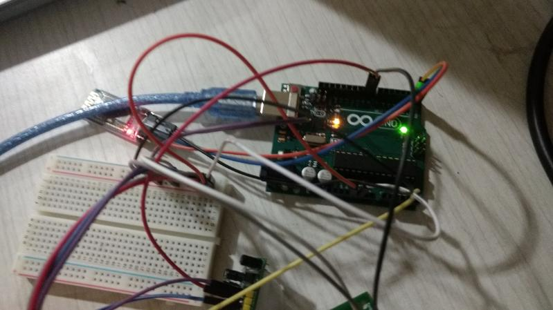

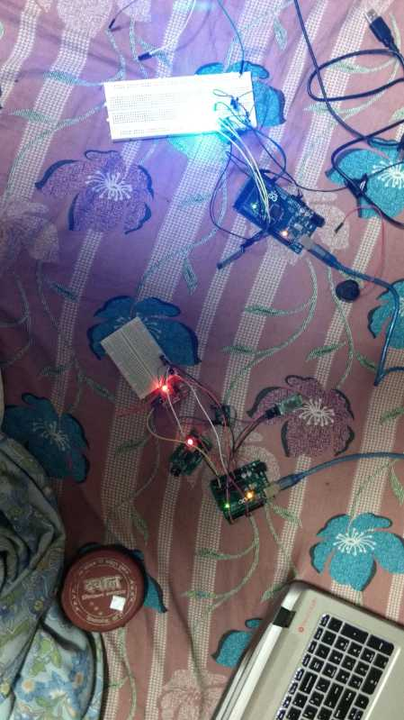

**BreadBoard View**  :

Arduino 2

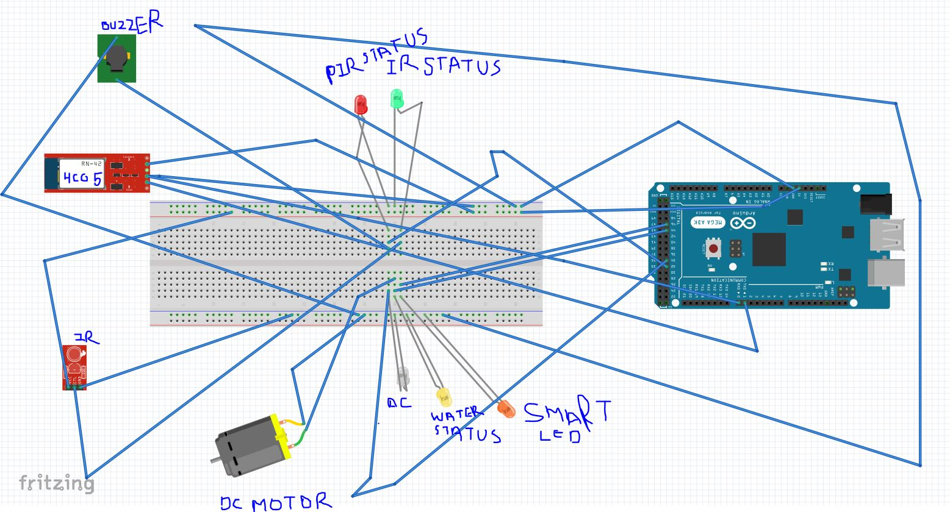

Arduino 1

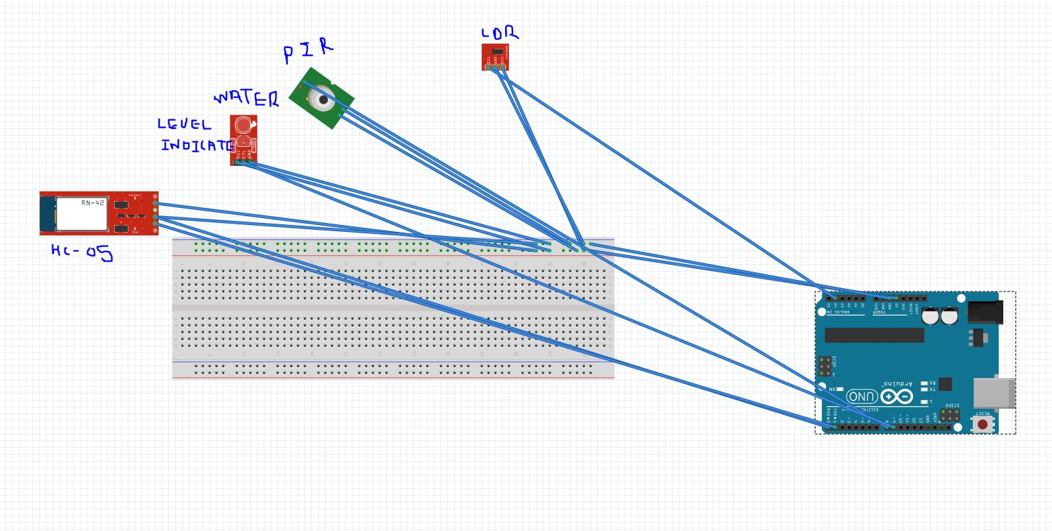

Arduino 1

