Arithmetic Coding For Data Compression
Zishan Kazi | Keshav Bansal

Introduction

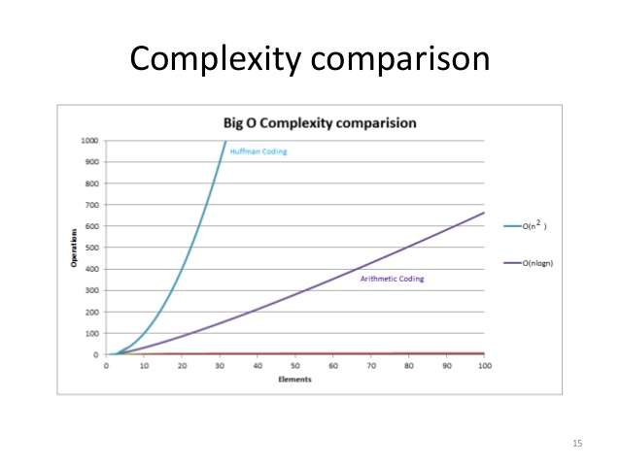
Arithmetic coding is the state of art in data compression, better than the well known huffman compression. In terms of complexity, arithmetic coding is asymptotically better than Huffman’s. It also gives greater compression and is faster for adaptive models.

Aim

Being more efficient and fast many people are unaware of this method. Even online resources on arithmetic coding are hard to get. We aim to help provide easy and accessible code and implementation of arithmetic coding.

Concept
Compression is basically representing more probable symbols into fewer bits than less probable symbol.

Arithmetic coding represents file by interval of real numbers between 0 and 1. When the file size increases, the interval needed to represent it becomes smaller, and the number of bits needed to specify that interval increases.

Arithmetic compression assigns one long code to entire input string whereas in Huffman each symbol needs integral number of bits.

Entropy :
E = – p*log2(p),
where, p = probability of symbol.
log2(p) = minimum number of bits needed to represent.

References
- https://a1bert.kapsi.fi/Dev/pucrunch/packing.html

