Text-to-SQL Dataset Quality Assessment: The First Open-Source Validation Framework
Volodymyr Sabadosh

Abstract
Background: Text-to-SQL systems that translate natural-language questions into SQL have advanced rapidly with large language models (LLMs). However, progress depends critically on the quality of benchmark and training datasets. Even a small fraction of flawed examples can introduce systematic errors into fine-tuned or in-context models.
Aim: Our objective is to develop and demonstrate a comprehensive automated system for evaluating Text-to-SQL dataset quality through multi-level validation addressing current gaps in systematic quality assessment.
Method: We introduce a Text-to-SQL dataset analysis tool, built on a streaming, protocol-oriented, dependency-injected architecture with pluggable analyzers. Our most novel component is the semantic correspondence analyzer, which employs an LLM-as-a-judge committee and derives a consensus label by majority vote. The system produces an annotated dataset and stores all analysis metrics in an analytical DuckDB database, from which metrics and findings can be queried directly or exported as structured JSONL files and Markdown reports.
Results: Applying the framework to all 11,840 examples of the Spider 1.0 benchmark, we obtain 100% parsability and 99.97% executability of SQL queries. Despite this, schema analysis reveals 89 invalid databases and over 41,000 referential integrity violations, 97% of which are concentrated in two databases. Semantic validation with GPT‑5 and Gemini 2.5 Pro indicates that only 60–70% of examples are unambiguously correct, around 10% are consistently judged incorrect, and roughly one third are disputed or only partially correct, with the training split having the lowest quality.
Conclusion: Multi-layer automated validation exposes hidden weaknesses in Text-to-SQL benchmarks that are invisible to standard exact-match or execution-based metrics. We release the first open-source framework for comprehensive Text-to-SQL dataset auditing and provide a prioritized remediation roadmap for Spider. The approach is generic and can be applied to other human-curated and synthetic datasets at scale.
Keywords: Text-to-SQL system, dataset quality, LLM, SQL validation, semantic evaluation, empirical software engineering.

1 Introduction
Text-to-SQL systems, which transform natural language queries into structured SQL queries, are experiencing a period of rapid development driven primarily by remarkable progress in Large Language Models (LLMs), as well as fundamental scientific interest and practical industry needs.
From a scientific perspective, the Text-to-SQL task serves as an important test of LLMs' capacity for structured reasoning and simultaneous understanding of natural language semantics and formal programming languages [1, 2]. Recent achievements in this area demonstrate impressive results: systems using GPT-4 have reached 86.6% execution accuracy [3] on the Spider 1.0 leaderboard [4], and 80.88% [5] on the BIRD leaderboard [6]—approximately 7-8× higher compared to results from 2018 [7], when the best non-LLM approaches (Seq2Seq/SQLNet/TypeSQL) on Spider 1.0 showed only ~10% accuracy.
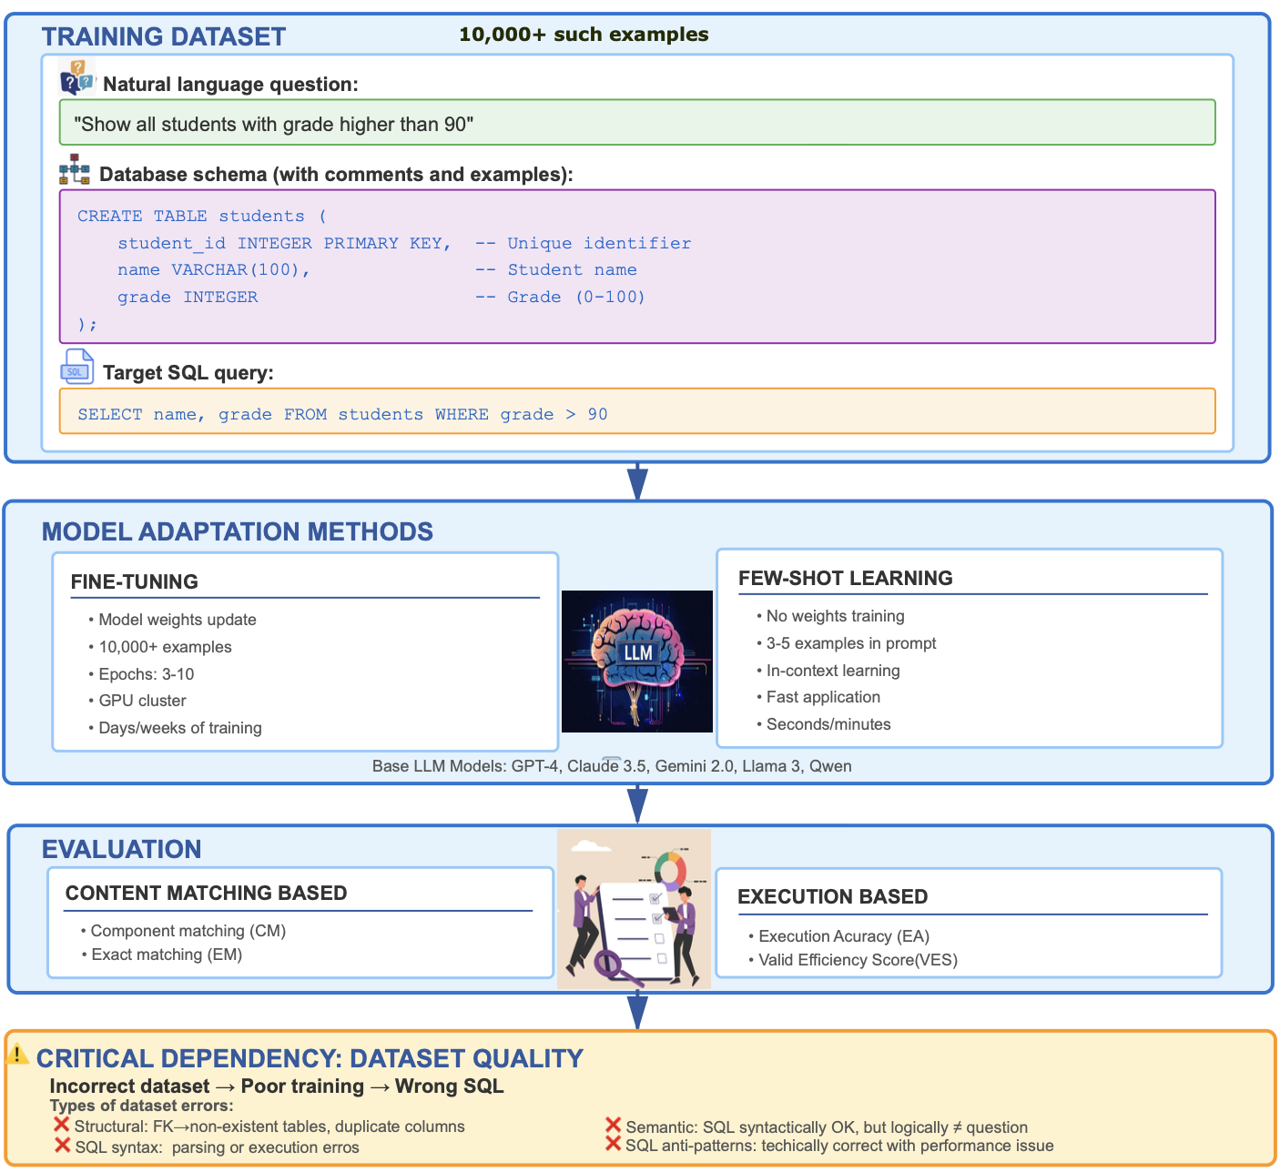
Figure 1. Complete training for LLMs in Text-to-SQL systems.
From a practical standpoint, Text-to-SQL LLM systems are being actively deployed by leading cloud platforms. Snowflake Copilot can generate SQL from natural language in Snowsight [8]; Databricks AI/BI Genie converts plain English questions into equivalent SQL queries [9]; Microsoft Copilot in Fabric/Azure SQL supports Natural Language → SQL in SQL Database workspaces [10]. This lowers the barrier for business analysts and non-technical users, providing data access without knowledge of SQL syntax.
The typical process of training LLMs for Text-to-SQL tasks includes three key components (Fig. 1): a training dataset containing triplets of {natural language question, database schema, Target SQL query}, an adaptation method (fine-tuning or few-shot learning) and evaluation (content matching and execution based). During fine-tuning, models adjust their weights on large Text-to-SQL datasets to better capture the mapping between natural language and SQL. In few-shot settings, by contrast, the model relies on in-context learning, using only a handful of examples in the prompt without updating its parameters. In both cases, dataset quality is critical: in fine-tuning, even a small fraction of flawed examples among tens of thousands can introduce systematic errors, while in few-shot prompting each individual example directly shapes model behavior, so a single incorrect pair may lead to consistently wrong generations. Consider specific types of errors that may be present in datasets:
- Database schema structural errors: incorrect foreign keys (references to non-existent tables/columns), duplicate columns, multiple primary keys, unknown data types.
- SQL syntax/execution errors: queries that cannot be parsed or executed on corresponding databases.
- Semantic mismatches: SQL queries that are syntactically correct but logically do not correspond to the natural language question (e.g., using SUM instead of AVG, incorrect JOIN conditions, missing necessary filters).
- SQL anti-patterns: technically correct queries with performance or style issues (SELECT *, absence of LIMIT, functions in WHERE that block index usage).
Despite the central role of datasets, most work on Text-to-SQL focuses on model architectures, prompting techniques and decoding strategies. Until recently, the quality of popular benchmarks was typically assumed rather than systematically measured. A small but growing body of work has begun to scrutinize benchmark quality more directly, but existing studies either provide high-level descriptive statistics, focus on semantic label auditing for selected subsets, or concentrate on runtime validation of single generated queries rather than auditing entire corpora (see Section 2.3 for a detailed discussion). Consequently, researchers and practitioners still have limited visibility into structural defects, semantic mismatches, or stylistic anti-patterns hidden in widely used Text-to-SQL datasets.
Therefore, our central research questions are:
RQ1: How can we systematically assess the overall quality of Text-to-SQL datasets?
RQ2: How accurate and internally consistent are popular Text-to-SQL benchmarks that serve simultaneously as training and evaluation data?
Research objective
This paper addresses this question by proposing a comprehensive validation framework for Text-to-SQL datasets and using Spider 1.0 as the primary end-to-end testbed for the framework. Our work is positioned within empirical software engineering: we treat benchmark datasets as software artefacts that should be inspected, measured and improved with the same rigour as source code or test suites.
Contribution statement
The main contributions of this paper are:
- A novel multi-layer validation architecture for Text-to-SQL datasets integrating DDL schema validation, syntax analysis, execution testing, antipattern detection, and LLM-based semantic verification.
- An open-source implementation of the validation framework, publicly available to enable reproducible quality assessment of existing and future Text-to-SQL benchmarks.
- The first comprehensive empirical audit of all three Spider 1.0 partitions (11,840 examples total) across five complementary quality dimensions.
- Concrete empirical evidence that widely-used benchmarks contain significant quality issues invisible to standard evaluation metrics, including concentrated referential integrity catastrophes, substantial schema heterogeneity, and systematic semantic ambiguities.

2 Related Work

2.1 Text-to-SQL Benchmarks and Datasets
The development of Text-to-SQL systems has been fundamentally shaped by the evolution of benchmark datasets. Early large-scale efforts, particularly WikiSQL [13], provided a foundational testbed with 80,654 natural-language questions and corresponding SQL queries over 24,241 Wikipedia tables. While WikiSQL enabled initial data-driven experimentation at scale, its design imposed significant constraints: queries were limited to single tables with a restricted SQL grammar excluding JOINs, nested subqueries, and complex aggregations. These limitations hindered the evaluation of compositional reasoning and realistic multi-table relational scenarios.
The release of Spider [7] at EMNLP 2018 marked a pivotal advancement in the field. Spider comprises 10,181 natural-language questions mapped to 5,693 unique SQL queries across 200 databases spanning 138 diverse domains. The dataset was meticulously constructed and validated by 11 Yale University students, ensuring rigorous annotation quality. A consolidated update published in 2020 resolved annotation inconsistencies and schema discrepancies, establishing the canonical Spider 1.0 version that remains the community standard. Spider's prominence derives from several key attributes: systematic human validation ensuring semantic correctness; balanced distribution across domains and difficulty levels; realistic multi-table schemas with extensive foreign-key relationships reflecting real-world database design; comprehensive coverage of SQL constructs including nested queries, set operations, aggregation with grouping, and multi-hop reasoning patterns. As of 2025, Spider has become the most widely adopted benchmark in the field, with over 700 citations across major academic indexing services.
Complementary benchmarks have emerged to address specific evaluation dimensions not fully captured by Spider. The BIRD benchmark [14] targets large-scale, content-rich databases (approximately 33 GB total), introducing practical challenges such as noisy data values, complex entity resolution requirements, and external knowledge dependencies. BIRD provides 12,751 question–SQL pairs across 95 substantial databases covering 37 professional domains, making it particularly valuable for assessing system robustness under realistic production conditions with imperfect data quality and ambiguous terminology.
Synthetic data generation has emerged as a scalable approach to augment training corpora. Gretel's synthetic Text-to-SQL dataset [15] (Gretel-Synth) offers over 100,000 high-quality examples spanning multiple business domains, while OmniSQL [16] employs a multi-stage generation pipeline to produce more than 2.5 million training instances across 16,000+ synthetic databases, incorporating chain-of-thought reasoning annotations.
Despite the proliferation of alternative resources, Spider 1.0 remains the most comprehensive and widely adopted benchmark due to its unique combination of scale, structural diversity, annotation reliability, and faithful representation of relational complexity. However, even carefully curated benchmarks like Spider and BIRD are not immune to annotation errors, ambiguous question formulations, or schema inconsistencies. Recent auditing work, most notably NL2SQL-BUGs [17], has reported non-trivial rates of semantic errors in the gold SQL labels of these datasets, calling into question the common assumption that benchmark annotations are error-free and motivating more systematic dataset-level validation. We return to these auditing efforts in more detail in Section 2.3.

2.2 Data Quality and Robustness in Text-to-SQL
Empirical evidence increasingly demonstrates that the quality of training and evaluation data has a direct and often nonlinear influence on the performance of Large Language Models (LLMs) in Text-to-SQL tasks.
The Dr.Spider study [11] provides one of the most rigorous analyses of this phenomenon. By applying controlled perturbations to questions, database schemas, and SQL queries, the authors showed that LLM performance degrades sharply under reduced data quality. On average, execution accuracy dropped by 14.0%, and under the most severe perturbations the degradation reached 50.7%, revealing that current models exhibit low robustness to inconsistencies or noise in the training and evaluation pipelines. Notably, errors involving schema semantics (e.g., incorrect foreign keys or column references) produced disproportionately large declines, underscoring the sensitivity of Text-to-SQL systems to structural dataset quality.
Complementary findings come from Snowflake’s Arctic-Text2SQL study [12], which evaluated the effects of mixing high-quality benchmark data (Spider, BIRD) with various forms of synthetic data, including Gretel-Synth. The authors observed that introducing lower-quality or weakly aligned synthetic examples into training can reduce final model accuracy, even when the overall dataset size increases—highlighting an inverse scaling trend. Their ablation experiments showed that quality mismatches between datasets lead to unstable gradients, degraded reasoning traces, and incorrect operator selection in generated SQL queries. These results reinforce the observation that the benefits of larger datasets cannot compensate for inconsistencies, noise, or semantic drift in the data.

2.3 Dataset Quality Assessment Frameworks
Although dataset quality is critical for Text-to-SQL system performance, systematic validation methodologies remain limited. A recent contribution addressing this gap is the benchmark analysis framework proposed by Mitsopoulou and Koutrika [18]. Their study characterizes Text-to-SQL datasets along three complementary dimensions: structural and operator diversity of SQL queries, schema size and complexity of associated databases, and lexical-syntactic properties of natural-language questions. This unified descriptive perspective provides valuable insight into dataset composition, differences across benchmarks, and how dataset properties relate to model error profiles. The authors further introduce an “informative evaluation” procedure that decomposes system errors into structural, operator, and variable mismatches, offering a more interpretable alternative to exact-match evaluation.
However, this analysis remains descriptive rather than diagnostic: it does not assess whether dataset entries are correct or semantically faithful. Several important aspects of dataset quality therefore fall outside its scope, including verification of schema integrity, checks of SQL syntactic and execution validity, and evaluation of semantic alignment between natural-language intent and SQL logic. Beyond surface-level schema linkage, the gold annotations are assumed to be correct, and no mechanisms are provided to detect mismatches between questions and queries. Moreover, the methodology is designed for aggregate statistics on existing benchmarks and does not scale to large modern datasets such as OmniSQL’s 2.5M+ synthetic examples.
A complementary line of work is represented by NL2SQL-BUGs [17], which explicitly targets semantic correctness of gold SQL annotations in popular benchmarks. The authors construct an expert-annotated corpus of 2,018 NL–SQL pairs, of which 999 contain semantically incorrect SQL, organized into a detailed two-level taxonomy of semantic error types. This benchmark captures a rich variety of semantic bugs, including wrong aggregation functions, missing or superfluous filters, incorrect joins, and more subtle logical inconsistencies. In addition, the authors apply GPT-4o as an automatic semantic error detector to the development splits of Spider and BIRD, and, after manual verification of the flagged cases, identify previously unknown semantic errors in the gold SQL of both benchmarks. NL2SQL-BUGs thus provides strong evidence that widely used Text-to-SQL datasets contain semantic label noise and offers a valuable diagnostic resource, together with example prompts, for studying semantic error detection in NL2SQL translation. However, beyond the benchmark itself and these prompt templates, NL2SQL-BUGs does not contribute a reusable software framework or end-to-end toolchain for dataset auditing. Its scope is constrained to semantic mismatches between natural-language questions and SQL queries on selected subsets of existing benchmarks.
A different perspective on data quality is offered by Pandey et al. [19], who propose a “data accuracy” validation framework for enterprise Text-to-SQL systems. Their approach focuses on runtime validation of generated SQL and query results through schema validation, syntax checking, logical consistency checks (e.g., aggregate–grouping coherence), data integrity verification, and multi-agent feedback loops implemented with LangGraph and AutoGen. Although this framework uses several components like those needed for dataset quality assurance, it is fundamentally designed for per-query validation in production systems rather than large-scale offline auditing of benchmark or synthetic corpora. It operates on individual generated queries and their results and therefore does not analyze dataset-level error patterns, measure overall “dataset health”, or provide tooling for systematic dataset curation. Moreover, the framework is presented primarily at an architectural and conceptual level: there is no publicly available implementation, no quantitative evaluation on standard benchmarks (e.g., Spider, BIRD, OmniSQL), and no support for batch-mode processing of tens of thousands of NL–SQL pairs. Semantic checks are restricted to intra-SQL consistency (e.g., aggregates vs. GROUP BY) and do not address the correctness of the natural-language–to-SQL mapping across an entire dataset.
Additional efforts in the literature acknowledge the importance of validation but remain fragmented and narrowly scoped. Synthetic data pipelines (e.g., Gretel, OmniSQL) typically apply internal LLM-based or heuristic filters, while many works rely almost exclusively on execution-based filtering—discarding examples whose SQL fails to run on the corresponding database. Although such filtering can improve training stability, it is ultimately naïve and insufficient: successful execution does not verify the correctness of SQL logic, the semantic alignment between the question and the query, the integrity of the underlying schema, or the presence of stylistic and efficiency-related anti-patterns. Consequently, these procedures cannot serve as general-purpose dataset auditing methods and address only a small subset of the quality issues that arise in modern Text-to-SQL datasets
Taken together, existing approaches provide important analytical foundations and illustrate the need for quality control, but they do not offer a comprehensive, automated, and scalable solution for validating Text-to-SQL datasets themselves. Our work builds on these insights by introducing a multi-level validation framework—covering structural, syntactic, semantic, and stylistic dimensions—implemented in an extensible open-source system designed to evaluate both human-curated benchmarks and large-scale synthetic datasets at scale.

3. Methods

3.1. Architectural overview of the text2sql-dataset-analyzer framework
In this section we present text2sql-dataset-analyzer, a novel framework and, to the best of our knowledge, the first dedicated tool for systematic, multi-layer quality assessment of Text-to-SQL benchmarks. The framework is released as open-source software, which allows other researchers and practitioners to inspect, extend, and apply it to their own Text-to-SQL corpora.
Design principles. The system represents a streaming data-processing architecture designed to address the challenges of large-scale Text-to-SQL dataset validation and quality assessment. The architecture implements three foundational design principles: modularity through protocol-based component interfaces, scalability via constant-memory streaming processing, and extensibility through automatic dependency injection. This design enables the system to process datasets of arbitrary size while maintaining deterministic memory footprint characteristics, a critical requirement when analyzing multi-gigabyte benchmark datasets such as Spider, BIRD, or OmniSQL 2.5 M.
Technology Stack. The implementation relies on a carefully selected technology stack centered on Python 3.11 [20], chosen for its mature ecosystem of SQL tooling and support for large language model integration. DuckDB[21] serves as the primary analytics backend, offering columnar storage optimized for analytical queries while exposing a standard SQL interface. For interaction with relational databases, we use SQLAlchemy 2.0[22]–based adapters, which provide a uniform abstraction layer over concrete engines; in the current implementation, SQLite and PostgreSQL are supported as execution backends, but additional engines can be integrated with minimal effort. SQL parsing and structural analysis are handled by sqlglot[23], a dialect-aware parser capable of dealing with syntactic variations across SQLite, PostgreSQL, MySQL, and other SQL dialects commonly encountered in Text-to-SQL datasets. Component orchestration relies on the dependency_injector library [24], which facilitates type-safe dependency resolution and enables runtime composition of analysis pipelines through declarative YAML configuration loaded via PyYAML[25].
User Interface. User interaction with the system occurs primarily through a command-line interface exposed via the `text2sql` entry point. The interface supports two distinct operational modes corresponding to the system's primary use cases. The first mode, invoked through `text2sql run --config <config.yaml>`, executes the complete analysis pipeline from raw dataset ingestion through all configured analyzers to final metric persistence and report generation. The second mode, accessible via `text2sql report`, enables standalone report generation from previously computed metrics, supporting both configuration-driven batch report generation (`--config`) and targeted single-report generation (`--database <path> --type <report-type>`). This separation of concerns between analysis and reporting allows researchers to iterate on report designs and formats without re-executing computationally expensive analysis stages, particularly relevant when semantic validation via large language models can require hours of processing time.

3.2. Five-Layer System Architecture
The system architecture follows a layered design pattern comprising five distinct layers, each responsible for a specific aspect of the data processing pipeline (Figure 2). This layered organization promotes separation of concerns, facilitates independent testing and development of components, and enables selective activation or deactivation of functionality based on analysis requirements.
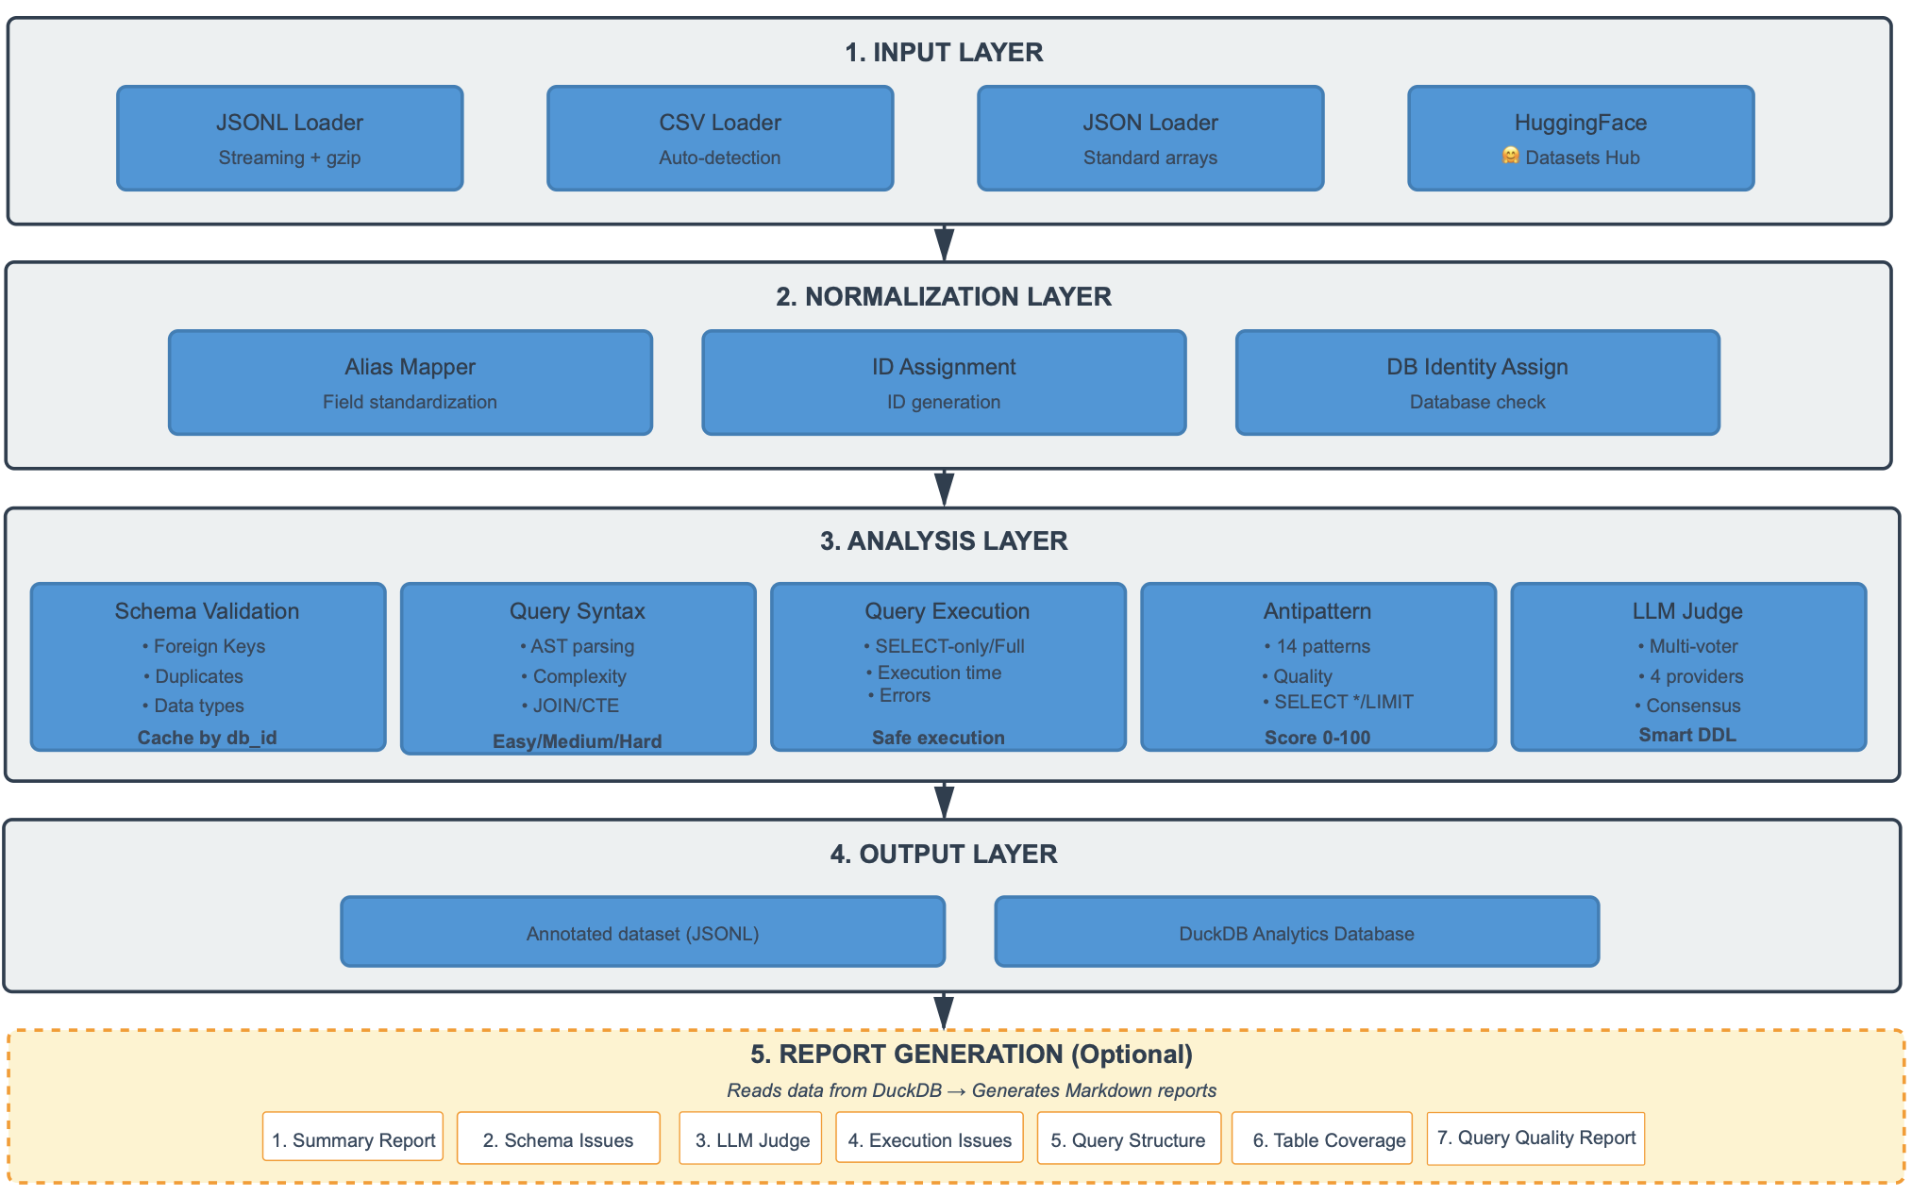Figure 2. Five-layer architecture of the text2sql-pipeline system
Input Layer. The Input Layer abstracts heterogeneous data sources behind a common iterator interface. It implements four specialized loaders tailored to data formats prevalent in Text-to-SQL research. The JSONL Loader provides streaming access to line-delimited JSON files, including gzip-compressed variants. The CSV Loader supports delimiter detection and encoding inference to handle noisy, real-world CSV files. Standard JSON arrays are handled by the JSON Loader, and the HuggingFace Loader connects directly to the HuggingFace Datasets Hub, avoiding manual download and reformatting. All loaders implement Python’s iterator protocol and yield records on demand, keeping memory usage essentially constant with respect to dataset size.
Normalization Layer. The Normalization Layer standardizes records originating from diverse datasets through three sequential normalizers. The Alias Mapper reconciles different field names (e.g., query vs. sql, db_id vs. dbId) into a canonical schema. The ID Assignment component guarantees a unique identifier for each record using either counters or content-based hashes, supporting consistent cross-referencing between the annotated dataset and the metrics database. The DB Identity Normalizer ensures that each record is linked to a valid database: it validates provided database identifiers or, when necessary, builds databases from embedded DDL schemas and derives stable IDs from schema hashes. The result is a normalized DataItem with mandatory fields (id, question, sql, dbId), an optional schema, and a metadata dictionary.
Analysis Layer. The Analysis Layer is the computational core, hosting five analyzers that cover complementary quality dimensions of Text-to-SQL data:
- Schema Validation Analyzer checks database integrity, including several classes of foreign-key violations, case-insensitive column name duplicates, and type compatibility with the target SQL dialect. A DB-ID-based cache reuses schema introspection results across queries sharing the same database.
- Query Syntax Analyzer performs static analysis using the sqlglot parser. It builds abstract syntax trees, derives normalized complexity scores on a 0–100 scale based on SQL constructs and nesting depth, extracts structural features (e.g., JOIN counts, subquery depth, CTEs, aggregations, window functions), and assigns difficulty labels (Easy, Medium, Hard, Expert).
- Query Execution Analyzer evaluates dynamic executability within the corresponding database. Queries are run in a sandboxed, SELECT-only mode; execution time and row counts are recorded, and failures are categorized to distinguish syntax problems, semantic errors, and connectivity issues.
- Query Antipattern Detector uses a rule-based approach to flag 14 common SQL antipatterns, such as missing LIMIT clauses, SELECT *, functions in WHERE predicates blocking index usage, correlated subqueries with quadratic complexity, and implicit joins. Each antipattern contributes a weighted penalty to a 0–100 quality score.
- Semantic LLM Judge Analyzer uses large language models to assess how well SQL queries answer their natural-language questions.
Output Layer. The Output Layer persists analysis results via two complementary streams. The Annotated Dataset augments each original record with all analyzer metadata and stores it in JSONL format, preserving a detailed provenance for downstream filtering or model training. In parallel, the DuckDB Analytics Database stores structured metrics in a columnar OLAP database. Users can query it with SQL, export results to Pandas or Polars, or write Parquet files for long-term storage and integration with external analytics workflows. This dual strategy preserves both record-level detail and dataset-level statistics without re-running the pipeline.
Report Generation Layer (optional). The Report Generation Layer converts metrics stored in DuckDB into human-readable Markdown reports. Controlled via a reports.enabled flag, it can be disabled during rapid experimentation on large datasets. When active, it produces seven report types: overall summary statistics; schema validation issues; semantic validation problems (queries judged incorrect or unanswerable); execution failures; structural complexity and difficulty distributions; table coverage analysis; and SQL quality assessments based on antipatterns. Because DuckDB is the single source of truth for metrics, reports can be regenerated or customized at any time via ad-hoc SQL queries, and report generation can be omitted entirely when performance constraints are critical.

3.3. Data Flow and Processing Model
Fig. 3 shows the lifecycle of a single dataset record as it moves through the streaming pipeline. The system follows the iterator pattern: each record is processed end-to-end before the next one is loaded, without ever holding the full dataset in memory. Processing starts when a loader reads a raw record and yields it as a Python dictionary. The record then passes through the three normalizers described earlier. Each normalizer applies its transformation or validation and forwards the result, producing a standardized DataItem with all required fields present and a verified database identity. The normalized DataItem then enters the analysis pipeline, implemented as a chain of generator-based analyzers. Each analyzer consumes a DataItem, runs its logic (schema validation, syntax analysis, execution testing, antipattern detection, or semantic judging), writes metrics to DuckDB, enriches the DataItem’s metadata, and yields it to the next analyzer. All configured analyses for one record complete before the next record is read, preserving strict streaming semantics. After the final analyzer, the fully annotated DataItem reaches the output layer. One branch serializes it to a JSONL file that contains the original fields plus all metadata, enabling downstream use without access to the metrics database. The other branch accumulates structured metrics in DuckDB with batched writes, supporting efficient aggregate analysis.
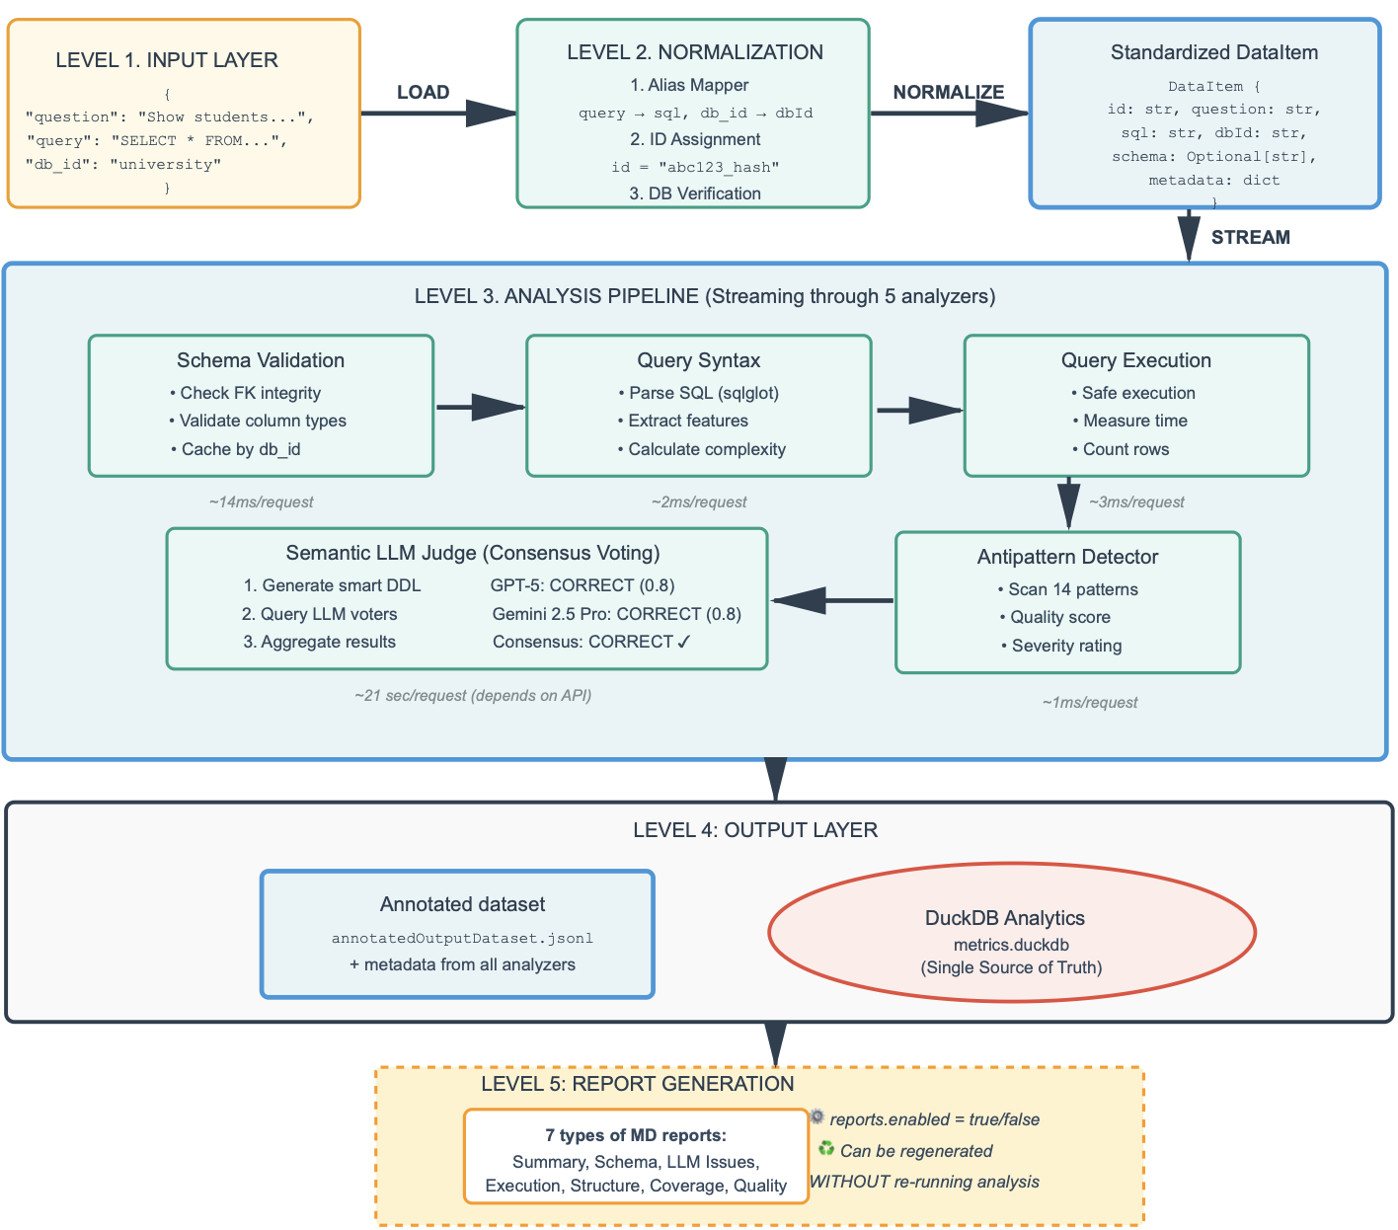Figure 3. Data flow through the pipeline from input to output
The last report layer, which can be disabled via configuration (reports.enabled = false), reads metrics from DuckDB and produces seven types of human-readable analytical reports in Markdown format.

3.4. Database Identity Normalization Algorithm
The Database Identity Normalizer addresses a fundamental challenge in Text-to-SQL dataset processing: ensuring that every record can be associated with a valid, accessible database instance against which SQL queries can be validated and executed. This challenge arises from the diversity of dataset formats and conventions employed across the Text-to-SQL research community, where some datasets provide explicit database identifiers referencing pre-existing database files (Spider and Bird datasets), others include DDL schemas allowing dynamic database construction, and some provide both, occasionally with inconsistencies between the identifier and schema.
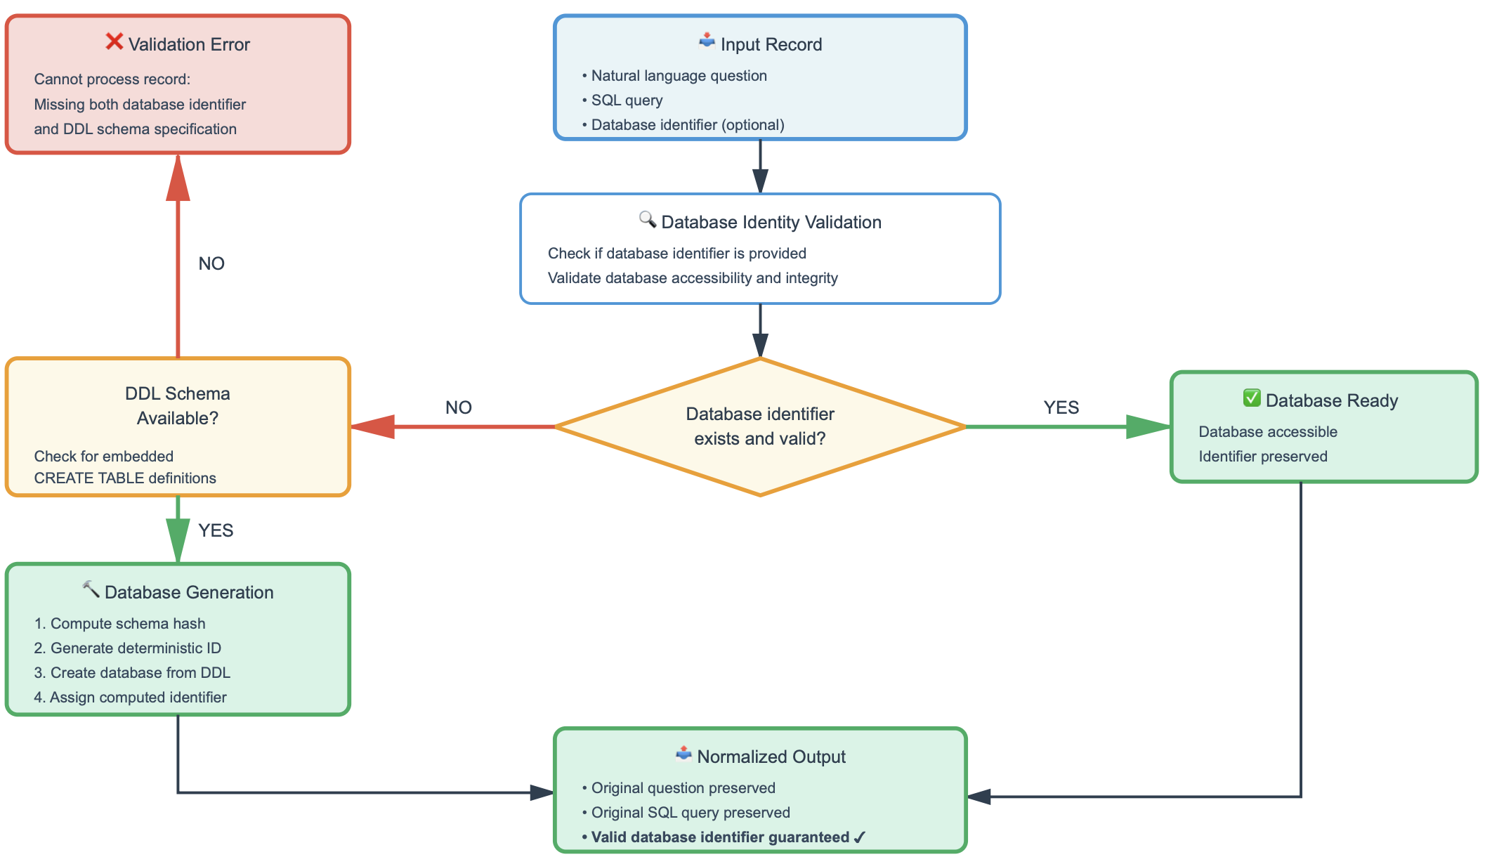
Figure 4. DbIdentity normalization process: guaranteed dbId filling via health check or creation from DDL
The algorithm implements a decision tree with three primary branches corresponding to different combinations of database identifier presence and schema availability (Fig. 4).
In the first scenario, when a record provides an explicit database identifier, the normalizer invokes a health check through the database manager, querying whether the referenced database exists and can be successfully opened. If the health check succeeds, the record passes through unchanged with the assumption that the provided database identifier is valid and all subsequent analyzers can safely reference it. If the health check fails but a DDL schema is present in the record, the normalizer attempts to recreate the database from the schema using the original identifier, effectively repairing a corrupted or missing database file. If the health check fails and no schema is available, the normalizer logs a warning but allows the record to proceed, acknowledging that while suboptimal, this situation may represent datasets where database files are expected to be provided separately from the dataset records.
The second scenario handles records lacking explicit database identifiers but including DDL schema specifications, a pattern commonly encountered in synthetic datasets or benchmark subsets designed for testing schema understanding capabilities. For these records, the normalizer computes a cryptographic hash (SHA-256) of the DDL schema text, generating a deterministic identifier that remains consistent across multiple pipeline executions processing the same schema. The normalizer then checks whether a database with this computed identifier already exists; if so, it reuses that database instance, leveraging caching to avoid redundant database creation operations when multiple records share identical schemas. If no such database exists, the normalizer creates a new database from the DDL schema, assigns it the computed hash identifier, and populates the record's dbId field with this identifier. This deterministic identifier generation strategy ensures reproducibility while supporting the analysis of DDL-only datasets that lack pre-existing database files.
The third scenario represents failure cases where records provide neither a database identifier nor a DDL schema. In this situation, the normalizer raises a Validation Error with a descriptive error message, immediately halting processing of that record. This fail-fast behavior reflects a deliberate design decision: rather than attempting graceful degradation by skipping validation steps that require database access, the system treats the absence of database identification as a fatal data quality issue that must be addressed at the source. This strict validation ensures that downstream analyzers can rely on the guaranteed presence of a valid database identifier, simplifying their implementation and preventing silent failures where analyses would be skipped due to missing database access.

3.5. Schema Validation Analyzer
The Schema Validation Analyzer constitutes a critical component of the quality assessment pipeline, scrutinizing database schema integrity to detect structural errors and data quality issues that could compromise query execution correctness or semantic validity. Unlike syntax analysis which examines SQL query correctness or execution testing which validates runtime behavior, schema validation focuses on the foundational layer—the database structure itself—identifying problems in table definitions, constraint specifications, and referential integrity that affect all queries operating against those databases. The analyzer implements a dual-level validation architecture distinguishing between structural errors in schema declarations (design flaws preventing proper constraint enforcement) and data violations in existing rows (integrity breaches where data contradicts declared constraints), enabling both proactive schema repair and targeted data cleaning strategies.
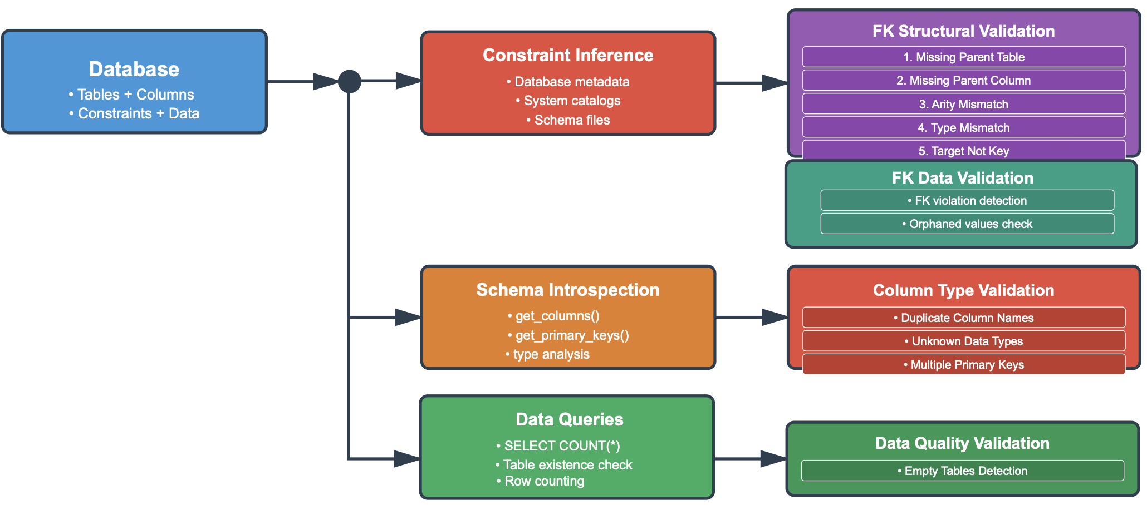
Figure 5. Schema validation analyzer architecture.
Figure 5 illustrates the three-branch schema validation architecture. The analyzer processes databases through parallel validation pathways, each targeting distinct quality dimensions. The first branch extracts foreign key definitions from database metadata through dialect-specific system catalogs, with fallback to dataset-provided schema files when explicit constraint metadata proves unavailable. The second branch performs schema introspection via column enumeration and primary key discovery to detect structural anomalies. The third branch executes data queries to assess content quality. This multi-pathway design enables comprehensive validation spanning constraint integrity, column definitions, and data completeness.
Foreign key structural validation examines constraint definitions through five checks: Missing Parent Table (verifying referenced tables exist), Missing Parent Column (confirming parent columns presence), Arity Mismatch (enforcing equal column counts in composite keys), Type Mismatch (detecting incompatible types after normalization to dialect affinity families), and Target Not Key (verifying parent columns possess uniqueness constraints). Foreign key data validation detects orphaned values—rows where foreign key column values lack corresponding parent table entries—through dialect-specific integrity check commands. Column and type validation operates independently, detecting duplicate column names within tables (case-insensitive comparison), unknown or unsupported data types, and tables with multiple primary key definitions. Data quality validation executes row count queries to identify empty tables—schema structures lacking actual data—which can confound training algorithms or produce misleading evaluation results when queries execute successfully against vacant schemas.

3.6. Query Syntax Analyzer
The Query Syntax Analyzer performs static structural analysis of SQL statements, extracting syntactic features and computing complexity metrics without database execution. The analyzer processes queries through four stages: abstract syntax tree construction, structural feature extraction, complexity score calculation, and difficulty classification (Figure 6).
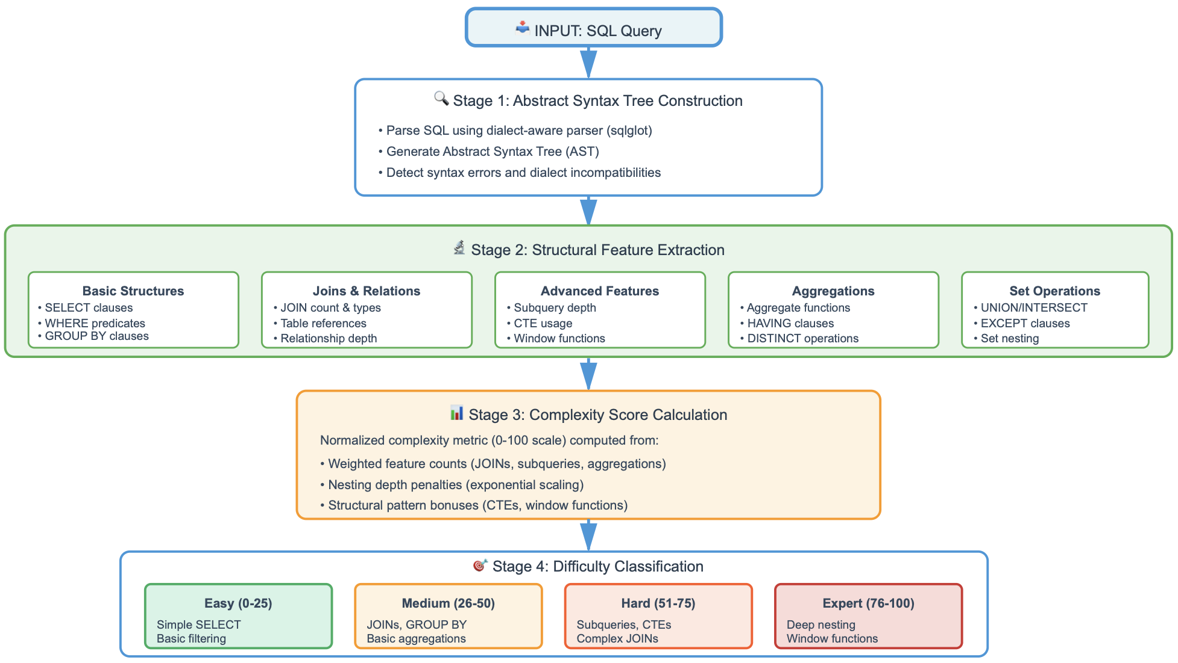
Figure 6. Query Syntax Analyzer architecture with four-stage processing pipeline
The Abstract Syntax Tree Construction stage employs sqlglot parser to transform SQL text into a hierarchical tree where nodes represent syntactic constructs—SELECT expressions, JOIN operations, WHERE predicates, subqueries, and CTEs. Parsing failures are captured with detailed error messages facilitating identification of malformed queries.
In the Structural Feature Extraction stage, the analyzer traverses the AST to compute a feature vector capturing syntactic properties relevant to query complexity. Five feature groups are extracted. Basic structure features count projections, quantify WHERE predicate complexity, and detect GROUP BY and ORDER BY clauses. Join and relation features count JOIN types (INNER, LEFT, …), enumerate distinct tables, and compute maximum join depth, capturing relational complexity. Advanced features measure subquery nesting depth, CTE usage, window functions (OVER clauses), and recursive CTEs. Aggregation features track aggregate functions (COUNT, SUM, …), HAVING clauses, and DISTINCT operations. Set operation features detect UNION, INTERSECT, and EXCEPT operators and their nesting patterns.
The Complexity Score Calculation stage synthesizes features into a 0-100 metric correlating with query difficulty. The algorithm implements weighted aggregation: single-table SELECT queries contribute 0-10 points, JOINs add 3-5 points, aggregates 2-4 points, and advanced features 5-10 points. Nesting depth penalties apply exponential scaling reflecting disproportionate cognitive costs, while well-structured CTEs and window functions receive bonuses. Raw scores undergo min-max normalization spanning 0-100.
The Difficulty Classification stage maps scores to four categorical labels with empirically calibrated thresholds. Easy queries (0-25) encompass single-table SELECT with simple predicates. Medium queries (26-50) introduce multi-table JOINs, GROUP BY, and straightforward subqueries requiring intermediate proficiency. Hard queries (51-75) exhibit multiple JOINs, nested subqueries, CTEs, and correlated subqueries challenging experienced practitioners. Expert queries (76-100) feature deep nesting, window functions, recursive CTEs, and intricate set operations representing frontier challenges. This enables benchmark coverage assessment, stratified evaluation, and imbalance identification.

3.7 Query Antipattern Detector
The Query Antipattern Detector implements rule-based static analysis identifying SQL code smells compromising maintainability, performance, correctness, or data safety. While the Syntax Analyzer characterizes complexity, the antipattern detector evaluates quality by detecting problematic patterns practitioners recognize as suboptimal or dangerous. The detector processes queries through four stages: AST traversal with pattern matching, severity classification, weighted scoring, and quality assignment (Figure 7).
The Rule-Based Detection Engine implements 14 independent rules traversing the AST to identify antipattern signatures. Each rule encapsulates domain knowledge about SQL best practices, performance optimization, and correctness pitfalls. Rules operate in parallel, enabling compositional analysis detecting multiple antipatterns simultaneously.
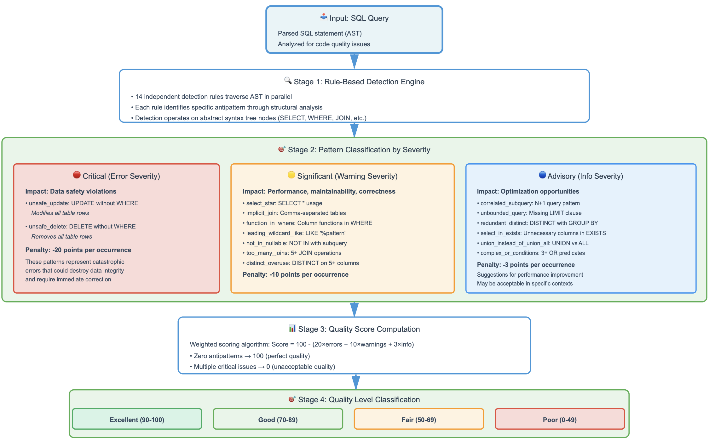
Figure 7. Query Antipattern Detector with four-stage quality assessment pipeline
The engine leverages sqlglot's AST node types: SELECT * detection searches for Star nodes; implicit join identifies FROM with multiple Tables but no Joins; function-in-WHERE locates Func nodes with Column references; leading wildcard LIKE examines patterns for wildcard prefixes; NOT IN combines Not wrapping In with Subqueries; correlated subquery performs scope analysis; unbounded query checks for missing Limits; unsafe UPDATE/DELETE identifies modifications lacking Where clauses; and additional rules target redundant DISTINCT with GROUP BY, unnecessary columns in EXISTS, UNION versus UNION ALL, complex OR chains, and DISTINCT overuse.
The Pattern Classification by Severity stage organizes antipatterns into three categories. Critical antipatterns (error severity) represent catastrophic patterns: unsafe UPDATE and DELETE lacking WHERE clauses unconditionally modifying or removing all rows. Significant antipatterns (warning severity) substantially compromise maintainability, performance, or correctness: SELECT * breaking interface contracts; implicit joins risking Cartesian products; functions in WHERE preventing index utilization; LIKE with leading wildcards; NOT IN with nullable subqueries; five or more JOINs; and DISTINCT on five or more columns. Advisory antipatterns (info severity) suggest optimization opportunities: correlated subqueries with N+1 patterns; unbounded SELECT queries; redundant DISTINCT with GROUP BY; unnecessary columns in EXISTS; UNION where UNION ALL suffices; and complex OR predicates.
The Quality Score Computation stage synthesizes antipatterns into a 0-100 metric through weighted penalties. Scoring begins at 100 points. Critical antipatterns subtract 20 points; significant antipatterns 10 points; advisory antipatterns 3 points. The formula: Quality Score = max(0, 100 - 20×critical - 10×warning - 3×info). This produces intuitive distributions: zero antipatterns achieve 100; advisory issues score 90s; several significant antipatterns score 50-70; critical antipatterns score below 50 necessitating revision or exclusion.
The Quality Level Classification stage maps scores to categorical labels with empirically calibrated thresholds. Excellent (90-100) designates professional-grade SQL with zero significant antipatterns. Good (70-89) encompasses one or two significant antipatterns representing acceptable quality. Fair (50-69) identifies multiple significant antipatterns requiring remediation. Poor (0-49) designates critical antipatterns or numerous issues requiring extensive revision or exclusion. This enables dataset-level profiling, quality-based filtering, correlation analyses with semantic correctness, and targeted improvement campaigns.

3.8. Multi-Model Semantic Validation Architecture
The Semantic LLM Judge Analyzer constitutes the most sophisticated component of our validation pipeline, employing large language models to assess whether SQL queries correctly answer their associated natural language questions. This semantic validation capability addresses a critical limitation in traditional formal validation approaches: while syntax checking and execution testing verify technical correctness, only semantic analysis can determine whether a syntactically valid, successfully executing query implements the intended meaning of the natural language question. Our analyzer implements this capability through a four-stage pipeline combining intelligent context generation, prompt engineering, multi-model consensus voting, and result aggregation (Figure 8).
Smart DDL Generation. The first stage addresses the token efficiency challenge inherent in providing database schema context to language models. The system supports two DDL generation modes: query_derived mode, which extracts only tables explicitly referenced in the SQL query to minimize token consumption, and full mode, which transmits complete database schemas for maximal context. The query_derived algorithm employs a multi-step optimization process. First, the system parses the SQL query using sqlglot to construct an abstract syntax tree, extracting the set of tables explicitly referenced in FROM clauses, JOIN specifications, and subqueries. Second, the database adapter queries system catalogs to retrieve metadata only for these referenced tables, including column names, data types, primary keys, and foreign key relationships. Third, the system executes SELECT queries to sample a configurable number of example values from each column (defaulting to 2 examples per column), providing concrete data instances that help language models understand the semantic content of columns beyond what data type information conveys. Finally, the collected metadata is formatted into CREATE TABLE statements with inline comments containing the example values. The query_derived mode typically reduces token consumption by factors of 5-10 compared to full mode, while the full mode provides complete database context for queries requiring comprehensive schema understanding or when table dependencies are complex.

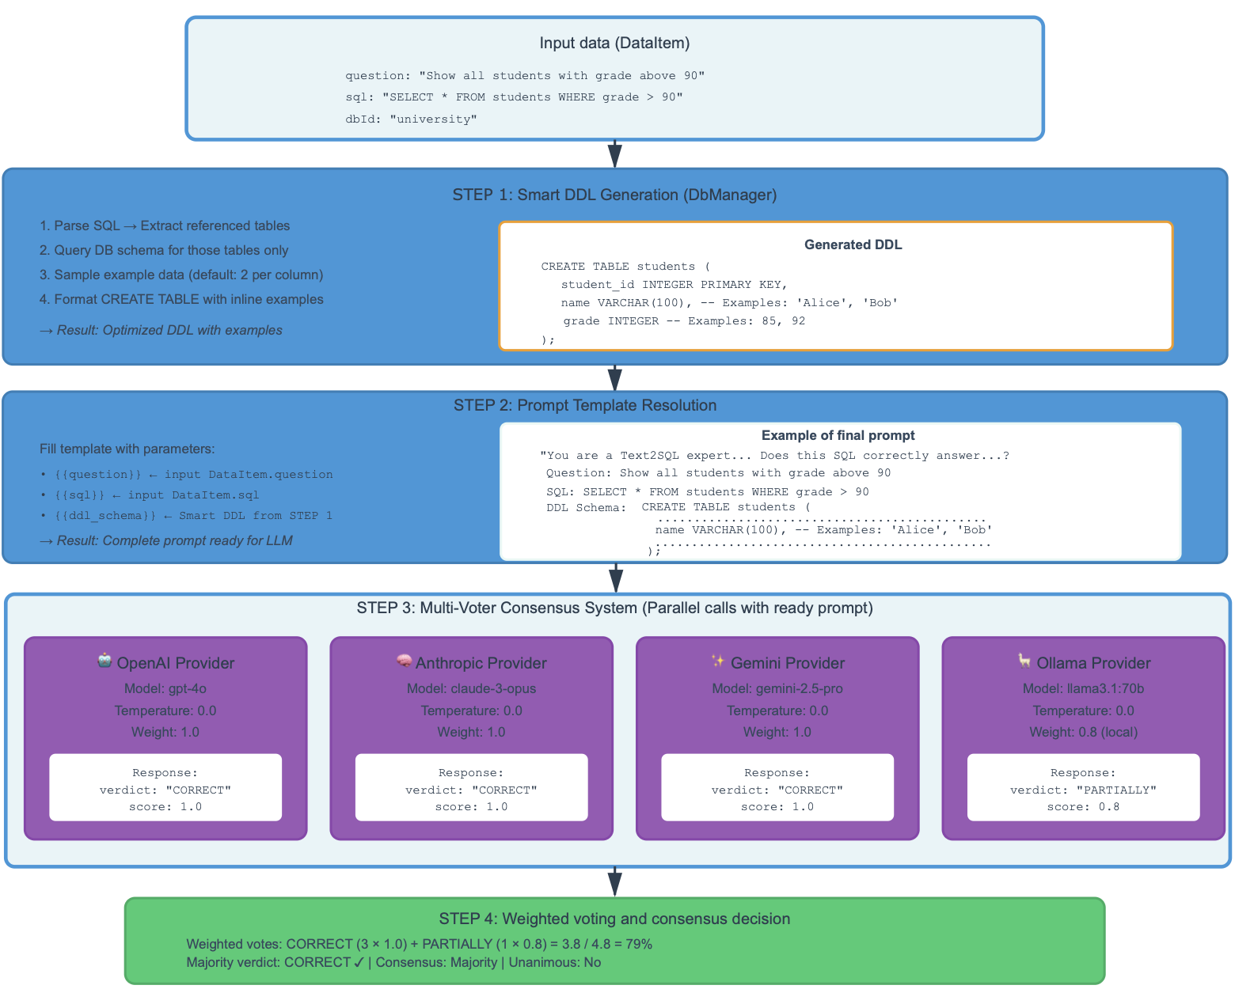
Figure 8. Architecture of the Semantic LLM Judge with multi-model consensus voting
Finally, the collected metadata is formatted into CREATE TABLE statements with inline comments containing the example values, producing a minimal DDL specification that includes only information relevant to the query under analysis.
Prompt Template Resolution. The second stage combines the generated smart DDL with contextual elements to produce complete evaluation prompts. Templates are loaded from YAML configuration files to facilitate experimentation with different prompt formulations. Each template contains dynamic placeholders:
- {{question}}: The natural language question from the dataset, providing ground truth for query semantics
- {{sql}}: The SQL query under evaluation, formatted with syntax highlighting and normalized whitespace
- {{ddl_schema}}: The smart DDL from Stage 1, supplying necessary schema context
- {{dialect}}: Optional SQL dialect specification (sqlite, postgresql, etc.) for correct interpretation of dialect-specific syntax
The assembled prompt specifies a strictly structured response format in which the model must return a single JSON object with exactly two keys, "verdict" and "explanation" (Fig. 9). The "verdict" field is constrained to one of four categorical labels: CORRECT (the query fully and accurately answers the question with no semantic issues), PARTIALLY_CORRECT (the query is mostly correct but exhibits minor deficiencies such as missing DISTINCT clauses when duplicates are possible, imprecise date/time boundaries, NULL-handling edge cases, or non-deterministic GROUP BY selections that do not fundamentally invalidate the result), INCORRECT (the query contains fundamental semantic errors including wrong table or column selections, missing or incorrect JOIN conditions, flawed aggregation logic, or erroneous WHERE clause predicates that produce fundamentally incorrect results), and UNANSWERABLE (the question cannot be answered from the provided schema due to missing tables or columns, requirements for external data not present in the database, or inherent ambiguity or contradictions in the question itself).
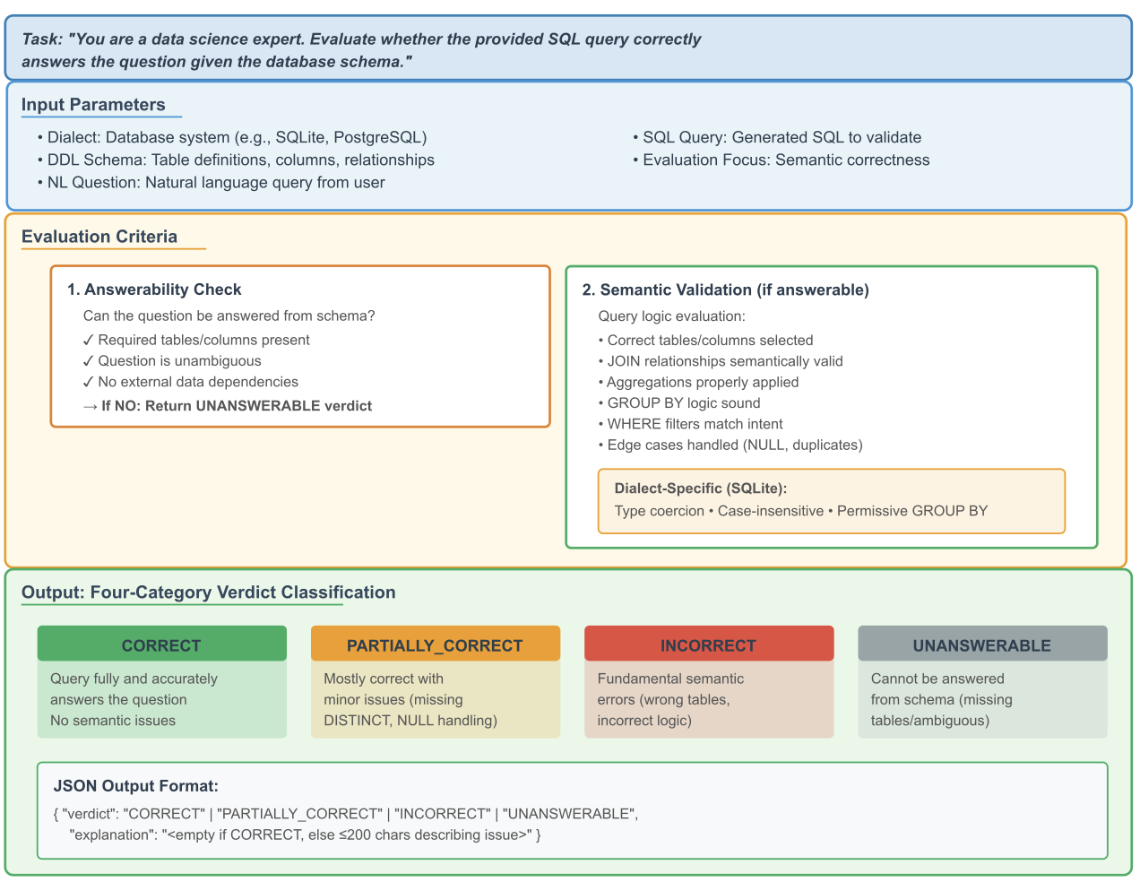
Figure 9. LLM prompt structure with input parameters, evaluation criteria, and structured response format with four-category verdict classification.
The "explanation" field encodes a short natural-language justification; for CORRECT verdicts, the explanation is required to be an empty string, thereby preventing spurious narrative output, while for all other verdicts, the explanation must be a concise single-line description (bounded to at most 200 characters) that identifies the dominant semantic issue. This response specification transforms otherwise free-form LLM outputs into machine-parseable judgments that can be aggregated systematically across large datasets.
Multi-Model Consensus Voting. This stage queries multiple language models in parallel, collecting independent judgments. Our architecture supports four provider categories, each offering distinct characteristics:
OpenAI models (GPT-5, GPT-4o, etc.) provide strong reasoning capabilities and reliable structured output generation, though with relatively high per-token costs.
Anthropic models (Claude-4.5-sonnet, Claude-3-sonnet, etc.) offer alternative reasoning approaches that often exhibit different error patterns from GPT models, valuable for identifying edge cases where consensus breaks down.
Google models (Gemini-2.5-pro, Gemini-1.5-pro, etc.) deliver competitive performance with distinct training data and architectural choices that surface different perspectives on ambiguous cases.
Ollama models (Llama-3.1-70b, Mistral, Mixtral, etc.) enable fully local execution without API costs or rate limits, though typically with reduced accuracy compared to frontier commercial models.
Consensus decision. The fourth stage aggregates the individual model responses through weighted voting to determine consensus verdicts and identify cases requiring human review. Each model is associated with a non-negative scalar weight specified in the configuration file, allowing researchers to encode prior beliefs about the relative reliability or cost-effectiveness of different providers (for example, assigning higher weights to empirically validated frontier models while giving lower weights to cheaper or fully local models). The aggregation procedure operates along two complementary axes. First, it computes an unweighted majority verdict by counting, for each of the four categories, how many models produced that verdict; a majority consensus is deemed to exist when a single category accounts for more than half of all non-failed model responses, and a verdict is unanimous when all such responses coincide. Second, it derives a scalar semantic quality score in the closed interval [0,1] by mapping CORRECT to 1.0, PARTIALLY_CORRECT to 0.5, and both INCORRECT and UNANSWERABLE to 0.0, and then computing a provider-weighted average according to formula
$$score = \frac{∑ w_{i} * v_{i}}{∑ w_{i}}$$
where $v_{i}$ denotes the mapped verdict value and $w_{i}$ the corresponding model weight. This score captures the aggregate tendency of weighted models to regard a query as semantically adequate, while the majority and unanimity indicators characterize the degree of inter-model agreement. Records lacking any strict majority or exhibiting strongly divergent verdicts across models are of particular interest for dataset curation, as they frequently correspond to questions whose intent is underspecified, to SQL queries with subtle semantic flaws, or to cases where multiple, mutually incompatible interpretations of the question are plausible.
We caution that query_derived mode requires particularly careful interpretation when analysing semantic validation results. When language models receive only query-referenced tables rather than complete schemas, UNANSWERABLE verdicts become ambiguous: models cannot distinguish between queries that reference semantically incorrect tables (which should be classified as INCORRECT when the full schema reveals that correct alternative tables exist) and questions that are genuinely unanswerable due to inherent information gaps. This motivates a two-stage validation protocol: queries receiving UNANSWERABLE verdicts in query_derived mode are re-evaluated under full-schema mode to disambiguate these scenarios. If re-evaluation yields INCORRECT, this indicates wrong table selection—a fundamental semantic error; if it maintains UNANSWERABLE, this confirms genuine unanswerability. Additionally, the sampling of instance values, while providing useful semantic cues about column content, may introduce bias when sampled values are unrepresentative of column distributions or mask data ambiguities that affect perceived query correctness. To empirically ground these considerations, in the experimental section we therefore partially examine the impact of schema context completeness and value sampling by re-running all queries labelled as UNANSWERABLE in query_derived mode under full-schema mode and analysing the resulting verdict shifts, which allows us to estimate how often UNANSWERABLE stems from wrong table selection versus genuine information gaps, while a full ablation over different value-sampling configurations is left for future work.
The multi-model semantic validation architecture addresses several research challenges in Text-to-SQL evaluation. By employing multiple models with different architectures and training data, the system reduces the risk of systematic biases that might arise from relying on a single model family. The consensus voting mechanism provides natural uncertainty quantification, with disagreement among models serving as a signal that examples may be problematic or ambiguous rather than clearly correct or incorrect. The structured output format with confidence scores enables downstream analysis to weight semantic validation results appropriately, for example by flagging low-confidence verdicts for human review or by analyzing whether certain query patterns systematically produce low-confidence judgments.

3.9. Protocol-Based Architecture and Dependency Injection
The system architecture employs Python's Protocol typing construct to establish clear contracts between components while maintaining loose coupling between interface definitions and their concrete implementations (Figure 8).
This architectural pattern, analogous to interface-based programming in statically typed languages, provides the benefits of explicit type checking and interface documentation while preserving the flexibility and dynamism characteristic of Python development.
The AnnotatingAnalyzer Protocol defines the essential contract that all analyzer implementations must satisfy, specifying required attributes including a string-valued name identifier and a boolean enabled flag for activation control, along with a mandatory analyze method signature accepting an iterable of DataItem instances, a MetricsSink for metrics persistence, and a string dataset identifier, while returning an iterator of potentially modified DataItem instances. This protocol enables the pipeline core to treat all analyzers uniformly regardless of their specific validation logic, facilitating the dynamic construction of analysis chains based on configuration file specifications without requiring central registry maintenance or explicit analyzer imports in the core pipeline logic.

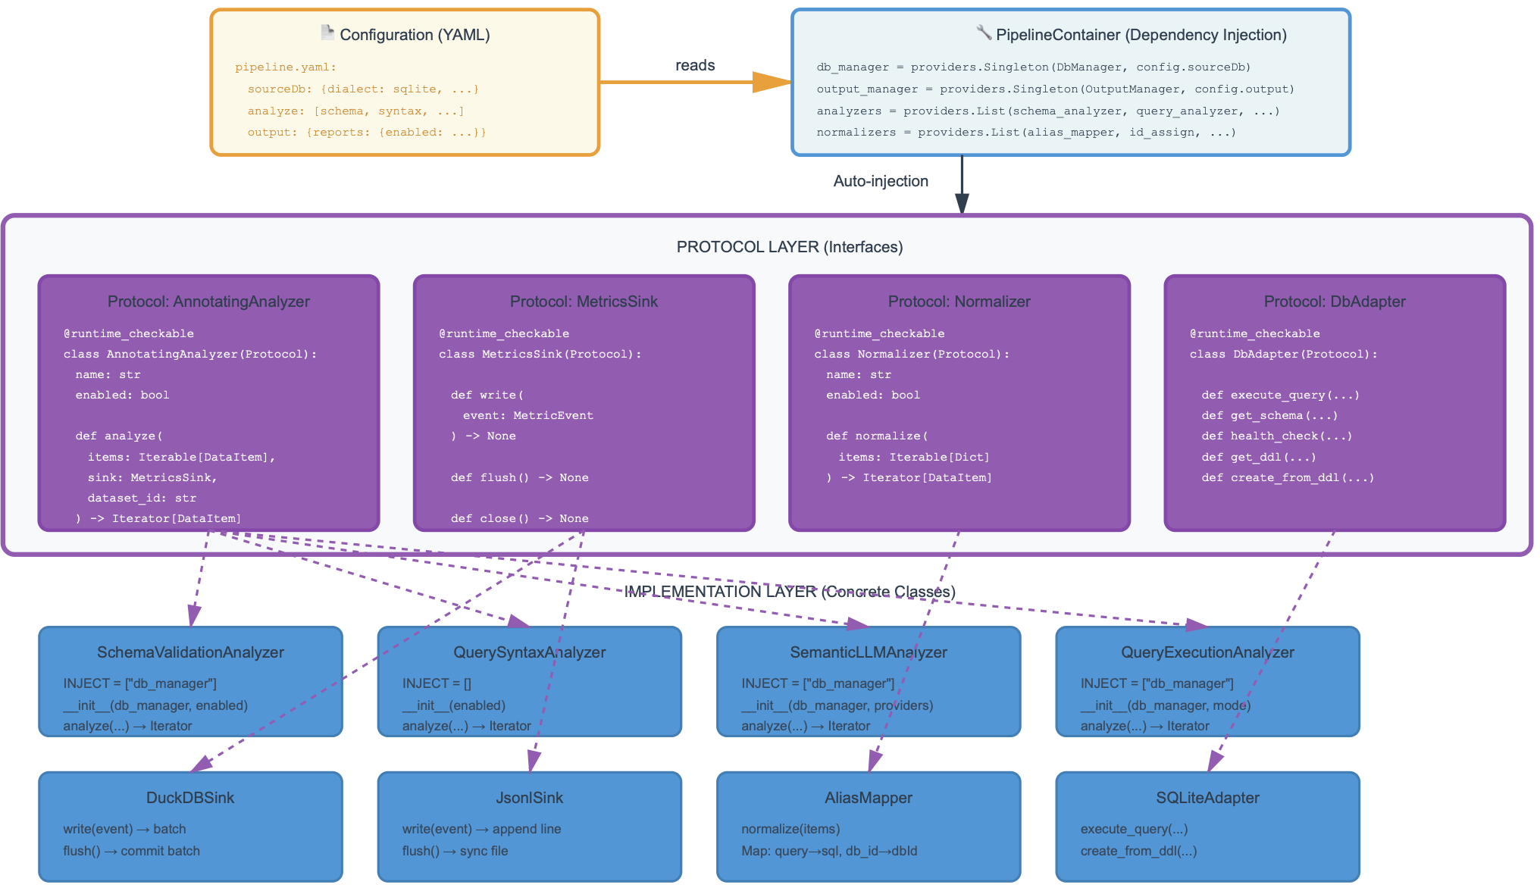
Figure 8. Protocol-based architecture with automatic dependency injection

The MetricsSink Protocol abstracts the mechanisms through which analyzers persist their computed metrics, defining three essential operations: write for accepting individual metric events, flush for ensuring buffered metrics are committed to persistent storage, and close for releasing any resources held by the sink. This abstraction enables multiple sink implementations with different performance and storage characteristics to coexist within the same system. The DuckDBSink implementation provides high-performance analytical access through SQL interfaces while automatically handling batched writes to amortize transaction overhead. The JsonlSink implementation offers a simple file-based storage format suitable for lightweight deployments or integration with external processing tools that expect line-delimited JSON. Additional sink implementations can be added without modifying analyzer code, as analyzers depend only on the protocol interface rather than specific sink implementations.
The Normalizer Protocol specifies the interface for components responsible for data standardization, requiring a normalize method that accepts an iterable of raw dictionary objects and returns an iterator of standardized DataItem instances. This protocol enables the composition of normalization pipelines where multiple normalizers operate in sequence, each consuming the output of the previous normalizer and producing input for the next. The loose coupling achieved through this protocol interface allows normalizers to be independently developed, tested, and versioned without impact on other pipeline components, facilitating the addition of new normalization strategies to handle emerging dataset formats or conventions without requiring modifications to the core pipeline infrastructure.
The DbAdapter Protocol encapsulates dialect-specific database operations, defining methods for query execution with configurable safety modes (read-only versus full read-write), schema introspection for retrieving table and column metadata, health checking for validating database accessibility, DDL export for extracting complete schema definitions, and database creation from DDL text specifications. This abstraction layer enables the system to support multiple SQL dialects (SQLite, PostgreSQL, MySQL) through different adapter implementations while presenting a uniform interface to higher-level components. The protocol-based approach facilitates unit testing by allowing test code to provide mock adapter implementations that simulate database operations without requiring actual database instances, significantly accelerating test suite execution and eliminating dependencies on external database installations.
Component orchestration within the protocol-based architecture relies on the dependency_injector library to automate the complex wiring of object graphs that arise from interdependent components. Each component declares its dependencies through a class-level INJECT attribute containing a list of dependency names. The dependency injection container, configured from YAML files, automatically instantiates dependencies, injects them into component constructors, and resolves transitive dependency chains. This automation eliminates substantial boilerplate code that would otherwise be required for manual object construction and wiring, while simultaneously improving testability by enabling test code to provide mock implementations for injected dependencies without modifying production code.
The protocol-based architecture with dependency injection offers several significant advantages for research software development. The explicit protocol interfaces serve as machine-checkable documentation of component contracts, with Python's runtime_checkable decorator enabling isinstance checks against protocol types for defensive programming patterns. The loose coupling between interfaces and implementations facilitates independent evolution of components, allowing researchers to experiment with alternative implementations of specific analysis strategies without modifying surrounding infrastructure. The architecture naturally supports A/B testing scenarios where multiple implementations of the same protocol are evaluated under identical conditions. Finally, the separation of concerns between business logic (implemented in concrete classes) and composition logic (specified in configuration files) enables non-programmers to assemble analysis pipelines from pre-built components through declarative YAML configuration, lowering barriers to adoption and experimentation.

4. Experimental setup and results

4.1. Experimental Methodology

We select Spider 1.0 dataset as our primary test dataset because it has become the most widely used benchmark for both training and evaluating Text-to-SQL models in the research community. Its ubiquitous adoption as the standard evaluation framework—reflected in countless publications and model leaderboards since 2018—means that any quality issues, ambiguous examples, or annotation errors we identify in Spider have direct implications for the validity of results reported across numerous studies that rely on this benchmark.
The experimental methodology employs comprehensive multi-layer validation across all three Spider partitions (test, dev, train) to assess both overall dataset quality and consistency characteristics between partitions. This comparative approach enables detection of systematic differences that might affect the reliability of training and evaluation procedures, a consideration particularly important given that many published Text-to-SQL systems report performance metrics only on the test partition while using dev for hyperparameter tuning.
The three analyzed partitions exhibit substantially different scales: Spider Test contains 2,147 examples spanning 40 unique databases, Spider Dev includes 1,034 examples across 20 databases, and Spider Train comprises 8,659 examples distributed over 146 databases. This size disparity introduces methodological considerations for certain analyses, particularly semantic validation via large language models, where the computational cost scales linearly with dataset size and were processing all 8,659 training examples would incur API costs exceeding $200-320 at current pricing.
All analyses employed SQLite as the target SQL dialect, matching Spider's native database format. The pipeline activated all five analyzers for all three partitions. The LLM configuration utilized Gemini 2.5 Pro and GPT-5 as voting models, both configured with temperature=0.0 to maximize determinism and weight=1.0 to ensure equal voting power, employing majority consensus for verdict determination. The DDL generation mode operated in query_derived mode, extracting only tables referenced in each SQL query rather than transmitting complete database schemas, reducing token.
Processing time varied substantially between partitions due to both dataset size and LLM API latency. Spider Test required approximately 12.7 hours when including LLM-based semantic validation, Spider Dev consumed roughly 6.1 hours under identical configuration, while Spider Train required approximately 49 hours to complete full semantic validation across all 8,659 examples. The LLM API latency and inference time typically requires 2-10 seconds per record compared to 50-100 milliseconds for the combined execution of all formal analyzers, explaining the domination of overall runtime by semantic validation. The decision to proceed with complete LLM validation across all partitions, despite the substantial computational investment, enables unprecedented comprehensive semantic quality assessment covering all 11,840 Spider examples rather than relying on sampling or limiting analysis to the smaller test partitions.

4.2. Database Schema Integrity Assessment
Schema integrity validation examines the structural correctness of database definitions, detecting errors that could prevent successful query execution even for syntactically valid SQL statements. Table 1 presents comparative results across all three partitions, revealing substantial heterogeneity in schema quality that contradicts the common assumption of uniform data quality within professionally curated benchmarks.
Metric | Spider Test | Spider Dev | Spider Train | Best
Total databases | 40 | 20 | 146 | —
Valid DBs | 36 (90.0%) | 13 (65.0%) | 114 (78.1%) | Test
DBs with errors | 4 (10.0%) | 7 (35.0%) | 32 (21.9%) | Test
Total tables | 180 | 80 | 793 | —
Empty tables | 0 (0%) | 0 (0%) | 68 (8.5%) | Test
Total foreign keys | 146 | 64 | 717 | —
Invalid FKs | 4 | 7 | 78 | Test
DBs with FK violations | 1 (1 viol.) | 3 (2,403 viol.) | 6 (39,523 viol.) | Test
Table 1. Comparative database schema validation results across Spider partitions
The results reveal a clear quality gradient across partitions, with Test achieving 90.0% schema validity, substantially exceeding Train at 78.1% and Dev at 65.0%. This ordering contradicts the intuitive expectation that the largest partition (Train) would exhibit the highest quality due to greater attention during curation. The Dev partition's unexpectedly low validity rate (35% error rate) raises concerns given its role in hyperparameter tuning and model selection, where schema errors might introduce confounding factors that obscure true performance differences between competing approaches.
Analysis of error type distribution (Table 2) identifies dominant patterns contributing to schema invalidity. Foreign Key Type Mismatch errors, where referencing and referenced columns possess incompatible data types, increase systematically from Test (1 occurrence) through Dev (5) to Train (34), suggesting either insufficient type checking during database creation or systematic differences in curation procedures between partitions. Foreign Key Target Not Key errors, where foreign keys reference non-key columns violating relational database normal forms, appear exclusively in Dev (2) and Train (41), with Train exhibiting particularly high frequency. Foreign Key Missing Column errors, indicating foreign keys referencing non-existent columns, occur infrequently and only in Test (3) and Train (3), suggesting typos or column renaming without corresponding foreign key updates.
Error Type | Spider Test | Spider Dev | Spider Train
FK Missing Column | 3 | 0 | 3
FK Type Mismatch | 1 | 5 | 34
FK Target Not Key | 0 | 2 | 41
Duplicate Columns | 0 | 0 | 0
Unknown Data Types | 0 | 0 | 0
Table 2. Distribution of schema error types across partitions
A particularly concerning finding emerges from analysis of foreign key data integrity violations, distinct from the structural foreign key errors discussed above. While 10 databases across all partitions exhibit referential integrity violations (where foreign key values fail to match any primary key values in the referenced table), the distribution of violation counts is extraordinarily skewed: two databases (sakila_1 in Train with 38,273 violations and flight_2 in Dev with 2,400 violations) account for 40,673 of the total 41,922 violations, representing 97% of all referential integrity issues across the entire dataset. This concentration suggests that these two databases contain systematic data generation or export problems rather than isolated data entry errors. For queries referencing these problematic databases, the presence of massive referential integrity violations may materially affect execution results, particularly for queries employing JOIN operations that implicitly assume referential integrity.
The Train partition exhibits an additional quality issue absent from Test and Dev: 41 tables across 4 databases (academic, imdb, yelp, restaurants) contain schema definitions but no data rows, representing 5.2% of all Train tables. While queries can syntactically reference these tables and may even execute successfully returning empty result sets, the lack of data precludes meaningful semantic validation and may confuse models during training if they learn spurious patterns from queries that execute without errors despite referencing empty tables. The systematic absence of empty tables in Test and Dev (100% data coverage) further emphasizes the quality inconsistency across partitions.
Estimating the impact scope of these schema issues requires correlating database-level errors with query distribution. In Test, the 4 databases with schema errors are referenced by approximately 213 queries (9.9% of the partition), in Dev the 7 problematic databases affect roughly 368 queries (35.6%), and in Train the 32 error-containing databases impact an estimated 1,900 queries (22% of the partition). These percentages indicate that schema quality issues are not merely outliers affecting obscure corner cases but rather systematic problems touching substantial portions of each partition, with Dev's 35.6% impact rate suggesting that more than one-third of its validation examples involve databases with known structural defects.

4.3. Syntactic Structure and Complexity Analysis
Syntactic analysis evaluates the structural characteristics of SQL queries independent of their semantic correctness, examining complexity, feature utilization, and parsing success rates. Table 3 demonstrates remarkable consistency across partitions in fundamental syntactic metrics, suggesting careful curation to maintain comparable difficulty distributions.
Metric | Spider Test | Spider Dev | Spider Train | Consistency
Total queries | 2,147 | 1,034 | 8,659 | —
Successfully parsed | 2,147 (100%) | 1,034 (100%) | 8,659 (100%)
Parse failures | 0 (0%) | 0 (0%) | 0 (0%)
Mean complexity | 39.5 | 39.0 | 40.7 | Max Δ=1.7
Median complexity | 41 | 41 | 41
Std deviation | 20.2 | 19.9 | 21.2 | Max Δ=1.3
Table 3. Overall syntactic analysis results showing strong cross-partition consistency
The perfect parsing success rate (100% across all 11,840 queries) constitutes a significant achievement, indicating that all queries conform to valid SQL syntax without requiring dialect-specific workarounds or error correction. This result validates the sqlglot parser's robustness for SQLite dialect and confirms the syntactic correctness of Spider's SQL annotations. The near-identical complexity statistics (maximum difference of 1.7 points on a 100-point scale, maximum standard deviation difference of 1.3) demonstrate intentional balancing of difficulty distributions across partitions, ensuring that test set performance metrics reflect genuine model capabilities rather than artifacts of easier or harder query distributions.
Examination of difficulty level distributions (Table 4) reinforces this consistency pattern, with Easy/Medium/Hard categories exhibiting nearly identical proportions across Test and Dev partitions. Train displays slightly higher medium representation (55.7% vs. 58-59% in Test/Dev) balanced by correspondingly lower Easy percentages, differences that likely reflect statistical variation rather than systematic curation differences given the magnitudes involved.
Difficulty | Spider Test | Spider Dev | Spider Train | Range
Easy | 516 (24.0%) | 250 (24.2%) | 2,039 (23.5%) | 10-29
Medium | 1,246 (58.0%) | 612 (59.2%) | 4,827 (55.7%) | 30-59
Hard | 385 (17.9%) | 172 (16.6%) | 1,727 (19.9%) | 60-79
Expert | 0 (0.0%) | 0 (0.0%) | 66 (0.8%) | 80-100
Table 4. Query difficulty distribution across partitions
One notable exception to cross-partition consistency emerges in the Expert difficulty category: Train contains 66 Expert-level queries (0.8% of the partition) while Test and Dev contain none. These 66 queries, with complexity scores ranging from 80-100, represent the most structurally complex examples in the entire dataset, typically involving deeply nested subqueries (depth ≥3), multiple JOIN operations (≥4 tables), and combinations of advanced features. The restriction of Expert queries to Train likely reflects a deliberate design decision to reserve the most challenging examples for training while maintaining test/dev difficulty within bounds where human annotation reliability remains high, though this asymmetry means that models cannot be comprehensively evaluated on Expert-level complexity using the provided test partition.
Analysis of JOIN distribution (Table 5) reveals a second dimension where Train exhibits systematically higher complexity compared to Test and Dev. Train contains a substantially larger proportion of multi-table queries (44.02% vs. approximately 40% in Test/Dev), with particularly pronounced differences in the 3-JOIN (4.15% vs. 1-2%) and 4+-JOIN (2.06% vs. 1%) categories. This pattern suggests that Train was specifically enriched with complex multi-table queries to provide training signal for JOIN operation learning, though the test/dev partitions' lower JOIN frequencies may underestimate models' capabilities on highly complex multi-table scenarios.
JOIN Count | Spider Test | Spider Dev | Spider Train | Best
0 (single-table) | 1,285 (59.85%) | 626 (60.54%) | 4,847 (55.98%) | Train
1 JOIN | 558 (25.99%) | 320 (30.95%) | 2,233 (25.79%) | Balanced
2 JOINs | 242 (11.27%) | 72 (6.96%) | 1,042 (12.03%) | Train
3 JOINs | 38 (1.77%) | 10 (0.97%) | 359 (4.15%) | Train
4+ JOINs | 24 (1.12%) | 6 (0.58%) | 178 (2.06%) | Train
Multi-table (≥1 J.) | 862 (40.15%) | 408 (39.46%) | 3,812 (44.02%) | Train
Table 5. JOIN distribution analysis showing Train's higher multi-table complexity
Despite the rich structural variation in JOIN complexity and overall difficulty levels, Spider exhibits complete absence of certain advanced SQL features. No queries in any partition employ common table expressions (CTEs), recursive CTEs, or window functions (ROW_NUMBER, RANK, LAG, LEAD), features commonly found in modern SQL codebases and supported by all major database systems. This limitation reflects Spider's 2018 origins when window functions had more limited adoption but represents a significant coverage gap for evaluating contemporary Text-to-SQL systems expected to support the full SQL feature set. The forthcoming Spider 2.0 reportedly addresses this limitation by including examples with modern SQL constructs.

4.4. Dynamic Executability Validation
Dynamic execution testing validates that syntactically correct queries can run against their associated databases, detecting semantic errors, missing tables/columns, type incompatibilities, and other runtime failures invisible to static analysis. Table 9 presents execution results demonstrating near-perfect executability across all partitions.
Metric | Spider Test | Spider Dev | Spider Train | Best
Total queries | 2,147 | 1,034 | 8,659 | —
Successfully executed | 2,147 (100%) | 1,034 (100%) | 8,656 (99.97%) | Test/Dev
Execution failures | 0 (0%) | 0 (0%) | 3 (0.03%) | Test/Dev
Mean time (ms) | 3.10 | 2.49 | 1.19 | Train
Table 9. Query execution results showing exceptional executability rates
The execution success rates—100% for Test and Dev, 99.97% for Train—represent a remarkable achievement given the complexity of the queries and the schema integrity issues documented in Section 3.2. That queries execute successfully despite the presence of foreign key errors and referential integrity violations indicates either that most queries avoid JOIN operations that would expose these structural problems, or that SQLite's permissive handling of constraint violations prevents runtime errors even when referential integrity is compromised. The three failed executions in Train (0.03% of 8,659 queries) likely represent genuine semantic errors—references to non-existent columns or tables, incompatible type operations, or division-by-zero scenarios—warranting manual inspection to determine whether these represent annotation errors requiring correction.
Execution time measurements reveal an unexpected pattern: Train queries execute fastest (mean 1.19ms), followed by Dev (2.49ms) and Test (3.10ms). This inverse relationship between partition size and execution time suggests that Train databases may contain smaller data volumes compared to Test/Dev databases, or that Train's database schemas include better indexing. The absolute magnitudes—all means under 3.5 milliseconds—indicate that execution testing contributes negligible overhead to overall pipeline runtime, validating the decision to include execution validation by default rather than making it optional.

4.5. Code Quality Assessment via Antipattern Detection
Antipattern detection identifies common SQL coding practices that, while syntactically valid and functionally correct, deviate from established best practices regarding performance, maintainability, or code clarity. It is important to emphasize that antipattern presence in training data does not constitute a critical flaw for Text-to-SQL model development. Training objectives focus on semantic correspondence between questions and queries rather than production-ready code optimization.
Metric | Spider Test | Spider Dev | Spider Train | Best
Mean quality score | 92.7 | 92.7 | 92.7 | Identical
Antipatterns per query | 1.35 | 1.32 | 1.39 | Dev
Success rate (0 antip.) | 6.1% | 8.4% | 6.0% | Dev
Table 11. Overall code quality metrics showing consistent high quality
Most detected antipatterns are stylistic (SELECT *, missing LIMIT) rather than logical errors, do not affect query execution correctness or result accuracy, and represent acceptable trade-offs in dataset creation where readability and annotation simplicity may outweigh optimization concerns. Nonetheless, antipattern analysis provides valuable insights into SQL coding style distributions. Table 11 demonstrates remarkably consistent quality scores across all partitions, with all three achieving exactly 92.7/100 mean scores. This precise agreement likely results from the weighted scoring formula where the same antipattern types appear with similar frequencies across partitions, producing identical aggregate scores despite individual query variations. The typical query contains 1.32-1.39 antipatterns, indicating that while queries achieve high overall quality, completely antipattern-free queries remain rare (6.0-8.4% success rate). This pattern suggests systematic presence of one or two dominant antipattern types affecting most queries rather than diverse antipattern distributions.
Table 12 confirms this hypothesis, revealing that Unbounded SELECT (queries lacking LIMIT clauses) dominates the antipattern distribution. In Test, 84.6% of queries lack LIMIT clauses, explaining why most queries exhibit at least one antipattern despite generally good coding practices. The SELECT * antipattern (selecting all columns rather than specifying explicit projections) affects 24.5-36.4% of queries depending on partition, with Dev showing the highest incidence. More concerning antipatterns like Functions in WHERE (preventing index usage) and Correlated Subqueries (exhibiting quadratic complexity) appear rarely (2.0-5.5%), and the most problematic pattern—Implicit JOIN syntax—is nearly absent with only 2 occurrences across the entire dataset.
Antipattern | Spider Test | Spider Dev | Spider Train | Severity
Unbounded SELECT | 1,816 (84.6%) | [n/a] | [n/a] | High
SELECT * | 673 (31.3%) | 376 (36.4%) | 2,120 (24.5%) | Medium
Functions in WHERE | 81 (3.8%) | 27 (2.6%) | 472 (5.5%) | Medium
Correlated subquery | 46 (2.1%) | 21 (2.0%) | 331 (3.8%) | Medium
Implicit JOIN | 0 (0.0%) | 0 (0.0%) | 2 (0.02%) | Medium
Table 12. Top-5 most frequent antipatterns
The antipattern distribution reflects sensible trade-offs in dataset design. The prevalence of Unbounded SELECT is appropriate for benchmark queries where result set sizes are typically small and deterministic, making LIMIT clauses unnecessary for correctness. The moderate frequency of SELECT * balances convenience in annotation (avoiding explicit column enumeration) against best-practice recommendations, with the variation across partitions (24.5% in Train vs. 36.4% in Dev) likely reflecting different annotation teams or evolving style guidelines. The low frequencies of performance-critical antipatterns (Functions in WHERE, Correlated Subqueries) indicate that dataset creators possessed solid SQL expertise and generally avoided the most problematic patterns. The near-complete absence of Implicit JOIN confirms that explicit JOIN syntax was consistently enforced, improving query readability and maintainability.

4.6. Semantic Correctness via LLM Consensus
Semantic validation represents the most critical quality dimension, as syntactically valid, successfully executing queries may nonetheless fail to correctly answer their associated natural language questions. This validation employs two large language models (Gemini 2.5 Pro and GPT-4o) in a consensus voting configuration, with unanimous agreement required for definitive verdicts and disagreement cases classified as Mixed requiring human review. The analysis was successfully conducted across all three Spider partitions: Test (2,147 queries), Dev (1,034 queries), and Train (8,659 queries), providing comprehensive semantic quality assessment covering the entire dataset of 11,840 examples. Table 14 reveals a clear quality gradient across all three partitions, with semantic correctness declining systematically from Test (70.4% correct) through Dev (64.5%) to Train (60.0%), representing a 10.4 percentage point span that exceeds expected statistical variation (p<0.001 by proportion test across all pairwise comparisons). This quality ordering mirrors the schema validation results presented earlier, where Test similarly exhibited superior quality compared to Dev and Train. The consistency of this pattern across multiple validation dimensions suggests that Test received more rigorous curation attention or quality assurance compared to the other partitions. Notably, Train exhibits the highest rates of both explicitly incorrect queries (10.0% vs. 8.1% in Test and 9.2% in Dev) and mixed/disputed cases (26.0% vs. 18.5% in Test and 24.9% in Dev), indicating that the largest partition paradoxically contains the greatest proportion of semantically problematic examples. The unanimous agreement characteristic (all non-Mixed verdicts represent complete model consensus) reflects the two-model configuration, where only two outcome patterns are possible: both models agree (producing a definitive verdict) or models disagree (producing Mixed classification).
The Mixed verdict category, indicating model disagreement, warrants particular attention given its substantial prevalence across all partitions.
Consensus Verdict | Spider Test | Spider Dev | Spider Train
CORRECT | 1,512 (70.4%) | 667 (64.5%) | 5,196 (60.0%)
PARTIALLY_CORRECT | 52 (2.4%) | 15 (1.5%) | 301 (3.5%)
INCORRECT | 174 (8.1%) | 95 (9.2%) | 865 (10.0%)
Mixed (disagreement) | 396 (18.5%) | 257 (24.9%) | 2,249 (26.0%)
UNANSWERABLE | 13 (0.6%) | 0 (0.0%) | 48 (0.6%)
TOTAL | 2,147 (100%) | 1,034 (100%) | 8,659 (100%)
Table 14. Semantic validation results via LLM consensus voting
Train exhibits the highest Mixed rate (26.0%), followed by Dev (24.9%) and Test (18.5%), suggesting that larger partitions contain more ambiguous or underspecified examples where reasonable SQL implementations might differ in interpretation. These cases may represent questions admitting multiple valid SQL formulations, queries with subtle semantic bugs difficult for both humans and models to detect, or scenarios where database schema ambiguities enable different but defensible interpretations. The explicitly incorrect verdicts (174 in Test, 95 in Dev, 865 in Train) identify examples where both models independently judged the SQL query as failing to answer the natural language question, likely representing genuine annotation errors or cases where the intended query logic was incorrectly implemented. Train's 865 incorrect queries represent approximately 10% of its examples, a concerning proportion that exceeds the incorrect rates in both Test and Dev. The partially correct category, while relatively small in Test (2.4%) and Dev (1.5%), reaches 3.5% in Train with 301 examples, capturing queries that answer part of the question but omit necessary constraints or return supersets of the correct results.
Table 15 synthesizes these findings into actionable quality categories across all three partitions. High-confidence correct examples decline from 70.4% in Test through 64.5% in Dev to 60.0% in Train, indicating that approximately 40% of the largest partition requires some form of manual review or exhibits semantic issues. Cases requiring review include both the Mixed disagreement cases (18.5% in Test, 24.9% in Dev, 26.0% in Train) and the partially correct examples, totaling approximately 21% of Test, 26% of Dev, and 29.5% of Train. Clearly incorrect examples (8.1% in Test, 9.2% in Dev, 10.0% in Train) should be flagged for correction or removal, representing 1,134 total examples across all three partitions—a substantial corpus of annotation errors that may influence model training and evaluation if left unaddressed.
Category | Spider Test | Spider Dev | Spider Train
Correct | 1,512 (70.4%) | 667 (64.5%) | 5,196 (60.0%)
Problematic (all) | 239 (11.1%) | 110 (10.6%) | 1,214 (14.0%)
Disputed (Mixed) | 396 (18.5%) | 257 (24.9%) | 2,249 (26.0%)
High confidence | 1,512 (70.4%) | 667 (64.5%) | 5,196 (60.0%)
Requires review | 448 (20.9%) | 272 (26.4%) | 2,550 (29.5%)
Clearly incorrect | 174 (8.1%) | 95 (9.2%) | 865 (10.0%)
Table 15. Semantic quality categorization summary
The semantic validation results should be interpreted with appropriate methodological caveats. The two-model consensus approach, while providing useful signal, cannot definitively establish ground truth semantic correctness. Both models may share systematic biases or blind spots, potentially producing unanimous incorrect verdicts for examples that are correct, or conversely judging correct examples as incorrect due to misunderstanding subtle question semantics or database content. The 60.0-70.4% correctness rates likely represent lower bounds on true semantic quality, as conservative classification strategies may flag some correct examples as Mixed or incorrect. Nonetheless, the comprehensive coverage across all 11,840 examples enables identification of 1,134 clearly incorrect queries and 2,902 disputed cases requiring targeted human review to adjudicate the genuine error rate and understand the nature of semantic issues present throughout the dataset. The successful completion of LLM validation across all partitions, including the computationally expensive Train partition, provides unprecedented visibility into Spider's semantic quality at full scale.

4.7. Integrated Quality Assessment and Recommendations
The comprehensive multi-layer analysis of Spider's three partitions enables an integrated quality assessment synthesizing findings across all validation dimensions. Table 20 summarizes key quality indicators, revealing patterns of consistency alongside several critical issues requiring remediation.
Quality Criterion | Spider Test | Spider Dev | Spider Train | Best
DATABASE SCHEMAS
Valid schemas | 90.0% | 65.0% | 78.1% | Test
Invalid FKs | 4 | 7 | 78 | Test
DBs with FK violations | 1 (1 viol.) | 3 (2,403 viol.) | 6 (39,523 viol.) | Test
SYNTACTIC QUALITY
Parse success | 100% | 100% | 100% | Equal
Mean complexity | 39.5 | 39.0 | 40.7 | Equal
Expert queries | 0 | 0 | 66 (0.8%) | Train
EXECUTABILITY
Execute success | 100% | 100% | 99.97% | Test/Dev
Mean time (ms) | 3.10 | 2.49 | 1.19 | Train
SQL CODE QUALITY
Quality score | 92.7 | 92.7 | 92.7 | Equal
SEMANTIC CORRECTNESS
Correct | 70.4% | 64.5% | 60.0% | Test
Clearly incorrect | 8.1% | 9.2% | 10.0% | Test
Disputed (Mixed) | 18.5% | 24.9% | 26.0% | Test
Table 20. Integrated quality assessment across all validation dimensions
The analysis identifies both strengths and critical weaknesses in Spider's construction. On the positive side, the dataset achieves exceptional syntactic quality with 100% parsing success across all 11,840 queries, near-perfect executability (100% for Test/Dev, 99.97% for Train), and consistent complexity distributions facilitating fair cross-partition comparison. The intentional balancing of difficulty levels and consistent code quality scores (92.7/100 uniformly) demonstrate careful curation attention to producing a usable benchmark. However, several critical issues emerged that require addressing to ensure dataset integrity and reliability for future research.
The most severe problem identified concerns referential integrity violations concentrated in two databases: sakila_1 (Train) with 38,273 violations and flight_2 (Dev) with 2,400 violations. Together these two databases account for 97% of all 41,922 referential integrity violations across the entire dataset, indicating systematic data export or generation problems rather than isolated errors. For queries referencing these databases (approximately 22% of Train queries and 35.6% of Dev queries touch databases with some form of schema issue), the massive referential integrity violations may materially affect JOIN operations and semantic correctness. Immediate remediation of these two databases through re-export from authoritative sources or systematic data cleaning should be prioritized as the highest-impact improvement to dataset quality.
Beyond these catastrophic cases, schema quality exhibits concerning heterogeneity across partitions. Test achieves 90% validity while Dev drops to 65% and Train to 78.1%, with Dev's particularly low validity raising questions about its suitability for model selection given that 35% of its databases contain known structural defects. The 78 invalid foreign keys in Train (compared to 4 in Test and 7 in Dev) indicate systematic differences in curation procedures or quality assurance practices between partitions. Train's 41 empty tables across 4 databases (academic, imdb, yelp, restaurants) represent another quality issue absent from Test and Dev, potentially confusing models during training when queries successfully execute against empty tables without producing semantic errors visible during training.
Semantic validation results across all three partitions reveal a systematic quality gradient, with correct percentages declining from 70.4% in Test through 64.5% in Dev to 60.0% in Train. This pattern indicates that approximately 30-40% of examples across Spider exhibit some degree of semantic problems, with the largest partition (Train) containing the highest proportion of issues. The clearly incorrect category (174 in Test, 95 in Dev, 865 in Train) totaling 1,134 examples represents cases where both language models independently judged queries as failing to answer their questions, likely indicating genuine annotation errors or implementation bugs requiring manual review and correction. The disputed category (396 in Test, 257 in Dev, 2,249 in Train) totaling 2,902 examples represents ambiguous cases where model disagreement signals potential under specification in questions, multiple valid interpretations, or subtle semantic issues difficult even for sophisticated models to adjudicate. These cases warrant expert human review to determine true correctness and potentially augment with clarifying information or alternative phrasings. The comprehensive LLM validation across all 11,840 examples provides unprecedented visibility into Spider's semantic quality at full scale, identifying 4,036 problematic examples (34.1% of the total dataset) requiring attention.
Based on these findings, we propose a prioritized remediation roadmap. Critical priority actions include immediate investigation and repair of sakila_1 and flight_2 databases to eliminate the 40,673 referential integrity violations representing 97% of all integrity problems, systematic correction of the 32 invalid schemas in Train (21.9% of Train databases), 7 invalid schemas in Dev (35% of Dev databases), and 4 invalid schemas in Test (10% of Test databases), manual verification of the 1,134 clearly incorrect queries identified by LLM consensus across all partitions to confirm and correct annotation errors, and expert review of the 2,902 disputed cases to adjudicate true correctness and identify needed clarifications or corrections.
Recommended (non-critical) improvements include systematic correction of the 34 Foreign Key Type Mismatch errors in Train through database schema modifications, addressing the 41 Foreign Key Target Not Key violations in Train that represent the dominant structural error type, populating the 41 empty tables across 4 Train databases with appropriate data or removing these tables from schemas if intentionally empty, correction of the 368 partially correct queries (52 in Test, 15 in Dev, 301 in Train) identified by LLM analysis, and potential addition of Expert-level queries to Test and Dev partitions given that Train uniquely contains 66 such queries while test/dev evaluation cannot assess model performance at this complexity level.
Optional enhancements for production usage (not critical for research purposes) include adding LIMIT clauses to unbounded SELECT queries where semantically appropriate, replacing SELECT * with explicit column lists (particularly in Dev where 36.4% of queries exhibit this pattern), optimizing or rewriting the correlated subqueries appearing in 3.8% of Train queries, and creating an extended Spider variant incorporating modern SQL features (CTEs, recursive CTEs, window functions) absent from the current version.
In conclusion, Spider maintains its position as one of the highest-quality publicly available Text-to-SQL benchmarks, with exceptional syntactic and execution quality (100% parsable, 99.97%+ executable) and carefully balanced difficulty distributions across partitions. However, the comprehensive multi-layer validation across all 11,840 examples—including full LLM-based semantic validation—reveals several critical issues: concentrated referential integrity catastrophes (sakila_1 and flight_2 containing 97% of all integrity violations), substantial schema quality heterogeneity (Test 90% valid vs. Dev 65% vs. Train 78.1%), and significant proportions of semantically problematic examples (30% in Test, 35.5% in Dev, 40% in Train). The systematic quality gradient across partitions, where Test consistently outperforms Dev and Train across multiple dimensions, suggests differential curation attention and raises questions about evaluation reliability when models are tuned on lower-quality Dev data. The Test partition emerges as the highest-quality subset suitable for reliable model evaluation, while Train remains critically important for model training despite its quality issues given that it contains 73% of all examples and the only Expert-level queries in the dataset. The remediation priorities outlined above provide a concrete roadmap for dataset maintainers to address the most impactful quality issues while preserving Spider's substantial strengths as a challenging, realistic Text-to-SQL benchmark.

5 Discussion

5.1 Summary of Findings
Our analysis shows that Spider is syntactically robust and almost perfectly executable, but it is not free of technical and semantic issues. Structural schema problems, especially in a subset of databases, coexist with near-perfect execution success. Semantic validation highlights that a substantial portion of examples exhibit questionable or ambiguous mappings between questions and queries, particularly in the training split.

5.2 Implications for Benchmark Use
For researchers, these findings imply that benchmark scores on Spider should be interpreted with caution. Models might achieve high execution accuracy while being trained and evaluated on data that contains hidden inconsistencies or incorrect supervision. Comparisons across systems can be confounded when model behavior on problematic examples is difficult to interpret. Our results suggest that the test split is the most reliable for reporting headline numbers, whereas training and development splits may benefit from targeted cleaning before use in fine-tuning.
For dataset maintainers, the identified issues provide a concrete prioritized roadmap. Addressing the two databases responsible for many referential integrity violations would substantially improve structural quality. Repairing or removing clearly incorrect and partially correct examples would increase semantic reliability. Finally, extending the benchmark with queries using modern SQL features and more realistic data distributions would better reflect contemporary industrial workloads.

5.3 Threats to Validity
The primary threat to validity in our study is that semantic validation relies on only two large language models as judges. Although we deliberately select models from different providers and require consensus for definitive labels, both models may still share systematic blind spots or biases. Some examples that we flag as incorrect may in fact be acceptable, and some that we mark as correct may contain subtle issues. Our framework supports larger and more diverse LLM committees, but due to budget constraints we limited the experiments in this paper to two models; using additional models could reduce the risk of systematic misclassification.
A second threat is the limited scope of human verification. Manual inspection was performed only for the Unanswerable category, which constitutes a small fraction of all examples. While this focus is justified by the fact that Unanswerable cases are the most critical—representing queries where automatic judges are least confident or cannot determine correctness—it means that we have not systematically verified the larger sets of examples labelled as Partially correct, or Incorrect and Mixed Decision. Future work with broader human annotation would be necessary to fully calibrate and refine the semantic quality estimates reported here.

6. Conclusions and Further Work
We presented text2sql-pipeline, the first open-source framework for comprehensive Text-to-SQL dataset validation and applied it to a full-scale audit of the Spider 1.0 benchmark. The framework integrates schema checks, syntactic analysis, execution testing, antipattern detection and LLM-based semantic validation within a streaming architecture that scales to large datasets while preserving constant memory usage.
Our empirical study of all three Spider partitions shows that, although the benchmark is syntactically well-formed and almost perfectly executable, it contains non-trivial structural defects and a significant proportion of semantically problematic examples. Quality differences between partitions are systematic: the test split consistently exhibits higher structural and semantic quality than the dev and train splits. These findings highlight the need for more systematic dataset curation in Text-to-SQL research.
Future work will extend the framework in several directions. First, we plan to add automatic repair suggestions for selected classes of problems, such as foreign key mismatches or simple semantic discrepancies, enabling semi-automatic dataset cleaning. Second, we aim to apply the framework to other benchmarks and large synthetic corpora to study how dataset origin (human-curated vs. generated) correlates with quality. Third, we intend to integrate validation checks into model training loops, allowing practitioners to dynamically filter or reweight training examples based on quality indicators.
We hope that making dataset validation tools widely available will encourage the community to treat benchmark quality as a first-class research concern, ultimately leading to more reliable Text-to-SQL systems and more meaningful empirical evidence.

Acknowledgements
The authors gratefully acknowledge the financial support of Intellias, which enabled the use of frontier large language models in this work.

CRediT authorship contribution statement
Volodymyr Sabadosh: Conceptualization, Software Design, Data curation, Formal analysis, Methodology, Investigation, Visualization, Writing – original draft, Writing – review and editing.

Declaration of Generative AI and AI-assisted technologies in the writing process
During the preparation of this work, the author used ChatGPT (OpenAI) to improve the grammar, clarity and structure of the manuscript. After using this tool, the author carefully checked and edited the content and takes full responsibility for the final version of the paper.

Declaration of competing interest
The author declares that there are no known competing financial interests or personal relationships that could have appeared to influence the work reported in this paper.

Data availability

The developed Text-to-SQL analysis tool is available as open-source software on GitHub at https://github.com/vsabadosh/text2sql-dataset-analyzer. The repository contains all con-figuration files, scripts, precomputed metrics, and generated reports for the Spider 1.0 dataset. The underlying Spider 1.0 dataset is publicly available from the original authors.

Funding
This research did not receive any specific grant from funding agencies in the public, commercial or not-for-profit sectors.

References
TODO:
Please convert your existing reference list to the journal’s BibTeX-based LaTeX style when preparing the final submission. All cited publications with an assigned DOI should include the DOI.
- Fürst J.; Kosten C.; Nooralahzadeh F.; Zhang Y.; Stockinger K. Evaluating the Data Model Robustness of Text-to-SQL Systems Based on Real User Queries [Електронний ресурс]. – arXiv:2402.08349, 2024. – DOI: 10.48550/arXiv.2402.08349. – Режим доступу: https://arxiv.org/abs/2402.08349 (дата звернення: 08.11.2025). arXiv
- Shi L.; Tang Z.; Zhang N.; Zhang X.; Yang Z. A Survey on Employing Large Language Models for Text-to-SQL Tasks [Електронний ресурс]. – arXiv:2407.15186, 2025. – DOI: 10.48550/arXiv.2407.15186; пов’язаний DOI видання: 10.1145/3737873. – Режим доступу: https://arxiv.org/abs/2407.15186 (дата звернення: 08.11.2025). arXiv
- D. Gao, H. Wang, Y. Li, X. Sun, Y. Qian, B. Ding, and J. Zhou, “Text-to-SQL Empowered by Large Language Models: A Benchmark Evaluation,” arXiv, 2308.15363, 2023. doi:10.48550/arXiv.2308.15363. [Online]. Available: https://arxiv.org/abs/2308.15363. Accessed: Nov. 8, 2025.
- Spider 1.0 — Leaderboard (Yale LILY Group). [Online]. Available: https://yale-lily.github.io/spider. Accessed: Nov. 8, 2025.
- V. Shkapenyuk, D. Srivastava, T. Johnson, and P. Ghane, “Automatic Metadata Extraction for Text-to-SQL,” arXiv, 2505.19988, 2025. doi:10.48550/arXiv.2505.19988. [Online]. Available: https://arxiv.org/abs/2505.19988. Accessed: Nov. 8, 2025.
- BIRD — Leaderboard. [Online]. Available: https://bird-bench.github.io/. Accessed: Nov. 8, 2025.
- Yu T.; Zhang R.; Yang K.; Yasunaga M.; Wang D.; Li Z.; Ma J.; Li I.; Yao Q.; Roman S.; Zhang Z.; Radev D. Spider: A Large-Scale Human-Labeled Dataset for Complex and Cross-Domain Semantic Parsing and Text-to-SQL Task [Електронний ресурс] // Proceedings of the 2018 Conference on Empirical Methods in Natural Language Processing (EMNLP 2018). – Brussels, Belgium: Association for Computational Linguistics, 2018. – С. 3911–3921. – DOI: 10.18653/v1/D18-1425. – Режим доступу: https://aclanthology.org/D18-1425/ (дата звернення: 08.11.2025). ACL Anthology+1
- Snowflake Inc., “Using Snowflake Copilot inline,” Snowflake Documentation. [Online]. Available: docs.snowflake.com/en/user-guide/snowflake-copilot-inline. Accessed: Nov. 8, 2025. Snowflake Documentation.
- Microsoft, “What is an AI/BI Genie space,” Azure Databricks Documentation. [Online]. Available: learn.microsoft.com/en-us/azure/databricks/genie/. Accessed: Nov. 8, 2025. Microsoft Learn.
- Microsoft, “Copilot in Fabric in the SQL database workload,” Microsoft Learn. [Online]. Available: learn.microsoft.com/en-us/fabric/database/sql/copilot-sql-database. Accessed: Nov. 8, 2025. Microsoft Learn.
- Chang, S., Wang, J., Dong, M., Pan, L., Zhu, H., Li, A. H., Lan, W., Zhang, S., Jiang, J., Lilien, J., Ash, S., Wang, W. Y., Wang, Z., Castelli, V., Ng, P., & Xiang, B. (2023). Dr.Spider: A Diagnostic Evaluation Benchmark towards Text-to-SQL Robustness. In International Conference on Learning Representations (ICLR 2023). arXiv:2301.08881.
- Yao, Z., Borchmann, Ł., Zhai, B., Zhang, H., He, Y. (2025). Arctic-Text2SQL-R1: Simple Rewards, Strong Reasoning in Text-to-SQL. arXiv:2505.20315 (включає абляції з додаванням Gretel-Synth). Див. також інженерний блог Snowflake із коротким підсумком абляцій.
- Victor Zhong, Caiming Xiong, and Richard Socher. "Seq2SQL: Generating Structured Queries from Natural Language Using Reinforcement Learning." In Proceedings of the 55th Annual Meeting of the Association for Computational Linguistics (ACL), 2017
- Jinyang Li, Binyuan Hui, Ge Qu, Jiaxi Yang, Binhua Li, Bowen Li, Bailin Wang, Bowen Qin, Ruiying Geng, Nan Huo, Xuanhe Zhou, and et al. 2023. Can LLM Already Serve as A Database Interface? A BIg Bench for Large-Scale Database Grounded Text-to-SQLs. In Advances in Neural Information Processing Systems 36: Annual Conference on Neural Information Processing Systems 2023, NeurIPS 2023, New Orleans, LA, USA, December 10 - 16, 2023.
- Gretel.ai (2024). Synthetic Text-to-SQL Dataset (Gretel-Synth). Hugging Face dataset card.
- H. Li, S. Wu, X. Zhang, X. Huang, J. Zhang, F. Jiang, S. Wang, T. Zhang, J. Chen, R. Shi, H. Chen, and C. Li, “OmniSQL: Synthesizing High-quality Text-to-SQL Data at Scale,” arXiv preprint, arXiv:2503.02240 $cs.CL$, 2025. [Online]. Available: https://arxiv.org/pdf/2503.02240. Accessed: Nov. 8, 2025.
- Xinyu Liu, Shuyu Shen, Boyan Li, Nan Tang, and Yuyu Luo. “NL2SQL-BUGs: A Benchmark for Detecting Semantic Errors in NL2SQL Translation.” In: Proceedings of the 31st ACM SIGKDD Conference on Knowledge Discovery and Data Mining (KDD ’25), vol. 2, ACM, 2025, pp. 5662–5673. doi:10.1145/3711896.3737427.
- A. Mitsopoulou and G. Koutrika, “Analysis of Text-to-SQL Benchmarks: Limitations, Challenges and Opportunities,” in Proc. 28th Int. Conf. on Extending Database Technology (EDBT 2025), Barcelona, Spain, Mar. 25–28, 2025. [Online]. Available: https://openproceedings.org/2025/conf/edbt/paper-41.pdf. Accessed: Nov. 8, 2025.
- P. Pandey, D. Patel, S. Mandvikar, and N. Kota,
Ensuring Data Accuracy in Text-to-SQL Systems: A Comprehensive Validation Framework. International Journal of Computer Trends and Technology (IJCTT),
vol. 72, no. 12, pp. 17–24, 2024.
Available online: https://www.researchgate.net/publication/387939936
(Accessed: Nov. 8, 2025).
- Python Software Foundation. Python 3.11 Documentation. Available at: docs.python.org/3.11. Python documentation+1
- DuckDB Foundation. DuckDB Documentation. Available at: duckdb.org/docs/stable. DuckDB+1
- Mike Bayer et al. SQLAlchemy 2.0 Documentation. Available at: docs.sqlalchemy.org. docs.sqlalchemy.org+2docs.sqlalchemy.org+2
- Toby Mao. SQLGlot: Python SQL Parser and Transpiler. GitHub repository. Available at: github.com/tobymao/sqlglot. GitHub
- Roman Mogylatov. Dependency Injector: Dependency Injection Framework for Python. Official documentation. Available at: python-dependency-injector.ets-labs.org. python-dependency-injector.ets-labs.org+2python-dependency-injector.ets-labs.org+2
- PyYAML Developers. PyYAML – YAML parser and emitter for Python. Project site and documentation. Available at: pyyaml.org and pypi.org/project/PyYAML. pyyaml.org+1

