**JSX**

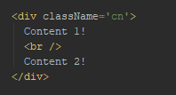

**JS**

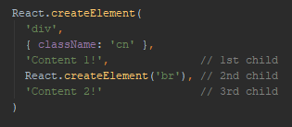

**VDOM**

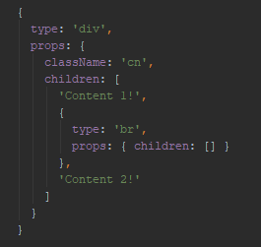

JSX

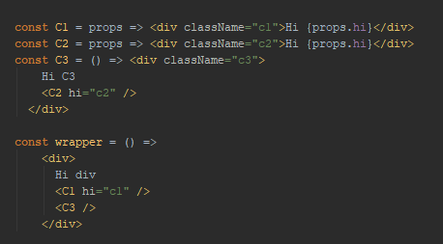

JS

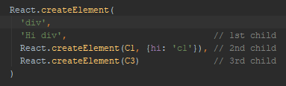

VDOM

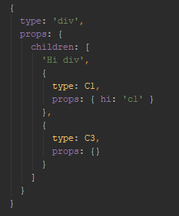

C1 and C3 have attachments

After a Virtual DOM object is built, ReactDOM.render will try to transform it into a DOM node our browser can display according to those rules:

* If a type attribute holds a string with a tag name—create a tag with all attributes listed under props.
* If we have a function or a class under type—call it and repeat the process recursively on a result.
* If there are any children under props—repeat the process for each child one by one and place results inside the parent’s DOM node.

Rebuilding the DOM – reconciliation or diffing

Conditions:

1. Node or parent Node component changes props
2. Node or parent Node component setState() is called
3. Node or parent Node component forceUpdte() is called

**Scenario 1: type is a string, type stayed the same across calls, props did not change either**

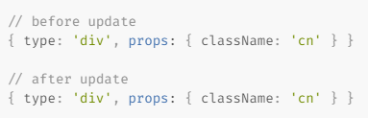

DOM stays the same

**Scenario 2: type is still the same string, props are different**

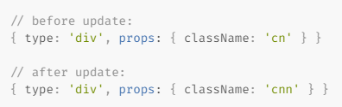

React knows how to change its properties through standard DOM API calls, without removing the node from a DOM tree

**Scenario 3: type has changed to a different String, or from String to a component**

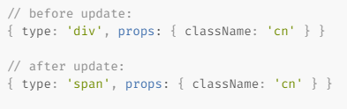

React would not even try to update our node: old element will be removed (*unmounted*) **together with all its children**. React uses === (triple equals) to compare type values, so they have to be the same *instance*of the same class or the *same* function.

**Scenario 4: type is a component**

If type is a reference to a function or a class, and we started tree reconciliation process, then React will always try to look inside the component to make sure that the values returned on render did not change. Repeat for each component down the tree

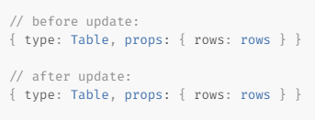

**shallow equality**

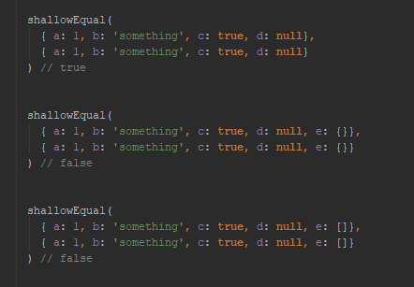

**Best practices:**

1. Use **short circuit boolean evaluation** – components will mount/unmount

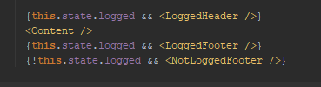

1. Don’t create **HOCs** inside render() – components will mount/unmount

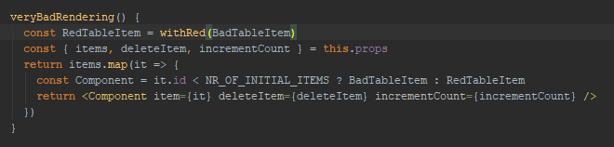

1. Use **key** when rendering an array – components could mount/unmount if index and type are different

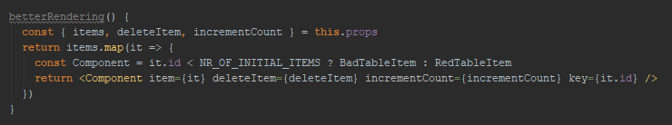

1. Use **shouldComponentUpdate()** or **PureComponent** implementation – only components with differing props will be updated
2. Don’t provide **new** functions as component props – it will make unnecessary updates as props will differ in **shallow comparison**



1. Sometimes better to pass object properties rather object itself in props – it could fail shallow equality

