Data Visualization, Data Preprocessing, and Statistical Analysis

Step 1: Data Collection
Dataset Preview (.head() output)
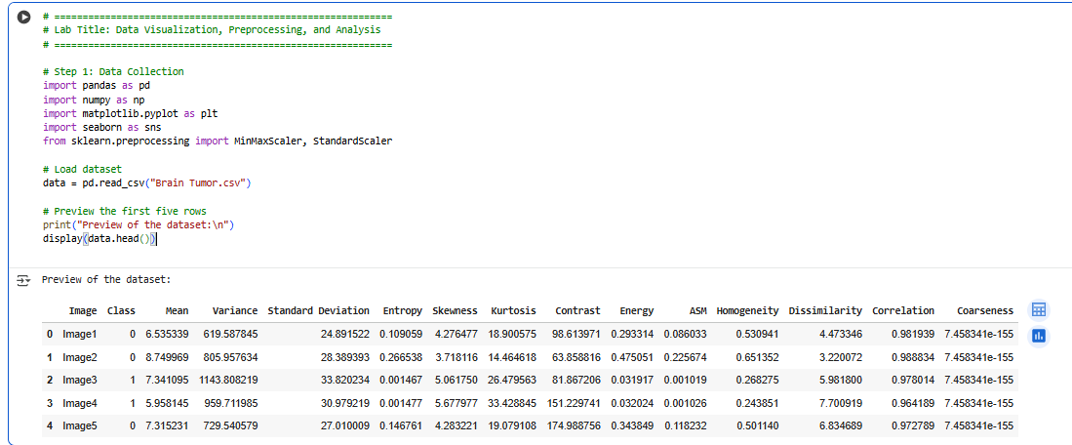
This screenshot displays the first five rows of the Brain Tumor dataset, showing key columns such as Mean, Variance, Skewness, and Class, confirming successful data import and structure integrity.

Step 2: Data Visualization
Screenshot 2 – Scatter Plot (Mean vs Variance)
This scatter plot visualizes the relationship between Mean and Variance for tumor and non-tumor images, revealing two distinguishable clusters that help identify intensity and variance patterns in medical images.
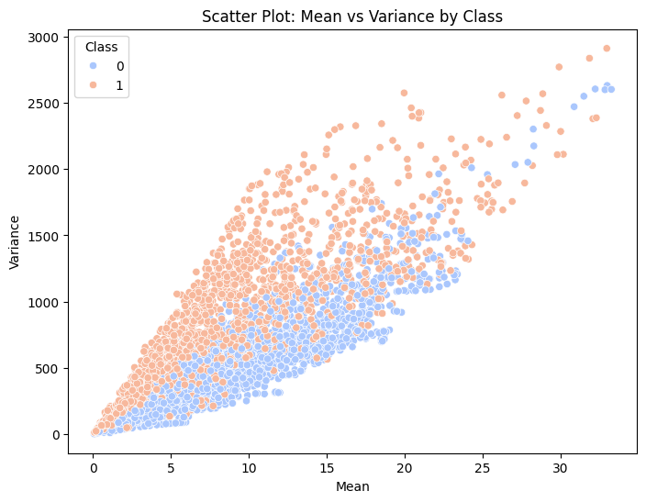
Histogram (Standard Deviation Distribution)
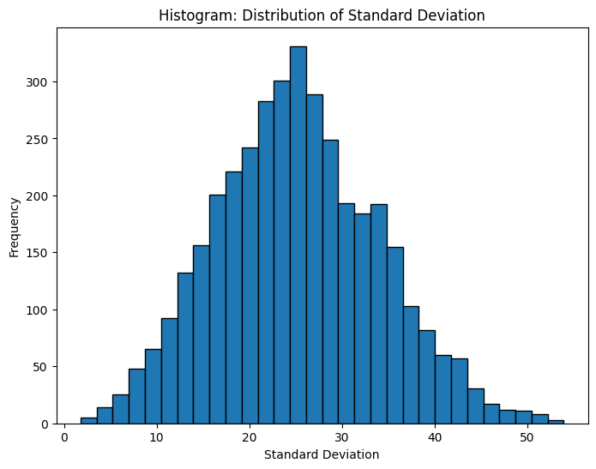
The histogram shows how Standard Deviation values are distributed across the dataset, indicating that most brain images have moderate texture variation, while a few exhibit extreme deviation levels representing image complexity.
Box Plot (Contrast)

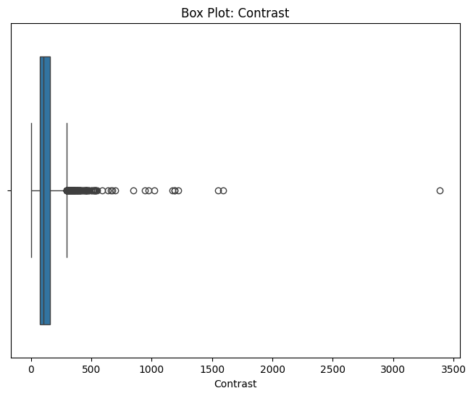
This box plot identifies outliers and overall spread in the Contrast feature, illustrating that certain tumor images have higher contrast values, which may indicate textural differences between healthy and abnormal regions.
Bar Chart (Tumor vs Non-Tumor Count)
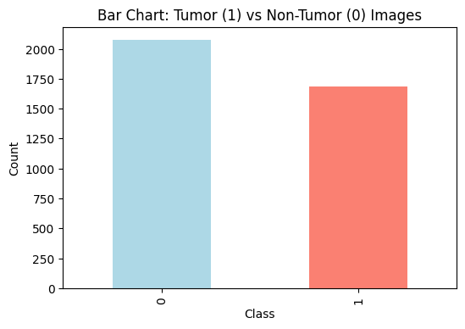
The bar chart compares the frequency of tumor and non-tumor classes, highlighting that the dataset is slightly imbalanced but still adequate for statistical modeling and classification tasks involving brain tumor detection.
Screenshot 6 – Pie Chart (Class Distribution)
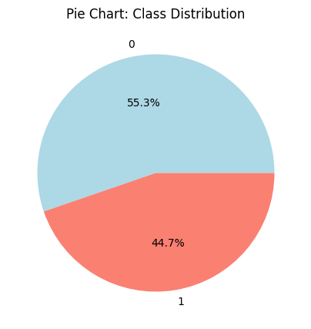
This pie chart represents the proportion of tumor and non-tumor samples, visually showing that non-tumor cases occupy a slightly larger portion, reinforcing the minor imbalance observed in the categorical distribution.

Step 3: Data Preprocessing

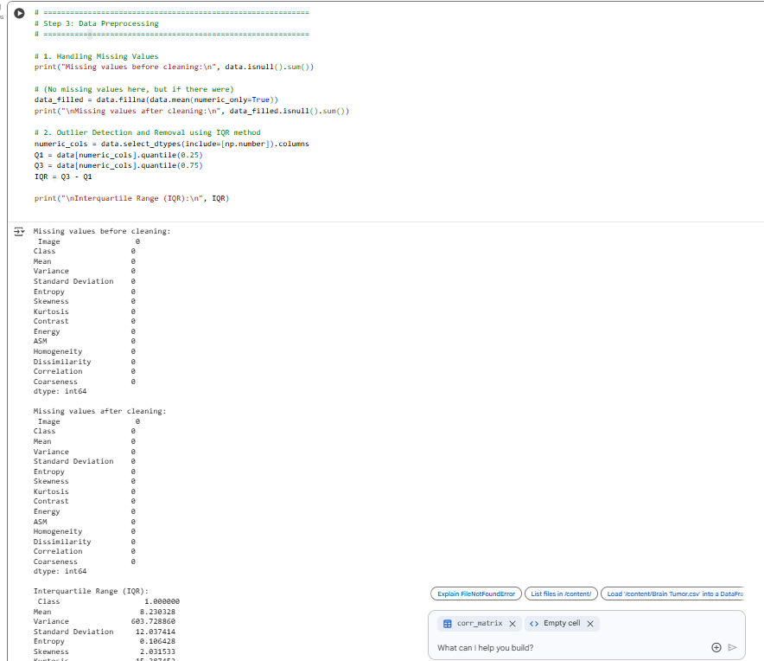
- Missing Values Before and After Cleaning : It displays missing value counts before and after applying mean imputation, confirming that the dataset is complete, with no null values detected in any of the 15 recorded columns.
- IQR Calculation and Outlier Detection
This output presents the calculated Interquartile Range (IQR) for all numerical columns and identifies several statistical outliers, which were later removed to improve data consistency and minimize skewness during analysis.
Dataset After Outlier Removal
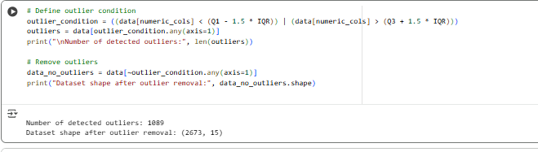
After eliminating extreme outliers using the IQR method, the dataset size decreased, enhancing data quality. This screenshot confirms successful outlier removal while retaining representative tumor and non-tumor data distributions.

Data Reduction (Column Dropping and Sampling)
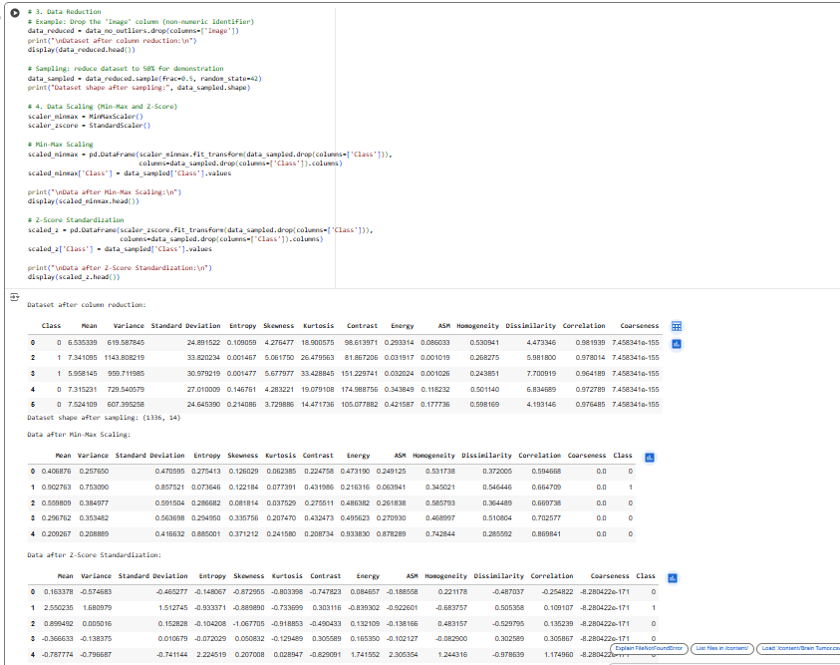
This screenshot shows the dataset after dropping the non-numeric Image column and applying 50% random sampling, effectively reducing dataset size while preserving proportional class representation for computational efficiency.
- Min-Max Scaled Dataset:The table demonstrates normalized feature values between 0 and 1 after Min-Max scaling, ensuring that attributes with varying magnitudes are brought to comparable scales for accurate statistical and machine learning analyses.
- Z-Score Standardized Dataset: This screenshot displays the same dataset standardized using Z-Score normalization, where each feature now has a mean of zero and unit variance, making it suitable for algorithms sensitive to feature magnitude differences.

Step 4: Statistical Analysis
Dataset Information (.info())
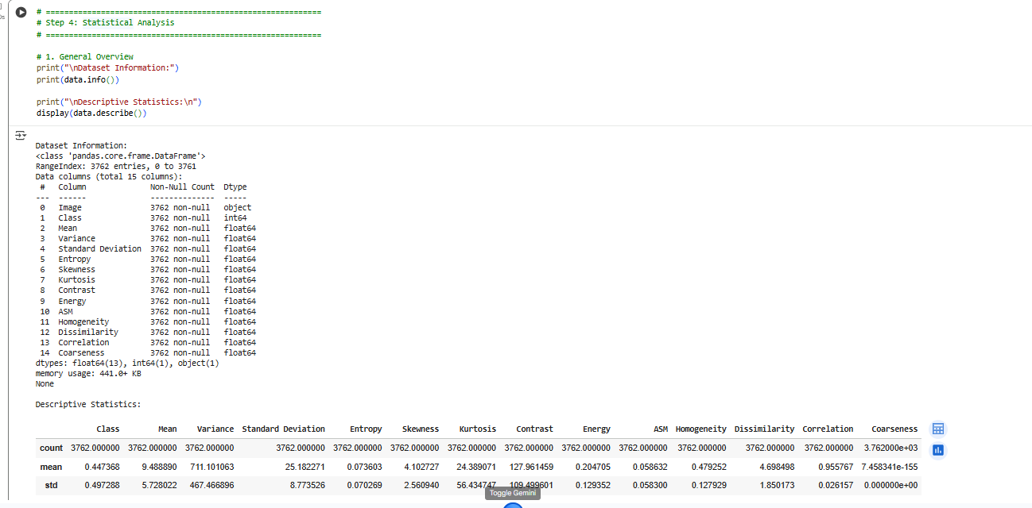
This screenshot provides dataset metadata, showing 3,762 entries and 15 columns, confirming data types, non-null counts, and memory usage, which validates dataset completeness and consistency before performing deeper analysis.
Descriptive Statistics (.describe()): This statistical summary presents key metrics such as mean, standard deviation, and percentiles for all numerical features, offering insight into overall data distribution and central tendency before advanced computations.
Central Tendency Calculations
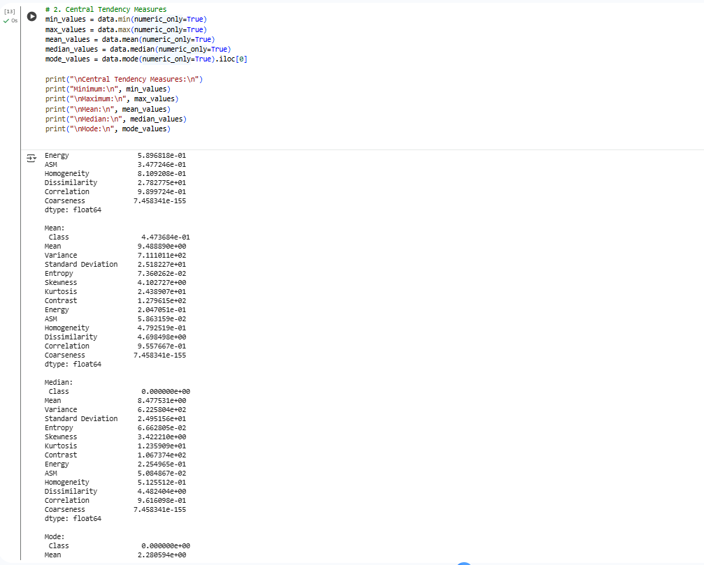
The displayed values represent minimum, maximum, mean, median, and mode for all numerical columns, highlighting the dataset’s average feature magnitudes and helping identify skewness in measures like Variance and Contrast.
Dispersion Measures (Range, IQR, Variance, Std Dev)
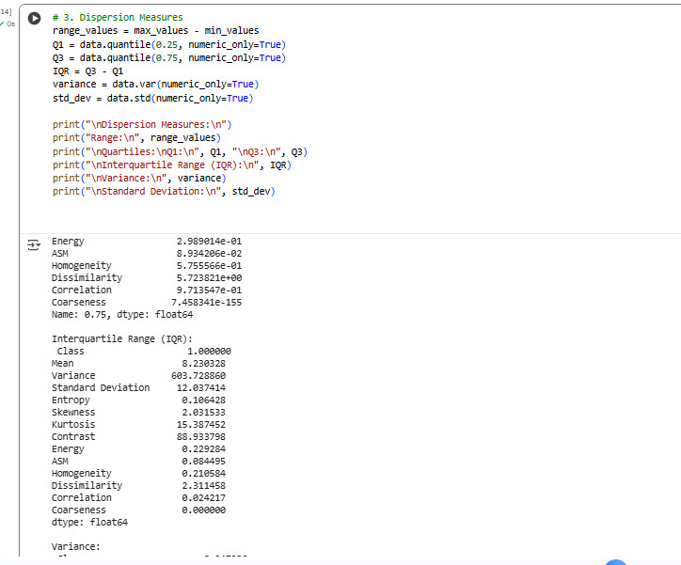
This screenshot illustrates the calculated dispersion measures, showing variability among attributes such as Variance and Contrast, helping assess feature spread, detect heterogeneity, and understand data consistency across tumor samples.
Correlation Matrix Output
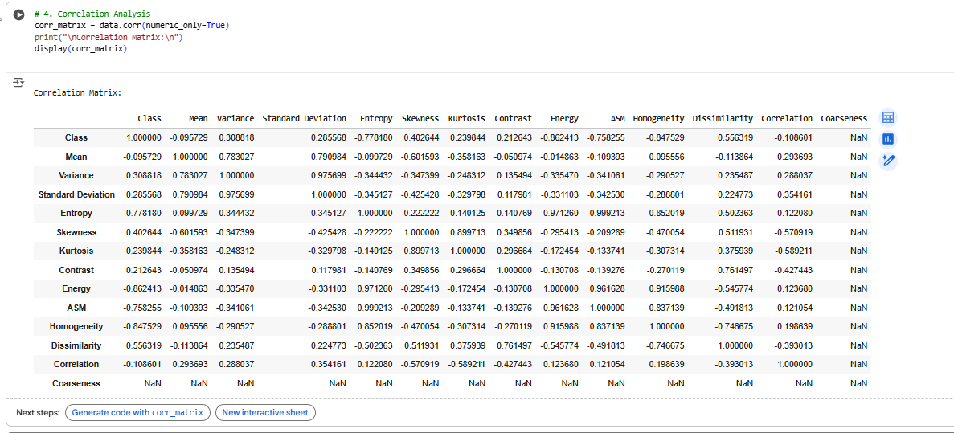
The correlation matrix numerically summarizes relationships among features, showing strong correlations between Energy, ASM, and Homogeneity, and moderate negative correlations between tumor presence and textural uniformity measures.
Correlation Heatmap
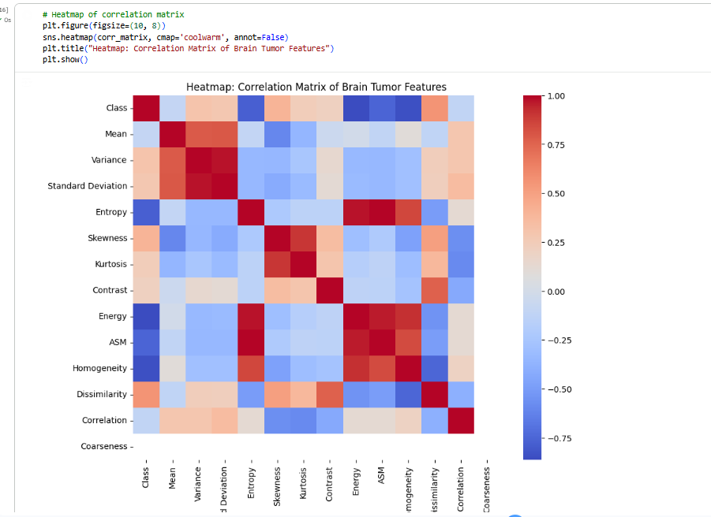
The heatmap visually displays correlation strength and direction across all numerical variables using color gradients, making it easier to identify interdependent features that could influence tumor classification outcomes.

