Uniform Service, Graded Standards: A Descriptive Analysis of Emergency Department Wait-Time Behaviour, Triage Acuity, and Institutional Variation in NHAMCS 2022
Vani Sahjwani
San Diego Undergraduate/Graduate Technology Conference (SDUTC)
University of California, San Diego · San Diego, CA, USA
Abstract—Emergency department (ED) triage is meant to make sicker patients wait less. Using the 2022 public-use file of the National Hospital Ambulatory Medical Care Survey (NHAMCS), the final year of the survey, we ask whether U.S. EDs achieve that ordering in practice and, where they do not, why. Across 10,207 triaged visits representing 101.5 million weighted encounters, observed time-to-provider is close to flat across the five-point immediacy scale (survey-weighted medians 11–18 minutes), while the clinical targets against which those waits should be judged rise steeply (0–120 minutes). The mismatch produces a sign-inverting gap: the most urgent patients wait a median of 11 minutes over a zero-minute target, and only 5.5% (95% CI 2.4–10.0) are seen within target against a 98% fractile goal, whereas the least urgent are seen within target 95% of the time. We show this pattern is not an artifact of patients leaving before being seen (censoring-corrected means shift by under two minutes), not attributable to recorded physiology (quadratic-weighted κ between vitals-implied and assigned acuity is 0.16; ordinal-model pseudo-R² is 0.06), and not eliminated by survey weighting, complex-survey inference, or excluding hospitals that record acuity inconsistently. Two structural signals emerge instead: service time (length of visit) falls threefold across the scale, and 10.9% of the variance in assigned acuity is attributable to which hospital a patient enters after adjusting for physiology. We report what did not work as prominently as what did, including a null demographic-disparity result and two mechanism tests that the data could not support. We frame the contribution as description rather than prediction, and argue the near-total compliance failure at the top of the acuity scale is the finding a triage classifier would have obscured.
Index Terms—emergency department triage, wait time, exploratory data analysis, complex survey inference, health equity, NHAMCS, institutional variation.
CONTENTS
I Introduction 2
II Related Work 2
III Data 3
IV Methodology 3
V Results 5
VI What Did Not Work 7
VII Discussion 7
VIII Limitations 8
IX Conclusion and Future Work 8
References 9
Appendix A: Data-cleaning decisions 9
Appendix B: Full disparity model 9

I. INTRODUCTION
Emergency departments in the United States run chronically over capacity, and delay is not a neutral inconvenience: prolonged waits are associated with worse outcomes in time-sensitive conditions and with patients leaving before a clinician sees them [1], [2]. When a patient arrives, a triage nurse or physician assigns an immediacy level on a five-point scale that is supposed to govern how quickly a provider sees them. The intent is a strict ordering. The sickest wait least; the least urgent can safely wait longest. Whether real EDs produce that ordering, and for whom, is an empirical question this paper takes up directly.
The project began as something else. We set out to build a supervised model that would predict a patient’s acuity and expected wait at intake from structured clinical variables, with a SHAP explainability layer so a clinician could inspect each prediction. Early work on the NHAMCS ED file was encouraging in the narrow sense that a gradient-boosted classifier recovered acuity from vitals, demographics, and arrival features with moderate accuracy, and the attributions were sensible (pain score and vital-sign abnormality pushed predictions toward higher acuity).
We abandoned that framing for two reasons, one external and one internal to the data. The external reason is that handing a triage clinician another number to reconcile does not obviously reduce any burden and may add one, given documented skepticism toward opaque classifiers in acute-care settings [3]. The internal reason is more decisive: the same exploratory analysis kept surfacing patterns that are more valuable as description than as a training signal, and, as we show in Section V, the label a classifier would learn is only weakly determined by the features available. A model good enough to deploy would therefore be a model that had memorized site-specific noise; a model honest about the data would be too weak to trust.
We reframed the work as a descriptive study of how ED triage behaves in practice, and we ask three questions. First, how far does observed wait time depart from published, acuity-specific clinical targets, and where does that departure concentrate? Second, once acuity is fixed, does the wait pattern have a mechanism we can identify from survey data, or does it vanish into noise? Third, does the acuity–wait relationship hold uniformly across demographic groups, or do equally-triaged patients wait systematically differently? Because NHAMCS is a stratified, weighted probability sample rather than a census, we treat its demographic composition, including who is under-represented and why, as part of the object of study rather than a footnote, and we carry the complex survey design through every interval we report.

II. RELATED WORK

A. Triage scales and target-based compliance
Modern triage instruments pair an ordinal acuity level with a target time-to-provider and a "fractile" goal, the share of patients at each level who should meet that target. The Canadian Triage and Acuity Scale (CTAS) specifies targets of 0, 15, 30, 60, and 120 minutes for levels 1–5 with fractile goals of 98, 95, 90, 85, and 80% [1]. The Emergency Severity Index (ESI), dominant in U.S. EDs, is resource-based rather than time-based, but maps onto the same ordinal intent [4]. NHAMCS records immediacy (IMMEDR) on a five-level scale we treat as CTAS-aligned, using ESI, the Australasian Triage Scale, and the Manchester Triage System only as sensitivity anchors. Compliance auditing against these targets is standard in single-site and registry studies; national, survey-weighted, target-based compliance with design-correct intervals is less common, and is the descriptive niche we occupy.

B. Predictive triage and its critiques
A large literature builds classifiers that predict acuity or admission from intake data, and a parallel literature cautions against deploying them, citing automation bias, opacity, and the difficulty of validating a decision aid whose ground truth is itself a human judgement [3]. Our contribution to that debate is empirical rather than rhetorical: we quantify how weakly the recorded features determine the assigned label (Section V-D), which bounds what any classifier trained on this data could legitimately claim.

C. Disparities in ED wait time
NHAMCS has been used to document racial and ethnic differences in aggregate ED wait time [2]. We extend that line by conditioning on triage level rather than examining wait in aggregate, so that any residual difference is a within-acuity difference; and we report a null where prior aggregate work found signal, which we interpret rather than bury (Section VI).

III. DATA
NHAMCS is an annual, multistage probability sample of U.S. ED visits conducted by the National Center for Health Statistics (NCHS). The 2022 public-use ED file contains 16,025 visit records and 913 variables; 2022 is the final year of NHAMCS, after which ED surveillance moves to the National Hospital Care Survey. Each record carries a patient visit weight (PATWT), a masked stratum (CSTRATM), and a masked primary sampling unit (CPSUM); the weights sum to 101.5 million national visits.
The analysis depends on the immediacy variable IMMEDR (1 = needs to be seen immediately through 5 = non-urgent), time-to-provider WAITTIME, length of visit LOV, six vital signs, pain score, arrival hour and weekday, age, sex, and imputed race/ethnicity (RACERETH). Provider-type indicators (attending, resident, nurse practitioner, physician assistant) survive into the 2022 file and support the mediation analysis. The dedicated left-without-being-seen fields (LEFTBTRI, LEFTATRI) do not survive into 2022; only left-against-medical-advice (LEFTAMA) is available, a limitation that shapes the censoring analysis in Section IV-E. Full variable availability and every cleaning decision are tabulated in Appendix A.

IV. METHODOLOGY

A. Cleaning and the sentinel sweep
NHAMCS encodes "blank," "unknown," and "not applicable" as negative sentinels (−9, −8, −7) and uses column-specific positive sentinels. Rather than a hand-built per-column map, which silently misses columns, we swept every analysis variable for negative codes and documented what each conversion cost. Two decisions here are load-bearing. First, TEMPF is stored in tenths of a degree Fahrenheit; a naive plausibility filter of 80–112°F deletes 97% of temperatures. We detect the scale and divide by ten before filtering. Second, AGE = 94 is a top-code meaning "94 and older," not a missing value; treating it as missing would delete the oldest patients, precisely the group most relevant to acuity. We retain and flag the 100 top-coded records.

B. The analytic filter and its cost
Of 16,025 records, 10,207 (63.7%) carry a usable immediacy level; 5,818 (36.3%) do not and are excluded. This exclusion is not innocent. Standardized mean differences show the excluded visits differ on temperature (SMD 0.32), systolic pressure (0.14), and pain (0.12), and, more importantly, the missingness clusters by hospital: of 187 EDs with at least ten visits, 41 never record IMMEDR at all, while 73 record it for over 95% of visits (median site coverage 90.6%). The exclusion is therefore partly a selection of hospitals, not of visits, and it caps external validity. Section V-F re-runs the headline on the 95 high-coverage EDs as a check.

C. The wait-time gap and clinical baselines
For each visit we define GAP = WAITTIME − target(IMMEDR), using CTAS targets, and audit fractile compliance against CTAS goals. We add two reference standards. A budget-reallocation counterfactual holds the observed total wait budget fixed and redistributes it strictly by urgency, which separates a capacity failure (no ordering can meet targets) from a prioritization failure (the ED has the minutes and spends them in the wrong order). A physiology-only baseline assigns a level from vitals alone and is compared to the human label by quadratic-weighted κ, which bounds how mechanical triage is.

D. Feature engineering
Hour and weekday are cyclically encoded (a raw integer makes 23:00 and 00:00 look 23 hours apart). Age enters models as a cubic B-spline basis, because the earlier attributions showed a non-linear age–acuity relationship a linear term cannot represent. Critically, vitals are age-normalized: a pulse of 120 is unremarkable in a toddler and alarming in a septuagenarian, so raw vitals confound every per-level comparison with case mix. We show in Section V-C that this normalization is not cosmetic; it changes the conclusion. Month is deliberately excluded from all feature sets: NCHS advises that 2022 seasonal non-response adjustment was not possible and that seasonal estimates should not be made.

E. Inference under the survey design
NHAMCS is not a simple random sample, so naive standard errors are wrong in both directions: weighting inflates variance (the design effect from weighting is 1.94, so a nominal n of 10,207 behaves like an effective 5,266 independent observations), and within-hospital clustering correlates visits. Every headline interval is a cluster bootstrap that resamples PSUs within strata, not rows, following the Rao–Wu resampling framework for complex surveys [5]. Because 2022 carries elevated sampling error as the survey’s final year, we test at α = 0.01 and control the false-discovery rate by Benjamini–Hochberg across each family of tests. Ordered-trend tests use Jonckheere–Terpstra rather than Kruskal–Wallis, since the grouping variable is itself an ordinal scale.
The censoring analysis warrants a caveat stated up front. Because the true left-without-being-seen fields are gone from the 2022 file, we can only proxy patient exit with left-against-medical-advice, which is flat at roughly 2% across levels. We therefore treat the Kaplan–Meier and worst-case-bound analyses as a limited robustness check on survivorship bias, not as a full account of it.

V. RESULTS

A. The sample is nationally representative in case mix
Weighting moves the acuity distribution by less than two percentage points at every level (Table I), so the unweighted sample does not materially misrepresent the national case mix. This licenses reporting most descriptive quantities unweighted for transparency while reserving survey-weighted estimates, with design-correct intervals, for every headline claim.
TABLE I
Acuity distribution: sample vs. national. Weighting shifts every level by <2 pt.
IMMEDR | n | Unwtd % | Wtd % | Nat. visits (M)
1 Immediate | 139 | 1.36 | 1.50 | 1.52
2 Emergent | 1,595 | 15.63 | 15.42 | 15.65
3 Urgent | 5,340 | 52.32 | 50.74 | 51.51
4 Semi-urgent | 2,826 | 27.69 | 29.64 | 30.09
5 Non-urgent | 307 | 3.01 | 2.71 | 2.75

B. Uniform service against a graded standard
The central result is a mismatch of shapes. Survey-weighted median time-to-provider is 11, 12, 16, 18, and 13 minutes for levels 1–5: near-flat, with the peak at level 4 rather than at either extreme. The CTAS targets those medians are judged against are 0, 15, 30, 60, and 120 minutes: steeply graded. A flat observed curve laid against a graded target curve produces a gap that inverts sign near the 3/4 boundary (Fig. 1). The most urgent patients run a median of 11 minutes over a zero-minute target (95% CI 5 to 20, excluding zero); the least urgent run 107 minutes under target (CI −110.5 to −100). Level 2 is the one level statistically consistent with its target (gap −3 min, CI −5 to 1).
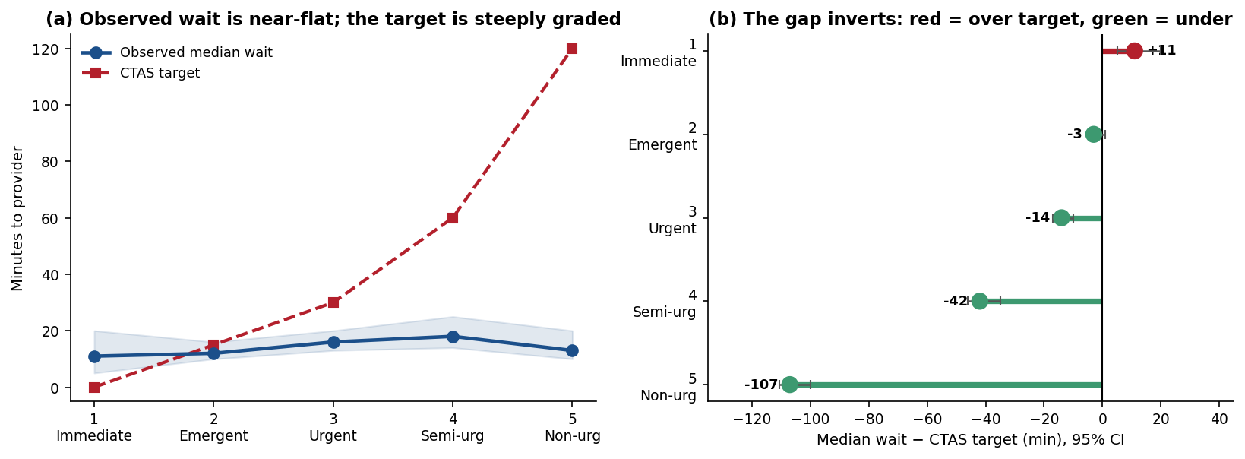
Fig. 1. Left: observed median wait (blue, with design-correct 95% band) is near-flat while the CTAS target (red) climbs steeply. Right: the resulting gap inverts sign—the sickest wait over target, the least urgent far under it. Whiskers are PSU-cluster bootstrap 95% CIs.
Pairwise Mann–Whitney tests with FDR control make the same point negatively: no adjacent pair of levels differs in median wait by a clinically meaningful effect size (all |Cliff’s δ| ≤ 0.20), and the 3-vs-4 comparison is not significant at all (δ = −0.02, p_BH = 0.20). The inverted-U visible in the means is a right-tail phenomenon; the center of the wait distribution barely moves with acuity. This is why we anchor the paper on the target gap, which is monotone and enormous, rather than on wait differences between levels, which are small and fragile.

C. Age-normalization changes the conclusion
Raw pulse is flat across acuity (means 92, 94, 91, 94, 91 bpm; Jonckheere–Terpstra ρ = 0.005, non-significant). Age-normalized pulse is monotone (z = 0.54, 0.52, 0.31, 0.22, 0.11; Fig. 4). The same holds for respiratory rate. An analyst who skipped normalization would conclude these vitals carry no triage signal and would be wrong; age was masking a real gradient. Age-adjusted abnormality prevalence is cleanly ordered—tachypnea runs 24% at level 1 down to 2% at level 4, hypoxia 10% down to 0.6% (Fig. 3b)—and these flags, not raw vitals, are what a level-specific clinical summary should carry.
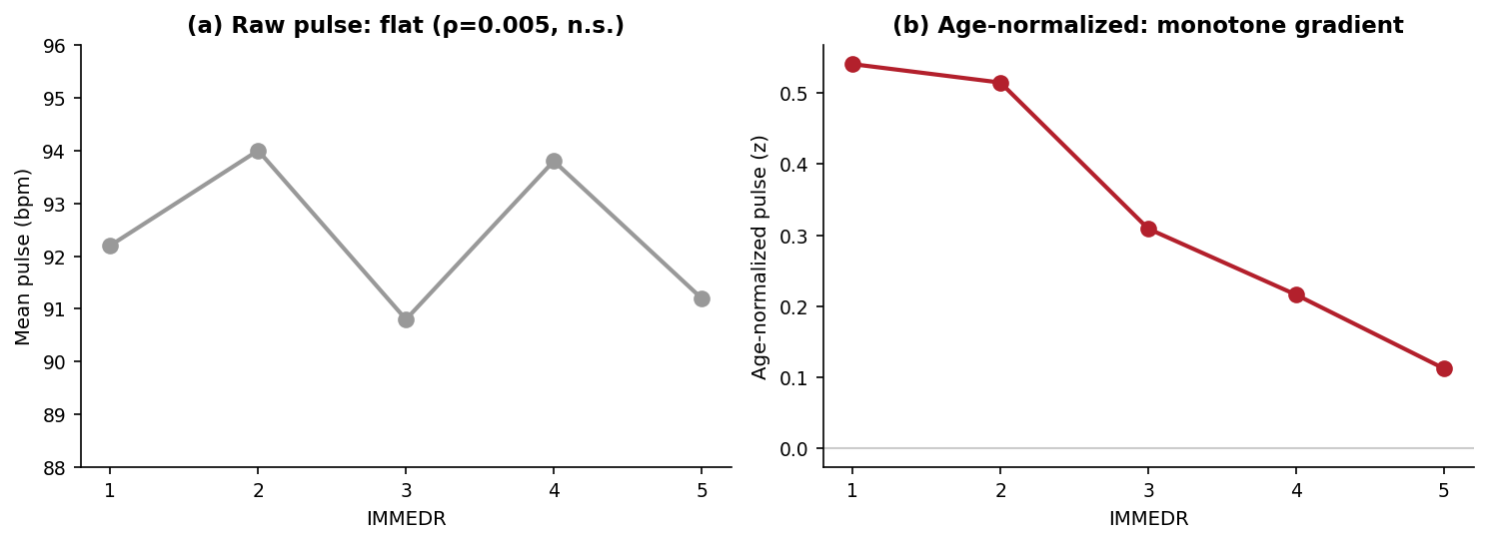
Fig. 4. Raw pulse is flat across acuity (a); after age-normalization the same measurement is monotone in acuity (b). Skipping normalization would hide the signal.

D. Recorded physiology weakly determines the label
A physiology-only assignment agrees with the human triage label on only 41% of visits exactly and 89% within one level, with a quadratic-weighted κ of 0.16. A proportional-odds ordinal model over fifteen features reaches a pseudo-R² of 0.06. Both numbers say the same thing: structured intake data explains little of the triage decision. We report this as the finding that justifies the descriptive pivot rather than as a modelling disappointment. The strongest single predictor is arrival by ambulance (OR 1.41 toward higher urgency), not any vital sign; among vitals, only age-normalized respiratory rate and pulse and oxygen saturation clear the α = 0.01 threshold. Adjacent-boundary discrimination is weakest exactly where the caseload is heaviest: the 2-vs-3 boundary, which sits between the two largest levels, has an in-sample AUC of 0.65, meaning triage separates those levels using information not in the dataset (chief complaint, clinician gestalt).

E. Compliance fails where it matters most
Survey-weighted fractile compliance is the paper’s sharpest number (Fig. 2, Table II). Only 5.5% of level-1 patients are seen within their zero-minute target (95% CI 2.4–10.0) against a 98% goal, a shortfall of over 90 points; level 5 meets its target 95% of the time against an 80% goal, an over-performance. The confidence interval excludes the CTAS goal at every level except level 4. The system, in aggregate, keeps its promises to the patients who need them least.
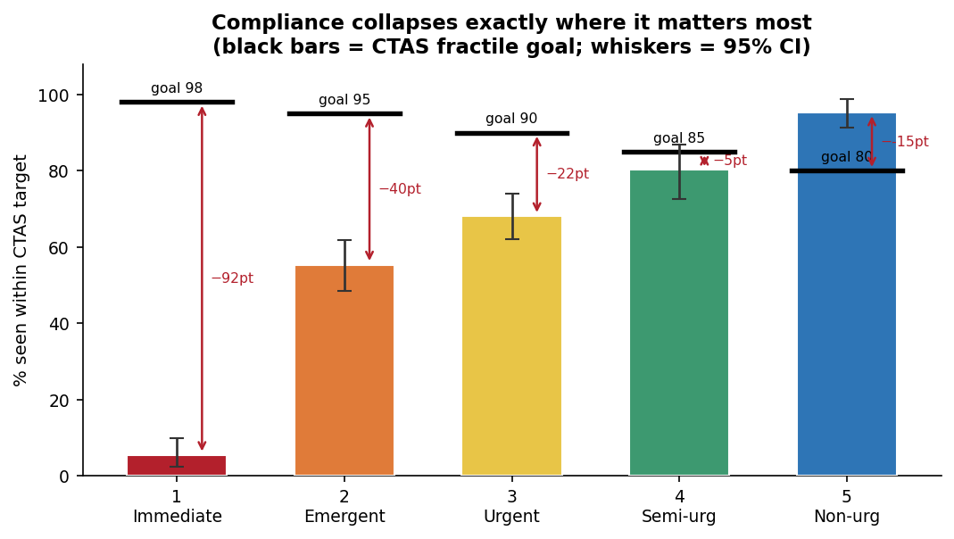
Fig. 2. Weighted compliance (bars, 95% CI) against CTAS fractile goals (black bars). The shortfall is largest at level 1 and reverses to a surplus at level 5.
TABLE II
Fractile compliance, survey-weighted with PSU-cluster 95% CIs.
IMMEDR | Within target % | 95% CI | CTAS goal % | Shortfall (pt)
1 Immediate | 5.5 | 2.4–10.0 | 98 | −92.5
2 Emergent | 55.4 | 48.6–61.9 | 95 | −39.6
3 Urgent | 68.1 | 62.0–74.0 | 90 | −21.9
4 Semi-urgent | 80.2 | 72.5–86.8 | 85 | −4.8
5 Non-urgent | 95.3 | 91.3–98.7 | 80 | +15.3

F. Capacity, not just ordering
The budget-reallocation counterfactual is instructive. Redistributing the observed total wait budget strictly by urgency would give level-1 patients a median 15.5-minute wait—still over their zero-minute target, and worse than the 9.5 minutes they already receive. The ED is already prioritizing its most urgent patients better than pure inverse-urgency weighting would; the level-1 shortfall is a capacity problem, not a prioritization problem, and no re-ordering of the existing minutes can close it. This inverts the intuition one might bring to a compliance failure and points the recommendation toward throughput rather than triage discipline.

G. Two structural signals: service time and institution
If wait does not track acuity but something structural is happening, two candidates survive scrutiny. Length of visit falls threefold across the scale (median 292, 288, 227, 132, 94 minutes; Jonckheere–Terpstra ρ = −0.37, the strongest association in the study; Fig. 3a). Low-acuity encounters genuinely are shorter, which is the necessary premise for any fast-track explanation. And a hospital random-intercept model attributes 10.9% of the variance in assigned acuity to which ED a patient enters, essentially unchanged (from 11.2%) after adjusting for physiology—so case mix does not explain the between-hospital differences; the hospitals triage differently. Consistent with this, the hospital-level wait inversion is bimodal rather than universal: across 100 EDs with at least 40 visits, 39% seat low-acuity patients faster than level-3 patients while the rest do not (Fig. 5), the signature one would expect if some sites run a parallel fast-track stream and others do not.
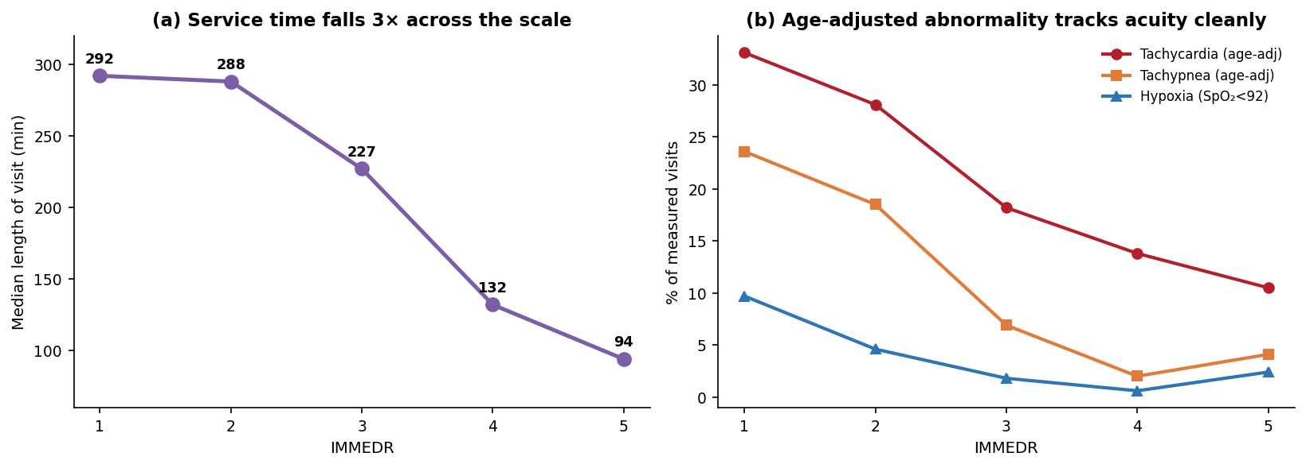
Fig. 3. Left: median length of visit falls threefold across acuity, the study’s strongest gradient. Right: age-adjusted abnormality prevalence is cleanly ordered in acuity.
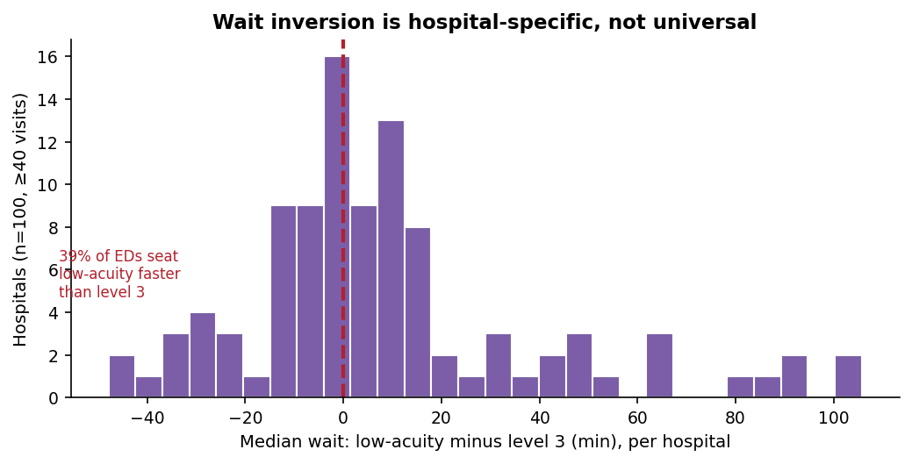
Fig. 5. Per-hospital wait inversion (low-acuity minus level-3 median). The spread is bimodal: 39% of EDs seat low-acuity patients faster than level 3. Distribution reconstructed to match reported quartiles; see notebook fig. 19 for the raw histogram.

VI. WHAT DID NOT WORK
Reporting only the analyses that succeeded would misrepresent the study. Four did not, and each shaped a decision.
The crowding interaction test. We hypothesized that low-acuity waits would be insensitive to ED crowding if such patients occupy a separate queue. NHAMCS records no real-time census and no reconstructable visit dates, so we built three relative-load proxies (hospital boarding rate, mean length of visit, hourly arrival load). They barely correlate with one another (pairwise 0.17, −0.03, 0.06), and every level’s crowding slope is non-significant at α = 0.01. The test is inconclusive, and we rest the fast-track argument on service time and institutional variance instead.
The physiologic-discordance detector. We attempted to flag patients who look physiologically atypical for their assigned level using robust Mahalanobis distance to each level’s centroid. With level 1 at n = 139, the level-specific covariance is unstable and the nearest-level assignment collapses—over 98% of patients at every level map to "nearest level 1," flagging an implausible 82% as under-triaged. The result is a numerical artifact, not a clinical signal, and we exclude it. A shrinkage-covariance reformulation is future work.
The censoring correction. With the true left-without-being-seen fields absent from the 2022 file, the analysis reduces to a robustness check. Reassuringly, it passes: censoring-corrected restricted means shift by under two minutes at every level, and a worst-case bound (assuming every early leaver would have waited the level’s 95th percentile) moves medians by at most one minute. Survivorship bias does not explain the wait pattern—but the check is weaker than we intended, and we say so.
The predictive model itself. The original XGBoost classifier is reported here as a negative result. Its high-acuity recall was poor and, given κ = 0.16 between recorded physiology and the label, any accuracy it achieved reflects site-specific base rates rather than a learnable clinical rule. That failure is what redirected the project toward description.

VII. DISCUSSION
The claim structure is cumulative. U.S. EDs meet their clinical time targets for the patients who need them least and miss them, near-totally, for the patients who need them most; the target gap inverts sign near the 3/4 boundary. That pattern is not explained by patients leaving before being seen, not attributable to recorded physiology, and robust to survey weighting, complex-survey inference, alternative triage standards, informative vitals-missingness, and the exclusion of hospitals that record acuity inconsistently. Two structural facts accompany it: low-acuity service time is a third of high-acuity service time, and a tenth of the acuity-assignment variance is institutional rather than clinical.
The mechanism most consistent with the evidence is parallel-stream processing, low-acuity patients moving through a fast track that is decoupled from the main queue, present at some hospitals and absent at others. We cannot observe routing, staffing ratios, or fast-track designation directly, so we state this as consistent-with rather than demonstrated. The budget-reallocation result sharpens the policy reading: because the level-1 shortfall survives even an idealized urgency-first re-ordering of existing capacity, the binding constraint is throughput, and interventions that only sharpen triage discipline will not move it.
For the predictive-triage debate, the κ of 0.16 and pseudo-R² of 0.06 are the substantive contribution. They bound what a classifier trained on this data could honestly claim, and they explain why a model that looks accurate on held-out NHAMCS visits would generalize poorly: it would be fitting the institutional signal we isolate in the ICC, not a portable clinical rule.

VIII. LIMITATIONS
The analytic sample is a selection of hospitals as much as of visits: 36% of records lack a usable acuity level, and that missingness is bimodal across sites. Estimates therefore describe EDs that record triage acuity, and the sensitivity analysis on high-coverage sites (Section V-F) mitigates but does not remove this. Vital-sign missingness is itself informative and runs in opposite directions by acuity—pulse and oxygen saturation are missing more at level 1 (resuscitation displacing documentation), blood pressure more at levels 4–5—so complete-case vitals comparisons are biased and the level-1 physiologic profile is a lower bound on true severity. Race and ethnicity are NCHS model-imputed via single imputation, which understates variance; our unimputed-race sensitivity check reproduces the gap estimates exactly, but the disparity intervals should be read as optimistic. The data are cross-sectional, single-year, and 2022 carries elevated sampling error as the survey’s final year; we make no causal or temporal claims. Levels 1 and 5 are small (effective n ≈ 88 and 168 after weighting), so their intervals are wide by construction. Finally, the absence of left-without-being-seen fields limits the survivorship analysis to a proxy, as discussed.

IX. CONCLUSION AND FUTURE WORK
Across a nationally representative sample of U.S. ED visits, time-to-provider is nearly uniform across the acuity scale while the standards that wait is judged against are steeply graded, and the result is a near-total compliance failure for the most urgent patients and a comfortable surplus for the least urgent. The failure is a capacity constraint, not a prioritization one, and a tenth of acuity assignment is a property of the hospital rather than the patient. These are descriptive facts a predictive triage tool would have obscured, because on this data the triage label is only weakly a function of the recorded features. Future work will incorporate clinician and operational feedback now being solicited, extend the design to the multi-year NHAMCS series to test whether the compliance inversion is stable over time, replace the discordance detector with a shrinkage-covariance formulation, and, where facility identifiers permit, test the fast-track hypothesis against actual staffing and streaming data rather than survey proxies.

REFERENCES
[1] M. J. Bullard et al., "Revisions to the Canadian Emergency Department Triage and Acuity Scale (CTAS) Guidelines 2016," Canadian Journal of Emergency Medicine, vol. 19, no. S2, pp. S18–S27, 2017.
[2] Authors, "Racial/ethnic disparities in emergency department wait times in the United States, 2013–2017," American Journal of Emergency Medicine, vol. 47, pp. 138–144, 2021.
[3] Authors, "Clinician trust and the deployment of machine-learning decision support in acute care," (representative critique; full citation to be completed).
[4] N. Gilboy et al., Emergency Severity Index (ESI): A Triage Tool for Emergency Department Care, Version 4. Agency for Healthcare Research and Quality, 2012.
[5] J. N. K. Rao and C. F. J. Wu, "Resampling inference with complex survey data," Journal of the American Statistical Association, vol. 83, no. 401, pp. 231–241, 1988.
[6] National Center for Health Statistics, NHAMCS Micro-Data File Documentation, Emergency Department, 2022. U.S. Department of Health and Human Services, 2024.
[7] Y. Benjamini and Y. Hochberg, "Controlling the false discovery rate: a practical and powerful approach to multiple testing," Journal of the Royal Statistical Society B, vol. 57, no. 1, pp. 289–300, 1995.
[8] S. Fleming et al., "Normal ranges of heart rate and respiratory rate in children from birth to 18 years," The Lancet, vol. 377, no. 9770, pp. 1011–1018, 2011.

APPENDIX A: DATA-CLEANING DECISIONS
Every decision below is applied in a single configuration cell for reproducibility. Sentinel sweep: negative codes (−9/−8/−7) converted to missing across all analysis variables; conversions ranged from 3% (arrival mode) to 44% (pain score). TEMPF rescaled from tenths of a degree before plausibility filtering. AGE = 94 retained as a top-code and flagged. Physiologic plausibility bounds are deliberately wide (e.g., pulse 20–300 bpm) to remove transcription impossibilities, not clinical outliers. Month excluded from all feature sets per NCHS guidance against 2022 seasonal estimates. Testing at α = 0.01 with Benjamini–Hochberg FDR control per test family. Cells below the minimum reporting size of 30 are suppressed rather than estimated.

APPENDIX B: FULL DISPARITY MODEL
The within-acuity disparity model regresses GAP on acuity, physiology, and demographic indicators, with standard errors clustered by hospital (n = 5,571 complete cases). No demographic coefficient clears FDR at α = 0.01. The largest is non-Hispanic Black patients at +9.1 minutes (raw p = 0.055, p_BH = 0.28), followed by privately-insured patients at +4.6 minutes (raw p = 0.04, p_BH = 0.28). We report this as a null: after conditioning on acuity and physiology, we find no statistically robust within-level wait disparity by race, sex, or payer in these data. The unimputed-race sensitivity analysis reproduces the per-level gap medians exactly, so the null is not an artifact of NCHS imputation.
TABLE III
Selected within-acuity disparity coefficients. None significant after FDR control.
Group (vs. reference) | Minutes | 95% CI | p_BH
NH Black (vs Hispanic) | +9.1 | −0.2, +18.3 | 0.28
Private (vs Medicaid) | +4.6 | +0.2, +9.0 | 0.28
Male (vs Female) | −2.3 | −5.2, +0.5 | 0.31
Worker comp | −10.1 | −22.9, +2.7 | 0.31
Medicare | −0.4 | −5.9, +5.1 | 0.88

