IPL Match Analytics
Insights & Recommendations Report
Based on 1,212 IPL matches (2008–2026), cleaned in Week 1, explored in Week 2, verified in SQL in Week 3, and visualized in the Week 4 Excel dashboard.

Summary
This analysis worked through 1,212 IPL matches end-to-end: cleaning the raw data, exploring it, verifying findings in SQL, and building an interactive dashboard. Along the way it surfaced two real data-quality issues that changed the results — a phantom "winner" recorded for rain-abandoned matches, and inconsistent venue naming that hid which ground has actually hosted the most cricket. Below are the three findings from this analysis with the biggest practical payoff, each backed by a chart, and a specific action to take on it.

Finding 1 — The toss barely predicts the winner, yet the whole league now plays as if it does
Across 1,187 completed matches, the team that wins the toss goes on to win the match only 51.6% of the time — statistically indistinguishable from a coin flip (613 of 1,187). Despite that, the league-wide toss decision has swung hard: in the first several seasons captains were close to split on batting vs. fielding first, but from 2016 onward, 80%+ of toss winners choose to field, expecting to chase. The strategy consensus moved a long way; the actual advantage from winning the toss did not move at all.
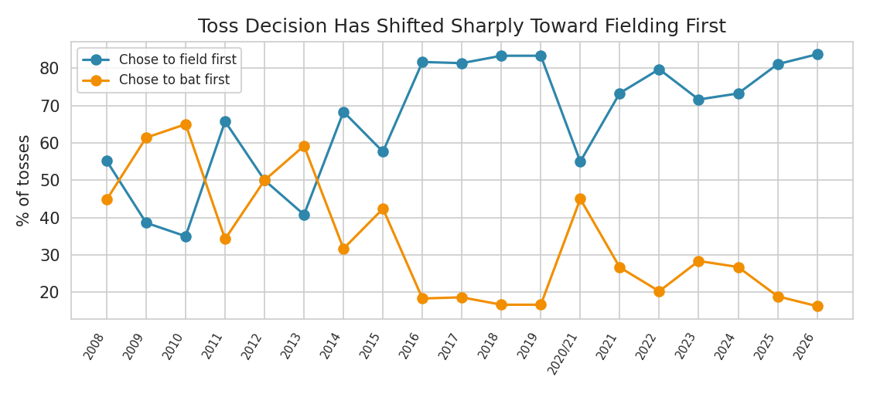
Toss decision by season — % of toss winners choosing to field first vs. bat first
Action:
- Analysts and coaching staff should stop treating "we won the toss" as a meaningful edge in pre-match win-probability estimates — condition instead on pitch report, dew forecast, and each team's specific chase-vs-defend record at that venue, not on toss result alone.
- Because the whole league has converged on "field first," a team willing to set a target well (rather than always chase) may find under-exploited value precisely because so few opponents now prepare seriously to defend a score.

Finding 2 — Venue analysis was wrong until the data was cleaned: Wankhede, not Eden Gardens, is IPL's busiest ground
The raw data records venues inconsistently — the same physical ground appears under multiple text variants across seasons (e.g. "Wankhede Stadium" vs. "Wankhede Stadium, Mumbai"; "M Chinnaswamy Stadium" vs. "M.Chinnaswamy Stadium"). Grouped naively, Eden Gardens looks like the most-used venue in IPL history (77 matches). Once 59 raw venue labels are normalized down to 41 real grounds, Wankhede Stadium is clearly first with 130 matches — 26 more than Eden Gardens' corrected total of 104.
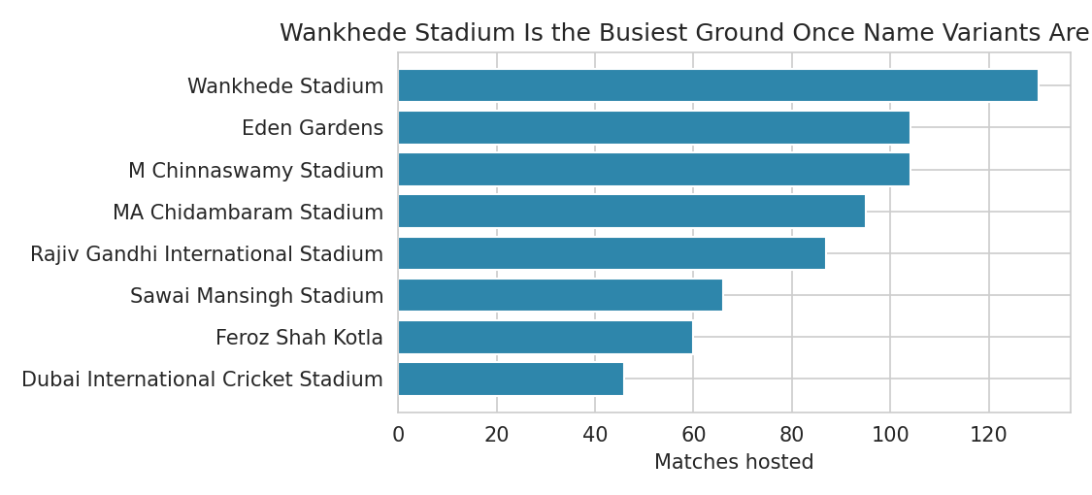
Top venues by matches hosted, after merging venue name variants
Action:
- Any venue-level analysis (ground-specific pitch behavior, average first-innings score by venue, home-advantage studies) must run on the cleaned venue_clean field, not the raw venue text — the raw field silently splits real samples in two and understates statistical confidence at high-traffic grounds.
- Add venue-name normalization as a standing step in the data pipeline (a lookup/mapping table maintained alongside the season data), not a one-off fix, since every new season keeps introducing fresh spelling/suffix variants.

Finding 3 — Ranking teams by total wins rewards longevity, not performance; win rate tells a different story
Mumbai Indians (155 wins) and Chennai Super Kings (145 wins) top the league by total wins, but they've also played roughly 4x as many matches as newer franchises. Looking at win rate instead: Gujarat Titans leads the league at 60.9% despite only 3 seasons of history, while three long-established franchises — Sunrisers Hyderabad (46.8%), Punjab Kings (47.4%) and Delhi Capitals (44.9%) — have below-.500 win rates despite 270+ matches of experience.
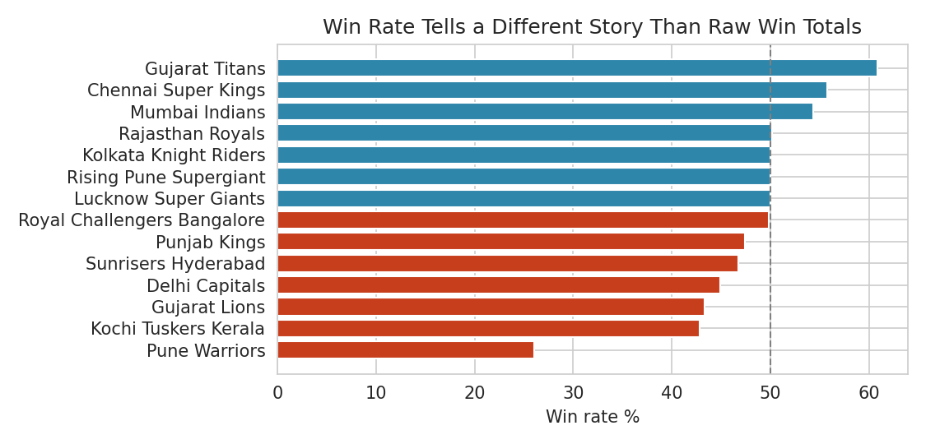
Team win rate (wins / matches played) — bars below the 50% line have a losing record
Action:
- Use win rate (or a possession-adjusted equivalent), not cumulative win count, as the headline KPI on any team-performance dashboard or leadership scorecard — cumulative counts favor teams that have simply existed longer.
- Flag Delhi Capitals, Punjab Kings, and Sunrisers Hyderabad for a specific strategic review: each has had a large enough sample (270+ matches) that a sub-50% win rate reflects a genuine, sustained performance gap rather than short-term variance, unlike Gujarat Titans' small 69-match sample, which needs more seasons before its 60.9% rate can be trusted to hold.

Where to go next
Full detail behind each finding — the data-cleaning steps, all 7 EDA charts, the 10 verified SQL queries, and the live dashboard — is in the accompanying notebooks, SQL file, and Week4_IPL_Dashboard.xlsx. The dashboard's stat sheets recalculate automatically from the Matches sheet, so a future season is a matter of appending rows, not rebuilding the model.

