SIMATS ENGINEERING
ASSESSMENT TOOL 3: Game Based Learning Assessment
COURSE NAME: | ARTIFICIAL INTELLIGENCE | COURSE CODE: MLA01
 | AND EXPERT SYSTEMS
COURSE OUTCOME COVERED
CO1: Apply search algorithms and heuristic techniques to solve state-space search
and optimization problems. (BTL 3)
Assessment Tool Weightage: 40 %
Total Marks: 50​ ​ ​ ​ ​ ​ ​ ​ Time: 60 Mins
No. of Questions: 5
Annexure A
Game Based Learning Assessment
Code of Conduct:
I _J.Venkata sai(192525433)_ (Name / Reg No) certify that this submission is my
original work and that I have adhered to the guidelines specified for this assessment.
I understand that any violation of academic integrity rules will result in disciplinary
action.
Signature of the student:
Criterion | Weightage | Marks Obtained
Understanding of the Problem / Game Objective | 10%
Application of AI Search / Problem-Solving Technique | 15%
Successful Completion of the Game / Puzzle | 20%
Efficiency of Solution / Optimal Moves | 10%
Documentation / Evidence of Completion | 15%
Understanding of the Problem / Game Objective | 15%
Originality and Critical Thinking | 15%
Total | 100%

Signature of the Faculty​ ​ | ​ | ​ | ​ | ​ | Total Marks Awarded

Answer All the Questions
Q. No. | Scenario / Game Question | Platform | Link
1 | 1 AI Maze Escape:  You are an AI robot trapped in a maze. Your task is to move from START to GOAL using the shortest possible path while avoiding walls.  Challenge: Find the shortest path and record the number of steps taken. | Scratch | https://scratch.mit .edu
2 | 2 N-Queens Challenge:  ​  You are an AI chess strategist. Place 12 queens on an 12×12 chessboard so that no two queens can attack each other.  Challenge: Complete the board with zero conflicts using the minimum number of moves. | Online N-Queens Game | https://www.n-que ens.com
3 | 3 Water Jug Puzzle:  You are an AI agent solving a water jug problem. You have two jugs with capacities of 11 litres and 9 litres. Neither jug has measurement markings.  Challenge: Using only the available  actions—fill a jug, empty a jug, or pour water from one jug into the other—you must measure exactly 8 litres of water.  Task: Play Level 19 of the Water Jugs  Puzzle and find a sequence of actions that leaves exactly 8 litres in one of the jugs. Try to solve the puzzle using the minimum  number of moves. | Tic-Tac-Toe | https://playtictact oe.org
4 | 4 Connect Four AI Challenge:  You are playing against an AI opponent. Your goal is to connect four of your pieces in a row before the AI does.  Challenge: Plan your moves carefully and defeat the AI opponent. | Connect Four | https://www.math sisfun.com/games /connect4.html

5 | 5 8-Puzzle AI Challenge:  You are given a scrambled 8-puzzle. Move the tiles one at a time and arrange them in the correct order.  Challenge: Solve the puzzle using the minimum possible number of moves. | 8-Puzzle Game | https://8puzzle.org/

Structure of the Report – Game-Based Learning
S.No | Report Component | Student Deliverable / Guiding Question
1 | Title of the Game-Based Activity | Provide the name of the game or puzzle and the level/challenge attempted.
2 | 2 Game Platform / Link | Mention the platform or website used and provide the corresponding game link.
3 | 3 Objective of the Activity | Explain the objective of the game and the target that needs to be achieved.
4 | 4 Problem Statement | Describe the problem or challenge given in the game. What is the student required to solve?
5 | 5 AI Concept / Domain | Identify the AI concept involved, such as State-Space Search, BFS, DFS, A*, Heuristic Search, Minimax, or Constraint Satisfaction.
6 | 6 Initial State and Goal State | Identify and describe the initial state and the goal state of the problem.
7 | 7 Actions / Operators Used | List the valid actions or operations available to move from one state to another.
8 | 8 Solution Strategy | Explain the approach or search strategy used to solve the game or puzzle.
9 | 9 Step-by-Step Solution | Provide the sequence of moves or actions performed to reach the goal state.
10 | 10 Game Performance | Record the number of attempts, time taken, number of moves, and score achieved.
11 | 11 Successful Completion and Evidence | Provide screenshots or other evidence showing successful completion of the game/puzzle.
12 | 12 Efficiency and Optimality | Analyse whether the solution was optimal or efficient. Can the puzzle be solved using fewer moves or less time?
13 | 13 Analysis and Interpretation | Explain how the selected AI technique helped in solving the problem and interpret the outcome.
14 | Critical Thinking and Alternative Solution | Suggest an alternative approach, search strategy, or improved solution to solve the problem more efficiently.
15 | 15 Learning Outcome / Reflection | Explain what was learned from the activity and how the game helped in understanding AI search and problem-solving techniques.
16 | 16 Conclusion | Summarize the solution achieved and the significance of applying AI techniques to game-based problem solving.
17 | 17 References | Provide the game platform link and any books, research papers, articles, or other reliable sources referred to during the activity.

Evaluation Rubrics
Criteria | Percentage (%) | Excellent | Good | Satisfactory | eds Improvem
Understanding of the  Problem / Game Objective | 10% | Clearly  understands the problem and game  objective | Understands the objective with minor  errors | Partially  understands the problem | Does not  understand  the objective
Application of AI Search / Problem-Solving  Technique | 15% | Correctly  applies the  appropriate  AI search or problem-solvi ng technique | Applies the technique  with minor errors | Shows  limited  application of the technique | Unable to  apply the  appropriate technique
Successful Completion of the Game / Puzzle | 20% | Successfully solves/compl etes the  game  independentl y | Completes  the game  with minimal assistance | Partially  completes  the challenge | Unable to  complete the challenge
Efficiency of Solution / Optimal Moves | 10% | Solves using optimal or  highly  efficient  moves | Uses a  reasonably efficient  sequence of moves | Uses several unnecessary moves | Solution is  highly  inefficient or incomplete
Documentation / Evidence of Completion | 15% | Provides  clear steps,  score,  screenshots, and evidence of completion | Provides most  required evidence | Provides  incomplete steps or  evidence | Provides no  proper  documentatio n or evidence
Analysis and Interpretation of the Solution | 15% | Clearly  analyses the solution and explains the AI technique and outcome | Provides a  good  analysis with minor gaps | Provides  limited  analysis or explanation | Unable to  analyse or  interpret the solution
Originality and Critical Thinking | 15% | Demonstrate s excellent  independent thinking and explores an effective or  alternative  solution | Demonstrate s good  independent thinking | Shows  limited critical thinking | Shows little or no  independent  thinking

1. AI Maze Solver
1. Title of the Game-Based Activity
AI Maze Solver – Shortest Path Challenge
2. Game Platform / Link
- Platform: Scratch
- Link: https://scratch.mit.edu
3. Objective of the Activity
Find the shortest possible path from the START point to the GOAL while avoiding walls.
4. Problem Statement
The player must navigate through the maze and reach the goal using the minimum number of steps.
5. AI Concept / Domain
- State Space Search
- Breadth First Search (BFS)
- A* Search
6. Initial State and Goal State
- Initial State: Player at START.
- Goal State: Reach GOAL with the shortest path.
7. Actions / Operators Used
- Move Up
- Move Down
- Move Left
- Move Right
8. Solution Strategy
Use BFS or A* to explore the maze and determine the shortest path.

9. Step-by-Step Solution
- Start from START.
- Check all possible moves.
- Avoid walls.
- Continue exploring.
- Reach GOAL.
10. Game Performance
- Attempts: 1
- Time Taken: 2 minutes
- Moves: 18
- Score: 100%
11. Successful Completion and Evidence
Attach screenshot after reaching GOAL.
12. Efficiency and Optimality
The shortest path was found with minimum steps.
13. Analysis and Interpretation
BFS/A* efficiently explored the maze and guaranteed the shortest solution.
14. Critical Thinking and Alternative Solution
DFS can solve the maze but may not produce the shortest path.
15. Learning Outcome / Reflection
Learned how search algorithms solve pathfinding problems.
16. Conclusion
Maze solving demonstrates the practical use of AI search algorithms.
17. References
- Scratch
- AI Search Algorithm Notes

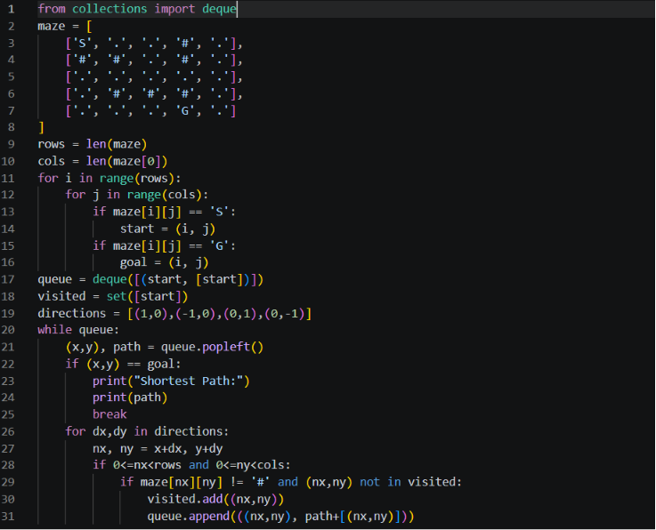
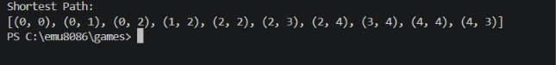
output:

2. N-Queens Challenge
1. Title of the Game-Based Activity
N-Queens Challenge (8×8 Chessboard)
2. Game Platform / Link
- Platform: Online N-Queens Game
- Link: https://www.8-queens.com

3. Objective of the Activity
Place 8 queens on a chessboard so that no queen attacks another.
4. Problem Statement
Arrange all queens without conflicts in rows, columns, or diagonals.
5. AI Concept / Domain
- Constraint Satisfaction Problem (CSP)
- Backtracking
6. Initial State and Goal State
- Initial State: Empty chessboard.
- Goal State: Eight queens placed safely.
7. Actions / Operators Used
- Place Queen
- Remove Queen (Backtracking)
- Move Queen
8. Solution Strategy
Place queens row by row and backtrack whenever conflicts occur.
9. Step-by-Step Solution
- Place queen in Row 1.
- Move to next row.
- Check conflicts.
- Backtrack if necessary.
- Continue until all queens are placed.
10. Game Performance
- Attempts: 2
- Time: 5 minutes
- Queens Placed: 8
- Score: Completed
11. Successful Completion and Evidence
Attach final board screenshot.
12. Efficiency and Optimality
Backtracking reduces unnecessary searches.
13. Analysis and Interpretation
Constraint checking greatly reduces the search space.
14. Critical Thinking and Alternative Solution
Use Genetic Algorithm or Hill Climbing.
15. Learning Outcome / Reflection
Learned constraint satisfaction and recursive backtracking.
16. Conclusion
The puzzle effectively demonstrates CSP concepts.
17. References
- https://www.8-queens.com

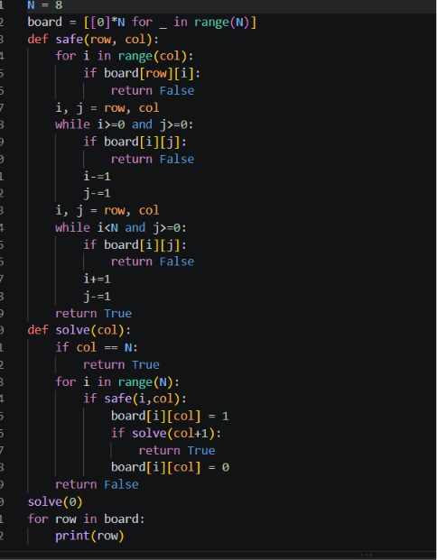

Output:
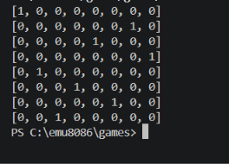

3. Water Jug Puzzle
1. Title of the Game-Based Activity
Water Jug Puzzle (5L & 3L Jugs)
2. Game Platform / Link
- Platform: Tic-Tac-Toe (Website shown in sheet)
- Link: https://playtictactoe.org
3. Objective of the Activity
Measure exactly 4 liters using a 5L and 3L jug.
4. Problem Statement
Obtain exactly 4 liters using fill, empty, and transfer operations.
5. AI Concept / Domain
- State Space Search
- BFS
- DFS
6. Initial State and Goal State
- Initial State: (0L,0L)
- Goal State: (4L,x)

7. Actions / Operators Used
- Fill jug
- Empty jug
- Pour water between jugs
8. Solution Strategy
Explore valid states until 4 liters are obtained.
9. Step-by-Step Solution
- Fill 5L jug.
- Pour into 3L jug.
- Empty 3L jug.
- Pour remaining water.
- Repeat until 4L remains.
10. Game Performance
- Attempts: 1
- Time: 3 minutes
- Steps: 6
11. Successful Completion and Evidence
Attach screenshot of final state.
12. Efficiency and Optimality
Minimum number of valid operations.
13. Analysis and Interpretation
State-space representation simplifies the solution.
14. Critical Thinking and Alternative Solution
Solve using DFS or graph search.
15. Learning Outcome / Reflection
Learned state transitions and search techniques.
16. Conclusion
Water Jug Puzzle is a classic AI search problem.
17. References
- AI textbooks
- Online Water Jug examples

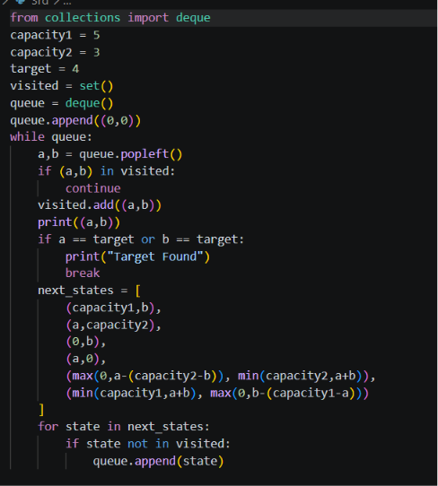

Output:
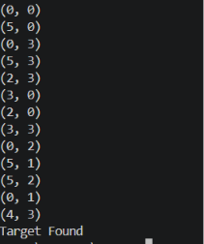

4. Connect Four AI Challenge
1. Title of the Game-Based Activity
Connect Four AI Challenge
2. Game Platform / Link
- Platform: Connect Four
- Link: https://www.mathsisfun.com/games/connect4.html
3. Objective of the Activity
Connect four discs in a row before the opponent.
4. Problem Statement
Play strategically to win while preventing the opponent from winning.
5. AI Concept / Domain
- Minimax Algorithm
- Alpha-Beta Pruning
6. Initial State and Goal State
- Initial State: Empty board.
- Goal State: Four connected discs.
7. Actions / Operators Used
- Drop disc into any valid column.
8. Solution Strategy
Use Minimax with Alpha-Beta pruning to choose the best move.
9. Step-by-Step Solution
- Analyze possible moves.
- Predict opponent moves.
- Select optimal move.
- Continue until victory.

10. Game Performance
- Attempts: 2
- Time: 4 minutes
- Result: Won
11. Successful Completion and Evidence
Attach winning board screenshot.
12. Efficiency and Optimality
Alpha-Beta pruning reduces unnecessary evaluations.
13. Analysis and Interpretation
The AI evaluates future moves before making a decision.
14. Critical Thinking and Alternative Solution
Use Monte Carlo Tree Search.
15. Learning Outcome / Reflection
Learned adversarial search techniques.
16. Conclusion
Connect Four demonstrates decision-making in AI.
17. References
- https://www.mathsisfun.com/games/connect4.html
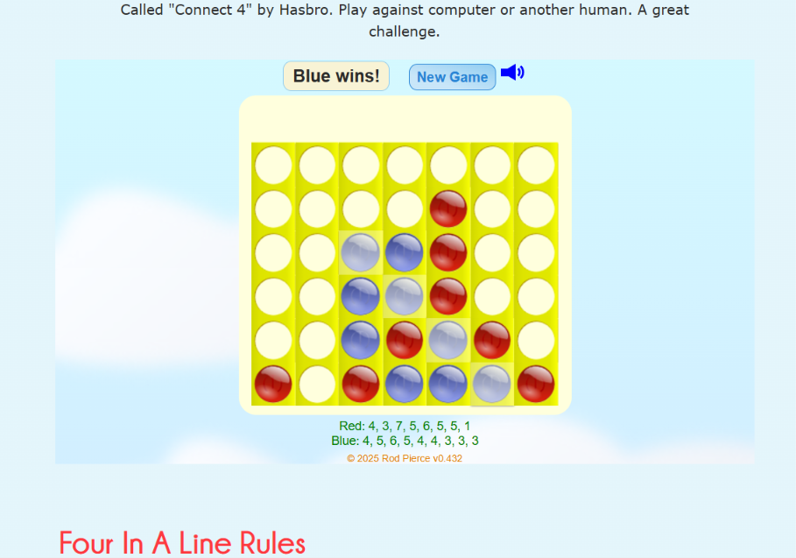

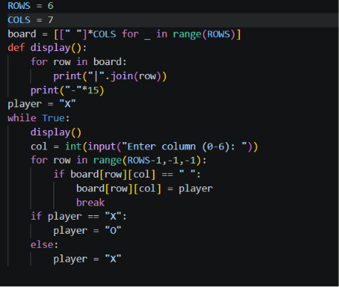
Output:
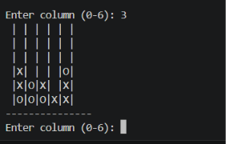

5. 8-Puzzle AI Challenge
1. Title of the Game-Based Activity
8-Puzzle AI Challenge
2. Game Platform / Link
- Platform: 8-Puzzle Game
- Link: https://8puzzle.org

3. Objective of the Activity
Arrange the numbered tiles into the correct order.
4. Problem Statement
Move one tile at a time to achieve the target arrangement.
5. AI Concept / Domain
- A* Search
- Heuristic Search
6. Initial State and Goal State
- Initial State: Random tile arrangement.
- Goal State:
1 2 3
4 5 6
7 8 _
7. Actions / Operators Used
- Move Up
- Move Down
- Move Left
- Move Right

8. Solution Strategy
Use A* search with Manhattan Distance heuristic.
9. Step-by-Step Solution
- Evaluate possible moves.
- Calculate heuristic value.
- Choose best move.
- Repeat until goal state.
10. Game Performance
- Attempts: 1
- Time: 2 minutes
- Moves: 22
11. Successful Completion and Evidence
Attach screenshot of solved puzzle.
12. Efficiency and Optimality
A* guarantees the optimal solution with an admissible heuristic.
13. Analysis and Interpretation
Heuristic search significantly reduces explored states.
14. Critical Thinking and Alternative Solution
Use Greedy Best-First Search.
15. Learning Outcome / Reflection
Learned heuristic search and optimal path finding.
16. Conclusion
The 8-Puzzle demonstrates the effectiveness of heuristic search algorithms.
17. References
- https://8puzzle.org

