**PPS MINI PROJECT**

NAME: V.SAI MATHUR

BRANCH: CSE

SECTION: A

ROLL NO: 1602-18-733-042

COURSE: B.E

SEMISTER: 1ST SEMISTER

**CODE**

#include<stdio.h>

#include<string.h>

typedef struct

{

char name[20];

long long int phone_number;

int age;

long long int pincode;

char res_name[30];

long long int income;

long long int bb;

int account_no;

}bank;

int new_account(bank p[20]);

int view_account(bank p[20],int t);

int update_account(bank p[20],int t);

int transaction(bank p[20],int t);

int remove_account(bank p[20],int t);

int display_customers(bank p[20],int t);

void main()

{

int t=0;

int decider;

printf("\t\tBANKING SOFTWARE\t\t\n");

printf("-----------------------------------------------------------------------------------------------------\n");

while(1)

{

bank p[20];

int choice;

printf("-----------------------------------------------------------------------------------------------------\n");

printf("\t\tMAINMENU\t\t\n");

printf("-----------------------------------------------------------------------------------------------------\n");

printf("1.Add a new account\n");

printf("2.Update an existing account\n");

printf("3.Check the details of existing account\n");

printf("4.Transactions\n");

printf("5.view customers list\n");

printf("6.Removing the existing account\n");

printf("\nEnter your choice:\t");

scanf("%d",&choice);

switch(choice)

{

case 1: t=new_account(p);

break;

case 2: update_account(p,t);

break;

case 3: view_account(p,t);

break;

case 4: transaction(p,t);

break;

case 5: display_customers(p,t);

break;

case 6: remove_account(p,t);

break;

default: printf("Invalid choice!\n");

break;

}

printf("enter 1 if you want to continue, else enter 0:\t");

scanf("%d",&decider);

if(decider==0)

{

break;

}

}

}

int new_account(bank p[20])

{

static int i=0;

printf("\nenter name:\t");

scanf("%s",p[i].name); //Don’t give spaces in between your name.

printf("\nenter age:\t"); //Don’t Enter the same person details again.

scanf("%d",&p[i].age);

printf("\nenter phone number:\t");

scanf("%lld",&p[i].phone_number);

printf("\nenter pincode:\t");

scanf("%lld",&p[i].pincode);

printf("\nenter residence name:\t");

scanf("%s",p[i].res_name);

printf("\nenter your income per annum:\t");

scanf("%lld",&p[i].income);

p[i].account_no=i+1;

p[i].bb=500; //Minimum Account Balance

printf("\nYour account has been created successfully\n");

printf("-----------------------------------------------------------------------------------------------------\n");

printf("\t\tTHANK YOU\t\t\n");

printf("-----------------------------------------------------------------------------------------------------\n");

i++;

return i;

}

int view_account(bank p[20],int t)

{

int s;

int i;

printf("enter bank account number:\t");

scanf("%d",&s);

for(i=0;i<t;i++)

{

if(s==0)

{

printf("This account is deleted\n");

printf("-----------------------------------------------------------------------------------------------------\n");

}

if(s==p[i].account_no)

{

printf("-----------------------------------------------------------------------------------------------------");

printf("\nname:\t%s",p[i].name);

printf("\nage:\t%d",p[i].age);

printf("\nphone number:\t%lld",p[i].phone_number);

printf("\npincode:\t%lld",p[i].pincode);

printf("\nresidence:\t%s",p[i].res_name);

printf("\nincome:\t%lld\n",p[i].income);

printf("account number:\t%d\n",p[i].account_no);

printf("bank account balance:\t%lld\n",p[i].bb);

printf("-----------------------------------------------------------------------------------------------------\n");

}

}

return 0;

}

int display_customers(bank p[20],int t)

{

int i;

printf("The list of customers are:\n");

printf("-----------------------------------------------------------------------------------------------------\n");

printf("\t\tS.NO\t\tNAME\t\tACCOUNT NUMBER\t\tBANK BALANCE\n");

printf("-----------------------------------------------------------------------------------------------------\n");

for(i=0;i<t;i++)

{

if(p[i].account_no==0)

{

continue;

}

printf("\t\t%d.\t\t%s\t\t\t%d\t\t\t%d\n",i+1,p[i].name,p[i].account_no,p[i].bb);

printf("-----------------------------------------------------------------------------------------------------\n");

}

return 0;

}

int update_account(bank p[20],int t)

{

int no_updateac;

int i;

printf("Enter bank account number:\t");

scanf("%d",&no_updateac);

if(no_updateac!=0)

{

for(i=0;i<t;i++)

{

if(no_updateac==p[i].account_no)

{

printf("Please enter the details again carefully:");

printf("\nenter name:\t");

scanf("%s",p[i].name); //Don’t give spaces in between your name.

printf("\nenter age:\t");

scanf("%d",&p[i].age);

printf("\nenter phone number:\t");

scanf("%lld",&p[i].phone_number);

printf("\nenter pincode:\t");

scanf("%lld",&p[i].pincode);

printf("\nenter residence name:\t");

scanf("%s",p[i].res_name);

printf("\nenter your income per annum:\t");

scanf("%lld",&p[i].income);

printf("\nYour account has been updated successfully\n");

printf("-----------------------------------------------------------------------------------------------------\n");

printf("\t\tTHANK YOU\t\t\n");

printf("-----------------------------------------------------------------------------------------------------\n");

}

}

}

else

{

printf("This account is deleted\n");

printf("-----------------------------------------------------------------------------------------------------\n");

}

return 0;

}

int transaction(bank p[20],int t)

{

int s1;

long long int amt1;

long long int amt2;

int select;

int i;

printf("Enter your bank account number:\t");

scanf("%d",&s1);

for(i=0;i<t;i++)

{

if(s1==0)

{

printf("This account has been removed\n\n");

printf("Enter a valid bank account number\n");

printf("-----------------------------------------------------------------------------------------------------\n");

printf("\t\tTHANK YOU\t\t\n");

printf("-----------------------------------------------------------------------------------------------------\n");

break;

}

if(s1==p[i].account_no)

{

printf("1. Deposit amount\n");

printf("2. Withdraw amount\n");

printf("3. Check balance\n");

printf("Enter your choice:\t");

scanf("%d",&select);

if(select==1)

{

printf("Enter the amount you want to deposit:\t");

scanf("%lld",&amt1);

p[i].bb+=amt1;

printf("\nCurrent Bank Balance is:\t%lld\n",p[i].bb);

printf("-----------------------------------------------------------------------------------------------------\n");

printf("\t\tTHANK YOU\t\t\n");

printf("-----------------------------------------------------------------------------------------------------\n");

}

else if(select==2)

{

printf("Enter the withdraw amount:\t");

scanf("%lld",&amt2);

if(p[i].bb < amt2)

{

printf("Bank balance is insufficient to withdraw:\n");

printf("-----------------------------------------------------------------------------------------------------\n");

printf("\t\tTHANK YOU\t\t\n");

printf("-----------------------------------------------------------------------------------------------------\n"); }

else if(p[i].bb >= amt2)

{

p[i].bb-=amt2;

printf("\nCurrent Bank Balance is:\t%lld\n",p[i].bb);

printf("-----------------------------------------------------------------------------------------------------\n");

printf("\t\tTHANK YOU\t\t\n");

printf("-----------------------------------------------------------------------------------------------------\n");}

}

else if(select==3)

{

printf("The current account balance is:\t%lld\n",p[i].bb);

printf("-----------------------------------------------------------------------------------------------------\n");

printf("\t\tTHANK YOU\t\t\n");

printf("-----------------------------------------------------------------------------------------------------\n");

}

}

}

return 0;

}

int remove_account(bank p[20],int t)

{

int a_no,lastcall;

printf("Enter the bank account number:\n");

scanf("%d",&a_no);

printf("Enter 1 if you are sure, else enter 0:\t");

scanf("%d",&lastcall);

if(a_no!=0)

{

if(lastcall==1)

{

p[a_no-1].income='\0';

p[a_no-1].bb='\0';

p[a_no-1].res_name[0]='\0';

p[a_no-1].account_no='\0';

p[a_no-1].pincode='\0';

p[a_no-1].age='\0';

p[a_no-1].phone_number='\0';

p[a_no-1].name[0]='\0';

printf("The account has been deleted successfully");

printf("\n-----------------------------------------------------------------------------------------------------\n");

printf("\t\tTHANK YOU\t\t\n");

printf("-----------------------------------------------------------------------------------------------------\n");

}

else

{

printf("\n-----------------------------------------------------------------------------------------------------\n");

printf("\t\tTHANK YOU\t\t\n");

printf("-----------------------------------------------------------------------------------------------------\n");

}

return 0;

}

else

{

printf("This account is already deleted");

printf("\n-----------------------------------------------------------------------------------------------------\n");

printf("\t\tTHANK YOU\t\t\n");

printf("-----------------------------------------------------------------------------------------------------\n");

}

}

**Screenshots:**

1. Main menu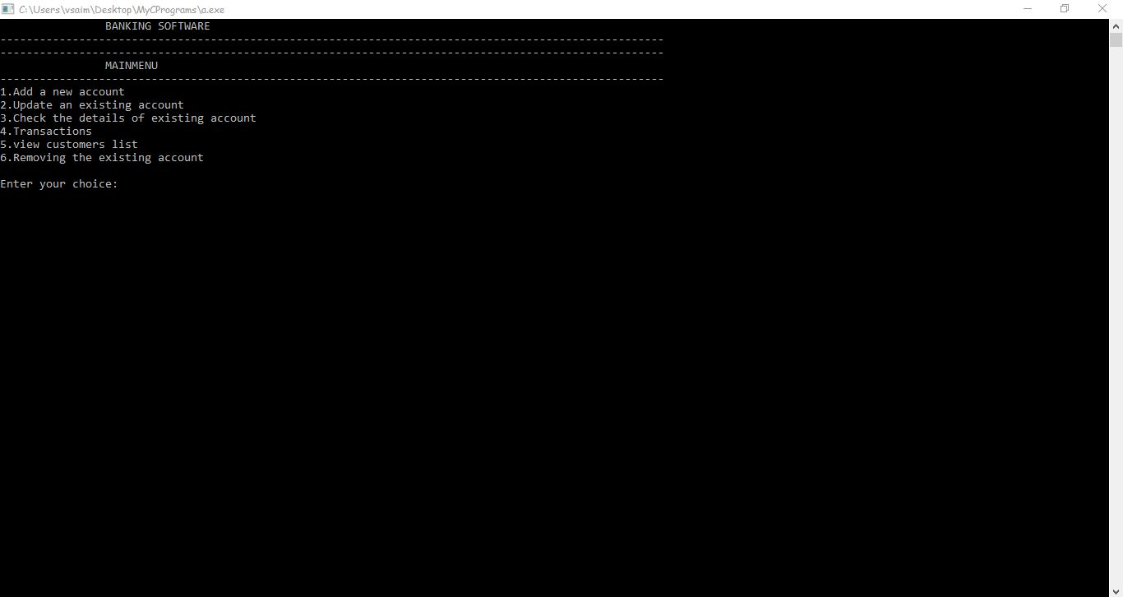
2. Creating a new account (choice=1)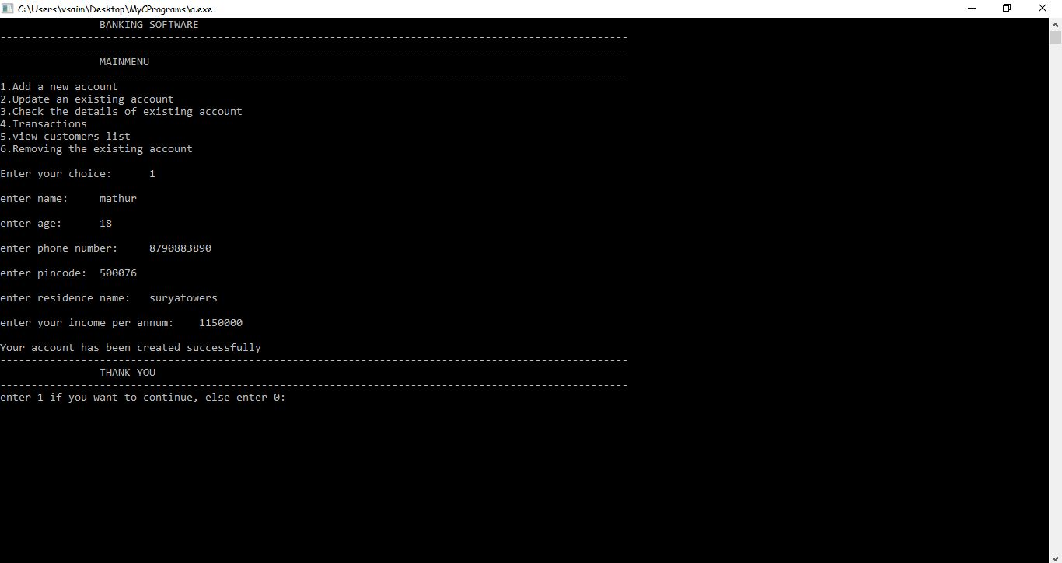
3. Updating mistakes in making account(choice=2)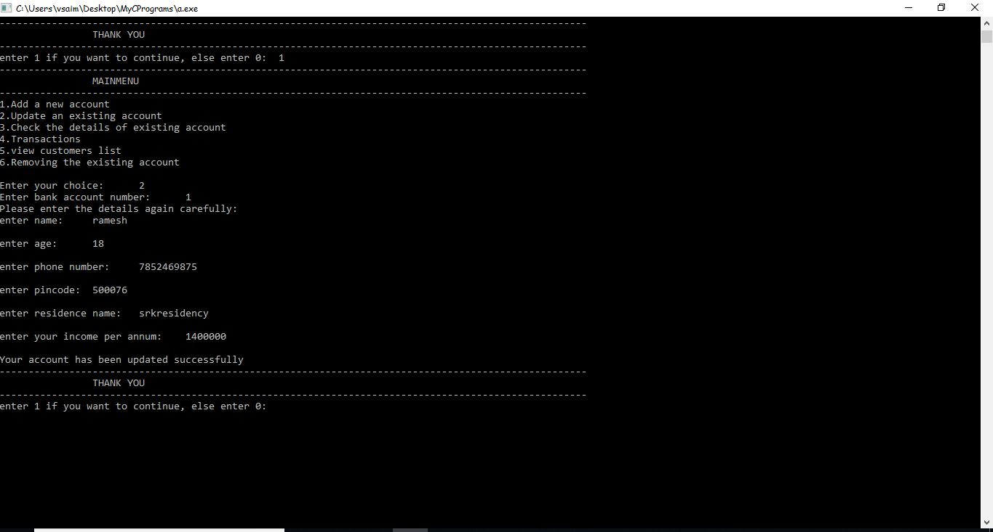
4. Viewing The Account (choice=3), Here Account number is created automatically (for 1st account, Account Number=1).Here Rs.500/- is minimum account balance.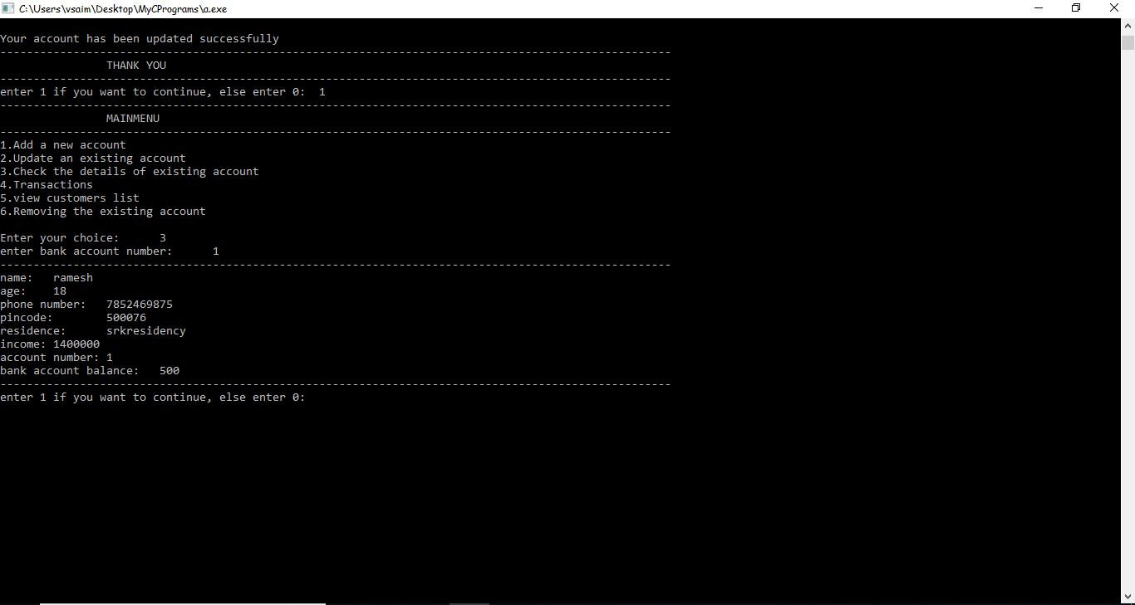
5. Checking Total Accounts (choice=5)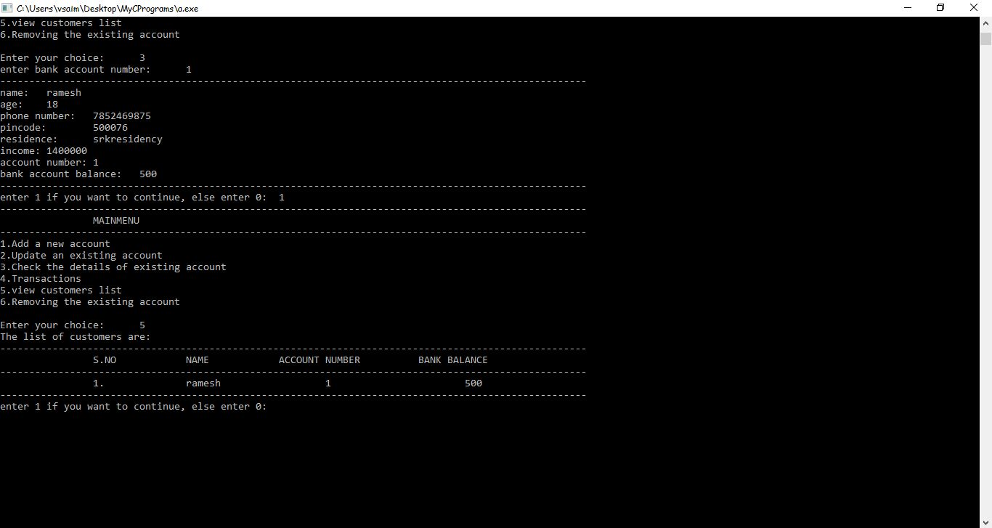
6. Adding 1 more account (choice=1)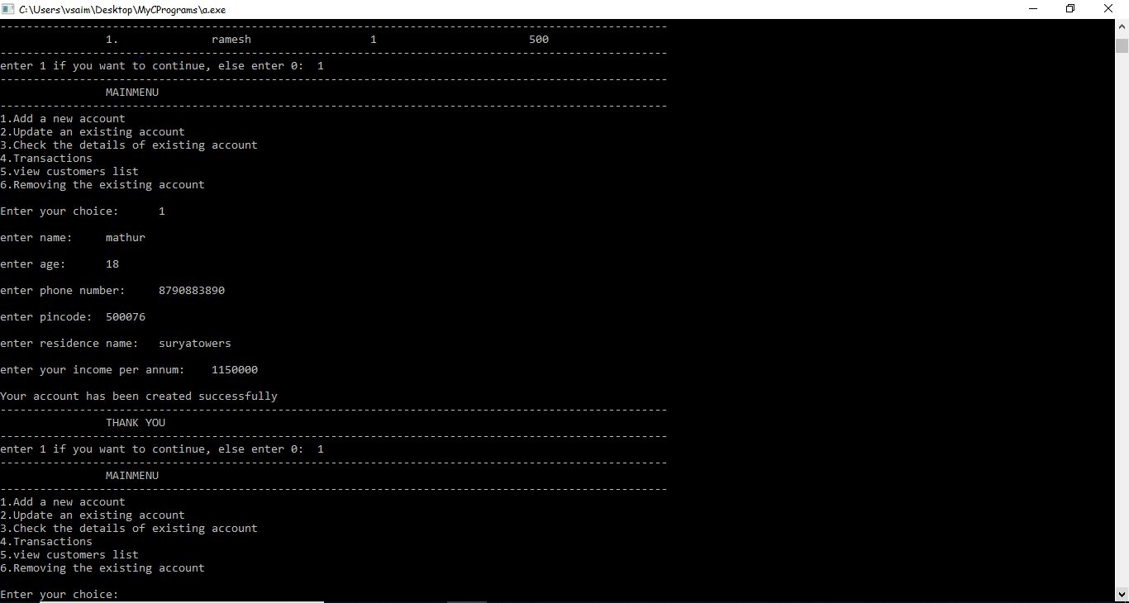
7. Checking Total Accounts (choice=5)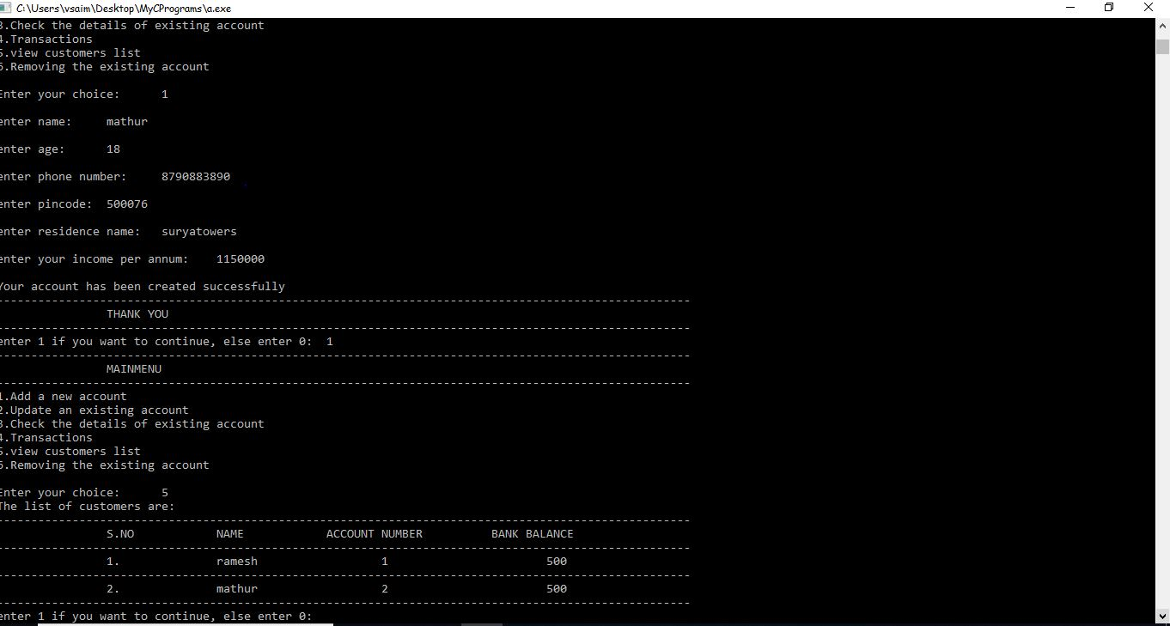
8. Performing Transactions-Depositing on Account 2(choice=4,1)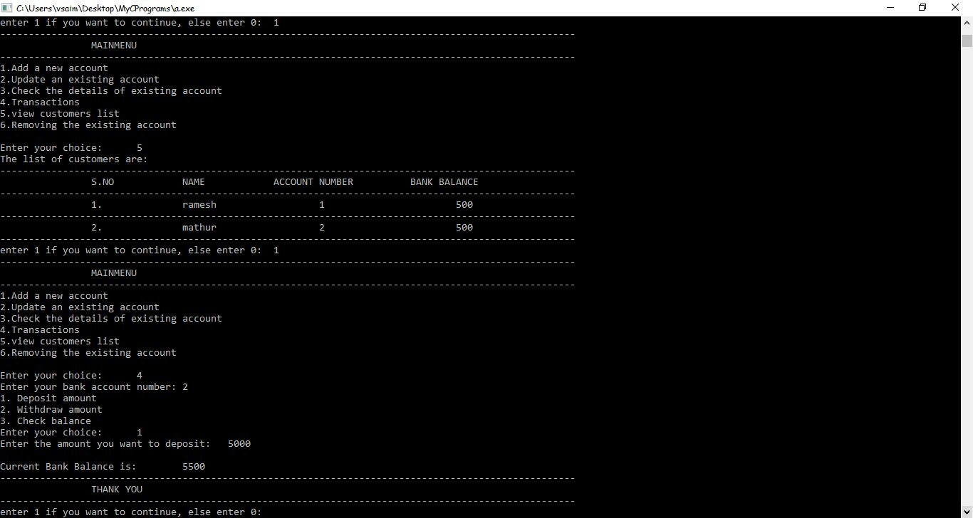
9. Performing Transactions- Withdrawing on Account 2(choice=4,2)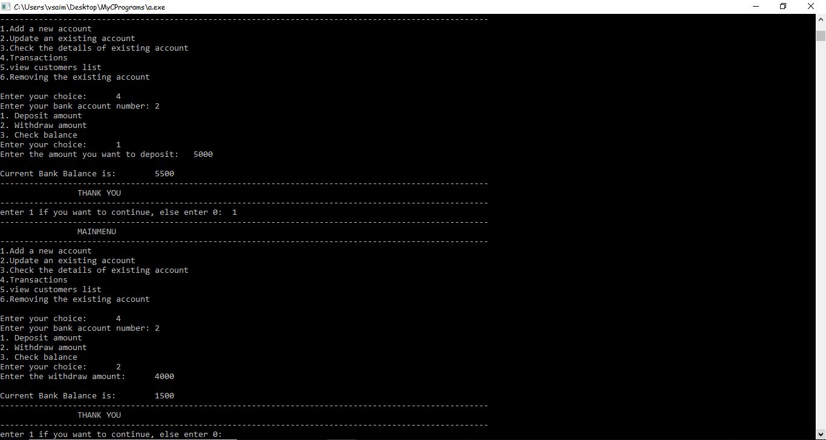
10. Performing Transactions-Checking balance on Account 2 (choice=4,3)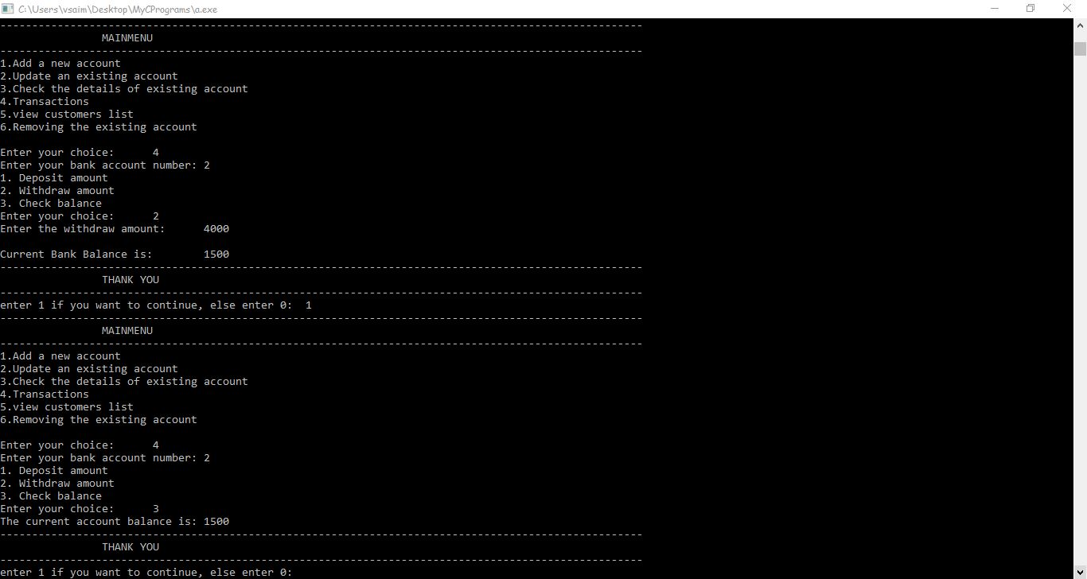
11. Removing an account (choice=6)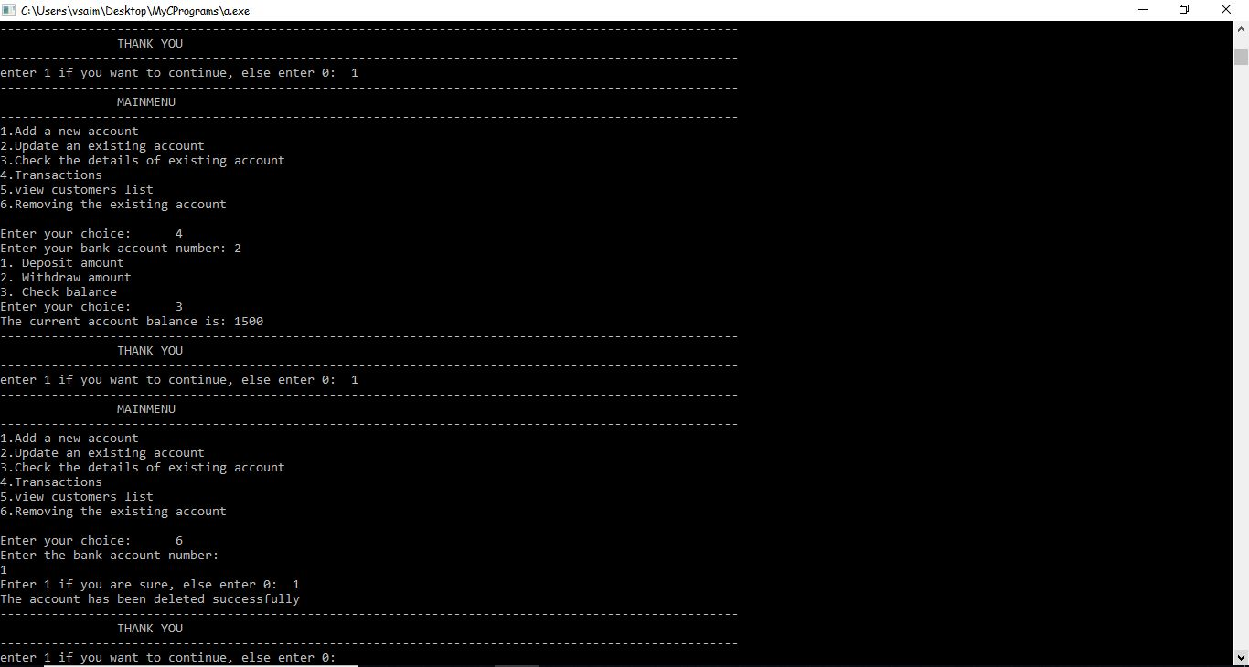
12. Total Accounts after removing (choice=5)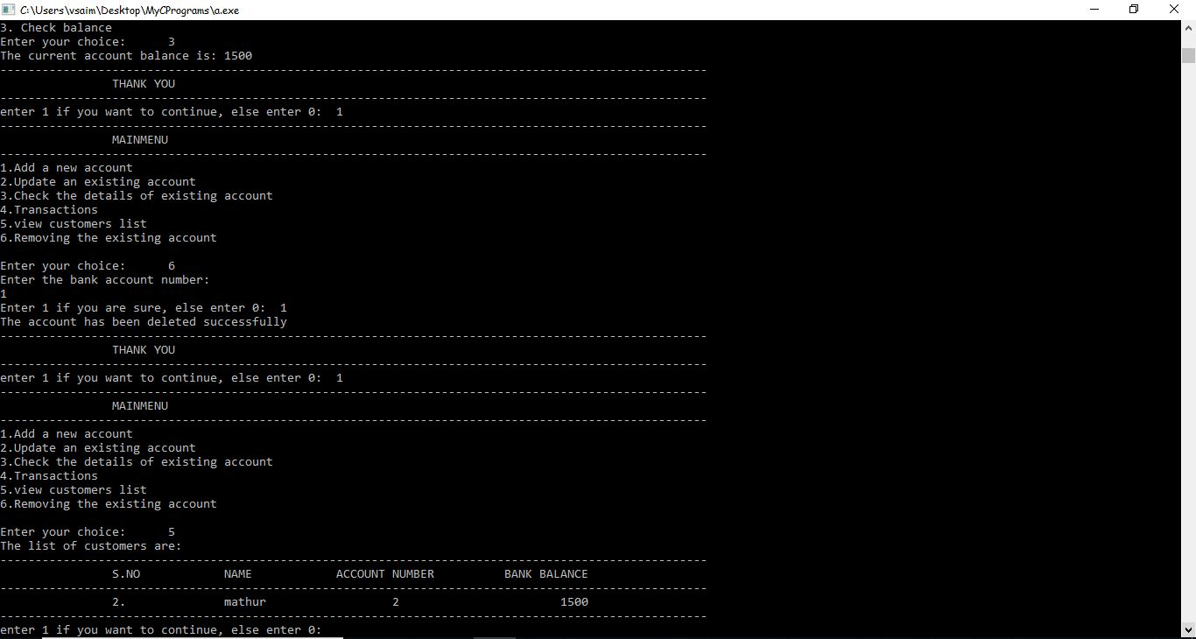

THANK YOU