MICROPROCESSOR MICROCONTROLLER AND INTERFACING

LAB MINI PROJECT REPORT
On

BLUETOOTH CONTROLLED ROBOT CAR USING 8051 MICRO CONTROLLER

By
V. SAI MATHUR
1602-18-733-042

S. SAI SUHRUT
1602-18-733-044


Department of Computer Science & Engineering
Vasavi College of Engineering (Autonomous)
(Affiliated to Osmania University)
Ibrahimbagh, Hyderabad-31
2020

CONTENTS | PAGE NO.
1) Acknowledgement | 03
2) List of Figures | 04
3) Project Abstract | 05
4) Introduction to 8051 Microcontroller | 06
5) Software Requirement | 08
6) Introduction to project and components used | 09
7) Working of project | 13
8) Sample Code | 14
9) Output Screenshots | 15
10) Conclusion | 18
11)References | 19

ACKNOWLEDGEMENT
We take this opportunity with pride and enormous gratitude, to express the deeply embedded feeling and gratefulness to our respectable guide Mrs. Syamala, Department of Computer Science and Engineering. Whose guidance was unforgettable and innovative ideas as well as her constructive suggestions has made the presentation of my thesis a grand success.
We are thankful to Dr. T. Adilakshmi, Head of Department (CSE), Vasavi College of Engineering for their help during our course work.

LIST OF FIGURES:
- Figure 1: Layout of 8051 Microcontroller
- Figure 2: Bluetooth Module HC-05
- Figure 3: L293D Motor Driver
- Figure 4: Circuit Diagram
- Figure 5: Output (Initial)
- Figure 6: Output (forward)
- Figure 7: Output (backward)
- Figure 8: Output (left)
- Figure 5: Output (right)
- Figure 5: Output (stop)

ABSTRACT
Many of the wireless-controlled robots use RF modules. But this project makes use of Android mobile phone for robotic control. The control commands available are more than RF modules. For this the android mobile user has to install an application on her/his mobile. Then user needs to turn on the Bluetooth in the mobile. The wireless communication techniques used to control the robot is Bluetooth technology. User can use various commands like move forward, reverse, move left, move right using these commands which are sent from the Android mobile. Robot has a Bluetooth receiver unit which receives the commands and give it to the microcontroller circuit to control the motors. The microcontroller then transmits the signal to the motor driver IC’s to operate the motors.

INTRODUCTION TO 8051 MICROCONTROLLER
8051 microcontroller is designed by Intel in 1981. It is an 8-bit microcontroller. It is built with 40 pins DIP (dual inline package), 4kb of ROM storage and 128 bytes of RAM storage, 2 16-bit timers. It consists of are four parallel 8-bit ports, which are programmable as well as addressable as per the requirement. An on-chip crystal oscillator is integrated in the microcontroller having crystal frequency of 11.0592 MHz. In case the data is larger than 8 bits then it has to be broken into parts so that the CPU can process conveniently. Most manufacturers have put 4Kbytes of ROM even though the quantity of ROM can be exceeded up to 64 K bytes. The 8051 has been in use in a wide number of devices, mainly because it is easy to integrate into a project or build a device around. Since the basic layout of a microcontroller includes a CPU, ROM, RAM, etc. the 8051 microcontroller also has a similar layout. The following image shows a brief layout of a typical 8051 Microcontroller. It is a CISC based Microcontroller with Harvard Architecture (separate program and data memory).

8051 Internal Architecture

- 8 – bit CPU with two Registers A (Accumulator) and B.

- Internal ROM of 8K Bytes – It is a flash memory that supports in – system programming.

- Internal RAM of 256 Bytes – The first 128 Bytes of the RAM i.e. 00H to 7FH is again divided in to 4 banks with 8 registers (R0 – R7) in each bank, 16 bit addressable registers and 80 general purpose registers. The higher 128 Bytes of the RAM i.e. 80H to FFH consists of SFRs or Special Function Registers. Using SFRs we can control different peripherals like Timers, Serial Port, all I/O Ports, etc.

- 32 I/O Pins (Input / Output Pins) – Arranged as 4 Ports: P0, P1, P2 and P3.

- 8- bit Stack Pointer (SP) and Processor Status Word (PSW).

- 16 – bit Program Counter (PC) and Data Pointer (DPTR).

- Two 16 – bit Timers / Counters – T0 and T1.

- Control Registers – SCON, PCON, TCON, TMOD, IP and IE.

- Serial Data Transmitter and Receiver for Full – Duplex Operation – SBUF.

- Interrupts: Two External and Three Internal.

- Oscillator and Clock Circuit.

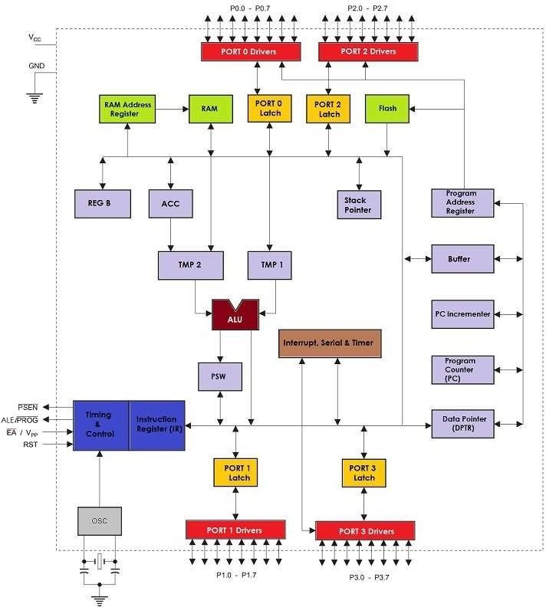

Figure 1: Layout of 8051 Microcontroller

SOFTWARE REQUIREMENT
Keil MicroVision5
For this project, we have used Keil MicroVision5 as the software development environment. Keil MDK is the complete software development environment for a wide range of Arm Cortex-M based microcontroller devices. MDK includes the µVision IDE and debugger, Arm C/C++ compiler, and essential middleware components.
The µVision IDE combines project management, run-time environment, build facilities, source code editing, and program debugging in a single powerful environment. µVision is easy-to-use and accelerates your embedded software development. µVision supports multiple screens and allows you to create individual window layouts anywhere on the visual surface.

The Debugger provides a single environment in which you may test, verify, and optimize your application code. The debugger includes traditional features like simple and complex breakpoints, watch windows, and execution control and provides full visibility to device peripherals.

Proteus 8
And for simulation, we have used Proteus 8 Professional (Schematic Capture). It allows us to develop hardware implementation of the project by providing a wide range of components to build circuits in workspace and thereby allows us to attach “hex” code to the simulation and run the simulation at real- time.
Proteus 8 Professional is a software which can be used to draw schematics, PCB layout, code and even simulate the schematic. It is developed by Lab center Electronic Ltd.

Features of Proteus:
- Schematic Capture – One can easily draw the schematic using proteus. We can select the devices by clicking ‘Pick Devices’ button and select the desired component.
- Simulation – Many components like microcontrollers can be simulated in proteus.
- Designing PCB
- 3D Visualization

INTRODUCTION
The project aims in designing a Robot that can be operated using Android mobile phone. The controlling of the Robot is done wirelessly through Android smart phone using the Bluetooth feature present in it. Here in the project the Android smart phone is used as a remote control for operating the Robot.
COMPONENTS REQUIRED:
- 8051 microcontroller (AT89C51)
- HC-05 Bluetooth module
- L293D Motor Driver
- DC Motors (2)
- Bluetooth terminal android app
- Jumper Wires
- Wheels (2)

Now, lets look at some of the components in detail,
BLUETOOTH HC-05 MODULE:
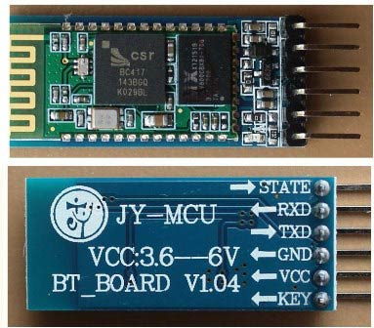
Figure 2: Bluetooth Module HC-05
HC-05 is a serial Bluetooth module. It can be configured using AT commands. It can work in three different configurations (Master, Slave, Loop back). In our project we will be using it as a slave. The features of HC-05 module includes,
- Typical -80dBm sensitivity.
- Default baud rate: 9600bps , 8 data bits , 1 stop bit , no parity.
- Auto-pairing pin code: “1234” default pin code
- It has 6 pins.
- Vcc and Gnd pins are used for powering the HC-05.
- Tx and Rx pins are used for communicating with the microcontroller.
- Enable pin for activating the HC-05 module. when it is low , the module is disabled
- State pin acts status indicator. When it is not paired/connected with any other Bluetooth device, LED flashes continuously. When it is connected/paired with any other Bluetooth device, then the LED flashes with the constant delay of 2 seconds.

L293D MOTOR DRIVER:
L293D is a dual H-bridge motor driver IC. This acts as a current amplifier, the output of L293D drives the DC Motors. It contains two inbuilt H-bridge circuits. In common mode of operation, it can drive two dc motors simultaneously in both the directions. The below table shows the pin description of L293D IC.
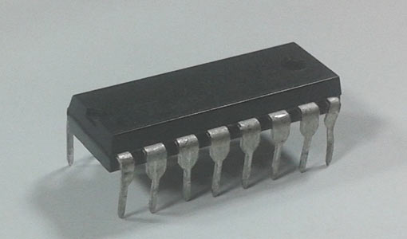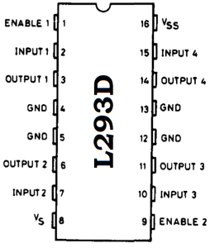
Figure 3: L293D Motor Driver

Pin Description:
Pin No. | Name | Function
1 | Enable 1,2 | Enable pin for motor 1
2 | Input 1 | Input 1 for motor 1
3 | Output 1 | Output 1 for motor 1
4 | Gnd | Ground (0V)
5 | Gnd | Ground (0V)
6 | Output 2 | Output 2 for motor 1
7 | Input 2 | Input 2 for motor 1
8 | Vcc 2 | Supply voltage for motors(5V)
9 | Enable 3,4 | Enable pin for motor 1
10 | Input 3 | Input 1 for motor 2
11 | Output 4 | Output 1 for motor 2
12 | Gnd | Ground (0V)
13 | Gnd | Ground (0V)
14 | Output 4 | Output 2 for motor 2
15 | Input 4 | Input 2 for motor 2
16 | Vcc 1 | Supply voltage (5V)

CIRCUIT DIAGRAM:

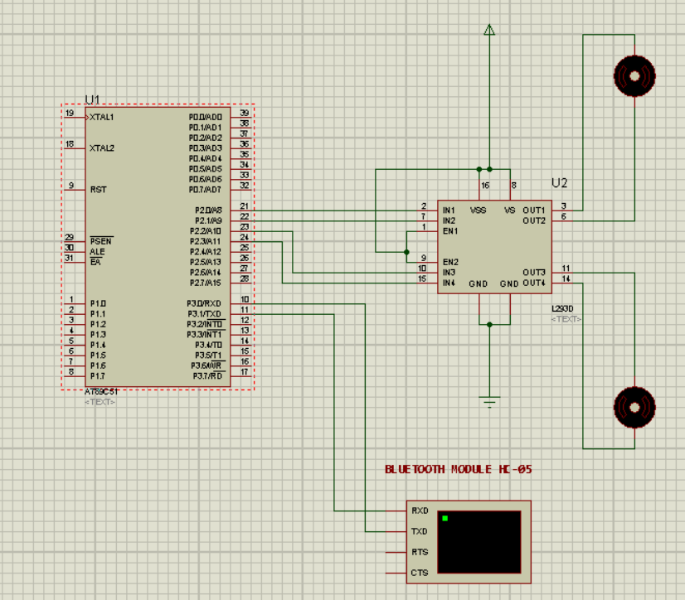
Figure 4: Circuit Diagram

WORKING OF BLUETOOTH - CAR
In this Smart Phone controlled Robot, the user of android app sends the data to 8051 microcontroller through HC-05 module. The received data is compared in 8051 microcontroller and the decision is made accordingly. The below table shows the direction of motors and status of robot for different received characters.
Received character | Motor 1 | Motor 2 | Status of robot
f | Forward | Forward | Moves forward
b | Backward | Backward | Moves backward
r | Forward | Backward | Moves Right
l | Backward | Forward | Moves left
s | Off | Off | Stopped

CODE
1 //works with HC-05 Bluetooth Module by interfacing with 8051 uC.
2 #include<reg51.h>
3 sbit m1p = P2^0;
4 sbit m1n = P2^1;
5 sbit m2p = P2^2; //interfacing ports with L293D motor driver
6 sbit m2n = P2^3;
7 //motor input connections//
8 void main()
9 {
10 unsigned char x;
11 SCON = 0x50; //initializing serial communication modes of operation.
12 TMOD = 0x20; //timer 1 mode 2
13 TH1 = -3; //setting baud rate to 9600
14 TR1 = 1; //start timer //initialize serial communication
15 while(1)
16 {
17 while(RI == 0);
18 x = SBUF; //receiving data from serial buffer
19 RI = 0;
20 SBUF = x;
21 while(TI == 0);
22 TI = 0; // we're not transferring any data to serial buffer
23 if(x == 'f')
24 {
25 m1p = 1; m1n = 0;
26 m2p = 1; m2n = 0; //robot moves forward
27 }
28 if(x == 'b')
29 {
30 m1p = 0; m1n = 1;
31 m2p = 0; m2n = 1; //robot moves backwards
32 }
33 if(x == 'l')
34 {
35 m1p = 1; m1n = 0;
36 m2p = 0; m2n = 1; // turns left
37 }
38 if(x == 'r')
39 {
40 m1p = 0; m1n = 1;
41 m2p = 1; m2n = 0; //turns right
42 }
43 if(x == 's')
44 {
45 m1p = 0; m1n = 0;
46 m2p = 0; m2n = 0; //stop
47 }
48 }
49 }

OUTPUTS
- Initially before given any input
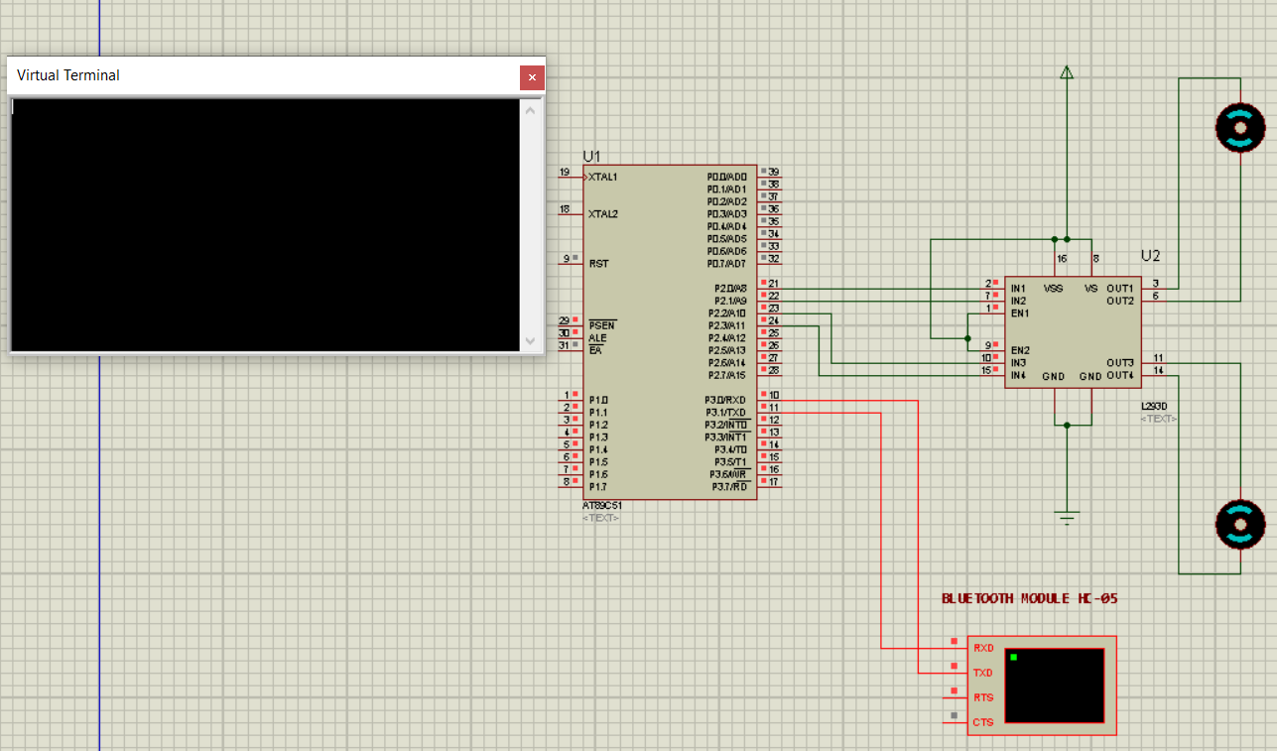
Figure 5: Output (Initial)
- After giving input as ‘f’ (both motors rotate in clockwise direction)
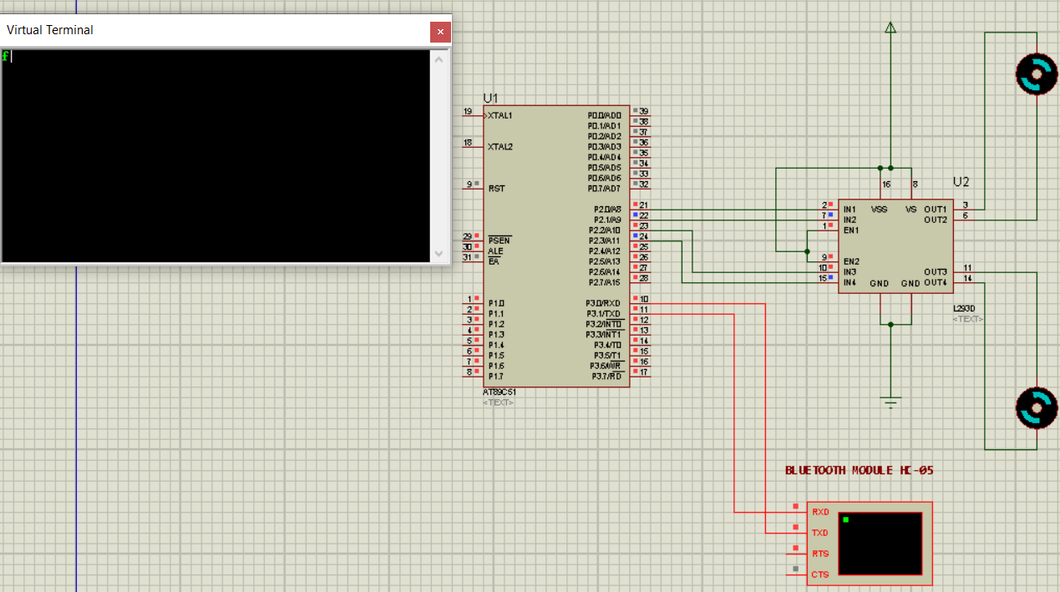Figure 6: Output (forward
- After giving input as ‘b’ (both motors rotate in anti-clock direction)
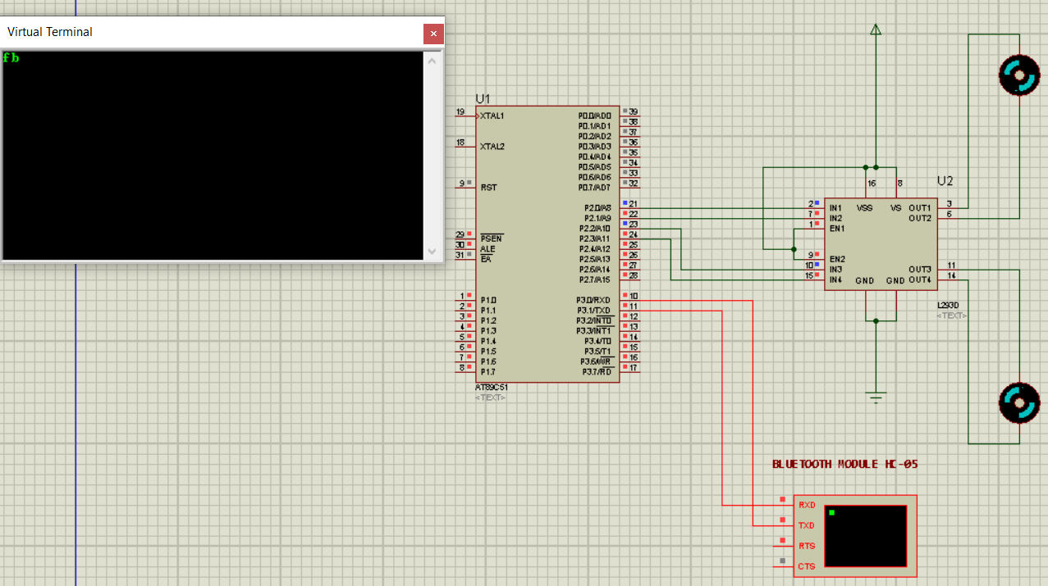
Figure 7: Output (backward)
- After giving input as ‘l’ (first motor rotates clockwise while second motor rotates anti-clockwise)
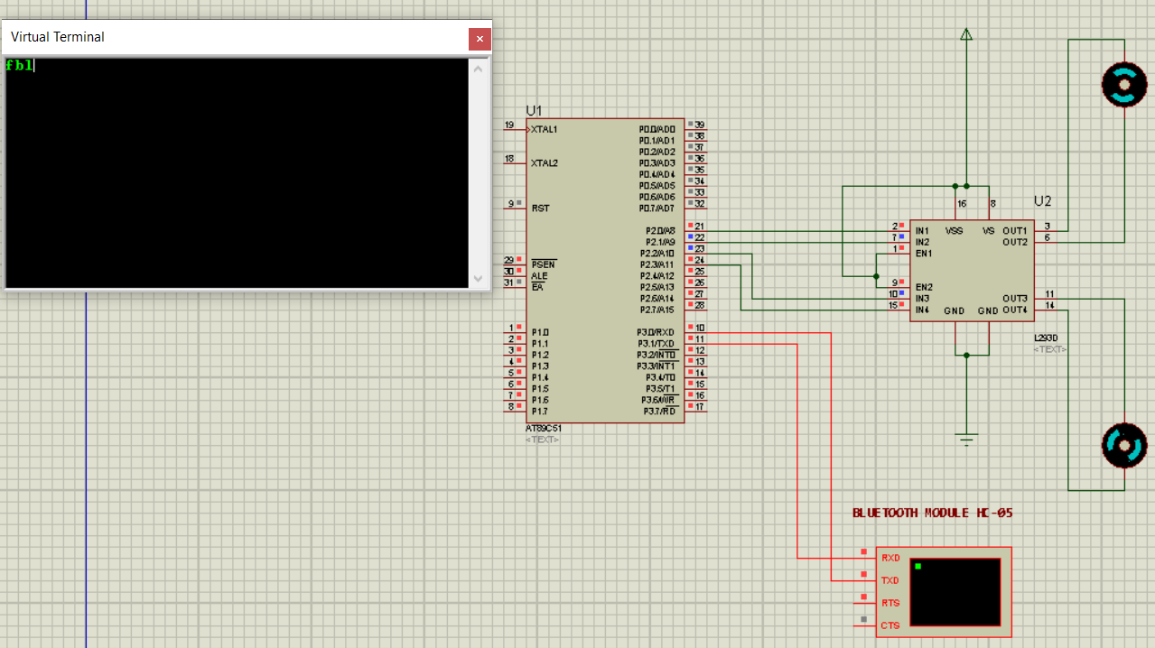
Figure 8: Output (left)
- After giving input as ‘r’ (first motor rotates in anti-clockwise direction and second motor rotates in clockwise direction)
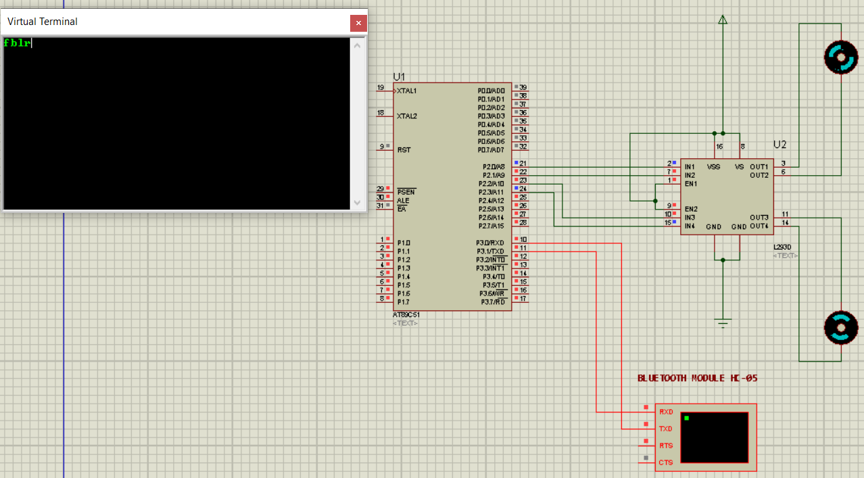
Figure 9: Output (right)
- After giving input as ‘s’ (both motors stopped)
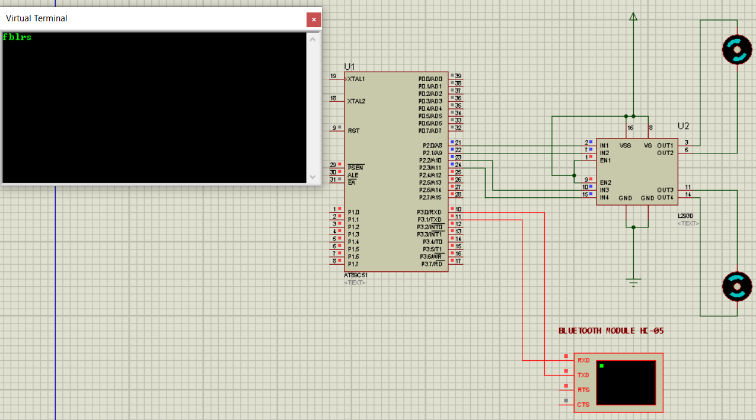
Figure 10: Output (stop)
CONCLUSION
The objective of the project is to realise the smart living, more specifically the home lighting control system using Bluetooth Technology. Robot and smart phones are a perfect match, especially mobile robots. As phones and mobile devices are each time more powerful, using them as robot for building robot with advanced feature such as voice recognition. Android Bluetooth-enable phones and Bluetooth module via HC-05 or HC-06 and communication among Bluetooth devices. It is concluded that smart living will gradually turn into a reality that consumer can control their home remotely and wirelessly.

REFERENCES
- https://wiki.eprolabs.com/index.php?title=Bluetooth_Module_HC-05
- https://components101.com/l293d-pinout-features-datasheet

