DESIGN AND ANALYSIS OF ALGORITHMS

LAB MINI PROJECT REPORT
On

ENTER THE DUNGEON GAME

By
V. SAI MATHUR
1602-18-733-042

KRISHNA VAMSI ANIRUDH CH
1602-18-733-026


Department of Computer Science & Engineering
Vasavi College of Engineering (Autonomous)
(Affiliated to Osmania University)
Ibrahimbagh, Hyderabad-31
2020

TABLE OF CONTENTS

1. Acknowledgment 3
2. Project Abstract 4
3. Description 5
and Algorithm
4. Code 6-13
4.1. Start.java……………………….……….6
4.2. Game.java……….……………………...7
5. Output 14-16
6. Conclusion 17
7. References 18

LIST OF FIGURES:

2.1 FIGURE 1 14
2.2 FIGURE 2 14
2.3 FIGURE 3 15
2.4 FIGURE 4 15
2.5 FIGURE 5 16
2.6 FIGURE 6 16

ACKNOWLEDGEMENT

We take this opportunity with pride and enormous gratitude, to express the deeply embedded feeling and gratefulness to our respectable guide Mr. Punna Rao, Department of Computer Science and Engineering. Whose guidance was unforgettable and innovative ideas as well as her constructive suggestions has made the presentation of my thesis a grand success.

We are thankful to Dr. T. Adilakshmi, Head of Department (CSE), Vasavi College of Engineering for their help during our course work.

ABSTRACT

Enter the Dungeon is a game, where an adventurer starts from start of cave and reaches treasure which is placed at the end of the cave with minimum possible health. We have used Dynamic Programming to implement this game.

DESCRIPTION

CODE
start.java

1 import java.awt.EventQueue;
2 import javax.swing.JFrame;
3 import java.awt.Color;
4 import javax.swing.JButton;
5 import java.awt.event.ActionListener;
6 import java.awt.event.ActionEvent;
7 import javax.swing.JLabel;
8 import java.awt.Font;
9 import daa_project.*;
10
11 public class start {
12
13 private JFrame mf;
14
15 /**
16 * Launch the application.
17 */
18 public static void main(String[] args) {
19 EventQueue.invokeLater(new Runnable() {
20 public void run() {
21 try {
22 start window = new start();
23 window.mf.setVisible(true);
24 } catch (Exception e) {
25 e.printStackTrace();
26 }
27 }
28 });
29 }
30
31 /**
32 * Create the application.
33 */
34 public start() {
35 initialize();
36 }
37
38 /**
39 * Initialize the contents of the frame.
40 */
41 private void initialize() {
42 mf = new JFrame();
43 mf.getContentPane().setBackground(new Color(244, 164, 96));
44 mf.getContentPane().setLayout(null);
45
46 JButton play = new JButton("PLAY");
47 play.setFont(new Font("Tahoma", Font.BOLD, 13));
48 play.setBackground(new Color(135, 206, 250));
49 play.addActionListener(new ActionListener() {
50 public void actionPerformed(ActionEvent e) {
51 mf.dispose();
52 // new window_1player();
53 new game();
54 }
55 });
56 play.setBounds(313, 259, 209, 46);
57 mf.getContentPane().add(play);
58
59 JLabel mf_title = new JLabel("ENTER THE DUNGEON");
60 mf_title.setForeground(new Color(255, 255, 0));
61 mf_title.setFont(new Font("Tahoma", Font.BOLD, 26));
62 mf_title.setBounds(271, 69, 302, 57);
63 mf.getContentPane().add(mf_title);
64 mf.setTitle("EnterTheDungeon");
65 mf.setResizable(false);
66 mf.setBackground(new Color(255, 165, 0));
67 mf.setForeground(Color.ORANGE);
68 mf.setBounds(100, 100, 828, 642);
69 mf.setDefaultCloseOperation(JFrame.EXIT_ON_CLOSE);
70 }
71 }

game.java
1 package daa_project;
2 import java.util.*;
3 import javax.swing.*;
4 import javax.swing.Timer;
5
6 import java.awt.*;
7 import java.awt.event.*;
8
9
10 @SuppressWarnings("unused")
11 public class game implements MouseListener
12 {
13 private JFrame f;
14 private JButton b[][]=new JButton[100][100], submit;
15 public JLabel l_ins;
16 private int n_rows,n_cols,treasure_row,treasure_col,n_traps,trap_row,trap_col,temp;
17 private String[] treasure_loc,n_rc,trap_loc;
18 private ImageIcon treasureImg, buttonImg, trapImg, healingImg;
19 private Timer inner_timer,outer_timer;
20 public int i,j,count=1,hp,tempHealth = 0;
21 public int visit[][];
22 private int grid[][]=new int[100][100];
23 public String s;
24 private JPanel p,pp;
25
26 public game()
27 {
28 initialize();
29
30 }
31 public ImageIcon create_scaleImage(String img_path)
32 {
33 ImageIcon imageIcon = new ImageIcon(img_path); // load the image to a imageIcon
34 Image image = imageIcon.getImage(); // transform it
35 Image newimg = image.getScaledInstance(1925/n_cols, 830/n_rows, java.awt.Image.SCALE_SMOOTH); // scale it the smooth way
36 imageIcon = new ImageIcon(newimg); // transform it back
37 return imageIcon;
38 }
39 private void initialize()
40 {
41 f = new JFrame();
42 f.setTitle("Enter The Dungeon");
43 f.setBounds(100, 100, 450, 300);
44 p=new JPanel();
45 pp = new JPanel();
46
47 //taking grid dimensions...
48 n_rc = JOptionPane.showInputDialog(f, "Enter number of rows and columns seperated by space: ").split(" ");
49 n_rows = Integer.parseInt(n_rc[0]);
50 n_cols = Integer.parseInt(n_rc[1]);
51
52 //instructions...
53 JOptionPane.showMessageDialog(f,"Instructions for input: \nPositive Value means health spot (increases HP)\nNegative Value means to encounter demon (Decreases HP)\nZero means safe area!");
54 JOptionPane.showMessageDialog(f,"\nEnter "+(n_rows*n_cols)+" values which are the values of spots in dungeon!");
55 visit=new int[n_rows][n_cols];
56 //taking input... and storing...
57 for(i=0;i<n_rows;i++)
58 {
59 for(j=0;j<n_cols;j++)
60 {
61 temp=Integer.parseInt(JOptionPane.showInputDialog(f,"Enter A Value: "));
62 grid[i][j]=temp;
63 visit[i][j]=0;
64 }
65 }
66 p.setLayout(new GridLayout(n_rows, n_cols));
67 // Using DP Algorithm to calculate HP
68 calculateHP();
69
70 //Images...
71 buttonImg = create_scaleImage("Images/tile2_final.png");
72 trapImg = create_scaleImage("Images/demon.jpg");
73 treasureImg = create_scaleImage("Images/treasure_chest_final.jpg");
74 healingImg = create_scaleImage("Images/fountain_of_youth.jpg");
75
76 //Creating rooms ( buttons with img's )
77 for(i=0;i<n_rows;i++)
78 {
79 for(j=0;j<n_cols;j++)
80 {
81 if(grid[i][j] < 0)
82 {
83 b[i][j] = new JButton(trapImg);
84 }
85 else if(grid[i][j] > 0)
86 {
87 b[i][j] = new JButton(healingImg);
88 }
89 else
90 {
91 b[i][j] = new JButton(buttonImg);
92 }
93 p.add(b[i][j]);
94 b[i][j].addMouseListener(this);
95 }
96 }
97
98 //Treasure room creation..
99 treasure_row=n_rows;
100 treasure_col=n_cols;
101 b[treasure_row-1][treasure_col-1].setIcon(treasureImg);
102
103 //instructions...
104 s ="<html><br><br><br><span style=\"color : blue;\"> FIND THE WAY OUT OF DUNGEON WITH MIN HEALTH!</span><br><br><br><span style=\"color : orange;\">********************************INSTRUCTIONS***************************************<br><br><br></span>1. START WITH THE 1ST SQUARE AND TRAVEL THE ROOMS TO REACH THE TREASURE.<br><br><br>POINTS TO REMEBER : <br><br><br>1. HEALING FOUNTAIN INDICATE INCREASE IN HP<br><br><br>2. DEMON INDICATE DECREASE IN HP<br><br><br>3. NORMAL TILES INDICATE SAFE POSITION.<br><br><br>DIAGONAL PATH TRAVELLING IS NOT ALLOWED!, YOU CAN ONLY TRAVEL HORIZONTALLY OR VERTICALLY<br><br><br></body></html>";
105 l_ins = new JLabel(s);
106
107 //submit button to submit answer...
108 submit = new JButton("Submit");
109 submit.addActionListener(new ActionListener() {
110
111 @Override
112 public void actionPerformed(ActionEvent e) {
113 // TODO Auto-generated method stub
114 if(e.getSource() == submit)
115 {
116 if (tempHealth<0) {
117 if((Math.abs(tempHealth)+1)==hp)
118 {
119 JOptionPane.showMessageDialog(f, "Congrats!, You Got Correct Ans!");
120 }
121 else {
122 JOptionPane.showMessageDialog(f, "Vari, You made it wrong!");
123 }
124 }
125 else {
126 if(tempHealth==hp)
127 {
128 JOptionPane.showMessageDialog(f, "Congrats!, You Got Correct Ans!");
129 }
130 else
131 {
132 JOptionPane.showMessageDialog(f, "Vari, You made it wrong!");
133 }
134 }
135 }
136 }
137 });
138 pp.add(l_ins);
139 pp.add(submit);
140 //initializing stuff...
141 f.add(p);
142 f.add(pp);
143 f.setLayout(new GridLayout(2,1));
144 f.isResizable();
145 f.setVisible(true);
146 f.setDefaultCloseOperation(JFrame.EXIT_ON_CLOSE);
147 }
148 public void calculateHP()
149 {
150 int dungeon[][]= new int[n_rows][n_cols];
151 for(int i=0;i<n_rows;i++) {
152 for(int j=0;j<n_cols;j++) {
153 dungeon[i][j]=grid[i][j];
154 }
155 }
156 hp=minHp(dungeon);
157 }
158 public int minHp(int dungeon[][])
159 {
160 if(dungeon==null || dungeon.length==0 || dungeon[0]==null || dungeon[0].length==0)
161 return 0;
162
163 int n = dungeon[0].length;
164 int dp[] = new int[n + 1];
165 Arrays.fill(dp, Integer.MAX_VALUE);
166 dp[n-1] = 1;
167
168 for(int row=dungeon.length-1; row>=0; row--) {
169 for(int col=n-1; col>=0; col--) {
170 int t = Math.min(dp[col], dp[col+1]);
171 dp[col] = Math.max(1, t - dungeon[row][col]);
172 }
173 }
174 return dp[0];
175 }
176 // public static void main(String[] args)
177 // {
178 // new ui();
179 // }
180 @Override
181 public void mouseClicked(MouseEvent e){ //this method handles all the mouse click events like when a room is clicked what to do...
182 // TODO Auto-generated method stub
183 for(i=0;i<n_rows;i++)
184 {
185 for(j=0;j<n_cols;j++)
186 {
187 if(e.getSource() == b[i][j])
188 {
189 if(grid[i][j] < 0)
190 {
191 if(visit[i][j]==0)
192 {
193 b[i][j].setIcon(null);
194 b[i][j].setBackground(Color.RED);
195 tempHealth-=Math.abs(grid[i][j]);
196 s ="<html><br><br><br><span style=\"color : blue;\"> FIND THE WAY OUT OF DUNGEON WITH MIN HEALTH!</span><br><br><br><span style=\"color : orange;\">********************************INSTRUCTIONS***************************************<br><br><br></span>1. START WITH THE 1ST SQUARE AND TRAVEL THE ROOMS TO REACH THE TREASURE.<br><br><br>POINTS TO REMEBER : <br><br><br>1. HEALING FOUNTAIN INDICATE INCREASE IN HP<br><br><br>2. DEMON INDICATE DECREASE IN HP<br><br><br>3. NORMAL TILES INDICATE SAFE POSITION.<br><br><br>DIAGONAL PATH TRAVELLING IS NOT ALLOWED!, YOU CAN ONLY TRAVEL HORIZONTALLY OR VERTICALLY<br><br><br>" + "Health : " + String.valueOf(tempHealth) +" </body></html>";
197 visit[i][j]=1;
198 }
199 else
200 {
201 if(i == n_rows-1 && j == n_cols-1)
202 {
203
204 b[i][j].setIcon(treasureImg);
205 }
206 else
207 {
208 b[i][j].setIcon(trapImg);
209 }
210 tempHealth+=Math.abs(grid[i][j]);
211
212 s ="<html><br><br><br><span style=\"color : blue;\"> FIND THE WAY OUT OF DUNGEON WITH MIN HEALTH!</span><br><br><br><span style=\"color : orange;\">********************************INSTRUCTIONS***************************************<br><br><br></span>1. START WITH THE 1ST SQUARE AND TRAVEL THE ROOMS TO REACH THE TREASURE.<br><br><br>POINTS TO REMEBER : <br><br><br>1. HEALING FOUNTAIN INDICATE INCREASE IN HP<br><br><br>2. DEMON INDICATE DECREASE IN HP<br><br><br>3. NORMAL TILES INDICATE SAFE POSITION.<br><br><br>DIAGONAL PATH TRAVELLING IS NOT ALLOWED!, YOU CAN ONLY TRAVEL HORIZONTALLY OR VERTICALLY<br><br><br>" + "Health : " + String.valueOf(tempHealth) +" </body></html>";
213 visit[i][j]=0;
214 }
215 l_ins.setText(s);
216 }
217 else if(grid[i][j] > 0)
218 {
219 if(visit[i][j]==0)
220 {
221 b[i][j].setIcon(null);
222 b[i][j].setBackground(Color.GREEN);
223 b[i][j].setForeground(Color.GRAY);
224 tempHealth+=grid[i][j];
225 s ="<html><br><br><br><span style=\"color : blue;\"> FIND THE WAY OUT OF DUNGEON WITH MIN HEALTH!</span><br><br><br><span style=\"color : orange;\">********************************INSTRUCTIONS***************************************<br><br><br></span>1. START WITH THE 1ST SQUARE AND TRAVEL THE ROOMS TO REACH THE TREASURE.<br><br><br>POINTS TO REMEBER : <br><br><br>1. HEALING FOUNTAIN INDICATE INCREASE IN HP<br><br><br>2. DEMON INDICATE DECREASE IN HP<br><br><br>3. NORMAL TILES INDICATE SAFE POSITION.<br><br><br>DIAGONAL PATH TRAVELLING IS NOT ALLOWED!, YOU CAN ONLY TRAVEL HORIZONTALLY OR VERTICALLY<br><br><br>" + "Health : " + String.valueOf(tempHealth) +" </body></html>";
226 l_ins.setText(s);
227 visit[i][j]=1;
228 }
229 else
230 {
231 if(i == n_rows-1 && j == n_cols-1)
232 {
233 b[i][j].setIcon(treasureImg);
234 }
235 else
236 {
237 tempHealth-=grid[i][j];
238 b[i][j].setIcon(healingImg);
239 }
240 s ="<html><br><br><br><span style=\"color : blue;\"> FIND THE WAY OUT OF DUNGEON WITH MIN HEALTH!</span><br><br><br><span style=\"color : orange;\">********************************INSTRUCTIONS***************************************<br><br><br></span>1. START WITH THE 1ST SQUARE AND TRAVEL THE ROOMS TO REACH THE TREASURE.<br><br><br>POINTS TO REMEBER : <br><br><br>1. HEALING FOUNTAIN INDICATE INCREASE IN HP<br><br><br>2. DEMON INDICATE DECREASE IN HP<br><br><br>3. NORMAL TILES INDICATE SAFE POSITION.<br><br><br>DIAGONAL PATH TRAVELLING IS NOT ALLOWED!, YOU CAN ONLY TRAVEL HORIZONTALLY OR VERTICALLY<br><br><br>" + "Health : " + String.valueOf(tempHealth) +" </body></html>";
241 l_ins.setText(s);
242 visit[i][j]=0;
243 }
244 }
245 else
246 {
247 if(visit[i][j]==0)
248 {
249 b[i][j].setIcon(null);
250 b[i][j].setBackground(Color.BLUE);
251 b[i][j].setForeground(Color.GRAY);
252 s ="<html><br><br><br><span style=\"color : blue;\"> FIND THE WAY OUT OF DUNGEON WITH MIN HEALTH!</span><br><br><br><span style=\"color : orange;\">********************************INSTRUCTIONS***************************************<br><br><br></span>1. START WITH THE 1ST SQUARE AND TRAVEL THE ROOMS TO REACH THE TREASURE.<br><br><br>POINTS TO REMEBER : <br><br><br>1. HEALING FOUNTAIN INDICATE INCREASE IN HP<br><br><br>2. DEMON INDICATE DECREASE IN HP<br><br><br>3. NORMAL TILES INDICATE SAFE POSITION.<br><br><br>DIAGONAL PATH TRAVELLING IS NOT ALLOWED!, YOU CAN ONLY TRAVEL HORIZONTALLY OR VERTICALLY<br><br><br>" + "Health : " + String.valueOf(tempHealth) +" </body></html>";
253 l_ins.setText(s);
254 visit[i][j]=1;
255 }
256 else
257 {
258 if(i == n_rows-1 && j == n_cols-1)
259 {
260 b[i][j].setIcon(treasureImg);
261 }
262 else
263 {
264 b[i][j].setIcon(buttonImg);
265 }
266 s ="<html><br><br><br><span style=\"color : blue;\"> FIND THE WAY OUT OF DUNGEON WITH MIN HEALTH!</span><br><br><br><span style=\"color : orange;\">********************************INSTRUCTIONS***************************************<br><br><br></span>1. START WITH THE 1ST SQUARE AND TRAVEL THE ROOMS TO REACH THE TREASURE.<br><br><br>POINTS TO REMEBER : <br><br><br>1. HEALING FOUNTAIN INDICATE INCREASE IN HP<br><br><br>2. DEMON INDICATE DECREASE IN HP<br><br><br>3. NORMAL TILES INDICATE SAFE POSITION.<br><br><br>DIAGONAL PATH TRAVELLING IS NOT ALLOWED!, YOU CAN ONLY TRAVEL HORIZONTALLY OR VERTICALLY<br><br><br>" + "Health : " + String.valueOf(tempHealth) +" </body></html>";
267 l_ins.setText(s);
268 visit[i][j]=0;
269 }
270 }
271 }
272 }
273 }
274 }
275 @Override
276 public void mouseEntered(MouseEvent arg0) {
277 // TODO Auto-generated method stub
278
279 }
280 @Override
281 public void mouseExited(MouseEvent arg0) {
282 // TODO Auto-generated method stub
283
284 }
285 @Override
286 public void mousePressed(MouseEvent arg0) {
287 // TODO Auto-generated method stub
288
289 }
290 @Override
291 public void mouseReleased(MouseEvent arg0) {
292 // TODO Auto-generated method stub
293
294 }
295 }

OUTPUTS

- Starting Screen for game
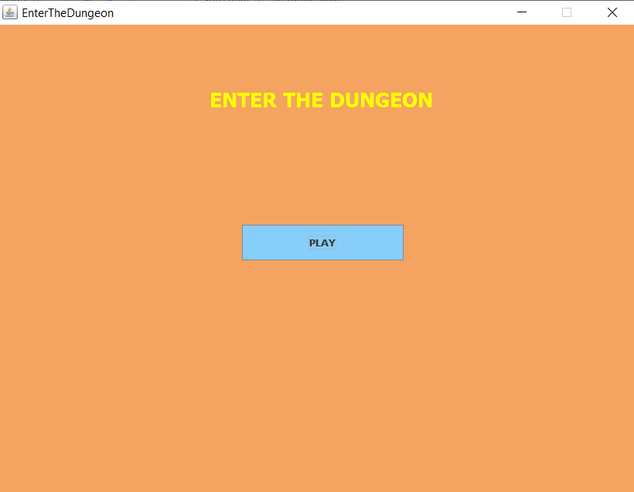

- Taking Inputs from User
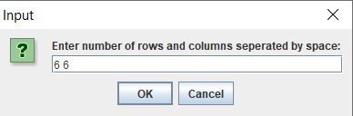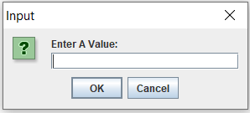

- Initial Display after input

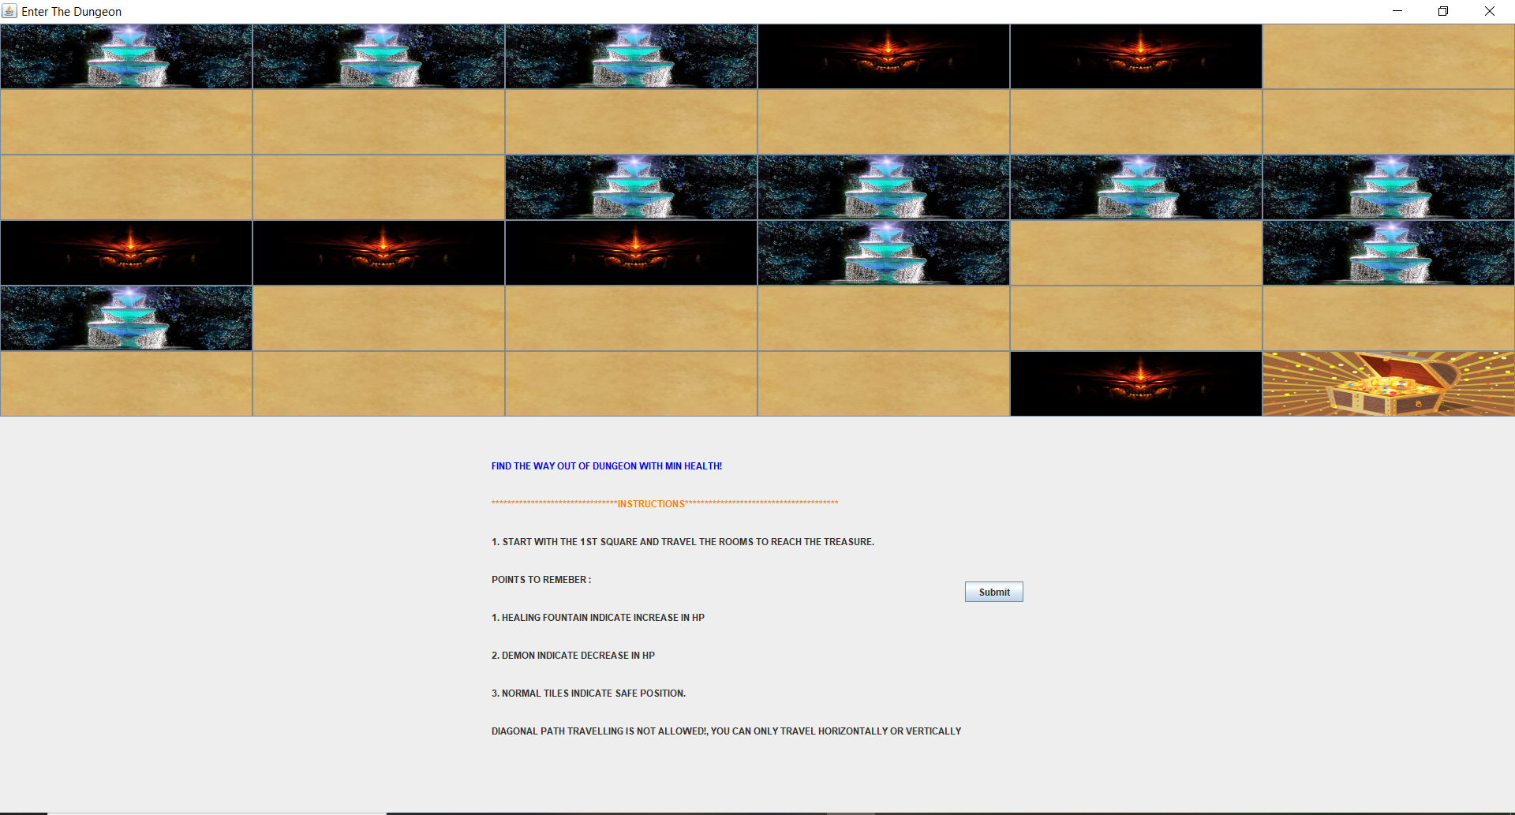

- While Playing the game (Green -> heal, Red -> Demon, Blue ->Normal Tile)
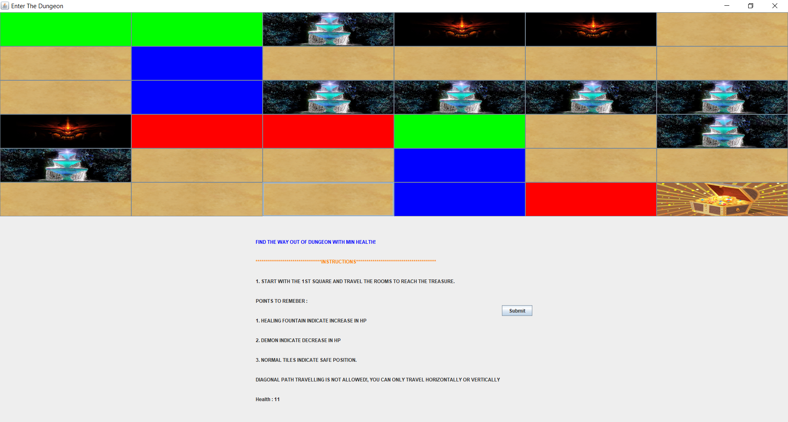

- Selecting Wrong Path and clicking on submit
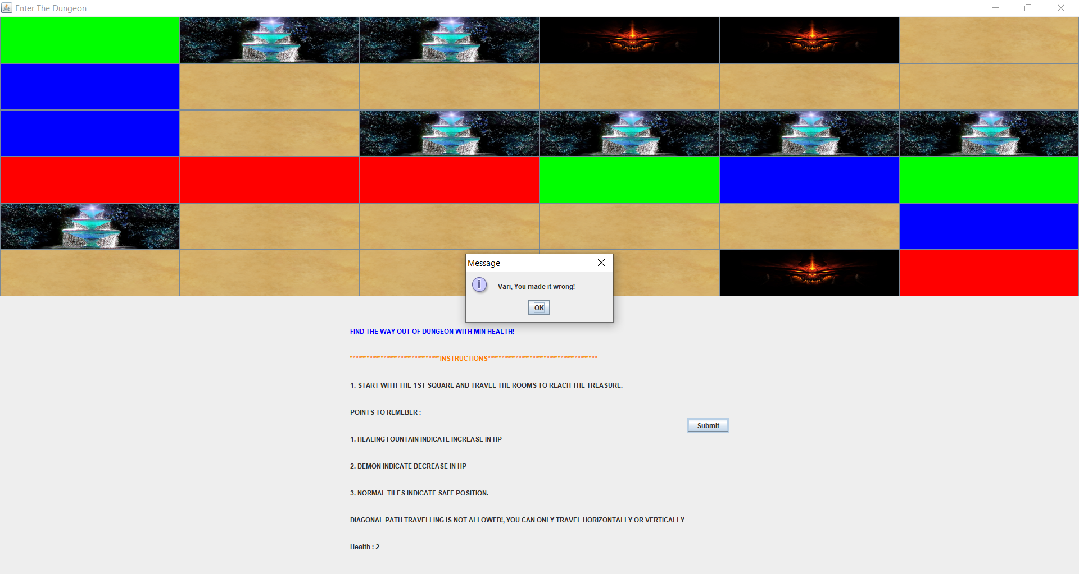

- Selecting One of the Correct Paths and Clicking on submit
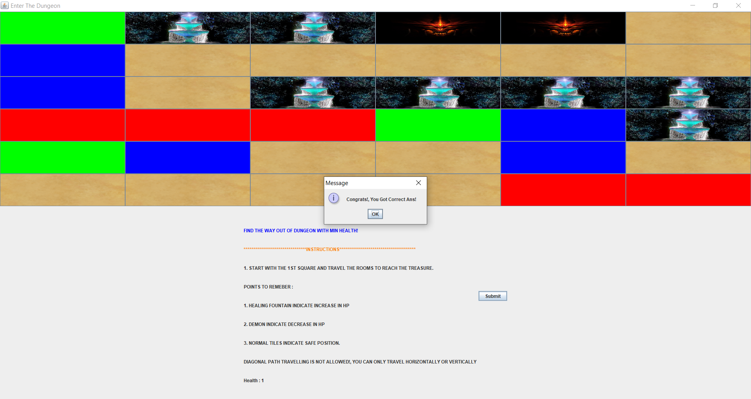

CONCLUSION

This Application uses dynamic programming to find minimum health point (HP) path so that any path selected which gives minimum HP is declared as correct answer (considering possibility of multiple paths for min. HP). This can be further extended by considering the inclusion of diagonal path traversing to get the answer and also by adding more features to the game.

REFERENCES

