**BARRACUDA FRONT-END WEB DEVELOPER TEST PROJECT**

**Running website on local system**

Install Xampp version 7 which is a free and open source cross-platform webserver solution developed by Apache Friends.

Link: <https://www.apachefriends.org/download.html>

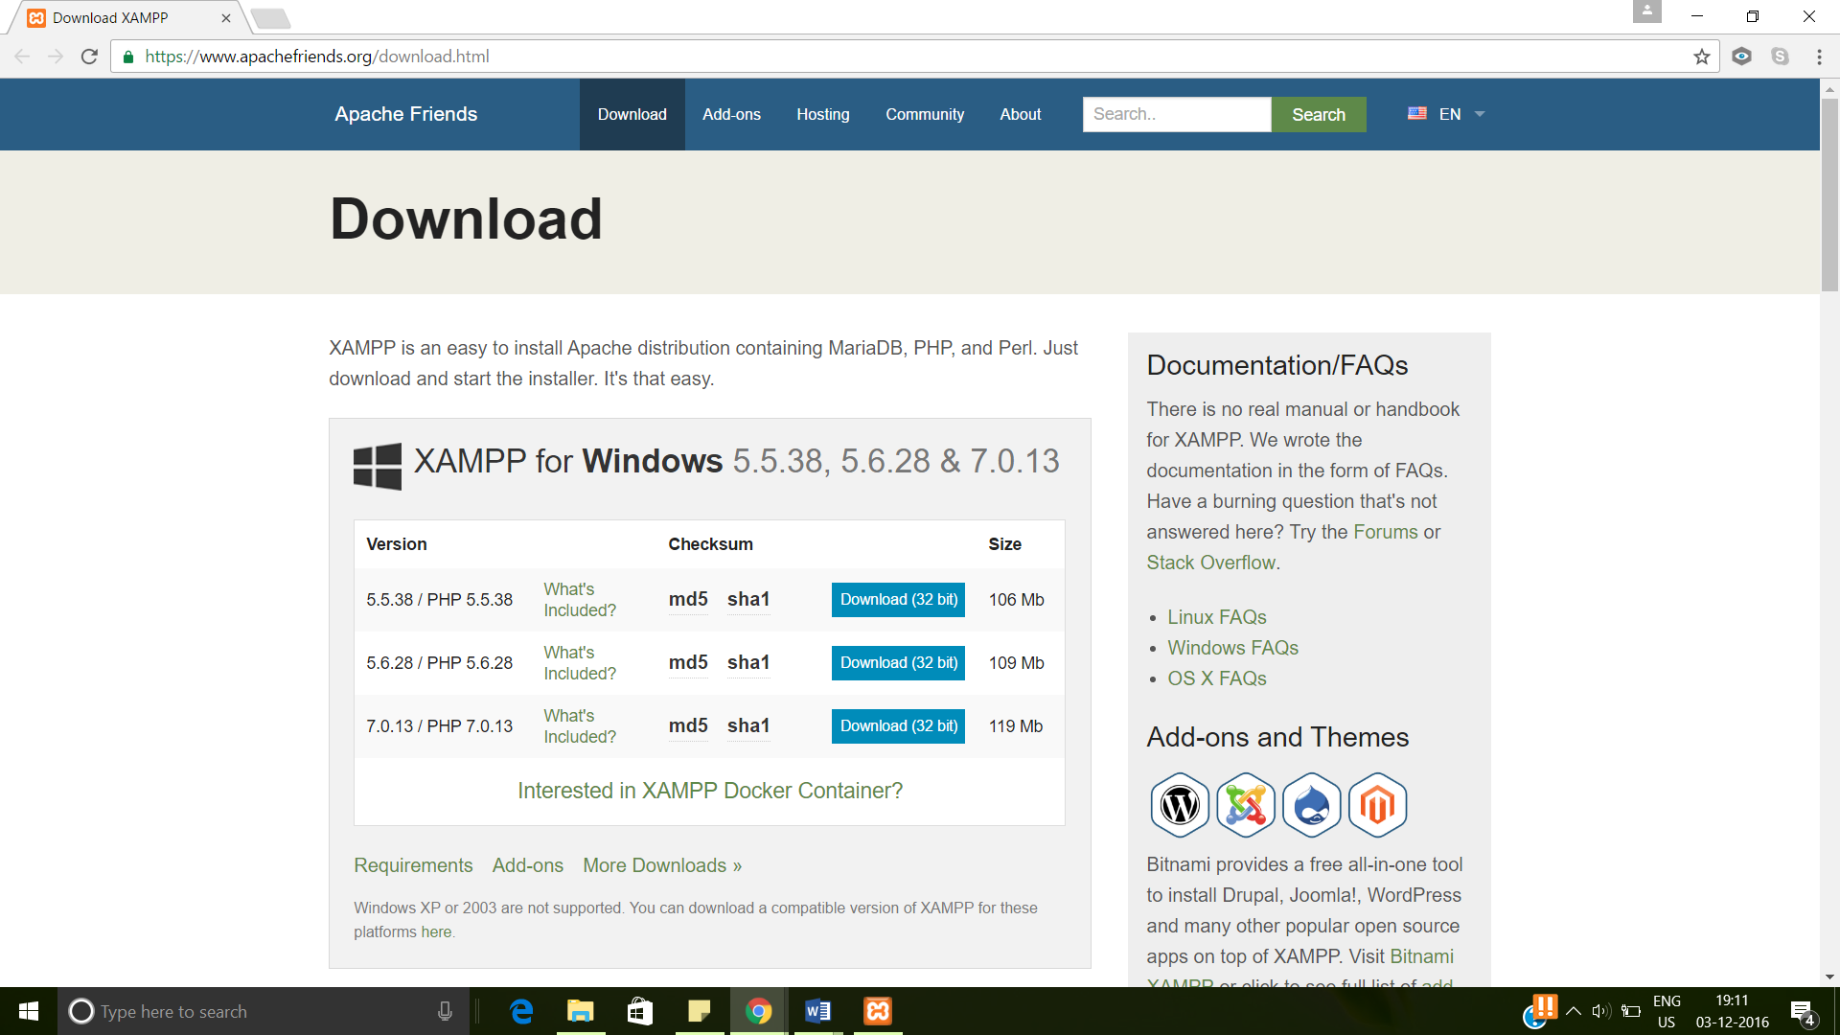

A new folder xampp should be created in the C folder. Go to xampp folder in C folder. Click on Xampp- control. A control panel window will pop up.

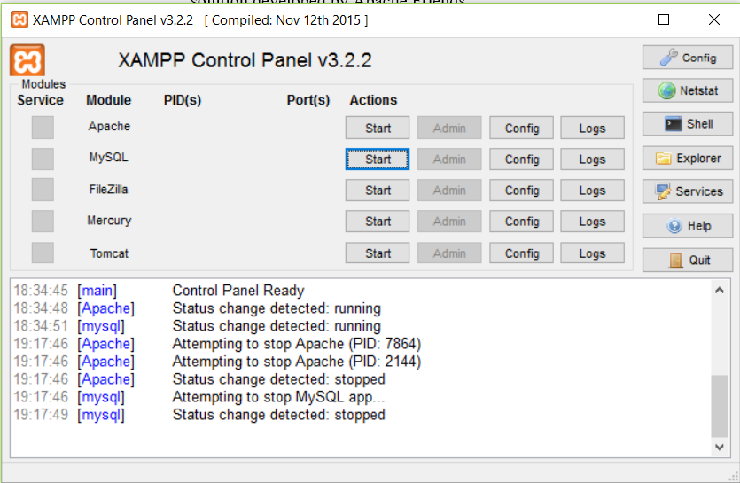

Start the Apache and MySQL modules from the XAMPP Control Panel.

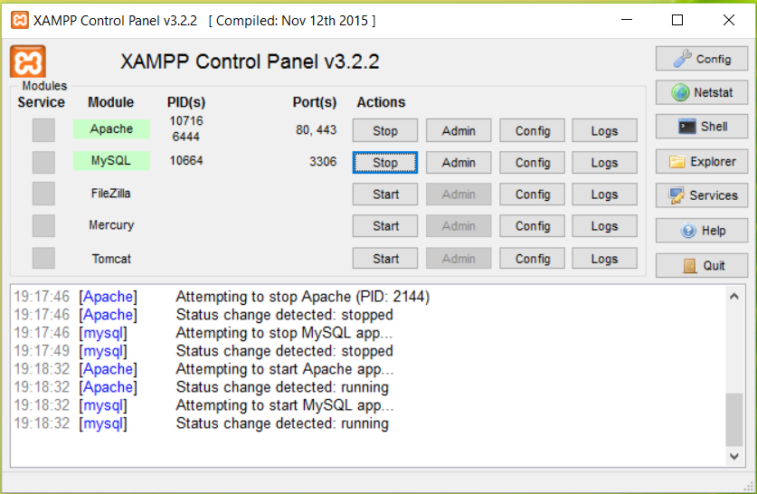

Copy the entire code in “Test Project” folder which has the source code in the C:\xampp\htdocs location.

The website can be run on local host now.

Go to web browser and type the address as localhost/TestProject/barracuda.html