DOCUMENT STUDIO
Complete Product, Architecture, UI/UX and Codex Build Blueprint
Local-first document and PDF workspace

Re-audited master specification
132 planned capabilities in one complete edition
Windows desktop first - optional web and mobile later
Black-and-white print edition
Prepared for V. Sai Rohith
Version 2.0.1 - 22 July 2026

Re-audit outcome
The earlier work was a strong starting point, but it was not ready to begin implementation without correction. The previous report still used the former name, several external-app updates were not verifiably complete, and the architecture/UI/model/dependency handoffs lacked enough operational detail. This master blueprint corrects those gaps and makes Document Studio the sole canonical name.
Area | Final decision
Product | Document Studio - one complete personal edition
First platform | Windows desktop; macOS follows
Desktop stack | Tauri 2.11.x + React 19.2.7+ + TypeScript + Vite 8.1.5+ + Rust
Processing | Local by default; optional browser/cloud/external paths are explicit
Viewer | PDF.js with progressive rendering and virtualized thumbnails
Core engines | qpdf, libvips, OCRmyPDF/Tesseract, LibreOffice
AI | Optional, provider-neutral, local-first, page-cited and consent-gated
Design | Precision Paper - calm, professional, accessible and document-first
Implementation | Codex vertical slices; Phase 0 before feature expansion

Planning package status: complete enough to create the private repository and start Phase 0. Live publication to Notion, Figma, GitHub or Canvs must be confirmed by their connectors; the import-ready assets are included in this package.

Contents
1. Audit and completion record
2. Product charter
3. Personas and jobs to be done
4. Unified feature catalogue
5. Platform strategy
6. UI/UX strategy
7. Information architecture
8. Screen specifications
9. Performance architecture
10. System architecture
11. Unified operation contract
12. Data and database design
13. API and IPC design
14. Security, privacy and threat model
15. Dependency and license register
16. Hugging Face and local model plan
17. Test and quality strategy
18. Delivery, CI/CD and observability
19. Roadmap and milestones
20. Codex delivery method
21. Figma handoff
22. Notion knowledge-base plan
23. Implementation readiness checklist
24. Development setup and first build
25. Final recheck record
Appendix A. Full feature catalogue
Appendix B. Codex prompt pack
Appendix C. Primary implementation references

1. Audit and Completion Record
Audit date: 22 July 2026 Canonical name: Document Studio Package version: 2.0.1-final-recheck

Finding
The previous work was a useful foundation but was not complete enough to begin implementation safely. The older specification still used the former product name, the live Notion/whiteboard state was not verified, the UI/UX handoff was incomplete, the Hugging Face and GitHub candidates were not governed by an explicit adoption policy, and the architecture did not clearly separate the desktop runtime from a future cloud backend.

Corrections completed in this package
- Renamed the product, repository, executable, workflow extension and all current documents to Document Studio.
- Preserved the old reports only under attachments/archive/ as historical inputs.
- Defined the platform sequence and a single canonical desktop architecture.
- Added a 132-item unified feature catalogue with phase, engine and priority.
- Added screen specifications, user journeys, component inventory, design tokens, accessibility criteria and a Figma build recipe.
- Added system, execution, data, security, performance and deployment architecture.
- Added SQLite/PostgreSQL schemas and API/operation contracts.
- Added a dependency decision register and local model registry.
- Added Codex prompts, AGENTS instructions, validation scripts and a Tauri starter scaffold.
- Added a browser-openable UI prototype and architecture/flow diagrams.
- Added Notion import folders containing the blueprint, source research, old reports, current report, diagrams and whiteboard assets.

What is deliberately not claimed
- No live GitHub repository was created from this environment.
- No live Figma file was edited from this environment.
- No Hugging Face model was downloaded or benchmarked; candidates are documented with gates.
- No external Notion or Canvs board update is claimed unless the connector confirms it.
- The full production application is not implemented; this package is the audited plan and starter scaffold.

Gate before implementation
Phase 0 can begin only after the project directory is opened in Codex, the starter is committed to a private repository, and the toolchain/dependency checks in docs/22-IMPLEMENTATION-READINESS-CHECKLIST.md are completed.

2. Product Charter

Product statement
Document Studio is a fast, beautiful and private document workspace for converting, organizing, optimizing, editing, OCR, forms, signatures, security, automation and optional document intelligence. It should feel like one coherent application rather than dozens of disconnected upload pages.

Primary outcome
A user can drop one or many files, choose an operation, inspect the exact pages/settings, run a cancellable job, verify the result and save a new file without losing the original.

Core principles
1. Local first. Routine PDF and image operations require no upload.
2. Truthful completion. Success appears only after output verification.
3. Speed by architecture. Avoid upload latency, warm heavy engines, stream progress, cache previews and choose the fastest safe execution path.
4. One complete edition. No artificial feature partitions in the personal build.
5. Preview before irreversible work. Redaction, signatures, destructive page changes and security settings require an explicit review.
6. Original product design. Match useful capabilities and performance expectations, not another product's brand, copy, assets or source code.
7. Progressive power. Simple defaults first; advanced controls are available without overwhelming routine users.
8. Accessible by default. Keyboard, screen reader, high contrast, reduced motion and zoom are design constraints.

Platform decision
Order | Platform | Why
1 | Windows desktop | Fastest local processing, simplest privacy story, highest value for school/office workflows
2 | macOS desktop | Reuse the Tauri/React workbench with platform packaging and Apple Silicon model options
3 | Optional web app | Reach and shareability; browser-local fast path plus cloud workers for unsupported/heavy tasks
4 | Android/iOS companion | Scan, capture, annotate, sign, send to desktop/web; do not duplicate every heavy converter initially

Success measures
- First meaningful result in under 60 seconds for a new user.
- Routine merge/split/rotate jobs complete locally without network access.
- No false-success reports in automated recovery tests.
- 95% of core workflows operable by keyboard.
- Performance budgets in 08-PERFORMANCE-ARCHITECTURE.md met on the reference machine.
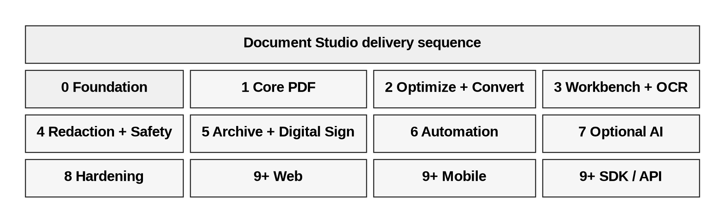
Figure 1. Product delivery sequence from foundation to optional ecosystem.

3. Personas and Jobs to Be Done

Primary persona: Rohith / school administrator
Needs to combine circulars, compress scanned records, convert Office files, add page numbers/watermarks, OCR English/Telugu/Hindi documents, protect sensitive files, sign documents and repeat routine workflows without uploading private school records.

Secondary personas
- Teacher: prepare, merge, annotate and print learning material.
- Office administrator: convert, batch rename, protect, redact and archive documents.
- Student: scan, compress, convert and organize assignments.
- Power user/developer: run repeatable jobs through workflows or CLI.

Highest-value jobs
1. Combine many documents in the right order without damaging originals.
2. Make large PDFs small enough to share while preserving readability.
3. Turn scans into searchable PDFs in English, Hindi and Telugu.
4. Convert Word/Excel/PowerPoint documents to consistent PDFs.
5. Add page numbers, watermarks, signatures and protection in a single reviewed flow.
6. Remove sensitive information so it cannot be recovered.
7. Re-run recurring document recipes without reconfiguring every step.
8. Ask a document a question and see the exact supporting pages.

Anxiety-reducing UX requirements
- Always show where the result will be saved.
- Always show whether processing is local or external.
- Never hide destructive implications behind vague labels.
- Provide plain-language recovery steps when a file is encrypted, damaged or unsupported.
- Keep a visible cancel action for long-running jobs.

4. Unified Feature Catalogue
The canonical machine-readable catalogue is feature-catalog.csv. It currently contains 132 planned capabilities. Phase numbers are implementation order, not access tiers.

Phase summary
- Phase 0: application foundation, privacy, accessibility, diagnostics, job lifecycle and history.
- Phase 1: structural PDF operations and basic image conversion.
- Phase 2: compression, Office conversion, overlays, batch processing and protection.
- Phase 3: editing workspace, forms, signatures and OCR.
- Phase 4: true redaction, sanitization, structured extraction and comparison foundations.
- Phase 5+: archival, digital signatures, advanced conversion, workflows, AI, web/mobile and plugin platform.

Product rule
Every implemented feature is available in one complete personal edition. “Must/Should/Could” expresses implementation priority only.

5. Platform Strategy

Decision
Build the desktop product first. It gives the shortest path to speed and privacy because files stay on the machine and mature native command-line engines can be used directly. Build a web version only after the operation contract and verification model are stable.

Shared product layers
- Shared React component library and design tokens.
- Shared operation manifests and JSON Schemas.
- Shared naming, validation, warning and error language.
- Shared test fixtures and acceptance cases.

Platform-specific execution

Desktop
- Tauri 2 shell and Rust orchestration.
- Direct adapters to signed/bundled qpdf, libvips and selected utilities.
- Optional separately installed LibreOffice, OCRmyPDF and language packs.
- SQLite history/presets/workflows.

Web
- Browser-local path for operations that can be safely implemented with PDF.js/pdf-lib/WASM and fit browser memory.
- Cloud worker path for Office conversion, heavy OCR, AI and very large files.
- Clear local/cloud badge before execution.

Mobile
- Capture, crop, dewarp, rotate, annotate, sign, simple organize/compress.
- Share-sheet integration and optional handoff to desktop/web.
- Heavy Office/OCR/AI features can be deferred or delegated with consent.

Why not build every platform at once
Simultaneous desktop, web and mobile builds multiply packaging, testing, security and performance variables before the core operation lifecycle is proven. One strong vertical slice is more valuable than three incomplete shells.

6. UI/UX Strategy - Precision Paper

Visual concept
Document Studio should look like a modern professional workspace: crisp geometry, strong typography, paper-like content surfaces, quiet chrome and one confident accent. It must be more polished than a grid of utility cards without becoming decorative or slow.

Experience principles
- Drop once, work continuously. A document remains open while the user moves between compatible operations.
- Contextual tools. Show controls relevant to the selected files/pages, not the entire catalogue.
- Progressive disclosure. Default presets are understandable; advanced controls expand on demand.
- Confidence through preview. Before/after, page thumbnails, output summary and verification results are visible.
- Locality is visible. A compact badge says “On this device” or names the external provider.
- One primary action. Each screen has one clear execution button.
- Recoverable mistakes. Reordering/removal/crop/overlay changes remain undoable until export.

Brand direction
- Name: Document Studio.
- Descriptor: “Your private document workspace.”
- Visual metaphor: stacked pages forming a precise aperture/letter D.
- Tone: direct, calm, respectful and technically honest.
- Avoid: gradients for decoration, glassmorphism, excessive shadows, cartoon illustrations, red as a brand color, and marketing claims without measurement.

Layout
- Collapsible left navigation rail.
- Context panel for files/pages.
- Central document canvas.
- Right inspector for operation settings and verification.
- Persistent bottom job tray.
- Global command palette and search.
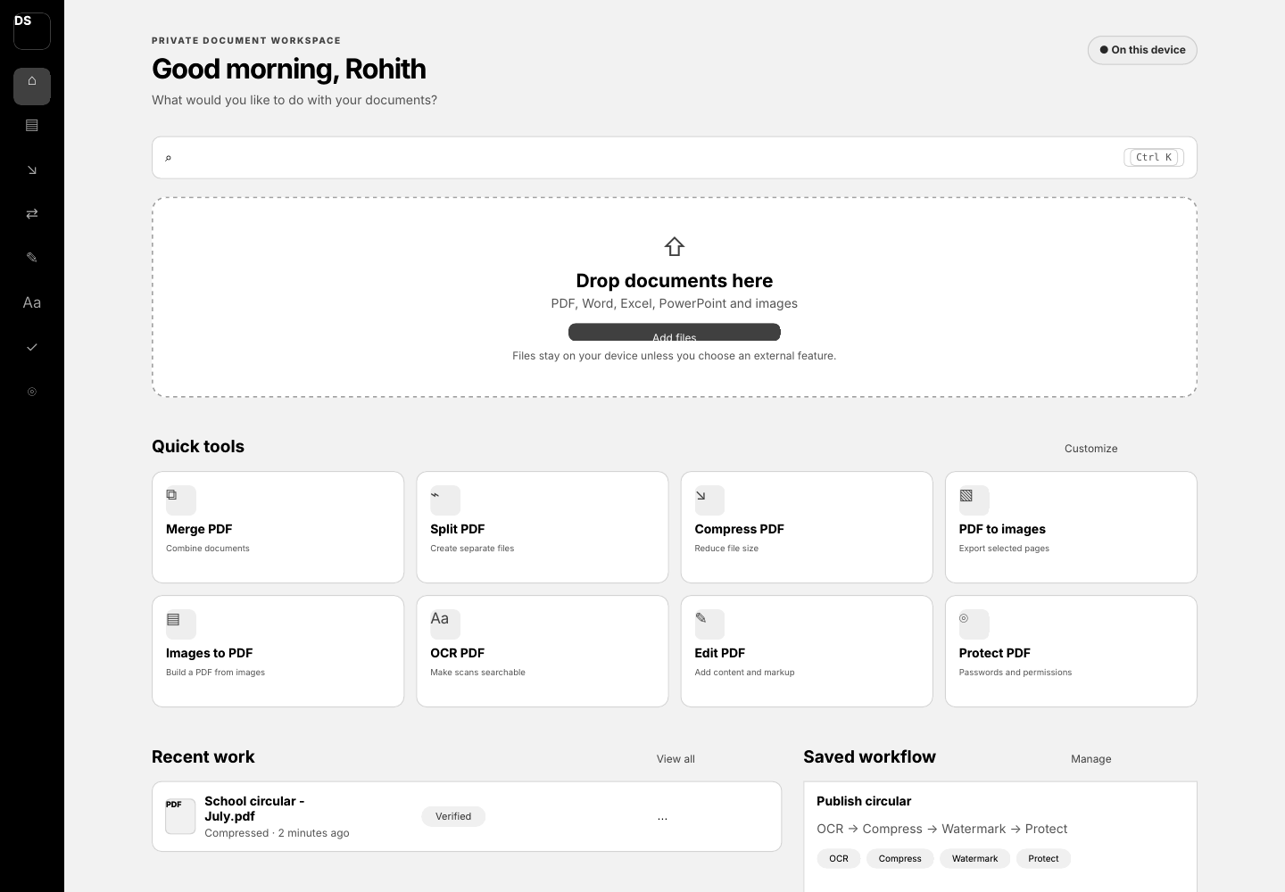
Figure 2. Home-screen design direction: local status, drop zone, quick tools, recent work and saved workflows.

7. Information Architecture

Main navigation
1. Home
2. Organize
3. Optimize
4. Convert
5. Edit
6. OCR
7. Forms & Sign
8. Protect
9. Automate
10. AI Lab (disabled until enabled)
11. History
12. Settings

Home
- New drop zone.
- Search/command bar.
- Pinned quick tools.
- Recent work.
- Saved workflows.
- System status: local engines, storage, offline/privacy mode.

Workbench anatomy
- Top bar: document name, save destination, undo/redo, help, locality badge.
- Left panel: input files and page thumbnails; multi-select, drag reorder, page warnings.
- Center canvas: PDF/image preview with selection and editing overlays.
- Right inspector: operation-specific settings, presets, output naming, validation messages.
- Bottom job tray: queued/running/completed jobs, stage, progress, cancel, retry, open/reveal.

Navigation rule
Catalog categories help discovery, but once files are open the workbench should recommend compatible actions without forcing the user back to Home.
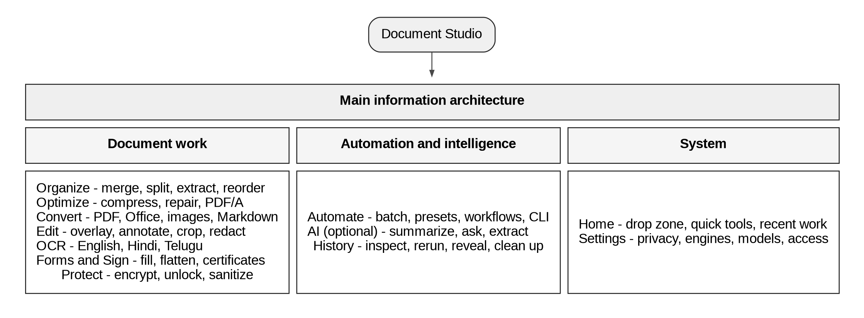
Figure 3. Main information architecture.

8. Screen Specifications

Home
- Greeting and compact privacy status.
- Universal “Search tools and commands” field.
- 640-760 px wide drop zone with local/cloud explanation.
- Eight configurable quick-tool cards.
- Recent jobs table with status, operation, time, output and action menu.
- Saved workflow cards with step chips and run button.

Tool setup screen
- Files list with validation state.
- Operation explanation in one sentence.
- Smart defaults selected.
- Advanced section collapsed.
- Output path and naming template always visible.
- “Run” button states exact action, e.g., “Merge 8 pages.”

Workbench
- Virtualized thumbnails for large files.
- First page appears while remaining previews render progressively.
- Canvas supports fit page/width, zoom, search and keyboard page navigation.
- Inspector uses sections: Selection, Operation, Output, Verification.
- Dangerous choices use warning copy, not only color.

Result screen
- Verified status and checks performed.
- Output path, size, page count and processing time.
- Open, reveal, compare, run another and add-to-workflow actions.
- Warnings remain visible; success is not shown when verification failed.

Settings
- General, Appearance, Privacy, Storage, Dependencies, OCR languages, AI providers, Updates, Accessibility, Diagnostics.
- Global network disable switch.
- Clear history/temporary storage with scope preview.
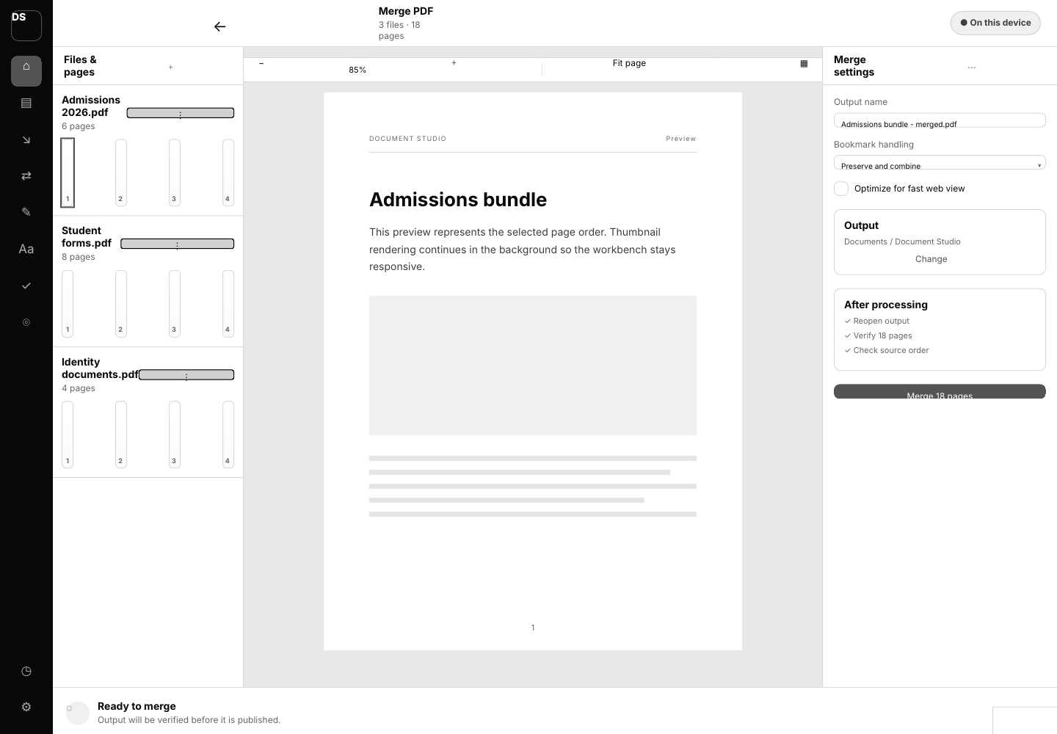
Figure 4. Merge workbench concept with files/pages, document canvas, inspector and persistent job tray.

9. Performance Architecture

Performance objective
The product should feel immediate for common local tasks and explain unavoidable delays for OCR, Office conversion and AI. Performance is measured on a named reference machine and with published test documents.

Reference budgets (initial targets)
Interaction | Target
Warm desktop launch to usable Home | <= 1.5 s
Cold desktop launch | <= 3.0 s
First visible page of a normal PDF | <= 1.0 s after selection
100-page thumbnail strip usable | <= 3.0 s with progressive rendering
Merge ten 10-page text PDFs locally | <= 2.0 s excluding antivirus overhead
Rotate/reorder metadata operation | <= 1.5 s
Cancel acknowledgement | <= 250 ms; worker termination/cleanup reported separately
UI input response while jobs run | <= 100 ms
Job progress update | 4-10 Hz, throttled to avoid UI overhead

These are engineering targets, not guarantees. They must be calibrated on Windows hardware used by the owner.

Techniques
- Keep structural operations in-process or in a warm trusted sidecar/CLI adapter.
- Avoid copying large inputs unless the operation or safety model requires it.
- Memory-map/read streams where supported; never load a multi-gigabyte file into the UI process.
- Render first page and visible thumbnails first; virtualize the rest.
- Cache thumbnails by file fingerprint and renderer version.
- Separate CPU, I/O and memory-heavy queues with concurrency limits.
- Keep LibreOffice and OCR warm only when resource budgets allow.
- Use libvips for low-memory streaming image transforms.
- Publish outputs with atomic rename after verification.
- Benchmark every operation with 10, 100, 500 and 1,000-page fixtures where practical.

Fast-path router
1. Inspect file, size, encryption, page count and operation.
2. Choose browser-local, desktop-local or cloud worker according to capability and policy.
3. Estimate work units and resource risk.
4. Run with bounded concurrency.
5. Verify output and record timing by stage.
6. Feed benchmarks into regression thresholds.
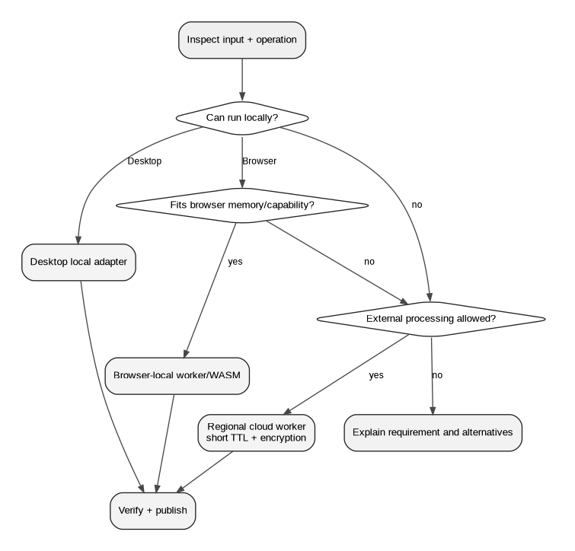
Figure 5. Execution-path router for desktop, browser-local and optional cloud work.

10. System Architecture

Desktop architecture
The desktop app uses Tauri as the trusted boundary. React renders the workbench. The UI invokes allow-listed typed commands. Rust validates paths/settings, creates a private job workspace, selects an operation adapter, streams structured progress, supports cancellation, verifies outputs and records history.

Components
- React workbench: presentation, local state, validation display, thumbnails and editor scene graph.
- Tauri command layer: secure IPC and capabilities.
- Rust job engine: state machine, queue, resource scheduler, cancellation, recovery, audit.
- Operation registry: manifests, schemas, dependencies and adapter factories.
- Adapters: qpdf, libvips, LibreOffice, OCRmyPDF/Tesseract, optional Docling/model services.
- SQLite repository: settings, jobs, presets, workflows, dependencies and model state.
- Workspace manager: per-job directories, staging, atomic publication and cleanup.

Future web architecture
- Static React web app/CDN.
- API gateway and Go control plane.
- PostgreSQL metadata, Redis/Valkey queue coordination and object storage.
- Isolated worker pools by engine/risk profile.
- Regional routing and explicit retention policy.
- Browser-local execution where safe and fast.

Architectural boundary
The local desktop should not depend on the future Go service. Both implement the same operation contract and schemas, but desktop remains fully useful offline.
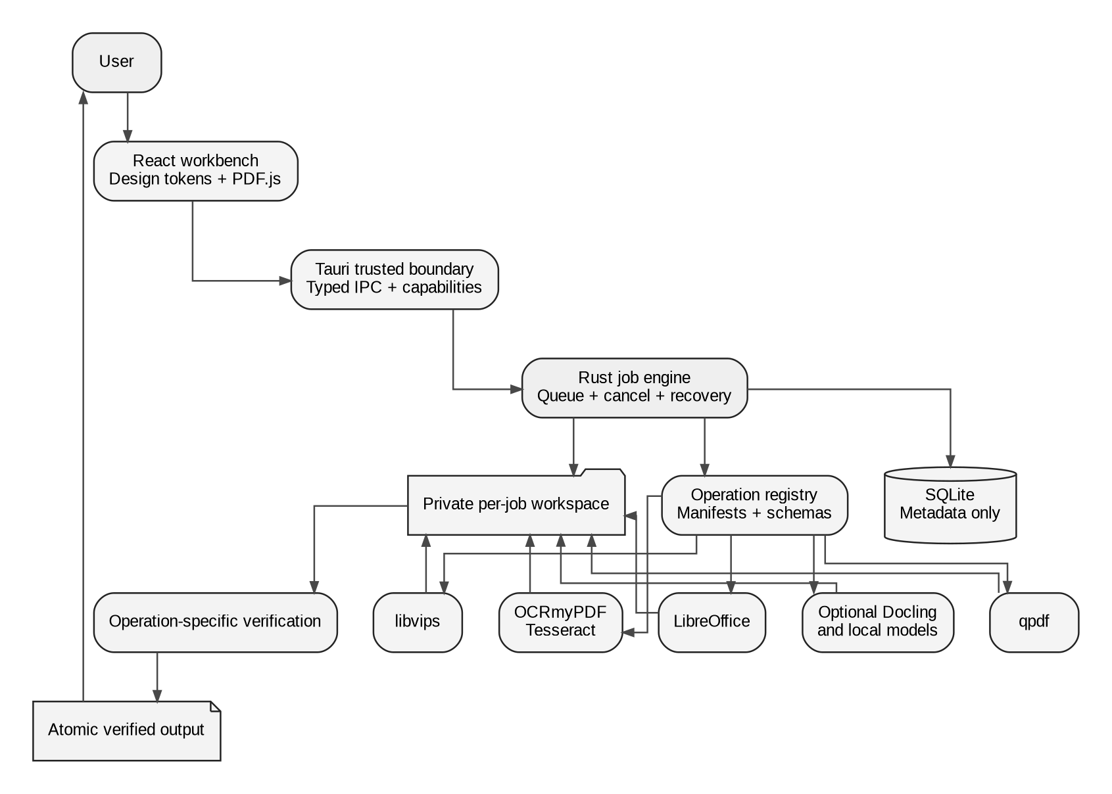
Figure 6. Canonical desktop system architecture.

11. Unified Operation Contract
Every tool must implement the same lifecycle.

Manifest fields
- id and semantic version.
- User-facing name, category and description.
- Accepted input types, multiplicity, page-selection rules and maximum tested sizes.
- Typed settings schema and defaults.
- Dependency and platform capabilities.
- Risk level and whether preview/confirmation is required.
- Output type and verification rules.

Lifecycle
1. inspect - collect safe metadata without mutating input.
2. preflight - validate files, passwords, dependencies, storage and settings.
3. estimate - work units, likely duration class and output-size range when possible.
4. plan - resolve adapter, arguments and workspace paths.
5. execute - cancellable processing with structured progress events.
6. verify - reopen output and assert operation-specific invariants.
7. publish - atomically move verified output to the destination.
8. audit - store timings, versions, fingerprints, warnings and result paths.
9. cleanup - remove temporary data on every terminal path.

Standard progress event
{
"jobId": "uuid",
"operationId": "pdf.merge",
"state": "running",
"stage": "assembling-pages",
"completedUnits": 32,
"totalUnits": 80,
"message": "Adding page 32 of 80",
"cancellable": true
}

Verification examples
- Merge: output opens, expected total pages, expected source order and no unintended encryption.
- OCR: output opens, page count preserved, text layer exists on representative/all pages as configured.
- Redaction: target regions are removed from text extraction and pixels are sanitized according to mode.
- Protect: wrong password fails, correct password opens, requested permission flags match.
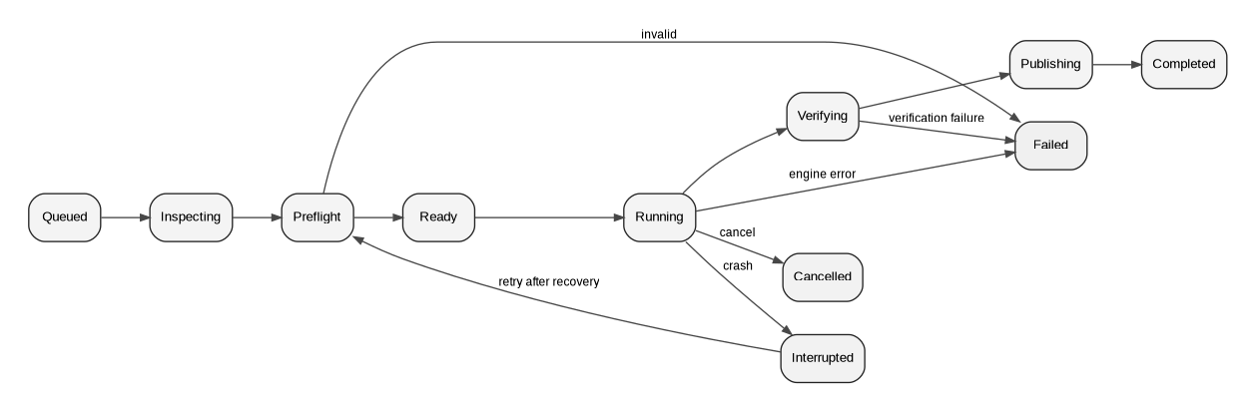
Figure 7. Verified job lifecycle and alternate terminal states.

12. Data and Database Design

Desktop storage
SQLite stores metadata only. Documents remain in user-selected locations or short-lived job workspaces.

Core entities
- jobs: state, operation, timestamps, progress, stage, destination, verification and error.
- job_inputs: path, fingerprint, MIME, size, page count and password reference.
- job_outputs: staging/final path, MIME, size, page count and verification result.
- presets: operation-scoped settings JSON.
- workflows: versioned directed sequence of operation steps.
- workflow_runs: resolved variables and per-step job IDs.
- dependencies: path, version, health and capabilities.
- models: model ID, revision, license, files, verification and install state.
- settings: scoped key/value store with migration version.
- signature_identities: references to protected local assets/certificates; no plaintext secrets.

Retention
- Job history is configurable.
- Temporary workspaces are removed after terminal states and reconciled at startup.
- Extracted text/embeddings are opt-in and scoped to AI features.
- Passwords/API keys/certificate secrets are stored in the OS credential store, referenced by opaque IDs.

Future cloud storage
PostgreSQL stores account, job and policy metadata. Object storage holds encrypted inputs/outputs with short TTLs. Redis/Valkey coordinates queues and locks. Storage region and deletion deadline are recorded per object.

13. API and IPC Design

Desktop IPC
The React app may call only named Tauri commands with serializable typed payloads. It cannot execute arbitrary binaries or write unrestricted paths.

Command groups
- files.inspect
- operations.list
- jobs.create
- jobs.cancel
- jobs.get
- jobs.subscribe
- history.list
- history.delete
- dependencies.scan
- settings.get/set
- models.list/install/remove

Future cloud API
- REST/JSON for job submission, metadata and downloads.
- Server-sent events or WebSocket for progress.
- Idempotency key for submissions.
- Pre-signed upload/download URLs with short expiry.
- Explicit operation/version and schema version.
- Authentication, rate limits and regional policy.

Error envelope
{
"code": "INPUT_ENCRYPTED",
"title": "This PDF needs a password",
"detail": "Provide the opening password to continue.",
"inputIndex": 1,
"stage": "preflight",
"retryable": true,
"helpId": "pdf-passwords"
}

14. Security, Privacy and Threat Model

Trust boundaries
- Untrusted documents and archives.
- UI/webview process.
- Tauri/Rust trusted core.
- Third-party document engines.
- Optional external AI/cloud providers.
- User filesystem and OS credential store.

Required controls
- Allow-list executables and operation arguments.
- Pass arguments as arrays; never concatenate shell strings.
- Canonicalize paths and enforce destination/workspace roots.
- Reject path traversal, symlink escape and dangerous archive entries.
- Isolate each job; use least privilege and resource limits where supported.
- Validate magic bytes and parser output, not only extensions.
- Patch bundled engines and record exact versions/hashes.
- Treat PDFs, images, fonts, Office files and archives as attacker-controlled.
- Disable network by default for document processing.
- Require per-job consent for external processing and show provider/data scope.
- Never log passwords, keys, document text or raw model prompts by default.
- Verify signed updates and bundled sidecar checksums.

Redaction safety
Visual cover-up is not redaction. The operation must remove underlying text/objects or rasterize/sanitize the affected area, then test extraction and visual output. The UI requires a final irreversible confirmation.

Privacy modes
- Normal local mode.
- Strict offline mode (all network disabled, including update/model checks).
- External-provider mode enabled per feature/provider with explicit scope.

15. Dependency and License Register
The dependency register distinguishes adopt, evaluate, optional service and inspiration only. Versions are verified at implementation time and pinned with checksums.
Component | Use | Status | License/notes
Tauri 2.11.x | Desktop shell and secure IPC | Adopt | MIT/Apache-2.0; CLI 2.11.4 and JS API 2.11.1 were current at the 22 July 2026 recheck
React 19.2.7+ | UI | Adopt | MIT; pin a patched 19.2.x or later
Vite 8.1.5+ | Front-end build | Adopt | MIT; Vite 8 uses Rolldown; pair with @vitejs/plugin-react 6.x
PDF.js 5.7.284+ | Viewer, text layer, annotations | Adopt | Apache-2.0
qpdf 12.3.2+ | Structural PDF transforms/encryption | Adopt | Apache-2.0; verify release signatures/checksums
libvips 8.18.2+ | Image conversion/compression | Adopt | LGPL-2.1-or-later; dynamic-linking/distribution review
OCRmyPDF 17.8.x | OCR orchestration | Evaluate as managed optional worker | MPL-2.0; native Windows needs Python, Tesseract and Ghostscript; packaging and sandboxing gate required
Tesseract 5.5.2+ | OCR engine/language packs | Adopt | Apache-2.0; Windows installer is third-party, so binary provenance must be governed
LibreOffice 26.2.4+ | Office conversion | Adopt external dependency | MPL-2.0 and bundled notices; detect installed version and isolate profile directories
Gotenberg 8.32+ | Server-side Office/HTML conversion | Optional web service | MIT; container deployment; keep patched because conversion surfaces process untrusted files
pdf-lib | Browser overlays/simple creation | Evaluate/adopt for narrow cases | MIT; not full arbitrary editing/decryption
pdfcpu 0.12+ | Go-side PDF operations/signature evaluation | Evaluate | Apache-2.0; project describes itself as evolving
veraPDF | PDF/A validation | Evaluate | dual-license/distribution review required
Docling | Structured document parsing | Evaluate | MIT; model licenses separate
Granite Docling 258M | Local document structure extraction | Evaluate | Apache-2.0; English model
multilingual-e5-small | Multilingual embeddings | Evaluate | MIT; 512-token chunk limit
UI UX Pro Max | Design guidance for Codex | Adopt as development skill | MIT; install through uipro-cli
Tokens Studio | Figma design-token sync | Recommend | MIT
Iconify | Icon exploration/import | Recommend with icon-set license review | Plugin/repository terms plus individual set licenses
Design Lint | Figma consistency checks | Recommend | MIT
Stirling-PDF | Feature inspiration/benchmarking | Inspiration only | Do not vendor or copy; separate open-core/security considerations

Adoption gate
A dependency is not production-approved until licensing, update channel, binary provenance, sandboxing, performance, failure behavior and output verification are documented in an ADR.

Version-policy note
The versions above are recheck baselines, not permanent pins. Before each release, update the dependency lock, verify upstream signatures/checksums and advisories, run the compatibility matrix, and record the adopted revision in an ADR and software bill of materials.

16. Hugging Face and Local Model Plan
Models are optional accelerators, not the foundation of ordinary PDF tools.

Approved for evaluation

IBM Granite Docling 258M
- Purpose: document layout, tables, formulas and structured conversion.
- License: Apache-2.0.
- Size: approximately 530 MB model repository.
- Caveat: model card identifies English as the language; do not assume Telugu/Hindi quality.
- Gate: benchmark against rule-based/Docling pipeline on owned test documents before enabling.

intfloat/multilingual-e5-small
- Purpose: local semantic search/retrieval for Ask Document.
- License: MIT.
- Approximately 117M parameters, 384-dimensional embeddings and 512-token input limit.
- Supports a broad multilingual training setup, but Telugu/Hindi retrieval must be benchmarked.

Tesseract language data
- eng, hin, tel are the initial OCR packs.
- Benchmark accuracy, speed and installation size on representative school documents.

PaddleOCR Telugu recognition model
- Benchmark-only alternative for Telugu recognition.
- Do not ship until integration, accuracy, license and runtime footprint beat or complement Tesseract.

Model governance
- Pin repository ID and immutable revision.
- Record model card, license, size and checksums.
- Download only after user action; support remove/update.
- Store under a dedicated model cache, not inside job folders.
- Run local models in a constrained worker process.
- Display model/provider and whether text/images leave the device.
- Evaluate accuracy by language and document type; never advertise universal accuracy.

17. Test and Quality Strategy

Layers
- Unit tests: schemas, range parsing, naming, path validation, job transitions, settings migrations.
- Adapter integration: known input -> operation -> verified output.
- Golden visual tests: render selected outputs and compare with tolerance.
- Cross-renderer tests: PDF.js plus at least one independent desktop/PDFium renderer.
- Security tests: malformed files, traversal, command injection, archive bombs, cancellation and secret logging.
- Recovery tests: kill the process during every stage and relaunch.
- Performance tests: named fixtures and thresholds by stage.
- Accessibility tests: keyboard, focus, screen-reader names, 200% zoom, high contrast and reduced motion.
- Packaging tests: clean Windows/macOS VM, upgrades, missing dependencies and uninstall.

Definition of done for a feature
1. Manifest and typed settings complete.
2. UI explains accepted inputs, locality and risky choices.
3. Preflight catches predictable failures.
4. Progress and cancellation work.
5. Output is staged and verified.
6. Original remains unchanged by default.
7. Temporary files are cleaned in all terminal paths.
8. Success and at least three meaningful failure tests exist.
9. History is useful and does not leak content/secrets.
10. User documentation and performance evidence are updated.

18. Delivery, CI/CD and Observability

Branch and release flow
- Protected main.
- Short-lived feature branches.
- Pull request requires specification validation, formatting, typecheck, tests and security/dependency review for new engines.
- Signed tags and release artifacts.
- Reproducible sidecar acquisition with checksums.

Desktop packaging
- Windows MSI/NSIS first.
- macOS universal/architecture-specific package later.
- Optional engine bundles separated when licensing or size requires it.
- Application update channel is signed and can be disabled.

Local observability
- Structured logs with correlation/job ID.
- Stage timings and engine version.
- No document text, password, key or prompt body by default.
- User-controlled diagnostics export with redaction.
- Local benchmark history to detect regressions.

Future cloud observability
- Metrics: queue wait, processing time by stage, failure code, worker saturation, upload/download duration and cleanup success.
- Distributed tracing without document content.
- Security audit logs and deletion proofs.
- SLOs defined only after real load tests.

19. Roadmap and Milestones

Phase 0 - Foundation
Tauri shell, React design system, PDF viewer placeholder, job lifecycle, SQLite, secure workspace, diagnostics, recovery, prototype parity and diagnostic.copy reference operation.
Exit: a cancellable job is created, processed, verified, published, recorded and recovered correctly after forced termination.

Phase 1 - Core PDF
Merge, split, extract, remove, reorder, rotate, linearize, PDF-to-images, images-to-PDF and naming templates.
Exit: golden and failure tests pass; performance budgets are measured.

Phase 2 - Optimize, convert and protect
Compression, Office-to-PDF, text/Markdown/HTML-to-PDF, page numbers, watermark, metadata, encrypt/unlock, batch runner.

Phase 3 - Workbench, OCR, forms and signatures
Viewer/editor interaction, overlays, crop, annotations, fill/flatten forms, signature placement, OCR in English/Hindi/Telugu.

Phase 4 - Safety-sensitive operations
True redaction, sanitization, suspicious-content preflight, compare foundation and structured extraction.

Phase 5 - Archival and digital signatures
PDF/A pipeline/validation, certificate signing/verification, print center.

Phase 6 - Automation
Saved workflows, CLI, watched folders and .dsflow exchange.

Phase 7 - Optional document intelligence
Local model manager, summary, Ask Document, classification and structured extraction with page citations.

Phase 8 - Product hardening
Accessibility audit, localization, signed updates, clean-machine packaging, benchmark regression gates.

Phase 9+ - Web/mobile/plugin ecosystem
Optional cloud control plane, browser-local router, mobile capture companion, signature requests and plugin SDK.

Figure 8. Milestone roadmap.

20. Codex Delivery Method

Vertical-slice template
Each Codex task should include:
- User-visible behavior.
- Manifest/schema changes.
- Rust command/adapter.
- Job progress, cancel, verification and cleanup.
- UI state and error copy.
- Unit/integration/failure tests.
- Documentation and ADR.
- Benchmark evidence if the hot path changed.

Prompt discipline
- Give Codex one milestone or one feature slice at a time.
- Require it to inspect the repository and propose a file-level plan before editing.
- Require exact commands and test output.
- Require screenshots for UI changes.
- Stop the task when acceptance criteria are met; do not let it expand scope.

First real feature
Implement PDF merge after Phase 0. It exercises multiple inputs, inspection, page counts, ordering, qpdf execution, cancellation, output naming, verification, cleanup and history without complex editing coordinates.

21. Figma Handoff

File pages
1. Cover & decisions
2. Foundations
3. Variables and tokens
4. Components
5. Patterns
6. Desktop flows
7. Web adaptation
8. Mobile capture
9. Prototypes
10. Accessibility and redlines
11. Archive

Variable collections
- Color / Light
- Color / Dark
- Color / High Contrast
- Spacing
- Radius
- Typography
- Elevation
- Motion
- Density

Core components
App shell, navigation item, command search, drop zone, tool card, file row, page thumbnail, canvas toolbar, inspector section, form controls, segmented control, locality badge, status chip, progress row, job tray, result summary, empty/error state, toast and dialog.

Plugins/workflow
- Tokens Studio: import/sync token JSON.
- Iconify: explore/import icons; verify each icon-set license and normalize to a small chosen set.
- Design Lint: find missing styles/inconsistent values.
- Accessibility checker: contrast and naming checks.
- Autoflow/equivalent: document user-flow arrows only, not production components.

Figma-to-code rule
Figma is the design source for behavior/layout and components; tokens JSON is the shared source for numeric values. Do not copy absolute pixel positions from screenshots into production code.

22. Notion Knowledge Base Structure

Recommended page tree
Use one private parent page named Document Studio - Project Hub. Create these child pages under it:
- 00 Audit and decisions
- 01 Product charter
- 02 Feature catalogue
- 03 Personas and workflows
- 04 UI/UX and Figma handoff
- 05 System architecture
- 06 Data, API and operation contract
- 07 Security and privacy
- 08 Performance plan
- 09 Dependencies and model registry
- 10 Roadmap
- 11 Codex prompts and implementation log
- 12 Testing and release checklist
- 13 Research archive
- 14 Diagrams and whiteboards
- 15 Development setup
- 16 Final recheck and publication boundary

Databases
- Features: category, phase, priority, status, owner, acceptance evidence.
- Decisions/ADRs: status, date, decision, alternatives, consequences.
- Milestones/tasks: phase, status, dependency, acceptance criteria.
- Dependencies/models: version/revision, license, status, benchmark, risk.
- Test cases: feature, platform, fixture, expected result, evidence.
The notion-import folder contains Markdown, CSV and attachments that mirror this structure. It includes the current master blueprint, the full research input, the historical reports, reference screens and all whiteboard diagrams.

23. Implementation Readiness Checklist

Identity and scope
- [DONE] Canonical name is Document Studio.
- [DONE] Desktop-first platform strategy chosen.
- [DONE] Unified feature catalogue created.
- [DONE] Personal edition has no artificial plan split.

Architecture
- [DONE] Tauri/Rust desktop boundary chosen.
- [DONE] Operation lifecycle and job state model defined.
- [DONE] Local SQLite and future cloud storage separated.
- [DONE] Browser/local/cloud routing documented.
- [DONE] Security/privacy and recovery rules documented.

Design
- [DONE] Information architecture defined.
- [DONE] Screen specifications and core components defined.
- [DONE] Tokens and Figma handoff included.
- [DONE] Accessibility criteria included.
- [DONE] Prototype included.

Engineering
- [DONE] Repository scaffold and AGENTS file included.
- [DONE] Codex prompts included.
- [DONE] Dependency/model registers included.
- [DONE] Validation scripts and CI skeleton included.
- [TODO] Create private GitHub repository and push this package.
- [TODO] Create/import live Notion knowledge base.
- [TODO] Create live Figma file from the handoff.
- [TODO] Run toolchain installation on the target Windows machine.
- [TODO] Execute Phase 0 prompt in Codex.

Proceed/no-proceed
Proceed to Phase 0 only after the five unchecked environment/publication items are confirmed. The planning package itself is complete enough to start.

Final local recheck
The local package validation and publication boundary are recorded in ../FINAL_RECHECK.md. The unchecked items above require connected external accounts or the target development machine; they are not silently marked complete.

24. Development Setup and First Build
This is the target-machine runbook for the Windows-first Phase 0 build. It intentionally separates development prerequisites, core engine packages, and later optional capabilities so Codex does not install a large, fragile toolchain before it is needed.

Target baseline
- Windows 11 x64, current security updates.
- 16 GB RAM minimum; 32 GB recommended for OCR, very large documents and local models.
- SSD with at least 20 GB free for toolchains, build caches, fixtures and temporary jobs.
- A private GitHub repository and a non-administrator day-to-day development account.

1. Install Tauri development prerequisites
Tauri requires Microsoft C++ Build Tools and Microsoft Edge WebView2 on Windows. In Visual Studio Build Tools, enable Desktop development with C++. WebView2 is normally already present on current Windows 10/11 systems. MSI packaging may also require the Windows VBSCRIPT optional feature.
Install the remaining tools from an elevated PowerShell window:
winget install --id Git.Git -e
winget install --id Rustlang.Rustup -e
winget install --id OpenJS.NodeJS.LTS -e
winget install --id Python.Python.3.12 -e
rustup default stable-msvc
Restart the terminal, then verify:
git --version
node --version
npm --version
rustc --version
cargo --version
python --version

2. Clone and validate the planning repository
git clone <PRIVATE_REPOSITORY_URL> document-studio
cd document-studio
python scripts/validate_repo.py
python scripts/check_links.py
npm install
npm run typecheck
cargo test --manifest-path apps/desktop/src-tauri/Cargo.toml
npm --workspace apps/desktop run tauri dev
The first successful checkpoint is the starter window plus the system_status Tauri command. Do not add PDF engines until this baseline builds and tests cleanly.

3. Core engine installation policy

qpdf
Use the signed official Windows release. Verify its published checksum/signature, store provenance in third_party/manifest.json, and invoke it through validated argument arrays. It is the Phase 1 engine for structural transforms, encryption, linearization and integrity checks.

libvips
Use a reviewed Windows binary or a reproducible build. Prefer dynamic linking and ship the required LGPL notices/source-offer information. Use it for image conversion, thumbnails and image-heavy compression paths.

PDF.js
Install through npm. Keep rendering in the UI process, but move expensive page inspection and document operations to workers/Rust commands. Use virtualized thumbnails and progressive page rendering.

4. Optional capability dependencies

LibreOffice
Treat LibreOffice as a separately installed dependency during development. Detect its version/path, create an isolated user profile per worker, impose time/memory limits and verify every converted output. Decide later whether the installer downloads it, bundles a permitted subset, or requires the user to install it.

OCRmyPDF and Tesseract
Do not require OCR in Phase 0. For the OCR milestone:
1. Benchmark direct Tesseract + controlled PDF assembly against OCRmyPDF.
2. For OCRmyPDF on native Windows, provision 64-bit Python, Tesseract and Ghostscript in a managed worker environment.
3. Treat Windows third-party Tesseract binaries as a provenance risk; record source, checksum and update channel.
4. Install only the requested language packs (eng, hin, tel) and verify checksums.
5. Keep WSL/Docker as development or optional-server paths, not silent desktop requirements.

Local AI models
No model is installed during the foundation. The model manager must require user action, pin an immutable revision, verify checksums, show disk/memory requirements and allow removal. Run the benchmarks in models/models.yaml before enabling any model-backed feature.

5. Phase 0 command sequence for Codex
1. Open the repository root in Codex.
2. Read AGENTS.md, CODEX_START_HERE.md and FINAL_RECHECK.md.
3. Run codex/prompts/01-foundation.md only.
4. Make one vertical slice at a time.
5. Run format, typecheck, Rust tests, repository validators and a Tauri smoke test.
6. Record command output and unresolved decisions under docs/implementation-log/.
7. Stop when the Phase 0 acceptance gate passes.

6. First-build evidence to retain
- Exact Node/npm/Rust/Cargo versions.
- Generated lockfiles and Cargo.lock.
- npm run typecheck output.
- cargo test output.
- Tauri dev-launch screenshot.
- Dependency diagnostic screen output.
- Phase 0 acceptance checklist and any deviations.
Never mark the toolchain ready based on installation alone; preserve reproducible evidence that the starter builds and runs on the target machine.

25. Document Studio - Final Recheck Record
Recheck date: 22 July 2026 Canonical product name: Document Studio Package version: 2.0.1-final-recheck

Final verdict
The earlier deliverables were not fully ready because the historical report still used the former working name and live publication to Notion, Canvs, Figma, GitHub and Hugging Face had not been verified. This recheck closes the package-level gaps and distinguishes completed local deliverables from external actions that require connected accounts or the target development machine.

Completed and rechecked
- Canonical naming is Document Studio in all current product, architecture, UI/UX and Codex documents.
- A single unified catalogue contains 132 capabilities without free-versus-paid product tiers.
- Product charter, personas, platform strategy, information architecture, screen specifications, performance budgets, system architecture, operation contract, database design, API/IPC contracts, threat model, dependencies, model policy, testing, CI/CD, roadmap and Codex delivery method are documented.
- The desktop starter includes Tauri 2, React, TypeScript, Vite 8 and a Rust boundary scaffold.
- The Vite React plugin was aligned with Vite 8 (@vitejs/plugin-react 6.x), and the desktop build script now performs a no-emit TypeScript check before bundling.
- A browser-openable interactive prototype, design tokens, Figma component inventory, Figma plugin plan, reference screens and prototype flows are included.
- Architecture, information architecture, job lifecycle, execution-routing and roadmap whiteboards are available as source plus PNG/SVG exports.
- Hugging Face candidates are recorded with explicit evaluation gates; no model is silently downloaded or treated as production-ready.
- GitHub-ready repository structure, CI workflow, ADRs, validation scripts, AGENTS instructions and staged Codex prompts are included.
- The Notion import package contains current documentation, the master DOCX/PDF, full feature CSV, source research, historical reports, prototype screenshots and all exported whiteboards.
- The printable master report was rendered and visually inspected page by page before packaging.

Validation completed in this environment
- Repository structure and feature-count validator.
- Internal Markdown-link checker.
- JSON and YAML parsing.
- JavaScript syntax check for the static prototype.
- Go control-plane skeleton unit test.
- DOCX ZIP integrity and accessibility audit.
- PDF openability, page count and text extraction.
- Canonical-name scan across current sources, with historical files excluded by design.
- The frontend package manifest and TypeScript/Vite configuration were statically reviewed. Full npm installation/typecheck/build did not run because registry resolution exceeded the environment timeout.
- Rust/Cargo compilation did not run because the Rust toolchain is not installed in this environment.

External or target-machine actions still required
These are execution/publication steps, not missing planning work:
1. Create a private GitHub repository and push the package.
2. Import/publish the prepared knowledge base in the connected Notion workspace.
3. Create the live Figma file from the supplied design tokens and handoff.
4. Import or recreate the supplied diagrams in the connected Canvs board.
5. Create the Hugging Face collection/Space only after model evaluations pass.
6. Install Rust/Cargo, qpdf, OCR, Office-conversion and packaging dependencies on the target Windows machine.
7. Run the Phase 0 Codex prompt and capture build/test evidence.

Proceed gate
The planning, design and starter package is complete. Production implementation has not been claimed. Begin Phase 0 only after the repository and target toolchain are available; publish the prepared external-app packages when those connectors are connected.

Appendix A. Full unified feature catalogue
The following 132 capabilities are planned as one complete product. Phase expresses sequence, not a subscription tier. “Must/Should/Could” is delivery priority.
Category | Feature | Required behavior | Phase / priority / engine
Organize | Merge PDF | Combine PDFs/images, page-range imports, drag reorder, bookmark and outline preservation | P1 · Must · qpdf
Organize | Split by ranges | Create files from explicit page ranges | P1 · Must · qpdf
Organize | Split every N pages | Split at a fixed page interval | P1 · Must · qpdf
Organize | Split by bookmarks | Use document outline levels as boundaries | P2 · Should · qpdf
Organize | Split by target size | Estimate boundaries to produce size-bounded parts | P3 · Could · qpdf + estimator
Organize | Extract pages | Export selected pages as one PDF, individual PDFs, or ZIP | P1 · Must · qpdf
Organize | Remove pages | Delete thumbnail/range selections with undo before export | P1 · Must · qpdf
Organize | Reorder pages | Drag, reverse, odd/even regroup, duplicate, and move pages | P1 · Must · qpdf
Organize | Rotate pages | Rotate selected/odd/even/all pages 90/180/270 degrees | P1 · Must · qpdf
Organize | Insert blank pages | Insert configurable blank page sizes and orientation | P2 · Should · pdf-lib/qpdf
Organize | Interleave documents | Alternate pages from two or more files | P2 · Should · qpdf
Organize | N-up and booklet | Impose pages for 2-up, 4-up, and booklet printing | P5 · Could · pdfcpu/print engine
Organize | Scan to PDF | Camera/scanner import, crop, dewarp, cleanup, reorder | P6 · Should · OpenCV + native camera
Optimize | Compress - lossless | Remove redundant structures and optimize streams without image loss | P1 · Must · qpdf
Optimize | Compress - balanced | Downsample/re-encode images with readable defaults | P2 · Must · libvips + qpdf
Optimize | Compress - strong | Aggressive image and font optimization with preview comparison | P2 · Should · libvips + qpdf
Optimize | Image-aware compression | Per-image DPI, JPEG quality, monochrome and transparency controls | P2 · Should · libvips
Optimize | Linearize PDF | Fast-web-view optimization | P1 · Should · qpdf
Optimize | Repair PDF | Rebuild xref/object streams and salvage readable pages | P2 · Must · qpdf + fallback parser
Optimize | Remove unused objects | Garbage collect orphaned objects/resources | P2 · Should · qpdf
Optimize | PDF/A conversion | Create archival variants and validate conformance | P5 · Should · LibreOffice/veraPDF
Optimize | Optimize scans | Deskew, despeckle, background cleanup, bilevel optimization | P3 · Should · OCRmyPDF + unpaper
Convert to PDF | JPG/PNG/WebP to PDF | Convert raster images with page size, margins, orientation, quality | P1 · Must · libvips + PDF writer
Convert to PDF | TIFF/BMP/HEIC to PDF | Convert additional image formats and multipage TIFF | P2 · Should · libvips/ImageMagick
Convert to PDF | Word to PDF | DOC/DOCX/ODT conversion | P2 · Must · LibreOffice
Convert to PDF | Excel to PDF | XLS/XLSX/ODS conversion with sheet/range options | P2 · Must · LibreOffice
Convert to PDF | PowerPoint to PDF | PPT/PPTX/ODP conversion | P2 · Must · LibreOffice
Convert to PDF | Markdown to PDF | Render Markdown with print themes and syntax highlighting | P2 · Should · Chromium/HTML pipeline
Convert to PDF | HTML to PDF | Render local HTML or approved URLs with page controls | P2 · Should · Chromium/Gotenberg
Convert to PDF | Text to PDF | Convert TXT/CSV/JSON/XML to formatted PDF | P2 · Should · native renderer
Convert to PDF | Email to PDF | Convert EML/MSG with headers and attachments index | P5 · Could · Docling/mail parser
Convert to PDF | SVG to PDF | Preserve vector content when possible | P3 · Should · resvg/Cairo
Convert to PDF | Archive package to PDF | Combine mixed supported inputs into an ordered PDF binder | P4 · Could · workflow engine
Convert from PDF | PDF to JPG/PNG/WebP | Render selected pages at configurable DPI | P1 · Must · PDFium/MuPDF/libvips
Convert from PDF | PDF to TIFF | Export single/multipage TIFF | P2 · Should · PDFium + libvips
Convert from PDF | PDF to text | Reading-order text extraction with OCR fallback | P1 · Must · PDF.js/Docling/Tesseract
Convert from PDF | PDF to Markdown | Structured headings, lists, tables, images and links | P4 · Should · Docling/Granite Docling
Convert from PDF | PDF to Word | Layout-aware DOCX with OCR fallback and confidence warnings | P5 · Should · Docling + DOCX writer
Convert from PDF | PDF to Excel | Detect tables; export CSV/XLSX with review step | P5 · Should · Docling/table engine
Convert from PDF | PDF to PowerPoint | Page-as-slide and editable reconstruction modes | P6 · Could · renderer + PPTX writer
Convert from PDF | PDF to HTML | Structured HTML with page/image assets | P4 · Could · Docling
Convert from PDF | Extract images | Export embedded images without unnecessary re-rendering | P2 · Should · qpdf/PDF parser
Convert from PDF | Extract attachments | List and export embedded files safely | P2 · Should · qpdf/PDF parser
Convert from PDF | Extract fonts report | Inventory embedded fonts without redistributing font binaries | P5 · Could · PDF parser
Convert from PDF | Extract annotations | Export comments/highlights to JSON/CSV/FDF-like formats | P4 · Could · PDF parser
Convert from PDF | PDF to searchable archive | OCR + PDF/A + metadata workflow | P5 · Should · workflow engine
Edit | Add text | Positioned text overlays with font embedding and alignment | P3 · Must · pdf-lib/PDF editor
Edit | Edit overlay text | Move/resize/delete objects created by Document Studio | P3 · Must · editor scene graph
Edit | Add shapes | Rectangles, ellipses, lines, arrows, polygons and callouts | P3 · Must · editor scene graph
Edit | Freehand draw | Pen/highlighter with smoothing, opacity and eraser | P3 · Should · canvas + PDF annotations
Edit | Highlight/underline/strikeout | Text-aware markup annotations | P3 · Must · PDF.js text layer
Edit | Comments and notes | Sticky notes and threaded local comments | P3 · Should · PDF annotations
Edit | Insert images | Place, crop, rotate and resize images/logos/stamps | P3 · Must · pdf-lib/PDF editor
Edit | Add page numbers | Position, format, range, start number and exclusions | P2 · Must · PDF overlay engine
Edit | Headers and footers | Templates using date, filename, page and page count | P3 · Should · PDF overlay engine
Edit | Watermark | Text/image watermark with opacity, angle and page scope | P2 · Must · PDF overlay engine
Edit | Crop pages | Visual crop boxes, margins and uniform/apply-to-range modes | P3 · Must · PDF page boxes
Edit | Resize pages | Change page media size and optionally scale content | P4 · Should · PDF page transform
Edit | Redact | Search/manual true redaction that removes underlying content | P4 · Must · MuPDF/PDF redaction engine
Edit | Sanitize after redaction | Remove metadata, hidden objects, attachments and scripts | P4 · Must · qpdf + sanitizer
Edit | Compare PDFs | Side-by-side, overlay and semantic text difference report | P5 · Should · renderer + diff engine
Edit | Replace pages | Swap selected pages while preserving order/bookmarks when possible | P3 · Should · qpdf
Edit | Layers/optional content | Inspect and toggle optional-content groups | P7 · Could · advanced PDF parser
Edit | Bates numbering | Legal document numbering with prefix/suffix and range rules | P5 · Could · overlay engine
Forms | Fill AcroForms | Text, checkbox, radio, choice, date and signature fields | P3 · Must · PDF form engine
Forms | Create form fields | Add form controls, names, validation, required state and tab order | P5 · Should · PDF form engine
Forms | Detect form fields | Suggest fields on flattened/scanned forms | P7 · Could · layout model
Forms | Flatten forms | Bake appearances into final pages | P3 · Must · PDF form engine
Forms | Import/export form data | FDF/XFDF/JSON-like data interchange | P6 · Could · form data adapter
Forms | Form validation report | Missing required values and field constraints | P5 · Should · form engine
Forms | Template forms | Save reusable field layouts for recurring documents | P6 · Could · workflow + form engine
OCR | Searchable PDF | Add hidden text layer while preserving page appearance | P3 · Must · OCRmyPDF + Tesseract
OCR | English OCR | Default English language pack | P3 · Must · Tesseract eng
OCR | Hindi OCR | Hindi language pack | P3 · Must · Tesseract hin
OCR | Telugu OCR | Telugu language pack with benchmark against PaddleOCR | P3 · Must · Tesseract tel / benchmark
OCR | Mixed-language OCR | Run multiple languages in one job | P3 · Must · Tesseract
OCR | Deskew/orientation | Detect page rotation and deskew | P3 · Must · OCRmyPDF
OCR | Cleanup scans | Denoise, remove background and optimize before OCR | P3 · Should · OCRmyPDF/unpaper
OCR | OCR confidence review | Page-level warnings and low-confidence text overlay review | P6 · Could · OCR pipeline
OCR | hOCR/ALTO export | Export OCR geometry and confidence | P6 · Could · Tesseract
OCR | Handwriting research mode | Optional experimental handwriting model; never promise accuracy | P8 · Could · HF model evaluation
Security | Protect PDF | Set open password, owner password and permissions | P2 · Must · qpdf
Security | Unlock PDF | Remove protection only with valid user-supplied credentials | P2 · Must · qpdf
Security | AES encryption | Support modern PDF encryption profiles | P2 · Must · qpdf
Security | Metadata editor | View, change and remove title/author/subject/keywords/dates | P2 · Must · qpdf/PDF parser
Security | Sanitize document | Remove scripts, actions, embedded files, selected annotations and hidden metadata | P4 · Must · sanitizer
Security | Malware-safe preflight | Detect suspicious actions/attachments and isolate risky files | P4 · Should · static scanner
Security | Secure erase temporary jobs | Best-effort cleanup and encrypted temp option | P4 · Should · OS storage layer
Security | Certificate validation | Inspect signatures, certificate chain and revocation where available | P5 · Should · PAdES verifier
Security | Permission report | Explain permissions and encryption status in plain language | P2 · Must · qpdf
Security | Privacy mode | Globally disable network and external providers | P0 · Must · platform policy
Sign | Draw/type/upload signature | Create reusable local signature assets | P3 · Must · editor + OS keychain
Sign | Place signature/initial/date | Drag placement and repeat across pages | P3 · Must · PDF overlay engine
Sign | Signature vault | Encrypt local identities and assets using OS credentials | P3 · Must · OS keychain
Sign | Certificate signing | PAdES/CMS-based digital signatures | P5 · Should · standards-compliant signer
Sign | Timestamp signing | Optional trusted timestamp integration | P6 · Could · TSA adapter
Sign | Signature validation | Show signer, integrity, trust and timestamp status | P5 · Should · PAdES verifier
Sign | Request signatures | Cloud-only multi-recipient workflow, optional future module | P9 · Could · cloud e-sign service
Automation | Batch processing | Apply one operation to many files with isolated failures | P2 · Must · job engine
Automation | Saved workflows | Chain typed operations with variables and review gates | P6 · Should · workflow engine
Automation | Watched folders | Run approved workflows for new files | P6 · Should · desktop watcher
Automation | Command-line interface | Expose stable operations for scripts | P6 · Should · Rust CLI
Automation | Local HTTP API | Optional loopback API with token protection | P7 · Could · Rust local API
Automation | Naming templates | Deterministic outputs with collision policies | P1 · Must · job engine
Automation | Presets | Reusable per-tool settings | P1 · Must · SQLite
Automation | Schedule jobs | Run local workflows at a chosen time | P7 · Could · OS scheduler
Automation | Share workflow file | Portable .dsflow JSON with versioned schema | P6 · Should · workflow engine
Automation | Hot folders with routing | Route by filename, type or detected document class | P8 · Could · workflow + classifier
AI | Document summary | Local-first summary with selectable pages and citations | P7 · Should · provider-neutral LLM
AI | Ask document | RAG over extracted text with page citations | P7 · Should · multilingual-e5 + LLM
AI | Classify and rename | Suggest type, filename and destination | P7 · Should · classifier/LLM
AI | Structured extraction | Invoices, receipts, forms and custom JSON schema | P7 · Should · Docling + LLM
AI | Table understanding | Detect/repair table structure for export | P7 · Should · Docling/Granite Docling
AI | Translate document | Translate text with clear layout-fidelity limitations | P8 · Could · translation provider
AI | Smart split | Suggest logical document boundaries | P8 · Could · layout model + rules
AI | Sensitive-data finder | Suggest PII/financial identifiers for manual review | P7 · Should · NER/rules
AI | AI-assisted redaction review | Never auto-commit; user confirms every redaction | P8 · Could · NER + review UI
AI | Document Q&A export | Export questions/answers with source-page references | P8 · Could · RAG engine
AI | Model download manager | Install, verify, update and remove local models | P7 · Should · model registry
AI | External-provider consent | Per-job approval with provider, scope and retention notice | P7 · Must · policy layer
Platform | Recent work and history | Search jobs, inspect settings, rerun, reveal output and clean history | P0 · Must · SQLite
Platform | Command palette | Keyboard-first access to tools, files and presets | P0 · Must · React UI
Platform | Dependency diagnostics | Detect missing engines, versions and remediation steps | P0 · Must · Rust core
Platform | Crash recovery | Recover interrupted jobs without false success | P0 · Must · job engine
Platform | Update manager | Signed releases with optional staged rollout | P8 · Should · Tauri updater
Platform | Localization framework | English first; Telugu and Hindi UI-ready strings | P0 · Should · i18n
Platform | Accessibility mode | Keyboard, screen reader, 200% scaling, high contrast, reduced motion | P0 · Must · design system
Platform | Theme modes | Light, dark and high-contrast variables | P0 · Should · design tokens
Platform | Print center | Preview, grayscale, duplex guidance, N-up, booklet and fit | P5 · Should · print pipeline
Platform | Cross-device handoff | Optional encrypted handoff between personal devices | P10 · Could · future cloud sync
Platform | Plugin SDK | Versioned operation manifests and sandboxed adapters | P9 · Could · operation SDK
Platform | Diagnostics export | Logs and dependency data without document content/secrets | P0 · Must · platform

Appendix B. Codex prompt pack

Codex Prompt 01 - Foundation
Read AGENTS.md, CODEX_START_HERE.md, docs/09-SYSTEM-ARCHITECTURE.md, docs/10-OPERATION-CONTRACT.md and docs/22-IMPLEMENTATION-READINESS-CHECKLIST.md before editing.
Implement Phase 0 only:
- Make the Tauri/React shell run.
- Implement design-token consumption and Home layout parity with the prototype.
- Add SQLite migrations for jobs, inputs, outputs, presets, workflows, dependencies and settings.
- Implement the typed job state machine.
- Implement secure per-job workspaces and startup reconciliation.
- Implement diagnostic.copy through inspect, preflight, estimate, execute, cancel, verify, publish, audit and cleanup.
- Add dependency diagnostics.
- Add tests for completion, cancel, failure, crash reconciliation and path safety.
Before editing, give a file-by-file plan. After editing, run formatting, typecheck, Rust/unit/integration tests and a development smoke test. Stop when Phase 0 acceptance criteria pass.

Codex Prompt 02 - PDF Merge
Implement pdf.merge as the first production operation using qpdf. Support multiple inputs, page-range selection, drag order, outline/bookmark policy, deterministic naming, cancellation, staged output, verification and history. Do not overwrite originals. Add corrupt/encrypted input errors and golden/cancel/collision/recovery tests.

Codex Prompt 03 - Core PDF operations
After merge is accepted, add split, extract, remove, reorder, rotate and linearize through the same operation contract. Reuse page-range parsing, file inspection, qpdf execution, verification and UI patterns. Add fixtures and benchmarks.

Codex Prompt 04 - Compression and conversion
Add lossless compression first, then image-aware balanced compression using libvips. Add images-to-PDF, PDF-to-images and Office-to-PDF through separately diagnosed dependencies. Include before/after size and representative visual comparison.

Codex Prompt 05 - OCR and security
Add OCRmyPDF/Tesseract with English, Hindi and Telugu packs, followed by protect/unlock/metadata. Use representative-page preview, stage progress, cancellation and operation-specific verification. External services remain disabled.

Codex Prompt 06 - Editor and true redaction
Implement overlays/annotations/crop before true redaction. Keep an editor scene graph separate from committed PDF content. Redaction must remove recoverable content and pass extraction plus visual verification; a black overlay is unacceptable.

Codex Prompt 07 - Automation and optional AI
Implement presets, saved workflows, CLI and watched folders. Only after those are stable, implement the model manager and evaluate Docling/Granite Docling and multilingual-e5-small. AI answers require source pages and external providers require consent.

Appendix C. Primary implementation references
- Tauri project and security/capability documentation: https://tauri.app/
- React 19.2 release: https://react.dev/blog/2025/10/01/react-19-2
- Vite 8.1 announcement: https://vite.dev/blog/announcing-vite8-1
- qpdf: https://github.com/qpdf/qpdf
- PDF.js: https://github.com/mozilla/pdf.js
- pdf-lib: https://github.com/Hopding/pdf-lib
- pdfcpu: https://github.com/pdfcpu/pdfcpu
- libvips: https://github.com/libvips/libvips
- OCRmyPDF: https://github.com/ocrmypdf/OCRmyPDF
- Tesseract: https://github.com/tesseract-ocr/tesseract
- LibreOffice: https://www.libreoffice.org/
- Gotenberg: https://github.com/gotenberg/gotenberg
- Docling: https://github.com/docling-project/docling
- Granite Docling 258M: https://huggingface.co/ibm-granite/granite-docling-258M
- multilingual-e5-small: https://huggingface.co/intfloat/multilingual-e5-small
- UI UX Pro Max: https://github.com/nextlevelbuilder/ui-ux-pro-max-skill
- Tokens Studio: https://github.com/tokens-studio/figma-plugin
- Design Lint: https://github.com/destefanis/design-lint
- Iconify Figma: https://github.com/iconify/iconify-figma
Companion package contents
- Codex-ready repository scaffold
- Interactive static UI prototype and two reference screens
- Figma tokens, file structure, components and plugin plan
- Hugging Face/local-model registry
- Architecture and workflow diagrams in DOT, Mermaid, PNG and SVG
- Notion import pack with source research and historical reports
- Validation scripts, CI skeleton, ADRs and acceptance checklists

