**Shopping Ingredients Application – User Manual**

1. **Overview:**
2. **Getting started**
   1. **Set-up:**
      1. Need Windows system to run the application
      2. Copy the .exe file present in dist folder to you windows system
   2. **Launching application**
      1. Double click on the **shopping_app.exe** file
      2. Other way to run the application is by right clicking on the .exe file and click on open
   3. **Exiting the application**

Closing the application window will exit the application. Click on X mark on window.

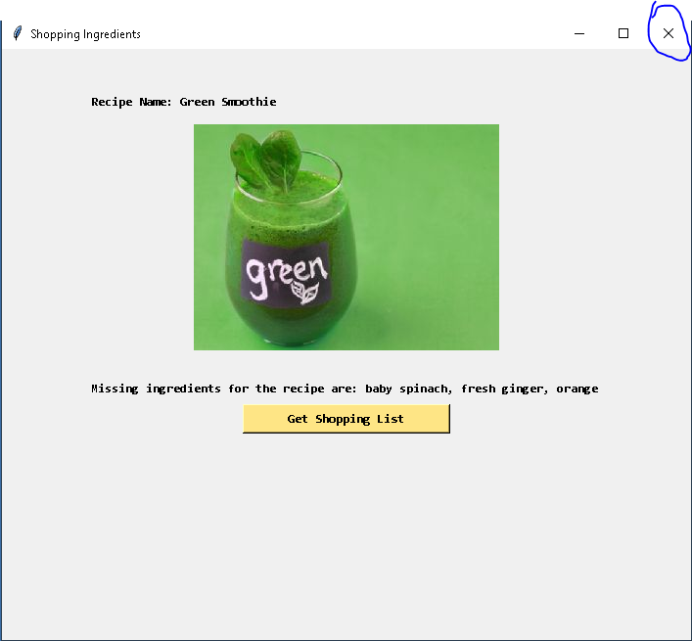

1. **Using the system**

Upon on launching the application, following screen will be displayed.

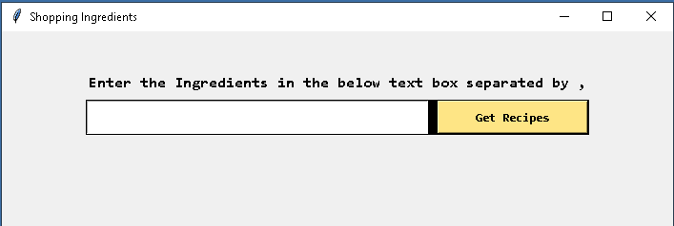

Enter the ingredients that you have to get recipes. Once you are done entering the values click on “Get Recipe” Button. Here is the example of entering the Ingredients

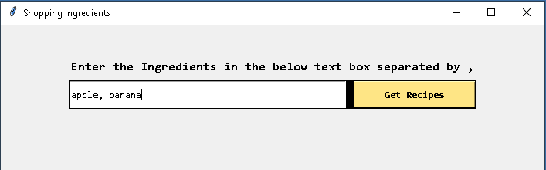

Upon clicking the button,

Scenario 1: No recipes found with Ingredients,

In this scenario, “No recipes found with the provided ingredients” message will be displayed. You can re-enter the Ingredients and click on “Get Recipe” button

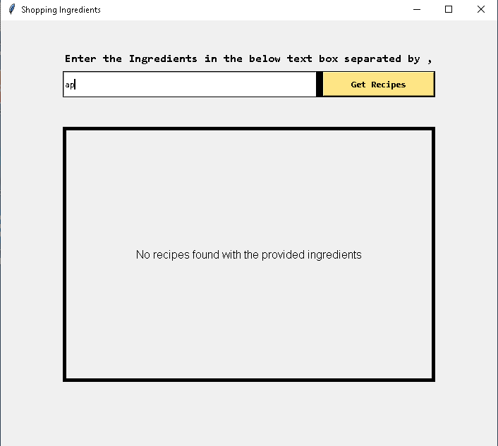

Scenario 2: A recipe found with no missing Ingredients

a recipe image with the provided ingredients will be displayed.

“Get shopping List” button will not be displayed. If you want to view another recipe, click on “view another Recipe” button

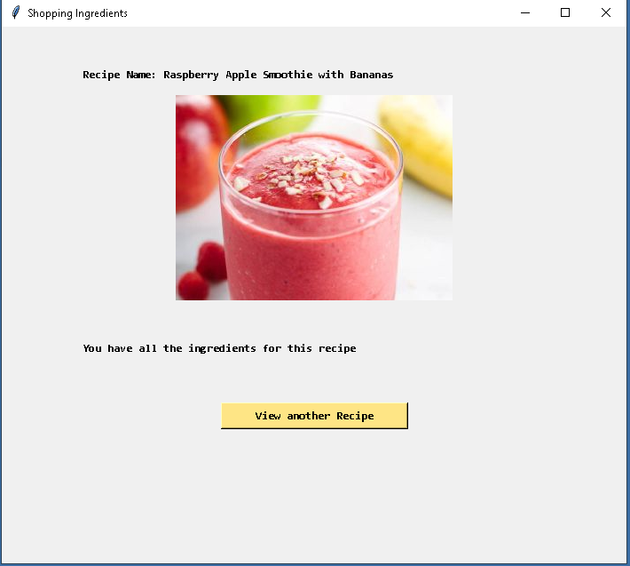

Scenario 3: Only one recipe found with the Ingredients

a recipe image with the provided ingredients will be displayed.

“view another Recipe” button will not be displayed. You can only click on “Get shopping list” button if there are missing Ingredients for the recipe.

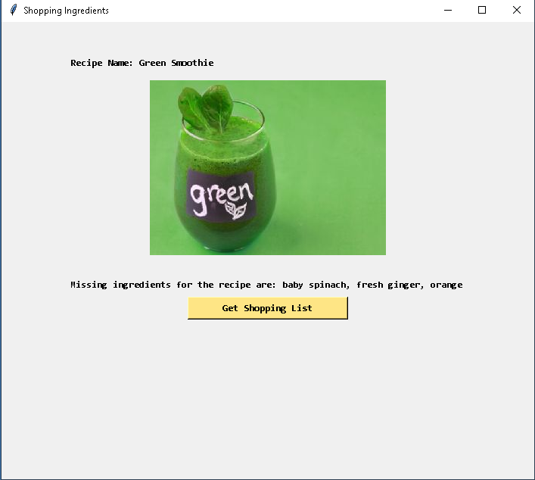

Scenario 4: recipe found with missing Ingredients.

a recipe image with the provided ingredients will be displayed. And also a message with missing ingredients will be displayed. You can click on “Get shopping list” button to see shopping list.

If you want to view another recipe, click on “view another Recipe” button, if it is enabled.

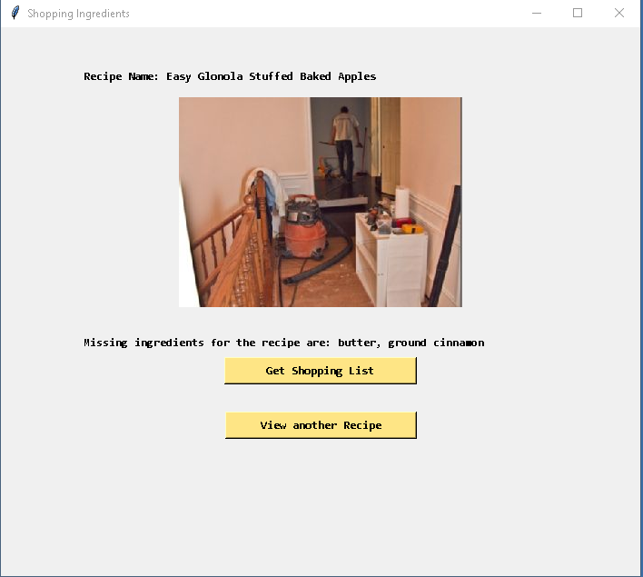

Get Shopping List: upon clicking “Get Shopping List”, Your shopping list with Aisle, Amount will be displayed.

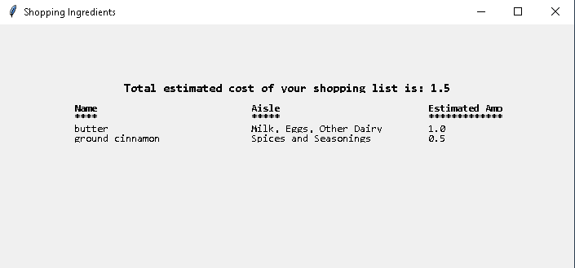

1. **Troubleshooting & Support:**

If you have issues, try restarting. If restarting does not work, **contact support @ 123-123-1234**

1. **Error Messages**

Application uses spoonacular API. If the API is not available, you will see “Error Occurred while getting recipes. Please try again later” message on the screen. Please try again later if you see that message. If the message continues to appear then **contact support @123-123-1234**