**DJANGO**

How to work on django(a simple example)

s1-To dowload python:

go to [www.python.org]

*click download

*click the latest version according to your computer whether 32 or 64 bit.

*after download before installing it tick the check box to add the path along.

s2-In command prompt

click cmd in search

*type python --version

*type pip --version

s3- open windows power shell

*give run as admin.

s4-in django documentation

copy( pip install virtualenvwrapper-win)

paste in wps

then enter

copy(mkvirtualenv myproject)

paste in wps

then enter

copy(workon myproject)

paste in wps

then enter

copy(pip install django)

paste in wps

then enter

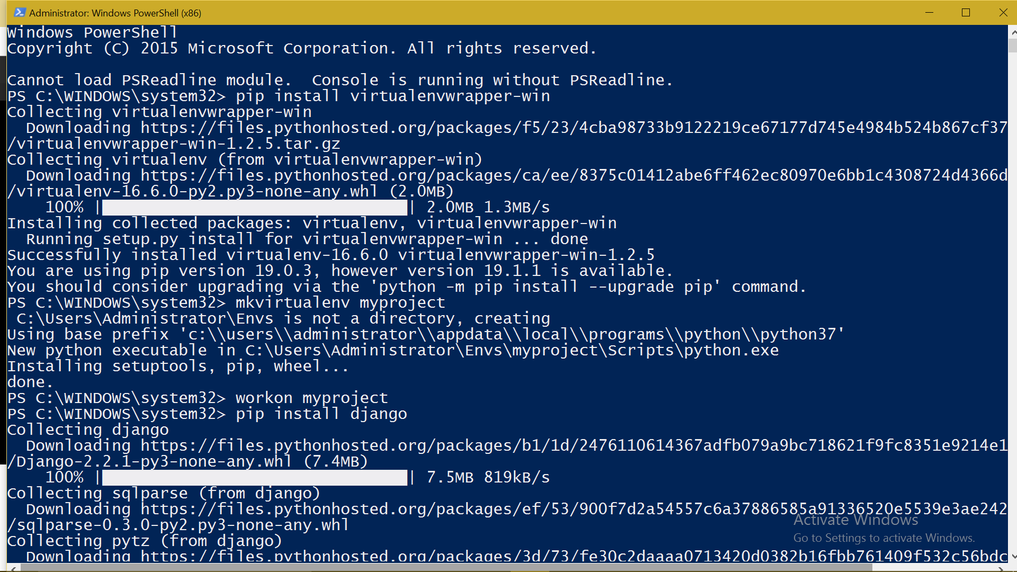

NOW EVERYTHIN IS INSTALLED READY

now to check the version of django

type python -m django --version in cmd prompt

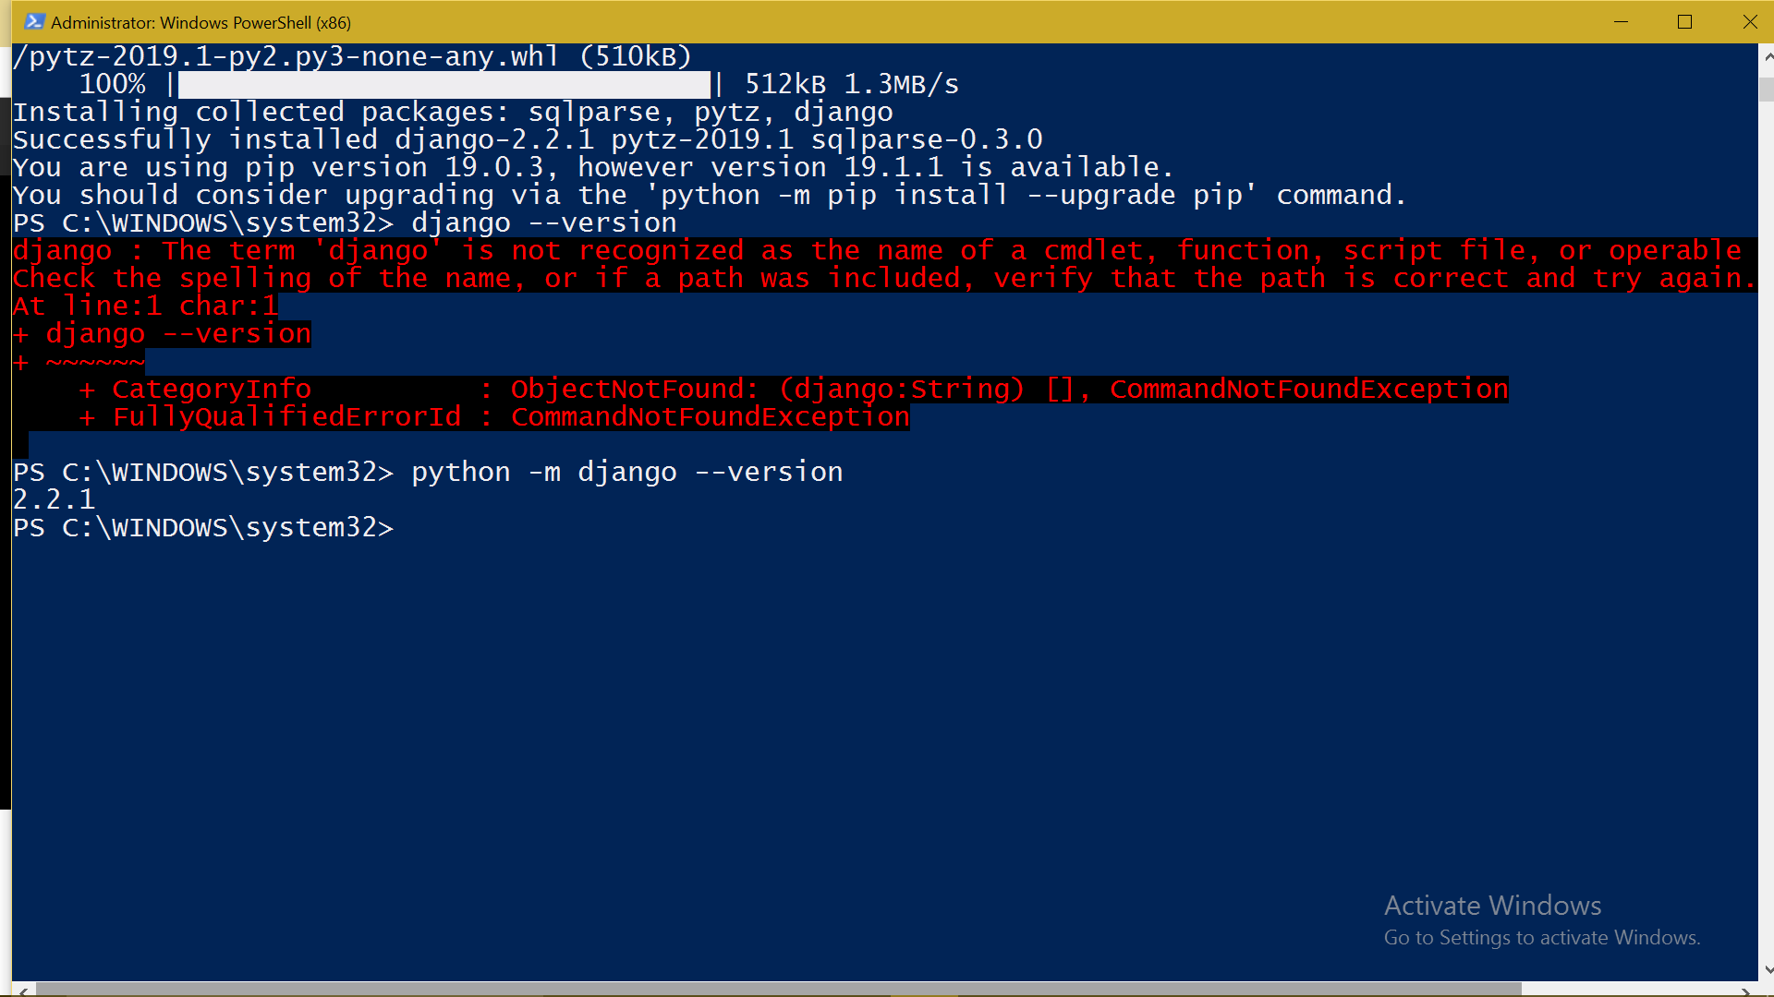

NOW IN WPS

give cls(enter)

give cd /(enter)

mkdir folder_name(enter)

cd ./folder_name/(enter)

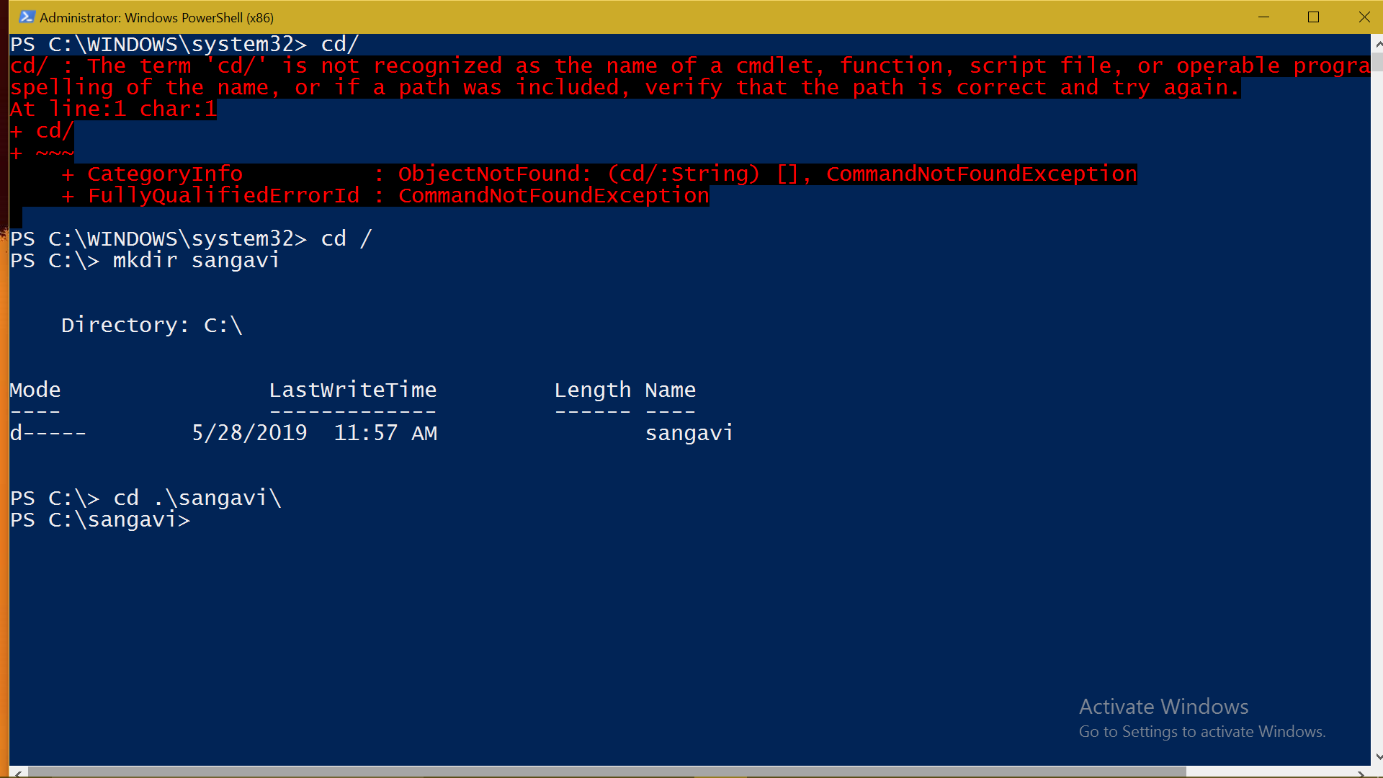

type (python manage.py runserver) to run the python server

then

django-admin startoroject (project name)

then cd ./project name/(enter)

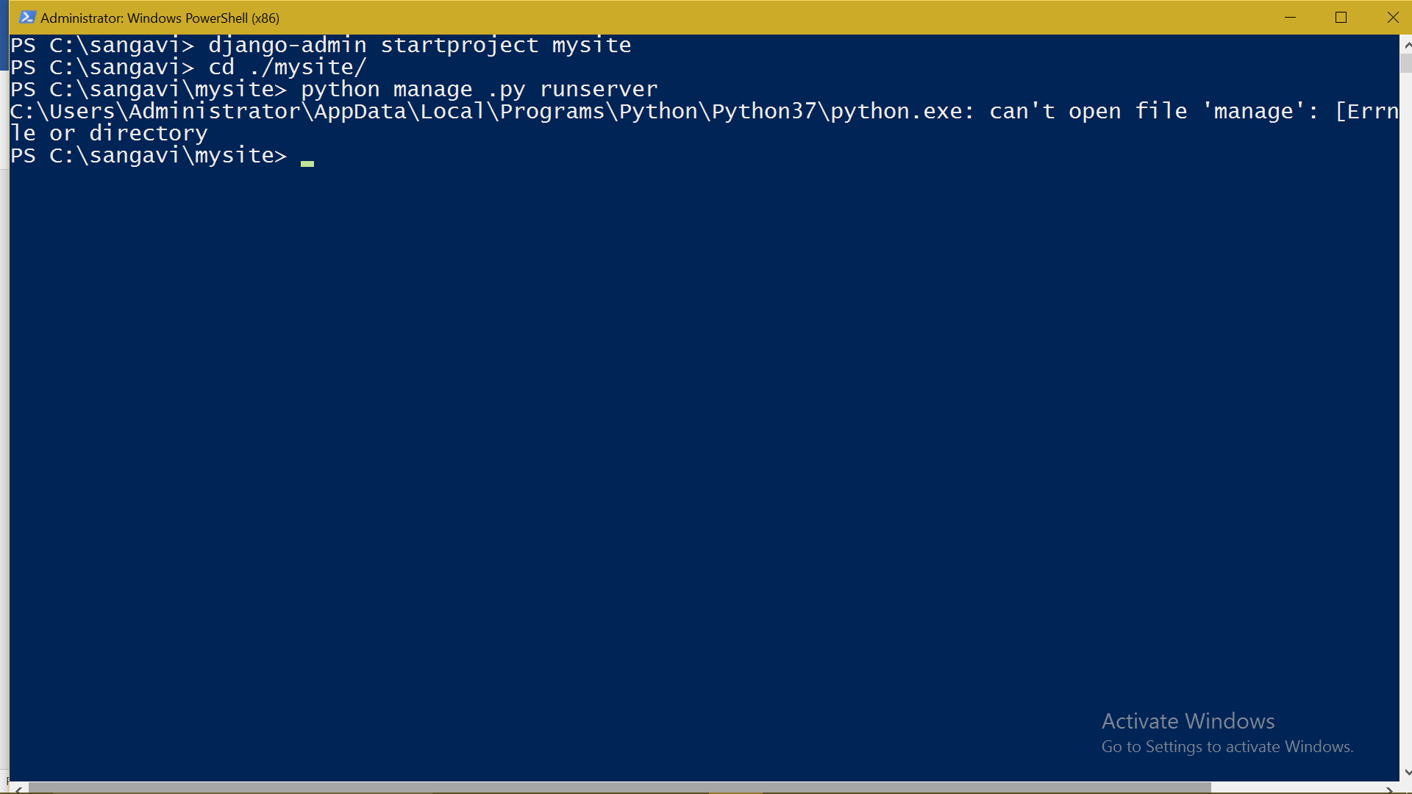

you will get a http link and by following the link u will get the host number

then u can type as local host(host number in the chrome)

so that u can get the desired web page for which u have written code in python.