scClinicalAudit: a field benchmark for single-cell clinical-label prediction under indication, portal, and provenance confounding
Authors: Sanker, V. (TN Omics)
Correspondence: [correspondence email to be completed]

Abstract
Background. Public single-cell RNA atlases are increasingly reused to predict clinical states such as metastasis, yet systematic audits for cancer-type, portal, and label-provenance confounding remain rare. We introduce scClinicalAudit, a reusable evaluation framework with four pre-specified estimands: confound fraction, transportability, signature graveyard survival, and bulk-RNA positive controls.
Results. Across a multi-drive registry of 1152 unique specimens (342 supervised), apparent pan-cohort scRNA metastasis ranking on the canonical specimen-authority cohort reached OOF AUROC 0.674 while a combined metadata ceiling reached 0.998 (confound fraction 1.00). Of 40 curated proxy programs, 30 survived strict within-indication correction (corrected AUROC ≥0.60; Δ<0.10). A balanced TCGA-BRCA bulk RNA positive control retained OOF AUROC 0.755, whereas a THCA null arm did not (OOF ≈0.47).
Conclusions. scClinicalAudit discriminates artifactual scRNA supervision from detectable within-indication bulk signal and provides a pilot field benchmark—not a metastasis-discovery claim. This work generalizes a companion single-cohort audit (Genome Biology submission; Zenodo 10.5281/zenodo.20610218).

Introduction
Computational reuse of public single-cell tumor-microenvironment (TME) atlases for supervised clinical labels has outpaced standardized evaluation. Models can rank specimens using indication tags, data portal, or label-provenance structure rather than metastasis biology. Donor-grouped cross-validation controls donor leakage but not indication-level confounding.
We present scClinicalAudit Archetype A: a field benchmark that (i) builds a multi-drive specimen registry, (ii) decomposes apparent AUROC into metadata-explained and residual components, (iii) quantifies transportability across indications and portals, (iv) re-evaluates curated proxy signatures under within-indication correction, and (v) anchors interpretation with balanced bulk TCGA positive and null controls. This paper is a methods and benchmark extension—not a claim of metastasis biomarker discovery.
Relation to companion audit. A deep single-cohort confound audit of the same canonical labels (142 supervised; 33 metastatic-positive) is reported separately (Zenodo 10.5281/zenodo.20610218; https://github.com/vsanker21/scrna-metastasis-confound-audit), including calibration failure, block-permutation nulls, and HTAPP composition warnings. Here we generalize estimands across integrated packs and publish the reusable software.

Results

Multi-drive specimen registry
The registry deduplicated 1152 graph-linked specimens across C/D/E/F assets, with 342 supervised rows under specimen-authority or pack-specific label policies. Leakage modes (specimen-grounded, portal–indication coupled, indication-saturated, inferred) are tabulated in Supplementary Table S1.
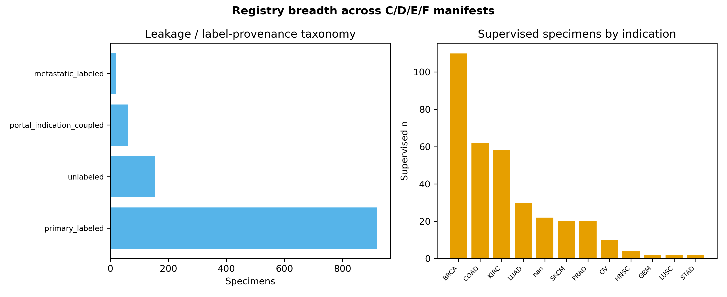
Figure 1. Registry breadth and leakage taxonomy across multi-drive manifests.

Confound decomposition spectrum (E1)
For each integrated pack we estimated task OOF AUROC, adversarial metadata ceilings, and confound fraction (fraction of AUROC above chance explained by metadata). Canonical specimen-authority confound fraction was 1.00. Headline scale verification via f142 D-graph symlink parity yielded mean fold AUROC 0.780 with gate pass True.
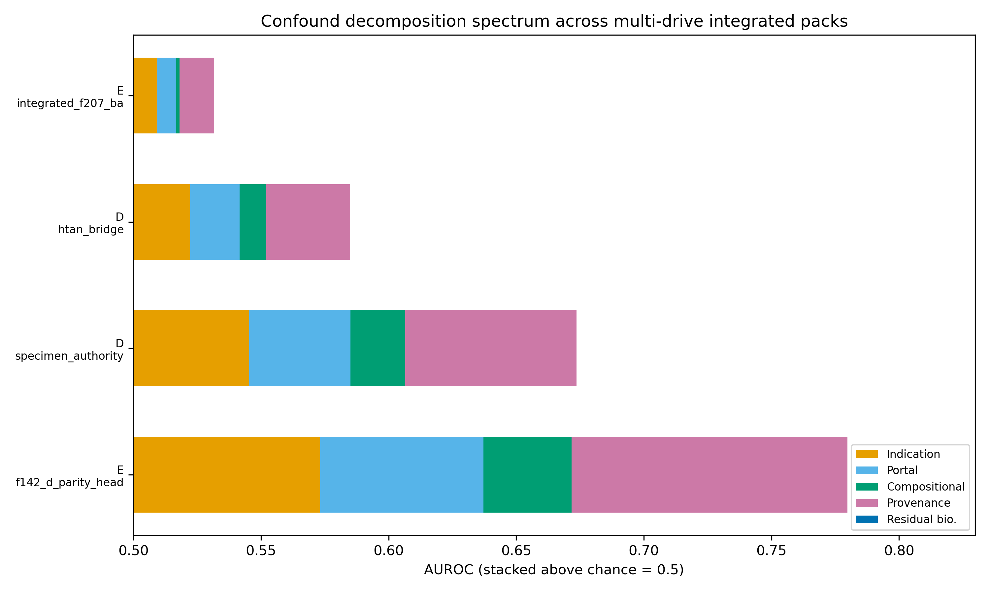
Figure 2. Stacked decomposition of apparent AUROC above chance across integrated packs.
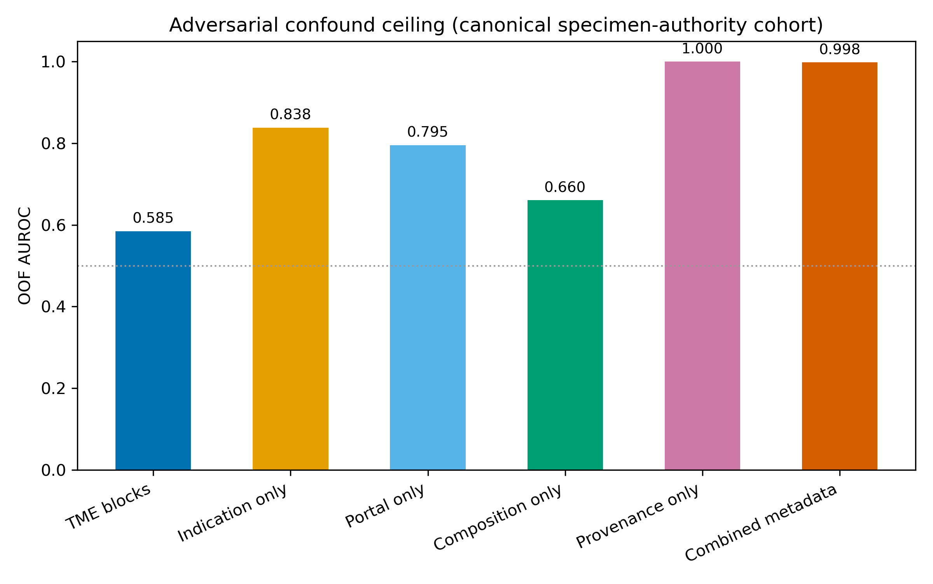
Figure 3. Adversarial metadata baselines versus TME block logistic regression on the canonical cohort.

Transportability matrices (E2)
Train-stratum → test-stratum block-logistic models quantify whether apparent performance transports across indications. Off-diagonal degradation indicates indication-specific structure rather than universal biology. Portal-stratified transport is shown in Supplementary Figure S1.
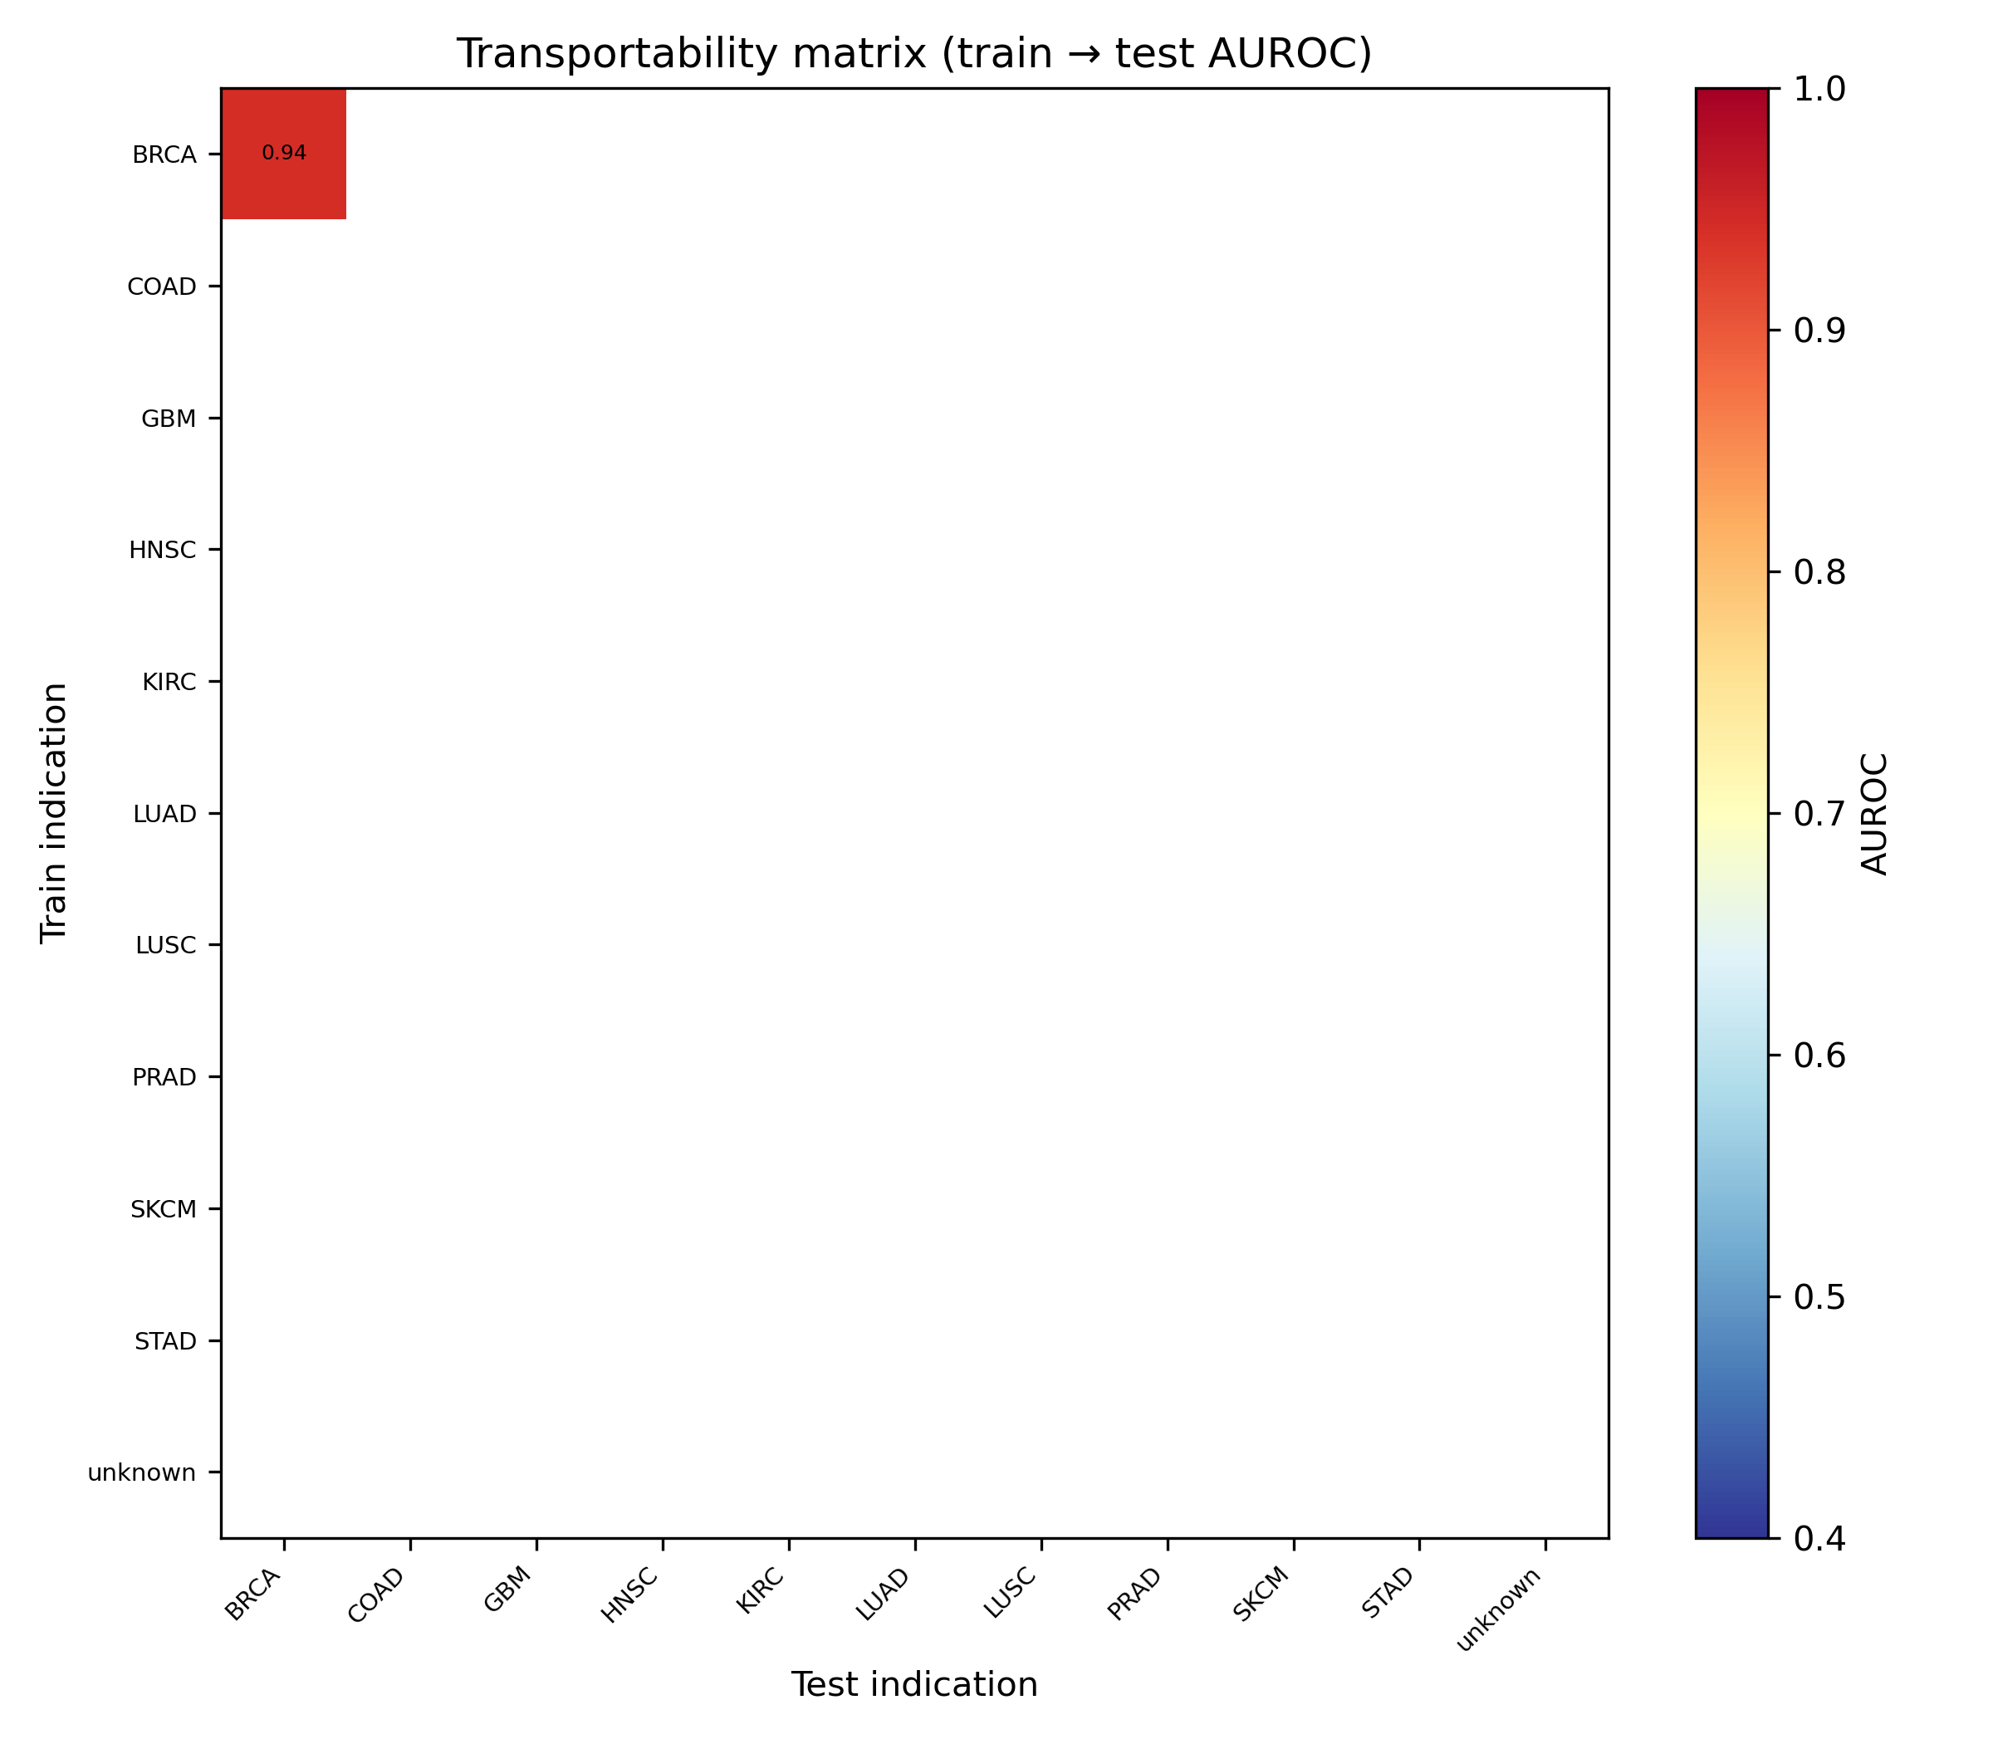
Figure 4. Indication × indication transportability matrix (canonical cohort).

Signature graveyard (E3)
We evaluated 40 curated proxy programs (literature gene sets, TME composition proxies, internal DE/GSEA panels). Primary survival used strict criteria: within-indication corrected OOF AUROC ≥0.60 and naive−corrected <0.10. 30 passed; 31 passed looser exploratory criteria (≥0.55; Δ<0.15). The graveyard reports audit outcomes, not pathway discovery.
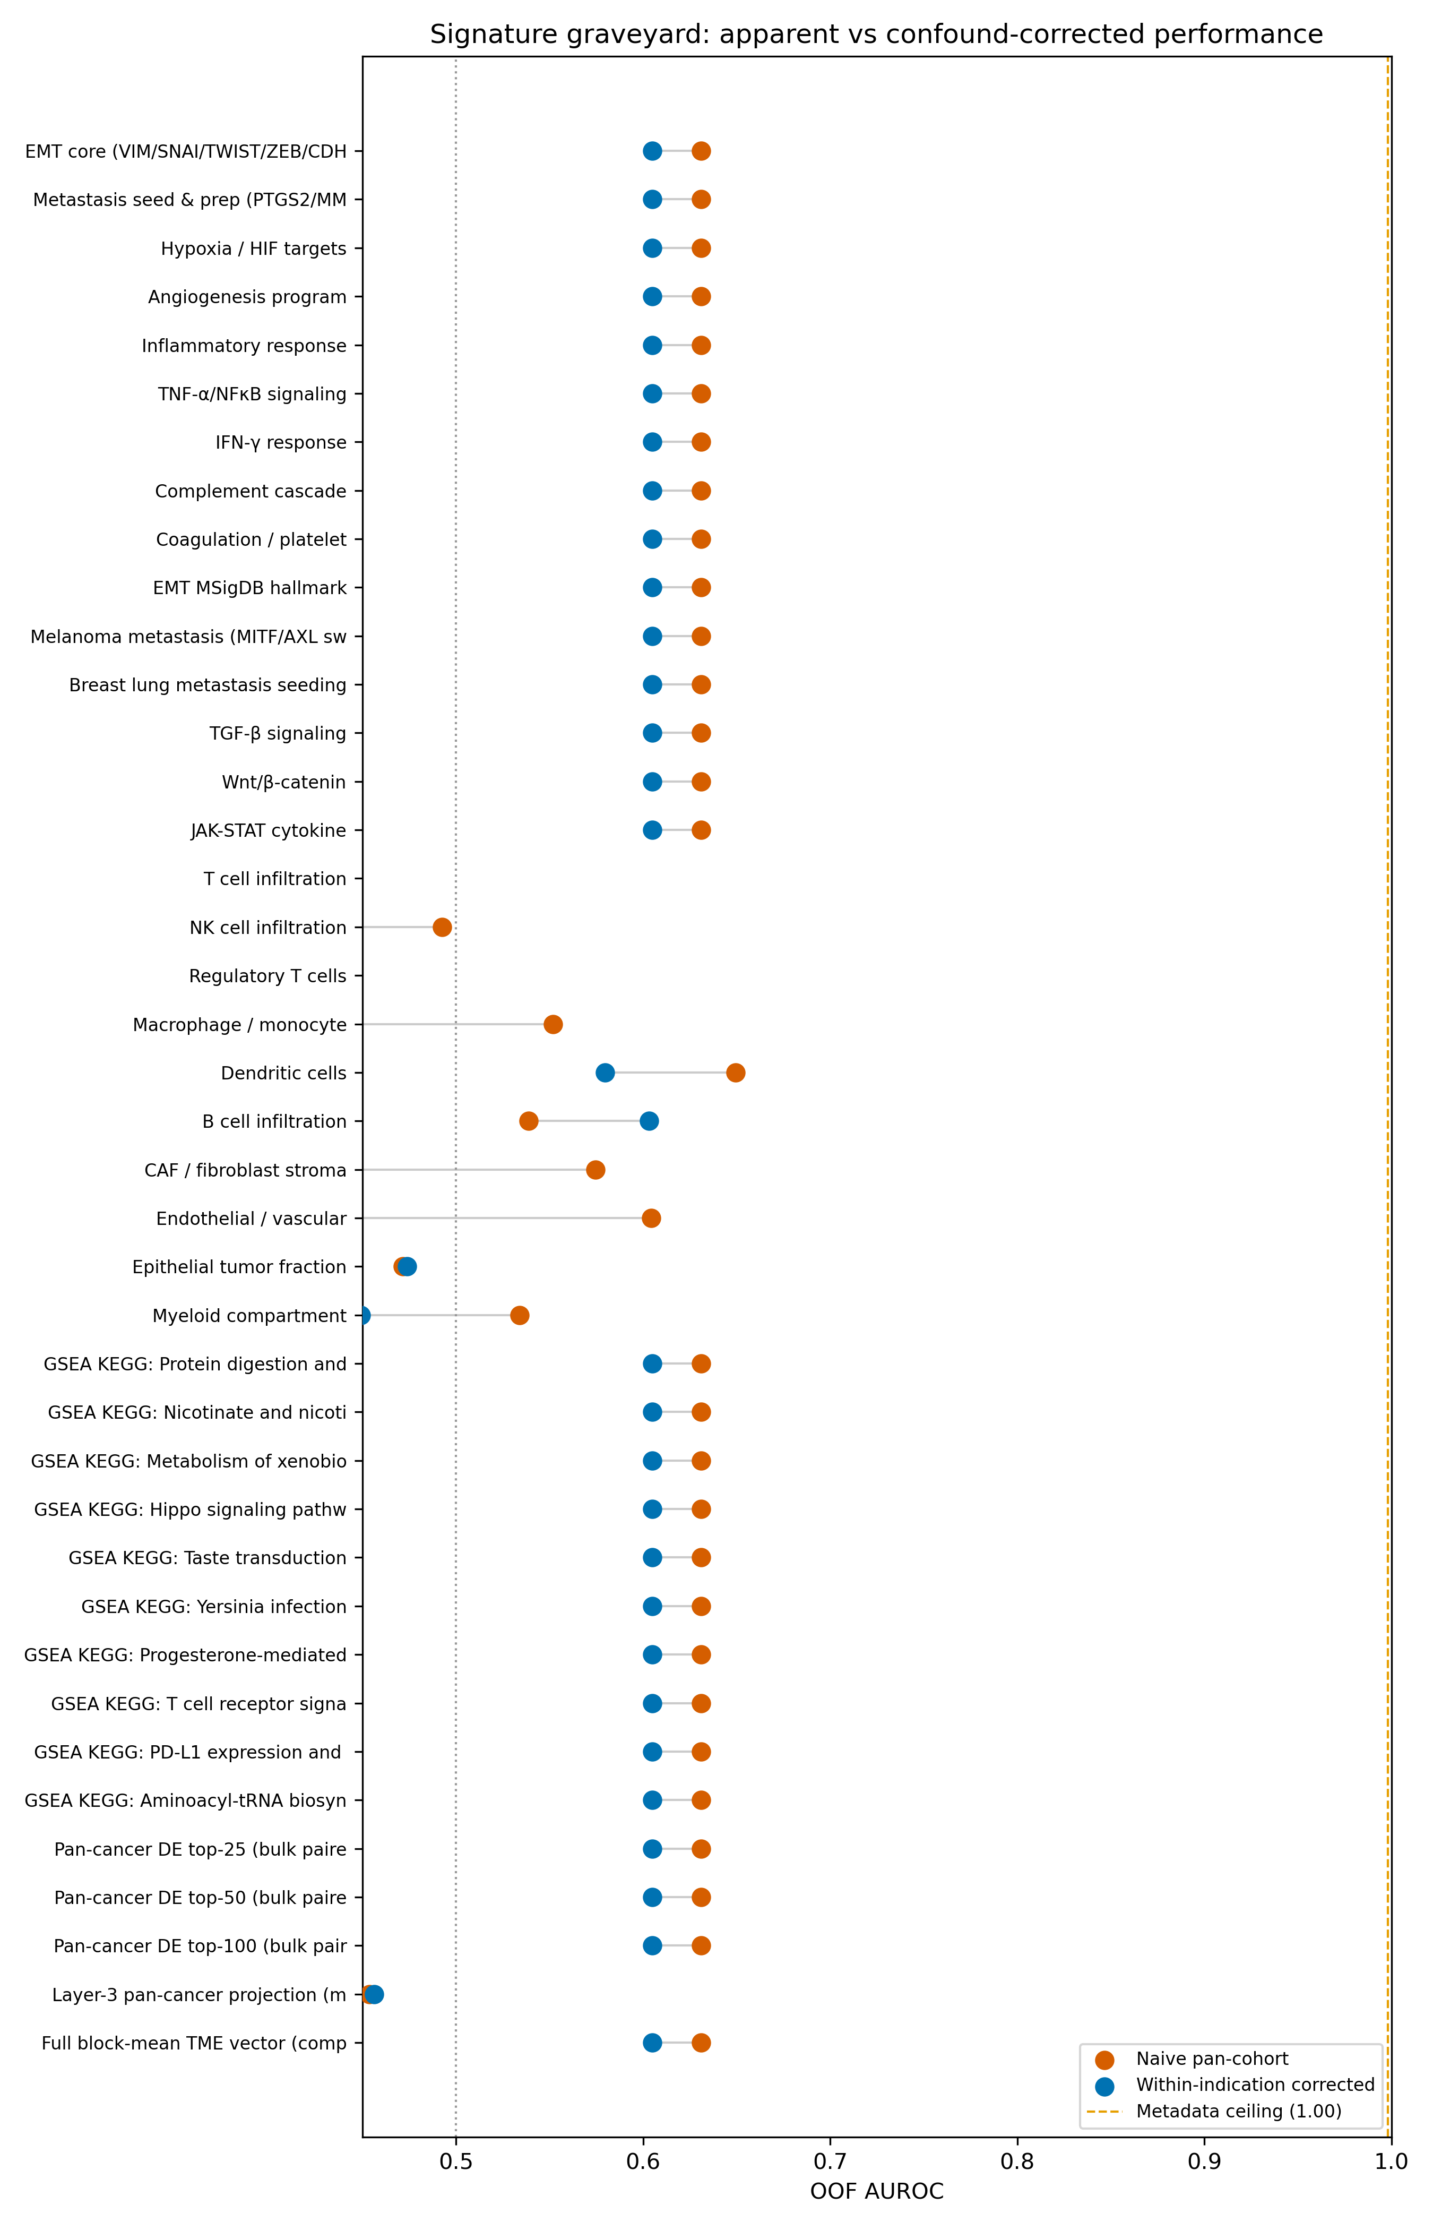
Figure 5. Naive pan-cohort versus within-indication corrected signature AUROC.

Bulk RNA positive and null controls (E4)
Balanced TCGA-BRCA bulk RNA (7 metastatic / 7 primary) yielded OOF AUROC 0.755 (primary positive control). Balanced TCGA-THCA (8+8) yielded OOF AUROC 0.469 (null arm). TCGA-SKCM expression was degenerate (196/200 metastatic) and excluded.
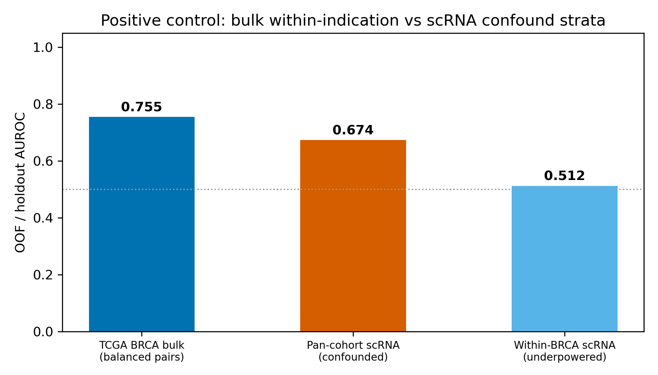
Figure 6. Bulk within-indication positive control versus confounded scRNA strata.

Discussion
scClinicalAudit supports a cautious field law: on available public assets, apparent scRNA metastasis predictability is routinely bounded by metadata and provenance ceilings, while balanced bulk within-indication controls can still show detectable signal. The framework is intentionally conservative—its value is discriminating real from artifactual supervision, not maximizing AUROC.
Limitations include pilot scale (342 registry-supervised specimens versus exhaustive atlas coverage), proxy signatures where gene-aligned scRNA indices are unavailable, partial portal holdout (transport only), and deferred F943 graph rebuild (~537 GB). Per-patient scRNA–genomics coupling awaits dbGaP barcodes.

Methods
Software. scClinicalAudit v2.0 (`src/sc_clinical_audit/`). Headline estimands E1–E4 are defined in the OSF pre-registration protocol. Cross-validation used donor-grouped GroupKFold; pooled OOF AUROC is reported for ranking tasks. Specimen-authority labels reject bare disease-string metastasis positives.
Data availability. Raw scRNA remains on HTAN and CZ CELLxGENE; bulk TCGA features via NCI GDC. Code, results, and figures are deposited on GitHub and Zenodo (Archetype A release). OSF pre-registration DOI to be inserted after upload.
Competing interests. The authors declare no competing interests.
Funding. This work received no specific external funding.

