**EXPERIMENT-5**

**AIM**

To design and deploy a simple Library Book Reservation System for SIMATS library using a Cloud Service Provider (CSP) and demonstrate the concept of Software as a Service (SaaS).

**PROCEDURE**

1. Select a Cloud Service Provider
   * Options: Zoho Creator (no-code SaaS builder), Google Cloud App Engine, AWS Elastic Beanstalk, Azure Web Apps, or Heroku.
   * For easy demonstration, Zoho Creator is recommended.
2. Create a New Application
   * Login to Zoho Creator.
   * Create a new app named “SIMATS Library Reservation System”.
3. Design the Reservation Form  
   Add fields for book reservation details:
   * Student Name (Text)
   * Roll Number (Number)
   * Department (Dropdown: CSE, ECE, MECH, CIVIL, etc.)
   * Book Title (Text)
   * Author (Text)
   * Reservation Date (Date Picker)
   * Contact Email (Email field)
4. Create a Report View
   * Add a Table/Report View to display all reserved books.
   * Allow search & filter by Department, Book Title, and Date.
5. Deploy the Application
   * Publish the app to the cloud.
   * A public URL will be generated (e.g., https://creatorapp.zoho.com/simats-library-reservation).
6. Demonstrate SaaS
   * Multiple students can open the link in their browser.
   * They can reserve books online without installing software.
   * Librarians can monitor reservations in real-time via the dashboard.

**OUTPUT**

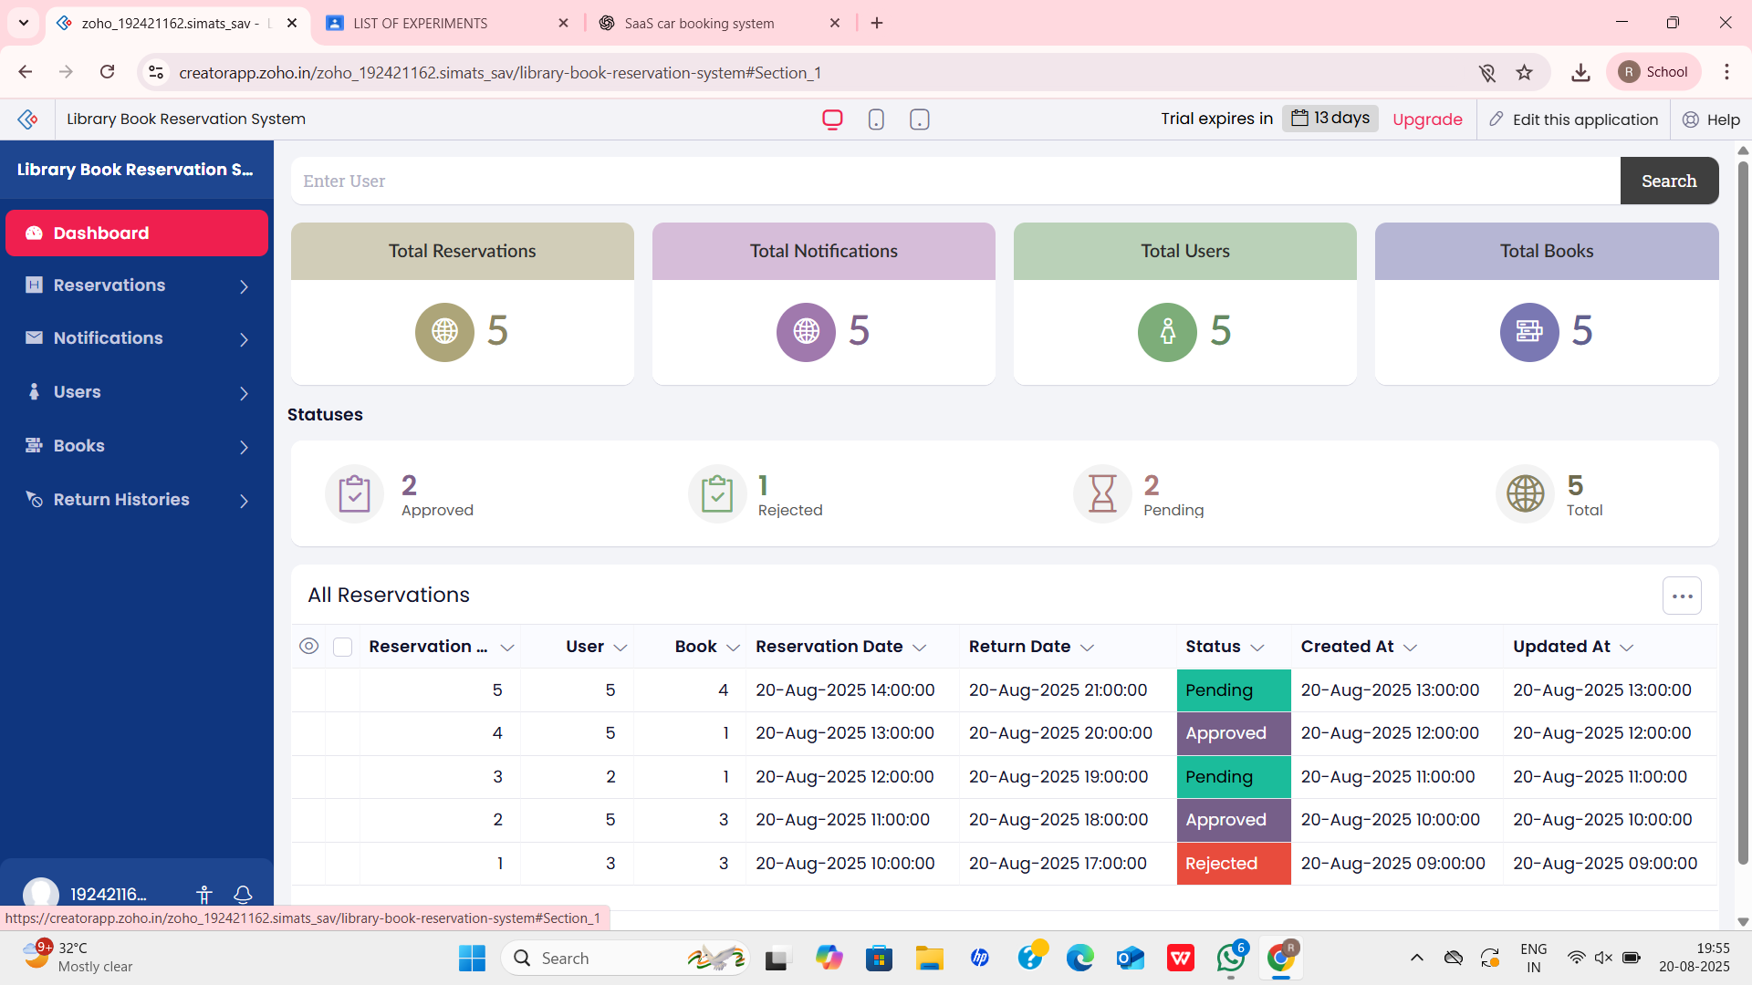

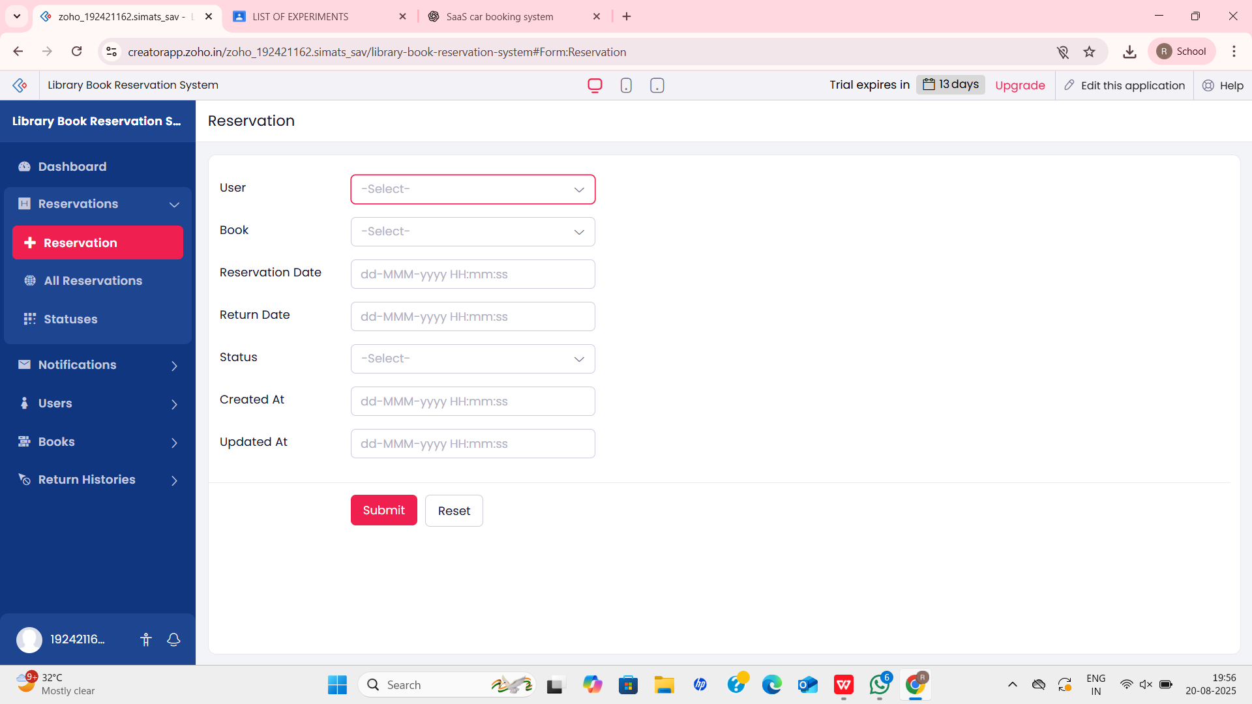

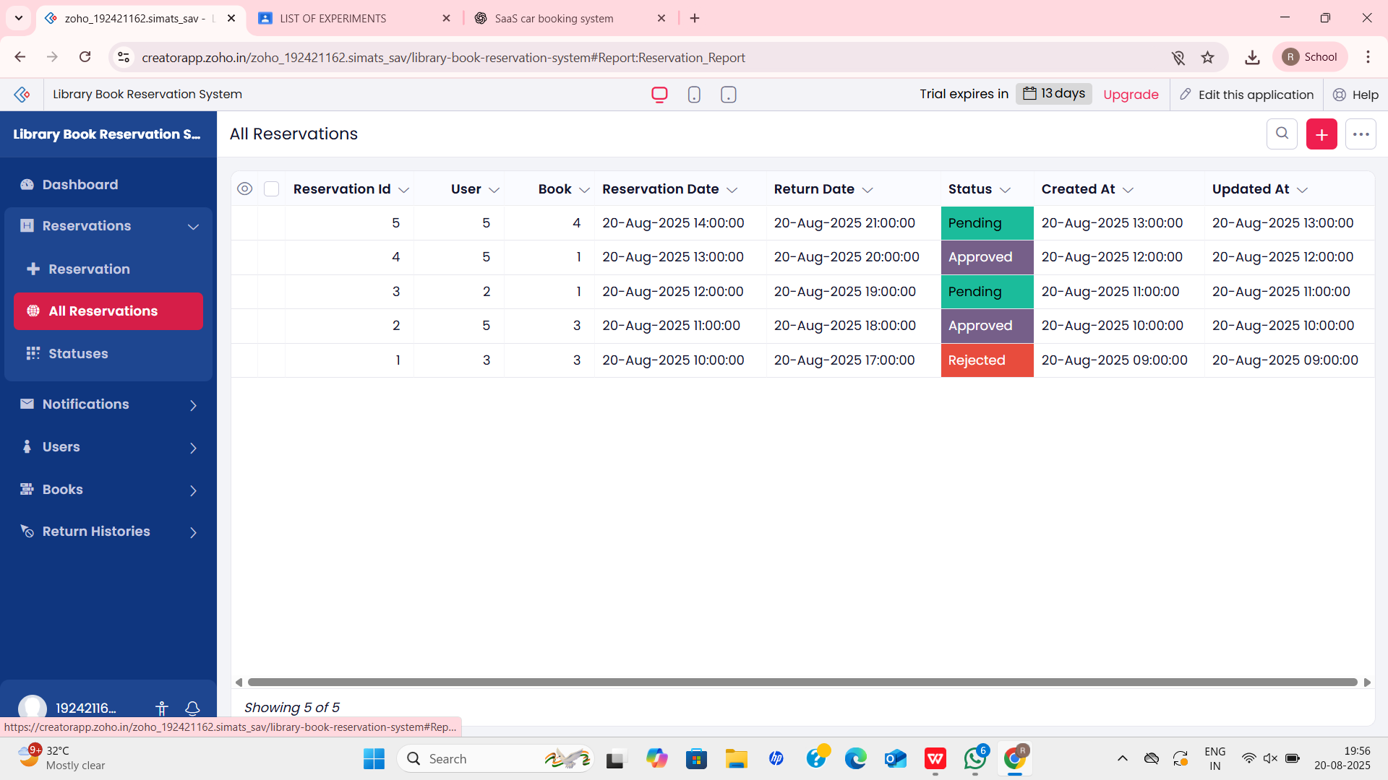

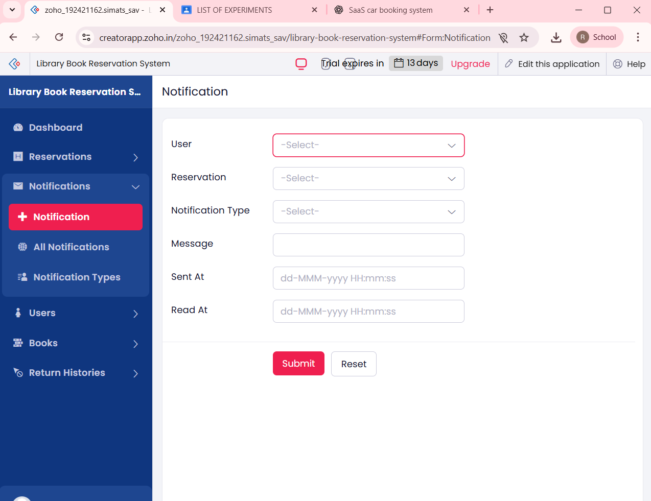

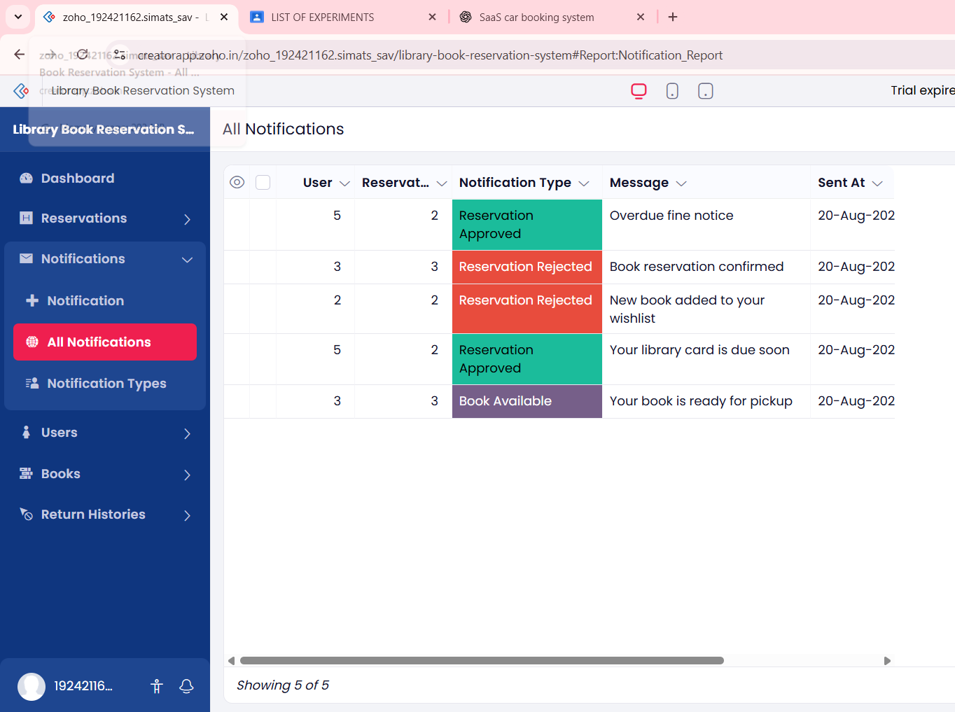

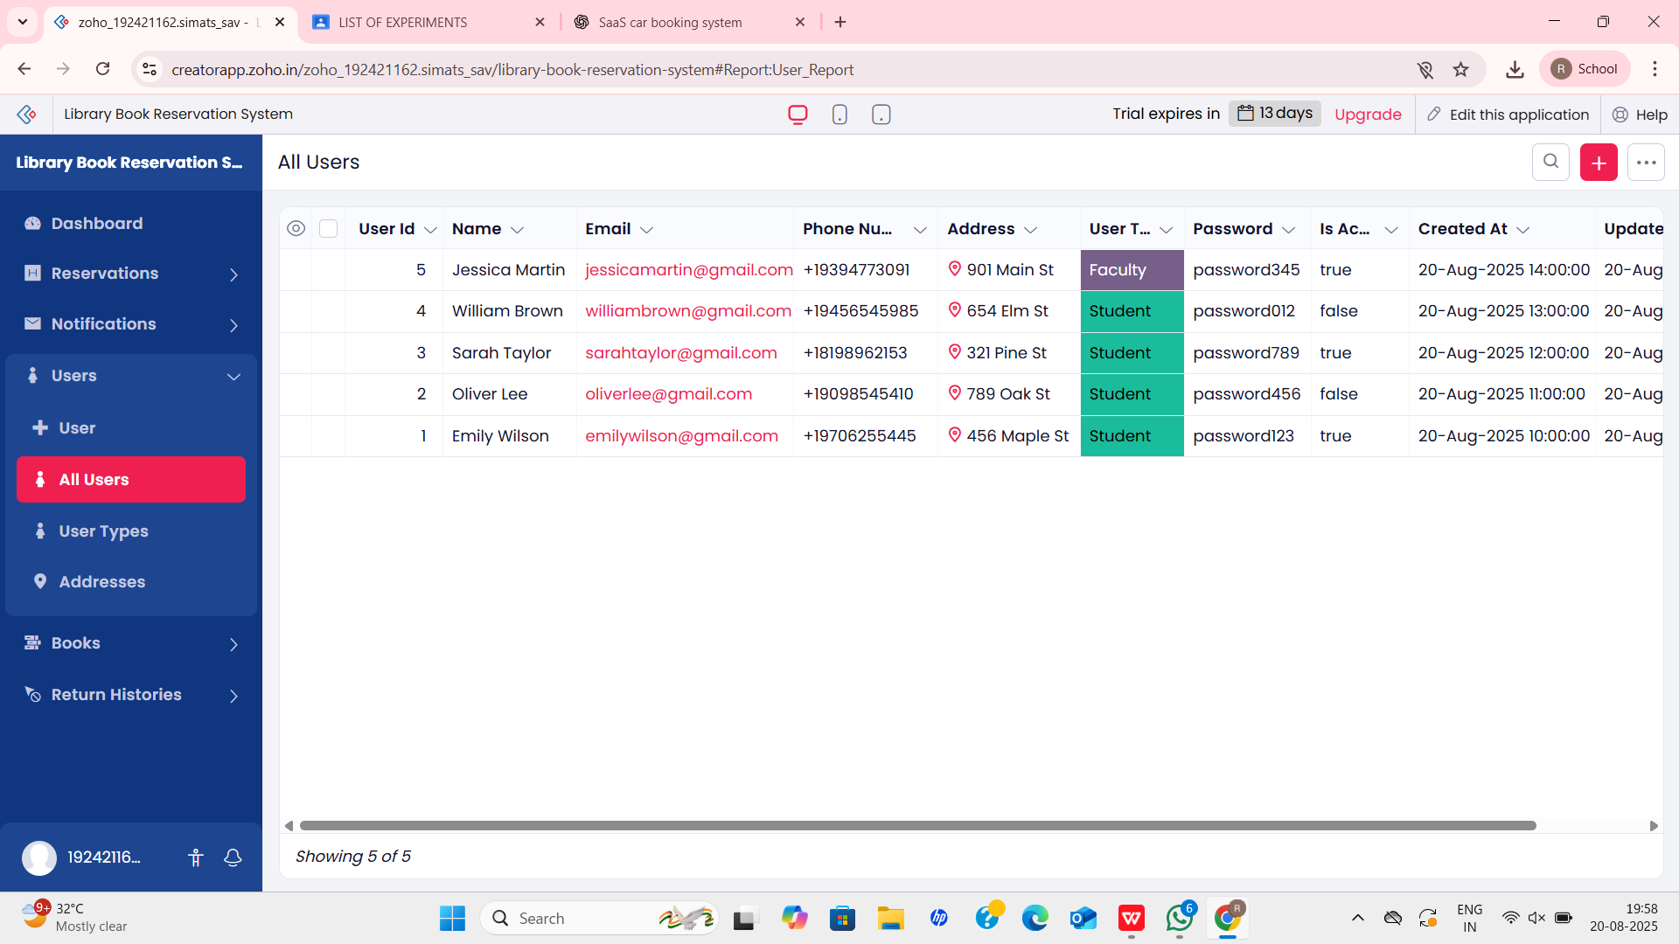

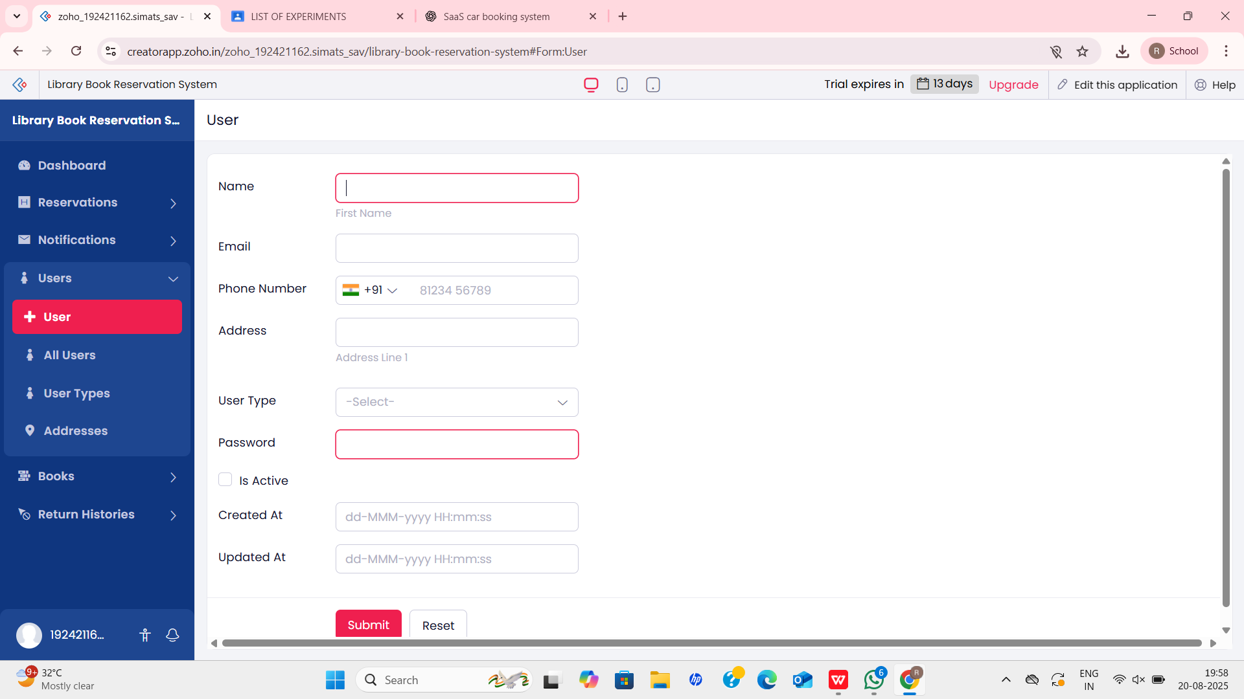

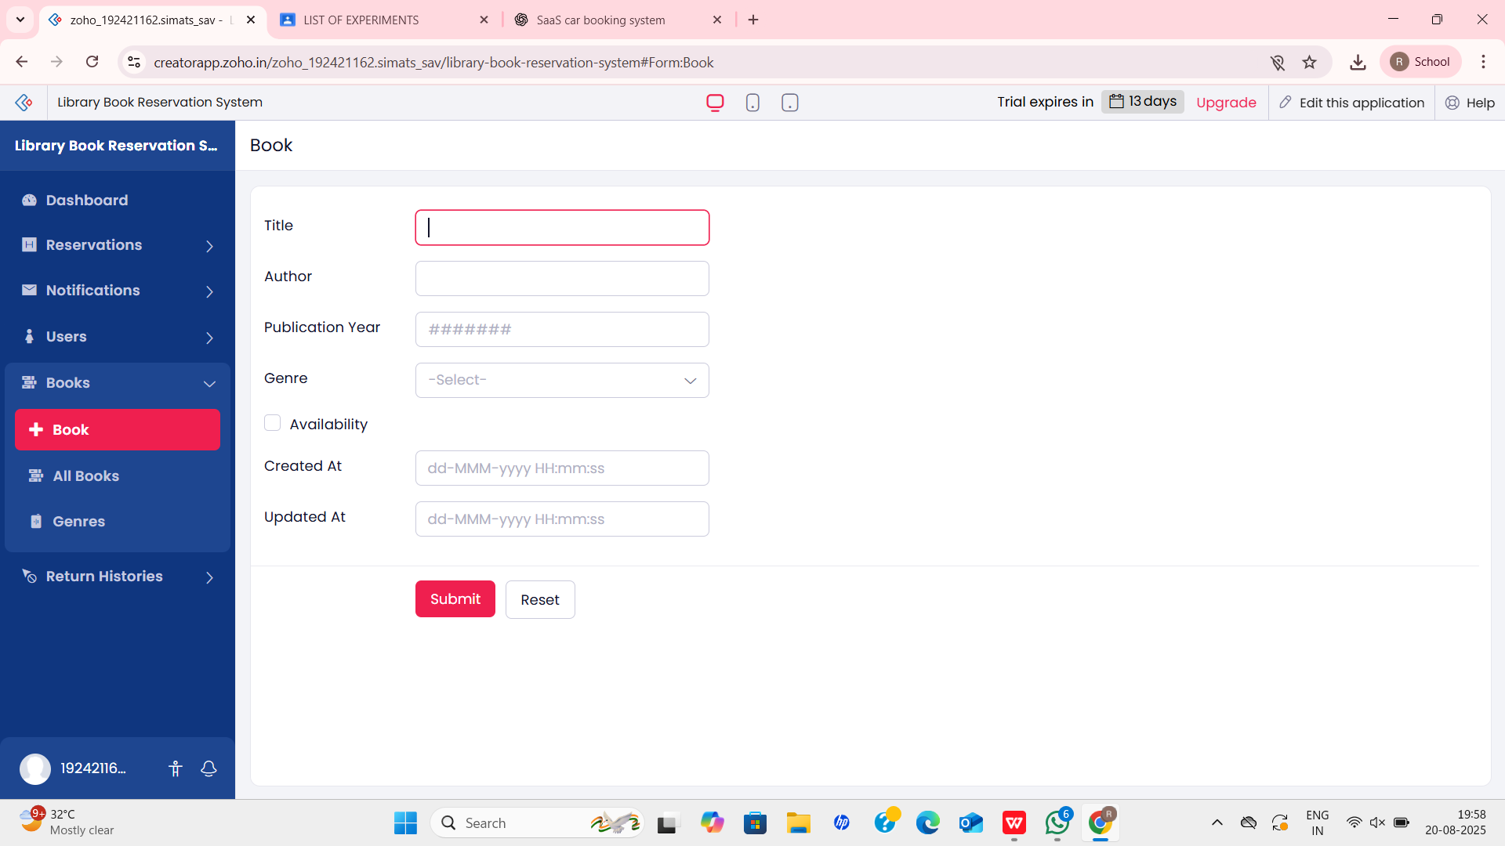

**RESULT**

A Library Book Reservation System for SIMATS Library was successfully developed and deployed on the cloud. The application can be accessed by students and librarians via a web browser without installation, thus demonstrating the concept of Software as a Service (SaaS).