**SPACE INVADERS**

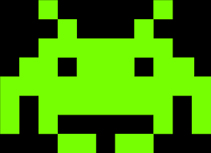

**Authors: Voicu Sara, Zeibel Antonia**

**Coordinator: Aron Baka**

**Group: 30421**

**Table of contents**

1. **Brief Description**
2. **Use-cases**
3. **Approached Solution**
4. **Further improvements**
5. **Brief Description**

“Space Invaders” is a classic arcade game where the shooter is trying to stop the invasion of aliens. The faith is in the hands of the player which has only his spaceship and his laser-gun. The aliens, the frightful enemy, are constantly moving across the board, making it a little bit difficult to be defeated.

Our version of “Space Invaders” may not have the animations of the classic game, but the experience itself will bring back the memories.

1. **Use-cases**
2. **User Experience**

Once you have started the game, you can control the spaceship using the left-arrow to move left, right-arrow to move right and “spacebar” to shoot your shot.

The movement of the aliens starts from the top of the board and goes between left and right until it reaches the bottom of the board.

The player wins the game if all the aliens have been defeated and loses if the aliens have reached the bottom of the board. In either case, a meaningful message will be displayed.

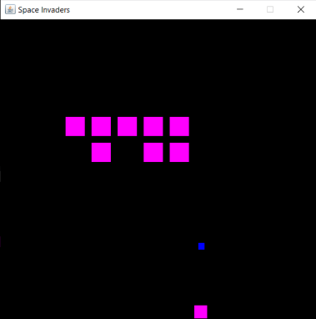

1. **Difficulty**

The user can choose the difficulty of the game in the main menu. The difficulty is defined by the speed of the aliens’ movement on the board. So, naturally, it goes from the slowest (easy) to the fastest (hard). The player’s speed and frequency of the shots does not change.

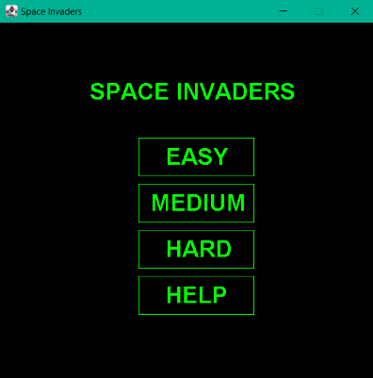

1. **Game themes**

The user can choose the colors of the characters, for the aliens, the spaceship and the bullet, during the game by pressing ‘1’ for the Christmas theme (green and red), ‘2’ for the Galaxy theme (magenta and blue) and ‘3’ for the Summer theme (yellow and red).

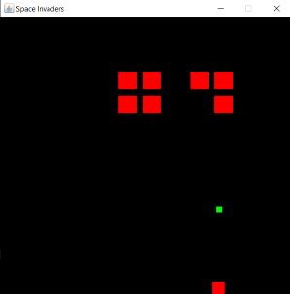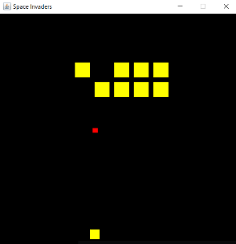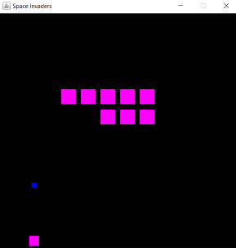

1. **Score**

With each defeated alien and each missed shot, the score of the game will be calculated accordingly. So, if you hit one alien, you will receive 10 points, but if you miss it, you will lose 5 points. At the end of the game, along the message which will be displayed, you can see how well you have played.

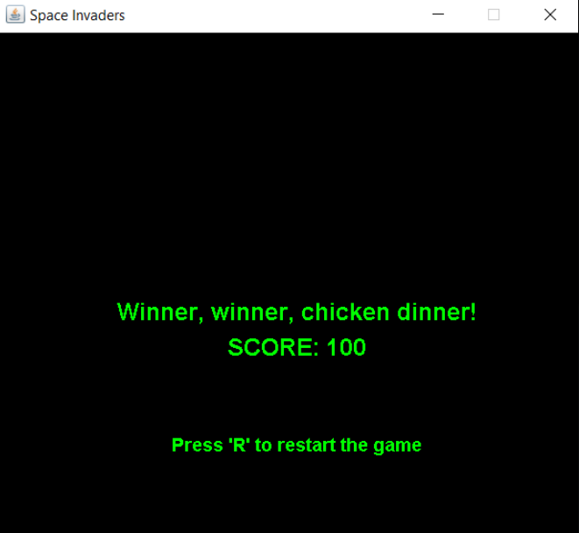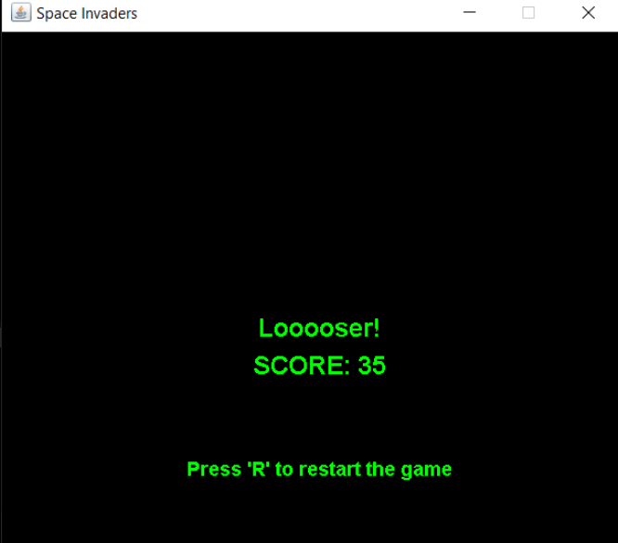

1. **Restart feature**

Once you have reached the end of the game, you can start again from the main menu, by pressing ‘R’, having the possibility of choosing a different level this time, without closing the application. This feature makes the application more convenient for the user.

1. **Help Button**

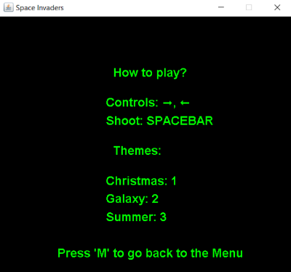

If you are new to this game and you do not know how to play it or change the themes, you can press the help button from the main menu, where you will find how to control the spaceship, how to shoot and the correspondence between the themes and the key.

1. **Approached solution**

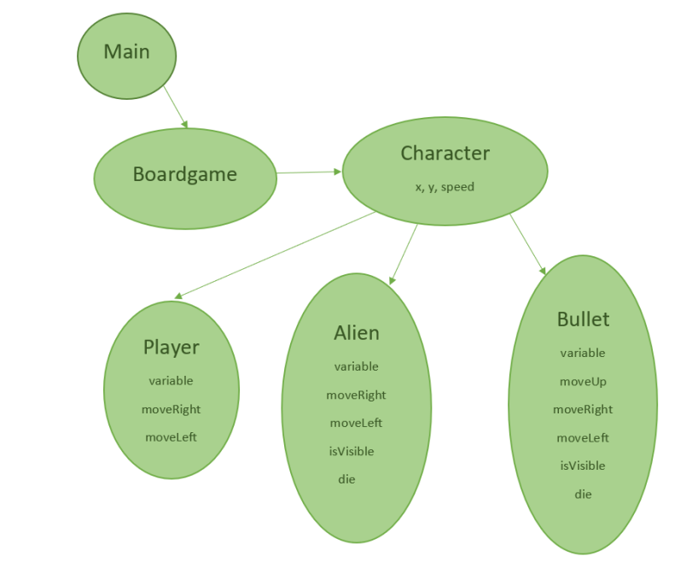

The main logic of the game is found in the BoardGame class: the movement of the characters, the created buttons, the levels, the restart feature, the relation between keys/mouse input and actions, the themes. This class implements the Runnable that contains the override method run() and Mouse Listener interface and also extends the JPanel class, which allows us to create the user interface.

The Player, Alien and Bullet classes are extensions of the Character class, being differentiable by the variables of the movement or the visibility. The Character class only contains the 2D coordinates and the speed of the object.

1. **Further improvements**

We can connect a database which will allow us to store all the players, by the username, along with their score and the played level. This will conduct to another improvement which can be made, being the highscore.

For the game itself, we can add the shooting feature to the aliens making it more difficult to play and a health bar which will tell us how close to death are we.