Check Project properties

And change TargetServerURL to your destination 10.6.x.x/ReportServer

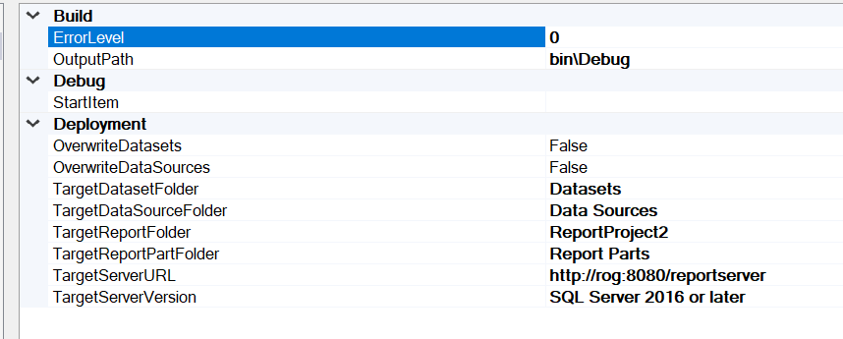

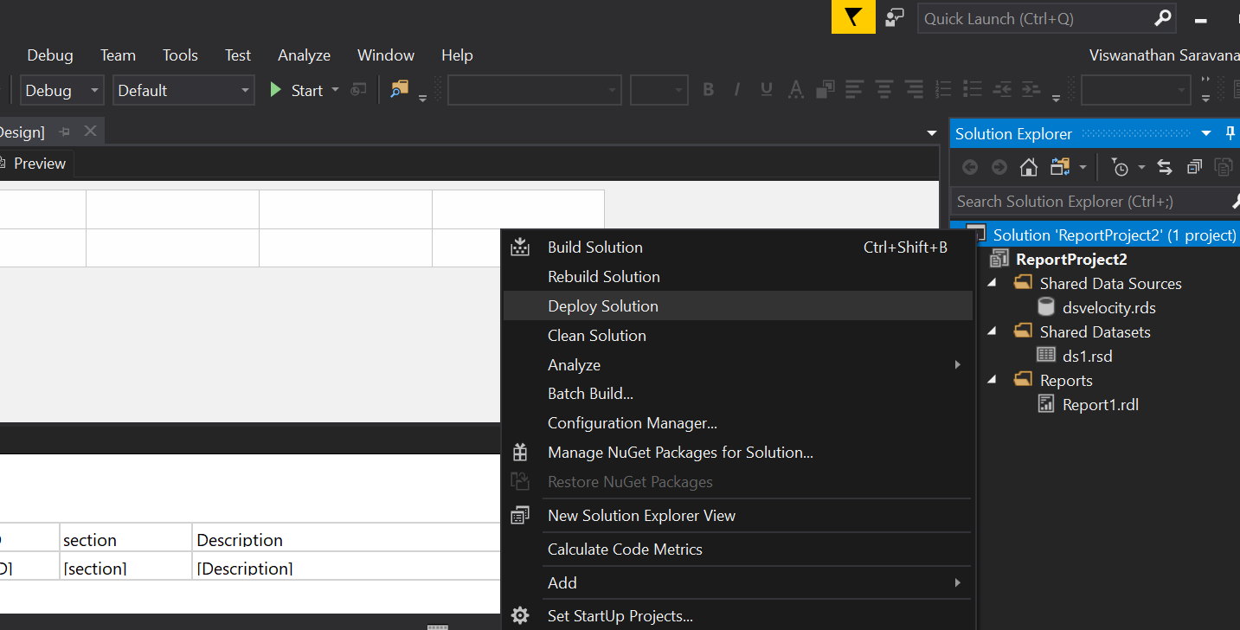

You can see successful deploy messages as below

