http://saravan-js.com:10300/swagger-ui.html  
  
**#** Challenge  
**##** In promotional items (method 1), 2nd item would be 50% discount  
**##** In promotional items (method 2), 3rd item would be free

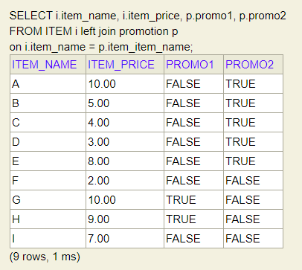

Use Case 1:

As per Promo1, second item would be 50% discount

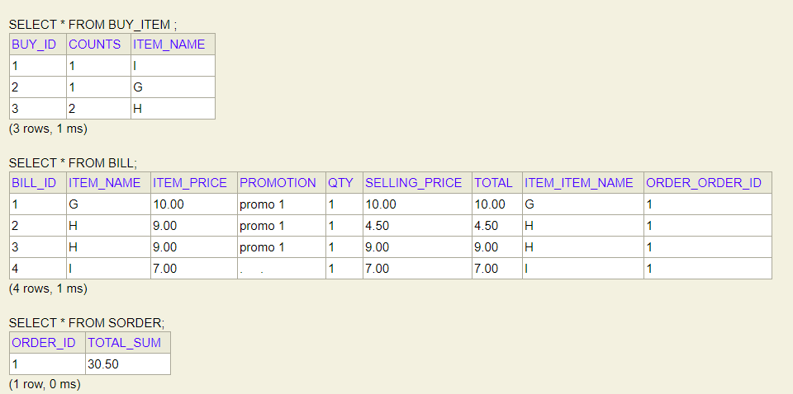

Use Case 2:

As per Promo2, third item will be free, but third item should be cheaper from the group

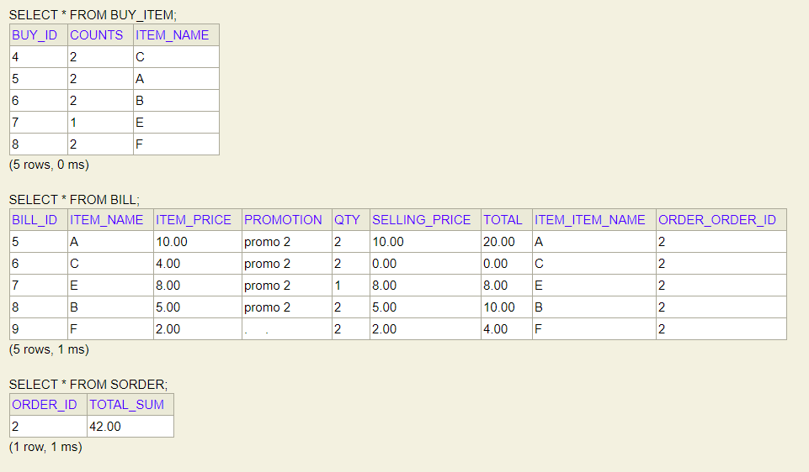

Use Case 3 : Promo 2 third item will be free

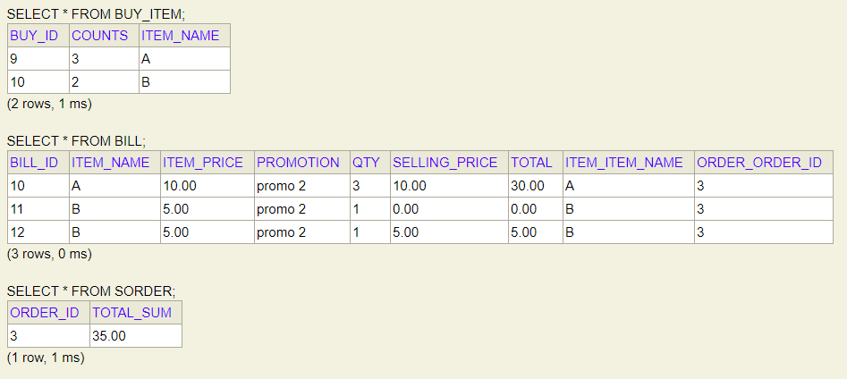

Use Case 4 : Promo 2 third item will be free

