Day -5 Assignment
1. On your Windows laptop or PC, open 'System Information' and take a screenshot showing your OS version, processor, and RAM details.

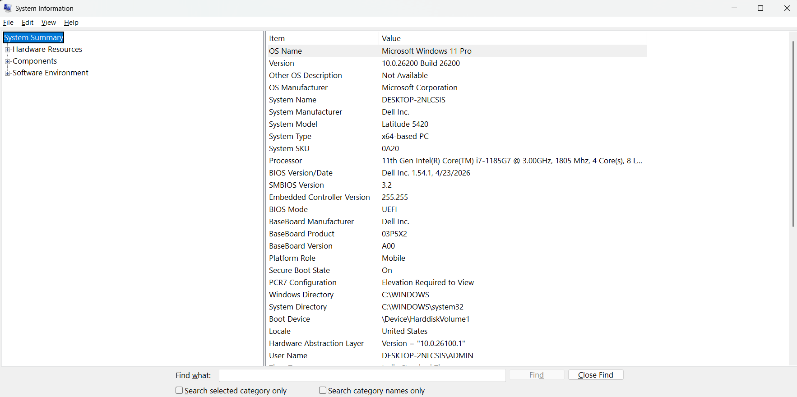

2. Download any official Linux distribution ISO (like Ubuntu or Fedora), and use Rufus or BalenaEtcher to create a bootable USB drive for installation.<br><br><em><strong>Hint:</strong> If you don't have a spare USB, use a virtual machine tool like VirtualBox to mount the ISO and start the installation process virtually.</em>

Create a Bootable Linux USB – 6 Simple Steps
- Download Ubuntu ISO – Download the official Ubuntu Linux ISO file.
- Download Rufus – Install or open Rufus on your Windows PC.
- Insert USB Drive – Connect an 8 GB or larger USB drive. Back up important files first, because the USB will be erased.
- Select ISO File – Open Rufus → select your USB → click Select → choose the Ubuntu ISO file.
- Create Bootable USB – Click Start → choose ISO Image Mode if asked → confirm the warning to erase the USB.
- Finish – Wait until Rufus shows READY, then safely eject the USB. The USB is now bootable.

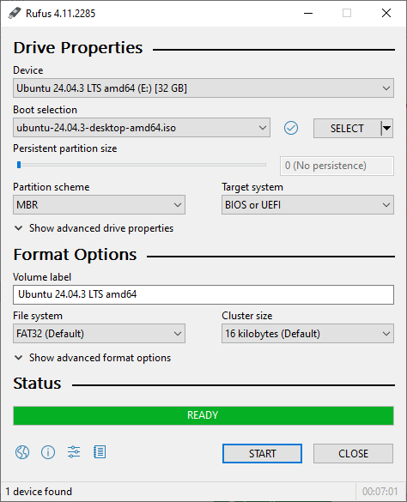

3. On a macOS device (or using a macOS virtual machine), open 'System Preferences' and change the desktop wallpaper, then adjust the system language to Hindi or Gujarati.<br><br><em><strong>Hint:</strong> Find 'Language & Region' in System Preferences to add or change languages.</em>

Steps on macOS
1. Open System Preferences.
2. Click Desktop & Screen Saver.
3. Choose a new desktop wallpaper.
4. Go back to System Preferences.
5. Click Language & Region.
6. Click the + button to add a language.
7. Select Hindi or Gujarati.
8. Choose Use Hindi/Gujarati as the main language.
9. Restart or log out if macOS asks you to.

4. Install a fresh copy of Ubuntu Linux (real or virtual machine) and create a new user account named 'gamer'. After installation, enable automatic login for this user and take a screenshot of the login screen showing the username.
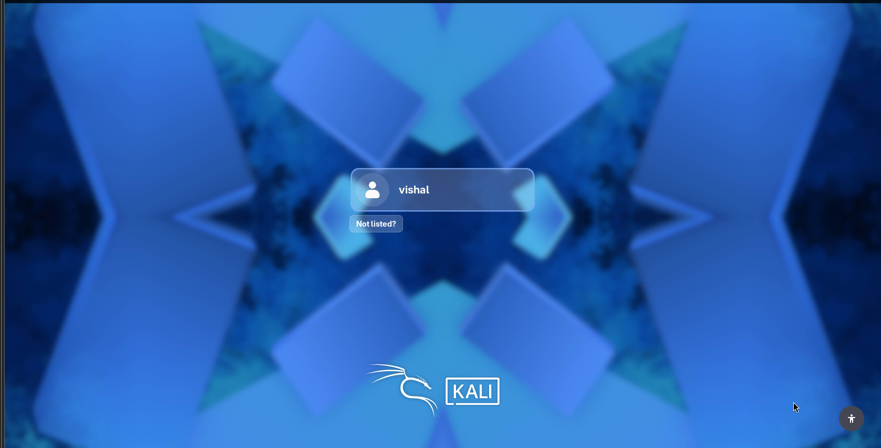
5. Use ChatGPT to generate a step-by-step guide for installing Windows 10 on a laptop, including partitioning tips and post-installation settings for privacy and updates. Follow the guide and note any steps that were unclear or missing.

- Backup your files first.
- Create a Windows 10 bootable USB using Microsoft's Media Creation Tool.
- Restart the laptop and boot from the USB.
- Choose Install now → Custom installation.
- For partitioning, select the correct SSD. If doing a completely clean install, delete the old Windows partitions and install into the unallocated space. A This erases data.
- Finish Windows setup and create your account.
- Install Wi-Fi, chipset, graphics, and other drivers if needed.
- Go to Settings → Update & Security → Windows Update and install available updates.
- Review Privacy settings and turn off unnecessary location, advertising ID, and app permissions.
- Keep Windows Security/Defender enabled and set up backups.

