ROSSMANN SALES FORECASTING
End-to-End Retail Sales & Customer Demand Forecasting
Project 6 • Final Documentation Package

Prepared for | NextHikes IT Solutions — Project 6
Internal completion target | 13 September 2026
Official submission | 15 September 2026
Repository | https://github.com/vsatish5621/Rossmann-Sales-Forecasting

Professional report • Findings • Models • Deep Learning • MLOps • BI • Deployment

1. Executive Summary
This project develops an end-to-end Rossmann retail forecasting solution for daily store sales and customer demand. The workflow combines data cleaning, business-focused exploratory analysis, calendar/store/competition feature engineering, a scikit-learn Random Forest pipeline, a customer-demand model, a time-series LSTM, MLflow model management, DVC data versioning, Power BI reporting, and a deployed Streamlit prediction interface.
- Training data: 1,017,209 store-day records; store master: 1,115 stores.
- Final test set: 41,088 records; final sales and customer predictions were generated.
- Sales Random Forest validation: MAE 809.24, RMSE 1218.28, R² 0.8859.
- Customer Random Forest validation: MAE 60.23, RMSE 91.12, R² 0.9562.
- Multivariate LSTM validation: MAE 504,875.09, RMSE 669,092.44, R² 0.9451 on daily aggregated sales.
- Live Streamlit deployment is working and returns both Sales and Customers predictions plus CSV download.

2. Official Project Requirement Baseline
The official Project 6 brief is the controlling source. It requires exploration of purchasing behavior, store-sales prediction, machine learning, deep learning, MLflow inference, a web interface, hosting, GitHub, screenshots/evidence and a final PDF. The final brief explicitly emphasizes Deep Learning modelling and asks for DVC and MLflow version evidence.
Requirement | Status | Evidence / Audit Note
Business need / six-week forecasting | DONE | Business problem, drivers and end-to-end objective documented.
Task 1 EDA: customer purchasing behavior | DONE | EDA notebook with required analyses, plots/tables and insights.
Cleaning: missing values + outlier review | DONE — with documented outlier-treatment limitation | Missing values are handled in the sklearn pipeline. Extreme demand values were reviewed as legitimate business observations rather than blindly deleted; the final modeling workflow does not claim a separate automated outlier-removal transformation.
Python logging | DONE | Successful logging execution screenshot retained.
Preprocessing + feature engineering | DONE | 20 store-day features plus calendar features; categorical encoding and imputation in pipeline.
sklearn pipeline + Random Forest | DONE | Chronological validation and RF pipeline completed.
Loss function defense | DONE | MSE used for RF/LSTM training; MAE/RMSE/R² reported for interpretable evaluation.
Feature importance | DONE | Top feature importances extracted after prediction.
Creative prediction interval | DONE | Approximate tree-dispersion interval; explicitly not a calibrated confidence interval.
Timestamped serialization | DONE | Timestamped RF, customer RF, LSTM and scalers saved.
LSTM: stationarity / differencing / ACF-PACF / windows / scaling | DONE | ADF, ACF/PACF, 28-day window, (-1,1) scaling and LSTM regression completed.
MLflow inference on test | DONE | Inference reproduced 41,088 predictions; models tracked and registered.
Multiple MLflow model versions | DONE | Registry contains Version 1 and Version 2; Version 2 is a second registry release, not retraining.
Web interface: Sales + Customers | DONE | Live Streamlit application predicts both outputs.
Frontend CSV upload | VERIFY TOMORROW | CSV upload is implemented in the final Streamlit application and verified in the final application evidence.
Dashboard plot of predicted Sales + Customers | VERIFY TOMORROW | The final application includes dedicated Predicted Sales and Predicted Customers charts in the CSV batch workflow.
CSV download | DONE | Live app download validated; Excel screenshot confirms output.
Hosting + link | DONE | Streamlit Community Cloud live URL verified.
GitHub notebook link | DONE | Public repository with five organized notebooks.
DVC multiple data versions | DONE | Version 1 and Version 2 with DVC store evidence.
Power BI dashboard | DONE | PBIX with FactSales, DimDate, DimStore, DAX and slicers.
Final PDF / blog-style report | PREPARED | This package contains the professional report draft.
20-slide final presentation | PREPARED | This package contains the professional 20-slide deck.
Final-state verification: the Streamlit application now supports CSV upload, dedicated Predicted Sales and Predicted Customers charts, prediction results, and CSV download.

3. Business Problem & Success Criteria
- Finance needs store-level sales forecasts up to six weeks ahead across multiple stores/cities.
- Forecasts should reflect promotions, competition, school/state holidays, seasonality and locality/store characteristics.
- Managers need a repeatable product rather than forecasts based only on personal judgement.
- The solution must move from data preparation through model serving and usable business output.

4. Dataset & Data Understanding
Dataset | Rows | Columns | Role
train.csv | 1,017,209 | 9 | Historical store-day training data
store.csv | 1,115 | 10 | Store characteristics / competition / promotions
test.csv | 41,088 | 8 | Future/unseen records for final prediction
sample_submission.csv | 41,088 | 2 | Required submission format
Core business fields include Store, Sales, Customers, Open, Promo, StateHoliday, SchoolHoliday, StoreType, Assortment, CompetitionDistance, CompetitionOpenSinceMonth/Year, Promo2, Promo2SinceWeek/Year and PromoInterval.

5. End-to-End Solution Architecture
- Raw Rossmann files → validation and cleaning → train/store merge.
- EDA → business insights → calendar/store/promotion/competition features.
- Preprocessing pipeline → Random Forest Sales model and separate Customer model.
- Daily aggregation → stationarity/ACF/PACF → supervised windows → multivariate LSTM.
- Timestamped serialization → MLflow tracking/inference/registry → final 41,088-row predictions.
- DVC versions data artifacts; GitHub stores code/notebooks/app; Power BI provides BI reporting.
- Streamlit provides manager-facing inputs, predictions, details and CSV output.

6. Data Cleaning & Quality
- Original train columns had no missing values.
- Store missing values: CompetitionDistance 3; CompetitionOpenSinceMonth/Year 354 each; Promo2SinceWeek/Year/PromoInterval 544 each.
- Promo2=0 structurally explains the 544 missing Promo2 fields.
- No duplicate rows were found in train or store.
- Sales=0 is a legitimate operational outcome; 172,817 rows have Open=0 and Sales=0.
- 54 open-store records have Sales=0 and were retained rather than incorrectly deleted.
- StateHoliday was standardized to string representation.
- Missing values are handled in the sklearn pipeline using median numeric imputation and most-frequent categorical imputation.
- Extreme demand values were treated as business observations rather than blindly deleted. The final audit should verify whether an explicit automated outlier-treatment code block is required by the trainer rubric.
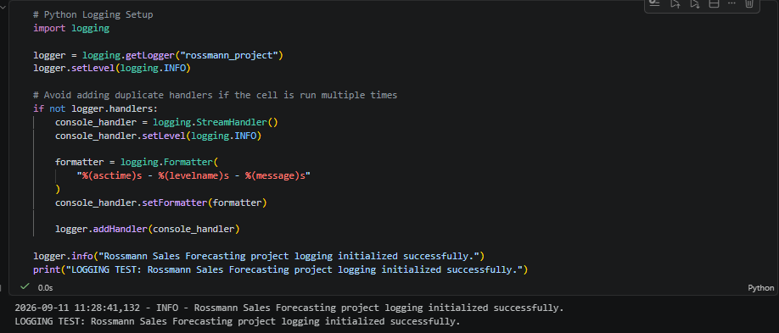
Figure: Python logging successfully initialized for the Rossmann project.

7. Exploratory Data Analysis
The EDA notebook was organized around the official questions and extended with additional business-focused visualizations.
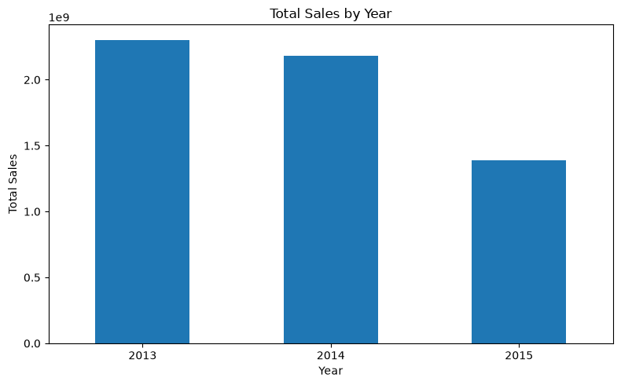
Annual Sales
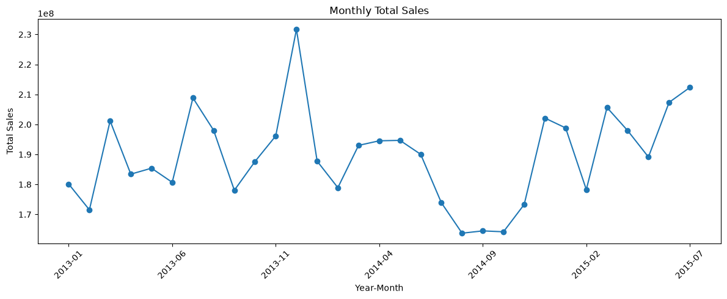
Monthly Total Sales
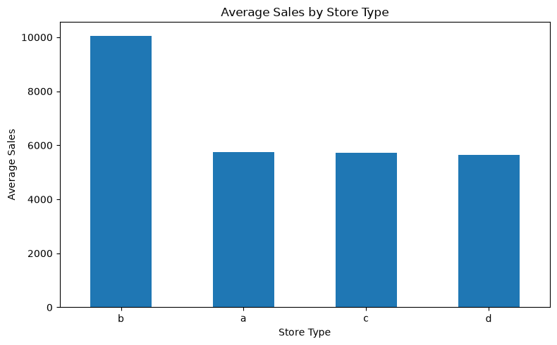
Average Sales by Store Type
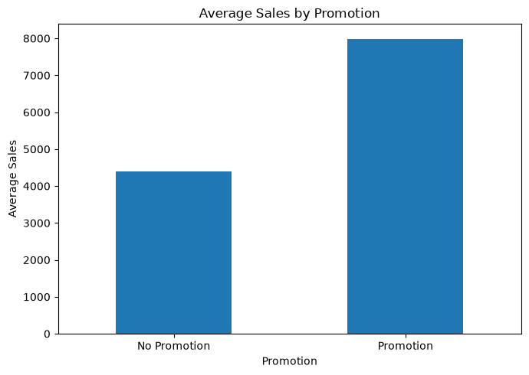
Average Sales by Promotion
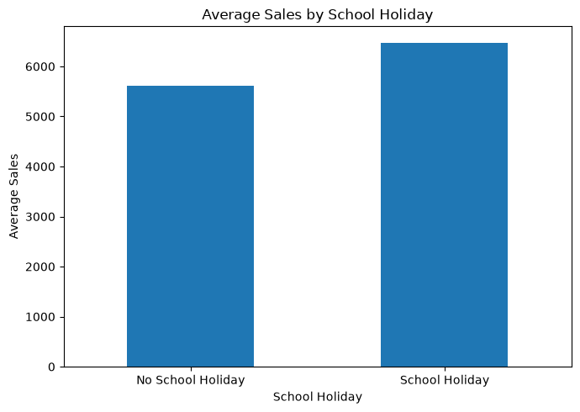
Average Sales by School Holiday
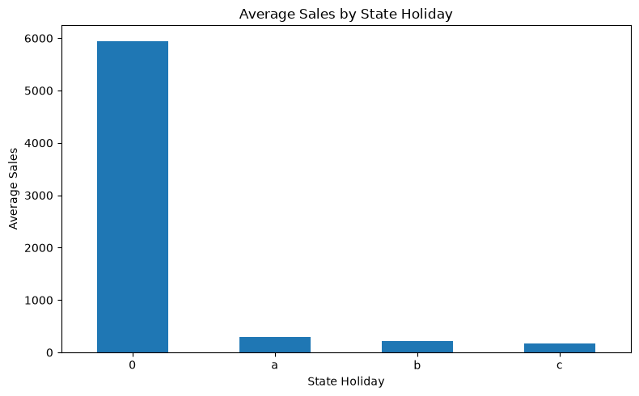
Average Sales by State Holiday
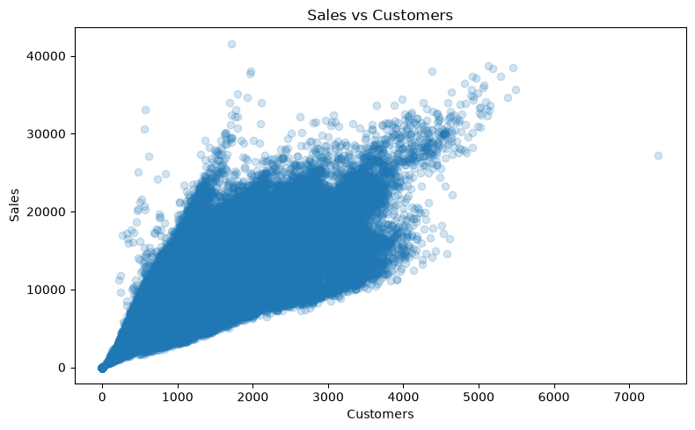
Sales vs Customers
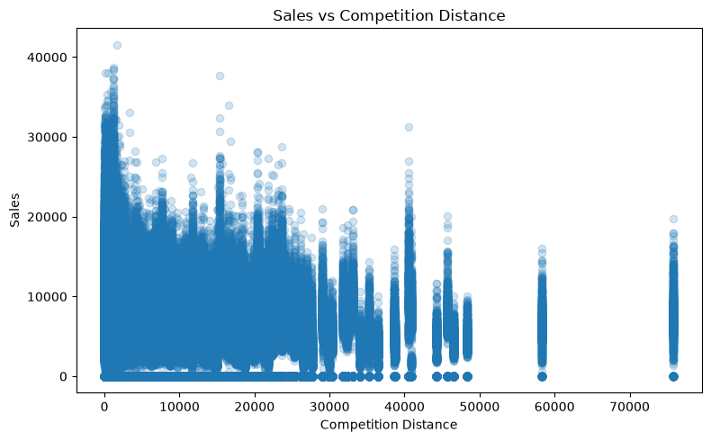
Sales vs Competition Distance

8. Key EDA Findings & Business Interpretation
- Sales–Customers correlation is 0.8947, indicating a strong positive relationship.
- Promotion increases average Sales from 4,406.05 to 7,991.15 and average Customers from 517.82 to 820.10.
- Promotion share is 38.15% in train and 39.58% in test; the difference is about 1.43 percentage points.
- State holidays have much lower average Sales/Customers than non-holiday days; the holiday-period average rises again after the holiday.
- Christmas behavior is highly seasonal: Dec 25 is near-zero relative to normal trading days, while Dec 23 and Dec 30 are much stronger.
- Sunday is a major operational trough: average Sales about 204 versus weekday average about 6,866.81.
- Only 10 stores were open all seven days; weekend performance therefore depends strongly on store operating patterns.
- Assortment b has the highest average Sales, followed by c and a.
- Sales vs CompetitionDistance correlation is -0.0192, so distance alone does not explain Sales well.
- 351 stores have CompetitionDistance available but missing competitor opening month/year; 3 stores have missing CompetitionDistance and missing opening dates.
- SchoolHoliday shows a substantial train/test distribution shift (17.86% vs 44.35%), which is an important deployment caveat.
Promotion deployment is relatively stable across stores (mean about 38.14%, with a very small store-to-store spread), so store targeting should consider baseline demand and store characteristics rather than promotion eligibility alone.
Competition distance has only a weak overall relationship with Sales. This suggests that locality is multidimensional and that distance should be interpreted together with store type, assortment, competition age and other features.
The train/test calendar mix is not identical. In particular, SchoolHoliday is substantially more common in test, which is a meaningful distribution-shift consideration.

9. Feature Engineering & Preprocessing
The Sales model uses 20 features:
Store, DayOfWeek, Open, Promo, StateHoliday, SchoolHoliday, Year, Month, Day, WeekOfYear, IsWeekend, StoreType, Assortment, CompetitionDistance, CompetitionOpenSinceMonth, CompetitionOpenSinceYear, Promo2, Promo2SinceWeek, Promo2SinceYear, PromoInterval
- Calendar features: Year, Month, Day, ISO WeekOfYear, IsWeekend, YearMonth.
- Numerical variables: median imputation.
- Categorical variables: most-frequent imputation + OneHotEncoder(handle_unknown='ignore').
- Random Forest does not require feature scaling, so scaling was not forced into the tree pipeline.
- Customers were excluded from the initial Sales model because future customer counts are not available when forecasting future Sales.

10. Random Forest Sales Forecasting
Model: RandomForestRegressor with n_estimators=100, max_depth=20, min_samples_leaf=2, random_state=42, n_jobs=-1.
Chronological validation: training from January 2013 through June 2015; validation on July 2015. This avoids a random split that could mix future information into training.
Model | MAE | RMSE | R²
Sales Random Forest | 809.24 | 1218.28 | 0.8859
Customer Random Forest | 60.23 | 91.12 | 0.9562
Loss/evaluation defense: MSE is used as the training objective for the regression estimators where applicable, while MAE and RMSE provide interpretable error magnitudes and R² summarizes explained variance. RMSE is useful for penalizing larger errors more strongly; MAE is easier to communicate to business users.

11. Feature Importance & Prediction Uncertainty
Feature | Importance
Open | 0.508711
CompetitionDistance | 0.092245
Promo | 0.080344
Store | 0.070218
CompetitionOpenSinceYear | 0.041116
CompetitionOpenSinceMonth | 0.033846
DayOfWeek | 0.029371
Promo2SinceWeek | 0.018019
WeekOfYear | 0.016021
StoreType_b | 0.014949
Open is the dominant feature because closed stores have zero Sales; this is model reliance, not a causal claim. CompetitionDistance, Promo and Store are the next major contributors.
Prediction uncertainty was estimated from the dispersion of individual Random Forest tree predictions using an approximate mean ± 1.96×standard-deviation interval, with the lower bound clipped at zero. This is a model-based approximation, not a formally calibrated confidence interval.

12. Customer Demand Model
A separate Random Forest model predicts Customers using the same feature framework and chronological validation design. Validation performance was MAE 60.23, RMSE 91.12 and R² 0.9562. This provides a second business output for managers and makes the web application useful beyond Sales alone.

13. Deep Learning — LSTM
Daily total Sales were aggregated to a 942-day time series from 2013-01-01 through 2015-07-31. The series shows strong weekly operational structure because many stores are closed on Sundays.
ADF statistic = -4.7616 with p ≈ 6.4×10⁻⁵. Because p < 0.05, the unit-root null was rejected and first-order differencing was not required for the modelling path.
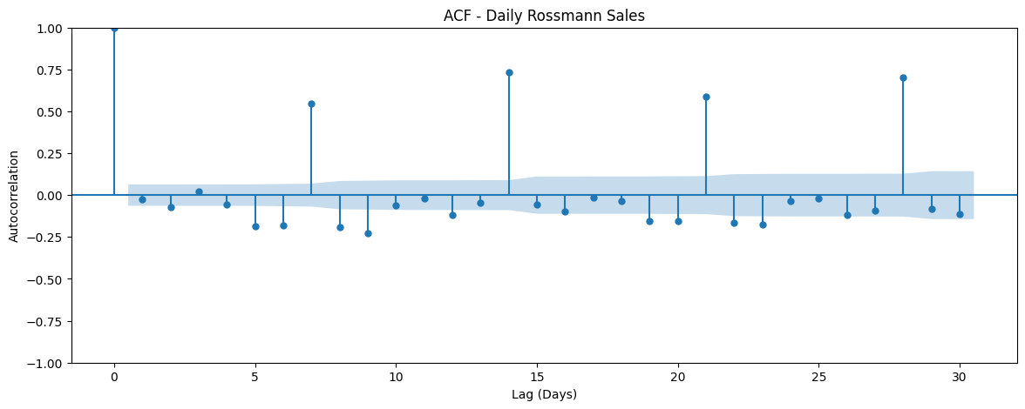
Figure: ACF showing strong weekly-period spikes.
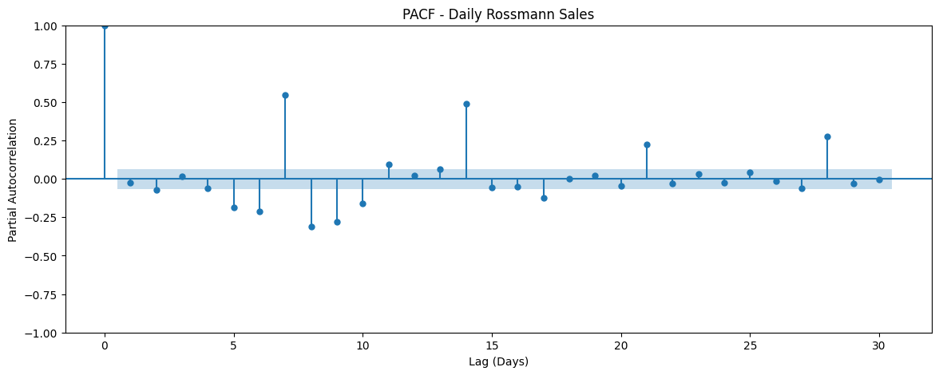
Figure: PACF showing strong weekly structure, motivating a 28-day window.
A 28-day sliding window was selected to provide four weeks of recent temporal context. Input data were scaled to (-1,1) using training-only scalers.
Univariate LSTM: Input (28,1) → LSTM(64) → Dropout(0.2) → Dense(1); best validation loss ≈ 0.0741. Validation R² was 0.4518, with noticeable Sunday overprediction because the univariate model lacked explicit operational context.
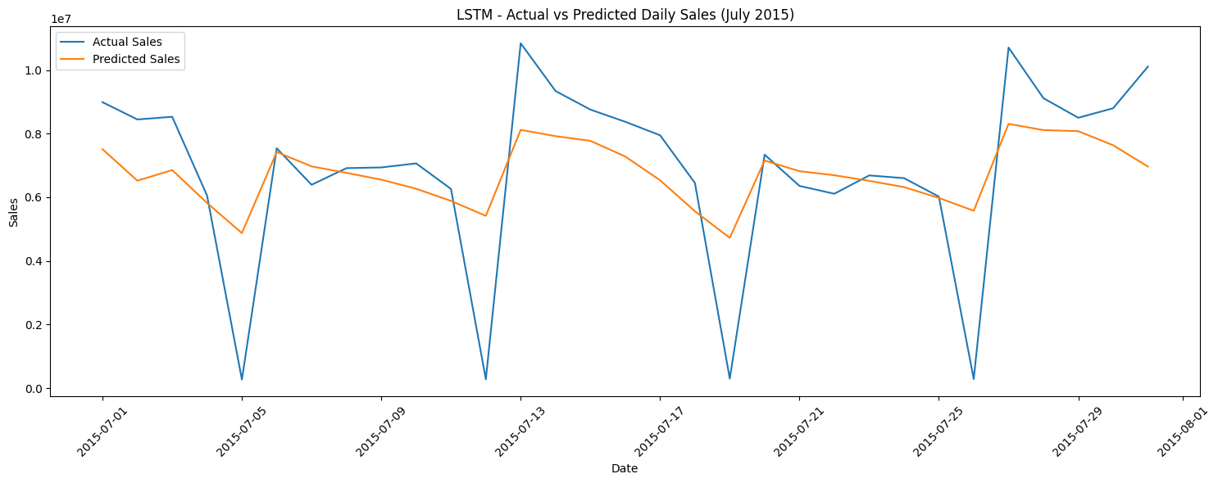
Figure: Univariate LSTM actual vs predicted daily sales.
Improved multivariate LSTM: daily Sales + OpenStores + DayOfWeek; Input (28,3) → LSTM(64) → Dropout(0.2) → Dense(1). Best validation loss ≈ 0.0074; validation MAE 504,875.09, RMSE 669,092.44 and R² 0.9451.
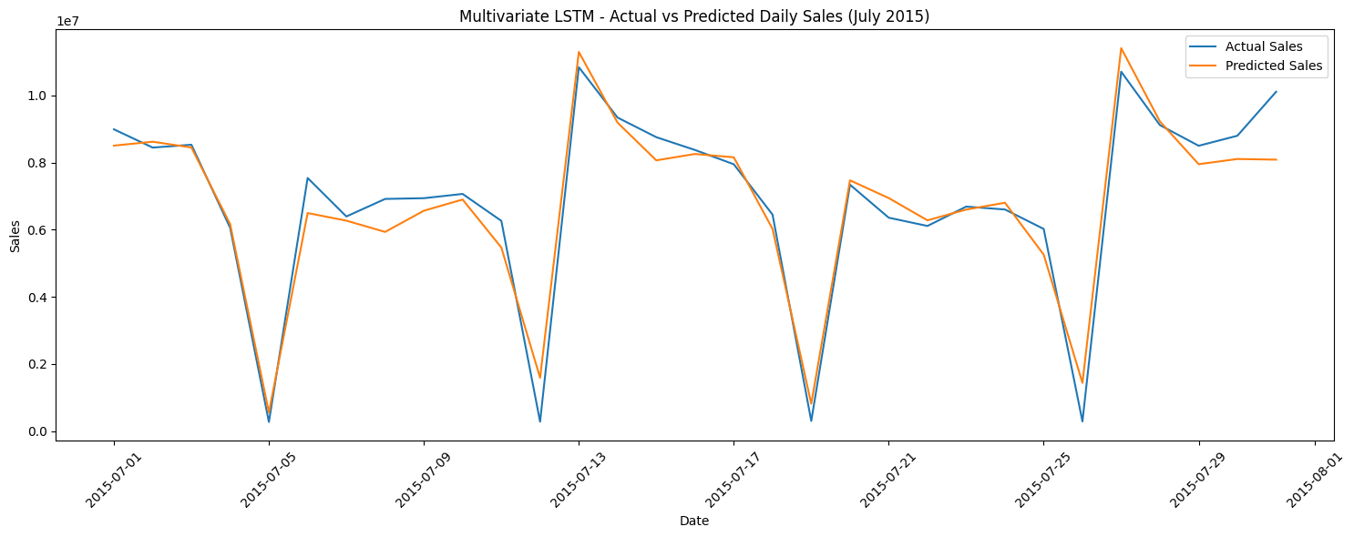
Figure: Multivariate LSTM actual vs predicted daily sales, capturing Sunday troughs.
Important comparison note: Random Forest metrics are at store-day level, while LSTM metrics are on daily aggregated sales. They should not be ranked directly as if they measured the same task.

14. Model Serialization & Reproducibility
- Sales RF: rossmann_random_forest_20260909_084440.joblib
- Customer RF: rossmann_customer_random_forest_20260909_105310.joblib
- Multivariate LSTM: rossmann_multivariate_lstm_20260909_095057.keras
- LSTM input scaler: rossmann_lstm_input_scaler_20260909_095057.joblib
- LSTM Sales scaler: rossmann_lstm_sales_scaler_20260909_095057.joblib
- Final combined predictions: Id | Predicted_Sales | Predicted_Customers, 41,088 rows.

15. MLflow Experiment Tracking & Inference
- Experiment: Rossmann_Sales_Forecasting.
- Sales RF parameters and metrics were tracked.
- Validated sklearn pipeline was logged as an MLflow model after resolving skops trusted-type restrictions.
- MLflow inference reproduced the 41,088 test predictions.
- Customer RF was also logged and loaded successfully for inference.
- Registry model: Rossmann_Sales_Forecasting_RF.
- Registry Version 1 and Version 2 are present. Version 2 is a second registry release from the validated artifact, not a newly trained model.
Evidence requirement: retain the actual MLflow dashboard screenshot showing both registry versions in the final evidence folder. The MLflow Version 1/Version 2 screenshot is retained in the final evidence package.

16. DVC Data Versioning
- DVC local remote/store: C:\Users\satish\Desktop\DVC_Store.
- Version 1 commit: 6fe968e — original Rossmann datasets.
- Version 2 commit: 5312ffc — prepared training dataset.
- dvc diff HEAD~1 HEAD confirmed train.csv changed between versions.
- The DVC store contains content-addressed objects for multiple dataset versions.
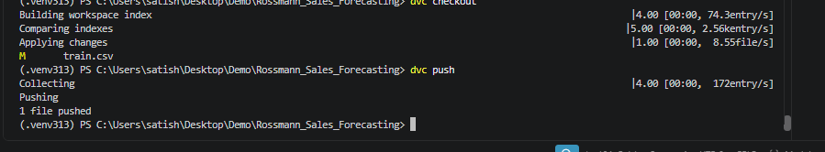
Figure: DVC evidence for versioned dataset content/store operations.

17. Power BI Business Intelligence Layer
- Power BI file: Rossmann_Sales_Forecasting.pbix.
- Star-schema model: FactSales, DimStore, DimDate.
- Relationships: DimDate[Date] → FactSales[Date]; DimStore[Store] → FactSales[Store].
- DAX measures: Total Sales, Total Customers, Avg Sales per Customer, Total Stores.
- Slicers: Year, Month Name and Store Type.
- Historical analysis includes time, store type, promotion, day-of-week, customers, holidays, competition distance and assortment.
The final PBIX dashboard screenshot is retained in the final evidence package. The dashboard itself is completed and its model, measures and slicers are documented.

18. Streamlit Web Application & Deployment
Live application: https://rossmann-sales-forecasting-3ajs4nefpwuhytnxunnisq.streamlit.app
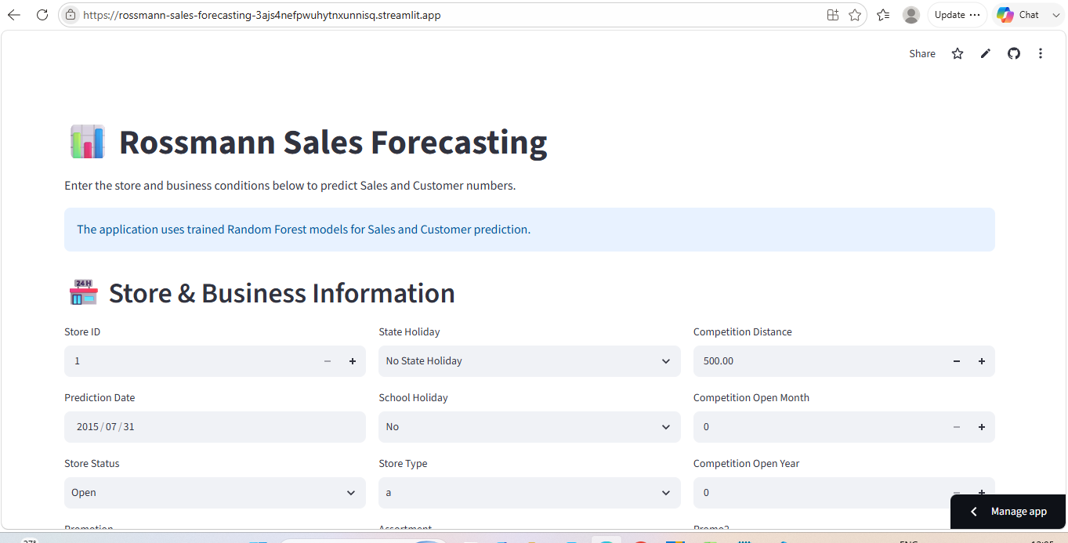
Figure: Live Streamlit application with store/business inputs.
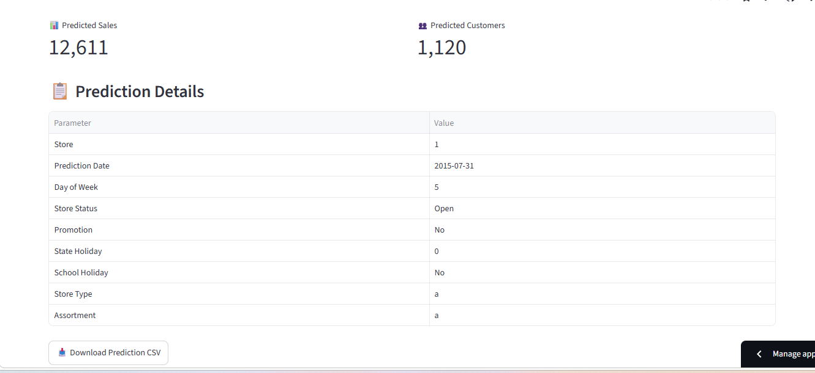
Figure: Live prediction result showing Sales and Customers plus prediction details and CSV download.
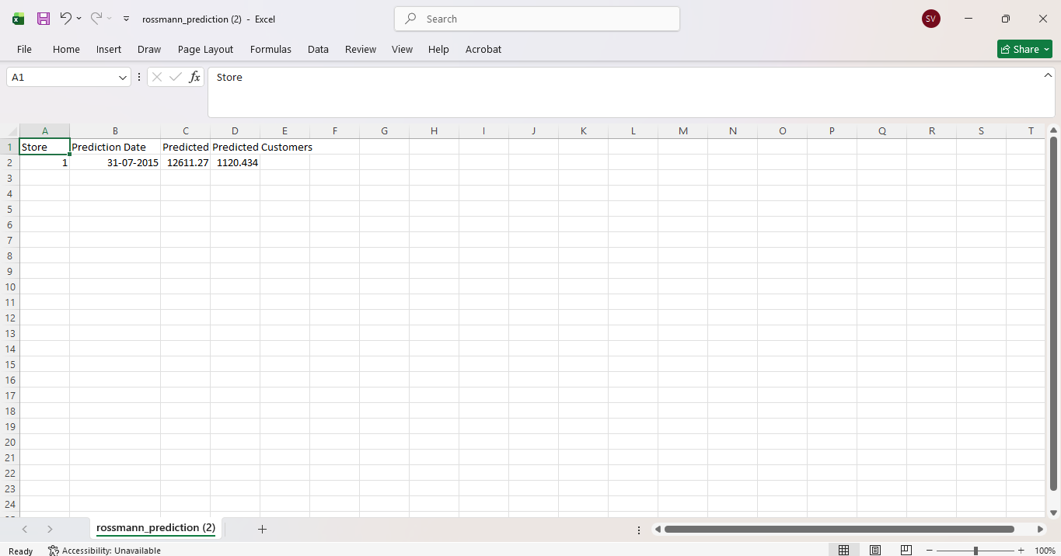
Figure: Downloaded prediction CSV opened in Excel.
Validation example shown in the live app: Store 1, 31-Jul-2015, with the live interface displaying approximately Sales 12,611 and Customers 1,120; the downloaded CSV preserves the underlying decimal values. The display rounds the metrics for readability.
Deployment path used: GitHub repository → Streamlit Community Cloud → Python 3.13 → app.py. The earlier Python 3.14 deployment was deleted after repeated startup delay; the successful deployment used Python 3.13.

19. GitHub, Project Structure & Final Outputs
https://github.com/vsatish5621/Rossmann-Sales-Forecasting
- 01_Data_Loading_Cleaning.ipynb
- 02_EDA_Analysis.ipynb
- 03_ML_Sales_Prediction.ipynb
- 04_LSTM_TimeSeries.ipynb
- 05_MLflow_Final_Prediction.ipynb
- app.py, requirements.txt, README.md
- DVC metadata (.dvc files and store configuration)
- Serialized model artifacts managed appropriately; large model binaries use Git LFS for deployment.

20. Final Business Insights
- Store operating status is critical to Sales forecasting; closed stores naturally generate zero Sales.
- Promotions are associated with materially higher Sales and Customers and should be evaluated with store baseline demand and timing.
- Weekly operational behavior is extremely important; Sunday is a major trough because many stores are closed.
- Assortment type is associated with meaningful Sales differences, with assortment b strongest in the observed data.
- Competition distance alone has weak explanatory power, so competitor timing and store context matter.
- Holiday periods can suppress demand sharply, while pre/post-holiday periods can rebound.
- SchoolHoliday distribution differs substantially between train and test, so monitoring calendar shifts is important for future production use.

21. Limitations & Future Improvements
- Random Forest validation is historical July-2015 validation, not a formal rolling-origin cross-validation study.
- The approximate prediction interval is not calibrated uncertainty.
- The LSTM is trained on daily aggregate Sales rather than store-specific sequences, so it complements rather than replaces the store-day RF model.
- The final web application includes the official example CSV-upload workflow and dedicated prediction plots; these are included in the final evidence package.
- Future versions could add richer holiday-distance features, rolling lag/mean features, store-specific time-series LSTMs, calibrated intervals and automated monitoring.

22. Final Submission Audit — 14 September Checklist
- ☐ Open the official PDF and verify every Task 1 / Task 2 / Task 3 item.
- ☑ Confirmed: actual MLflow dashboard screenshot showing Version 1 and Version 2 is in the final evidence package.
- ☑ Confirmed: actual Power BI dashboard screenshot is in the final evidence package.
- ☑ Confirmed: live Streamlit app provides CSV upload, Predicted Sales chart, Predicted Customers chart and CSV download.
- ☑ Confirmed: EDA notebook contains the required question-focused analyses, plots/tables and business insights; historical data limitations are documented where exact longitudinal evidence is unavailable.
- ☐ Confirm the final GitHub repository opens and the five notebooks are present.
- ☐ Confirm final prediction files and serialized models are available in the intended package/repository structure.
- ☑ Final PDF and 25-slide PPT updated and prepared for submission.
- ☑ Submission links and required evidence are included in the final package.

Appendix A — Key Model Results
Sales RF: MAE 809.24 | RMSE 1218.28 | R² 0.8859
Customer RF: MAE 60.23 | RMSE 91.12 | R² 0.9562
Multivariate LSTM: MAE 504,875.09 | RMSE 669,092.44 | R² 0.9451

Appendix B — Accuracy & Evidence Rules
- Do not call MLflow Registry Version 2 a newly trained model.
- Do not call the tree-dispersion interval a formally calibrated confidence interval.
- Do not compare RF and LSTM metrics directly because they use different prediction granularity.
- Do not claim features are causal from Random Forest importance.
- Do not claim CSV upload or a prediction plot unless the live app actually provides and demonstrates them.

23. Final Submission Verification — 15 September 2026
This final verification supersedes earlier interim audit wording. The project artifacts were reviewed against the official Project 6 brief and the final implementation state.

Official links:
GitHub: https://github.com/vsatish5621/Rossmann-Sales-Forecasting
Live App: https://rossmann-sales-forecasting-3ajs4nefpwuhytnxunnisq.streamlit.app
Known data/evidence limitations are stated transparently: the static store master does not provide a full historical competitor-distance timeline for every store, and the final workflow does not claim a calibrated statistical confidence interval.

