**Summarizing**

**1.** EDA Findings

**2.** Model Comparison and Performance Metrics

**3.** Business Insights and Recommendations

**1. EDA Findings**

There is imbalance in the data set. The number of customers who churned are less than the number of customers who did not churn.

**Churned Users:** 42

**Active Users:** 158

**How I solved:** Used Synthetic Minority Over Sampling Technique (SMOT)

**Key Insights from EDA:**

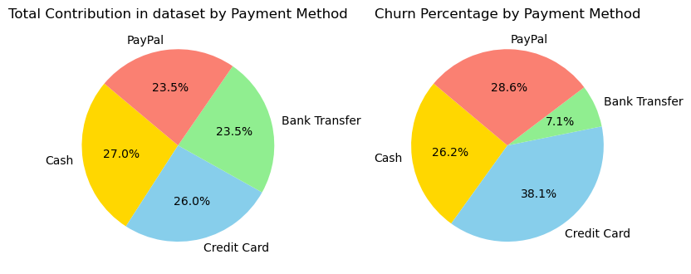

* Customers whose payment method is **Bank Transfer has less churn rate**.
* Customers whose payment method is **Credit Card has high churn rate**.

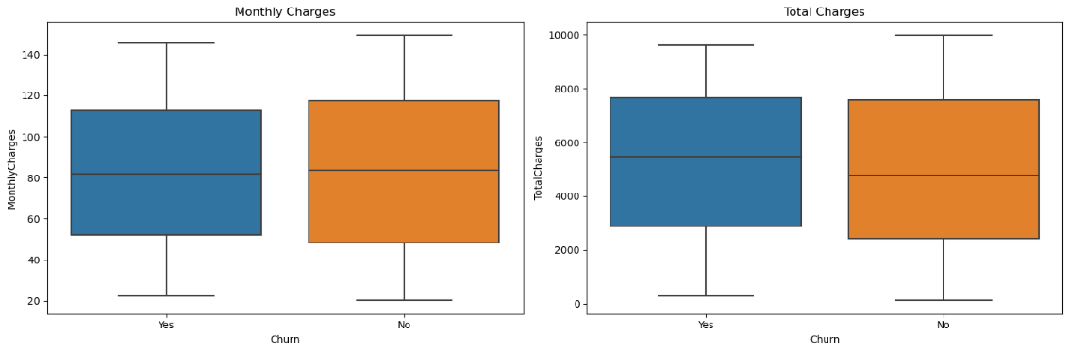

* Average Total charges of churned customers are greater than the customers who did not churn

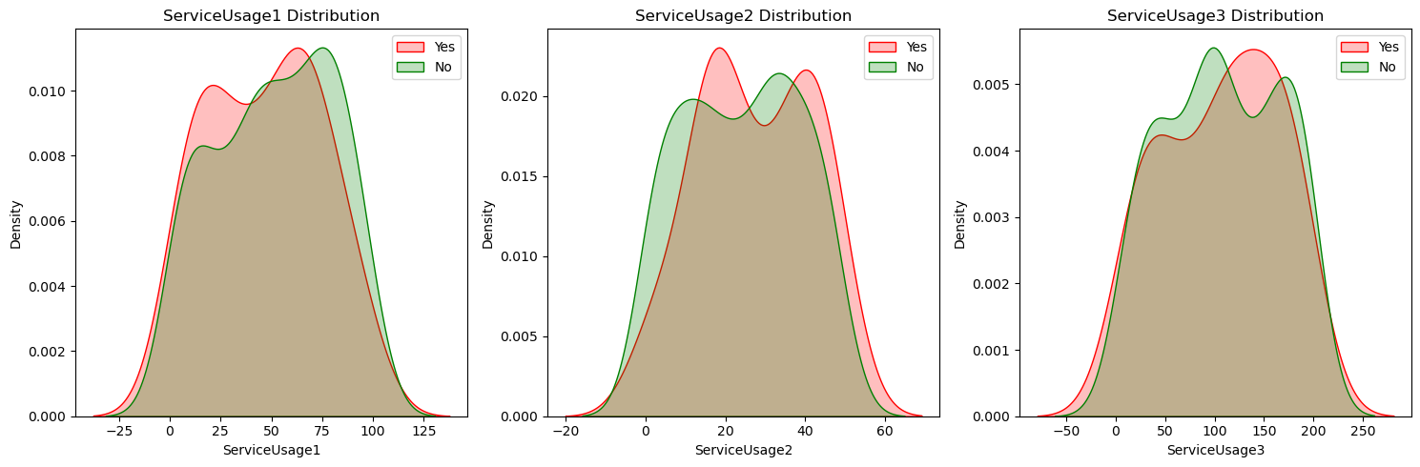

* Customers with High ServiceUsage1 likely to churn
* Customers with ServiceUsage2 are churning more at all levels, so serviceusage2 is a good predictor for churn
* Customers with High ServiceUsage3 likely to churn
* Average Monthly Spend < 1800 has High churn Rate, it means customers who spends more than 1800 on an average are retaining the subscription

**Feature Importance:**

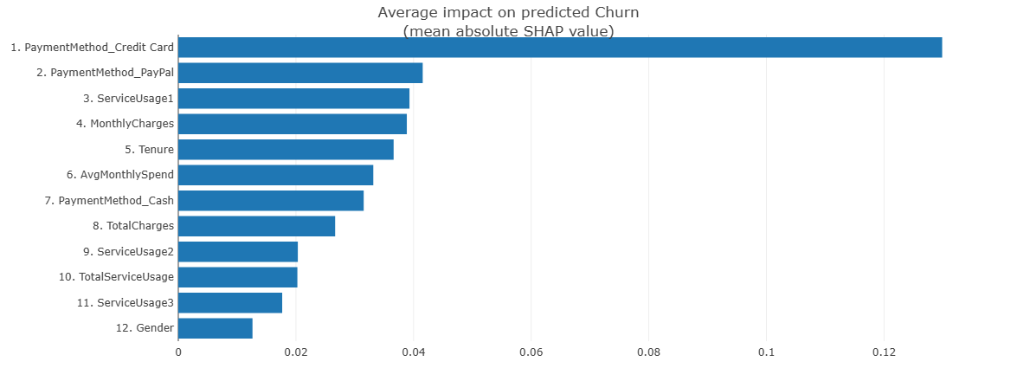

**PaymentMethod Credit Card** has the highest impact on the target variable i.e churn rate

**Gender** has the least impact on the churn rate

**2. Model comparison and performance metrics.**

**Logistic vs Random Forest vs Decision Tree**

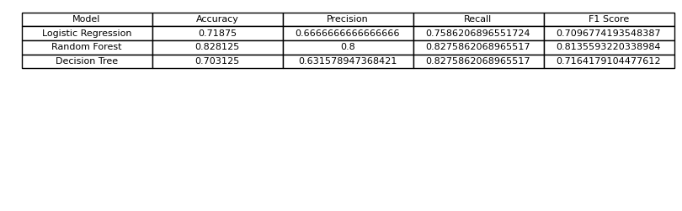

* Among all the models Random Forest is achieving balanced precision and recall score
* Random Forest is able to predict the churned customers with high accuracy
* We are more interested in predicting the customers who are likely to churn, so that we can take necessary actions to retain them, so we need to focus more on Recall score

**3. Business Insights and Recommendations**



* Bank Transfer Payment Method has less churn rate and Credit Card Payment Method has very high churn rate,
* It's good to conduct A/B testing with and without Credit Card Payment. If we observe same number of new users than we can takeout Credit Card Payment Option.
* Tenure Greater than 55 has less churn rate, long time users are habituated to the services.

**ServiceUsage1** has the highest retention impact, with a **4% higher churn rate** for users without the service.

**ServiceUsage2** has a **2.5% higher churn rate** for users with the service.

**ServiceUsage3** has a **6% higher churn rate** for users with the service.

**Customer Retention Recommendations:**

1. Avoid the cold start problem by recommending the most popular services to the new users.
2. By the given data, we can recommend **ServiceUsage1** to the new users as ServiceUsage1 has the highest retention impact, with a **4% higher churn rate** for users without the service.
3. Focus on **ServiceUsage3** to improve the retention rate because customers using **ServiceUsage3 has High Churn Rate.**
4. It's good to conduct A/B testing with and without Credit Card Payment. If we observe same number of new users than we can takeout Credit Card Payment Option.
5. Identifying underutilized services that similar customers find valuable.
6. Suggesting personalized service combinations that correlate with higher retention.
7. Enabling proactive recommendations before customers show churn signals.