1. Create a Git Repository.

Commands –

git init

$ git init

Initialized empty Git repository in E:/Github/GitTest/.git/

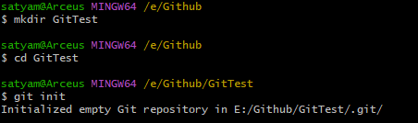

1. Create a new file.

Commands –

touch main.txt // Create a file

echo // Edit file

git add // Add file to staging area

git commit -m “” // Commit the changes

$ touch main.txt

$ echo "This is the content of the master file" >> main.txt

$ git add main.txt

warning: LF will be replaced by CRLF in main.txt.

The file will have its original line endings in your working directory

$ git commit -m “First Commit”

[master (root-commit) 9ba1b5e] First Commit

1 file changed, 1 insertion(+)

create mode 100644 main.txt

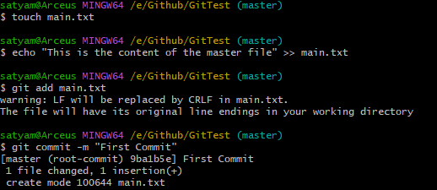

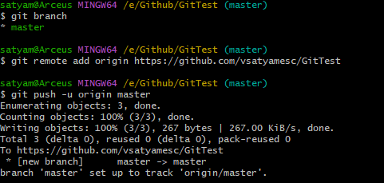

1. Create a new branch

Commands –

git branch // list the git branches

git branch FirstBranch // Make a new Branch of the master

git checkout FirstBranch // change the branch

git status // check the status

git push -u origin FirstBranch // push to the branch to reflect changes

$ git branch

* master

$ git branch FirstBranch

$ git checkout FirstBranch

Switched to branch 'FirstBranch'

$ git status

On branch FirstBranch

nothing to commit, working tree clean

$ git push -u origin FirstBranch

Total 0 (delta 0), reused 0 (delta 0), pack-reused 0

remote:

remote: Create a pull request for 'FirstBranch' on GitHub by visiting:

remote: https://github.com/vsatyamesc/GitTest/pull/new/FirstBranch

remote:

To https://github.com/vsatyamesc/GitTest

* [new branch] FirstBranch -> FirstBranch

branch 'FirstBranch' set up to track 'origin/FirstBranch'.

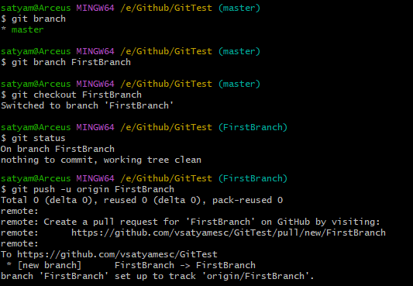

1. Make Changes in the Branch

Commands –

echo // make changes to the main.txt

git status // check the status

git add // Add file to staging area

git commit -m “” // Commit the changes

git push // push changes to the remote repository

$ echo "This is the First Branch Content" >> main.txt

$ git status

On branch FirstBranch

Your branch is up to date with 'origin/FirstBranch'.

Changes not staged for commit:

(use "git add <file>..." to update what will be committed)

(use "git restore <file>..." to discard changes in working directory)

modified: main.txt

no changes added to commit (use "git add" and/or "git commit -a")

$ git add .

warning: LF will be replaced by CRLF in main.txt.

The file will have its original line endings in your working directory

$ git commit -m "Edit to First Branch"

[FirstBranch 71f7823] Edit to First Branch

1 file changed, 1 insertion(+)

$ git push

Enumerating objects: 5, done.

Counting objects: 100% (5/5), done.

Delta compression using up to 12 threads

Compressing objects: 100% (2/2), done.

Writing objects: 100% (3/3), 326 bytes | 326.00 KiB/s, done.

Total 3 (delta 0), reused 0 (delta 0), pack-reused 0

To https://github.com/vsatyamesc/GitTest

9ba1b5e..71f7823 FirstBranch -> FirstBranch

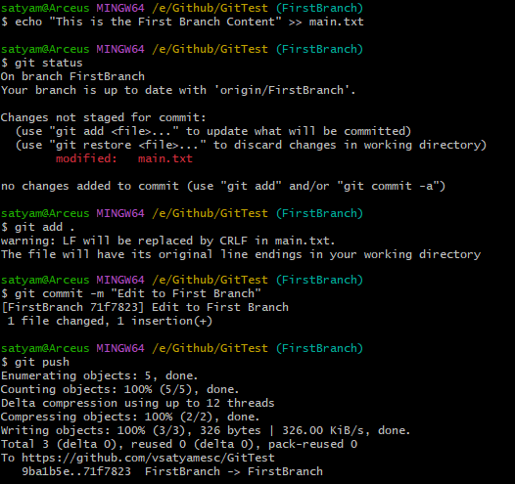

1. Create Another Branch

Commands –

git branch name // Create a new branch

git checkout SecondBranch // Change the branch

touch // create a new file in the branch

git add . // Add modified files to the staging area

git commit – m “” // Commit the files

git push --set-upstream origin SecondBranch

$ git branch SecondBranch

satyam@Arceus MINGW64 /e/Github/GitTest (FirstBranch)

$ git checkout SecondBranch

Switched to branch 'SecondBranch'

$ touch secondfile.txt

$ git status

On branch SecondBranch

Untracked files:

(use "git add <file>..." to include in what will be committed)

secondfile.txt

nothing added to commit but untracked files present (use "git add" to track)

$ git add secondfile.txt

$ git commit -m "Added a second file"

[SecondBranch 30feb42] Added a second file

1 file changed, 0 insertions(+), 0 deletions(-)

create mode 100644 secondfile.txt

$ git push --set-upstream origin SecondBranch

Enumerating objects: 4, done.

Counting objects: 100% (4/4), done.

Delta compression using up to 12 threads

Compressing objects: 100% (2/2), done.

Writing objects: 100% (3/3), 306 bytes | 306.00 KiB/s, done.

Total 3 (delta 0), reused 0 (delta 0), pack-reused 0

remote:

remote: Create a pull request for 'SecondBranch' on GitHub by visiting:

remote: https://github.com/vsatyamesc/GitTest/pull/new/SecondBranch

remote:

To https://github.com/vsatyamesc/GitTest

* [new branch] SecondBranch -> SecondBranch

branch 'SecondBranch' set up to track 'origin/SecondBranch'.

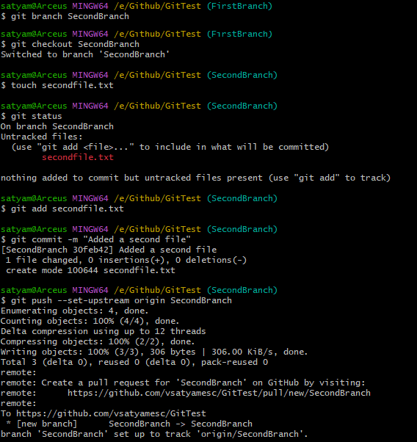

1. Merge Branches

Commands –

Git checkout name // change branch

Git merge name // the name of the branch to merge to

satyam@Arceus MINGW64 /e/Github/GitTest (SecondBranch)

$ git checkout FirstBranch

Switched to branch 'FirstBranch'

Your branch is up to date with 'origin/FirstBranch'.

satyam@Arceus MINGW64 /e/Github/GitTest (FirstBranch)

$ git merge SecondBranch

Updating 71f7823..30feb42

Fast-forward

secondfile.txt | 0

1 file changed, 0 insertions(+), 0 deletions(-)

create mode 100644 secondfile.txt

$ git status

On branch FirstBranch

Your branch is ahead of 'origin/FirstBranch' by 1 commit.

(use "git push" to publish your local commits)

nothing to commit, working tree clean

satyam@Arceus MINGW64 /e/Github/GitTest (FirstBranch)

$ git push

Total 0 (delta 0), reused 0 (delta 0), pack-reused 0

To https://github.com/vsatyamesc/GitTest

71f7823..30feb42 FirstBranch -> FirstBranch

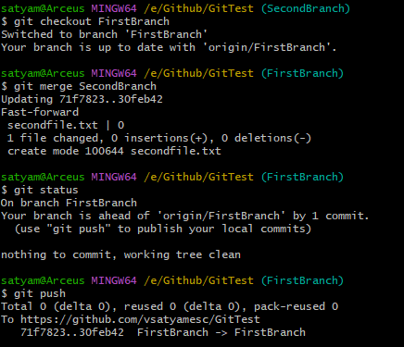

1. Pull Changes from Remote

Commands –

Git remote add origin // add remote url

Git pull origin master // pull the master branch

// Created a new folder to pull changes from remote repository

satyam@Arceus MINGW64 /e/Github/Gitss (master)

$ git remote add origin https://github.com/vsatyamesc/GitTest

satyam@Arceus MINGW64 /e/Github/Gitss (master)

$ git pull origin master

remote: Enumerating objects: 3, done.

remote: Counting objects: 100% (3/3), done.

remote: Total 3 (delta 0), reused 3 (delta 0), pack-reused 0 (from 0)

Unpacking objects: 100% (3/3), 247 bytes | 10.00 KiB/s, done.

From https://github.com/vsatyamesc/GitTest

* branch master -> FETCH_HEAD

* [new branch] master -> origin/master

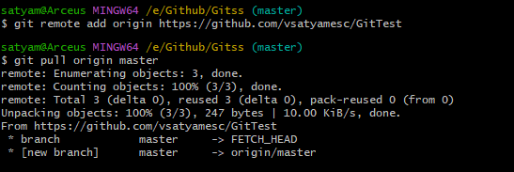

1. View Git Log and History

Commands –

Git checkout name // change branches

Git log // check the logs of the changes

satyam@Arceus MINGW64 /e/Github/GitTest (FirstBranch)

$ git checkout master

Switched to branch 'master'

Your branch is up to date with 'origin/master'.

satyam@Arceus MINGW64 /e/Github/GitTest (master)

$ git log

commit 9ba1b5e982236da28a5996978ce5e5d1d2658d72 (HEAD -> master, origin/master)

Author: Satyam Verma <60954779+vsatyamesc@users.noreply.github.com>

Date: Wed Feb 19 07:35:49 2025 +0530

First Commit

satyam@Arceus MINGW64 /e/Github/GitTest (master)

$ git checkout FirstBranch

Switched to branch 'FirstBranch'

Your branch is up to date with 'origin/FirstBranch'.

satyam@Arceus MINGW64 /e/Github/GitTest (FirstBranch)

$ git log --decorate --graph

* commit 30feb422d54ded3511d04fc99ff7669cb9d864b7 (HEAD -> FirstBranch, origin/SecondBranch, origin/FirstBranch, SecondBranch)

| Author: Satyam Verma <60954779+vsatyamesc@users.noreply.github.com>

| Date: Wed Feb 19 07:59:45 2025 +0530

|

| Added a second file

|

* commit 71f782326b6c6808e27ba2247b04ff91c525436a

| Author: Satyam Verma <60954779+vsatyamesc@users.noreply.github.com>

| Date: Wed Feb 19 07:55:09 2025 +0530

|

| Edit to First Branch

|

* commit 9ba1b5e982236da28a5996978ce5e5d1d2658d72 (origin/master, master)

Author: Satyam Verma <60954779+vsatyamesc@users.noreply.github.com>

Date: Wed Feb 19 07:35:49 2025 +0530

First Commit

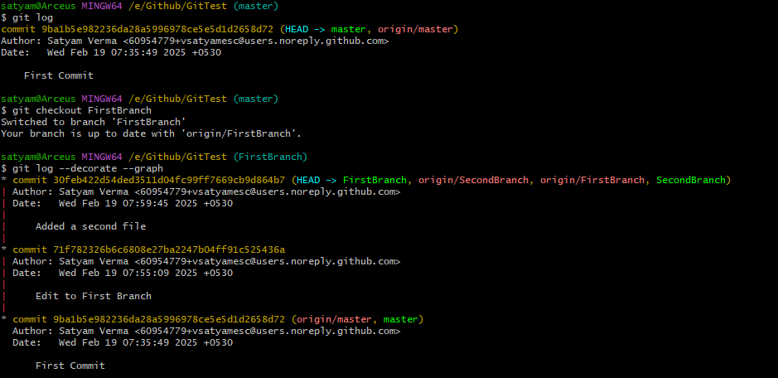

1. Git Status and Staging

Commands –

git status // displays the state of the working directory

git add . // adds the files to the staging area

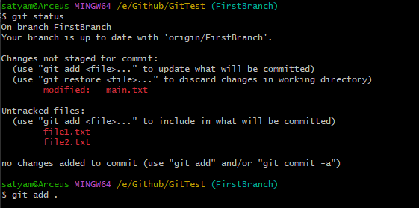

1. Revert and Reset

Commands –

git log // check the history of the commits

git revert <<commit-hash>>

git reset <<commit-hash>>

satyam@Arceus MINGW64 /e/Github/Gitss (FirstBranch)

$ git log --graph

* commit 74feaf488ab3e3a8cb77ba03b66dfb1bcbfe4464 (HEAD -> FirstBranch, origin/FirstBranch)

| Author: Satyam Verma <60954779+vsatyamesc@users.noreply.github.com>

| Date: Wed Feb 19 09:47:37 2025 +0530

|

| New Update

|

* commit 30feb422d54ded3511d04fc99ff7669cb9d864b7 (origin/SecondBranch)

| Author: Satyam Verma <60954779+vsatyamesc@users.noreply.github.com>

| Date: Wed Feb 19 07:59:45 2025 +0530

|

| Added a second file

|

* commit 71f782326b6c6808e27ba2247b04ff91c525436a

| Author: Satyam Verma <60954779+vsatyamesc@users.noreply.github.com>

| Date: Wed Feb 19 07:55:09 2025 +0530

|

| Edit to First Branch

|

* commit 9ba1b5e982236da28a5996978ce5e5d1d2658d72 (origin/master, master)

Author: Satyam Verma <60954779+vsatyamesc@users.noreply.github.com>

Date: Wed Feb 19 07:35:49 2025 +0530

First Commit

satyam@Arceus MINGW64 /e/Github/Gitss (FirstBranch)

$ git revert 30feb422d54ded3511d04fc99ff7669cb9d864b7

[FirstBranch f256366] Revert "Added a second file"

1 file changed, 0 insertions(+), 0 deletions(-)

delete mode 100644 secondfile.txt

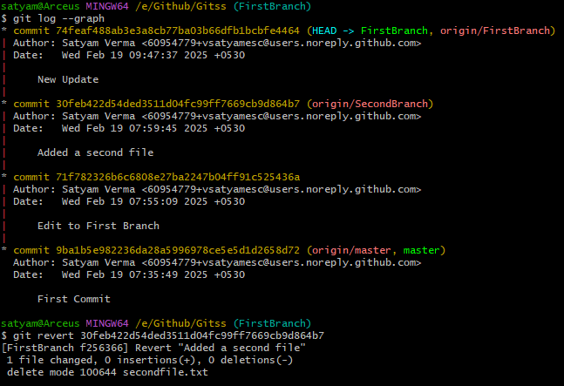

satyam@Arceus MINGW64 /e/Github/Gitss (FirstBranch)

$ git log

commit 90bf37ab439f9083c9adbbbf3ed088fa01daf5f0 (HEAD -> FirstBranch)

Author: Satyam Verma <60954779+vsatyamesc@users.noreply.github.com>

Date: Wed Feb 19 09:56:42 2025 +0530

Next

commit 74feaf488ab3e3a8cb77ba03b66dfb1bcbfe4464 (origin/FirstBranch)

Author: Satyam Verma <60954779+vsatyamesc@users.noreply.github.com>

Date: Wed Feb 19 09:47:37 2025 +0530

New Update

commit 30feb422d54ded3511d04fc99ff7669cb9d864b7 (origin/SecondBranch)

Author: Satyam Verma <60954779+vsatyamesc@users.noreply.github.com>

Date: Wed Feb 19 07:59:45 2025 +0530

Added a second file

commit 71f782326b6c6808e27ba2247b04ff91c525436a

Author: Satyam Verma <60954779+vsatyamesc@users.noreply.github.com>

Date: Wed Feb 19 07:55:09 2025 +0530

Edit to First Branch

commit 9ba1b5e982236da28a5996978ce5e5d1d2658d72 (origin/master, master)

Author: Satyam Verma <60954779+vsatyamesc@users.noreply.github.com>

Date: Wed Feb 19 07:35:49 2025 +0530

First Commit

satyam@Arceus MINGW64 /e/Github/Gitss (FirstBranch)

$ git reset --hard 30feb422d54ded3511d04fc99ff7669cb9d864b7

HEAD is now at 30feb42 Added a second file

