Problem Statement

These days students do not get an opportunity to have a detailed insight into the courses of their interest offered in colleges. So we want to provide them with an opportunity to pursue their desired courses in a detailed manner, based on a pre-requisite format by applying a tree structure.

The existing websites provide courses in a random manner without prompting the user to complete a pre-requisite for that course. The project that we are implementing will like to do the same in a more orderly fashion by providing a detailed description of the pre-requisite as well as the courses to follow in a tree structure.

Objectives

**Vishal**

1. To provide a dashboard for each student, which will specify the courses completed.

2. To maintain a tree structure which will specify the hierarchy of courses.

**Ketan**

3. To provide a registration portal which will initiate an account for each student.

4. To provide faculty conatct details.

**Ankit**

5. To add a discussion forum.

6. Adding/deleting courses.

Feasibility

This project will be extensively useful for the students as it will provide them with an opportunity to explore their interests.And as there are no exsisting websites providing courses in an organised way it will really help them to study courses as they are ment to be done.

It is technically feasible because all the frountend features can implemented using html and css .For the Backend , data structures in Java will come handy.Remaining account for each student can be dealt by RDMS.

Process Model

We will be using **Agile** process model.

**Justification**

1. Since the project contains several modules using agile we will be able to launch our product early in the market implementing only the important features (like Course content and Student account) first.

2. New features like assignments, discussion forums etc can be implemented later on easily in the existing product using agile model.

3. Unlike the waterfall model in agile model very limited planning is required to get started with the project. Agile assumes that the end users’ needs are ever changing in a dynamic technical project. Changes can be discussed and features can be newly affected or removed based on feedback. This will give students the finished system they want or need.

Deliverables

**Services Provided**

1. Distance learning portal for online courses.

2. Rich course content in organised format.

3. Assignments and exams.

4. Discussion forum.

**Platform Used**

1. Netbeans for the entire web application.

2. Oracle 10g for the database integration.

Gratt Chart

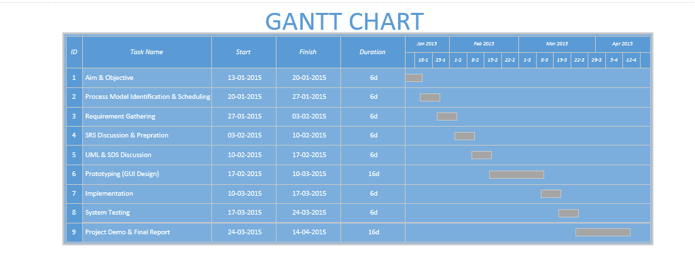

Pert Chart

