前端vue.config.js配置，参考

<https://www.jianshu.com/p/cb13f845b204>

前端代码

https://github.com/vsaxin/vue_nginx_config_demo.git

Nginx 配置

server {

  # 开启gzip

  gzip on;

  gzip_static on;

  gzip_min_length 1024;

  gzip_buffers 4 16k;

  gzip_comp_level 2;

  gzip_types text/plain application/javascript application/x-javascript text/css application/xml text/javascript application/x-httpd-php application/vnd.ms-fontobject font/ttf font/opentype font/x-woff image/svg+xml;

  gzip_vary off;

  gzip_disable "MSIE [1-6]\.";

  # gzip设置结束

  listen       8000;

  server_name  servername;

  index index.html index.htm;

  # 前端打包放的位置，dist目录下有index.html

  root /www/wwwroot/wangxin/dist;

  # 代理

  location /api1 {

    proxy_pass http://127.0.0.1:8080/v1;

  }

  location /api2 {

    proxy_pass http://49.235.74.32:8080/v2;

  }

}

线上环境

接口请求 [http://101.133.166.140:8000/ap2/login](http://101.133.166.140/ap2/login)

转到 [http://49.235.74.32:8080/v2/login](http://101.133.166.140/ap2/login)

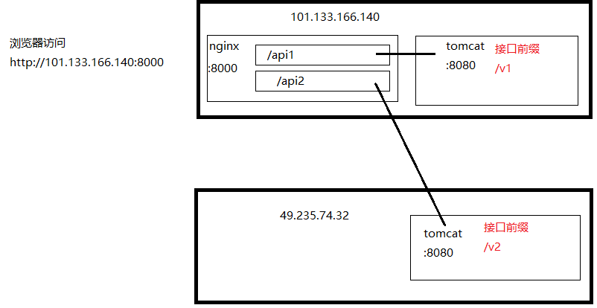

前端开发环境配置代理

devServer: {

    port: 8001,

    host: "0.0.0.0",

    open: true,

    overlay: {

      warnings: true,

      errors: true

    },

    proxy: {

      "/api1": {

        target: "http://101.133.166.140:8080",

        changeOrigin: true,

        pathRewrite: {

          "^/api1": "/v1"

        }

      },

      "/api2": {

        target: "http://49.235.74.32:8080",

        changeOrigin: true,

        pathRewrite: {

          "^/api2": "/v2"

        }

      }

    }

  }