KLE Society's

KLE Technological University

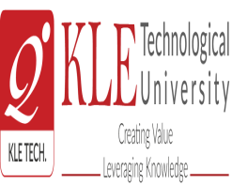

**Blockchain and Distributed Ledgers Course Project Report**

**On**

**DECENTRALIZED BOOK SHARING SYSTEM**

**Submitted By**

### sHREYAS M 01FE21BCS278

### nISCHAY N S 01FE21BCS322

### VINOD BADNI 01FE21BCS305

### ROHAN JADAV 01FE21BCS272

.

School of Computer Science and Engineering

,

Vidyangar, Hubballi – 580031, India.

Academic year 2023-24

**ABSTRACT**

In this report, we present the design and implementation of a decentralized book sharing system leveraging blockchain technology to ensure transparency, security, and user autonomy. The system addresses key issues in traditional book sharing platforms such as centralized control, lack of transparency, and vulnerability to data breaches. By utilizing blockchain's decentralized ledger, we create a peer-to-peer network where users can share and access books without relying on a central authority.

Our approach involves developing a smart contract-based protocol that manages book transactions, verifies user identities, and enforces sharing rules autonomously. The system also incorporates encryption techniques to safeguard user privacy and secure data exchange. We conducted extensive testing to evaluate the system's performance, scalability, and security under various conditions.

The results of our project demonstrates that the decentralized book sharing system significantly enhances security and transparency compared to conventional methods. It also offers a scalable solution that can accommodate a growing number of users and transactions without compromising efficiency. These findings are particularly relevant for protocol designers, security experts, and developers in the blockchain and decentralized systems communities.

**CONTENTS**

**Abstract. I**

|  |  |  |
| --- | --- | --- |
| **Chapter No.** | **Title** | **Page No.** |
| **1.** | **Introduction** | **1** |
| **2.** | **Literature Review** | **2** |
| **3.** | **Proposed Work** | **3-5** |
| **4** | **Results and Discussion** | **6-8** |
| **5** | **Conclusion** | **8** |
| **References** | | **9** |
|  | |  |

**INTRODUCTION**

Blockchain technology, initially developed as the underlying framework for cryptocurrencies like Bitcoin, has evolved into a versatile tool with applications across various domains beyond finance. At its core, blockchain is a decentralized and distributed ledger technology (DLT) that enables transparent and immutable record-keeping. Each block in a blockchain contains a cryptographic hash of the previous block, creating a secure and chronological chain of transactions or data entries. This inherent security and transparency make blockchain suitable for applications requiring trust-less peer-to-peer interactions and verifiable data integrity.

The motivation for our project lies in revolutionizing the traditional book sharing paradigm. Existing systems for book lending often suffer from inefficiencies such as centralized control, lack of transparency, and vulnerability to manipulation or loss of records. By harnessing blockchain technology, we aim to create a decentralized book sharing platform that mitigates these shortcomings. Our system will empower users to lend and borrow books securely, track ownership history transparently, and enforce lending agreements autonomously through smart contracts.

The primary contribution of our work is the design and implementation of a decentralized book sharing system using blockchain technology. This system not only addresses the current limitations of centralized book lending but also introduces novel features enabled by blockchain, such as immutable transaction records, automated ownership verification, and decentralized governance.

This report is structured as follows: Proposed work provides a detailed review of related works in blockchain applications for digital asset management and decentralized systems. System model outlines the architecture and components of our decentralized book sharing system, including the integration of smart contracts for automated book lending agreements. Results and discussion presents our experimental approach and results, demonstrating the feasibility of our system.

**LITERATURE SURVEY**

The proposed methodology in the paper, authored by Esra Erdem and Hannes Strass, involves a multi-disciplinary approach, integrating insights and techniques from computer science, engineering, economics, and social sciences. It utilizes advanced computational models and econometric analysis to examine the dynamics of non-fungible tokens (NFTs). The literature survey highlights the intersection of these fields, detailing prior research on blockchain technology, digital asset valuation, and market behavior. Previous studies have focused on the technical aspects of NFTs, their economic implications, and their social impact, providing a foundation for the current research. This paper builds on these studies by proposing a novel framework that combines these diverse methodologies to offer a comprehensive analysis of NFT markets.

The proposed methodology in the paper "Data sharing: using blockchain and decentralized data technologies to unlock the potential of artificial intelligence: What can assisted reproduction learn from other areas of medicine?" by Cristina Fontes Lindemann Hickman, Hoor Alshubbar, Jerome Chambost, Celine Jacques, Chris-Alexandre Pena, Andrew Drakeley, and Thomas Freour involves leveraging blockchain technology to address the challenges of data sharing in healthcare, specifically in the field of assisted reproduction. The literature survey conducted in this study highlights the use of blockchain as a secure and transparent solution for managing sensitive healthcare data. Prior research has shown that blockchain technology can facilitate trustless transactions and ensure data immutability, which are critical for maintaining data integrity and security. The methodology integrates blockchain with federated learning to enable efficient and privacy-preserving AI training on decentralized data sets. This approach addresses the limitations of traditional data collection methods, such as data insufficiency and bias, by providing a robust framework for large-scale data sharing and analysis in healthcare.

The authors Harris Niavis, Nikolaos Papadis, Venu Reddy, Hanumantha Rao, and Leandros Tassiulas propose a decentralized data sharing infrastructure named DEON for off-grid networking in their paper. DEON integrates blockchain frameworks (Hyperledger Fabric, Indy, Aries) with an off-grid network device and a distributed file system to enable secure and privacy-respecting data sharing among untrusted participants. The methodology focuses on a data management layer for transparent data exchanges and an identity management layer to ensure user privacy and self-sovereignty. The platform supports decentralized applications, meshing, distributed storage, and access control without relying on tokens, and is evaluated through experiments demonstrating its adequate performance for off-grid scenarios.

**PROPOSED WORK**

#### System Model

The proposed work aims to develop a book sharing system using blockchain technology, specifically leveraging the Ethereum ecosystem. This system is designed to enhance organizational governance by enabling transparent and decentralized decision-making processes. The core components of the system include:

1. **Smart Contract Architecture**: The system will utilize Solidity, a programming language for writing smart contracts on the Ethereum blockchain. Key contracts include the membership contracts which implement the ERC721 standard to issue Non-Fungible Tokens (NFTs) representing membership rights of the users within the book sharing system**.**
2. **Meta**-**mask:** It is a cryptocurrency wallet that allows users to interact with the Ethereum blockchain through a browser extension which monitors the transactions i.e. book sharing and access control.
3. **User Interface (UI)**: A user-friendly frontend developed using React.js will allow members to interact seamlessly with the blockchain-based system. The UI features include:
   * Access control: Users can allow and disallow the accounts that can access their books.
   * File uploading: Users can upload the books using the upload portal in the system in PDF format.
   * Book sharing: Users can share the uploaded books with the account addresses that have been granted access by the user.
   * Meta-mask connection: Users can connect their accounts to Meta-Mask to view the transactions on the blockchain during book sharing and access control.
4. **Interplanetary File System (IPFS):** It is a peer-to-peer system for storing the uploaded books, sharing and accessing the books without compromising on size and quality similar to a database. The IPFS used in this project is Pinata which at the center of media storage and data sharing across Web3.

#### Features

#### The system incorporates several key features and algorithms to ensure its functionality, security, and scalability:

**Features**

1. **File Upload on Blockchain:** Users can upload their files to the blockchain, ensuring their data is securely stored and tamper-proof.
2. **Direct Browser Access:** Users can directly access and view their files through a web browser when connected to the same wallet.
3. **File Sharing:** Users can share files with other users by adding their addresses to the allow-list, granting them access to the shared content.
4. **Allow-list Management:** Users can easily manage the allow-list by adding or removing addresses, controlling who can view the shared files.
5. **Privacy and Security:** The system provides privacy and security by allowing users to disallow specific addresses from accessing their files, maintaining control over shared content.

#### Algorithm

Within our decentralized book sharing system, the Book Sharing and Access Control Algorithm relies on ERC721 tokens deployed on the Ethereum blockchain to manage book ownership and access rights securely. Implemented as the 'BookSharingContract', this smart contract inherits from OpenZeppelin's ERC721 standard, ensuring robust functionality for token creation, ownership tracking, and secure transfer mechanisms.

The algorithm begins with the deployment of the 'BookSharingContract', initializing it with a name ('Book NFT') and symbol ('BOOK') to uniquely identify book tokens. Upon uploading a book, users are issued ERC721 tokens that serve as digital certificates of ownership. These tokens are minted and assigned to users, allowing them to assert ownership and control access to their books.

Books are uploaded to the Inter-Planetary File System (IPFS) via Pinata, a service that simplifies IPFS file management. Each uploaded book receives a unique IPFS hash, which is stored on the blockchain within the ERC721 token metadata. This ensures that the book content is securely stored in a decentralized manner and can be retrieved efficiently. Users can upload their books using the system's upload portal in PDF format, ensuring proper storage and indexing on the IPFS.

Users have the ability to manage access to their books by allowing and disallowing specific accounts. This access control ensures that only authorized users can view or borrow the books, maintaining the security and privacy of book transactions. When sharing books, users can grant access to specific account addresses, and only these authorized accounts can interact with the shared content.

Additionally, users can connect their accounts to Meta-Mask to view the transactions on the blockchain during book sharing and access control. This connection provides an intuitive interface for managing digital assets and ensures transparency and immutability of ownership records, which is crucial for maintaining trust and accountability within the system.

For book sharing, users can transfer their ERC721 tokens securely using the transferBook function, which verifies ownership and records transactions on the blockchain. The ERC721 tokens play a pivotal role in managing access rights, as only users in possession of the respective book tokens can access or share the books. This linkage between book tokens and access rights enhances the security and efficiency of our decentralized book sharing platform, ensuring that all transactions and access permissions are handled by legitimate stakeholders.

**RESULTS AND DISCUSSION**

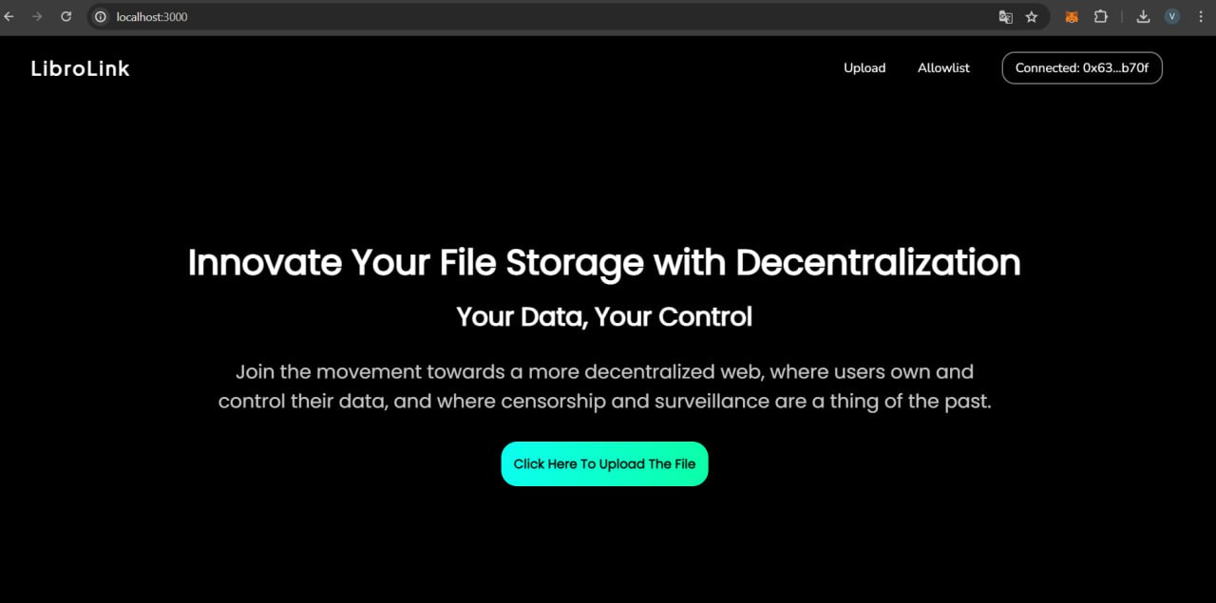

Fig. 1: The user interface of the book sharing system.

The above figure shows the final user interface of the decentralized book sharing system, which is connected to Meta-mask wallet (top right).

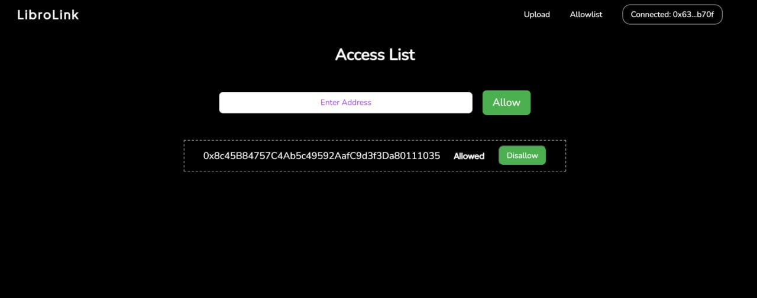

Fig. 2: User granting access.

The figure 2 shows the page that is used by the user to grant access of his books to other accounts i.e. access control page. User enters other accounts address and grants access. User can also disallow the access of his/her books via the access list below.

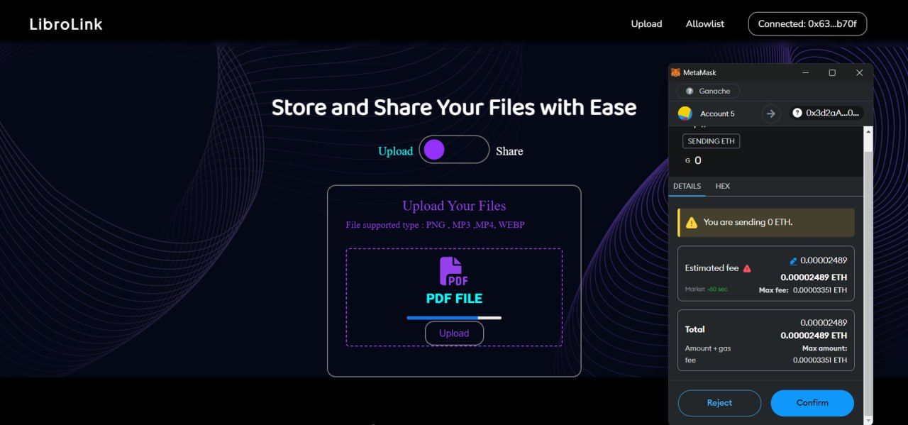

Fig. 3: Uploading the images.

The images are uploaded by the user into the system which are stored in the Pinata IPFS. The Meta-mask wallet shows the completed transactions of the Ethers during the uploading of the images to IPFS as shown in figure 3.

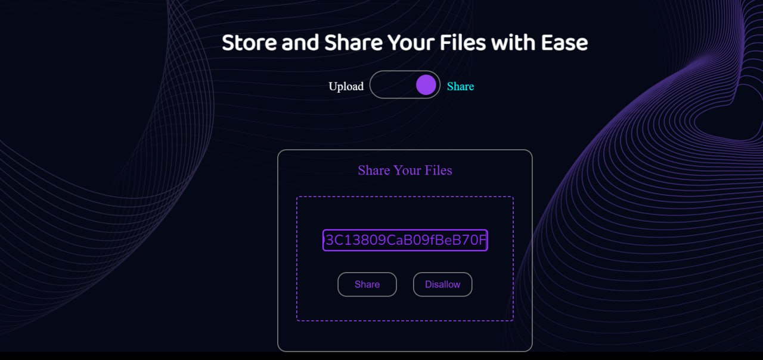

Fig. 4: Sharing of books

The figure 4 shows the book sharing page. The allowed account address is entered by the user and the uploaded books are shared in a peer-to-peer manner.

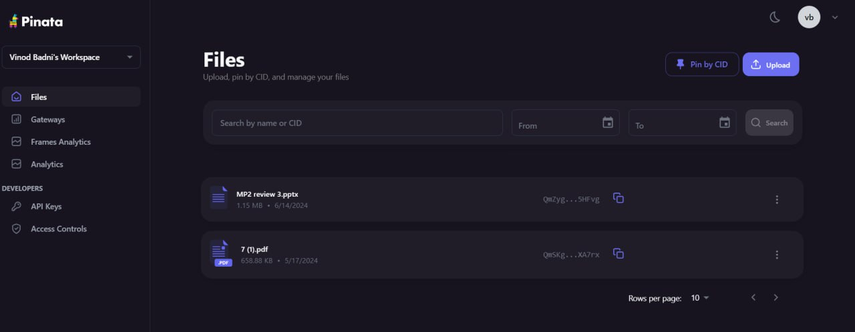

Fig. 5: Books stored in Pinata.

The uploaded books are stored in the Pinata IPFS as shown in figure 5.

**CONCLUSION**

In conclusion, our decentralized book sharing system demonstrates the transformative potential of blockchain technology in creating secure, transparent, and efficient digital asset management solutions. By leveraging ERC721 tokens on the Ethereum blockchain, we have developed a robust framework for managing book ownership and access rights, ensuring that users can securely share and transfer digital books with confidence. The integration of IPFS via Pinata for book storage further enhances the system's decentralization, providing a reliable and efficient means of storing and retrieving book content.

The inclusion of key functionalities such as dynamic access control, seamless book uploading, and Meta-Mask connectivity ensures a user-friendly experience while maintaining high security and privacy standards. By automating and recording transactions on the blockchain, our system guarantees the immutability and transparency of ownership records, fostering trust and accountability within the book sharing community.

This project not only addresses the limitations of traditional book lending models but also sets a precedent for future applications of blockchain technology in various domains. As we continue to refine and expand our system, we anticipate broader adoption and further innovations that will enhance the efficiency and security of digital content sharing in the decentralized ecosystem.

**REFERENCES**