K.R. MANGALAM UNIVERSITY, GURUGRAM-122103

SCHOOL OF ENGENIERRING AND TECHNOLOGY

ASSIGNMENT 3

Data Analysis with Power BI s KNIME

ETMMML174


Department: SOET | Session: 2025-27
Program: MCA (AI & ML) | Semester: 1
Course Code: ETMMML174 | Roll no: 2501940012
Course Name: Data Analysis with Power BI & KNIME
Submitted by: Vinayak Sharma | Faculty: Mr. Mohammad Aijaz

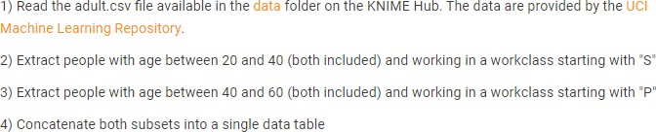

- Read the adult.csv file

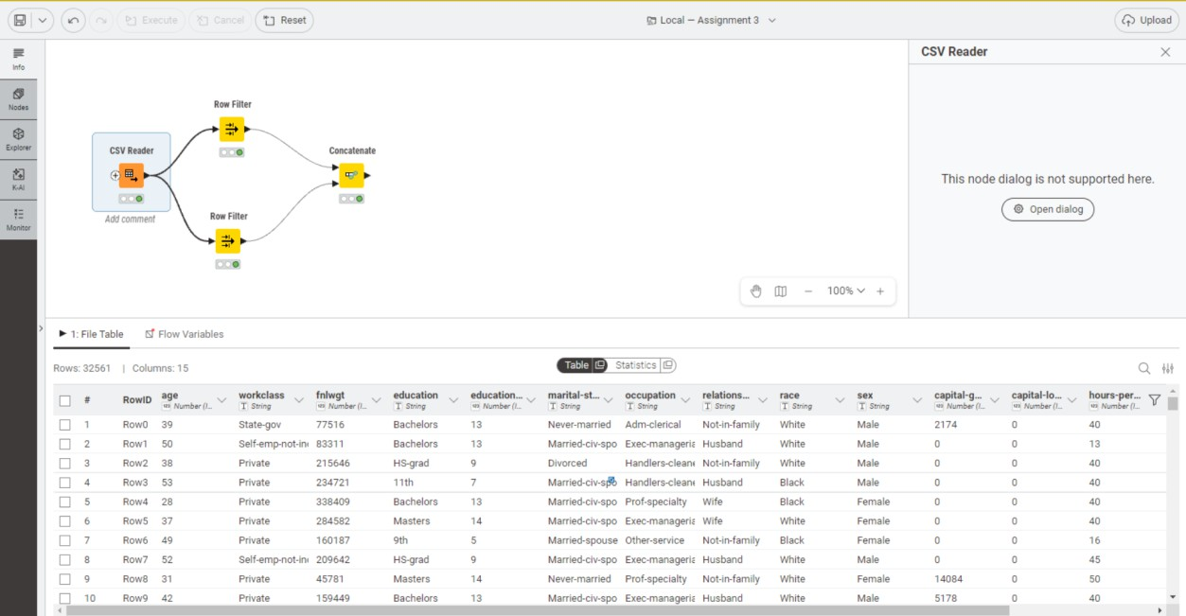

- Extract people with age between 20 and 40 (both included) and working in a work class starting with “S”

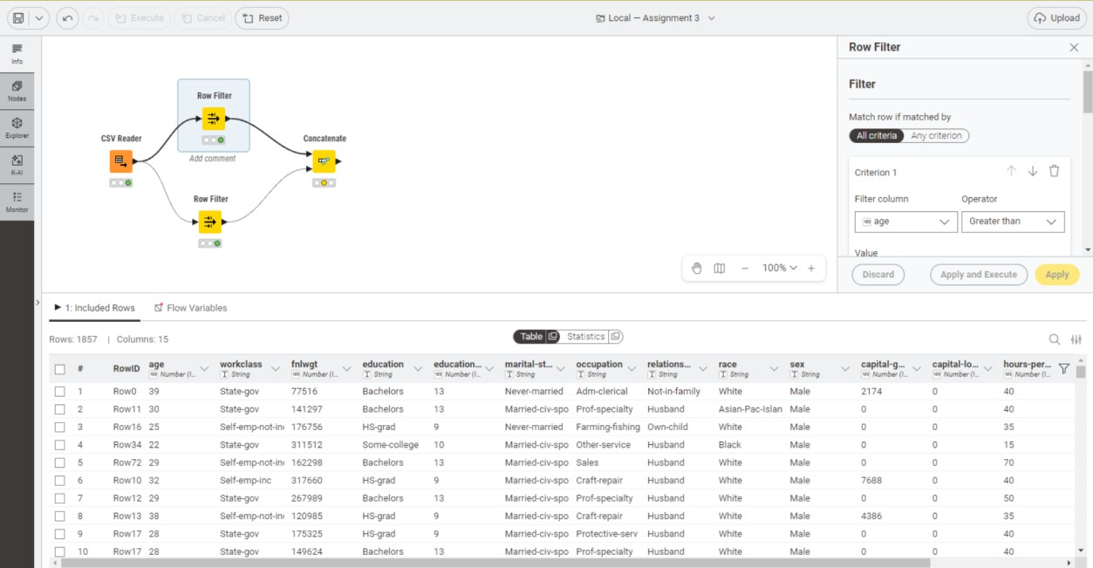
- Extract People with age between 40 and 60 (both included) and working in a work class starting with “P”
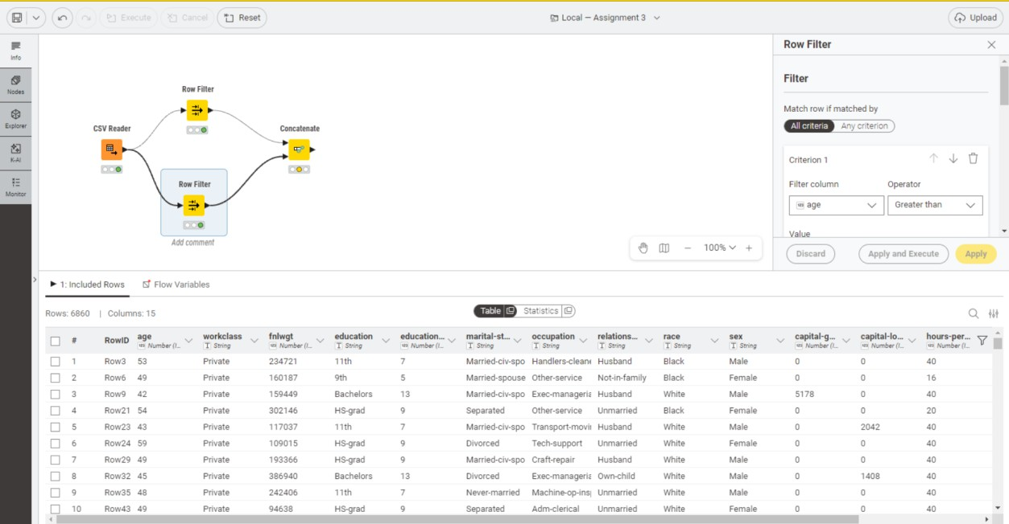

- Concatenate both subsets into a single data

