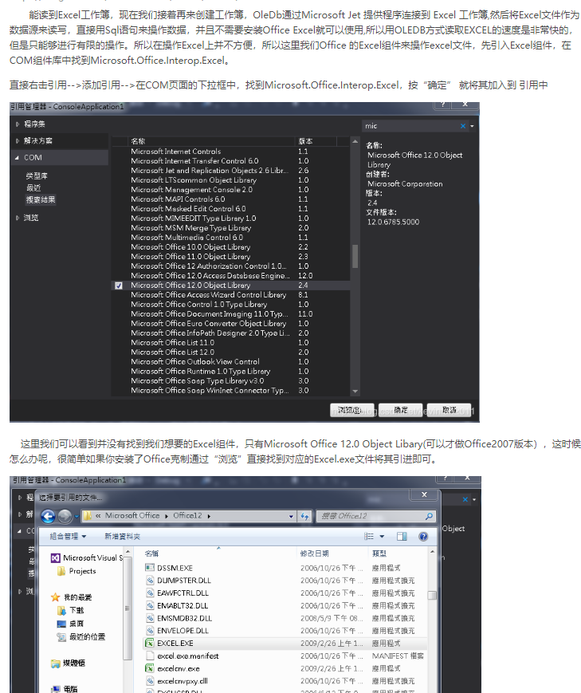

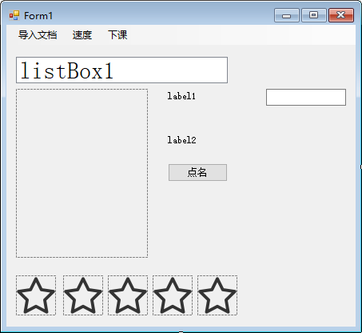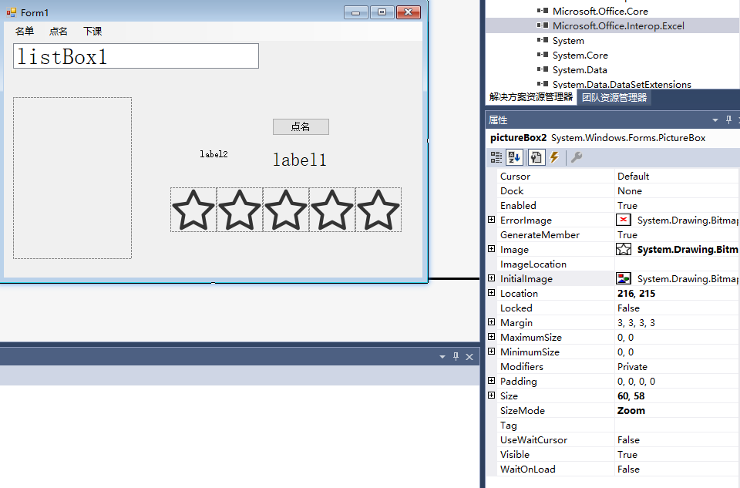

using System;

using System.Collections.Generic;

using System.ComponentModel;

using System.Data;

using System.Drawing;

using System.Linq;

using System.Text;

using System.Threading.Tasks;

using System.Windows.Forms;

using Microsoft.Office.Core;//引用中需要添加

using Microsoft.Office.Interop.Excel;

using Excel = Microsoft.Office.Interop.Excel;//创建别名

namespace 学生信息管理系统

{

public partial class Form1 : Form

{

public Form1()

{

InitializeComponent();

}

string fileName = "";//excel文件的路径

private void 导入文档ToolStripMenuItem_Click(object sender, EventArgs e)

{

//读取Excel，放到列表框

OpenFileDialog ofd = new OpenFileDialog();

if (ofd.ShowDialog() == DialogResult.OK)

{

try

{

LoadExcel(ofd.FileName);

fileName = ofd.FileName;

colum = BlackCol();//记录空白列号

label2.Text = "导入名单成功，可以开始点名";

}

catch

{

MessageBox.Show("打开文件失败！");

}

}

}

Excel.Application excelApp;

Excel.Workbooks excelBooks;

Excel.Workbook excelBook;

Excel.Worksheet excelSheet;

private void LoadExcel(string filename)

{

excelApp = new Excel.Application();

excelBooks = excelApp.Workbooks;

excelBook = excelBooks.Add(filename);

excelSheet = excelBook.Sheets[1];

//提取Excel表中数据到listbox

int i = 1;

Excel.Range range = excelSheet.Cells[i, 1];

label2.Text = range.Value;

string row = "";

while (range.Value != null)

{

row = range.Value;

range = excelSheet.Cells[i, 2];

row += range.Value;

listBox1.Items.Add(row);

i++;

range = excelSheet.Cells[i, 1];

}

}

//返回空白列号

private int BlackCol()

{

int i = 3;

Excel.Range r = excelSheet.Cells[1, i];

while (r.Value != null)

{

i++;

r = excelSheet.Cells[1, i];

}

return i;

}

int nameIndex,colum;

private void WriteExcel()

{

Excel.Range range = excelSheet.Cells[1, colum];

range.Value = DateTime.Now.ToString();

range = excelSheet.Cells[nameIndex, colum];

range.Value = score;

}

private void button1_Click(object sender, EventArgs e)

{

if (button1.Text == "点名")

{

button1.Text = "停止点名";//文字变化

initPic();

timer1.Enabled = true;//计时器开始

stopPic();//打分禁用

//把打分信息放入excel（内存）

if (score != "")

WriteExcel();

}

else

{

button1.Text = "点名";//文字变化

timer1.Enabled = false;//计时器停止

startPic();//打分开启

//记录选中名单信息——行

nameIndex = listBox1.SelectedIndex + 1;

}

}

private void 下课ToolStripMenuItem_Click(object sender, EventArgs e)

{

WriteExcel();

//保存excel到外存

//写入当前信息作为列标题

excelBook.SaveAs(fileName, Type.Missing, "", "", Type.Missing, Type.Missing, Microsoft.Office.Interop.Excel.XlSaveAsAccessMode.xlNoChange, 1, false, Type.Missing, Type.Missing, Type.Missing);

excelBook.Close();

excelApp.Quit();

this.Close();

}

private void Form1_Load(object sender, EventArgs e)

{

stopPic();

}

string sno = "";//当前点名人的信息

Random r = new Random();//定义一个随机种子

private void timer1_Tick(object sender, EventArgs e)

{

listBox1.SelectedIndex = r.Next(1, listBox1.Items.Count);//文本信息变化

//图像信息变化

sno = (listBox1.SelectedItem.ToString()).Substring(0, 10);

pictureBox1.Image = Image.FromFile(@"photo\\" + sno + ".jpg");//注意转译字符

}

//五个星星变灰色

private void initPic()

{

pictureBox2.Image = Image.FromFile("star1.png");

pictureBox3.Image = Image.FromFile("star1.png");

pictureBox4.Image = Image.FromFile("star1.png");

pictureBox5.Image = Image.FromFile("star1.png");

pictureBox6.Image = Image.FromFile("star1.png");

}

private void startPic()

{

pictureBox2.Enabled = true;

pictureBox3.Enabled = true;

pictureBox4.Enabled = true;

pictureBox5.Enabled = true;

pictureBox6.Enabled = true;

}

private void stopPic()

{

pictureBox2.Enabled = false;

pictureBox3.Enabled = false;

pictureBox4.Enabled = false;

pictureBox5.Enabled = false;

pictureBox6.Enabled = false;

}

string score = "";

private void pictureBox6_Click_1(object sender, EventArgs e)

{

initPic();

pictureBox2.Image = Image.FromFile("star2.png");

pictureBox3.Image = Image.FromFile("star2.png");

pictureBox4.Image = Image.FromFile("star2.png");

pictureBox5.Image = Image.FromFile("star2.png");

pictureBox6.Image = Image.FromFile("star2.png");

score = "优秀";

label1.Text = score;

}

private void pictureBox4_Click_1(object sender, EventArgs e)

{

initPic();

pictureBox2.Image = Image.FromFile("star2.png");

pictureBox3.Image = Image.FromFile("star2.png");

pictureBox4.Image = Image.FromFile("star2.png");

score = "一般";

label1.Text = score;

}

private void pictureBox2_Click_1(object sender, EventArgs e)

{

initPic();

pictureBox2.Image = Image.FromFile("star2.png");

score = "不合格";

label1.Text = score;

}

private void pictureBox3_Click_1(object sender, EventArgs e)

{

initPic();

pictureBox2.Image = Image.FromFile("star2.png");

pictureBox3.Image = Image.FromFile("star2.png");

score = "合格";

label1.Text = score;

}

private void pictureBox5_Click_1(object sender, EventArgs e)

{

initPic();

pictureBox2.Image = Image.FromFile("star2.png");

pictureBox3.Image = Image.FromFile("star2.png");

pictureBox4.Image = Image.FromFile("star2.png");

pictureBox5.Image = Image.FromFile("star2.png");

score = "良好";

label1.Text = score;

}

private void 快ToolStripMenuItem_Click(object sender, EventArgs e)

{

timer1.Interval = 50;

}

private void 中ToolStripMenuItem_Click(object sender, EventArgs e)

{

timer1.Interval = 100;

}

private void 慢ToolStripMenuItem_Click(object sender, EventArgs e)

{

timer1.Interval = 300;

}

}

}