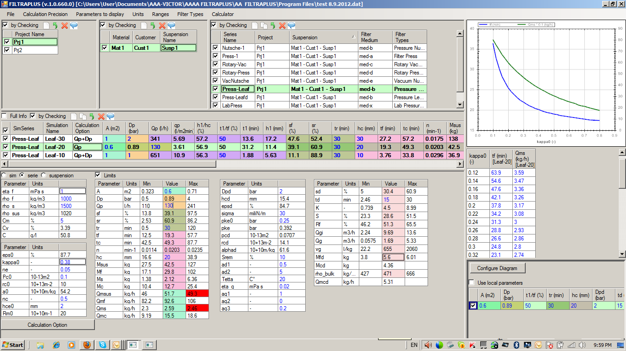
There is a problem with the limits and the speed regarding the option Qp=const

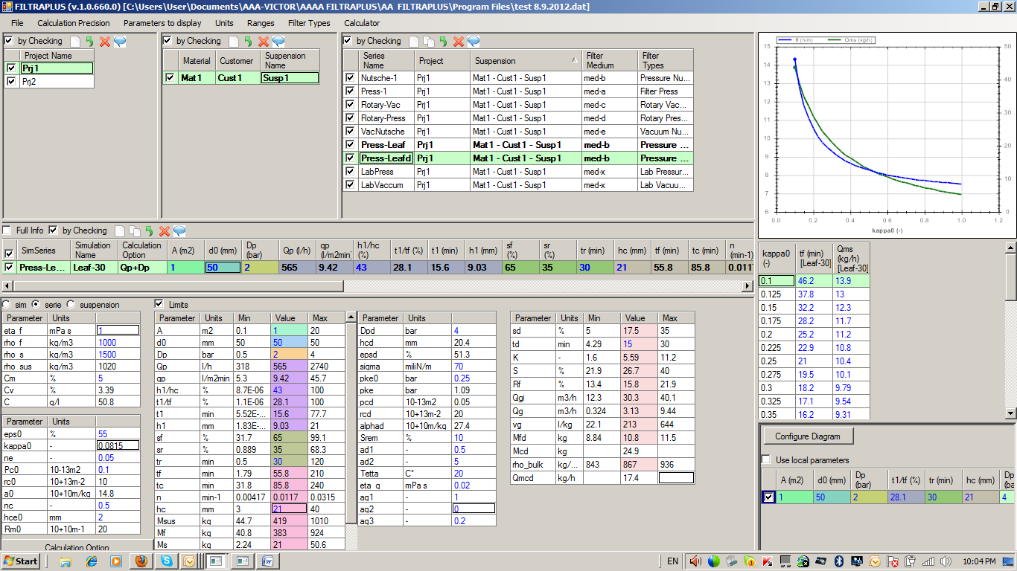
For temperature and ag2 enable the input of negative values.

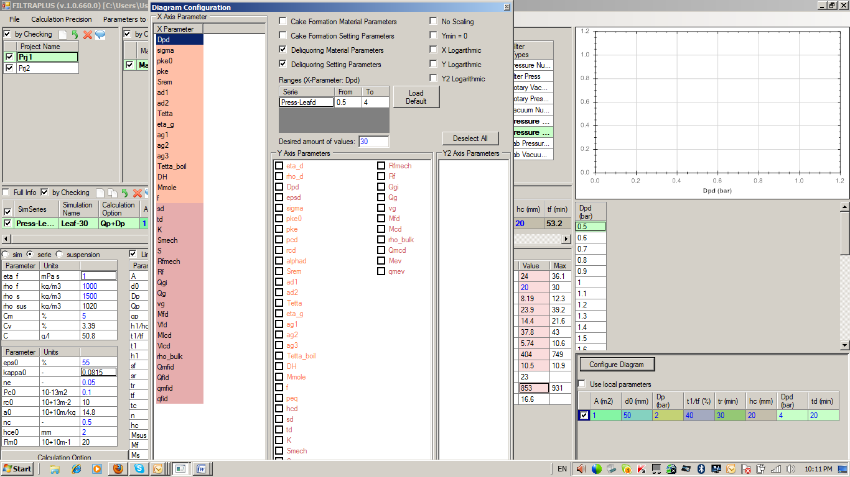
The color of the letters should be more distinguished.

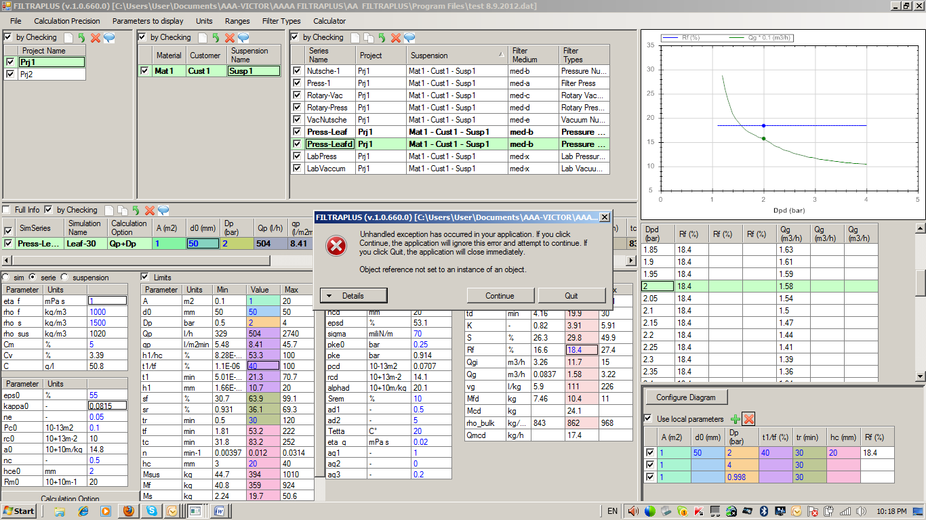
I had selected “Use local parameters” and then I wanted delete one simulation there and got an error.

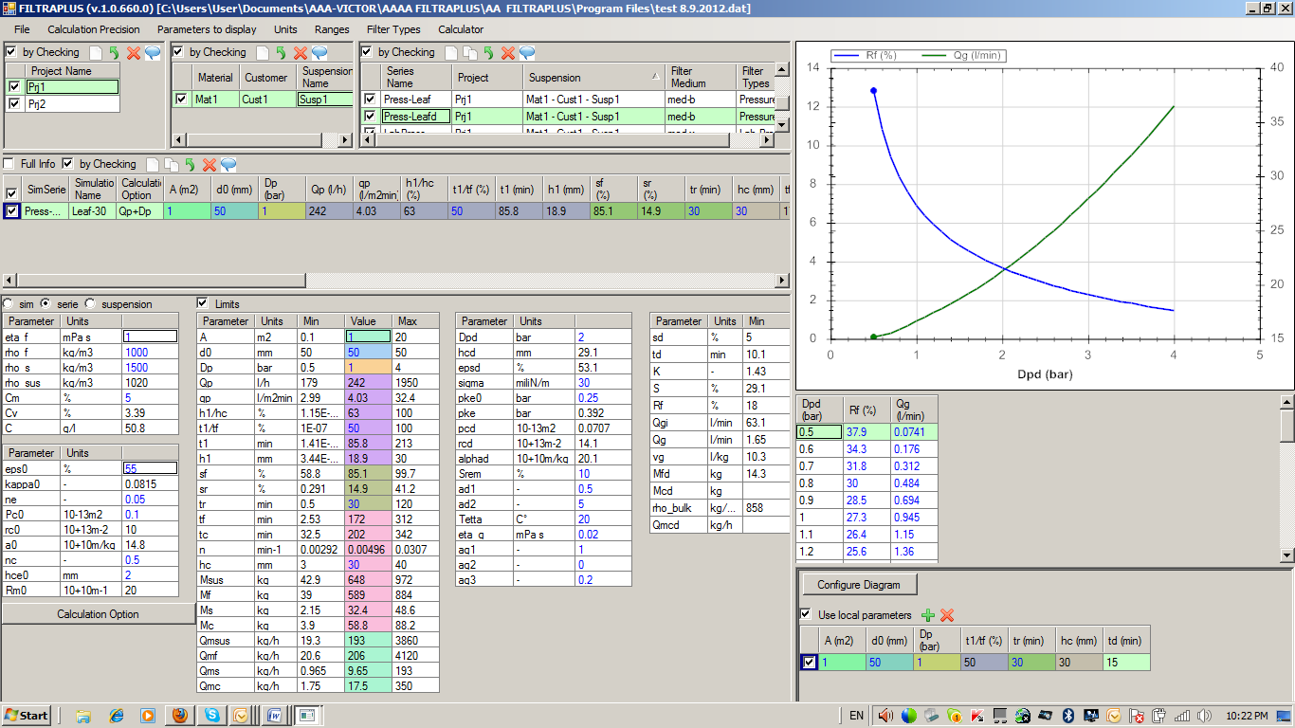
I have the above screenshot and then I do save. When restarting the program I get the following:

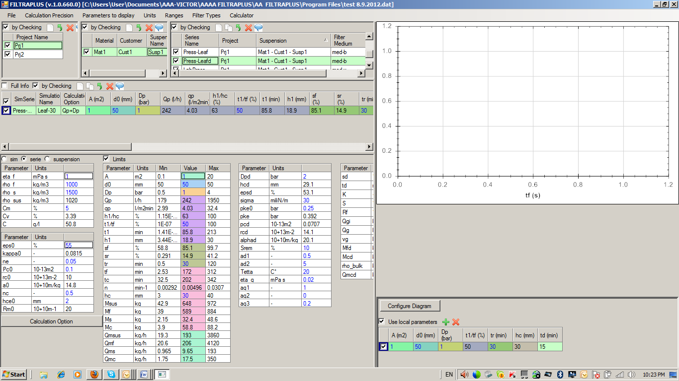
That is not correct that we have no diagram!
The reason is that the Dpd is not saved as the x-axis parameter when saving and then exiting the program.
This problem we have also for the case that we have NOT local parameters.

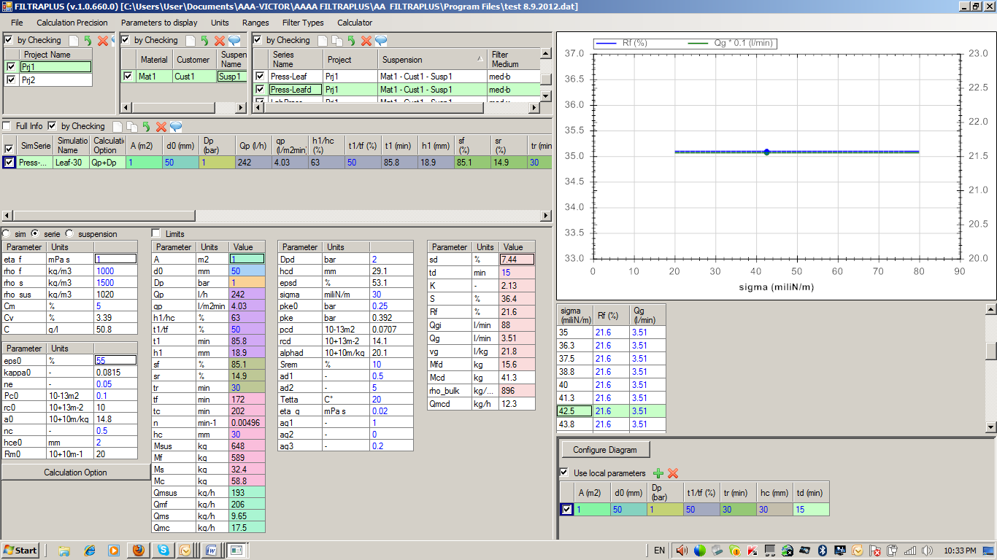
The “Use local parameters” does not work correctly regarding the influence of sigma!

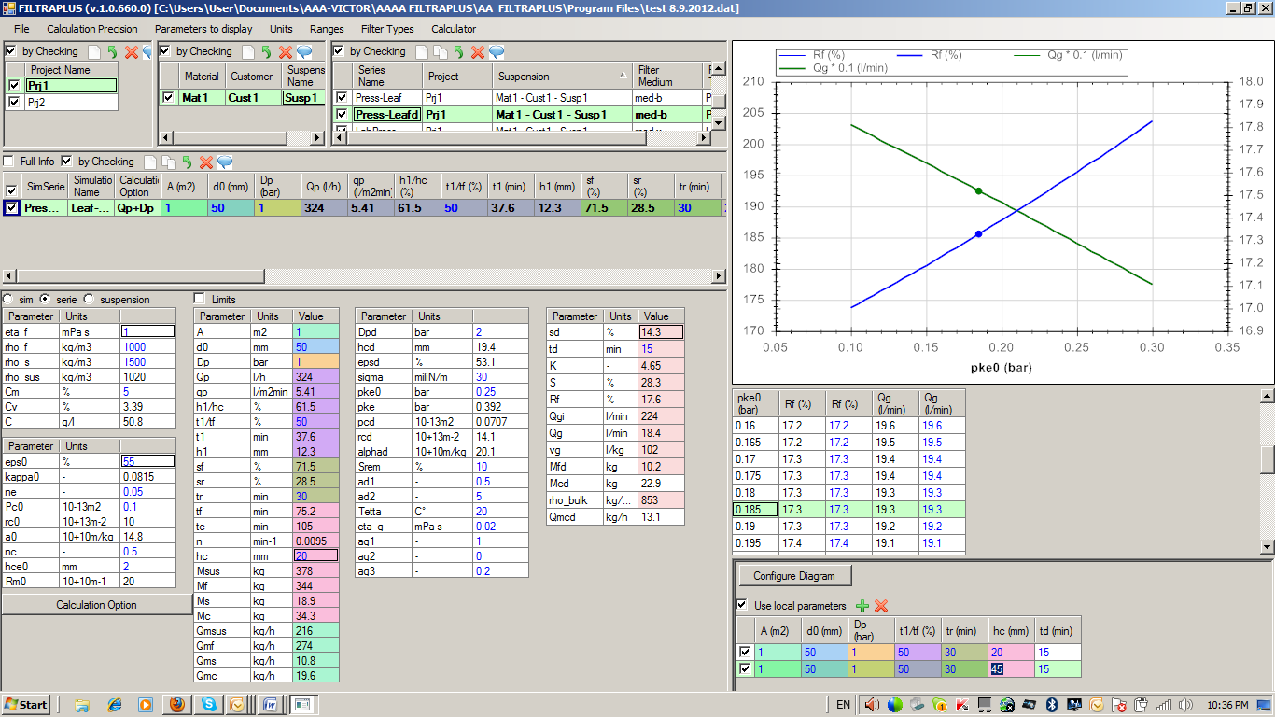
Changing the hc we do not have any change in the diagram and it is wrong!

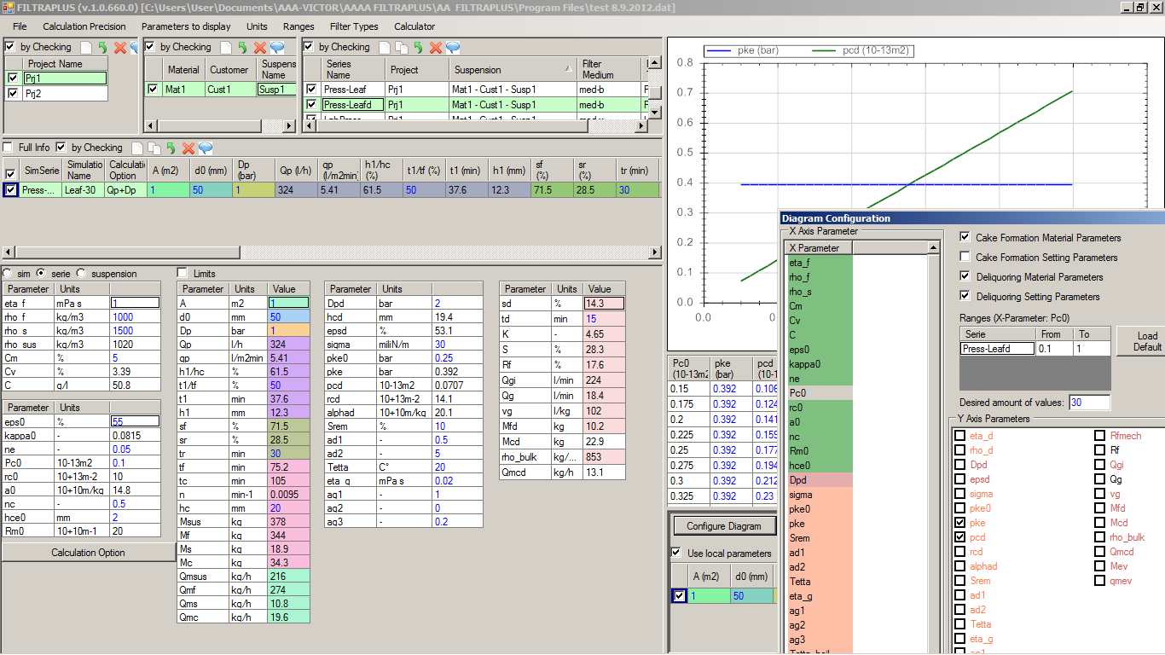
If we vary pc0 then the pcd is changed and of course also the pke. In the diagram we see that the pcd is changing with variation of pc0 but the pke is constant. That is not correct!

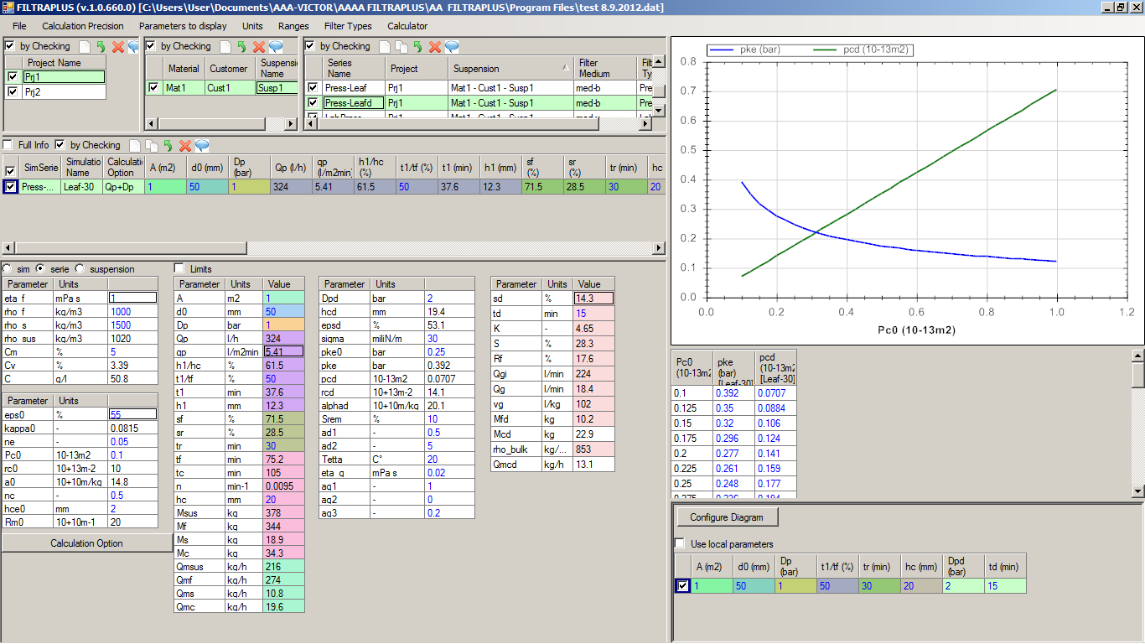
But when we have the option “NOT use local parameters” then everything is calculated correctly!

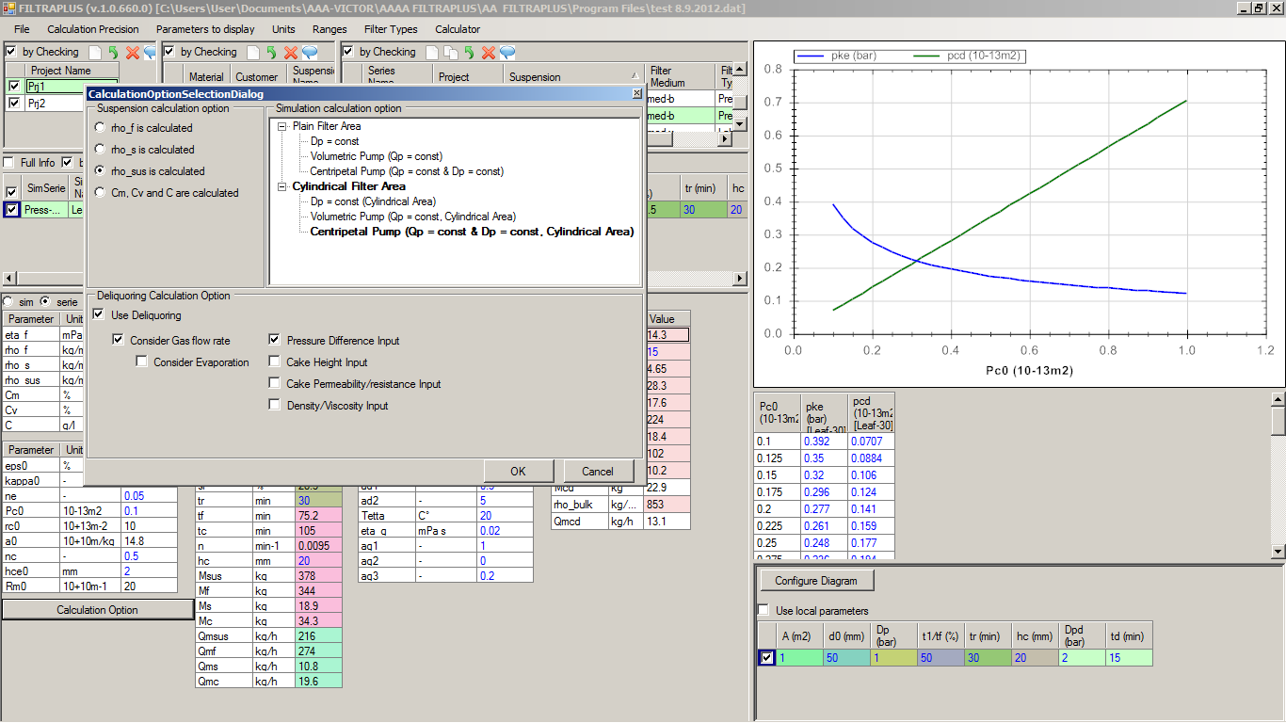
This should be the default size of the calculation option window.
The entries “Plain Filter Area” and “Cylindrical Filter Area” should be always in bold and the current simulation option in bold blue.

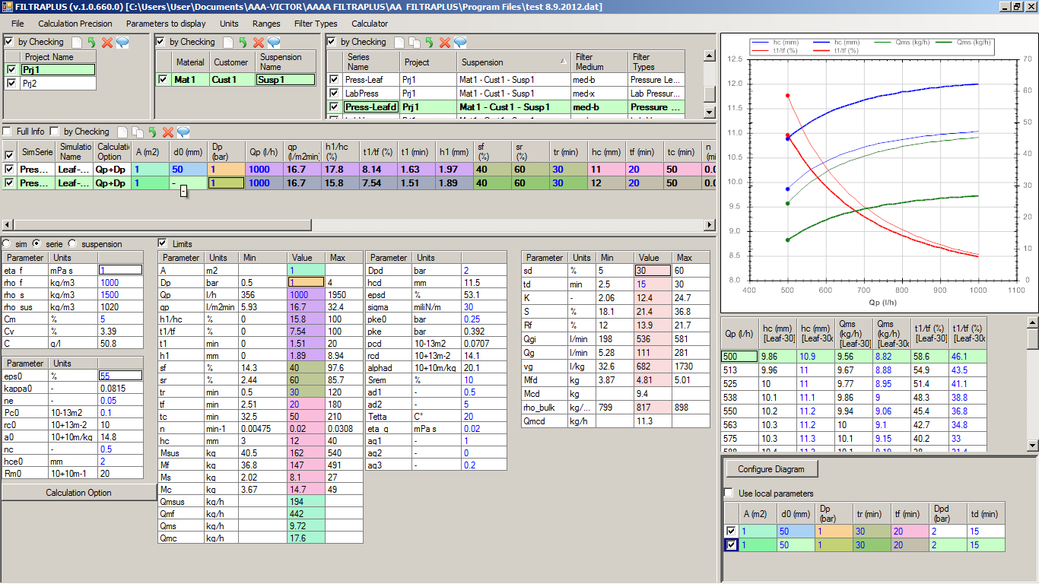
That is an error that for this simulation we have not cylindrical area but there we display the d-value. We should have there a horizontal line.

