Last Tasks With my comments
- Limits have to work correctly for all calculation options (there is a problem now with the option Qp+Dp=const).
If you see limits works wrongly then please provide me a screenshot with .dat file. For now I don't know exact cases with incorrect calculations.
- Default diagrams, so that the user can select immediately some typical diagrams.
You didn't send me the listing of these diagrams.
- Sim-Series-Susp option buttons above the material deliquoring parameters, so that we can select for example for Dpd and hcd that the inputs are valids only for the current simulation.
Can we leave this feature? It takes a lot of time to make it and may bring errors.
- Check why the Rf and S when we have evaporation can be negative. Maybe is because the tdmax is not equat tr!
Shall I do something here? As far as I remember you told me this problem may disappear if we change equation in 7. But do we really need to do it? If so, maybe Dima can work on this later?
- Enable hint explaining the parameters (which has to be switched off and on). Maybe to be done by Andrey?
It isn't the hard task. The first necessary thing is the parameters listing with their descriptions. As soon as I have it I can explain to Andrey or Dima how to integrate it. Or we can leave it?
- Default values for Evaporation which gives peq=0! (Teta_boil=100, DH=10000, f=1)
I don't know what to do here. Do we need to change something here? If so, then please write me details.
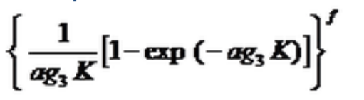
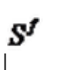
- The expression Has to be replaced by much easier expression.
It is hard. As I mention in 4. Maybe we can leave it or pass to Dima?
- Optimize limits calculation and calculation for some options.
You said if program doesn't block inputs then it will be OK. But it may be harder to make this feature then optiomize calculations... Anyway I'll take a look to the performance with limits.
- Creating a new object should have some default data.
You didn't provided me screenshot. Shall we do something here or we can leave it?
All these tasks are “open”. To make some of them I need info from you. For some others it is unclear if it is possible to make it at all. And for some others it is necessary to spend a lot of time that I hadn't. Anyway I think these tasks are not so important and the most important work is already done. These open tasks make me unhappy. I will investigate 8. and 1. if you find any errors. But all others I would like to pass to somebody else or just to leave. Is it possible?
Thanks,
Victor

