Introduction

The Project Report focuses on the outline of the Project,References of the knowledge gained during the

Project,practicality of the idea and a small conclusion.

Description

The idea of our group was to create a backup system,with seperate account for different users.We used Flask which is a framework for basic functions so some libraries are needed to be downloaded.We used SQLAlchemy as extension for managing our database in object-oriented manner.We used sqlite as our database to flask using python,developing required templates and linking them to flask,developing logical part of the code of flask.
We must use python3 to run over program.
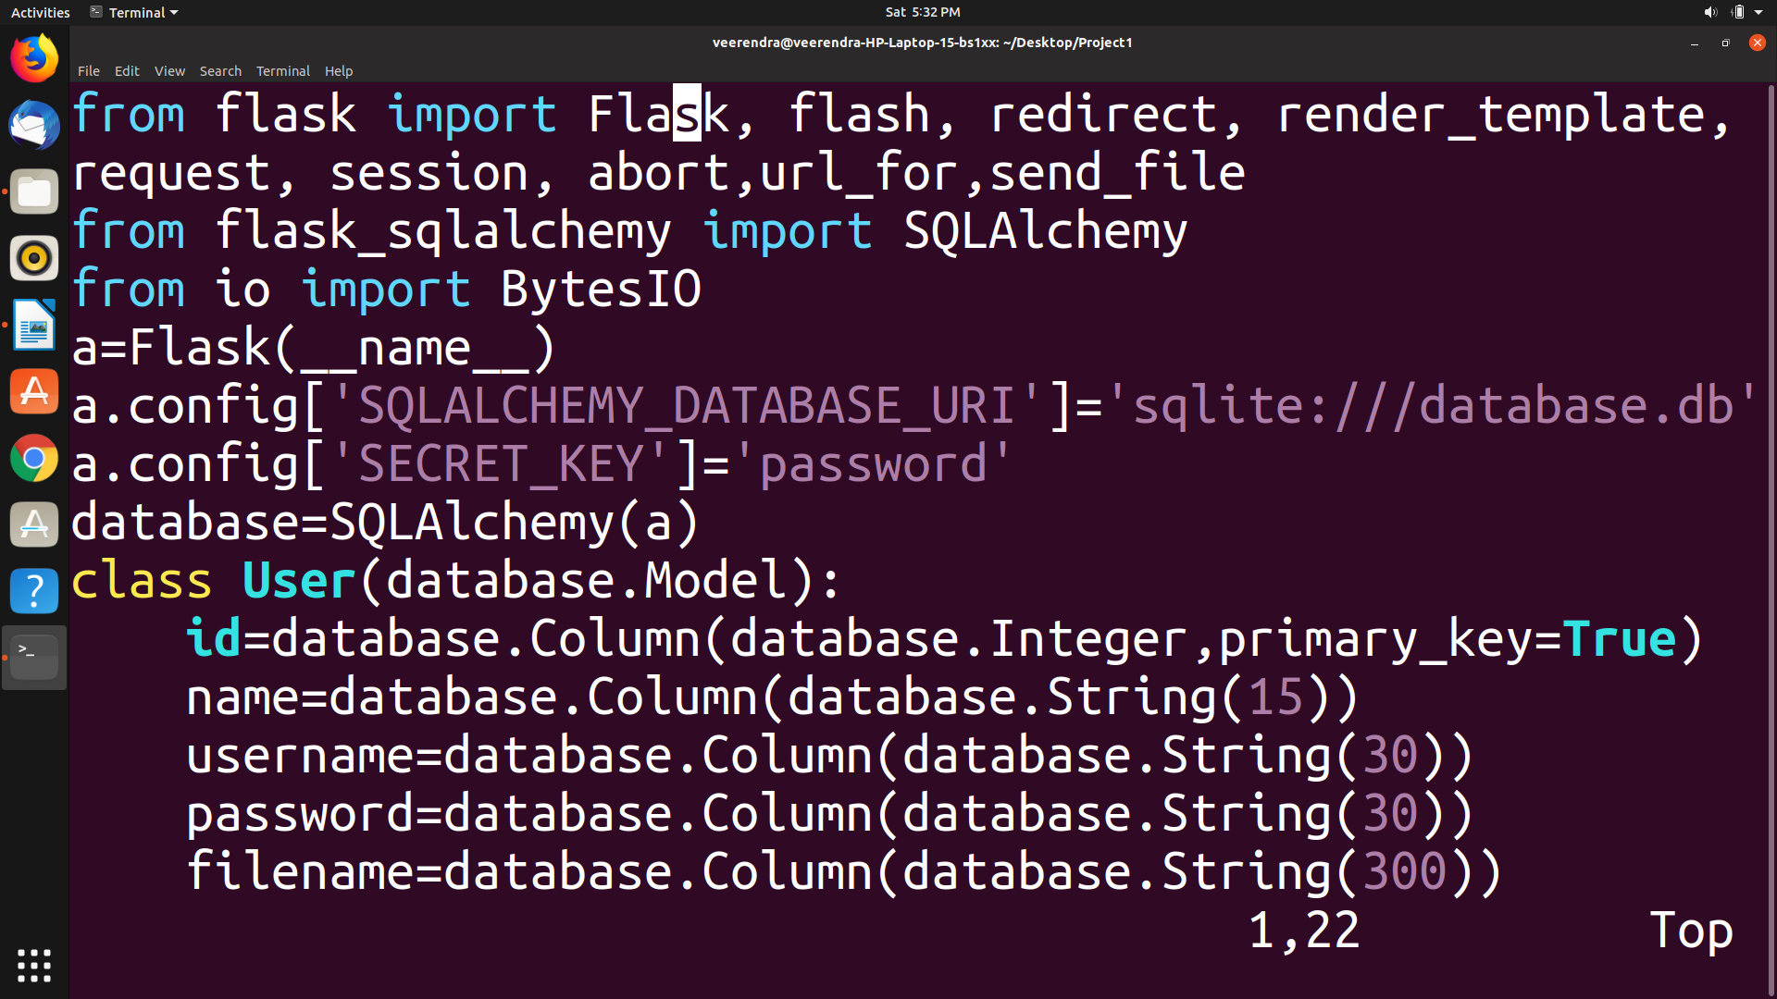

We faced a continuous crash of program because we didn’t used id column as it was as Compulsory column later we were able to rectify it.
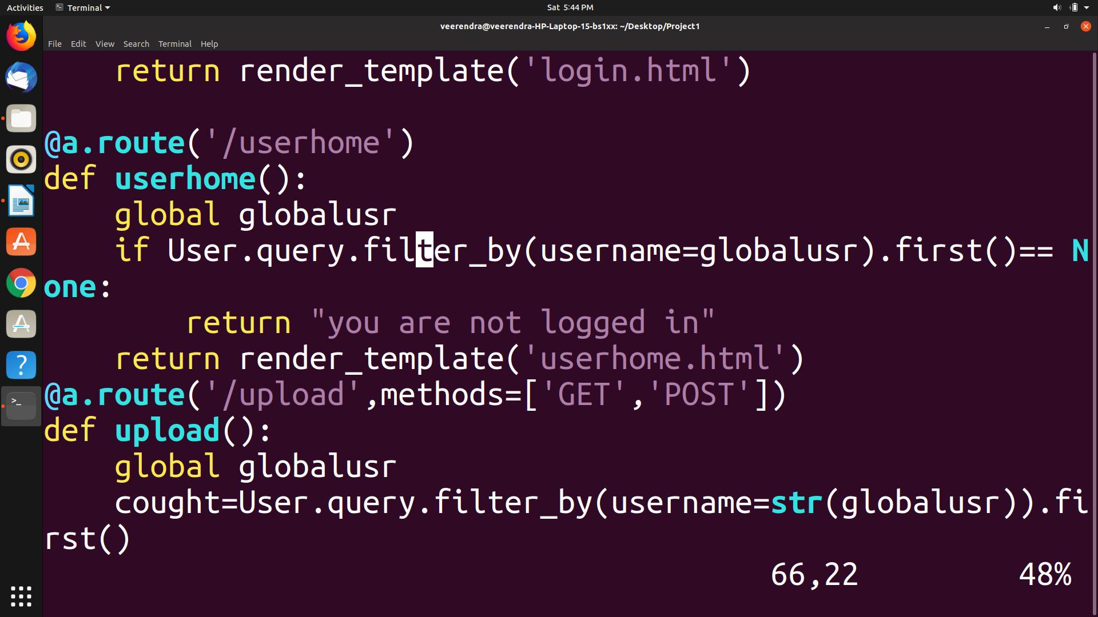
We have a global variable named globalusr which keeps on tracking whenever we go from one page to other page.
Example:When we host the server and if we directly try to open any page like /userhome we get you are not logged in message.

Conclusion

The Project was successful in reaching the objective of the idea,The Project was very helpful to understand

basic working of website.

References

The method to impliment our logical part and syntax were refered from following sources:

1.Pretty Printed(youtube channel).

2.http://flask.pocoo.org/ (for syntax).

3.Traversy Media (basic tutorial for html).

4.Articles(understand function of all keywords).

