MOVIE & PRODUCT RECOMMENDATION ENGINE
A Project Based Learning Report
Submitted in partial fulfilment of the requirements for
the award of the degree
of
Bachelor of Technology
In
The Department of Computer Science and Engineering
Submitted by
Sai Nath Reddy – 2510030198
Venkata Sai Dheeraj G – 2510030165
N Rishikesh Reddy – 2510030414
K Abhilash Goud – 2510030298
J Akhil Sagar – 2510030412

Under the guidance of

Dr.M.Saidi Reddy

Koneru Lakshmaiah Education Foundation, Aziz Nagar
Aziz Nagar – 500075
2026

Abstract
The Movie & Product Recommendation Engine is an algorithm-driven system designed to provide personalized suggestions for movies and products instead of presenting the same recommendations to every user. The system analyzes user behavior such as search history, watch history, purchase history, ratings, browsing behavior, similar-user preferences, trending content, and previous recommendations. A unified data structures and algorithms pipeline is used to transform these signals into relevant and ranked results.
The proposed system integrates String Similarity for matching user queries with movie and product titles, Edit Distance for spelling correction, Hashing for fast lookup, Randomized Algorithms for candidate selection, Parallel Processing for independent recommendation tasks, and ranking for ordering candidates according to recommendation scores. The workflow moves from user interaction and data preprocessing to candidate generation, scoring, ranking, and personalized output. The same methodology supports both entertainment and e-commerce applications, making the system flexible, scalable, and explainable.

List of Figures
Figure 1. Proposed Movie & Product Recommendation Engine workflow
Figure 2. Technical architecture of the recommendation pipeline
Figure 3. Edit Distance based search correction
Figure 4. Recommendation scoring and ranking process

List of Tables
Table 1. DSA techniques and their roles in the recommendation system
Table 2. Validation areas and expected evidence
Table 3. Complexity snapshot of core algorithms

Table of Contents
1. INTRODUCTION
2. METHODOLOGY
3. EXPERIMENTS
4. RESULTS
5. CONCLUSION AND FUTURE WORK
REFERENCES

1. INTRODUCTION
Online platforms contain a very large number of movies and products, making it difficult for users to discover items that match their interests. A generic system may show the same suggestions to different users even though their search behavior, viewing habits, purchases, ratings, and preferences are different. The Movie & Product Recommendation Engine addresses this problem by converting user behavior and item information into personalized recommendations.
The system considers multiple user signals, including search history, watch history, purchase history, ratings, browsing behavior, similar users, trending content, and previous recommendations. These signals are processed through a complete decision pipeline: user behavior data is collected, cleaned and normalized, relevant candidates are generated, recommendation scores are calculated, and the candidates are ranked to produce personalized movie and product suggestions. This approach aims to improve relevance without sacrificing lookup and processing speed.
A major focus of the project is the integration of classical Data Structures and Algorithms rather than depending on a single recommendation technique. String Similarity is used to compare queries with movie and product titles. Edit Distance identifies spelling differences and can correct misspelled searches. Hashing supports fast average-case lookup of users, items, and processed information. Randomized selection helps reduce the candidate set before expensive scoring, while Parallel Processing allows independent recommendation tasks to execute concurrently. Finally, recommendation ranking orders the candidate items using their calculated scores.
The same algorithmic methodology can be applied to both entertainment and e-commerce. For movies, the system can identify similar or recommended movies; for products, it can identify related products and personalized purchases. The project also has wider applicability to music streaming, online learning, digital marketing, and business analytics, where personalized discovery is important.
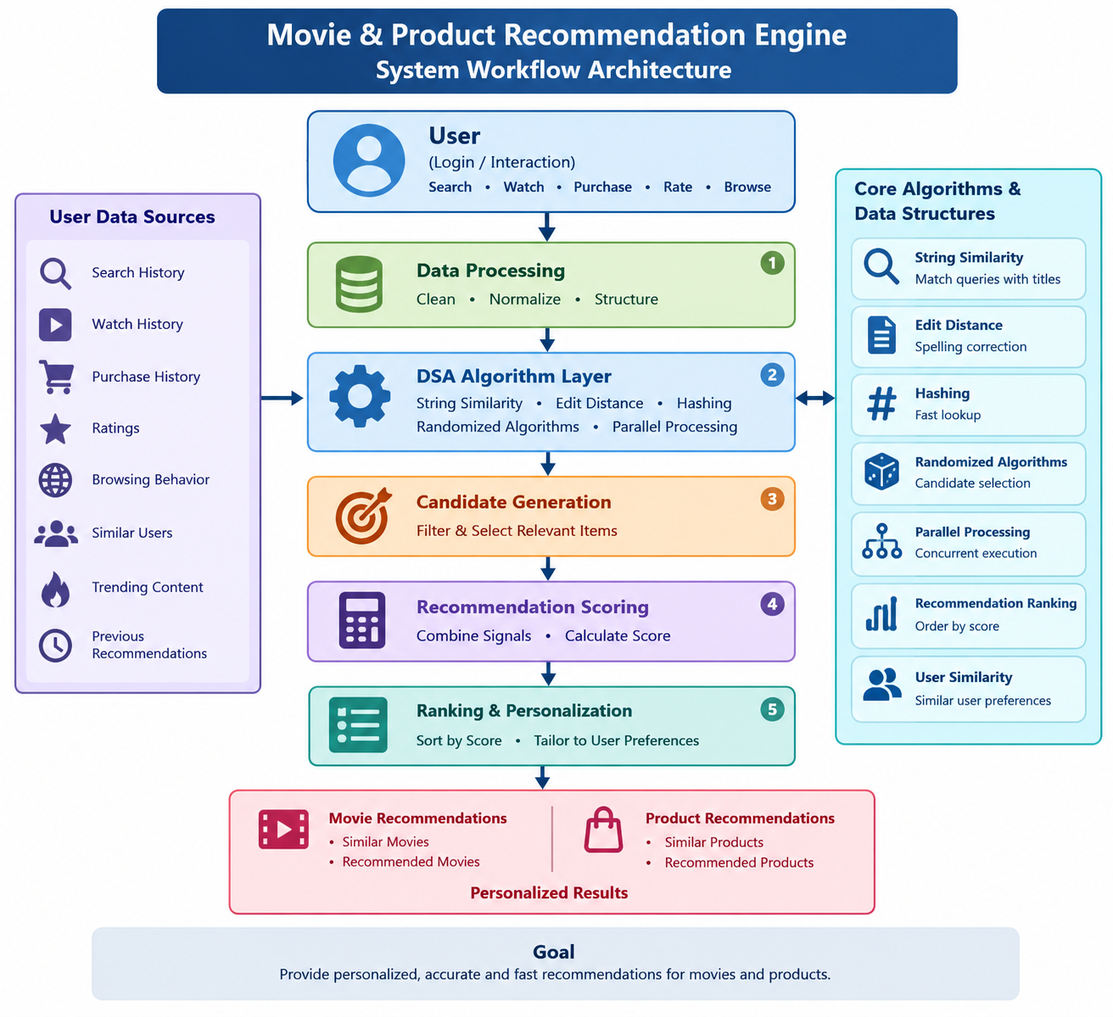
The project is therefore designed as an efficient, personalized, fast, and scalable recommendation framework. Its main contribution is not the invention of new algorithms, but the integration of several well-understood DSA techniques into one coherent recommendation pipeline. This integration provides clear roles for each algorithm and makes the recommendation process easier to understand and demonstrate.

2. METHODOLOGY

2.1 System Architecture
The proposed architecture connects the user request to the final ranked recommendations through several stages. A user first provides a query or interaction. User behavior data such as searches, views, purchases, ratings, and browsing activity is then collected and processed. The DSA layer performs similarity matching, spelling correction, hashing, candidate selection, and parallel processing. Candidate items are then scored and ranked, after which personalized movies or products are displayed.
- Query / Interaction – receives the user's search or interaction.
- Preprocessing – cleans, normalizes, and structures the input data.
- DSA Layer – applies String Similarity, Edit Distance, Hashing, Randomized Algorithms, and Parallel Processing.
- Candidate Generation – identifies relevant movies or products.
- Score and Rank – calculates a weighted recommendation score and orders the candidates.
- Output – displays personalized movie or product recommendations.

2.2 Core Algorithms and Data Structures
String Similarity is used to match user queries with movie and product titles and retrieve related items. Edit Distance finds the minimum number of insertions, deletions, and substitutions needed to transform one string into another. This makes it useful for correcting spelling mistakes in searches. Hashing provides fast average-case lookup for users, items, and processed states. Randomized Algorithms sample candidate items before expensive scoring to reduce unnecessary work. Parallel Processing runs independent recommendation tasks concurrently, reducing wall-clock processing time. Ranking then orders the candidates according to their recommendation scores.
The relevant data includes user data, movie and product data, search history, ratings, watch history, purchase history, and recommendation history. Hash maps, arrays, candidate lists, and ranked lists are used to organize this information.

2.3 Recommendation Scoring
Each candidate item receives a weighted recommendation score based on the available evidence. The score can consider user ratings, previous interactions, search behavior, item similarity, and similar-user preferences. A higher score results in a higher rank. The ranked candidate set is then personalized for the current user.

2.4 Search Intelligence
The search component uses Edit Distance to handle spelling mistakes and map an incorrect input to a close valid title. For example, an input such as “interstllar” can be compared against candidate titles and mapped to “Interstellar”. The corrected search result can then be passed to candidate generation, allowing the system to continue the recommendation workflow even when the user's input contains spelling errors.

3. EXPERIMENTS
The implementation is organized as a Java-based DSA recommendation workflow. The experimental process focuses on demonstrating algorithm execution, validating search and recommendation outputs, observing processing performance, and showing practical usefulness and scalability.
The workflow begins with a user query or interaction. The input is preprocessed and passed through the algorithm layer. String Similarity and Edit Distance support query matching and correction. Hashing is used for quick lookup, while randomized candidate selection reduces the number of items that require expensive scoring. Independent tasks can be processed concurrently. The final candidates are assigned recommendation scores and ranked before being displayed.
- Movie experiment: generate similar and personalized movie recommendations.
- Product experiment: generate similar and personalized product recommendations.
- Search experiment: test spelling correction using Edit Distance.
- Ranking experiment: verify that higher recommendation scores receive higher ranks.
- Lookup experiment: observe the efficiency of hash-based access.
- Processing experiment: observe the effect of parallel execution on independent tasks.

4. RESULTS
The expected system output includes personalized movie recommendations, personalized product recommendations, recommendation score generation, similar movie and product suggestions, user similarity analysis, smart search suggestions, fast recommendation processing, improved recommendation accuracy, and an interactive recommendation interface.
Validation focuses on observable evidence rather than unsupported numerical claims. Search accuracy is checked by verifying that a misspelled query maps to a meaningful correction. Recommendation accuracy is checked by confirming that relevant items appear in the ranked output. Lookup efficiency is evaluated by observing hash-based access, while processing performance is evaluated using measured runtime when the system is executed. Ranking consistency is verified by checking that higher recommendation scores receive higher ranks.
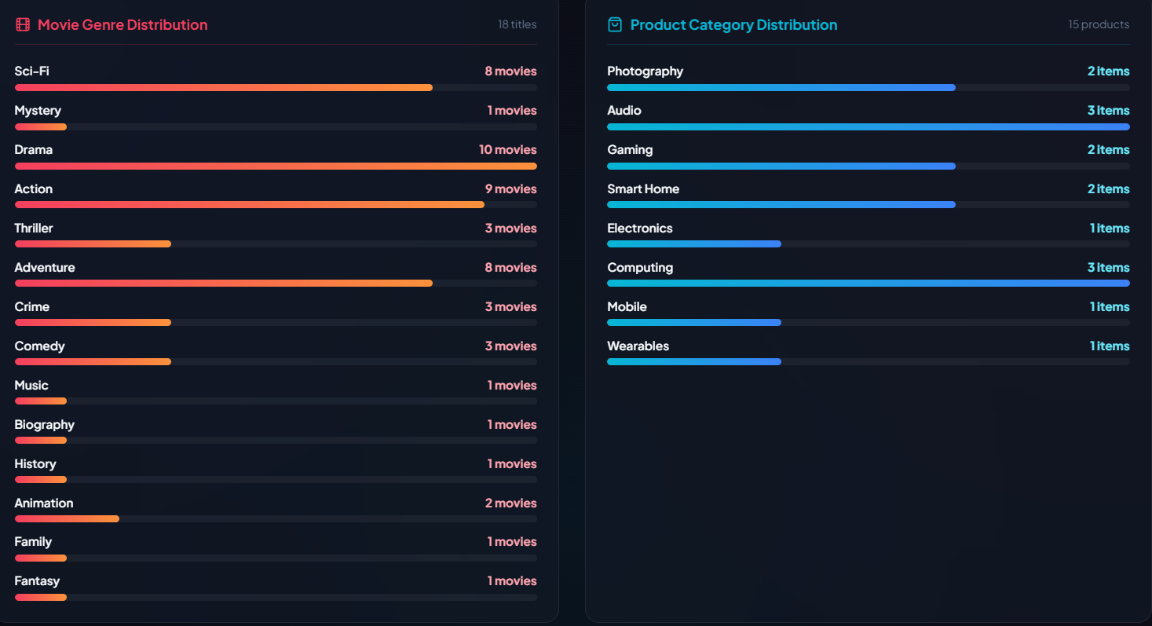
The project should not claim numerical accuracy or performance improvements until those values are measured from the running system. Therefore, measured processing time, response time, and recommendation relevance can be inserted into the final report after execution.



Table 1. DSA Techniques and Their Roles
Technique | Role in the System
String Similarity | Matches user queries with movie/product titles
Edit Distance | Finds spelling differences and corrections
Hashing | Provides fast lookup of users and items
Randomized Algorithms | Samples recommendation candidates efficiently
Parallel Processing | Processes independent tasks simultaneously
Ranking | Orders items using recommendation scores
User Similarity | Finds users with similar interests

Table 2. Validation Areas
Validation Area | What is Verified
Search accuracy | Misspelled query maps to a correct/closest title
Recommendation accuracy | Relevant items appear in ranked output
Lookup efficiency | Hash-based access avoids unnecessary scanning
Processing time | Runtime is measured from the executed system
Ranking consistency | Higher score receives higher rank

Table 3. Complexity Snapshot
Algorithm | Complexity / Consideration
Edit Distance | O(m × n)
Hashing | O(1) average lookup
Comparison Ranking | O(n log n)
String Matching | Depends on matching method
Randomized Selection | Depends on sampling strategy
Parallel Processing | Can reduce wall-clock time for concurrent tasks

5. CONCLUSION AND FUTURE WORK
The Movie & Product Recommendation Engine provides a unified DSA-based approach for personalized discovery. It transforms user behavior and item information into fast, ranked, and personalized recommendations. String Similarity supports intent matching, Edit Distance supports spelling correction, Hashing enables fast lookup, Randomized Algorithms support candidate reduction, Parallel Processing improves concurrent execution, and recommendation scoring and ranking produce the final ordered results.
The project demonstrates that several classical algorithms can work together as a complete recommendation pipeline. The methodology supports both movie and product recommendations and can improve search convenience, discovery, and user engagement. Its design is also adaptable to other domains such as entertainment, e-commerce, music streaming, online learning, digital marketing, and business analytics.
Future work includes using larger datasets, supporting real-time updates, integrating advanced machine learning techniques, developing a mobile application, deploying the system in the cloud, tracking user behavior more extensively, and improving personalization. These extensions can help the engine handle larger catalogues and provide more responsive and accurate recommendations.

REFERENCES
[1] Nazari, A., Mansoorizadeh, M., & Khotanlou, H. (2026). A multi-task heterogeneous graph learning with cross-attention fusion for robust recommendation. Scientific Reports, 16, 18089.
[2] Movie Recommendation System Using Heterogeneous Graph Neural Network. (2026). Procedia Computer Science, 279, 1538–1544. DOI: 10.1016/j.procs.2026.03.382.
[3] Gao, Y., Zheng, H., & Cui, H. (2025). User preference modeling for movie recommendations based on deep learning. Scientific Reports, 15, 16592. DOI: 10.1038/s41598-025-00030-5.
[4] Movie Recommendation Based on Deep Neural Networks. (2025). Procedia Computer Science, 266, 32–40. DOI: 10.1016/j.procs.2025.08.005.
[5] Behera, G., Panda, S. K., Hsieh, M.-Y., & Li, K.-C. (2024). Hybrid collaborative filtering using matrix factorization and XGBoost for movie recommendation. Computer Standards & Interfaces, 90, 103847. DOI: 10.1016/j.csi.2024.103847.
[6] Behera, G., et al. (2023). Collaborative Filtering with Temporal Features for Movie Recommendation System. Procedia Computer Science.
[7] Performance Evaluation of Time-based Recommendation System in Collaborative Filtering Technique. (2023). Procedia Computer Science, 218, 1834–1844. DOI: 10.1016/j.procs.2023.01.161.
Project Repository: https://github.com/vsdheerajg04-sys/Movie-product-Recommendation-Engine

