UDEMY COURSES DATA ANALYSIS
An Exploratory Study of 3,678 Online Courses

Anvi Patel | June 2026

Somewhere between a midnight idea and a career transformation, there is a Udemy course. This dataset captures 3,678 of them — each one a bet placed by an instructor that their knowledge is worth packaging, pricing, and publishing to the world.
Udemy is not a university. There are no admission committees, no prerequisite chains, no degree at the end. What it has instead is a marketplace: instructors on one side, learners on the other, and a vast middle ground where topics as varied as investment banking, guitar technique, graphic design, and web development compete for the same finite resource — a learner's attention. Understanding how that competition plays out, who wins, and why, is the purpose of this analysis.

3,678  Total Courses | 4  Subjects | 91.5%  Paid Courses | 11,534  Avg Free Subscribers | 29  Python Courses

FOUR SUBJECTS, ONE MARKETPLACE

Every course in the dataset belongs to one of four subjects: Web Development, Business Finance, Musical Instruments, and Graphic Design. These four are not randomly chosen; they represent Udemy's core audience — the self-improvers, career-changers, creative explorers, and side-hustle builders who make up the platform's lifeblood.

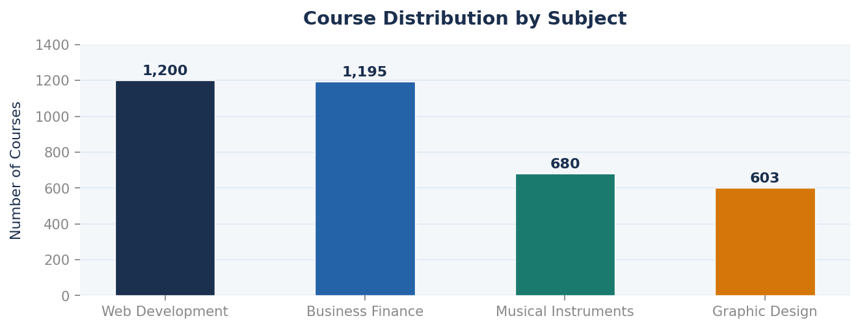
Figure 1 — Web Development and Business Finance dominate the catalogue, together accounting for 65% of all courses. Musical Instruments and Graphic Design serve smaller but distinct learner communities.
Web Development (1,200 courses) and Business Finance (1,195) are nearly level-pegging in catalogue size — a tight race for the platform's most contested territory. Both subjects appeal to professionals with strong economic incentives to upskill: developers who want better salaries, finance professionals who want better credentials. Musical Instruments (680) and Graphic Design (603) are smaller but far from niche — they collectively represent nearly a quarter of the catalogue and serve a different kind of learner: someone driven by passion rather than purely by career calculus.
But catalogue size and learner interest are not the same thing. To understand what learners actually choose, we need to look at where the subscribers go.

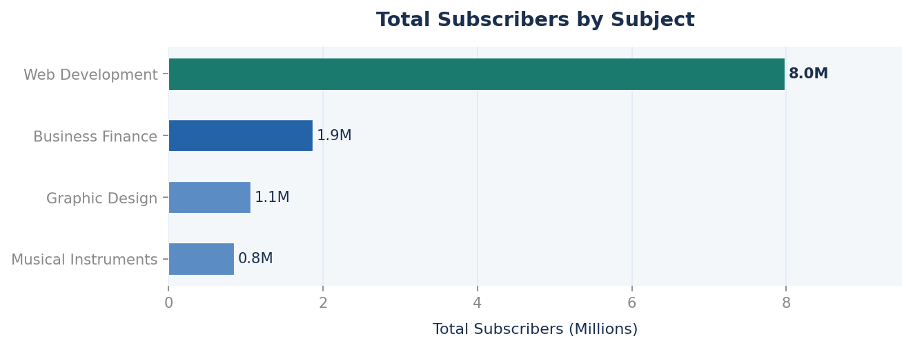
Figure 2 — Web Development commands nearly 8 million total subscribers — four times more than Business Finance. The gap between course count and subscriber count reveals where real learner demand lives.
The subscriber chart tells a story that the course count chart obscures entirely. Web Development's 7.98 million total subscribers dwarf Business Finance's 1.87 million — despite the two subjects having almost the same number of courses. Web Development does not just have more courses; it has far more learners per course. Business Finance, Musical Instruments, and Graphic Design are respectable subjects, but in terms of raw learner demand, Web Development operates in a different league.
The implication for an aspiring instructor is stark: entering the Web Development space means competing for enormous demand, but also fighting for visibility in a highly saturated market. Entering Graphic Design or Musical Instruments means smaller total audience, but potentially less competition and stronger community loyalty.

Web Development has nearly four times more subscribers than Business Finance — despite nearly identical course counts. Demand and supply are not the same thing.

THE PRICE OF LEARNING

Of 3,678 courses in the dataset, 3,368 are paid (91.5%) and just 310 are free. Udemy, unlike YouTube or Wikipedia, is overwhelmingly a paid platform. Instructors price their courses anywhere from a few dollars to the maximum of $200 — and the data reveals both the median behaviour and the outliers.
The median course price is $45, with the upper quartile reaching $95 and the ceiling sitting at $200. This is not cheap education. A $200 Udemy course is priced comparably to a professional workshop or a short college module. Yet hundreds of courses carry that ceiling price, suggesting that instructors — and learners — believe the value justifies the cost.

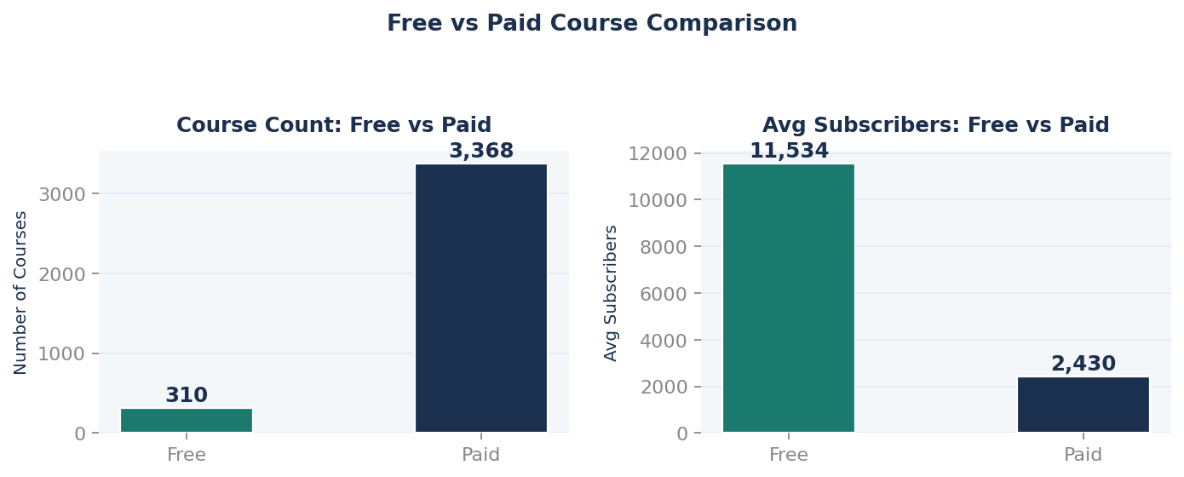
Figure 3 — Free courses are a small fraction of the catalogue (310 vs 3,368) yet attract nearly five times more average subscribers than paid courses (11,534 vs 2,430). The economics of free are powerful and counterintuitive.
The subscriber gap between free and paid courses is the dataset's most counterintuitive finding. Free courses average 11,534 subscribers each — nearly five times the 2,430 average for paid courses. This is not surprising in principle: free means no barrier to entry. But the magnitude of the gap is instructive. It suggests that price sensitivity on Udemy is very high, and that the conversion from free-course-browser to paid-course-buyer requires either very strong social proof (reviews, ratings) or very high perceived career value.
There is also a content depth dimension. Paid courses average 41.8 lectures — nearly double the 21.4 lectures of free courses. Instructors who charge more deliver significantly more content, which may partly justify the price differential and partly explain why paid courses attract a more committed, if smaller, audience. A learner who pays $100 and receives 40+ lectures is making a qualitatively different decision than one who downloads a free 10-lecture primer.

Metric | Free Courses | Paid Courses | Insight
Number of Courses | 310 | 3,368 | Paid dominates the catalogue (91.5%)
Avg Subscribers | 11,534 | 2,430 | Free = 5x more subscribers on average
Avg Lectures | 21.4 | 41.8 | Paid courses offer significantly more content
Price Range | $0 | $20 – $200 | Wide pricing spectrum in paid tier
Avg Reviews | — | Higher | Paid learners are more engaged reviewers

WHO GETS ENROLLED, AND WHY

Not all courses are designed for the same learner. The dataset segments courses into four difficulty levels — All Levels, Beginner, Intermediate, and Expert — and the subscriber distribution across these levels reveals where the platform's centre of gravity lies.

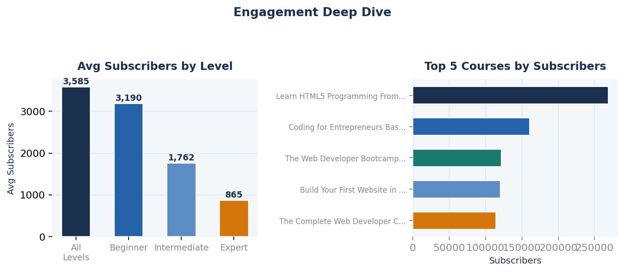
Figure 4 — Left: All Levels courses attract the highest average subscribers (3,585), followed by Beginner Level. Expert Level courses command the smallest audiences. Right: The top 5 most subscribed courses are all free or in Web Development — often both.
"All Levels" courses are the platform's most-enrolled, averaging 3,585 subscribers each. This is the instructor's equivalent of writing a book for a general audience: by casting the widest possible net — telling every learner that this course is for them — these courses minimise barriers and maximise appeal. Beginner Level courses (3,190 avg) follow closely: the largest pool of potential learners is always those just starting out.
The Expert Level category tells a different story entirely. With just 58 courses and an average of only 865 subscribers each, expert content finds a much smaller audience. This is partly a market-size problem — there are simply fewer expert-level practitioners seeking further education — and partly a trust problem: an expert learner is also a skeptical learner, one who knows enough to evaluate quality and is harder to impress.
The top five most subscribed courses crystallise the platform's dynamics perfectly. Four of the five are free. The single paid outlier — The Web Developer Bootcamp at $200 with 121,584 subscribers — is an extraordinary achievement: a $200 course that attracted more paid learners than almost any other on the platform. It succeeds because of its 27,445 reviews (the most of any course in the dataset) and its reputation as the definitive beginner-to-professional web development pathway.

Course Title | Type | Price | Subscribers | What It Tells Us
Learn HTML5 Programming From Scratch | Free | $0 | 268,923 | Free access + clear value = massive reach
Coding for Entrepreneurs Basic | Free | $0 | 161,029 | Business + tech hybrid is a powerful draw
The Web Developer Bootcamp | Paid | $200 | 121,584 | Premium price + trust signals = paid success
Build Your First Website (HTML5 & CSS3) | Free | $0 | 120,291 | Entry-level, free = second-tier volume
The Complete Web Developer Course 2.0 | Paid | $200 | 114,512 | Depth + brand recognition drives paid enrolment

THE PYTHON PHENOMENON

Within the 1,200 Web Development courses sits a sub-community that deserves its own examination: 29 Python-related courses. Python is the language of data science, automation, back-end web development, and machine learning. Its rise from a niche scripting language to the world's most popular programming language is one of the defining technology trends of the last decade — and Udemy's catalogue reflects it.
The most subscribed Python course — Web Programming with Python — has 35,267 subscribers, making it one of the stronger performers in the entire Web Development category. The top three Python courses collectively focus on practical application: web programming, Django-based entrepreneurship courses, and payment processing. This is not Python as abstract computer science; it is Python as career tool, as business builder, as income generator.
The correlation between course price and number of reviews across the full dataset is a modest 0.114 — almost no relationship. This is a liberating finding for instructors: pricing a course higher does not meaningfully suppress review engagement. Learners who enrol and find value will review, regardless of what they paid. What drives reviews is not price — it is relevance, quality, and the feeling that the course delivered on its promise.

The correlation between price and reviews is nearly zero. Learners who find value will review. What drives engagement is not cost — it is relevance and quality.

WHAT THE DATA TELLS THE INSTRUCTOR

Pull back and the picture is coherent. Udemy is a marketplace where Web Development dominates by subscriber volume, free courses dominate by individual reach, beginner and all-levels content dominates by enrolment, and quality signals — primarily review count and course depth — matter far more than price in determining long-term success.
Four lessons emerge for anyone thinking about building a course on the platform. First, subject selection is destiny: Web Development commands four times the subscriber base of the next largest subject. If you can teach it credibly, the audience is there. Second, free content is a growth strategy, not a revenue strategy: the 11,534 average subscribers for free courses versus 2,430 for paid courses suggests that many instructors use free courses as lead generation for a paid portfolio. Third, depth signals commitment: paid courses average twice as many lectures as free ones, and the most subscribed paid courses are comprehensive enough to serve as full learning pathways, not just introductions. And fourth, reviews are currency: The Web Developer Bootcamp's 27,445 reviews — the highest in the entire dataset — did not happen by accident. They accumulated over years of real learner outcomes. Reviews are earned slowly and lost quickly, and no amount of marketing replaces them.
The data does not tell you what to teach. It tells you what the market has already rewarded — and what it has quietly passed over. The 3,678 courses in this dataset are 3,678 experiments in the same question: what do people want to learn, and what are they willing to pay for it? The answers are all here, waiting to be read.

Anvi Patel • Udemy Courses Data Analysis • June 2026

