Bug Report - Supplier Item (Sorting and Filters)
Module: Admin > Supplier Item List | Build: Ultriva Lean Suite POC
Application URL | https://engineering.ultrivalms.com/POC/SupplierItem/List
User | buyeruser (Buyer K Test), Business Unit TCEK-Ram, Application (Plant)
Browser | Google Chrome (Selenium automation), 1920x1080
Plants tested | Cust240720 (7 items), Cust1201023 (7 items)
Execution date | 2026-10-09
Scope | Sorting of all 8 data columns (header click, column menu, multi-sort), set filters, number filters, Search all columns, filter combinations, Clear Filters
Cases executed | 261 (Pass: 244, Fail: 16, Skipped due to system error: 1)
Bugs logged | 5

1. Bug Summary
Bug ID | Title | Area | Severity | Plant(s)
BUG-SI-001 | Unit Description column cannot be sorted (header click and column menu) | Sorting | Medium | Cust1201023, Cust240720
BUG-SI-002 | Search all columns does not match the displayed Qty On Card value (e.g. 45.0000) | Search all columns | Medium | Cust1201023, Cust240720
BUG-SI-003 | Description set-filter merges values that differ only by case ('Test' and 'test') | Filter | Medium | Cust1201023
BUG-SI-004 | Unit Description set-filter lists blank value with an empty label instead of '(Blanks)' | Filter | Low | Cust1201023, Cust240720
BUG-SI-005 | Text columns are sorted case-sensitively (lowercase values placed after uppercase values) | Sorting | Low | Cust1201023, Cust240720

2. Bug Details

BUG-SI-001 - Unit Description column cannot be sorted (header click and column menu)
Bug ID | BUG-SI-001
Summary | Unit Description column cannot be sorted (header click and column menu)
Module | Admin > Supplier Item List
Environment | https://engineering.ultrivalms.com/POC, Chrome, user buyeruser
Severity | Medium
Priority | P2
Related test cases | TC_023, TC_024, TC_040, TC_041, TC_152, TC_153, TC_169, TC_170
Steps to reproduce | 1. Log in as buyeruser / Ultriva!23.  2. Open Supplier Item menu (Admin > Supplier Item).  3. Click the 'Unit Description' column header (1st/2nd click); open the column menu (three dots) of 'Unit Description' and look for Sort Ascending/Descending.
Expected result | Column sorts ascending/descending like all other columns, or the sort controls are consistently hidden/disabled with a clear indicator.
Actual result | Cust240720: Order=['', '', '', '', '', '', '']; sort indicator='None' || Cust240720: Order=['', '', '', '', '', '', '']; sort indicator='None' || Cust240720: menu option not found || Cust240720: menu option not found
Status | Open
Screenshot | 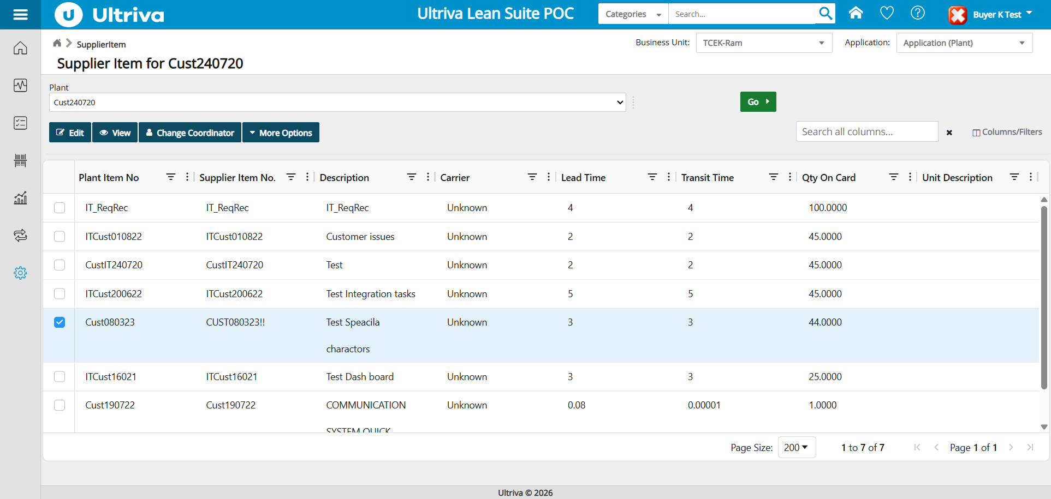

BUG-SI-002 - Search all columns does not match the displayed Qty On Card value (e.g. 45.0000)
Bug ID | BUG-SI-002
Summary | Search all columns does not match the displayed Qty On Card value (e.g. 45.0000)
Module | Admin > Supplier Item List
Environment | https://engineering.ultrivalms.com/POC, Chrome, user buyeruser
Severity | Medium
Priority | P2
Related test cases | TC_109, TC_110, TC_238
Steps to reproduce | 1. Log in as buyeruser / Ultriva!23.  2. Open Supplier Item menu (Admin > Supplier Item).  3. Type the exact displayed value '45.0000' (or '44.0000') in 'Search all columns...'.
Expected result | Rows whose Qty On Card is displayed as 45.0000 are returned (same as searching '45').
Actual result | Cust240720: Grid shows 0 row(s): [] | Pagination: 'Page Size: 200 0 to 0 of 0 Page 0 of 0' || Cust240720: Grid shows 0 row(s): [] | Pagination: 'Page Size: 200 0 to 0 of 0 Page 0 of 0' || Cust1201023: Grid shows 0 row(s): [] | Pagination: 'Page Size: 200 0 to 0 of 0 Page 0 of 0'
Status | Open
Screenshot | 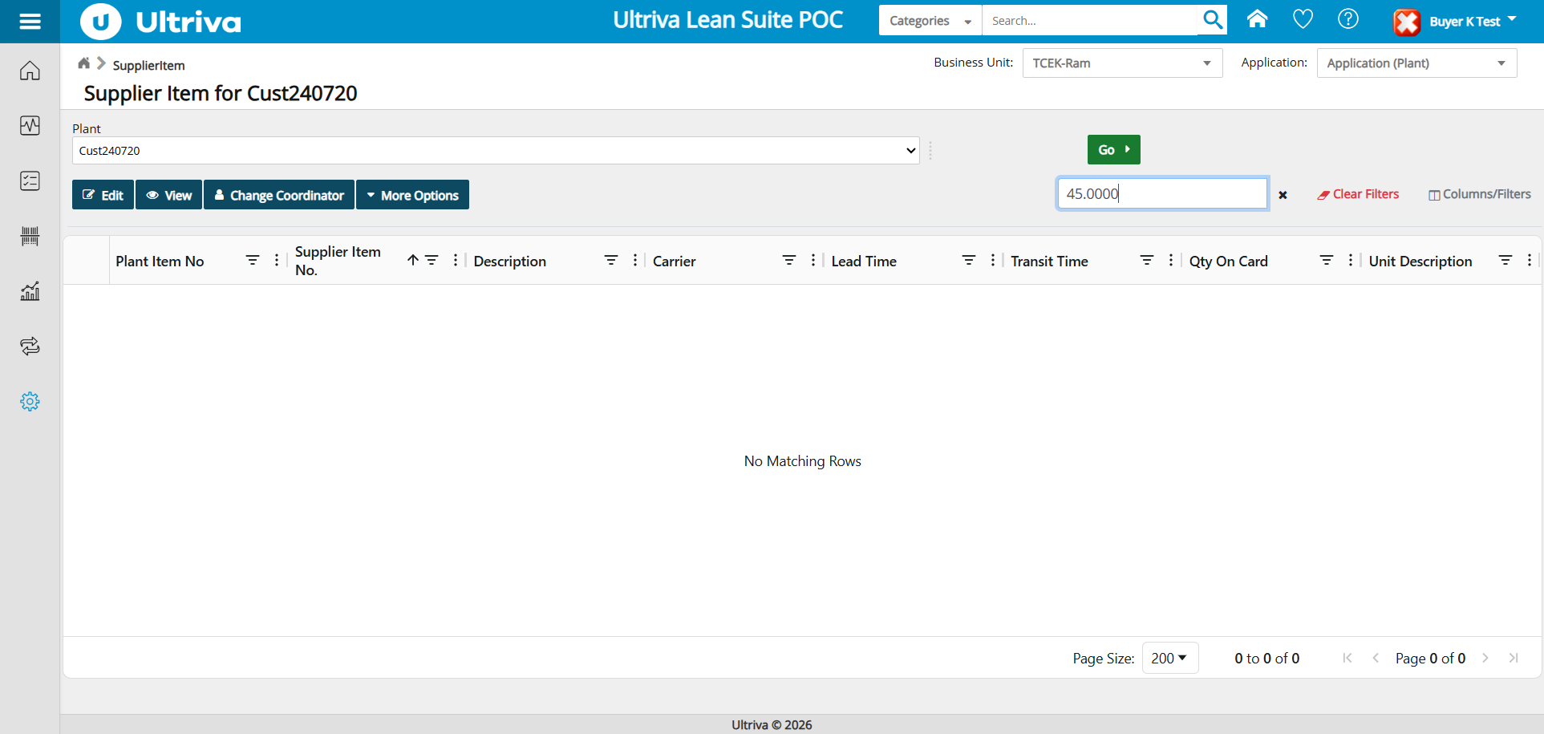

BUG-SI-003 - Description set-filter merges values that differ only by case ('Test' and 'test')
Bug ID | BUG-SI-003
Summary | Description set-filter merges values that differ only by case ('Test' and 'test')
Module | Admin > Supplier Item List
Environment | https://engineering.ultrivalms.com/POC, Chrome, user buyeruser
Severity | Medium
Priority | P2
Related test cases | TC_175, TC_187, TC_189
Steps to reproduce | 1. Log in as buyeruser / Ultriva!23.  2. Open Supplier Item menu (Admin > Supplier Item).  3. Plant Cust1201023 > open Description filter > observe values; select only 'Test' (or 'Test' + '111_testitem1').
Expected result | 'Test' and 'test' listed as separate values (as they are shown and sorted separately); filtering by 'Test' returns 2 rows.
Actual result | Cust1201023: Filter list=['111_testitem1', 'Cust Item', 'Test', 'cust005test', 'cut006test']; expected=['111_testitem1', 'Cust Item', 'cust005test', 'cut006test', 'Test', 'test'] || Cust1201023: Grid shows 3 row(s): ['Cust121023', 'Cust121023-1', 'cust1234'] | Pagination: 'Page Size: 200 1 to 3 of 3 Page 1 of 1' || Cust1201023: Grid shows 4 row(s): ['111_testitem1', 'Cust121023', 'Cust121023-1', 'cust1234'] | Pagination: 'Page Size: 200 1 to 4 of 4 Page 1 of 1'
Status | Open
Screenshot | 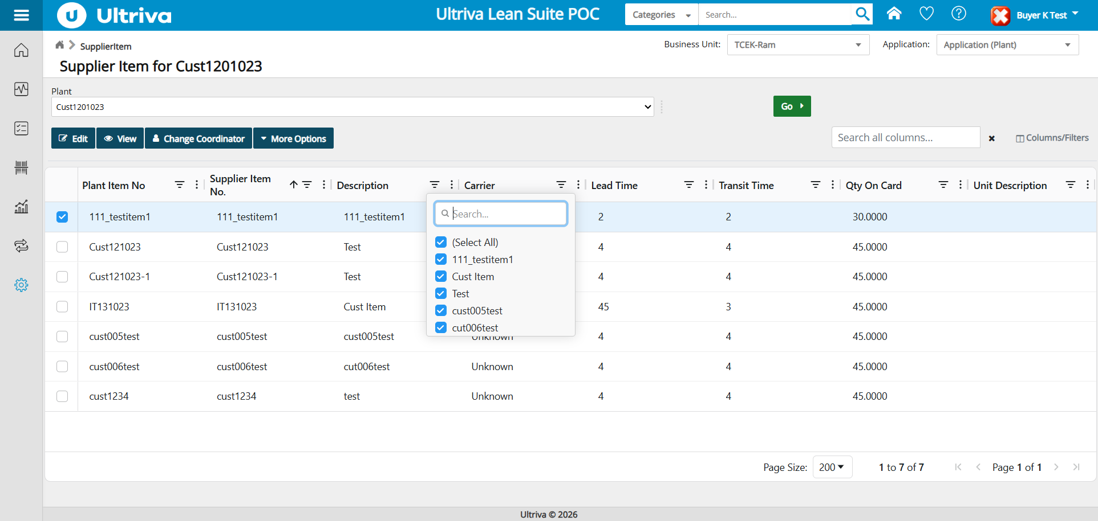

BUG-SI-004 - Unit Description set-filter lists blank value with an empty label instead of '(Blanks)'
Bug ID | BUG-SI-004
Summary | Unit Description set-filter lists blank value with an empty label instead of '(Blanks)'
Module | Admin > Supplier Item List
Environment | https://engineering.ultrivalms.com/POC, Chrome, user buyeruser
Severity | Low
Priority | P3
Related test cases | TC_048, TC_177
Steps to reproduce | 1. Log in as buyeruser / Ultriva!23.  2. Open Supplier Item menu (Admin > Supplier Item).  3. Open the filter (funnel icon) of 'Unit Description'.
Expected result | Blank values listed as '(Blanks)' so the user can see/select the option.
Actual result | Cust240720: Filter list=['']; expected=['(Blanks)'] || Cust1201023: Filter list=['']; expected=['(Blanks)']
Status | Open
Screenshot | 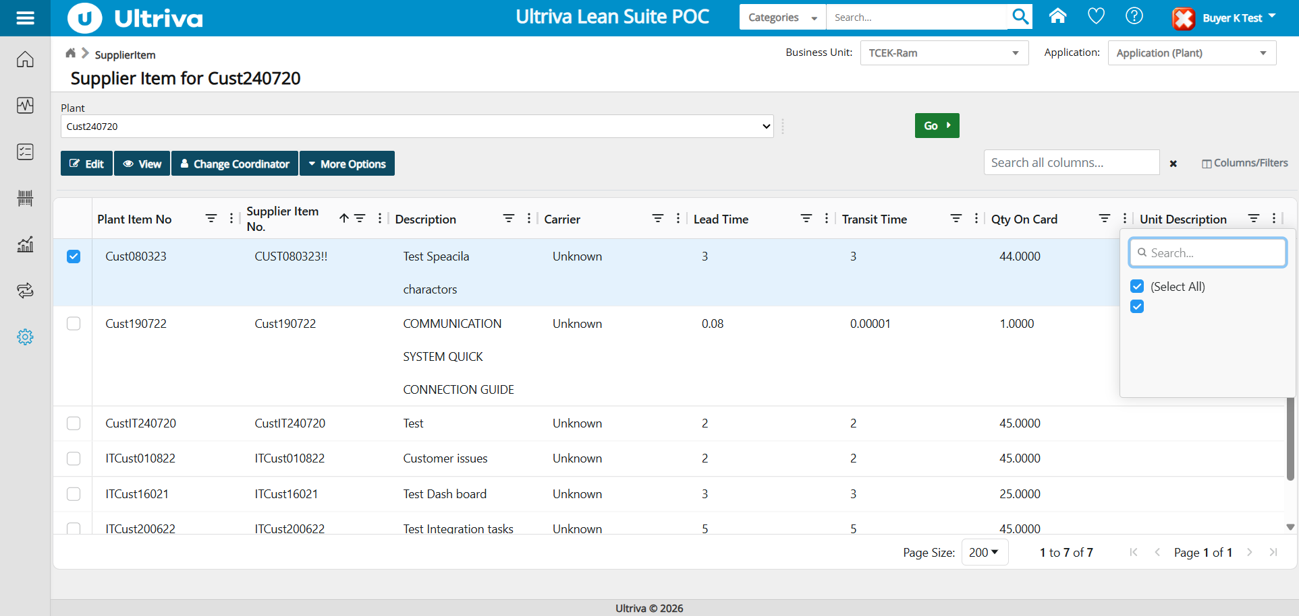

BUG-SI-005 - Text columns are sorted case-sensitively (lowercase values placed after uppercase values)
Bug ID | BUG-SI-005
Summary | Text columns are sorted case-sensitively (lowercase values placed after uppercase values)
Module | Admin > Supplier Item List
Environment | https://engineering.ultrivalms.com/POC, Chrome, user buyeruser
Severity | Low
Priority | P3
Related test cases | Sorting TC_002-TC_168 (see log), Sorting TC_002-TC_168 (see log), Sorting TC_002-TC_168 (see log), Sorting TC_002-TC_168 (see log), Sorting TC_002-TC_168 (see log)
Steps to reproduce | 1. Log in as buyeruser / Ultriva!23.  2. Open Supplier Item menu (Admin > Supplier Item).  3. Plant Cust1201023 > click 'Plant Item No' (or Supplier Item No. / Description) header and view the order.
Expected result | Case-insensitive alphabetical order: 111_testitem1, cust005test, cust006test, Cust121023, Cust121023-1, cust1234, IT131023.
Actual result | Cust1201023: Column PlantItemNo: lowercase values sorted after uppercase values || Cust1201023: Column SupplierItemCode: lowercase values sorted after uppercase values || Cust1201023: Column SupplierItemDesc: lowercase values sorted after uppercase values || Cust240720: Column PlantItemNo: lowercase values sorted after uppercase values
Status | Open
Screenshot | 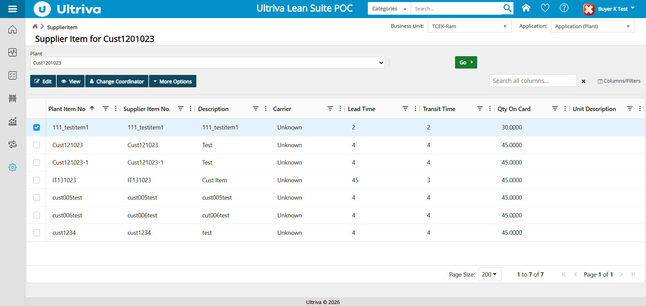

3. Cases Skipped (System / Automation Error)
Case ID | Plant | Title | Error
TX_001 | Cust240720 | Lead Time Between 0.08 | System/automation error, case skipped: Message: stale element reference: stale element not found in the current frame (Session info: chrome=154.0.8037.98); For documentation on this error, please visit: https://www.selenium.dev/documentati

4. Execution Notes
Sorting (all 8 columns, header click and column menu, multi-sort, sort + filter) and filters (set filters, number filters with all operators, Search all columns, 10 cross-column combinations, Clear Filters, Go after filter) were executed on two plants with data. Cases that hit a system/automation error were skipped and listed in section 3; two transient grid-read mismatches were re-run and passed.

5. Executed Test Case Log
ID | Plant | Area | Test case | Result
TC_001 | Cust240720 | Sorting | Default sort on page load | PASS
TC_002 | Cust240720 | Sorting | Sort Plant Item No ascending (header click) | PASS
TC_003 | Cust240720 | Sorting | Sort Plant Item No descending (header click) | PASS
TC_004 | Cust240720 | Sorting | Remove sort on Plant Item No (3rd click) | PASS
TC_005 | Cust240720 | Sorting | Sort Supplier Item No. ascending (header click) | PASS
TC_006 | Cust240720 | Sorting | Sort Supplier Item No. descending (header click) | PASS
TC_007 | Cust240720 | Sorting | Remove sort on Supplier Item No. (3rd click) | PASS
TC_008 | Cust240720 | Sorting | Sort Description ascending (header click) | PASS
TC_009 | Cust240720 | Sorting | Sort Description descending (header click) | PASS
TC_010 | Cust240720 | Sorting | Remove sort on Description (3rd click) | PASS
TC_011 | Cust240720 | Sorting | Sort Carrier ascending (header click) | PASS
TC_012 | Cust240720 | Sorting | Sort Carrier descending (header click) | PASS
TC_013 | Cust240720 | Sorting | Remove sort on Carrier (3rd click) | PASS
TC_014 | Cust240720 | Sorting | Sort Lead Time ascending (header click) | PASS
TC_015 | Cust240720 | Sorting | Sort Lead Time descending (header click) | PASS
TC_016 | Cust240720 | Sorting | Remove sort on Lead Time (3rd click) | PASS
TC_017 | Cust240720 | Sorting | Sort Transit Time ascending (header click) | PASS
TC_018 | Cust240720 | Sorting | Sort Transit Time descending (header click) | PASS
TC_019 | Cust240720 | Sorting | Remove sort on Transit Time (3rd click) | PASS
TC_020 | Cust240720 | Sorting | Sort Qty On Card ascending (header click) | PASS
TC_021 | Cust240720 | Sorting | Sort Qty On Card descending (header click) | PASS
TC_022 | Cust240720 | Sorting | Remove sort on Qty On Card (3rd click) | PASS
TC_023 | Cust240720 | Sorting | Sort Unit Description ascending (header click) | FAIL
TC_024 | Cust240720 | Sorting | Sort Unit Description descending (header click) | FAIL
TC_025 | Cust240720 | Sorting | Remove sort on Unit Description (3rd click) | PASS
TC_026 | Cust240720 | Sorting | Column menu 'Sort Ascending' on Plant Item No | PASS
TC_027 | Cust240720 | Sorting | Column menu 'Sort Descending' on Plant Item No | PASS
TC_028 | Cust240720 | Sorting | Column menu 'Sort Ascending' on Supplier Item No. | PASS
TC_029 | Cust240720 | Sorting | Column menu 'Sort Descending' on Supplier Item No. | PASS
TC_030 | Cust240720 | Sorting | Column menu 'Sort Ascending' on Description | PASS
TC_031 | Cust240720 | Sorting | Column menu 'Sort Descending' on Description | PASS
TC_032 | Cust240720 | Sorting | Column menu 'Sort Ascending' on Carrier | PASS
TC_033 | Cust240720 | Sorting | Column menu 'Sort Descending' on Carrier | PASS
TC_034 | Cust240720 | Sorting | Column menu 'Sort Ascending' on Lead Time | PASS
TC_035 | Cust240720 | Sorting | Column menu 'Sort Descending' on Lead Time | PASS
TC_036 | Cust240720 | Sorting | Column menu 'Sort Ascending' on Transit Time | PASS
TC_037 | Cust240720 | Sorting | Column menu 'Sort Descending' on Transit Time | PASS
TC_038 | Cust240720 | Sorting | Column menu 'Sort Ascending' on Qty On Card | PASS
TC_039 | Cust240720 | Sorting | Column menu 'Sort Descending' on Qty On Card | PASS
TC_040 | Cust240720 | Sorting | Column menu 'Sort Ascending' on Unit Description | FAIL
TC_041 | Cust240720 | Sorting | Column menu 'Sort Descending' on Unit Description | FAIL
TC_042 | Cust240720 | Sorting | Multi-column sort (Carrier, then Shift+Lead Time) | PASS
TC_043 | Cust240720 | Sorting+Filter | Description descending sort retained after Lead Time >= 3 filter | PASS
TC_044 | Cust240720 | Filter | Plant Item No filter value list matches grid data | PASS
TC_045 | Cust240720 | Filter | Supplier Item No. filter value list matches grid data | PASS
TC_046 | Cust240720 | Filter | Description filter value list matches grid data | PASS
TC_047 | Cust240720 | Filter | Carrier filter value list matches grid data | PASS
TC_048 | Cust240720 | Filter | Unit Description filter value list matches grid data | FAIL
TC_049 | Cust240720 | Filter | Plant Item No set-filter = ['Cust080323'] | PASS
TC_050 | Cust240720 | Filter | Plant Item No set-filter = ['Cust190722'] | PASS
TC_051 | Cust240720 | Filter | Plant Item No set-filter = ['CustIT240720'] | PASS
TC_052 | Cust240720 | Filter | Plant Item No set-filter = ['Cust080323', 'Cust190722'] | PASS
TC_053 | Cust240720 | Filter | Supplier Item No. set-filter = ['CUST080323!!'] | PASS
TC_054 | Cust240720 | Filter | Supplier Item No. set-filter = ['Cust190722'] | PASS
TC_055 | Cust240720 | Filter | Supplier Item No. set-filter = ['CustIT240720'] | PASS
TC_056 | Cust240720 | Filter | Supplier Item No. set-filter = ['CUST080323!!', 'Cust190722'] | PASS
TC_057 | Cust240720 | Filter | Description set-filter = ['Test Speacila charactors'] | PASS
TC_058 | Cust240720 | Filter | Description set-filter = ['COMMUNICATION SYSTEM QUICK CONNECTION GUIDE'] | PASS
TC_059 | Cust240720 | Filter | Description set-filter = ['Test'] | PASS
TC_060 | Cust240720 | Filter | Description set-filter = ['Test Speacila charactors', 'COMMUNICATION SYSTEM QUICK CONNECTION GUIDE'] | PASS
TC_061 | Cust240720 | Filter | Carrier set-filter = ['Unknown'] | PASS
TC_062 | Cust240720 | Filter | Unit Description set-filter = ['(Blanks)'] | PASS
TC_063 | Cust240720 | Filter | Lead Time Equals 3 | PASS
TC_064 | Cust240720 | Filter | Lead Time Does not equal 3 | PASS
TC_065 | Cust240720 | Filter | Lead Time Greater than 3 | PASS
TC_066 | Cust240720 | Filter | Lead Time Greater than or equal to 3 | PASS
TC_067 | Cust240720 | Filter | Lead Time Less than 3 | PASS
TC_068 | Cust240720 | Filter | Lead Time Less than or equal to 3 | PASS
TC_070 | Cust240720 | Filter | Lead Time Blank | PASS
TC_071 | Cust240720 | Filter | Lead Time Not blank | PASS
TC_072 | Cust240720 | Filter | Lead Time Equals smallest value 0.08 | PASS
TC_073 | Cust240720 | Filter | Lead Time Less than smallest value (no match expected) | PASS
TC_074 | Cust240720 | Filter | Lead Time Less than 3 OR Greater than 3 | PASS
TC_075 | Cust240720 | Filter | Lead Time Greater than 0.08 AND Less than 5 | PASS
TC_076 | Cust240720 | Filter | Lead Time > max AND < min (contradictory, no rows expected) | PASS
TC_077 | Cust240720 | Filter | Transit Time Equals 3 | PASS
TC_078 | Cust240720 | Filter | Transit Time Does not equal 3 | PASS
TC_079 | Cust240720 | Filter | Transit Time Greater than 3 | PASS
TC_080 | Cust240720 | Filter | Transit Time Greater than or equal to 3 | PASS
TC_081 | Cust240720 | Filter | Transit Time Less than 3 | PASS
TC_082 | Cust240720 | Filter | Transit Time Less than or equal to 3 | PASS
TC_084 | Cust240720 | Filter | Transit Time Blank | PASS
TC_085 | Cust240720 | Filter | Transit Time Not blank | PASS
TC_086 | Cust240720 | Filter | Transit Time Equals smallest value 1e-05 | PASS
TC_087 | Cust240720 | Filter | Transit Time Less than smallest value (no match expected) | PASS
TC_088 | Cust240720 | Filter | Transit Time Less than 3 OR Greater than 3 | PASS
TC_089 | Cust240720 | Filter | Transit Time Greater than 1e-05 AND Less than 5 | PASS
TC_090 | Cust240720 | Filter | Transit Time > max AND < min (contradictory, no rows expected) | PASS
TC_091 | Cust240720 | Filter | Qty On Card Equals 44 | PASS
TC_092 | Cust240720 | Filter | Qty On Card Does not equal 44 | PASS
TC_093 | Cust240720 | Filter | Qty On Card Greater than 44 | PASS
TC_094 | Cust240720 | Filter | Qty On Card Greater than or equal to 44 | PASS
TC_095 | Cust240720 | Filter | Qty On Card Less than 44 | PASS
TC_096 | Cust240720 | Filter | Qty On Card Less than or equal to 44 | PASS
TC_098 | Cust240720 | Filter | Qty On Card Blank | PASS
TC_099 | Cust240720 | Filter | Qty On Card Not blank | PASS
TC_100 | Cust240720 | Filter | Qty On Card Equals smallest value 1 | PASS
TC_101 | Cust240720 | Filter | Qty On Card Less than smallest value (no match expected) | PASS
TC_103 | Cust240720 | Filter | Qty On Card Greater than 1 AND Less than 100 | PASS
TC_104 | Cust240720 | Filter | Qty On Card > max AND < min (contradictory, no rows expected) | PASS
TC_106 | Cust240720 | Search all columns | Search all columns = 'TEST' | PASS
TC_107 | Cust240720 | Search all columns | Search all columns = 'unknown' | PASS
TC_108 | Cust240720 | Search all columns | Search all columns = '45' | PASS
TC_109 | Cust240720 | Search all columns | Search all columns = '45.0000' | FAIL
TC_110 | Cust240720 | Search all columns | Search all columns = '44.0000' | FAIL
TC_111 | Cust240720 | Search all columns | Search all columns = '0.00001' | PASS
TC_112 | Cust240720 | Search all columns | Search all columns = '0.08' | PASS
TC_113 | Cust240720 | Search all columns | Search all columns = '!!' | PASS
TC_114 | Cust240720 | Search all columns | Search all columns = '_' | PASS
TC_115 | Cust240720 | Search all columns | Search all columns = 'test cust' | PASS
TC_116 | Cust240720 | Search all columns | Search all columns = 'zzzz' | PASS
TC_117 | Cust240720 | Search all columns | Search all columns = ' cust ' | PASS
TC_118 | Cust240720 | Filter Combination | Carrier set-filter = ['Unknown']; Lead Time Greater than or equal to 3 | PASS
TC_119 | Cust240720 | Filter Combination | Description set-filter = ['Test Speacila charactors']; Qty On Card Equals 45 | PASS
TC_121 | Cust240720 | Filter Combination | Lead Time Less than 3; Qty On Card Greater than 40 | PASS
TC_122 | Cust240720 | Filter Combination | Search all columns = 'cust'; Lead Time Less than or equal to 3 | PASS
TC_123 | Cust240720 | Filter Combination | Carrier set-filter = ['Unknown']; Search all columns = 'test' | PASS
TC_124 | Cust240720 | Filter Combination | Plant Item No set-filter = ['Cust080323', 'IT_ReqRec']; Transit Time Greater than 2 | PASS
TC_125 | Cust240720 | Filter Combination | Lead Time Equals 4; Transit Time Equals 4; Qty On Card Equals 45 | PASS
TC_126 | Cust240720 | Filter Combination | Unit Description set-filter = ['(Blanks)']; Carrier set-filter = ['Unknown']; Qty On Card Greater than or equal to 45 | PASS
TC_127 | Cust240720 | Filter Combination | Lead Time Less than 3 OR Greater than 4; Search all columns = 'it' | PASS
TC_128 | Cust240720 | Filter | Clear Filters button resets all column filters | PASS
TC_129 | Cust240720 | Filter | Filter behaviour after clicking Go again | PASS
TC_130 | Cust1201023 | Sorting | Default sort on page load | PASS
TC_131 | Cust1201023 | Sorting | Sort Plant Item No ascending (header click) | PASS
TC_132 | Cust1201023 | Sorting | Sort Plant Item No descending (header click) | PASS
TC_133 | Cust1201023 | Sorting | Remove sort on Plant Item No (3rd click) | PASS
TC_134 | Cust1201023 | Sorting | Sort Supplier Item No. ascending (header click) | PASS
TC_135 | Cust1201023 | Sorting | Sort Supplier Item No. descending (header click) | PASS
TC_136 | Cust1201023 | Sorting | Remove sort on Supplier Item No. (3rd click) | PASS
TC_137 | Cust1201023 | Sorting | Sort Description ascending (header click) | PASS
TC_138 | Cust1201023 | Sorting | Sort Description descending (header click) | PASS
TC_139 | Cust1201023 | Sorting | Remove sort on Description (3rd click) | PASS
TC_140 | Cust1201023 | Sorting | Sort Carrier ascending (header click) | PASS
TC_141 | Cust1201023 | Sorting | Sort Carrier descending (header click) | PASS
TC_142 | Cust1201023 | Sorting | Remove sort on Carrier (3rd click) | PASS
TC_143 | Cust1201023 | Sorting | Sort Lead Time ascending (header click) | PASS
TC_144 | Cust1201023 | Sorting | Sort Lead Time descending (header click) | PASS
TC_145 | Cust1201023 | Sorting | Remove sort on Lead Time (3rd click) | PASS
TC_146 | Cust1201023 | Sorting | Sort Transit Time ascending (header click) | PASS
TC_147 | Cust1201023 | Sorting | Sort Transit Time descending (header click) | PASS
TC_148 | Cust1201023 | Sorting | Remove sort on Transit Time (3rd click) | PASS
TC_149 | Cust1201023 | Sorting | Sort Qty On Card ascending (header click) | PASS
TC_150 | Cust1201023 | Sorting | Sort Qty On Card descending (header click) | PASS
TC_151 | Cust1201023 | Sorting | Remove sort on Qty On Card (3rd click) | PASS
TC_152 | Cust1201023 | Sorting | Sort Unit Description ascending (header click) | FAIL
TC_153 | Cust1201023 | Sorting | Sort Unit Description descending (header click) | FAIL
TC_154 | Cust1201023 | Sorting | Remove sort on Unit Description (3rd click) | PASS
TC_155 | Cust1201023 | Sorting | Column menu 'Sort Ascending' on Plant Item No | PASS
TC_156 | Cust1201023 | Sorting | Column menu 'Sort Descending' on Plant Item No | PASS
TC_157 | Cust1201023 | Sorting | Column menu 'Sort Ascending' on Supplier Item No. | PASS
TC_158 | Cust1201023 | Sorting | Column menu 'Sort Descending' on Supplier Item No. | PASS
TC_159 | Cust1201023 | Sorting | Column menu 'Sort Ascending' on Description | PASS
TC_160 | Cust1201023 | Sorting | Column menu 'Sort Descending' on Description | PASS
TC_161 | Cust1201023 | Sorting | Column menu 'Sort Ascending' on Carrier | PASS
TC_162 | Cust1201023 | Sorting | Column menu 'Sort Descending' on Carrier | PASS
TC_163 | Cust1201023 | Sorting | Column menu 'Sort Ascending' on Lead Time | PASS
TC_164 | Cust1201023 | Sorting | Column menu 'Sort Descending' on Lead Time | PASS
TC_165 | Cust1201023 | Sorting | Column menu 'Sort Ascending' on Transit Time | PASS
TC_166 | Cust1201023 | Sorting | Column menu 'Sort Descending' on Transit Time | PASS
TC_167 | Cust1201023 | Sorting | Column menu 'Sort Ascending' on Qty On Card | PASS
TC_168 | Cust1201023 | Sorting | Column menu 'Sort Descending' on Qty On Card | PASS
TC_169 | Cust1201023 | Sorting | Column menu 'Sort Ascending' on Unit Description | FAIL
TC_170 | Cust1201023 | Sorting | Column menu 'Sort Descending' on Unit Description | FAIL
TC_171 | Cust1201023 | Sorting | Multi-column sort (Carrier, then Shift+Lead Time) | PASS
TC_172 | Cust1201023 | Sorting+Filter | Description descending sort retained after Lead Time >= 3 filter | PASS
TC_173 | Cust1201023 | Filter | Plant Item No filter value list matches grid data | PASS
TC_174 | Cust1201023 | Filter | Supplier Item No. filter value list matches grid data | PASS
TC_175 | Cust1201023 | Filter | Description filter value list matches grid data | FAIL
TC_176 | Cust1201023 | Filter | Carrier filter value list matches grid data | PASS
TC_177 | Cust1201023 | Filter | Unit Description filter value list matches grid data | FAIL
TC_178 | Cust1201023 | Filter | Plant Item No set-filter = ['111_testitem1'] | PASS
TC_179 | Cust1201023 | Filter | Plant Item No set-filter = ['Cust121023'] | PASS
TC_180 | Cust1201023 | Filter | Plant Item No set-filter = ['Cust121023-1'] | PASS
TC_181 | Cust1201023 | Filter | Plant Item No set-filter = ['111_testitem1', 'Cust121023'] | PASS
TC_182 | Cust1201023 | Filter | Supplier Item No. set-filter = ['111_testitem1'] | PASS
TC_183 | Cust1201023 | Filter | Supplier Item No. set-filter = ['Cust121023'] | PASS
TC_184 | Cust1201023 | Filter | Supplier Item No. set-filter = ['Cust121023-1'] | PASS
TC_185 | Cust1201023 | Filter | Supplier Item No. set-filter = ['111_testitem1', 'Cust121023'] | PASS
TC_186 | Cust1201023 | Filter | Description set-filter = ['111_testitem1'] | PASS
TC_187 | Cust1201023 | Filter | Description set-filter = ['Test'] | FAIL
TC_188 | Cust1201023 | Filter | Description set-filter = ['Cust Item'] | PASS
TC_189 | Cust1201023 | Filter | Description set-filter = ['111_testitem1', 'Test'] | FAIL
TC_190 | Cust1201023 | Filter | Carrier set-filter = ['Unknown'] | PASS
TC_191 | Cust1201023 | Filter | Unit Description set-filter = ['(Blanks)'] | PASS
TC_192 | Cust1201023 | Filter | Lead Time Equals 4 | PASS
TC_193 | Cust1201023 | Filter | Lead Time Does not equal 4 | PASS
TC_194 | Cust1201023 | Filter | Lead Time Greater than 4 | PASS
TC_195 | Cust1201023 | Filter | Lead Time Greater than or equal to 4 | PASS
TC_196 | Cust1201023 | Filter | Lead Time Less than 4 | PASS
TC_197 | Cust1201023 | Filter | Lead Time Less than or equal to 4 | PASS
TC_199 | Cust1201023 | Filter | Lead Time Blank | PASS
TC_200 | Cust1201023 | Filter | Lead Time Not blank | PASS
TC_201 | Cust1201023 | Filter | Lead Time Equals smallest value 2 | PASS
TC_202 | Cust1201023 | Filter | Lead Time Less than smallest value (no match expected) | PASS
TC_203 | Cust1201023 | Filter | Lead Time Less than 4 OR Greater than 4 | PASS
TC_204 | Cust1201023 | Filter | Lead Time Greater than 2 AND Less than 45 | PASS
TC_205 | Cust1201023 | Filter | Lead Time > max AND < min (contradictory, no rows expected) | PASS
TC_206 | Cust1201023 | Filter | Transit Time Equals 3 | PASS
TC_207 | Cust1201023 | Filter | Transit Time Does not equal 3 | PASS
TC_208 | Cust1201023 | Filter | Transit Time Greater than 3 | PASS
TC_209 | Cust1201023 | Filter | Transit Time Greater than or equal to 3 | PASS
TC_210 | Cust1201023 | Filter | Transit Time Less than 3 | PASS
TC_211 | Cust1201023 | Filter | Transit Time Less than or equal to 3 | PASS
TC_213 | Cust1201023 | Filter | Transit Time Blank | PASS
TC_214 | Cust1201023 | Filter | Transit Time Not blank | PASS
TC_215 | Cust1201023 | Filter | Transit Time Equals smallest value 2 | PASS
TC_216 | Cust1201023 | Filter | Transit Time Less than smallest value (no match expected) | PASS
TC_217 | Cust1201023 | Filter | Transit Time Less than 3 OR Greater than 3 | PASS
TC_218 | Cust1201023 | Filter | Transit Time Greater than 2 AND Less than 4 | PASS
TC_219 | Cust1201023 | Filter | Transit Time > max AND < min (contradictory, no rows expected) | PASS
TC_220 | Cust1201023 | Filter | Qty On Card Equals 45 | PASS
TC_221 | Cust1201023 | Filter | Qty On Card Does not equal 45 | PASS
TC_222 | Cust1201023 | Filter | Qty On Card Greater than 45 | PASS
TC_223 | Cust1201023 | Filter | Qty On Card Greater than or equal to 45 | PASS
TC_224 | Cust1201023 | Filter | Qty On Card Less than 45 | PASS
TC_225 | Cust1201023 | Filter | Qty On Card Less than or equal to 45 | PASS
TC_227 | Cust1201023 | Filter | Qty On Card Blank | PASS
TC_228 | Cust1201023 | Filter | Qty On Card Not blank | PASS
TC_229 | Cust1201023 | Filter | Qty On Card Equals smallest value 30 | PASS
TC_230 | Cust1201023 | Filter | Qty On Card Less than smallest value (no match expected) | PASS
TC_231 | Cust1201023 | Filter | Qty On Card Less than 45 OR Greater than 45 | PASS
TC_232 | Cust1201023 | Filter | Qty On Card Greater than 30 AND Less than 45 | PASS
TC_233 | Cust1201023 | Filter | Qty On Card > max AND < min (contradictory, no rows expected) | PASS
TC_234 | Cust1201023 | Search all columns | Search all columns = 'cust' | PASS
TC_235 | Cust1201023 | Search all columns | Search all columns = 'TEST' | PASS
TC_236 | Cust1201023 | Search all columns | Search all columns = 'unknown' | PASS
TC_237 | Cust1201023 | Search all columns | Search all columns = '45' | PASS
TC_238 | Cust1201023 | Search all columns | Search all columns = '45.0000' | FAIL
TC_239 | Cust1201023 | Search all columns | Search all columns = '44.0000' | PASS
TC_240 | Cust1201023 | Search all columns | Search all columns = '0.00001' | PASS
TC_241 | Cust1201023 | Search all columns | Search all columns = '0.08' | PASS
TC_242 | Cust1201023 | Search all columns | Search all columns = '!!' | PASS
TC_243 | Cust1201023 | Search all columns | Search all columns = '_' | PASS
TC_244 | Cust1201023 | Search all columns | Search all columns = 'test cust' | PASS
TC_245 | Cust1201023 | Search all columns | Search all columns = 'zzzz' | PASS
TC_246 | Cust1201023 | Search all columns | Search all columns = ' cust ' | PASS
TC_247 | Cust1201023 | Filter Combination | Carrier set-filter = ['Unknown']; Lead Time Greater than or equal to 3 | PASS
TC_248 | Cust1201023 | Filter Combination | Description set-filter = ['111_testitem1']; Qty On Card Equals 45 | PASS
TC_250 | Cust1201023 | Filter Combination | Lead Time Less than 3; Qty On Card Greater than 40 | PASS
TC_251 | Cust1201023 | Filter Combination | Search all columns = 'cust'; Lead Time Less than or equal to 3 | PASS
TC_252 | Cust1201023 | Filter Combination | Carrier set-filter = ['Unknown']; Search all columns = 'test' | PASS
TC_253 | Cust1201023 | Filter Combination | Plant Item No set-filter = ['111_testitem1', 'cust1234']; Transit Time Greater than 2 | PASS
TC_254 | Cust1201023 | Filter Combination | Lead Time Equals 4; Transit Time Equals 4; Qty On Card Equals 45 | PASS
TC_255 | Cust1201023 | Filter Combination | Unit Description set-filter = ['(Blanks)']; Carrier set-filter = ['Unknown']; Qty On Card Greater than or equal to 45 | PASS
TC_256 | Cust1201023 | Filter Combination | Lead Time Less than 3 OR Greater than 4; Search all columns = 'it' | PASS
TC_257 | Cust1201023 | Filter | Clear Filters button resets all column filters | PASS
TC_258 | Cust1201023 | Filter | Filter behaviour after clicking Go again | PASS
TX_001 | Cust240720 | Filter | Lead Time Between 0.08 | SKIP
TX_002 | Cust240720 | Filter | Transit Time Between 1e-05 | PASS
TX_003 | Cust240720 | Filter | Qty On Card Between 1 | PASS
TX_004 | Cust240720 | Filter | Qty On Card Less than 44 OR Greater than 44 | PASS
TX_005 | Cust240720 | Search all columns | Search all columns = 'cust' | PASS
TX_006 | Cust240720 | Filter Combination | Lead Time Between 1; Transit Time Greater than 2 | PASS
TX_007 | Cust240720 | Filter Combination | Search all columns = 'cust'; Lead Time Less than or equal to 3 | PASS
TX_008 | Cust1201023 | Filter | Lead Time Between 2 | PASS
TX_009 | Cust1201023 | Filter | Transit Time Between 2 | PASS
TX_010 | Cust1201023 | Filter | Qty On Card Between 30 | PASS
TX_011 | Cust1201023 | Search all columns | Search all columns = 'cust' | PASS
TX_012 | Cust1201023 | Filter Combination | Lead Time Between 1; Transit Time Greater than 2 | PASS
TX_013 | Cust1201023 | Filter Combination | Search all columns = 'cust'; Lead Time Less than or equal to 3 | PASS

