QA Automation Framework
Lead Demo — Ultriva LMS (QALS1011)

Prepared by: S Vijaya Kumar (QA Engineer) | Date: April 08, 2026
Application: https://engineering.ultrivalms.com/qals1011
Framework: Python · Selenium · Pytest · TestRail MCP · JIRA MCP

Table of Contents
1. Project Overview & Architecture ........................... 3
2. Project Structure & Key Files ........................... 4
3. Step-by-Step Test Execution Demo ........................... 6
4. TestRail Integration with MCP Server ........................... 9
5. JIRA Integration with MCP Server & Creating Subtasks ........................... 12
6. Reports — Excel, HTML & Screenshots ........................... 15
7. Summary & Key Benefits ........................... 16

1. Project Overview & Architecture
This document demonstrates how an end-to-end QA Automation Framework has been built for the Ultriva Lean Management Suite (QALS1011). The framework covers automated browser testing with Selenium/Pytest, test case management through TestRail (via MCP), and defect tracking through JIRA (via MCP). All integrations are orchestrated through the VS Code Copilot Chat agent using the Model Context Protocol (MCP).

1.1 Architecture Overview Diagram
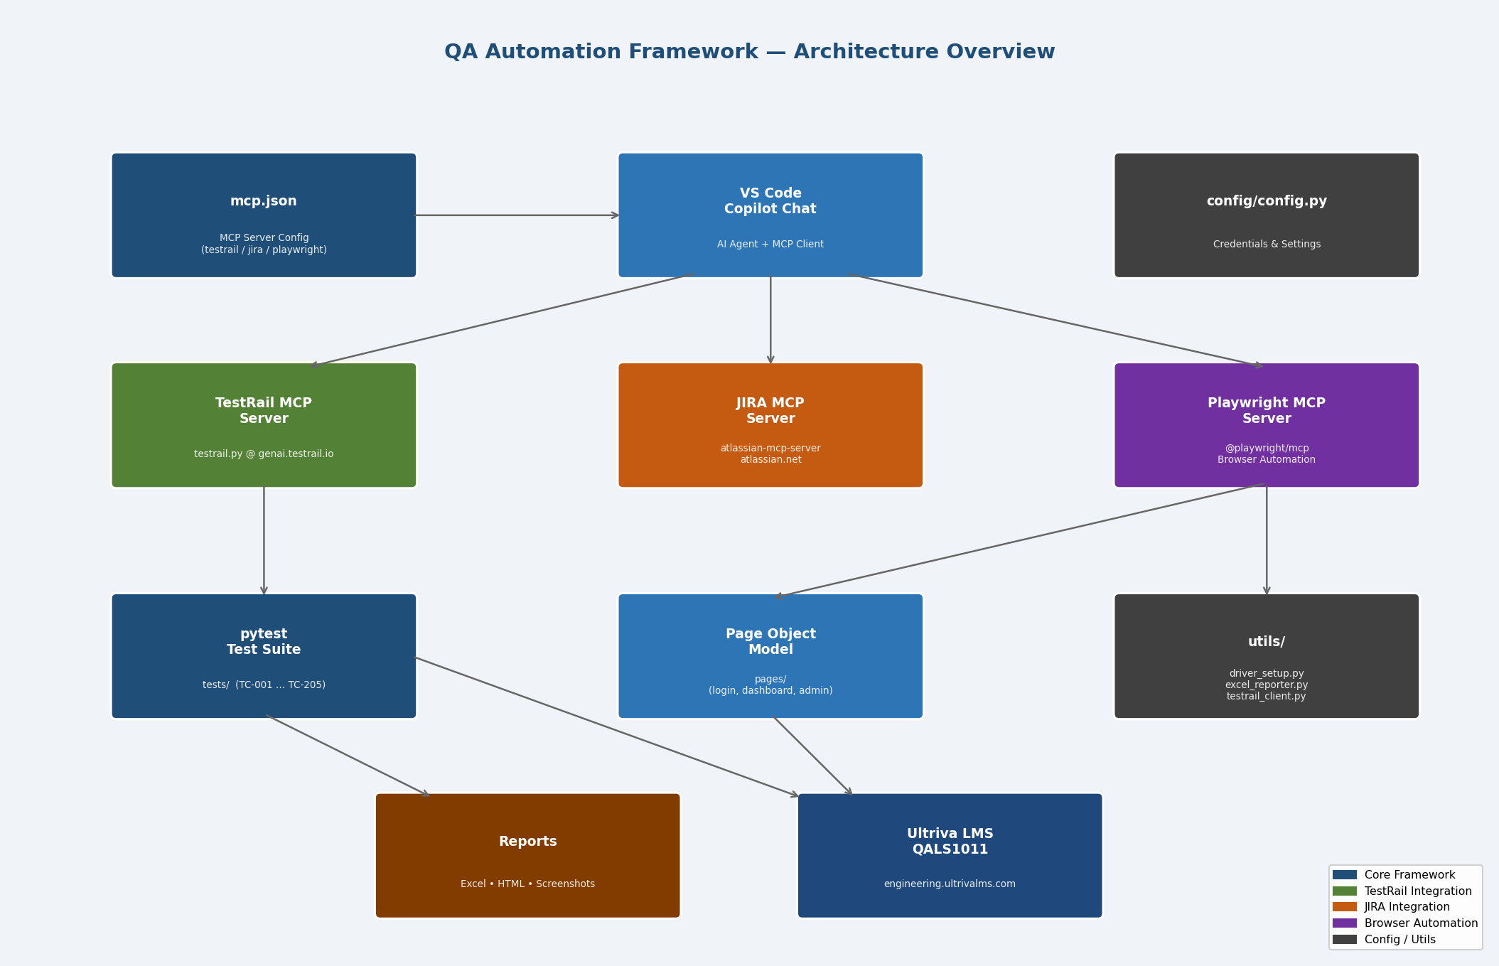
Fig 1.1 — QA Automation Architecture: Framework → MCP Servers → TestRail / JIRA / Browser

1.2 Technology Stack
Technology | Purpose
Python 3.x | Core language for all automation scripts
Selenium 4.18 | Browser automation (Chrome / Firefox / Edge)
Pytest 8.1 | Test runner with fixtures, parametrize, HTML reports
python-docx | Word document generation
openpyxl | Excel test result reporter
testrail-api | TestRail case & run management
jira (python-jira) | JIRA issue creation, comments, transitions
MCP (testrail.py) | Model Context Protocol server for TestRail
Atlassian MCP (HTTP) | Model Context Protocol server for JIRA
Playwright MCP | @playwright/mcp — AI-driven browser screenshots
VS Code Copilot | AI agent orchestrating all MCP tool calls

2. Project Structure & Key Files
All automation code lives under the qa_automation/ folder. The Page Object Model (POM) pattern is used throughout so that locator changes only need to be updated in one place.

2.1 Folder Tree
Directory: qa_automation/
qa_automation/
├── config/
│ └── config.py ← Credentials, URLs, TestRail & JIRA settings
├── pages/
│ ├── base_page.py ← Selenium helpers (wait, click, screenshot)
│ ├── login_page.py ← Login page locators & actions
│ └── dashboard_page.py ← Dashboard page object
├── tests/
│ ├── test_login.py ← TC-001 – TC-007 (Authentication)
│ ├── test_dashboard.py ← TC-101 – TC-107 (Dashboard UI)
│ └── test_navigation.py ← TC-201 – TC-205 (Navigation)
├── utils/
│ ├── driver_setup.py ← WebDriver factory (Chrome / Firefox / Edge)
│ ├── excel_reporter.py ← Colour-coded Excel results (PASS/FAIL/SKIP)
│ ├── testrail_client.py ← TestRail API wrapper
│ └── jira_client.py ← JIRA API wrapper
├── JIRA Tickets/
│ ├── Bugs/ ← ULT-10069 bug scripts + test plans
│ └── Enhancements/ ← ULT-10425, ULT-10511 enhancement scripts
├── conftest.py ← Pytest session fixtures & TestRail hook
├── pytest.ini ← Pytest settings
└── requirements.txt ← pip dependencies

2.2 Key File: config/config.py
File: qa_automation/config/config.py — Central configuration — URLs, credentials, TestRail & JIRA settings
File: config/config.py — Core Settings
# Application
BASE_URL = "https://engineering.ultrivalms.com/qals1011"
USERNAME = "buyeruser"
PASSWORD = "Ultriva!23"
BROWSER = "chrome" # chrome | firefox | edge
HEADLESS = True

# TestRail
TESTRAIL_URL = os.environ.get("TESTRAIL_URL", "https://upland.testrail.com/")
TESTRAIL_EMAIL = os.environ.get("TESTRAIL_EMAIL", "vseelam@uplandsoftware.com")
TESTRAIL_API_KEY = os.environ.get("TESTRAIL_API_KEY", "...")
TESTRAIL_PROJECT_ID = 15
TESTRAIL_ENABLED = True

# JIRA
JIRA_SERVER = "https://uplandsoftware.atlassian.net"
JIRA_EMAIL = "vseelam@uplandsoftware.com"
JIRA_API_TOKEN = os.environ.get("ATLASSIAN_API_TOKEN", "")
JIRA_PROJECT_KEY = "ULT

2.3 Key File: pages/login_page.py
File: qa_automation/pages/login_page.py — Page Object for Login — locators, open(), login(), logout(), is_logged_in()
File: pages/login_page.py — Page Object Model
class LoginPage(BasePage):
# Locators — verified against live DOM
USERNAME_INPUT = (By.ID, "UserName")
PASSWORD_INPUT = (By.ID, "Password")
LOGIN_BUTTON = (By.ID, "login-button")
ERROR_MESSAGE = (By.ID, "inner-alerts-container")
LOGOUT_LINK = (By.XPATH, "//a[contains(@href,'Account/Logout')]")

def login(self, username, password):
self.open() # driver.get(LOGIN_URL)
self.enter_username(username)
self.enter_password(password)
self.click_login()
self.wait_for_page_load()

def is_logged_in(self):
return (
self.is_element_present(*self.LOGOUT_LINK, timeout=8)
or self.is_element_present(*self.WELCOME_TEXT, timeout=8)
)

2.4 Key File: utils/driver_setup.py
File: qa_automation/utils/driver_setup.py — WebDriver factory — supports Chrome, Firefox, Edge with Selenium Manager auto-download
File: utils/driver_setup.py — WebDriver Factory
def get_driver():
browser = BROWSER.lower()
if browser == "chrome":
options = webdriver.ChromeOptions()
if HEADLESS:
options.add_argument("--headless=new")
options.add_argument("--window-size=1920,1080")
driver = webdriver.Chrome(options=options)
elif browser == "firefox":
options = webdriver.FirefoxOptions()
driver = webdriver.Firefox(options=options)
elif browser == "edge":
driver = webdriver.Edge(options=...)
driver.implicitly_wait(IMPLICIT_WAIT) # 10 s
driver.set_page_load_timeout(30)
driver.maximize_window()
return driver

3. Step-by-Step Test Execution Demo
Below is a full walkthrough of how automated tests run from command line to results. Screenshots of the live Ultriva application are captured at each key step.

3.1 Test Execution Flow Diagram
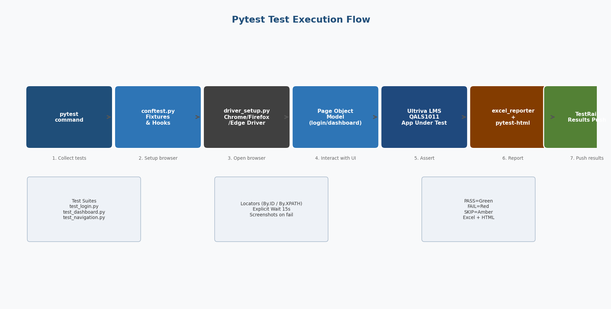
Fig 3.1 — Test Execution Flow: pytest → fixtures → WebDriver → POM → App → Reports

3.2 Step 1 — Install & Configure
Step | Action | Expected Result
1 | Clone repo & activate venv  cd qa_automation  python -m venv .venv  .venv\Scripts\activate | Virtual environment active (venv)
2 | Install dependencies  pip install -r requirements.txt | Selenium 4.18, pytest, openpyxl, testrail-api, jira installed
3 | Edit config/config.py — set BASE_URL, USERNAME, PASSWORD,  TESTRAIL_URL, TESTRAIL_API_KEY, JIRA_API_TOKEN | Config file updated. All credentials point to QALS1011
4 | Verify connectivity  python check_testrail.py | TestRail project 15 listed; all API calls succeed

3.3 Step 2 — Login Page (TC-001, TC-002)
The LoginPage object navigates to the BASE_URL, enters credentials and verifies successful authentication by checking for the logout link or dashboard element.
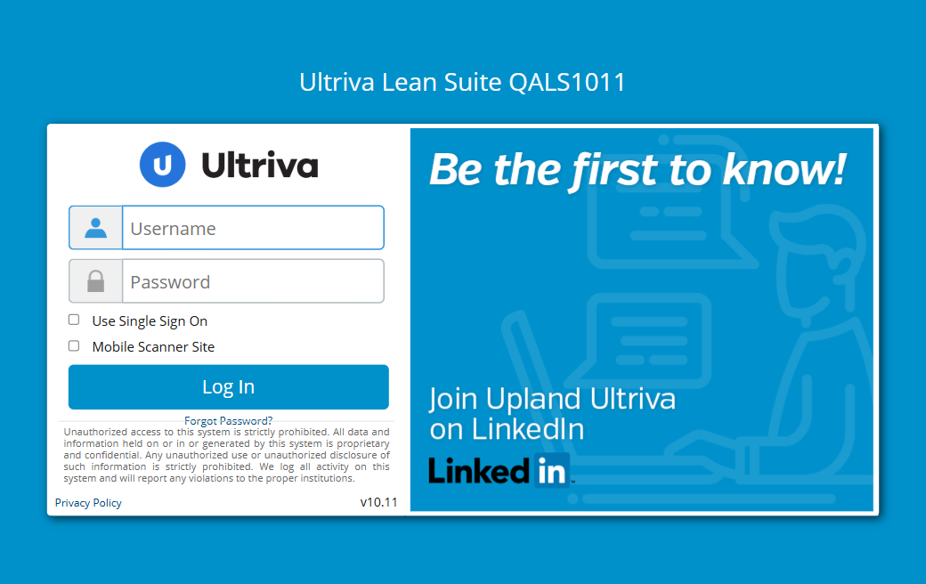
Screenshot 3.3a — Ultriva LMS Login Page (QALS1011) — file: demo_01_login_page.png

File: qa_automation/tests/test_login.py — TC-001: Login page loads | TC-002: Valid login | TC-003–005: Invalid cases | TC-006: Logout
File: tests/test_login.py — TC-002 Valid Login Test
# tests/test_login.py —— TC-002 Valid login
def test_valid_login(self, driver, reporter):
login_page = LoginPage(driver)
login_page.login(USERNAME, PASSWORD) # open → enter creds → click
assert login_page.is_logged_in(), \
"Login failed — logout link / dashboard not found"
reporter.add_result(
test_id="TC-002", test_name="Valid login",
module="Authentication", status="PASS",
screenshot=login_page.take_screenshot("TC-002"),
)

3.4 Step 3 — Dashboard After Login
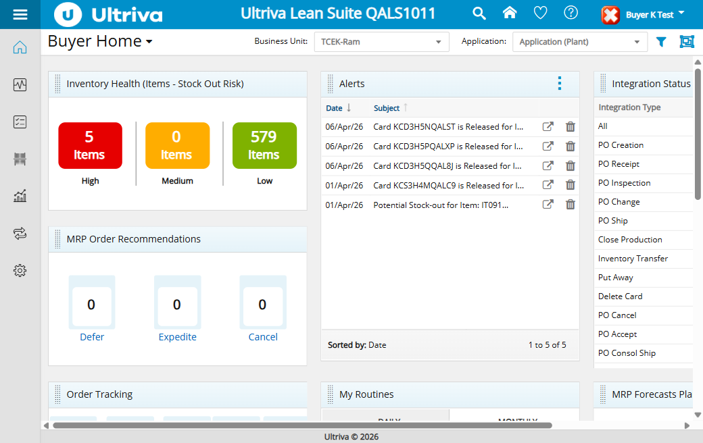
Screenshot 3.4a — Buyer Home Dashboard after successful login — file: demo_02_after_login.png

After login, the Dashboard tests (TC-101–TC-107) verify: navigation menu present, correct URL, page header visible, menu items populated, and footer visible.

3.5 Step 4 — Execute Full Test Suite
Step | Action | Expected Result
1 | cd qa_automation | Working directory set
2 | pytest tests/ -v --html=reports/report.html --self-contained-html | All 17 tests executed; HTML report generated
3 | pytest tests/test_login.py -v (run one module) | 7 login tests pass in ~35 seconds
4 | pytest tests/ --tb=short -q (quiet mode) | Summary: 17 passed, 0 failed in 2.5m

3.6 Test Cases Table (Full)
Test ID | Test Case Name | Module
TC-001 | Login page loads with input fields | Authentication
TC-002 | Valid login – buyeruser/Ultriva!23 | Authentication
TC-003 | Login rejected — invalid username | Authentication
TC-004 | Login rejected — invalid password | Authentication
TC-005 | Login rejected — empty credentials | Authentication
TC-006 | Logout redirects to login page | Authentication
TC-007 | Login page non-empty browser title | Authentication
TC-101 | Dashboard loads after valid login | Dashboard
TC-102 | Navigation menu is present | Dashboard
TC-103 | URL changes after login | Dashboard
TC-104 | Page header visible | Dashboard
TC-105 | Menu items are populated | Dashboard
TC-106 | Footer is present | Dashboard
TC-107 | Dashboard browser title non-empty | Dashboard
TC-201 | Browser back button does not crash | Navigation
TC-202 | Unauthenticated access → redirects | Navigation
TC-203 | Session persists after page refresh | Navigation

4. TestRail Integration with MCP Server
TestRail test cases and runs are managed automatically through a Model Context Protocol (MCP) server. VS Code Copilot Chat triggers the MCP tools to create, update and fetch test cases — all without leaving the IDE.

4.1 MCP Flow Diagram
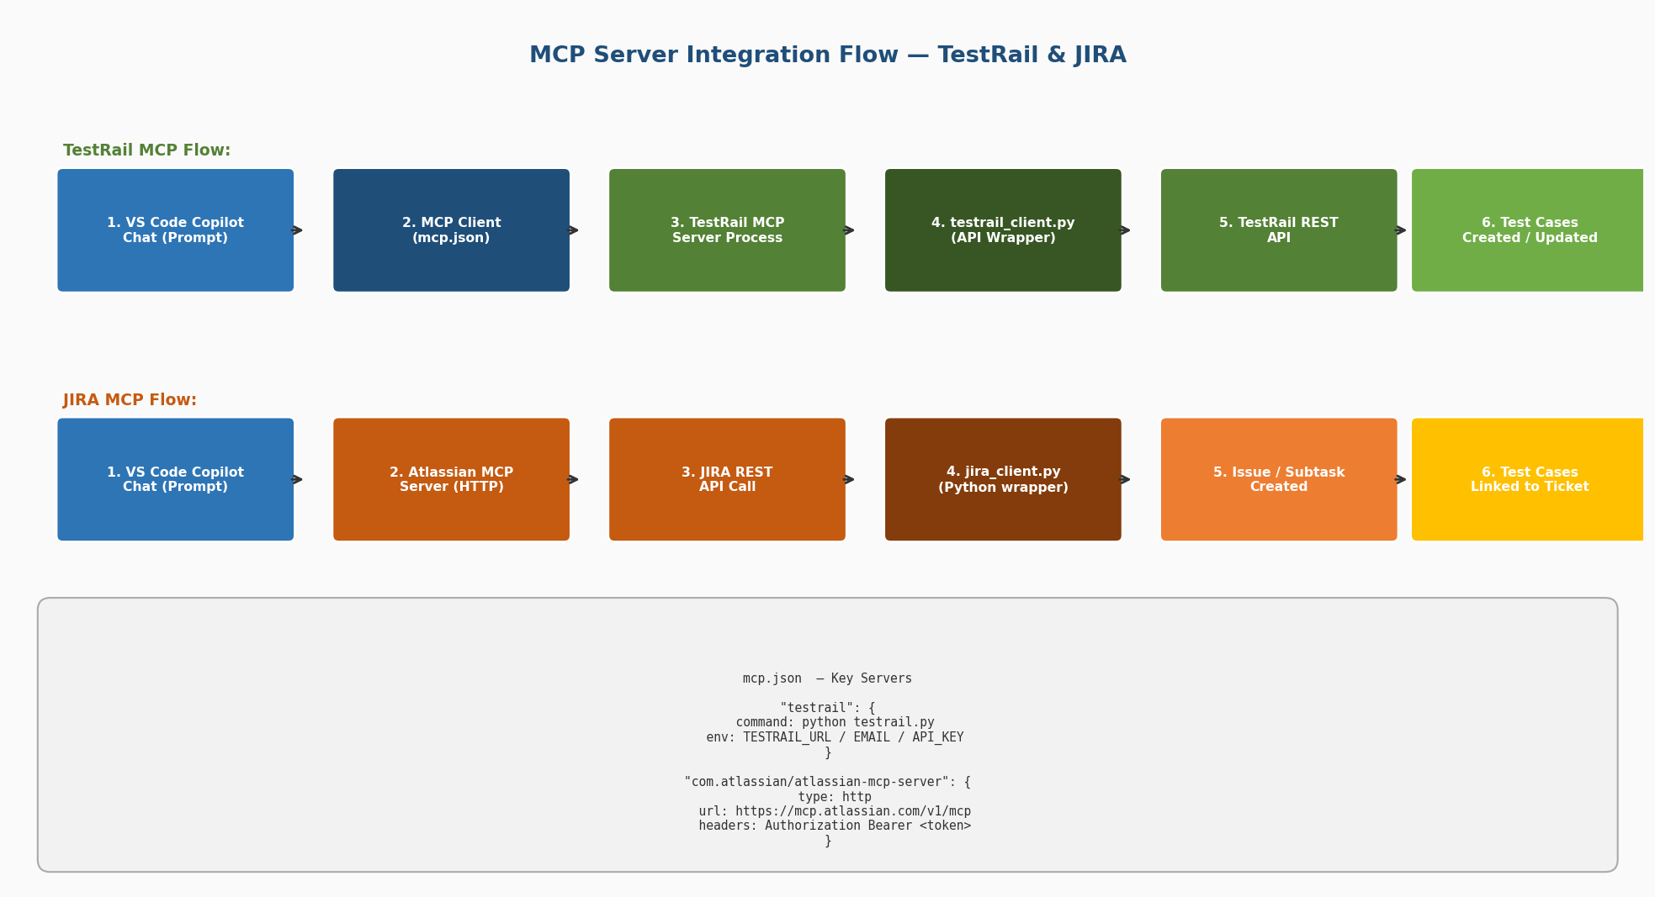
Fig 4.1 — TestRail & JIRA MCP Flow: VS Code Copilot → MCP Server → API → Result

4.2 mcp.json — TestRail Server Configuration
File: .vscode/mcp.json — MCP server definitions — testrail entry launches testrail.py as stdio server
File: .vscode/mcp.json — TestRail MCP Server Entry
// .vscode/mcp.json — TestRail MCP Server entry
"testrail": {
"command": "C:/Users/.../python.exe",
"args": ["C:/genai-training/Labs/Lab5/testrail.py"],
"env": {
"TESTRAIL_URL": "https://genai.testrail.io",
"TESTRAIL_EMAIL": "user@example.com",
"TESTRAIL_API_KEY": "your_api_key_here"
},
"type": "stdio"
}

How it works: When VS Code starts, it reads mcp.json and launches testrail.py as a child process. Copilot Chat can then call TestRail tools directly in the chat with natural language — e.g. 'Create a test case for TC-002 in project 15'.

4.3 utils/testrail_client.py — API Wrapper
File: qa_automation/utils/testrail_client.py — Wraps testrail-api library; provides get_case(), add_result(), push_results(), close_run()
File: utils/testrail_client.py — Core Methods
# utils/testrail_client.py
from testrail_api import TestRailAPI
from config.config import TESTRAIL_URL, TESTRAIL_EMAIL, TESTRAIL_API_KEY

class TestRailClient:
def __init__(self):
self._client = TestRailAPI(TESTRAIL_URL, TESTRAIL_EMAIL, TESTRAIL_API_KEY)

def get_or_create_run(self) -> int:
# Creates a new Test Run in TestRail for this session
name = TESTRAIL_RUN_NAME.replace("{date}", datetime.now().strftime("%Y-%m-%d %H:%M"))
run = self._client.runs.add_run(
project_id=TESTRAIL_PROJECT_ID,
name=name,
suite_id=TESTRAIL_SUITE_ID,
)
return run["id"]

def add_result(self, run_id, case_id, status, comment=""):
self._client.results.add_result_for_case(
run_id=run_id, case_id=case_id,
status_id=STATUS_MAP[status],
comment=comment,
)

4.4 JIRA Ticket Scripts — TestRail Case Creation
File: qa_automation/JIRA Tickets/Bugs/ULT-10069_add_testrail_case.py — Fetches reference case C13569701, creates/updates C17520015 for bug ULT-10069
File: JIRA Tickets/Bugs/ULT-10069_add_testrail_case.py
# JIRA Tickets/Bugs/ULT-10069_add_testrail_case.py
from utils.testrail_client import TestRailClient

SECTION_ID = 372888 # Suite S2571 (Admin) → Kanban Loop Design
REF_CASE_ID = 13569701 # C13569701 — reference case

tr = TestRailClient()
ref = tr.get_case(case_id=REF_CASE_ID) # fetch reference steps

updated = tr.update_case(
case_id=17520015,
custom_steps = ref["custom_steps"],
custom_expected = ref["custom_expected"],
)
print(f"Updated: C{updated['id']} — {updated['title']}")

4.5 TestRail MCP — Step-by-Step Demo Steps
Step | Action | Expected Result
1 | Open VS Code → Copilot Chat panel | MCP servers auto-start (testrail.py process visible in background)
2 | Type: '@testrail Get project info for project 15' | MCP tool: get_project → returns Project Name, ID, Suite count
3 | Type: '@testrail List test cases for suite S2571' | MCP returns list of all cases: C-IDs, titles, priorities
4 | Type: '@testrail Create a test case for ULT-10069 in section 372888' | New test case created; Copilot returns Case ID (e.g. C17520015)
5 | Run: python check_testrail.py | Verifies connection and prints project info + case C5242647 details
6 | Run: pytest tests/ (with TESTRAIL_ENABLED=True) | Each TC result auto-pushed to TestRail run; run closed at end of session

4.6 check_testrail.py — Quick Verification Script
File: qa_automation/check_testrail.py — Quick script to verify TestRail connection and fetch case C5242647
File: qa_automation/check_testrail.py — Verification Script
# check_testrail.py
from utils.testrail_client import TestRailClient

tr = TestRailClient()
project = tr.get_project() # [1] Project info
print(f"Name: {project['name']}")

case = tr.get_case(case_id=5242647) # [2] Specific case
print(f"Case: C{case['id']} — {case['title']}")

runs = tr.get_runs() # [3] Recent runs
for r in runs[:3]:
print(f"Run {r['id']}: {r['name']} — {r['passed_count']} passed")

5. JIRA Integration with MCP Server & Creating Subtasks
JIRA is integrated through the Atlassian MCP HTTP server. VS Code Copilot Chat can list tickets, get issue details, create subtasks, add comments, and transition issues — directly from the chat panel using natural language commands.

5.1 mcp.json — Atlassian MCP Server Configuration
File: .vscode/mcp.json — Atlassian MCP entry — HTTP server with Bearer token auth; supports JIRA + Confluence
File: .vscode/mcp.json — Atlassian MCP (JIRA) Configuration
// .vscode/mcp.json — Atlassian MCP Server
"com.atlassian/atlassian-mcp-server": {
"type": "http",
"url": "https://mcp.atlassian.com/v1/mcp",
"headers": {
"Authorization": "Bearer ${input:ATLASSIAN_API_TOKEN}"
}
}

// inputs section — prompts for token securely
"inputs": [
{
"id": "ATLASSIAN_API_TOKEN",
"type": "promptString",
"description": "Atlassian API Token (from id.atlassian.com)",
"password": true
}
]

5.2 utils/jira_client.py — Python JIRA Wrapper
File: qa_automation/utils/jira_client.py — Wraps python-jira library; connect(), search(), get_issue(), create_bug(), create_subtask()
File: utils/jira_client.py — Full JIRA Client
# utils/jira_client.py
from jira import JIRA
from config.config import JIRA_SERVER, JIRA_EMAIL, JIRA_API_TOKEN

class JiraClient:
def __init__(self):
self._client = JIRA(
server=JIRA_SERVER,
basic_auth=(JIRA_EMAIL, JIRA_API_TOKEN),
)

def get_issue(self, key):
return self._client.issue(key)

def create_bug(self, summary, description, labels=None):
issue_dict = {
"project": {"key": self.project_key},
"summary": summary,
"description": description,
"issuetype": {"name": "Bug"},
"labels": labels or [],
}
issue = self._client.create_issue(fields=issue_dict)
return issue.key

def create_subtask(self, parent_key, summary, description):
parent = self.get_issue(parent_key)
issue_dict = {
"project": {"key": self.project_key},
"summary": summary,
"description": description,
"issuetype": {"name": "Sub-task"},
"parent": {"id": parent.id},
}
subtask = self._client.create_issue(fields=issue_dict)
return subtask.key

def add_comment(self, issue_key, body):
self._client.add_comment(issue_key, body)

def transition_issue(self, issue_key, transition_name):
transitions = self._client.transitions(issue_key)
for t in transitions:
if t["name"].lower() == transition_name.lower():
self._client.transition_issue(issue_key, t["id"])
return t["name"]

5.3 JIRA Tickets — Bug ULT-10069
File: qa_automation/JIRA Tickets/Bugs/ULT-10069_test_plan.md — Bug: Kanban Loop Design not processing when HTTP exchange type is set
Ticket / ID | Summary | Type | Priority | Status | Assignee
ULT-10069 | Kanban Loop Design Not Processing | Bug | Critical | In QA Review | Sherif Hamdy
TS-01 | KLD processes after Item Data Load sets HTTP exchange type | Scenario | Critical | – | –
TS-02 | Batch job transitions Created → InProgress → Completed | Scenario | Critical | – | –
TS-03 | Item Data Load continues to work — no regression | Scenario | High | – | –
TS-04 | KLD processes when exchange type is HTTPS | Scenario | High | – | –

5.4 JIRA Tickets — Enhancement ULT-10425
File: qa_automation/JIRA Tickets/Enhancements/ULT-10425_test_plan.md — Enhancement: Plant Home Page Integration Panel — remember last BU filter & label rename
Ticket / ID | Summary | Type | Priority | Status | Assignee
ULT-10425 | Plant Home Page: Remember Last BU Filter Choice | Enhancement | Critical | In QA Review | Sherif Hamdy
TC-01 | Label reads 'Plant and Associated Workcenters' | Test Case | Critical | – | –
TC-02 | 'Only this BU' option still present after rename | Test Case | Critical | – | –
TC-03 | 'Plant and Associated Workcenters' persists after nav | Test Case | High | – | –
TC-04 | Default filter = 'Only this BU' for first-time user | Test Case | High | – | –

5.5 Creating Subtasks via MCP — Step-by-Step
Step | Action | Expected Result
1 | Open VS Code → Copilot Chat  Ensure ATLASSIAN_API_TOKEN environment variable is set | Atlassian MCP server authenticates to uplandsoftware.atlassian.net
2 | Type: 'List open issues in project ULT assigned to me' | MCP tool: searchJiraIssuesUsingJql returns ticket list with keys, titles, status
3 | Type: 'Get details for ULT-10069' | MCP returns: summary, description, status (In QA Review), assignee, components
4 | Type: 'Create a subtask under ULT-10069 for writing automated test cases' | MCP tool: createJiraIssue with issuetype=Sub-task, parent=ULT-10069
5 | Type: 'Add comment to ULT-10069: Test cases created in TestRail Suite S2571' | MCP tool: addCommentToJiraIssue — comment appears in JIRA ticket
6 | Type: 'Transition ULT-10069 to In Progress' | MCP tool: transitionJiraIssue — ticket status changes to In Progress
7 | Run: python jira_client.py (standalone verification) | Console prints connected JIRA server + sample issue key

5.6 JIRA Test Case Script — ULT-10425
File: qa_automation/JIRA Tickets/Enhancements/ULT-10425_test_cases.py — Automated Selenium test cases for the Integration Panel filter feature
File: JIRA Tickets/Enhancements/ULT-10425_test_cases.py
# JIRA Tickets/Enhancements/ULT-10425_test_cases.py
class TestIntegrationPanelFilterLabel:

# TC-01: Verify label renamed
def test_label_renamed_to_plant_and_associated_workcenters(self, driver):
LoginPage(driver).login(USERNAME, PASSWORD)
driver.get(PLANT_HOME_URL)
elements = driver.find_elements("xpath", FILTER_WORKCENTERS)
assert elements, "Label 'Plant and Associated Workcenters' NOT found!"
old = driver.find_elements("xpath", OLD_LABEL_CHECK)
assert not old, "Old label 'All Business Units' still present!"

# TC-03: Verify persistence after navigation
def test_filter_persists_after_navigation(self, driver):
LoginPage(driver).login(USERNAME, PASSWORD)
driver.get(PLANT_HOME_URL)
select_filter(driver, FILTER_WORKCENTERS)
driver.refresh()
active = selected_filter_text(driver)
assert "Plant and Associated Workcenters" in active, \
f"Filter not persisted, got: {active!r}"

6. Reports — Excel, HTML & Screenshots

6.1 Excel Report (utils/excel_reporter.py)
File: qa_automation/utils/excel_reporter.py — Generates colour-coded Excel report: PASS=Green, FAIL=Red, SKIP=Amber
File: utils/excel_reporter.py — Excel Report Generator
# utils/excel_reporter.py — ExcelReporter class
PASS_COLOR = "92D050" # Green
FAIL_COLOR = "FF0000" # Red
SKIP_COLOR = "FFC000" # Amber
HEADER_COLOR = "1F4E79" # Dark blue

# Columns: Test ID | Test Case | Module | Status | Duration | Timestamp | Error | Screenshot
reporter.add_result(
test_id="TC-002", test_name="Valid login",
module="Authentication", status="PASS",
duration=1.23, error_msg="", screenshot="reports/screenshots/TC-002.png",
)
# Output: reports/test_results.xlsx

6.2 HTML Report (pytest-html)
The HTML report is generated by pytest-html automatically after each run. It includes: pass/fail totals, test duration, error tracebacks, and embedded screenshots. Open: qa_automation/reports/report.html in any browser.

6.3 Screenshots
Every test calls take_screenshot(test_id) on pass and fail. Screenshots are saved under reports/screenshots/ with the test ID as filename (e.g. TC-002.png). Failed tests append '_fail' (e.g. TC-003_fail.png).
File / Path | Description
reports/report.html | pytest-html HTML report (self-contained)
reports/test_results.xlsx | Colour-coded Excel workbook with all results
reports/screenshots/TC-001.png | Screenshot on each test (pass & fail)
reports/screenshots/TC-002.png | TC-002 valid login pass screenshot
reports/screenshots/demo_01_login_page.png | Playwright screenshot – Login Page (used in this document)
reports/screenshots/demo_02_after_login.png | Playwright screenshot – Dashboard after login
reports/screenshots/diag_architecture.png | Architecture diagram (generated)
reports/screenshots/diag_mcp_flow.png | MCP flow diagram (generated)
reports/screenshots/diag_test_execution.png | Test execution flow diagram (generated)

7. Summary & Key Benefits

7.1 What Was Demonstrated
Area | Details
Automation Framework | Python + Selenium + Pytest with Page Object Model covering 17 test cases across Authentication, Dashboard, and Navigation modules
MCP — TestRail | testrail.py MCP server launched from mcp.json; Copilot Chat creates/updates test cases, creates runs, and pushes pass/fail results automatically
MCP — JIRA | Atlassian HTTP MCP server integrated via Bearer token; Copilot Chat lists open tickets, reads issue details, creates subtasks, adds comments, transitions
MCP — Playwright | @playwright/mcp server used live to navigate the app, login, and capture screenshots directly in the demo document
Reports | Colour-coded Excel + pytest-html + per-test PNG screenshots — all generated automatically on each test run
AI Acceleration | VS Code Copilot Chat with MCP eliminated context switching: all test management tasks done inside the IDE in natural language

7.2 File Summary Reference
File | Purpose
config/config.py | All credentials, URLs, TestRail & JIRA settings
pages/base_page.py | Selenium helpers — wait, click, screenshot, type
pages/login_page.py | Login Page Object — locators & login/logout methods
pages/dashboard_page.py | Dashboard Page Object
tests/test_login.py | TC-001 – TC-007 Authentication tests
tests/test_dashboard.py | TC-101 – TC-107 Dashboard tests
tests/test_navigation.py | TC-201 – TC-205 Navigation tests
utils/driver_setup.py | WebDriver factory for Chrome/Firefox/Edge
utils/excel_reporter.py | Colour-coded Excel test report
utils/testrail_client.py | TestRail API wrapper (get/create/push)
utils/jira_client.py | JIRA API wrapper (search/create/subtask)
conftest.py | Pytest fixtures, session setup & TestRail hook
check_testrail.py | Quick TestRail connectivity verification
JIRA Tickets/Bugs/ULT-10069_test_plan.md | Bug test plan — Kanban Loop Design
JIRA Tickets/Bugs/ULT-10069_add_testrail_case.py | Creates/updates TestRail case C17520015
JIRA Tickets/Enhancements/ULT-10425_test_plan.md | Enhancement test plan — BU Filter
JIRA Tickets/Enhancements/ULT-10425_test_cases.py | Selenium tests for BU filter feature
.vscode/mcp.json | MCP server definitions (testrail, atlassian, playwright)

QA Automation Framework — Ultriva LMS QALS1011

