Test 1
Uniting of two regions, composed of N simple polygons each
 | N = 100 | N = 1000 | N = 2000 | N = 4000 |  |  | Asymptotic
MyOr | 0,03 (sec.) | 2,07 | 12,18 | 65,68 |  |  | ~ N*N*log(N)
MyOr2 | 0,05 | 0,58 | 1,13 | 2,42 |  |  | ~ N*log(N)

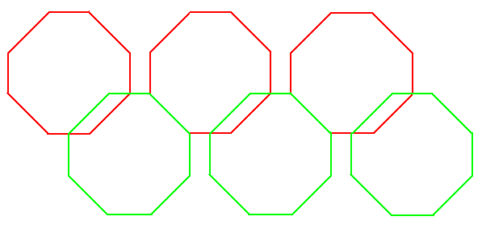

Test 2
Uniting of 2*N simple polygons (result union is identical with one of test 1)
 | N = 100 | N = 1000 | N = 2000 | N = 4000 |  |  | Asymptotic
MyOr | 0,03 | 2,01 | 11,86 | 64,66 |  |  | ~ N*N*log(N)
MyOr2 | 0,04 | 0,54 | 1,09 | 2,25 |  |  | ~ N*log(N)

Test 3

Coupling of two “combs” with N teeth each
 | N = 100 | N = 1000 | N = 2000 | N = 4000 |  |  | Asymptotic
MyOr | 0 | 0,99 | 6,4 | 29,34 |  |  | ~ N*N*log(N)
MyOr2 | 0,02 | 0,28 | 0,58 | 1,21 |  |  | ~ N*log(N)

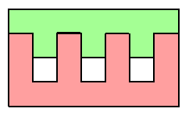

Test 4
Train of N partially overlapping polygons
 | N = 100 | N = 1000 | N = 2000 | N = 4000 | N = 8000 |  | Asymptotic
MyOr | 0,01 | 0,41 | 1,44 | 9,1 | 56,66 |  | ~ N*N*log(N)
MyOr2 | 0,04 | 0,39 | 0,8 | 1,7 | 3,42 |  | ~ N*log(N)



